**DEDICATED TO**

**MY BELOVED PARENTS**

**TITLE OF THE PROJECT**

**PICTZA**

**ACKNOWLEDGEMENT**

**ACKNOWLEDGEMENT**

The successful completion of my task would be incomplete without greeting those who made it possible. I would like to place a record of my gratitude to a number of people who helped me and whose guidance and encouragement made it success.

I thank God to his blessings and heartly thank my beloved parents for their constant love support and affection I wish to take this opportunity to express my deepest thanks to

**Dr. Anuradha Naik** Principal of Shivaji Arts, Commerce & BCA college Baad, karwar for providing all provision for studies during the entire course, it gives me immense pleasure to avail this opportunity to thanks **Miss.Pratyaksha Siddarkar**, head of the department. I also thank Miss.Nausheen Mulla for the guidance.

I would like to thank my client **. )** forgiving me an opportunity to do my project and also providing me details of the project.

And lastly thank my all staff members and my friends who have directly or indirectly helped me by extending their invaluable support and encouragement in completing the project.

**MR. RAHUL G NAIK**

BCA 6th SEM

**CONTENTS**

**CONTENTS**

1. Introduction 7-8
2. Objectives 9-10
3. System Design 11-13

* Existing System
* Proposed System

1. Feasibility Study 14-15
2. Hardware and Software Requirements 16-17
3. Software Requirement Specification 18-21

* XML
* JAVA
* ANDROID STUDIO

1. System design 22-29

* Data Flow Diagram
* ER Diagram

1. User Interface Design 30-35
2. Testing 36-37
3. Validation 38-39
4. Future Scope 40-41
5. Conclusion 42-43
6. Bibliography 44-45

**INTRODUCTION**

**INTRODUCTION**

The Pictza mobile application project provides a convenient platform for art enthusiasts, collectors, and artists to explore, discover, and engage with a wide range of artworks, fostering appreciation for art, supporting artists, and facilitating the buying and selling of artworks in a user-friendly and immersive digital environment.

The Art Gallery mobile application project includes the ability for users to add, view, update, and delete paintings, allowing artists and collectors to showcase and manage their artworks within the app. The application also provides features to manage users, allowing for registration, authentication, and profile management. Additionally, the app enables the management of art shows, allowing organizers to create, update, and promote exhibitions and events. The search functionality allows users to search for specific paintings, users, or art shows, enhancing the discoverability and accessibility of artworks and artists within the platform. Overall, the project encompasses a comprehensive set of features to facilitate the seamless interaction between artists, collectors, and art enthusiasts in a digital art gallery setting.

**OBJECTIVES**

**OBJECTIVES**

**The main objectives of our website are :**

* To provide a secure login page where users can enter their credentials such as username and password
* To authenticate and gain access to the system.
* Users should have the ability to add new paintings to the gallery by providing details such as title, artist, medium, dimensions, and images.
* To provide features to manage art shows.

**SYSTEM**

**ANALYSIS**

**EXISTING SYSTEM**

* Users are visiting shops to buy paintings.
* They have to wait in a queue for long time.
* They get confused in choosing the paintings.
* Some shops are not opened on certain days.
* Their paintings doesn’t reach to many peoples.

**PROPOSED SYSTEM**

* Instead of visiting the shops the user can easily search paintings through our application.
* It will reduce the efforts of people who search for artists.
* And also there will not be an particular art medium , the user will have variety of artworks to choose.

**FEASIBILITY**

**STUDY**

**FEASIBILITY STUDY**

Feasibility study is a test of a system proposed according to its workability, Impact on the organization, ability to user needs and effective use of resources. The objective of feasibility study is not to solve the problem, but to acquire a sense of its scope. The result of the feasibility is formal proposal. This is simply a report a formal document detailing the nature and scope of the proposed solution.

**ECONOMICAL FEASIBILITY :**

Economic analysis is the most frequently used method for evaluating the effectiveness of the candidate system. More commonly known as cost/benefit analysis, the procedure is to determine the benefits and saving that are expected from a candidate system and compare them with cost. This is an ongoing effect that improves in accuracy at each face of system life cycle.

**TECHNICAL FEASIBILITY :**

As computers are spread everywhere with an optimum configuration of 40 GB, HDD, 128 MB RAM and other accessories, the said system will certainly improvise the existing minimum infrastructure. This project is undertaken is technically feasible and is within sate of art.

Software is like MS SQL server 2005 and Visual Studio 2008 are used to meet the software requirements.

**OPERATIONAL FEASIBILITY :**

The project is user friendly and with a demonstration. Any computer user can work on the package without any additional training. Using this software package, the user can get all the required information regarding customer, vendor and design details with a mouse click.

**HARDWARE**

**AND**

**SOFTWARE**

**REQUIREMENTS**

**HARDWARE REQUIREMENTS**

* Processor : Intel core i5
* RAM : 8 GB
* Storage : 64GB or Higher
* Android OS : Kitkat 4.4 version or higer

**SOFTWARE REQUIREMENTS**

* Operating System : Windows 10,11
* IDE : Android Studio
* Formatting Language : XML & Java

**SOFTWARE**

**REQUIREMENT**

**SPECIFICATIONS**

**XML**

XML (eXtensible Markup Language) is a versatile markup language widely used for structuring, storing, and transporting data across different platforms and applications. Its human-readable format and customizable structure make it a fundamental tool for representing information hierarchies in a wide range of contexts.

XML follows a simple yet powerful syntax consisting of tags enclosed in angle brackets. These tags define elements that organize and label the data. Each XML document has a root element, and the elements can nest within each other, forming a hierarchical structure that mirrors the relationships between the data.

One of XML's primary strengths is its flexibility. Unlike fixed data formats, XML allows developers to define their own custom tags and document structures tailored to their specific needs. This adaptability makes XML an excellent choice for representing complex and diverse data types, from configuration files to document content, making it an essential part of various industries like web development, data interchange, and configuration management.

XML documents can also incorporate attributes within elements to provide additional information or metadata. This enhances the document's expressiveness and allows for more detailed data representation. However, while XML is human-readable, it can become verbose for large datasets, leading to increased file sizes.

**JAVA**

Java is a versatile, object-oriented programming language that has been a cornerstone of software development for decades. Created by Sun Microsystems (now owned by Oracle), Java's design principles emphasize portability, readability, and reliability, making it a popular choice for a wide range of applications.

One of Java's defining features is its "write once, run anywhere" capability. It achieves platform independence by compiling source code into an intermediate form called bytecode, which is then executed by the Java Virtual Machine (JVM) on different platforms. This allows Java applications to run consistently across various operating systems without modification.

Java's object-oriented nature encourages modular and organized code development. It promotes the use of classes and objects, facilitating code reuse, encapsulation, and maintenance. Java's vast standard library provides pre-built classes for common tasks, saving developers time and effort.

Exception handling is a crucial aspect of Java, enhancing the robustness of applications. Java enforces compile-time and runtime checks to catch errors, promoting stable and reliable software.

Java's influence extends beyond traditional application development. It's a key language for Android app development, powering millions of mobile devices. Java's usage in big data processing (Hadoop), web development (Java EE), and scientific computing further demonstrates its versatility.

**ANDROID STUDIO**

PHP is a servAndroid Studio is the official Integrated Development Environment (IDE) for Android app development, created by Google. It offers a comprehensive set of tools and features that enable developers to design, develop, test, and debug Android applications efficiently.

The Layout Editor within Android Studio allows developers to create visually appealing user interfaces using a drag-and-drop interface, along with XML code editing. It supports various screen sizes and orientations, facilitating responsive design.

The Code Editor offers intelligent code completion, syntax highlighting, and error checking, which aid in writing clean and error-free code. Android Studio supports multiple programming languages, including Java and Kotlin, making it versatile for developers with different language preferences.

The Gradle-based build system automates the compilation, packaging, and deployment of Android applications. It manages project dependencies, allowing developers to easily integrate external libraries and resources. This streamlines the development process and ensures consistent and efficient builds.

The Android Emulator lets developers test their applications on virtual devices with different Android versions and screen configurations, aiding in identifying compatibility issues. Additionally, Android Studio supports physical devices for testing and debugging.

**SYSTEM DESIGN**

**DATA FLOW**

**DIAGRAM**

**LEVEL – 0**

Shows

**PICTZA**

User

Admin

Cart

**LEVEL – 1**

On failure

On success

Reject

Process entrance

User

**LEVEL – 2**

Updates

Paintings

Add to

Admin

Cart

If not an existing user

User

**LEVEL – 3**

Managed by

Books the

Admin

Shows

User

**ENTITY RELATIONSHIP DIAGRAM**

**ER – DIAGRAM**

**Adds paintings to**

**Uploaded by**

**Books**

**Shows**

**Cart**

**Managed by**

**Admin**

**Checks for**

**User**

**Paintings**

**USER INTERFACE DESIGN**

**SNAPSHOTS**

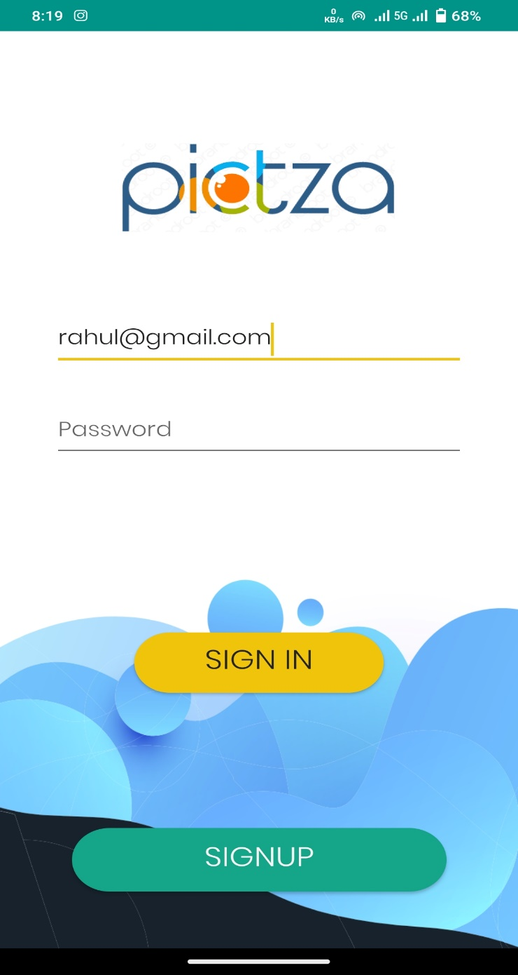

**Description:**

Screenshot showing the login page.

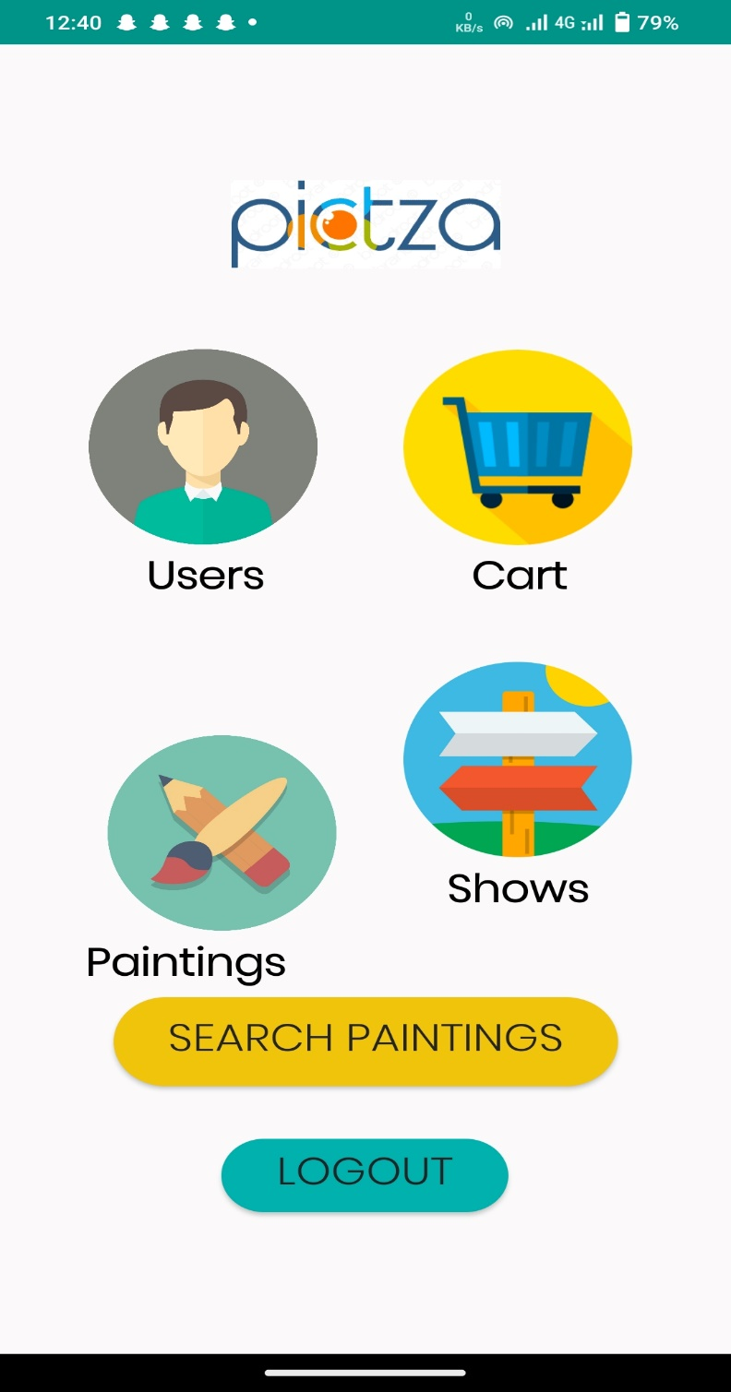

**Description:**

Screenshot showing the main page of the app.

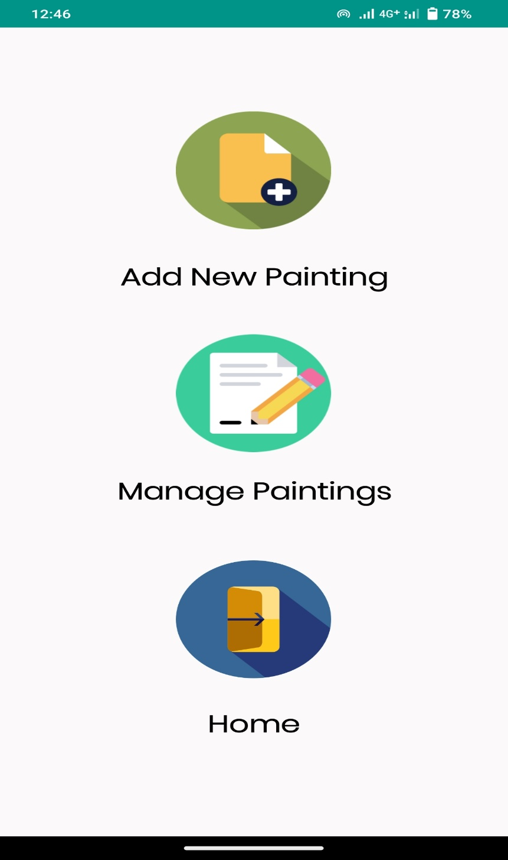

**Description:**

Screenshot showing the painting section.

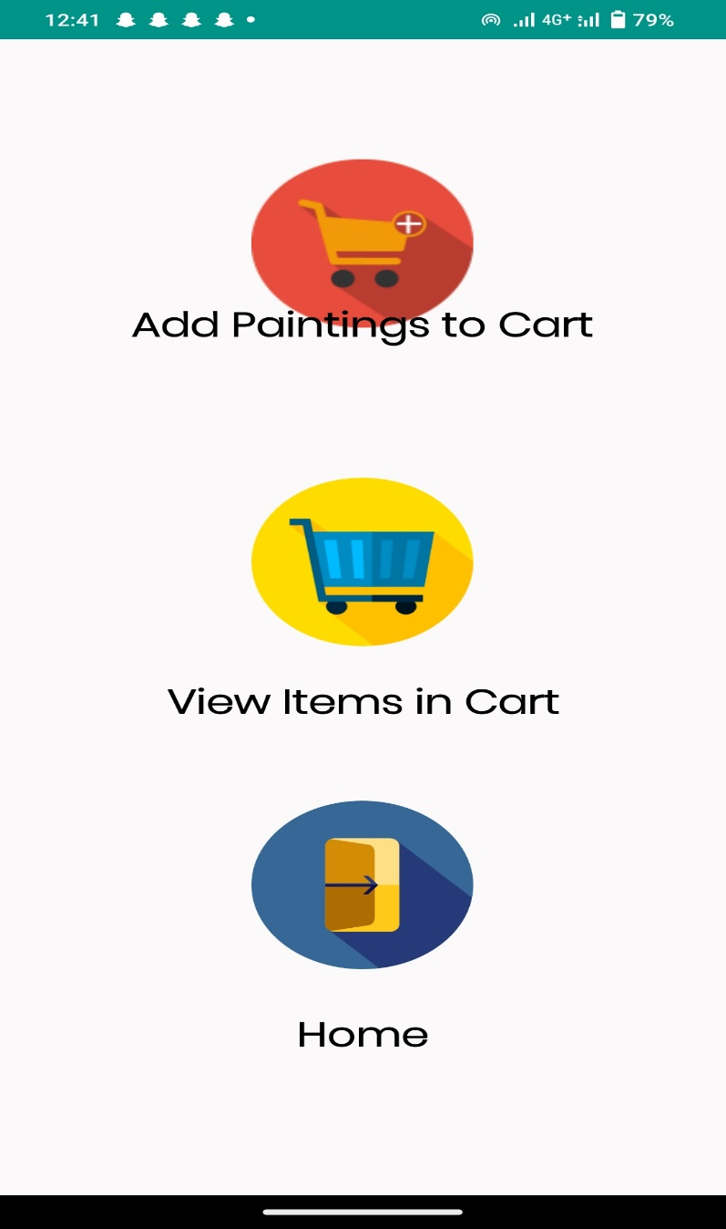

**Description:**

Screenshot showing the cart page.

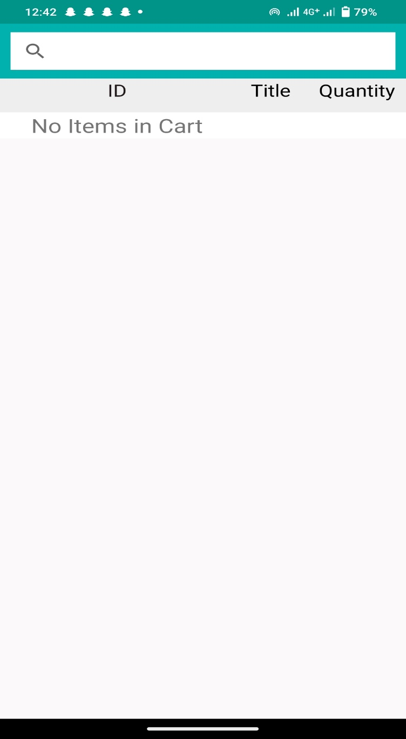

**Description:**

Screenshot of cart.

**TESTING**

**TESTING**

**SOFTWARE TESTING**

Software testing is a process of executing a program or application with the internet of finding the software bugs.

It can also be started as the process of validating and verifying that a software program or application or product:

* Meets the business and technical requirements that guided is design and development
* Works as expected
* Can be implemented with the same characteristic

**UNIT TESTING**

Unit testing is the testing of an individual unit or group of related units. It falls under the class of white box testing. It is often done by the programmer to test that the unit he/she has implemented is producing expected output against given input.

**FUNCTIONAL TESTING**

Functional testing is the testing to ensure that the specified functionality required in the system requirements works.

**SYSTEM TESTING**

System testing is the testing to ensure that by putting the software in different environment (e.g.. operating system) it still works. System done with full system implementation and environment.

**VALIDATION**

**VALIDATION**

Validation testing is mainly done to confirm that each value of different fields are of their specific type and also check whether any fields is left black that is any fields are left without entering any value.

* If we try to save the Painting without adding any details then, the “Please Fill All The Fields” Message Appears.
* While adding painting details, if the painting name is blank Then “Please Fill All The Fields” Warning appears.
* It takes time in numeric format only.
* It Takes Date by default From the system.

**FUTURE SCOPE**

**FUTURE SCOPE**

* In future we will be adding other art based products like Plaster of paris works, abstract paintings, wall paintings.
* We will also feature multiple images of a particular artwork so that the buyer can have a goodlook at artwork before purchasing it.

**CONCLUSION**

**CONCLUSION**

In conclusion, the **PICTZA** Android application is an project that aims to create a comprehensive and user- friendly platform for art enthusiasts, collectors, and artists to explore, discover, and engage with artworks. By incorporating features such as a login page, the ability to add, view, update, and delete paintings, user management, art show management, and robust search functionality, the application strives to provide a seamless experience. This project not only facilitates the buying and selling of artworks but also fosters appreciation for art and supports artists by creating a digital environment that promotes art discovery, interaction, and community engagement.

.

**BIBILIOGRAPHY**

**BIBLIOGRAPHY**

**BOOKS**

* **Android Programming** - The Big Nerd Ranch Guide - By Bryan Sills
* **Java Programming for Android Developers for dummies**- Barry Burd
* **GUI Design for Android Apps** - By Ryan Cohen
* **Android Application Development All in one for dummies** - By Barry Burd

**WEBSITES**

<https://github.com/>

<https://www.youtube.com/>

<https://console.firebase.google.com/>

**YOUTUBE REFERENCE:**

* Code With Harry (Android Development Complete Tutorials)

**THANK YOU**