print("Name : Rahul Nair")

print("Roll No: 22073")

print("Write a program to compute distance between two points taking input from the user ")

x1=int(input("enter x1 : "))

x2=int(input("enter x2 : "))

y1=int(input("enter y1 : "))

y2=int(input("enter y2 : "))

result= ((((x2 - x1 )**2) + ((y2-y1)**2) )**0.5)

print("distance between",(x1,x2),"and",(y1,y2),"is : ",result)

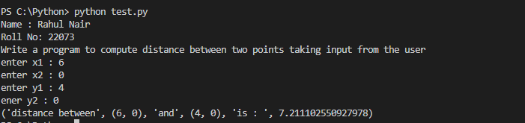

print("Name : Rahul Nair")

print("Roll No: 22073")

print("Write a Python program to compute the GCD of two numbers.  ")

def gcd(a, b):

    if(b == 0):

        return a

    else:

        return gcd(b, a % b)

a = int(input("Enter Number:"))

b = int(input("Enter Number:"))

print("The gcd of both numbers is : ", gcd(a ,b))

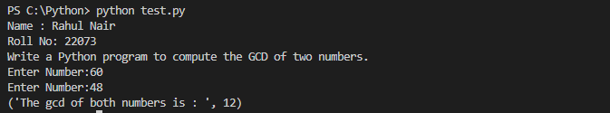

print("Name : Rahul Nair")

print("Roll No: 22073")

print("Q.3 Write a Python program to find square root of given number. ")

num = int(input("Enter a number:"))

num_sqrt = num ** 0.5

print('The square root of %0.3f is %0.3f'%(num ,num_sqrt))

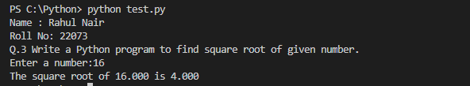

print("Name : Rahul Nair")

print("Roll No: 22073")

print("Q.4 Write a Python program to demonstrate various base conversion function ")

print("Decimal Value of binary number -101:",0b101);

print("Decimal Value of octal number -154:",0o154);

print("Decimal Value of hexadecimal number -AF22:",0xAF22);

print("Hexadecimal Value of decimal number -44834:",hex(44834));

print("Octal Value of decimal number -154:",oct(154));

print("Binary Value of decimal number -5:",bin(5));

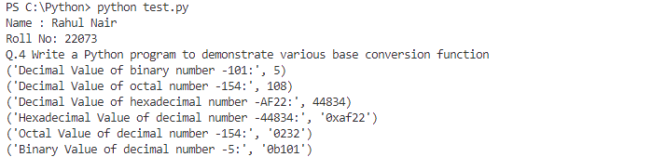

print("Name : Rahul Nair")

print("Roll No: 22073")

print("Q.5 Write a Python program to demonstrate various type conversion function ")

print(int(9.09))

print(float(22))

print(bool(1))

print(bool(0))

print(int("22"))

print(str(10))

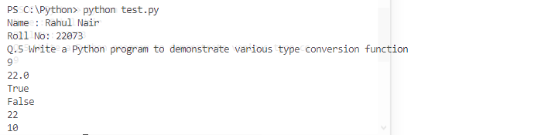

print("Name : Rahul Nair")

print("Roll No: 22073")

import math

print("Q.5 Write a Python program to exponentiation power of number ")

print("Exponential value of e power 2(e^2):", math.e**2)

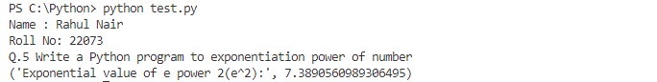

print("Name : Rahul Nair")

print("Roll No: 22073")

import math

print("Q.7 Write a Python program to find even number ")

num = int(input("Enter a number: "))

if (num % 2) == 0:

   print("{0} is Even".format(num))

else:

   print("{0} is Odd".format(num))

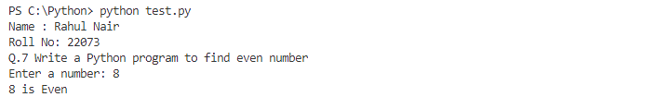

print("Name : Rahul Nair")

print("Roll No:22073")

print("Q.8 Write a Python program to find whether a number is Postive negative or zero")

num = float(input("Enter a number: "))

if num > 0:

   print("Positive number")

elif num == 0:

   print("Zero")

else:

   print("Negative number")

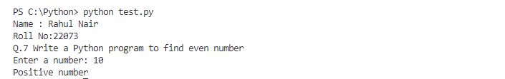

int("Name : Rahul Nair")

print("Roll No:22073")

print("Q.9 Write a Python program to find Prime Number betwwen interval")

lower = int(input("Enter a first Number:"))

upper = int(input("Enter a second Number:"))

print("Prime numbers between", lower, "and", upper, "are:")

for num in range(lower, upper + 1):

   # all prime numbers are greater than 1

   if num > 1:

       for i in range(2, num):

           if (num % i) == 0:

               break

       else:

           print(num)

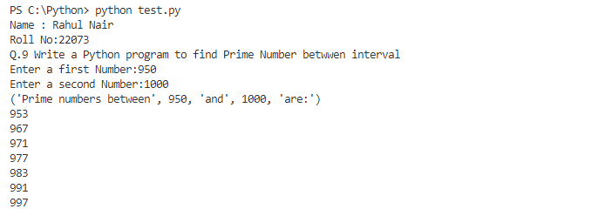

print("Name : Rahul Nair")

print("Roll No:22073")

print("Q.10 Write a Python program to find factorial of given number")

def factorial(n):

    # single line to find factorial

    return 1 if (n==1 or n==0) else n * factorial(n - 1)

# Driver Code

num = int(input("Enter a number:"))

print("Factorial of",num,"is",factorial(num))

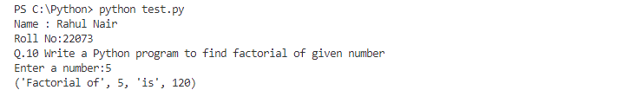

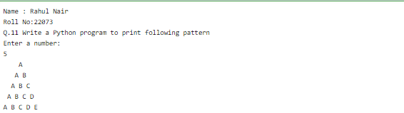

print("Name : Rahul Nair")

print("Roll No:22073")

print("Q.12 Find the number of digit in the given number should also work for negative number")

for i in range(2000,3200):

if i %7==0 and i %5 ==0:

print(i,end=" ")

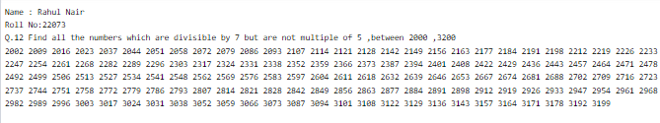

print("Name : Rahul Nair")

print("Roll No:22073")

print("Q.13 Find the number of digit in the given number should also work for negative number")

a= int (input("enter a number:"))

if a<0:

    a*=-1

print("Number of digits",len(str(a)))

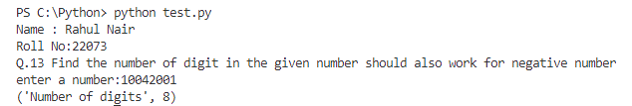

print("Name : Rahul Nair")

print("Roll No:22073")

print("Q.14 Reverse the number (should also work fro negative number)")

def reverse_int(m):

    x = 0

    n = m

    if m < 0 :

      n *= -1

    while n > 0 :

        x *= 10

        x += n % 10

        n /= 10

    if m < 0:

      #concatenate a - sign at the end

      return `x` + "-"

    return x

print ("Reverse of 1234 is ",reverse_int(1234))

print ("Reverse of -1234 is ",reverse_int(-1234))

