Predicting Diabetes Disease Progression
OLS, Ridge and Lasso Regression with Feature Engineering
Andhur Rahul Nair
EO ID: x3arn123
ePGD in AI & DS, Semester 2 | Machine Learning | Mid-Semester Project

Summary
In this project I looked at how well regression models can predict diabetes disease progression one year after a patient's baseline measurements. I used the load_diabetes dataset from scikit-learn, which has 442 patients and 10 baseline features. I didn't want to just chase the lowest error. I wanted to understand how feature engineering, model complexity and regularization change what OLS, Ridge and Lasso regression can do.
What I found. BMI and s5 (log serum triglycerides) have the strongest link with progression, followed by blood pressure, s4, HDL (s3, the only negative one) and blood sugar (s6). A linear model explains about half of the variation, with a cross-validated R² of 0.48. On the original 10 features, regularization doesn't make predictions more accurate, but it does steady the coefficients of the strongly correlated lipid features. Nonlinear models (Random Forest, Gradient Boosting, SVR) didn't beat the linear model, and adding squares, cubes and interaction terms didn't help either. OLS overfits badly as the polynomial degree goes up, Ridge degrades gently, and Lasso holds up best. In the end, I'd pick Ridge regression on the original features. On the held-out test set it reaches an R² of 0.454, with an RMSE of 53.8 and an MAE of 42.8.

1. Project Objective
This is a regression problem because the target is a continuous number. The goal is to learn a function f: R^10 → R so that ŷ = f(x) is a good estimate of the progression score y from a patient's baseline characteristics x. The question I kept coming back to throughout the project was:
How do feature engineering, model complexity and regularization affect the ability of OLS, Ridge and Lasso regression to predict diabetes disease progression?

2. Data and Exploratory Analysis

2.1 Dataset
The dataset has 442 individuals and 10 baseline features covering demographic, physiological and biochemical measurements. I checked for problems first: there are no missing values and no duplicate rows. scikit-learn already mean-centres and scales the features (each has a standard deviation of about 0.048), so the raw coefficients are on a comparable scale. The target has a mean of 152.1 and a standard deviation of 77.1, and it ranges from 25 to 346.
Feature | Description
age | Age of the individual
sex | Sex of the individual
bmi | Body Mass Index
bp | Average blood pressure
s1 | Total serum cholesterol
s2 | Low-density lipoproteins (LDL)
s3 | High-density lipoproteins (HDL)
s4 | Total cholesterol / HDL ratio
s5 | Log-transformed serum triglycerides level
s6 | Blood sugar level
Table 1. Features in the diabetes dataset.
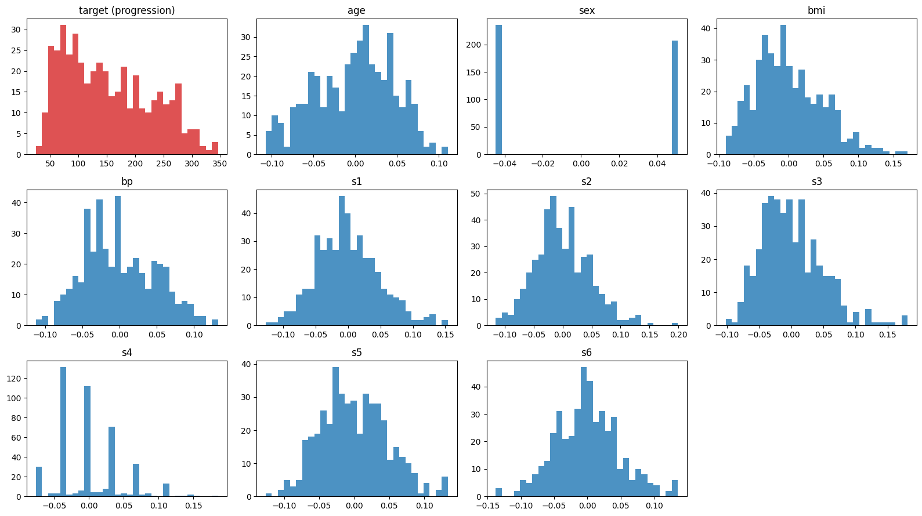
Figure 1. Distributions of the target (top left) and the ten features.

2.2 Correlations and multicollinearity
Figure 2 shows the correlation matrix for the features and the target. A few of the serum measurements are strongly correlated with each other, most clearly s1 and s2 (about 0.9). The variance inflation factors (VIF) in Table 2 back this up. s1 (59.2), s2 (39.2), s3 (15.4), s5 (10.1) and s4 (8.9) are strongly collinear, while every other feature is below 1.6. This turned out to matter later, because collinearity makes individual OLS coefficients unstable.
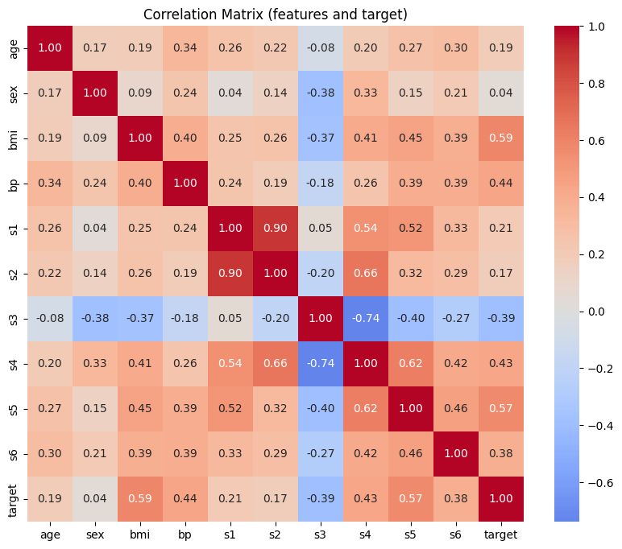
Figure 2. Correlation matrix of the features and the target.
Feature | VIF | Feature | VIF
s1 | 59.20 | bmi | 1.51
s2 | 39.19 | s6 | 1.48
s3 | 15.40 | bp | 1.46
s5 | 10.08 | sex | 1.28
s4 | 8.89 | age | 1.22
Table 2. Variance inflation factors (VIF above 5-10 means strong multicollinearity).

3. Methodology
Training and testing. I split the data once into a training set (80%, 353 rows) and a test set (20%, 89 rows). Everything that involved choosing or tuning a model, including the Ridge and Lasso penalty strengths, used only the training data and 5-fold cross-validation. I used the same shuffled folds for every model so the comparisons are fair. I only used the test set at the end, to report how the models do on unseen data, and never to choose between them. I used one random seed (42) throughout so the results can be reproduced.
Models. My baseline is ordinary least squares (OLS), which has no penalty. Ridge adds an ℓ2 penalty that shrinks the coefficients and keeps them steadier when predictors are correlated. Lasso adds an ℓ1 penalty that can set coefficients exactly to zero, so it regularizes and selects features at the same time. For comparison I also fit three nonlinear models: Random Forest, Gradient Boosting and an RBF-kernel SVR. I standardise the features inside each pipeline so the penalties treat them all equally.
Feature engineering. For the engineered feature set I added the square and cube of every feature plus all 45 pairwise interactions, which gives 75 features (10 + 10 + 10 + 45). To see what happens as complexity grows, I also used full polynomial expansions of degree 1, 2 and 3 (10, 65 and 285 features).
Metrics. I report R², RMSE and MAE. Cross-validated R² is my main criterion for choosing a model, and the gap between training R² and CV R² tells me how much a model overfits.

4. Results: Research Questions

Q1. Which baseline characteristics have the strongest association with progression?
BMI (+0.59) and s5 (+0.57) are clearly the strongest. Blood pressure (+0.44), s4 (+0.43), s3 (−0.39) and s6 (+0.38) come next with moderate associations. s3 (HDL) is the only negatively correlated feature, so higher HDL goes with less progression, while every other feature goes the other way. One caveat is that these are simple one-feature-at-a-time Pearson correlations. They show association, not causation.
Feature | bmi | s5 | bp | s4 | s6 | s1 | age | s2 | sex | s3
Correlation with target | 0.586 | 0.566 | 0.441 | 0.430 | 0.382 | 0.212 | 0.188 | 0.174 | 0.043 | −0.395
Table 3. Pearson correlation of each feature with the target.

Q2. How well can a linear model explain the variation in the target?
On the training data, OLS gets a 5-fold CV R² of 0.480 (± 0.041), with a CV RMSE of about 55.4 and a CV MAE of about 45.0. So a linear model explains roughly half of the variation in disease progression. The other half could be noise, predictors we don't have, or non-linear effects, and R² on its own can't tell me which. The final model's test R² (0.454) is close to the CV estimate, so the CV number was a fair guide.

Q3. Does regularization improve generalization when predictors are correlated?
Not for accuracy. OLS, Ridge and Lasso all land at a CV R² of about 0.48 and a CV RMSE of about 55.4. The differences are tiny next to the fold-to-fold spread of about 0.04. With only 10 predictors and 353 training rows, OLS doesn't have much variance for regularization to remove.
Model | CV R² | R² std | CV RMSE | CV MAE
OLS | 0.48 | 0.041 | 55.395 | 45.048
Ridge | 0.48 | 0.041 | 55.419 | 45.119
Lasso | 0.48 | 0.040 | 55.394 | 45.180
Table 4. OLS vs Ridge vs Lasso, 5-fold CV on the training data (original features).
Where regularization does help is stability, as Table 5 shows. The shaky OLS coefficients of the collinear features get shrunk. s1 goes from −44.4 (OLS) to −34.7 (Ridge) to −8.2 (Lasso), s2 goes from 24.6 to 17.1 to 0.0, and s5 goes from 35.2 to 31.4 to 22.6. Lasso also flips s3 from +7.7 to −9.0. I read that as Lasso picking one feature from a group of correlated ones more or less arbitrarily, not as a real negative effect. The less collinear features (bmi, bp, sex, s6) barely change.
Feature | OLS | Ridge | Lasso
age | 1.8 | 1.8 | 0.7
sex | −11.5 | −11.4 | −9.3
bmi | 25.6 | 25.7 | 26.2
bp | 16.8 | 16.7 | 15.7
s1 | −44.4 | −34.7 | −8.2
s2 | 24.6 | 17.1 | 0.0
s3 | 7.7 | 3.4 | −9.0
s4 | 13.1 | 11.8 | 3.4
s5 | 35.2 | 31.4 | 22.6
s6 | 2.4 | 2.5 | 2.1
Table 5. Coefficients on standardised features, fitted on the training data (selected alpha = 1.0 for both Ridge and Lasso).

Q4. Do nonlinear models capture relationships that a linear model cannot?
I didn't find any evidence of that. SVR with an RBF kernel (R² 0.475) is tied with OLS (0.480), while Random Forest (0.432) and Gradient Boosting (0.423) come out about 0.05 to 0.06 lower. The polynomial models in Section 5 point the same way, since adding non-linear terms never beat the plain linear fit. My reading is that any non-linear structure is small compared with the noise. The tree ensembles probably lose a bit because 353 training rows isn't much to learn from. I didn't tune the nonlinear models, so I can't fully rule out small non-linear effects.
Model | CV R² | R² std | CV RMSE | CV MAE
OLS (baseline) | 0.480 | 0.041 | 55.395 | 45.048
Random Forest | 0.432 | 0.068 | 57.793 | 47.591
Gradient Boosting | 0.423 | 0.035 | 58.425 | 47.582
SVR (RBF) | 0.475 | 0.058 | 55.591 | 45.185
Table 6. Linear vs nonlinear models, 5-fold CV on the training data.

Q5. How sensitive are the conclusions to the choice of model?
The conclusion about performance holds up well. In a repeated 5×5 cross-validation, OLS (0.479), Ridge (0.476), Lasso (0.475) and SVR (0.474) are essentially the same, and Random Forest (0.425) and Gradient Boosting (0.410) are lower and more variable. No model gets meaningfully above 0.48, so whichever one I pick, the message is the same: about half of the variation is explained.
Model | CV R² | R² std
OLS | 0.479 | 0.081
Ridge | 0.476 | 0.079
Lasso | 0.475 | 0.077
Random Forest | 0.425 | 0.106
Gradient Boosting | 0.410 | 0.105
SVR (RBF) | 0.474 | 0.083
Table 7. Repeated 5×5 cross-validation across all models (training data).
Conclusions about individual coefficients are more sensitive, but only for the correlated predictors. Across OLS, Ridge and Lasso, s1, s2, s3 and s5 change a lot (s2 goes from 24.6 to 17.1 to 0.0, and s3 even changes sign under Lasso), so anything I say about those features depends on the model. BMI and blood pressure keep similar coefficients in all three. The engineered-feature results also depend on the model, because OLS falls apart there while Lasso holds up.

Q6. Which model gives the best balance of accuracy and interpretability?
I'd go with Ridge regression on the original 10 features. Accuracy is basically tied across OLS, Ridge, Lasso and SVR (CV R² about 0.48, RMSE about 55.4 to 55.6), and the tree ensembles are lower. Ridge also had the best CV R² of all twelve configurations I compared at the end (0.481), which is why the final evaluation selects it.
Interpretability is what separates the models. Linear models give one coefficient per feature, with a sign and a size I can read directly. Random Forest, Gradient Boosting and SVR need extra tools to explain, and they don't buy any accuracy here. Among the linear models, Ridge matches OLS on accuracy but shrinks the unstable coefficients of the correlated predictors s1, s2 and s3. Lasso is a fair choice if I wanted a sparser model, but with this group of correlated features it picks one somewhat arbitrarily (it zeroes s2 and flips the sign of s3), so its individual coefficients are harder to trust. Plain OLS is fine too if I'm not going to interpret the correlated lipid features one by one.

5. Feature-Engineered Regression
In this part I added powers (x², x³) and pairwise interaction terms (xᵢxⱼ) and fit OLS, Ridge and Lasso on the expanded features. I used wider penalty grids here because there are many more correlated features. I looked at three things: what the engineered features do, what the polynomial degree does, and which coefficients each method keeps.

5.1 Effect of the engineered features
Adding squares, cubes and interactions (75 features) did not beat the original 10 features. On the original features the CV R² is 0.480 (OLS), 0.481 (Ridge) and 0.477 (Lasso). On the engineered set it drops to 0.293 for OLS and 0.442 for Ridge. Only Lasso stays level, at 0.475.
Features | Model | n | Train R² | CV R² | CV std | CV MAE | Gap
Original | OLS | 10 | 0.531 | 0.480 | 0.041 | 45.05 | 0.050
Original | Ridge | 10 | 0.526 | 0.481 | 0.039 | 45.07 | 0.045
Original | Lasso | 10 | 0.524 | 0.477 | 0.036 | 45.33 | 0.047
x², x³, xᵢxⱼ | OLS | 75 | 0.647 | 0.293 | 0.095 | 50.66 | 0.354
x², x³, xᵢxⱼ | Ridge | 75 | 0.568 | 0.442 | 0.053 | 46.56 | 0.126
x², x³, xᵢxⱼ | Lasso | 75 | 0.545 | 0.475 | 0.044 | 45.71 | 0.070
Table 8. Original vs engineered features (5-fold CV on the training data). Gap = train R² minus CV R².

5.2 Polynomial degree and overfitting
As the degree goes from 1 to 2 to 3, OLS fits the training data better and better (train R² 0.531, 0.626, 0.980), while its CV R² collapses (0.480, 0.339, then −1279). A negative R² means the model does worse than just predicting the mean of the target. With 285 features and only about 350 training rows per fold, degree-3 OLS nearly memorises the training data, and its predictions on unseen rows are way off. Ridge degrades gently and Lasso degrades the least, so the more features there are, the more regularization matters.
Degree | Model | n | Train R² | CV R² | CV std | CV MAE | Gap
1 | OLS | 10 | 0.531 | 0.480 | 0.041 | 45.05 | 0.050
1 | Ridge | 10 | 0.526 | 0.481 | 0.039 | 45.07 | 0.045
1 | Lasso | 10 | 0.524 | 0.477 | 0.036 | 45.33 | 0.047
2 | OLS | 65 | 0.626 | 0.339 | 0.070 | 49.63 | 0.287
2 | Ridge | 65 | 0.559 | 0.447 | 0.052 | 46.81 | 0.113
2 | Lasso | 65 | 0.524 | 0.460 | 0.033 | 46.52 | 0.064
3 | OLS | 285 | 0.980 | −1279.029 | 1488.828 | 1066.02 | 1280.0
3 | Ridge | 285 | 0.580 | 0.403 | 0.030 | 48.99 | 0.177
3 | Lasso | 285 | 0.527 | 0.442 | 0.033 | 47.29 | 0.085
Table 9. Effect of polynomial degree (5-fold CV on the training data).
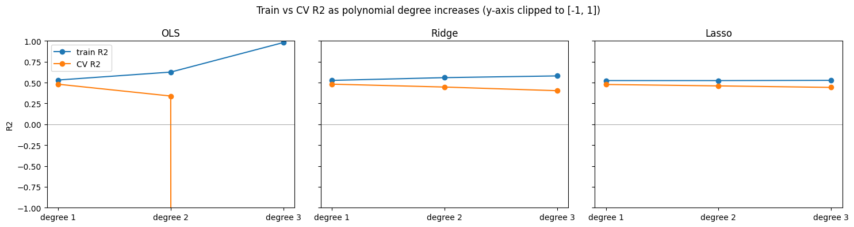
Figure 3. Train vs CV R² as the polynomial degree increases (y-axis clipped to [−1, 1]).

5.3 Coefficients selected by each method
On the 75 engineered features, OLS keeps all of them and some get very large (the largest absolute coefficient is 176.2). Its biggest ones are interactions between the highly collinear lipid features, which are unstable. Ridge shrinks everything (largest 15.0) but still keeps all 75. Lasso keeps only 27 of the 75. Under both Ridge and Lasso, the strongest coefficients are the original main effects s5, bmi, bp and s3. Lasso also keeps a few non-linear terms (sex², s5³, bmi³, age×sex), but they are smaller than the main effects. So most of the signal is linear in s5, bmi, bp and s3.
Rank | OLS | Ridge | Lasso
1 | s1*s2 | s5 | s5
2 | s1*s5 | bmi | bmi
3 | s2*s5 | bp | s3
4 | s2² | s3 | bp
5 | s4² | bmi³ | sex²
6 | s5² | bp³ | s5³
7 | s3*s4 | s4 | bmi³
8 | s5³ | bmi*bp | age*sex
9 | s1*s4 | s2³ | bp³
10 | s3*s5 | age*s2 | bmi*bp
Table 10. Top 10 features by absolute coefficient for each method (engineered feature set).

6. Final Evaluation on the Held-Out Test Set
I chose and tuned every configuration using the training data only. Table 11 shows each feature set with each model, with the CV R² on the training data next to the test-set R², RMSE and MAE. The final model is the one with the best CV R², so the test set has no say in which model gets picked.
Features | Model | CV R² (train) | Test R² | Test RMSE | Test MAE
Original | OLS | 0.480 | 0.453 | 53.853 | 42.794
Original | Ridge | 0.481 | 0.454 | 53.773 | 42.813
Original | Lasso | 0.477 | 0.471 | 52.923 | 42.787
x², x³, xᵢxⱼ | OLS | 0.293 | 0.411 | 55.840 | 44.901
x², x³, xᵢxⱼ | Ridge | 0.442 | 0.472 | 52.886 | 43.283
x², x³, xᵢxⱼ | Lasso | 0.475 | 0.518 | 50.543 | 40.635
Degree 2 | OLS | 0.339 | 0.416 | 55.642 | 43.582
Degree 2 | Ridge | 0.447 | 0.491 | 51.912 | 42.111
Degree 2 | Lasso | 0.460 | 0.516 | 50.626 | 41.196
Degree 3 | OLS | −1279.029 | −14.561 | 287.134 | 164.854
Degree 3 | Ridge | 0.403 | 0.414 | 55.713 | 46.011
Degree 3 | Lasso | 0.442 | 0.479 | 52.520 | 43.532
Table 11. CV R² on the training data and test-set metrics for all twelve configurations. The selected model (original features, Ridge) is in bold.
Final model. Selecting by CV R² picks Ridge on the original features (CV R² 0.481). On the test set it reaches an R² of 0.454, an RMSE of 53.8 and an MAE of 42.8. That is close to the CV estimate, so cross-validation gave me a fair picture of how the model generalizes.
A note on the other test scores. Lasso on the engineered features (test R² 0.518) and on degree 2 (0.516) scored higher on the test set than the model I chose. Their CV R² wasn't higher (0.475 and 0.460), and the test set has only 89 rows, so a gap of about 0.06 could easily be noise. Switching to them because of the test result would mean using the test set to select a model, so I stuck with the CV choice. Degree-3 OLS has a test R² of −14.6, which confirms the overfitting I saw in cross-validation.
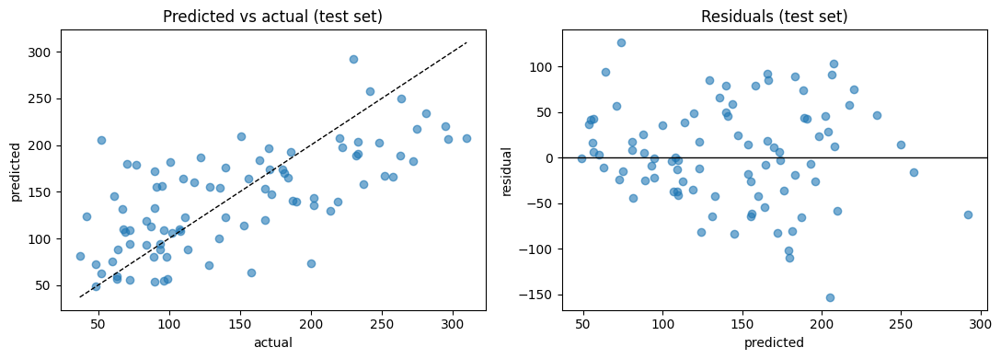
Figure 4. Predicted vs actual values and residuals on the test set for the selected model.

7. Conclusion
Coming back to the central question of how feature engineering, model complexity and regularization affect OLS, Ridge and Lasso, here is what I found.
- Feature engineering didn't improve prediction. The best CV R² stays at about 0.48, and the original features already reach it.
- More complexity hurts OLS badly. Its CV R² falls from 0.480 to 0.339 to −1279 as the degree goes from 1 to 3. Ridge degrades gently, and Lasso is the most robust.
- Regularization matters more as features multiply. With 10 features it doesn't improve accuracy, but it does steady the coefficients of the correlated lipid features. Lasso also selects features, keeping 27 of the 75 on the engineered set.
- The signal is mostly linear. It is carried mainly by s5, bmi, bp and s3. About half of the variation in progression is still unexplained by every model I tried.

Limitations
- The dataset is small (442 rows) and the test set has only 89 rows, so a single test score is noisy.
- I didn't tune the nonlinear models, so I can't fully rule out small non-linear effects.
- The correlations and coefficients show association, not causation.
- The features come already scaled by scikit-learn and I don't have the original measurements, so I can't interpret the coefficients in clinical units.

