## Lighting

Project 4

Name: Rahul Kumar Nalubandhu

Email id: [nalubanr@oregonstate.edu](mailto:nalubanr@oregonstate.edu)

Output:

1. 1st light -0 white

1. 2nd light-1

3) 3rd light-2 moving light

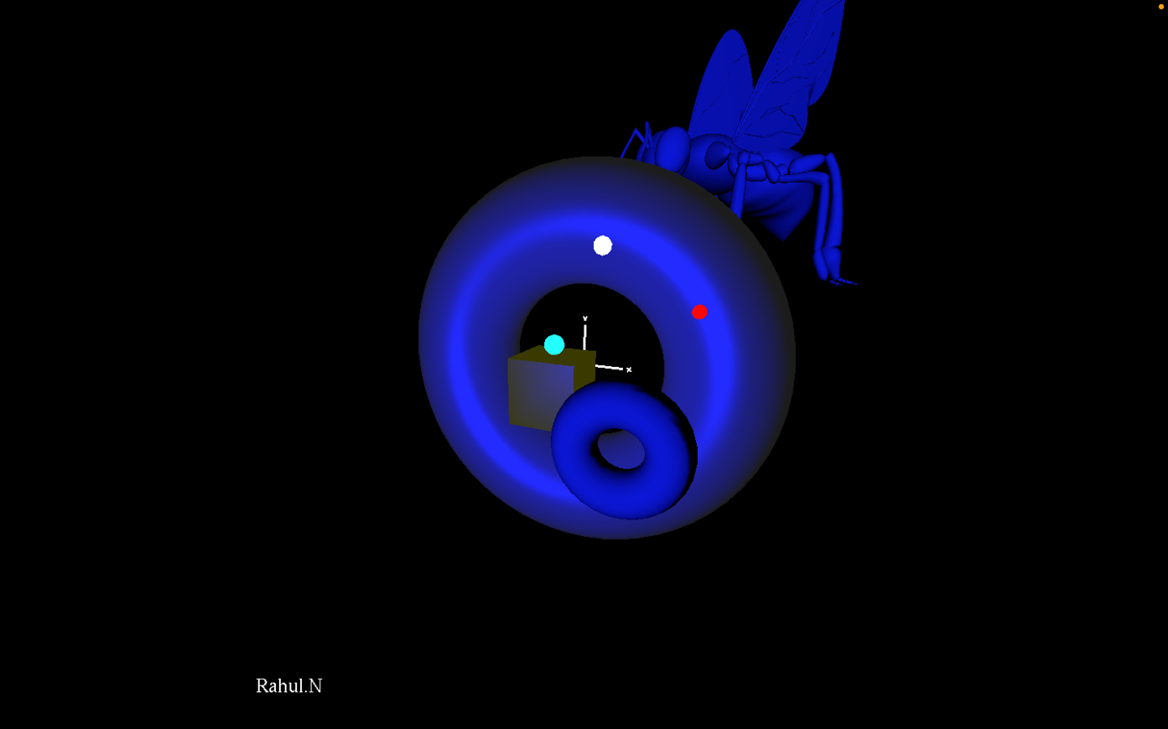

Here is the video with 2 stationary light motion i.e., white and red whereas blue is moving.

Also, I have point and spotlight.

The big torus is had material set to shinny and the moving torus has dull object material.

The cube has GL_FLAT and Big torus is GL_SMOOTH. 2 stationary objects i.e., the insect and the big size torus and

2 moving Objects i.e., small torus and the box also

OSU Sphere with earth texture and lighting also lightened, not textured.

Vídeo Link: <https://media.oregonstate.edu/media/t/1_b3lmm6i2>