## Shaders

Project 5

Name: Rahul Kumar Nalubandhu

Email id: [nalubanr@oregonstate.edu](mailto:nalubanr@oregonstate.edu)  
  
  
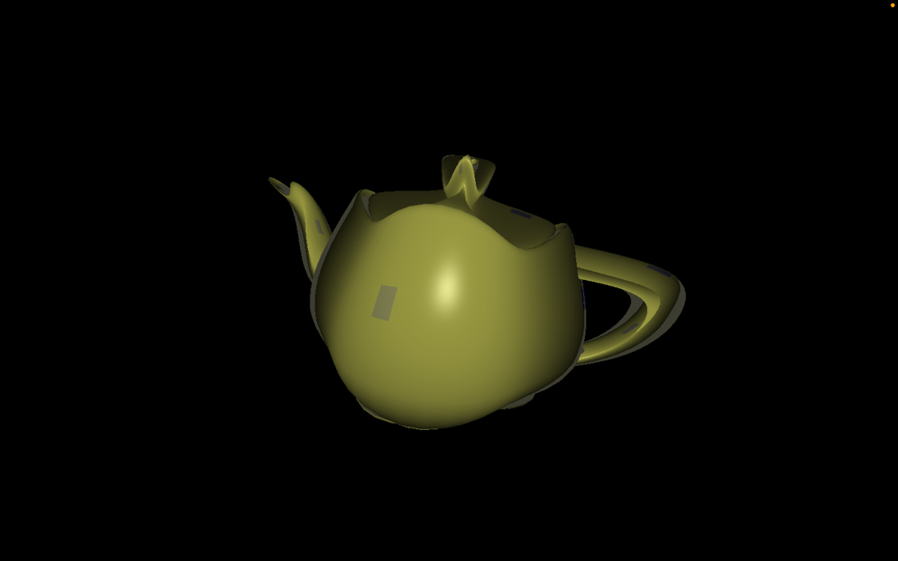

In this project I have included stationary vertex shader and animated vertex shader patterns also stationery and animated fragment shader and pre fragment lightning.

Vídeo link: <https://media.oregonstate.edu/media/t/1_wwqso8tg>