class04.R

rahulnedunuri

2024-01-23

# R Script from week 2 lab 4  
x = 1:100  
plot(x, sin(x))

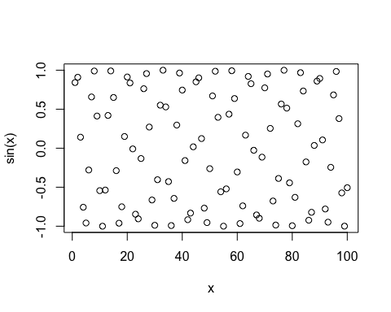

plot(x, sin(x), typ="l")

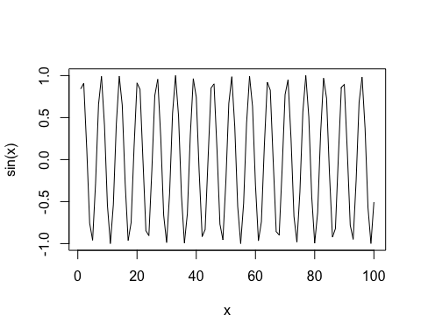

plot(x, sin(x),type="l", main="Sine", xlab="xlab", ylab="Sine wave", lwd=2, col="navyblue")

