SESHADRIPURAM ACADEMY OF BUSINESS STUDIES
(Permanently Affiliated to Bangalore University)
NAAC Accredited ‘B’ Grade
Kengeri Satellite Town,Bangalore-560060
Website: www.sabs.ac.in

S0FTWARE PROJECT TITLED
“DETECTION OF MALICIOUS SOCIAL BOTS USING LEARNING AUTOMATA WITH URL FEATURES IN TWITTER NETWORK”
A Dissertation Submitted to Bangalore University in Partial Fulfilment for the Award of Degree of 6th Semester

Bachelor of Computer Application
Submitted by
RAHUL N SANGOLGI (U18EZ21S0030)

Under the Guidance of
Ms. CHAITHRA H S
Asst. Professor, Department of Computer Science
2023-2024

SESHADRIPURAM ACADEMY OF BUSINESS STUDIES
(Permanently Affiliated to Bangalore University)
NAAC Accredited ‘B’ Grade
Kengeri Satellite Town,Bangalore-560060
Website: www.sabs.ac.in

CERTIFICATE
This is to certify that the Software Project entitled
“DETECTION OF MALICIOUS SOCIAL BOTS USING LEARNING AUTOMATA WITH URL FEATURES IN TWITTER NETWORK”
has been submitted in partial fulfillment of the requirement for the award of the degree
Bachelor of Computer Application
is a result of the bonafide work carried out by
RAHUL N SANGOLGI (U18EZ21S0030)

During the Academic Year 2023-2024

Signature of the Guide Signature of HOD Principal

Date of Practical Examination
Examination Center

SESHADRIPURAM ACADEMY OF BUSINESS STUDIES
(Permanently Affiliated to Bangalore University)
NAAC Accredited ‘B’ Grade
Kengeri Satellite Town,Bangalore-560060
Website: www.sabs.ac.in

CERTIFICATE OF APPROVAL OF PROJECT WORK

This is to certify that Rahul N Sangolgi (U18EZ21S0030) has satisfactorily completed the project work of VI semester BCA entitled “ Detection of malicious social bots using learning automata with URL features in twitter network” in partial fulfillment of the academic requirement for the award of the degree in Bachelor of Computer Application by Bangalore University 2023-2024.

Date:
Place: Bangalore
Guide: Ms.Chaithra H S

ACKNOWLEDGEMENT

The satisfaction that accompanies the successful work would be incomplete without the mention of the people who made it possible, and whose constant encouragement and guidance has been the source of inspiration throughout the course of the project work.
We would like to express our deep sense of gratitude to our Institute, Seshadripuram Academy of Business Studies, K S Town, Bangalore, for providing us an opportunity to learn new technology
We convey our sincere gratitude to Prof. Jayarama, Principal, Seshadripuram Academy of Business Studies for providing all the required needs to accomplish the task successfully.
We thank our guide Ms. Archana M, Asst. Professor and HOD, Department of Computer Science, Seshadripuram Academy of Business Studies, Bangalore for her kind support and valuable guidance throughout the project.
We would like to mention our gratitude to all the teaching faculty and non-teaching staff members of Seshadripuram Academy of Business Studies and all our friends, for their support and enc

Contents
Chapter 1: Introduction
1.1 Overview of The Project
1.2 Objective
1.3 Existing System
1.4 Propsed System
1.5 Modules
1.5.1 Data Collection
1.5.2 Dataset
1.5.3 Data Preparation
1.5.4 Model Selection
1.5.5 Analyze and Prediction
1.5.6 Accuracy on test set
1.5.7 Saving the Trained Model
1.5.8 Database connecting using Mysql
Chapter 2: Requirements and Specifications
2.1 Hardware Requirements
2.2 Software Requirements
2.3 About Python
Chapter 3: Feasibility Study
3.1 Economic feasibility
3.2 Technical feasibility
3.3 Social feasibility
Chapter 4: System Design
4.1 System architecture
4.2 Data flow diagram
4.3 Use case diagram
4.4 Class diagram
4.5 Sequence diagram
4.6 Activity diagram
Chapter 5: Implementation and Coding
Chapter 6: Testing and Validation
6.1 unit testing
6..2 . Integration testing
6..3 Functional testing
6..4 System testing
6..5 White Box testing
6.6 Black Box testing
Chapter 7: Screenshots
7.1 Homepage
7.2 Dataset Uploading page
7.3 Training and Testing page
7.4 User Registration page
7.5 User Login page
7.6 User Homepage
7.7 Tweeting page
7.8 Collection of Tweets page
7.9 Admin Page
7.10 User Registration Page

7.11 User Full Details
7.12 Analysis Page
Conlusion
Future Enhancement
Bibliography

List of figures

Figure Number | Figure Name | Page Number
4.1 | System architecture
4.2 | DFD
4.3 | Use case Diagram
4.4 | Class Diagram
4.5 | Sequence Diagram
4.6 | Activity Diagram
7.1 | Homepage
7.2 | Dataset Uploading Page
7.3 | Training and Testing Page
7.4 | User Registration Page
7.5 | User Login Page
7.6 | User Home Page
7.7 | Tweeting Page
7.8 | Collection of Tweets Page

Chapter 1
INTRODUCTION
1.1 OVERVIEW OF THE PROJECT
The project "Detection of Malicious Social Bots Using Learning Automats with URL Features in Twitter Network" aims to develop a novel method for identifying malicious social bots on Twitter. By employing learning automata, the system analyses URL features to distinguish between genuine accounts and malicious bot, effectively mitigating the spread of misinformation and harmful content. This research holds promise in enhancing the security and trustworthiness of online social networks by providing an efficient and automated approach to bot detection.
1.2 OBJECTIVE
The project's objective is to develop a novel and efficient method for identifying malicious social bots on Twitter. By utilizing learning automata and analysing URL. features, the project aims to differentiate between genuine user accounts and malicious bots. This approach will help mitigate the dissemination of misinformation and harmful content on the platform, enhancing the overall security and trustworthiness of online social networks. By accurately detecting social bots, the project seeks to protect users from potential scams, phishing attempts, and other malicious activities perpetrated by such bots. Additionally, this research can contribute valuable insights to the field of bot detection and cybersecurity, aiding in the development of more robust measures to safeguard online platforms and their users from various forms of digital threats.
1.3 EXISTING SYSTEM:
- The existing malicious URL detection approaches are based on DNS information and lexical properties of URLs. The malicious social bots use URL redirections in order to avoid detection.
- Besel et al. analyzed social botnet attack on Twitter. The authors have presented that social bots use URL shortening services and URL redirection in order to redirect users to malicious web pages.
- Echeverria and Zhou presented methods to detect, retrieve, and analyze botnet over thousands of users to observe the social behavior of bots.
- Dorri et.al., proposed a social bot hunter model has been presented based on the user behavioral features, such as follower ratio, the number of URLs, and reputation score.
- M. Agarwal et. al. features a trust model has been designed to detect malicious activities in an OSN.
DISADVANTAGES OF EXISTING SYSTEM:
- The malicious social bots can manipulate profile features, such as hashtag ratio, follower ratio, URL ratio, and the number of retweets. The malicious social bots can also manipulate tweet-content features, such as sentimental words, emoticons, and most frequent words used in the tweets, by manipulating the content of each tweet. The social relationship-based features are highly robust because the malicious social bots cannot easily manipulate the social interactions of users in the Twitter network.
- The existing approaches rely on statistical features instead of analyzing the social behavior of users. Moreover, these approaches are not highly robust in detecting the temporal data patterns with noisy data (i.e., where the data is biased with untrustworthy or fake information) because the behavior of malicious bots changes over time in order to avoid detection.
1.4 PROPOSED SYSTEM:
- In the proposed system, the malicious behavior of participants is analyzed by considering features extracted from the posted URLs (in the tweets), such as URL redirection, frequency of shared URLs, and spam content in URL, to distinguish between legitimate and malicious tweets. To protect against the malicious social bot attacks, our proposed LA-based malicious social bot detection (LA-MSBD) algorithm integrates a trust computational model with a set of URL-based features for the detection of malicious social bots.
- In the proposed system, we Analyze the malicious behavior of a participant by considering URL-based features, such as URL redirection, the relative position of URL, frequency of shared URLs, and spam content in URL.
- In the proposed system, we Evaluate the trustworthiness of tweets (posted by each participant) by using the Bayesian learning and Dempster–Shafer theory (DST).
- Also we Design the system by integrating a trust model with a set of URL-based features.

ADVANTAGES OF PROPOSED SYSTEM:
- The proposed system helps to detect malicious social bots accurately.
- The experimental results illustrate that our proposed system gives better performance compared with conventional machine learning algorithms in terms of precision.
- The precision value obtained for The Fake Project data set is better than the Social Honeypot data set because the Social Honeypot data set contains noisy and untrustworthy information in its user content features than The Fake Project data set.
- The proposed system achieves the highest precision level. This is due to the fact that the proposed system executes for a finite set of learning actions to update the action probability value and achieves the advantages of incremental learning. Hence, the LA model with a trust component identifies the malicious tweets that are posted by malicious social bots.
1.5 MODULES:
- Data Collection
- Dataset
- Data Preparation
- Model Selection
- Analyze and Prediction
- Accuracy on test set
- Saving the Trained Model
- Database connecting using Mysql

1.5.1 Data Collection:
This is the first real step towards the real development of a machine learning model, collecting data. This is a critical step that will cascade in how good the model will be, the more and better data that we get, the better our model will perform.
There are several techniques to collect the data, like web scraping, manual interventions and etc.
Detection of Malicious Social Bots taken from kaggle and some other source

1.5.2 Dataset:
The dataset consists of 969812 individual data. There are 3 columns in the dataset, which are described below
- Id: unique id
- Labels : Labels
Malicious
No Malicious
- URL: url comment

1.5.3 Data Preparation:
We will transform the data. by getting rid of missing data and removing some columns. First we will create a list of column names that we want to keep or retain.
Next we drop or remove all columns except for the columns that we want to retain.
Finally we drop or remove the rows that have missing values from the data set.
Steps to follow:
- Removing extra symbols
- Removing punctuations
- Removing the Stopwords
- Stemming
- Tokenization
- Feature extractions
- CountVectorizer
- Counter vectorizer with TF-IDF transformer

1.5.4 Model Selection:
We used Logistic regression algorithm
Logistic regression is a classification algorithm, used when the value of the target variable is categorical in nature. Logistic regression is most commonly used when the data in question has binary output, so when it belongs to one class or another, or is either a 0 or 1.
Remember that classification tasks have discrete categories, unlike regressions tasks.
Here, by the idea of using a regression model to solve the classification problem, we rationally raise a question of whether we can draw a hypothesis function to fit to the binary dataset. For simplification, we only concern the binary classification problem
The answer is that you will have to use a type of function, different from linear functions, called a logistic function, or a sigmoid function.
(Note: Here’s something important to remember: although the algorithm is called “Logistic Regression”, it is, in fact, a classification algorithm, not a regression algorithm. This can be confusing at first, but just try to remember it.)

1.5.5 The Sigmoid Function
The sigmoid function/logistic function is a function that resembles an “S” shaped curve when plotted on a graph. It takes values between 0 and 1 and “squishes” them towards the margins at the top and bottom, labeling them as 0 or 1.
The equation for the Sigmoid function is this:
What is the variable e in this instance? The e represents the exponential function or exponential constant, and it has a value of approximately 2.71828.
Let’s see how the sigmoid function represent the given dataset.
This gives a value y that is extremely close to 0 if xis a large negative value and close to 1 if x is a large positive value. After the input value has been squeezed towards 0 or 1, the input can be run through a typical linear function, but the inputs can now be put into distinct categories.

1.5.6 Analyze and Prediction:
In the actual dataset, we chose only 2 features :
1. URL: url comment
2. Labels : Labels
Malicious
No Malicious

1.5.7 Accuracy on test set:
We got a accuracy of 96.02% on test set.

1.5.8 Saving the Trained Model:
Once you’re confident enough to take your trained and tested model into the production-ready environment, the first step is to save it into a .h5 or . pkl file using a library like pickle .
Make sure you have pickle installed in your environment.
Next, let’s import the module and dump the model into . pkl file

1.5.9 Import MYSQLdb
So long as that works, do a quick control+d to exit the python instance.
Next, we want to make a Python file that can connect to the database. Generally you will have a separate "connect" file, outside of any main files you may have. This is usually true across languages, and here's why. Initially, you may have just a simple __init__.py, or app.py, or whatever, and that file does all of your operations. What can happen in time, however, is that your website does other things. For example, with one of my websites, Sentdex.com, I perform a lot of analysis, store that analysis to a database, and I also operate a website for users to use. Generally, for tasks, you will use what is called a "cron." A cron is a scheduled task that runs when you program it to run. Generally this runs another file, almost certain to not be your website's file. So then, to connect to a database, you'd have to write the database connecting code again in the file being run by your cron.
As time goes on, these sorts of needs stack up where you have some files modifying the database, but you still want the website to be able to access it, and maybe modify it too. Then, consider what might happen if you change your database password. You'd then need to go to every single file that connects to the database and change that too. So, usually, you will find the smartest thing to do is to just create one file, which houses the connection code.

1.5.10 Import the module.
Create a connection function to run our code. Here we specify where we're connecting to, the user, the user's password, and then the database that we want to connect to.
As a note, we use "localhost" as our host. This just means we'll use the same server that this code is running on. You can connect to databases remotely as well, which can be pretty neat. To do that, you would connect to a host by their IP, or their domain. To connect to a database remotely, you will need to first allow it from the remote database that will be accessed/modified.
Next, let's go ahead and edit our __init__.py file, adding a register function. For now we'll keep it simple, mostly just to test our connection functionality.
We allow for GET and POST, but aren't handling it just yet.
We're going to just try to run the imported connection function, which returns c and conn (cursor and connection objects).
If the connection is successful, we just have the page say okay, otherwise it will output the error.

Chapter 2
SYSTEM REQUIREMENTS:
2.1 HARDWARE REQUIREMENTS:

- System : Pentium IV 2.4 GHz.
- Hard Disk : 40 GB.
- Floppy Drive : 1.44 Mb.
- Monitor : 15 VGA Colour.
- Mouse : Logitech.
- Ram : 512 Mb.

2.2 SOFTWARE REQUIREMENTS:

- Operating system : Windows 7.
- Coding Language : Python
- Database : MYSQL

2.3 Python:
Python is a high-level, interpreted, interactive and object-oriented scripting language. Python is designed to be highly readable. It uses English keywords frequently where as other languages use punctuation, and it has fewer syntactical constructions than other languages.
- Python is Interpreted − Python is processed at runtime by the interpreter. You do not need to compile your program before executing it. This is similar to PERL and PHP.
- Python is Interactive − You can actually sit at a Python prompt and interact with the interpreter directly to write your programs.
- Python is Object-Oriented − Python supports Object-Oriented style or technique of programming that encapsulates code within objects.
- Python is a Beginner's Language − Python is a great language for the beginner-level programmers and supports the development of a wide range of applications from simple text processing to WWW browsers to games.
History of Python
Python was developed by Guido van Rossum in the late eighties and early nineties at the National Research Institute for Mathematics and Computer Science in the Netherlands.
Python is derived from many other languages, including ABC, Modula-3, C, C++, Algol-68, SmallTalk, and Unix shell and other scripting languages.
Python is copyrighted. Like Perl, Python source code is now available under the GNU General Public License (GPL).
Python is now maintained by a core development team at the institute, although Guido van Rossum still holds a vital role in directing its progress.
Python Features
Python's features include −
- Easy-to-learn − Python has few keywords, simple structure, and a clearly defined syntax. This allows the student to pick up the language quickly.
- Easy-to-read − Python code is more clearly defined and visible to the eyes.
- Easy-to-maintain − Python's source code is fairly easy-to-maintain.
- A broad standard library − Python's bulk of the library is very portable and cross-platform compatible on UNIX, Windows, and Macintosh.
- Interactive Mode − Python has support for an interactive mode which allows interactive testing and debugging of snippets of code.
- Portable − Python can run on a wide variety of hardware platforms and has the same interface on all platforms.
- Extendable − You can add low-level modules to the Python interpreter. These modules enable programmers to add to or customize their tools to be more efficient.
- Databases − Python provides interfaces to all major commercial databases.
- GUI Programming − Python supports GUI applications that can be created and ported to many system calls, libraries and windows systems, such as Windows MFC, Macintosh, and the X Window system of Unix.
- Scalable − Python provides a better structure and support for large programs than shell scripting.
Apart from the above-mentioned features, Python has a big list of good features, few are listed below −
- It supports functional and structured programming methods as well as OOP.
- It can be used as a scripting language or can be compiled to byte-code for building large applications.
- It provides very high-level dynamic data types and supports dynamic type checking.
- It supports automatic garbage collection.
- It can be easily integrated with C, C++, COM, ActiveX, CORBA, and Java.
Python is available on a wide variety of platforms including Linux and Mac OS X. Let's understand how to set up our Python environment.
Getting Python
The most up-to-date and current source code, binaries, documentation, news, etc., is available on the official website of Python https://www.python.org.
Windows Installation
Here are the steps to install Python on Windows machine.
- Open a Web browser and go to https://www.python.org/downloads/.
- Follow the link for the Windows installer python-XYZ.msifile where XYZ is the version you need to install.
- To use this installer python-XYZ.msi, the Windows system must support Microsoft Installer 2.0. Save the installer file to your local machine and then run it to find out if your machine supports MSI.
- Run the downloaded file. This brings up the Python install wizard, which is really easy to use. Just accept the default settings, wait until the install is finished, and you are done.
The Python language has many similarities to Perl, C, and Java. However, there are some definite differences between the languages.

First Python Program
Let us execute programs in different modes of programming.

Interactive Mode Programming
Invoking the interpreter without passing a script file as a parameter brings up the following prompt −
$ python
Python2.4.3(#1,Nov112010,13:34:43)
[GCC 4.1.220080704(RedHat4.1.2-48)] on linux2
Type"help","copyright","credits"or"license"for more information.
>>>
Type the following text at the Python prompt and press the Enter −
>>>print"Hello, Python!"
If you are running new version of Python, then you would need to use print statement with parenthesis as in print ("Hello, Python!");. However in Python version 2.4.3, this produces the following result −
Hello, Python!

Script Mode Programming
Invoking the interpreter with a script parameter begins execution of the script and continues until the script is finished. When the script is finished, the interpreter is no longer active.
Let us write a simple Python program in a script. Python files have extension .py. Type the following source code in a test.py file −
print"Hello, Python!"
We assume that you have Python interpreter set in PATH variable. Now, try to run this program as follows −
$ python test.py
This produces the following result −
Hello, Python!

Flask Framework:
Flask is a web application framework written in Python. Armin Ronacher, who leads an international group of Python enthusiasts named Pocco, develops it. Flask is based on Werkzeug WSGI toolkit and Jinja2 template engine. Both are Pocco projects.
Http protocol is the foundation of data communication in world wide web. Different methods of data retrieval from specified URL are defined in this protocol.
The following table summarizes different http methods −
Sr.No | Methods & Description
1 | GET  Sends data in unencrypted form to the server. Most common method.
2 | HEAD  Same as GET, but without response body
3 | POST  Used to send HTML form data to server. Data received by POST method is not cached by server.
4 | PUT  Replaces all current representations of the target resource with the uploaded content.
5 | DELETE  Removes all current representations of the target resource given by a URL
By default, the Flask route responds to the GET requests. However, this preference can be altered by providing methods argument to route() decorator.
In order to demonstrate the use of POST method in URL routing, first let us create an HTML form and use the POST method to send form data to a URL.
Save the following script as login.html
<html>
<body>
<formaction="http://localhost:5000/login"method="post">
<p>Enter Name:</p>
<p><inputtype="text"name="nm"/></p>
<p><inputtype="submit"value="submit"/></p>
</form>
</body>
</html>
Now enter the following script in Python shell.
from flask importFlask, redirect,url_for, request
app=Flask(__name__)
@app.route('/success/<name>')
def success(name):
return'welcome %s'% name
@app.route('/login',methods=['POST','GET'])
def login():
ifrequest.method=='POST':
user=request.form['nm']
return redirect(url_for('success',name= user))
else:
user=request.args.get('nm')
return redirect(url_for('success',name= user))
if __name__ =='__main__':
app.run(debug =True)
After the development server starts running, open login.html in the browser, enter name in the text field and click Submit.
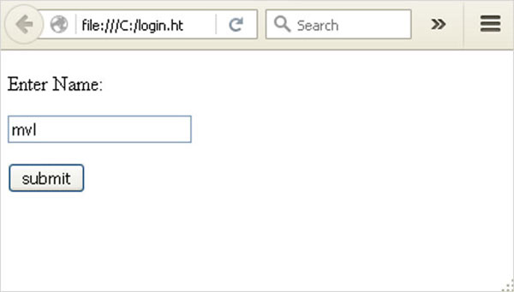
Form data is POSTed to the URL in action clause of form tag.
http://localhost/login is mapped to the login() function. Since the server has received data by POST method, value of ‘nm’ parameter obtained from the form data is obtained by −
user = request.form['nm']
It is passed to ‘/success’ URL as variable part. The browser displays a welcome message in the window.
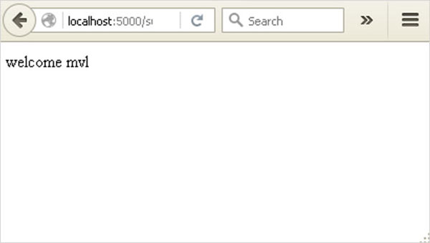
Change the method parameter to ‘GET’ in login.html and open it again in the browser. The data received on server is by the GET method. The value of ‘nm’ parameter is now obtained by −
User = request.args.get(‘nm’)
Here, args is dictionary object containing a list of pairs of form parameter and its corresponding value. The value corresponding to ‘nm’ parameter is passed on to ‘/success’ URL as before.

What is Python?
Python is a popular programming language. It was created in 1991 by Guido van Rossum.
It is used for:
- web development (server-side),
- software development,
- mathematics,
- system scripting.
What can Python do?
- Python can be used on a server to create web applications.
- Python can be used alongside software to create workflows.
- Python can connect to database systems. It can also read and modify files.
- Python can be used to handle big data and perform complex mathematics.
- Python can be used for rapid prototyping, or for production-ready software development.
Why Python?
- Python works on different platforms (Windows, Mac, Linux, Raspberry Pi, etc).
- Python has a simple syntax similar to the English language.
- Python has syntax that allows developers to write programs with fewer lines than some other programming languages.
- Python runs on an interpreter system, meaning that code can be executed as soon as it is written. This means that prototyping can be very quick.
- Python can be treated in a procedural way, an object-orientated way or a functional way.
Good to know
- The most recent major version of Python is Python 3, which we shall be using in this tutorial. However, Python 2, although not being updated with anything other than security updates, is still quite popular.
- In this tutorial Python will be written in a text editor. It is possible to write Python in an Integrated Development Environment, such as Thonny, Pycharm, Netbeans or Eclipse which are particularly useful when managing larger collections of Python files.
Python Syntax compared to other programming languages
- Python was designed to for readability, and has some similarities to the English language with influence from mathematics.
- Python uses new lines to complete a command, as opposed to other programming languages which often use semicolons or parentheses.
- Python relies on indentation, using whitespace, to define scope; such as the scope of loops, functions and classes. Other programming languages often use curly-brackets for this purpose.

Python Install
Many PCs and Macs will have python already installed.
To check if you have python installed on a Windows PC, search in the start bar for Python or run the following on the Command Line (cmd.exe):
C:\Users\Your Name>python --version
To check if you have python installed on a Linux or Mac, then on linux open the command line or on Mac open the Terminal and type:
python --version
If you find that you do not have python installed on your computer, then you can download it for free from the following website: https://www.python.org/

Python Quickstart
Python is an interpreted programming language, this means that as a developer you write Python (.py) files in a text editor and then put those files into the python interpreter to be executed.
The way to run a python file is like this on the command line:
C:\Users\Your Name>python helloworld.py
Where "helloworld.py" is the name of your python file.
Let's write our first Python file, called helloworld.py, which can be done in any text editor.
helloworld.py
print("Hello, World!")
Simple as that. Save your file. Open your command line, navigate to the directory where you saved your file, and run:
C:\Users\Your Name>python helloworld.py
The output should read:
Hello, World!
Congratulations, you have written and executed your first Python program.

The Python Command Line
To test a short amount of code in python sometimes it is quickest and easiest not to write the code in a file. This is made possible because Python can be run as a command line itself.
Type the following on the Windows, Mac or Linux command line:
C:\Users\Your Name>python
From there you can write any python, including our hello world example from earlier in the tutorial:
C:\Users\Your Name>python
Python 3.6.4 (v3.6.4:d48eceb, Dec 19 2017, 06:04:45) [MSC v.1900 32 bit (Intel)] on win32
Type "help", "copyright", "credits" or "license" for more information.
>>> print("Hello, World!")
Which will write "Hello, World!" in the command line:
C:\Users\Your Name>python
Python 3.6.4 (v3.6.4:d48eceb, Dec 19 2017, 06:04:45) [MSC v.1900 32 bit (Intel)] on win32
Type "help", "copyright", "credits" or "license" for more information.
>>> print("Hello, World!")
Hello, World!
Whenever you are done in the python command line, you can simply type the following to quit the python command line interface:
exit()
Execute Python Syntax
As we learned in the previous page, Python syntax can be executed by writing directly in the Command Line:
>>> print("Hello, World!")
Hello, World!
Or by creating a python file on the server, using the .py file extension, and running it in the Command Line:
C:\Users\Your Name>python myfile.py

Python Indentations
Where in other programming languages the indentation in code is for readability only, in Python the indentation is very important.
Python uses indentation to indicate a block of code.
Example
if 5 > 2:
print("Five is greater than two!")
Python will give you an error if you skip the indentation:
Example
if 5 > 2:
print("Five is greater than two!")

Comments
Python has commenting capability for the purpose of in-code documentation.
Comments start with a #, and Python will render the rest of the line as a comment:
Example
Comments in Python:
#This is a comment.
print("Hello, World!")
Docstrings
Python also has extended documentation capability, called docstrings.
Docstrings can be one line, or multiline.
Python uses triple quotes at the beginning and end of the docstring:
Example
Docstrings are also comments:
"""This is a
multiline docstring."""
print("Hello, World!")

Chapter 3
SYSTEM STUDY

FEASIBILITY STUDY

The feasibility of the project is analyzed in this phase and business proposal is put forth with a very general plan for the project and some cost estimates. During system analysis the feasibility study of the proposed system is to be carried out. This is to ensure that the proposed system is not a burden to the company. For feasibility analysis, some understanding of the major requirements for the system is essential.
Three key considerations involved in the feasibility analysis are
- ECONOMICAL FEASIBILITY
- TECHNICAL FEASIBILITY
- SOCIAL FEASIBILITY

3.1 ECONOMICAL FEASIBILITY
This study is carried out to check the economic impact that the system will have on the organization. The amount of fund that the company can pour into the research and development of the system is limited. The expenditures must be justified. Thus the developed system as well within the budget and this was achieved because most of the technologies used are freely available. Only the customized products had to be purchased.

3.2 TECHNICAL FEASIBILITY

This study is carried out to check the technical feasibility, that is, the technical requirements of the system. Any system developed must not have a high demand on the available technical resources. This will lead to high demands on the available technical resources. This will lead to high demands being placed on the client. The developed system must have a modest requirement, as only minimal or null changes are required for implementing this system.

3.3 SOCIAL FEASIBILITY
The aspect of study is to check the level of acceptance of the system by the user. This includes the process of training the user to use the system efficiently. The user must not feel threatened by the system, instead must accept it as a necessity. The level of acceptance by the users solely depends on the methods that are employed to educate the user about the system and to make him familiar with it. His level of confidence must be raised so that he is also able to make some constructive criticism, which is welcomed, as he is the final user of the system.

Chapter 4
SYSTEM DESIGN
Systems design is the process of defining the architecture, product design, modules, interfaces, and data for a system to satisfy specified requirements. Systems design could be seen as the application of systems theory to product development. There is some overlap with the disciplines.
The purpose of the System Design process is to provide sufficient detailed data and information about the system and its system elements to enable the implementation consistent with architectural entities as defined in models and views of the system architecture.
The process of systems design includes defining software and hardware architecture, components, modules, interfaces, and data to enable a system to satisfy a set of well specified operational requirements.

4.1 SYSTEM ARCHITECTURE:

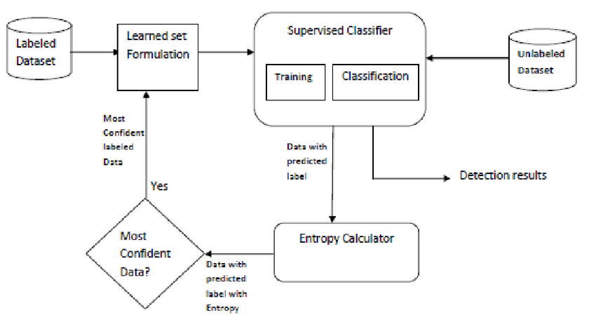

4.2 DATA FLOW DIAGRAM:
- The DFD is also called as bubble chart. It is a simple graphical formalism that can be used to represent a system in terms of input data to the system, various processing carried out on this data, and the output data is generated by this system.
- The data flow diagram (DFD) is one of the most important modeling tools. It is used to model the system components. These components are the system process, the data used by the process, an external entity that interacts with the system and the information flows in the system.
- DFD shows how the information moves through the system and how it is modified by a series of transformations. It is a graphical technique that depicts information flow and the transformations that are applied as data moves from input to output.
- DFD is also known as bubble chart. A DFD may be used to represent a system at any level of abstraction. DFD may be partitioned into levels that represent increasing information flow and functional detail.

Input data
Preprocessing
Training dataset
Feature Extraction
Register
Login

Malicious

No Malicious
Prediction/Classification
4.3 USE CASE DIAGRAM:
A use case diagram in the Unified Modeling Language (UML) is a type of behavioral diagram defined by and created from a Use-case analysis. Its purpose is to present a graphical overview of the functionality provided by a system in terms of actors, their goals (represented as use cases), and any dependencies between those use cases. The main purpose of a use case diagram is to show what system functions are performed for which actor. Roles of the actors in the system can be depicted.

User
Input data
Preprocessing
Training
Classification
4.4 CLASS DIAGRAM:
In software engineering, a class diagram in the Unified Modeling Language (UML) is a type of static structure diagram that describes the structure of a system by showing the system's classes, their attributes, operations (or methods), and the relationships among the classes. It explains which class contains information.
Input

Input data

Preprocessing ( )
Output
Features extraction
Classification

Finally get Classified &Display Result: No Malicious or Malicious

4.5 SEQUENCE DIAGRAM:
A sequence diagram in Unified Modeling Language (UML) is a kind of interaction diagram that shows how processes operate with one another and in what order. It is a construct of a Message Sequence Chart. Sequence diagrams are sometimes called event diagrams, event scenarios, and timing diagrams.
Datacollection
Training
Testing
Collect the data from the user feature on cnn
Send the data to the traing stage
Perforn Preprocessing
Train the data
Extracted feature with images sending to the testing stage
Give input
Predict the type using proposed algorithm
4.6 ACTIVITY DIAGRAM:
Activity diagrams are graphical representations of workflows of stepwise activities and actions with support for choice, iteration and concurrency. In the Unified Modeling Language, activity diagrams can be used to describe the business and operational step-by-step workflows of components in a system. An activity diagram shows the overall flow of control.

Input
Preprocessing
Training
Prediction using proposed algorithm(Logistic regression)
Predicted Label As Malicious or no Malicious

Chapter 5
IMPLEMENTATION

from flask import Flask, render_template, request, url_for, Markup, jsonify
import pickle
import pandas as pd
import numpy as np
import pandas as pd
import numpy as np
import matplotlib.pyplot as plt
from flask import Flask, render_template, request, url_for, session, redirect, flash
from flask_mysqldb import MySQL
import MySQLdb.cursors
import re
import pickle
import pandas as pd
import pymsgbox
app = Flask(__name__)
pickle_in = open('model.pkl','rb')
pac = pickle.load(pickle_in)
tfid = open('tfidf_vectorizer.pkl','rb')
tfidf_vectorizer = pickle.load(tfid)

app.secret_key = 'neha'

app.config['MYSQL_HOST'] = 'localhost'
app.config['MYSQL_USER'] = 'root'
app.config['MYSQL_PASSWORD'] = 'root'
app.config['MYSQL_DB'] = 'malware'
mysql = MySQL(app)

@app.route('/')
def index():
return render_template('index.html')

@app.route('/login', methods = ['GET',"POST"])
def login():
# Output message if something goes wrong...
msg = ''
# Check if "username" and "password" POST requests exist (user submitted form)
if request.method == 'POST' and 'username' in request.form and 'password' in request.form:
# Create variables for easy access
username = request.form['username']
password = request.form['password']
# Check if account exists using MySQL
cursor = mysql.connection.cursor(MySQLdb.cursors.DictCursor)
cursor.execute('SELECT * FROM employee WHERE username = %s AND password = %s AND status="Approved" ', (username, password))
# Fetch one record and return result
account = cursor.fetchone()
# If account exists in accounts table in out databas0e
if account:
# Create session data, we can access this data in other routes
session['loggedin'] = True
global Id
session['Id'] = account['Id']

Id = session['Id']
session['username'] = account['username']
# Redirect to home page
return redirect(url_for('profile'))
else:
# Account doesnt exist or username/password incorrect
flash('Incorrect username/password! or Account Blocked')
return redirect(url_for('login'))
# Show the login form with message (if any)

return render_template('login.html', msg=msg)

@app.route('/register',methods= ['GET',"POST"])
def register():
# Output message if something goes wrong...
msg = ''
# Check if "username", "password" and "email" POST requests exist (user submitted form)
if request.method == 'POST' and 'username' in request.form and 'password' in request.form and 'email' in request.form:
# Create variables for easy access
username = request.form['username']
password = request.form['password']
email = request.form['email']
reg = "^(?=.*[a-z])(?=.*[A-Z])(?=.*\d)(?=.*[@$!%*#?&])[A-Za-z\d@$!#%*?&]{6,10}$"
pattern = re.compile(reg)
cursor = mysql.connection.cursor(MySQLdb.cursors.DictCursor)
# Check if account exists using MySQL)
cursor.execute('SELECT * FROM employee WHERE Username = %s', (username,))
account = cursor.fetchone()
# If account exists show error and validation checks
if account:
msg = 'Account already exists!'
elif not re.match(r'[^@]+@[^@]+\.[^@]+', email):
msg = 'Invalid email address!'
elif not re.match(r'[A-Za-z0-9]+', username):
msg = 'Username must contain only characters and numbers!'
elif not re.search(pattern,password):
msg = 'Password should contain atleast one number, one lower case character, one uppercase character,one special symbol and must be between 6 to 10 characters long'
elif not username or not password or not email:
msg = 'Please fill out the form!'
else:
# Account doesnt exists and the form data is valid, now insert new account into employee table
cursor.execute('INSERT INTO employee VALUES (NULL, %s, %s, %s, "Approved")', (username, email, password))
mysql.connection.commit()
flash('You have successfully registered! Please proceed for login!')
return redirect(url_for('login'))
elif request.method == 'POST':
# Form is empty... (no POST data)
msg = 'Please fill out the form!'
return msg
# Show registration form with message (if any)
return render_template('register.html', msg=msg)

@app.route('/loginadmin')
def loginadmin():
return render_template('loginadmin.html')

@app.route('/upload')
def upload():
return render_template('upload.html')
@app.route('/preview',methods=["POST"])
def preview():
if request.method == 'POST':
dataset = request.files['datasetfile']
df = pd.read_csv(dataset,encoding = 'unicode_escape')
df.set_index('Id', inplace=True)
return render_template("preview.html",df_view = df)

@app.route('/prediction')
def prediction():
return render_template("prediction.html")

@app.route('/chart')
def chart():
#if request.method == 'POST':

#query_content=request.form['news']
#news=['query_content']
#msg = ''
abc = request.args.get('news')

#input_data=re.search("(?P<url>https?://[^\s]+)",abc).group("url")
#string = [input_data.rstrip()]
pattern = r'(?:http://)?\w+\.\S*[^.\s]'
input_data=re.findall(pattern, abc)

if input_data:

tfidf_test = tfidf_vectorizer.transform(input_data)
# predicting the input

y_pred = pac.predict(tfidf_test)
#if y_pred[0] == 'bad':
# label="malware"
#elif y_pred[0] == 'good':
# label="no malware"
pred=format(y_pred[0])

login()
cur = mysql.connection.cursor()
cur.execute("INSERT INTO review(news_content,pred,userid,url) VALUES ( %s, %s,%s,%s) ", (input_data,pred,Id,abc))

mysql.connection.commit()
cur.close()

else:
#msg = 'Enter the url'
#return msg
#return render_template('prediction.html', msg=msg)
pymsgbox.alert('Enter the url', 'warning')
return render_template('prediction.html')
return redirect('/users')

@app.route('/users')
def users():

cur = mysql.connection.cursor()
resultValue = cur.execute(" SELECT * from employee INNER JOIN review ON employee.ID = review.USERID WHERE status !='Blocked';")

if resultValue > 0:
userDetails = cur.fetchall()

return render_template('users.html',userDetails=userDetails)

@app.route('/admin')
def admin():
cur = mysql.connection.cursor()
resultValue = cur.execute(" SELECT * from employee INNER JOIN review ON employee.ID = review.USERID;")

if resultValue > 0:
userDetails = cur.fetchall()

return render_template('admin.html',userDetails=userDetails)
@app.route('/profile')
def profile():

cursor = mysql.connection.cursor()
cursor.execute('SELECT * from employee WHERE Id = %s', (Id,))
account = cursor.fetchone()

return render_template('profile.html', account=account)

@app.route('/userdetail')
def userdetail():
cur = mysql.connection.cursor()
cur.execute("SELECT * from employee")
useradmin=cur.fetchall()
print(useradmin)

return render_template('userdetail.html',useradmin=useradmin)

@app.route('/blockUser',methods=['GET','POST'])
def blockUser():
if request.method == 'POST' and 'fid' in request.form:
f1 = request.form['fid']

con=mysql.connection.cursor()
con.execute("UPDATE employee SET status='Blocked' WHERE Id=%s " , (f1,))
mysql.connection.commit()

con.close()

return redirect(url_for('admin'))

@app.route('/user')
def user():
legend = "review by pred"
cursor = mysql.connection.cursor()
try:
cursor.execute("SELECT pred from review GROUP BY pred")
# data = cursor.fetchone()
rows1 = cursor.fetchall()
labels = list()
i = 0
for row1 in rows1:
labels.append(row1[i])

cursor.execute("SELECT pred from review GROUP BY pred")
# data = cursor.fetchone()
rows2 = cursor.fetchall()

label = list()
j = 0
values = list()
k = 0
for row2 in rows2:
label.append(row2[j])
cursor.execute("SELECT COUNT(id) from review WHERE pred=%s", (row2[j],))
rows3 = cursor.fetchall()

#j=j+1
# Convert query to objects of key-value pairs

for row3 in rows3:
values.append(row3[k])
#k=k+1
mysql.connection.commit()
cursor.close()

except:
print('Error: unable to fetch items')

return render_template('user.html', values=values, labels = labels, legend=legend)

if __name__=='__main__':
app.run(debug=True)

Chapter 6

SYSTEM TESTING

The purpose of testing is to discover errors. Testing is the process of trying to discover every conceivable fault or weakness in a work product. It provides a way to check the functionality of components, sub assemblies, assemblies and/or a finished product It is the process of exercising software with the intent of ensuring that the
Software system meets its requirements and user expectations and does not fail in an unacceptable manner. There are various types of test. Each test type addresses a specific testing requirement.

TYPES OF TESTS

6.1 Unit testing
Unit testing involves the design of test cases that validate that the internal program logic is functioning properly, and that program inputs produce valid outputs. All decision branches and internal code flow should be validated. It is the testing of individual software units of the application .it is done after the completion of an individual unit before integration. This is a structural testing, that relies on knowledge of its construction and is invasive. Unit tests perform basic tests at component level and test a specific business process, application, and/or system configuration. Unit tests ensure that each unique path of a business process performs accurately to the documented specifications and contains clearly defined inputs and expected results.

6.2 Integration testing
Integration tests are designed to test integrated software components to determine if they actually run as one program. Testing is event driven and is more concerned with the basic outcome of screens or fields. Integration tests demonstrate that although the components were individually satisfaction, as shown by successfully unit testing, the combination of components is correct and consistent. Integration testing is specifically aimed at exposing the problems that arise from the combination of components.

6.3 Functional test
Functional tests provide systematic demonstrations that functions tested are available as specified by the business and technical requirements, system documentation, and user manuals.
Functional testing is centered on the following items:
Valid Input : identified classes of valid input must be accepted.
Invalid Input : identified classes of invalid input must be rejected.
Functions : identified functions must be exercised.
Output : identified classes of application outputs must be exercised.
Systems/Procedures: interfacing systems or procedures must be invoked.

Organization and preparation of functional tests is focused on requirements, key functions, or special test cases. In addition, systematic coverage pertaining to identify Business process flows; data fields, predefined processes, and successive processes must be considered for testing. Before functional testing is complete, additional tests are identified and the effective value of current tests is determined.

6.4 System Test
System testing ensures that the entire integrated software system meets requirements. It tests a configuration to ensure known and predictable results. An example of system testing is the configuration oriented system integration test. System testing is based on process descriptions and flows, emphasizing pre-driven process links and integration points.

6.5 White Box Testing
White Box Testing is a testing in which in which the software tester has knowledge of the inner workings, structure and language of the software, or at least its purpose. It is purpose. It is used to test areas that cannot be reached from a black box level.

6.6 Black Box Testing
Black Box Testing is testing the software without any knowledge of the inner workings, structure or language of the module being tested. Black box tests, as most other kinds of tests, must be written from a definitive source document, such as specification or requirements document, such as specification or requirements document. It is a testing in which the software under test is treated, as a black box .you cannot “see” into it. The test provides inputs and responds to outputs without considering how the software works.

Chapter 7
SCREEN SHOTS

7.1 HOME PAGE
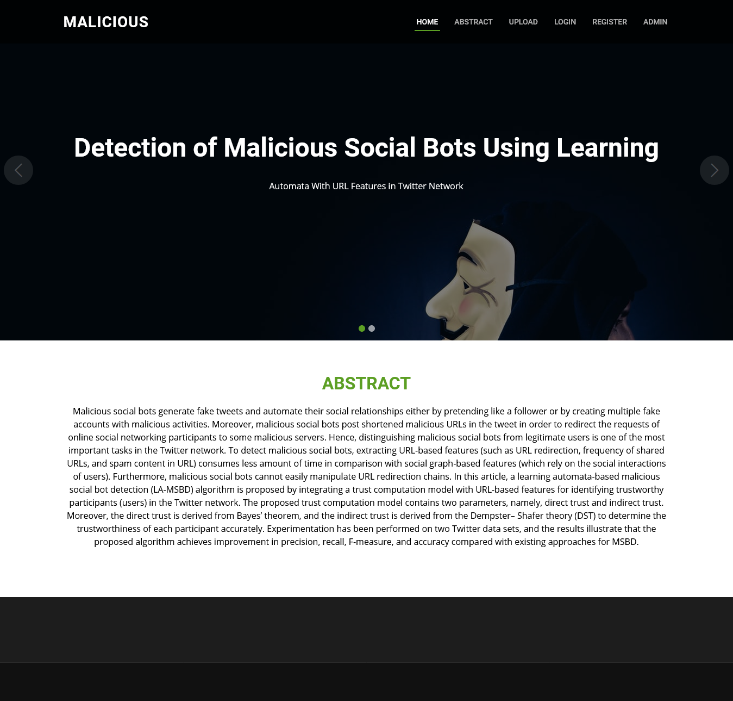

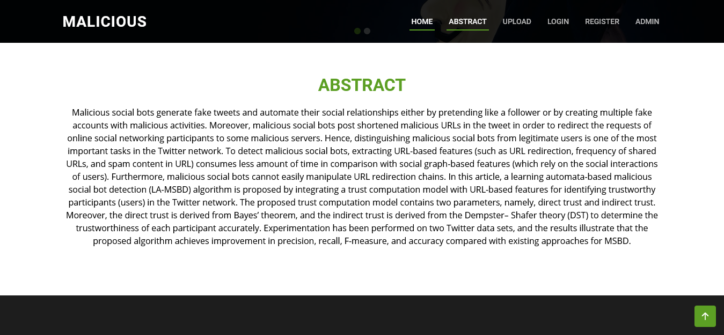

7.2 DATASET UPLOADING PAGE
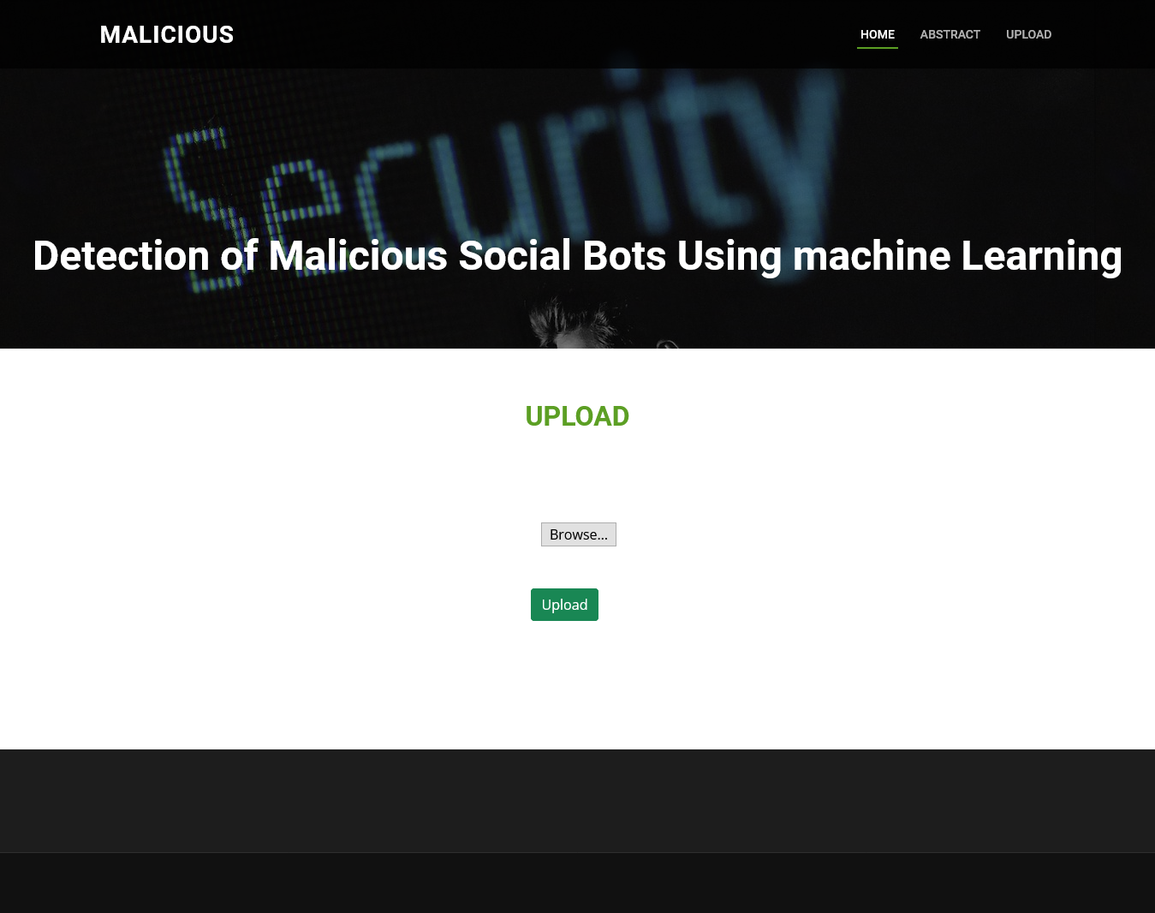

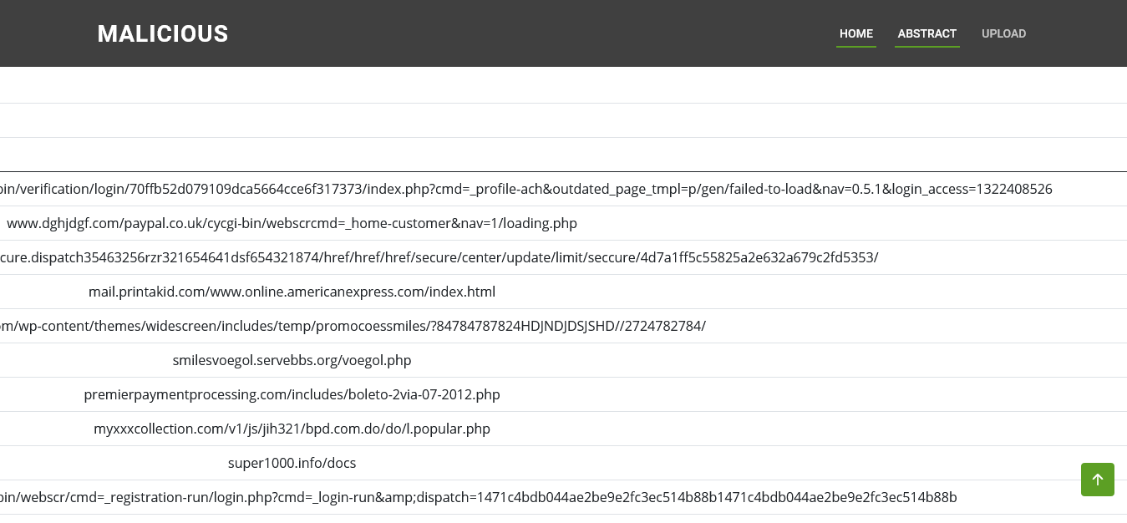

7.3 TRAINING AND TESTING PAGE
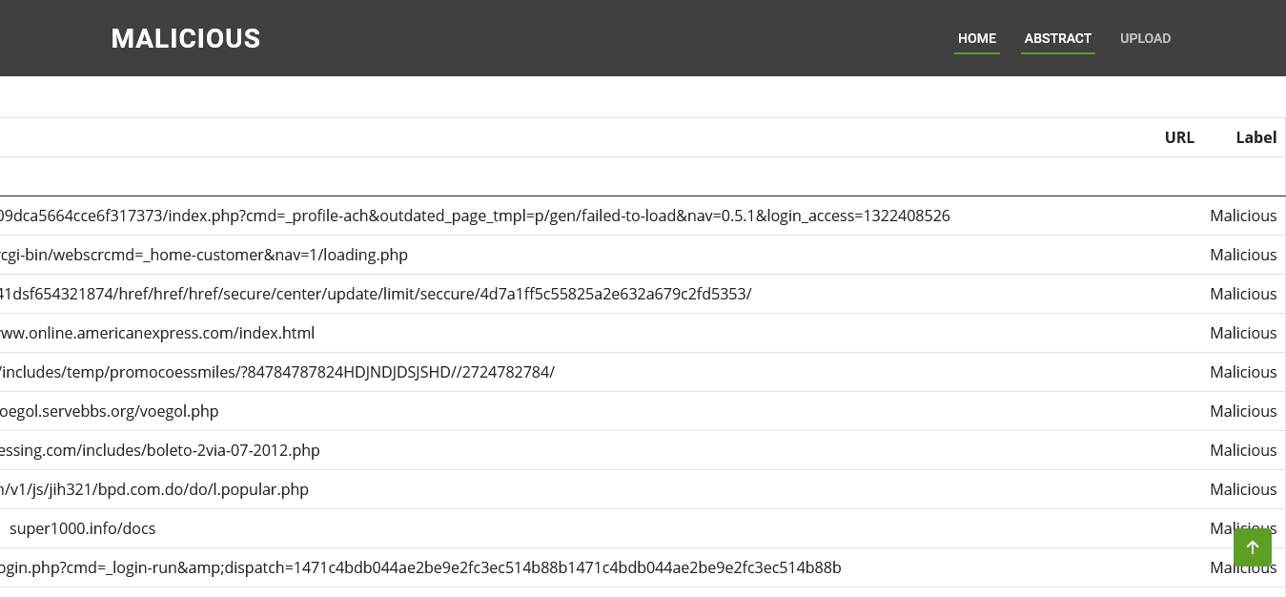

7.4 USER REGISTRATION PAGE
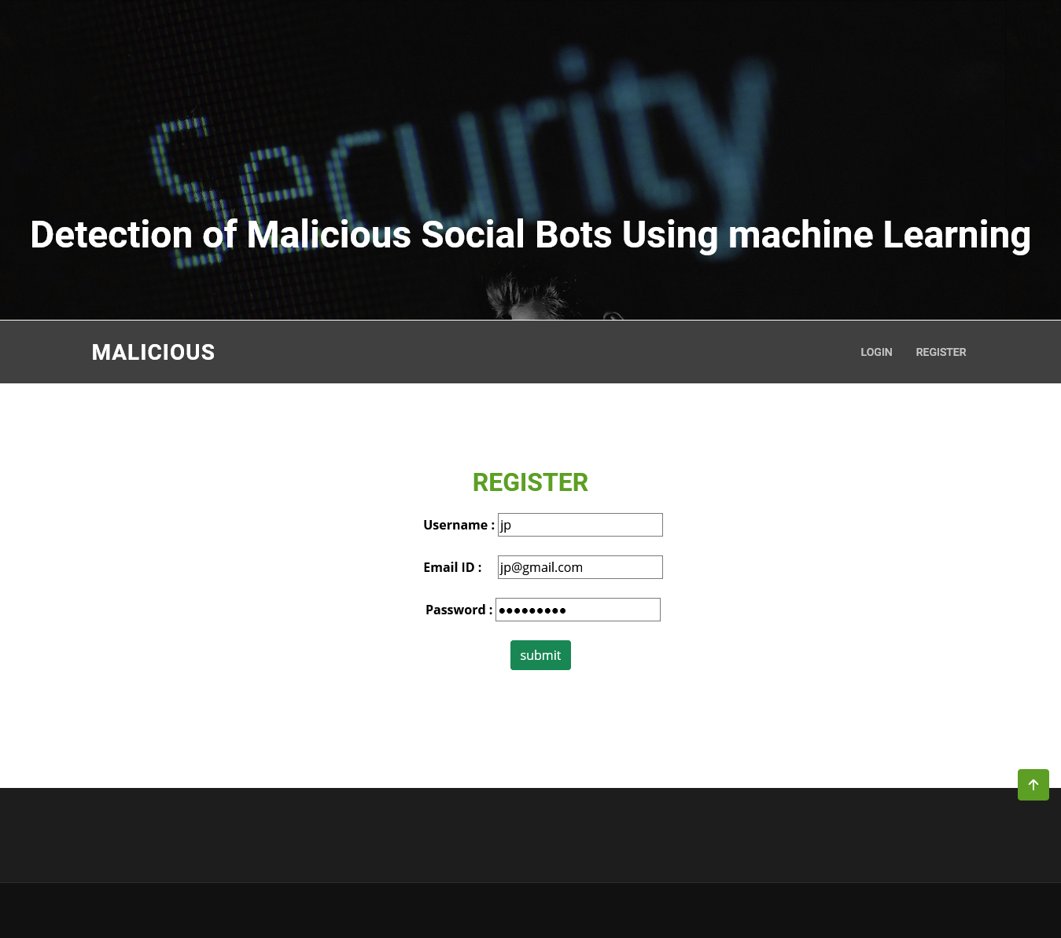

7.5 USER LOGIN PAGE
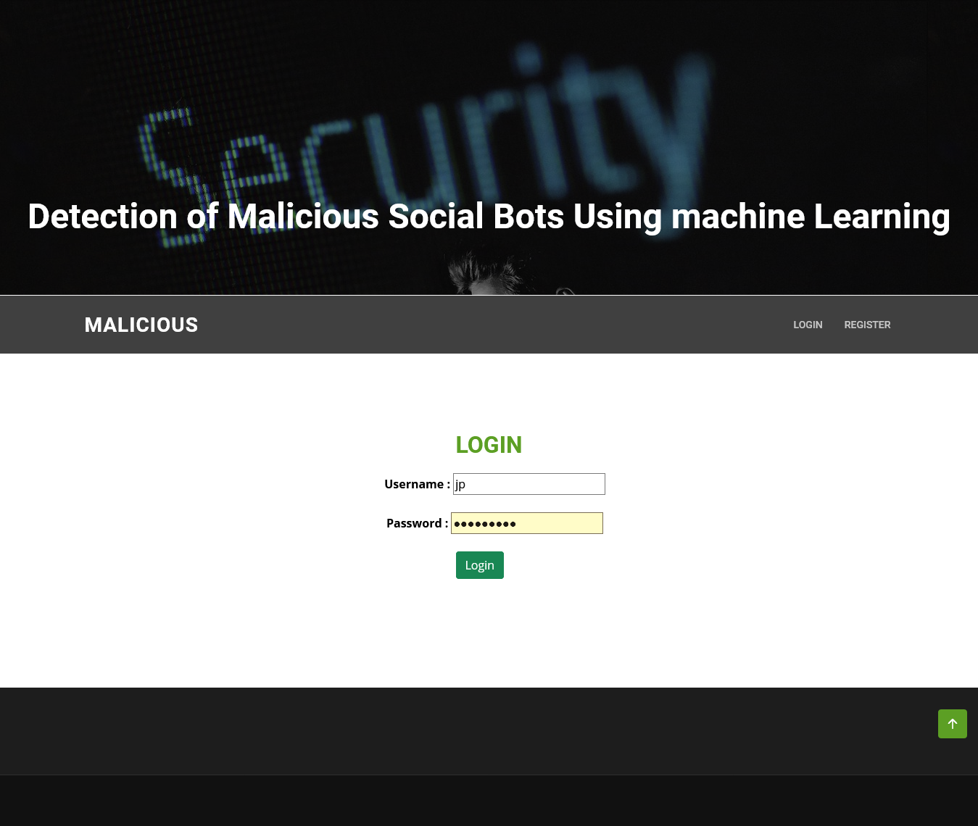

7.6 USER HOME PAGE
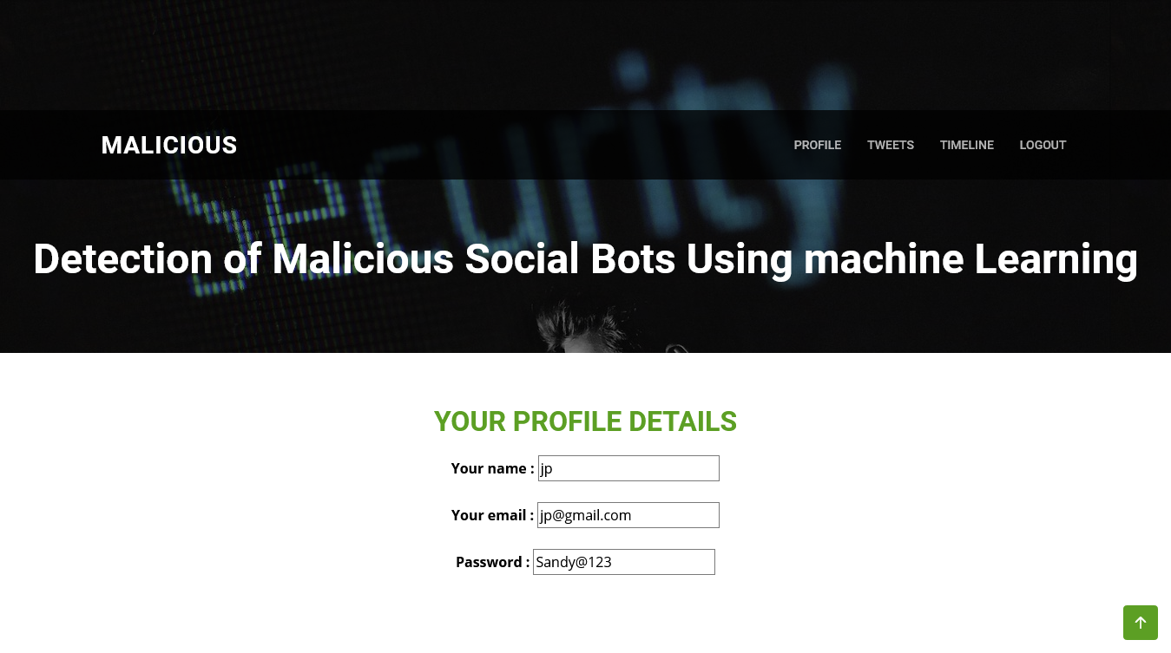

7.7 TWEETING PAGE
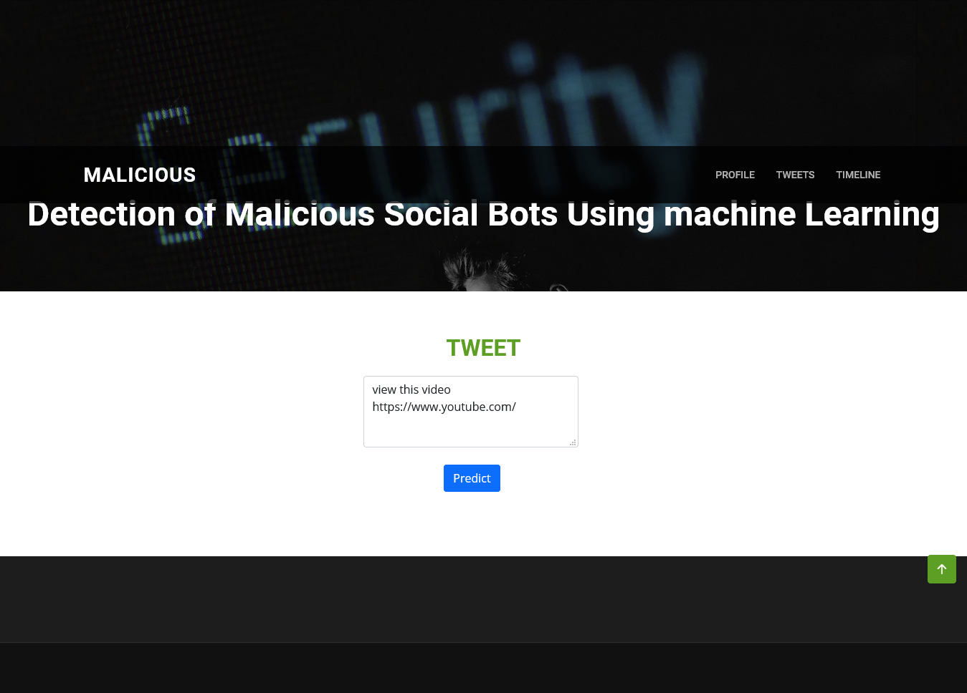

7.8 COLLECTION OF TWEETS
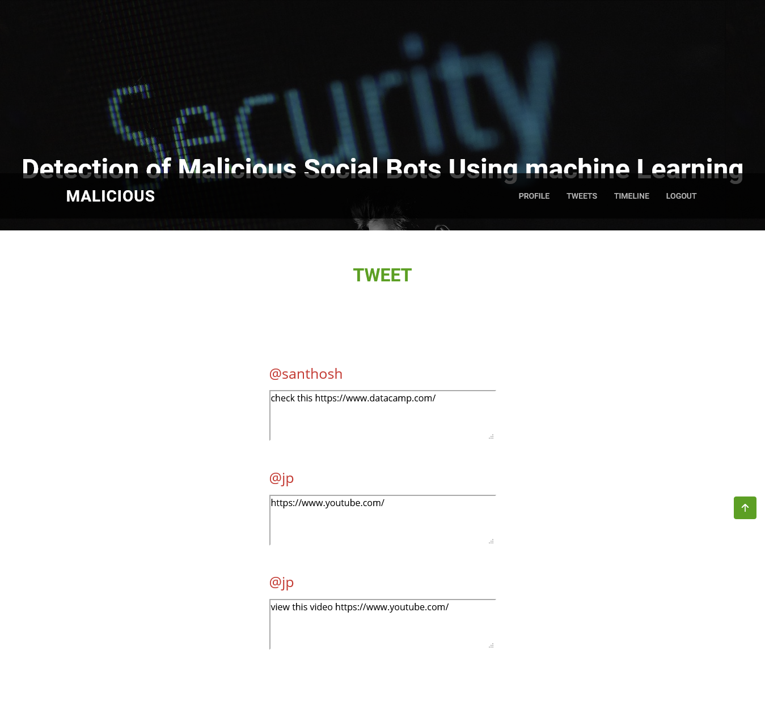

7.9 ADMIN LOGIN
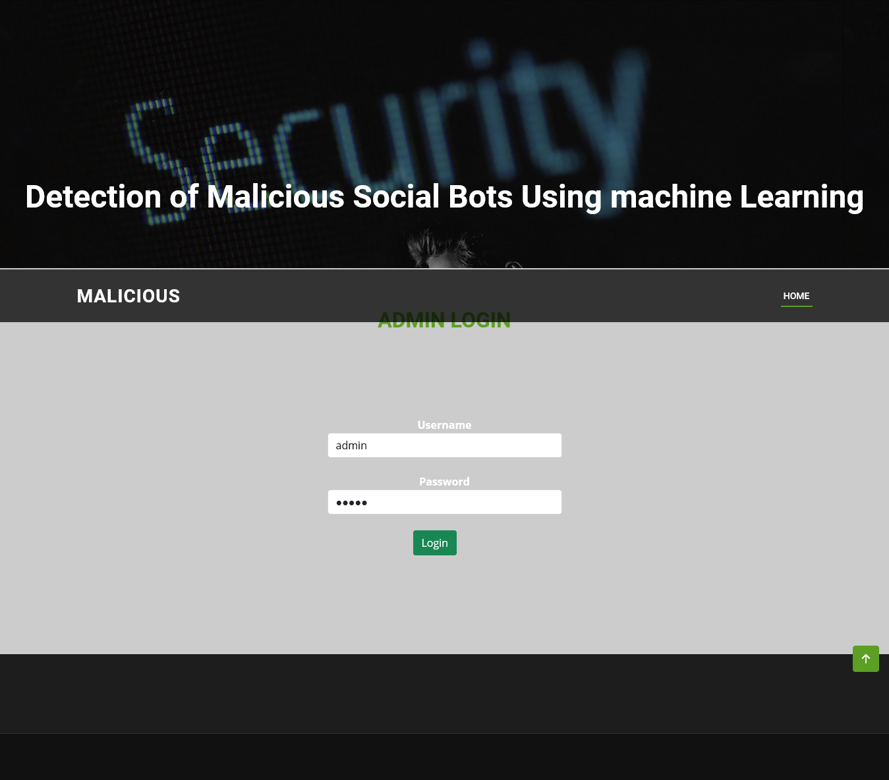

7.10 USER REGISTRATION LOGIN
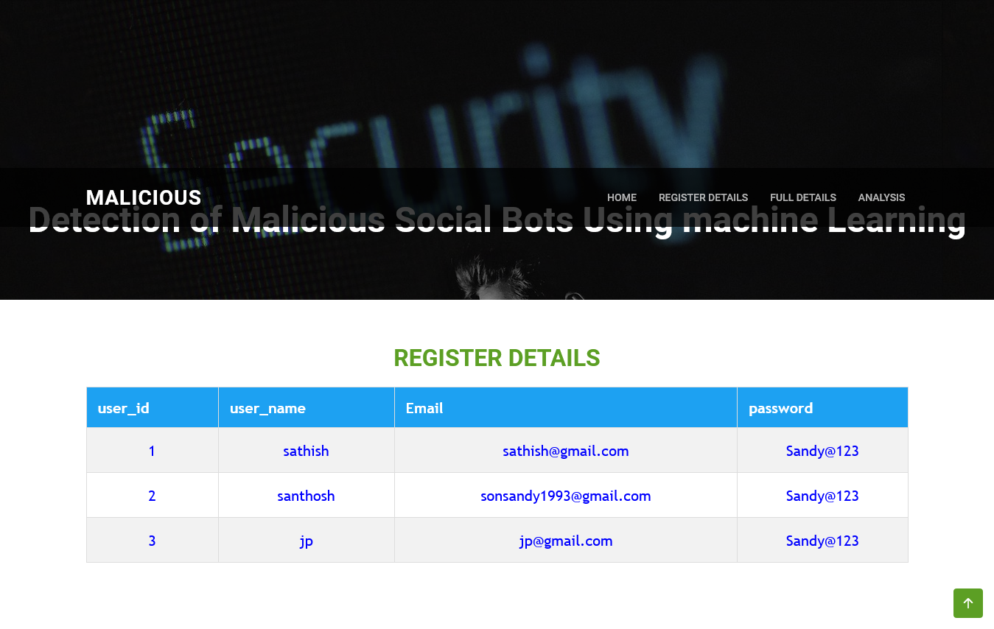

7.11 USER FULL DETAILS PAGE
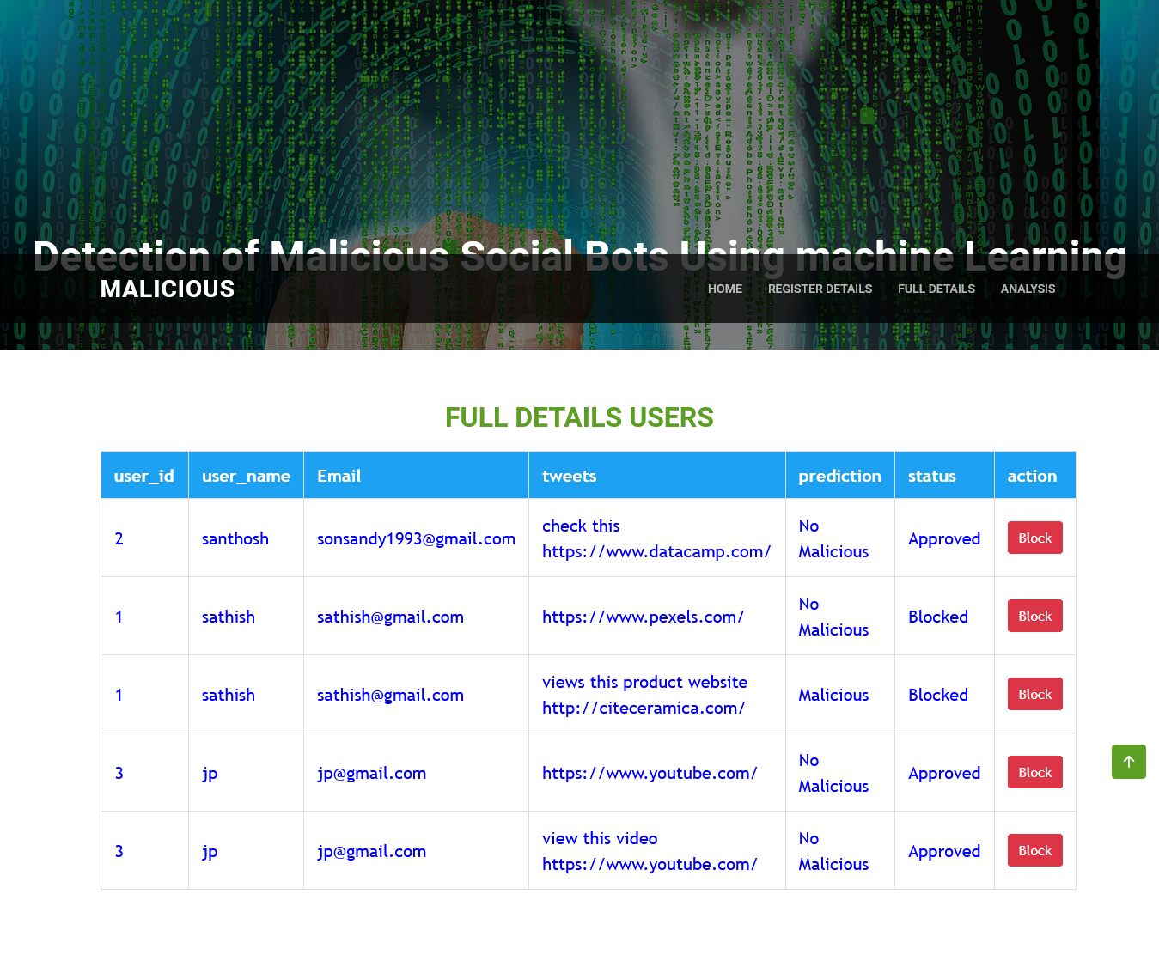
7.12 TWEET ANALYSIS PAGE
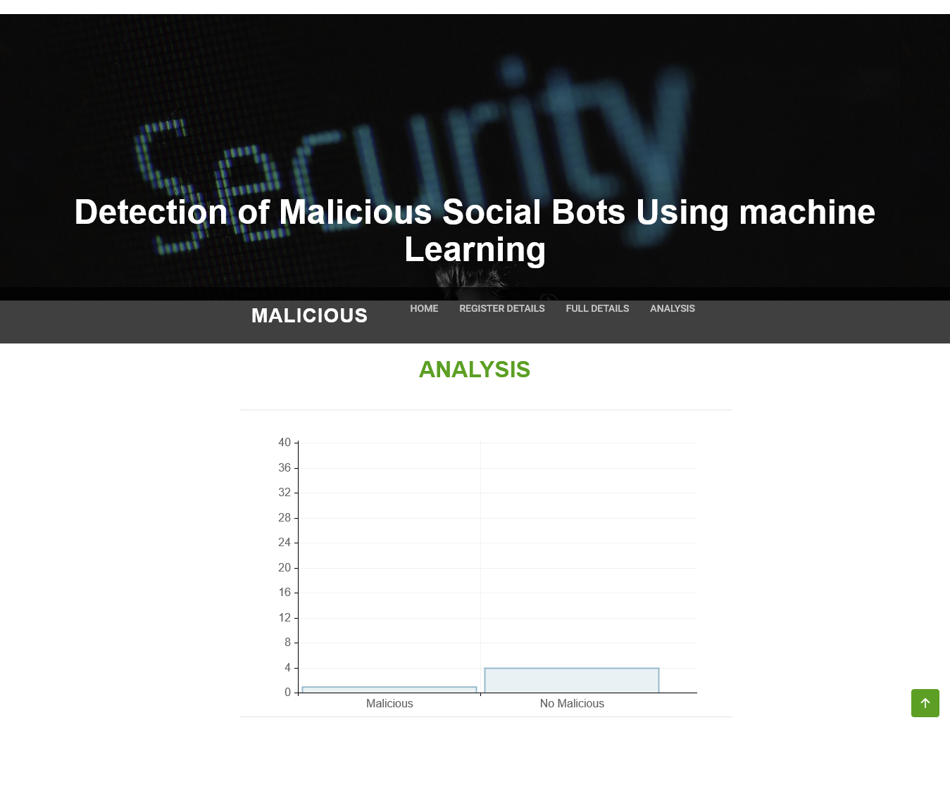

CONCLUSION
This article presents an LA-MSBD algorithm by integrating a trust computational model with a set of URL-based features for MSBD. In addition, we evaluate the trustworthiness of tweets (posted by each participant) by using the Bayesian learning and DST. Moreover, the proposed LA-MSBD algorithm executes a finite set of learning actions to update action probability value (i.e., probability of a participant posting malicious URLs in the tweets). The proposed LA-MSBD algorithm achieves the advantages of incremental learning. Two Twitter data sets are used to evaluate the performance of our proposed LA-MSBD algorithm. The experimental results show that the proposed LA-MSBD algorithm achieves up to 7% improvement of accuracy compared with other existing algorithms. For The Fake Project and Social Honeypot data sets, the proposed LA-MSBD algorithm has achieved precisions of 95.37% and 91.77% for MSBD, respectively. Furthermore, as a future research challenge, we would like to investigate the dependence among the features and its impact on MSBD.

FUTURE ENHANCEMENT
Future enhancements can focus on expanding the dataset,real-time data analysis,collaboration with social media platforms, advanced NLP techniques, and improving model interpretablility.These improvements will strengthen bot detection and enhance online platform security.Also,flagging the malicious URL can also be an option which improves overall user experience.

REFERENCES
[1] P. Shi, Z. Zhang, and K.-K.-R. Choo, “Detecting malicious social bots based on clickstream sequences,” IEEE Access, vol. 7, pp. 28855–28862, 2019.

[2] G. Lingam, R. R. Rout, and D. V. L. N. Somayajulu, “Adaptive deep Q-learning model for detecting social bots and influential users in online social networks,” Appl. Intell., vol. 49, no. 11, pp. 3947–3964, Nov. 2019.

[3] D. Choi, J. Han, S. Chun, E. Rappos, S. Robert, and T. T. Kwon, “Bit.ly/practice: Uncovering content publishing and sharing through URL shortening services,” Telematics Inform., vol. 35, no. 5, pp. 1310–1323, 2018.

[4] S. Lee and J. Kim, “Fluxing botnet command and control channels with URL shortening services,” Comput. Commun., vol. 36, no. 3, pp. 320–332, Feb. 2013.

[5] S. Madisetty and M. S. Desarkar, “A neural network-based ensemble approach for spam detection in Twitter,” IEEE Trans. Comput. Social Syst., vol. 5, no. 4, pp. 973–984, Dec. 2018.

[6] H. B. Kazemian and S. Ahmed, “Comparisons of machine learning techniques for detecting malicious webpages,” Expert Syst. Appl., vol. 42, no. 3, pp. 1166–1177, Feb. 2015.

[7] H. Gupta, M. S. Jamal, S. Madisetty, and M. S. Desarkar, “A framework for real-time spam detection in Twitter,” in Proc. 10th Int. Conf. Commun. Syst. Netw. (COMSNETS), Jan. 2018, pp. 380–383.

[8] T. Wu, S. Liu, J. Zhang, and Y. Xiang, “Twitter spam detection based on deep learning,” in Proc. Australas. Comput. Sci. Week Multiconf. (ACSW), 2017, p. 3.

[9] Y. Boshmaf, I. Muslukhov, K. Beznosov, and M. Ripeanu, “Key challenges in defending against malicious socialbots,” Presented at the 5th USENIX Workshop Large-Scale Exploits Emergent Threats, 2012, pp. 1–4.

[10] G. Yan, “Peri-watchdog: Hunting for hidden botnets in the periphery of online social networks,” Comput. Netw., vol. 57, no. 2, pp. 540–555, Feb. 2013.

[11] D. Canali, M. Cova, G. Vigna, and C. Kruegel, “Prophiler: A fast filter for the large-scale detection of malicious Web pages,” in Proc. 20th Int. Conf. World Wide Web (WWW), 2011, pp. 197–206.

[12] A. K. Jain and B. B. Gupta, “A machine learning based approach for phishing detection using hyperlinks information,” J. Ambient Intell. Hum. Comput., vol. 10, no. 5, pp. 2015–2028, May 2019.

[13] C. Chen, J. Zhang, X. Chen, Y. Xiang, and W. Zhou, “6 million spam tweets: A large ground truth for timely Twitter spam detection,” in Proc. IEEE Int. Conf. Commun. (ICC), Jun. 2015, pp. 7065–7070.

[14] Z. Chu, S. Gianvecchio, H. Wang, and S. Jajodia, “Detecting automation of Twitter accounts: Are you a human, bot, or cyborg?” IEEE Trans. Dependable Secure Comput., vol. 9, no. 6, pp. 811–824, Nov. 2012.

