## 

## 

## 

# CA - SVM Models for Customer Default (Credit card company) data report

## 

## 

## 

## 

## 

## 

## Team: 18

Tran Khanh Trung (e0146769)

Rahul Chauhan (e0146878)

Woo Yee Wan (e0146940)

# 

# 

# CA - SVM Models report

Libraries:

ISLR e1071

Data: Default (data size = 10,000, 9667=No, 333=Yes)

Customer default records for a credit card company

Four columns:

default (Yes/No),

student (Yes/No),

balance,

income

Task:

To fit SVM model for prediction of default of customers in “No” and “Yes”, using the other variables as predictors.

Steps:

1. Partition training and testing data at 80%:20% ratio
2. Train the models with 3 kernel functions of predictors; student-income and income-balance
3. Test the models with test data and analyze the results

## Model1: SVM with kernel function RBF

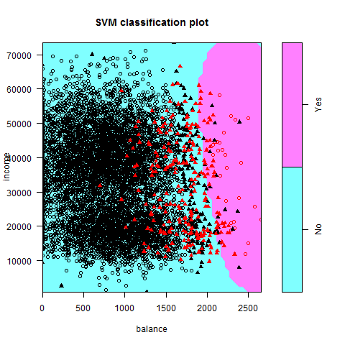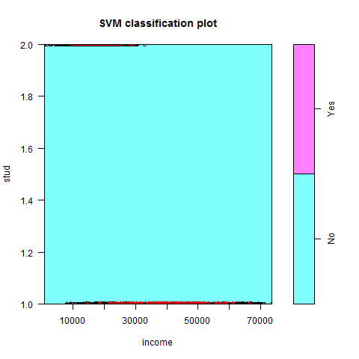

|  |  |
| --- | --- |
| **Predictors: income-balance** | **Predictors: student-income** |
| Parameters:  SVM-Type: C-classification  SVM-Kernel: radial  cost: 1  gamma: 0.5  Number of Support Vectors: 543  ( 295 248 )  Number of Classes: 2  Levels:  No Yes | Parameters:  SVM-Type: C-classification  SVM-Kernel: radial  cost: 1  gamma: 0.5  Number of Support Vectors: 640  ( 366 274 )  Number of Classes: 2  Levels:  No Yes |
| [1] "Predictors: income-balance"  truth  prediction No Yes  No 1938 48  Yes 3 11  [1] **97.45** | [1] "Predictors: student-income"  truth  prediction No Yes  No 1941 59  Yes 0 0  [1] **97.05** |

## 

## Model2: SVM with kernel function Polynomial

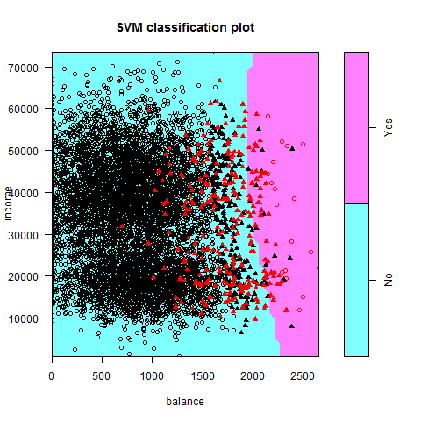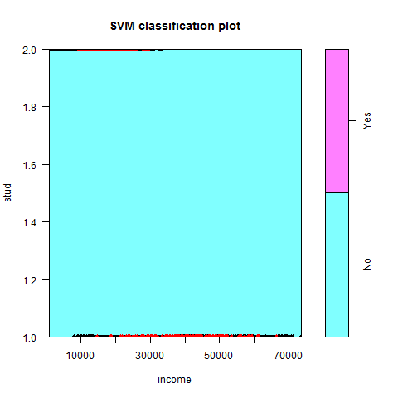

|  |  |
| --- | --- |
| **Predictors: income-balance** | **Predictors: student-income** |
| Parameters:  SVM-Type: C-classification  SVM-Kernel: polynomial  cost: 1  degree: 3  gamma: 0.5  coef.0: 0  Number of Support Vectors: 513  ( 257 256 )  Number of Classes: 2  Levels:  No Yes | Parameters:  SVM-Type: C-classification  SVM-Kernel: polynomial  cost: 1  degree: 3  gamma: 0.5  coef.0: 0  Number of Support Vectors: 601  ( 327 274 )  Number of Classes: 2  Levels:  No Yes |
| [1] "Predictors: income-balance"  truth  prediction No Yes  No 1938 48  Yes 3 11  [1] **97.45** | [1] "Predictors: student-income"  truth  prediction No Yes  No 1941 59  Yes 0 0  [1] **97.05** |

## 

## Model3: SVM with kernel function Sigmoid

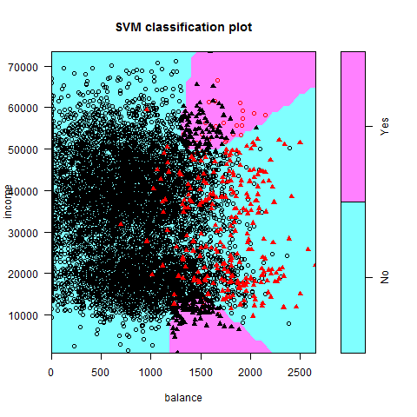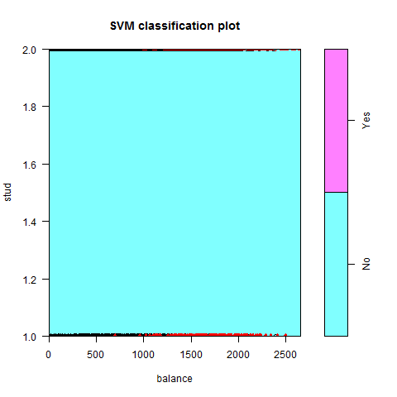

|  |  |
| --- | --- |
| **Predictors: income-balance** | **Predictors: student-income** |
| Parameters:  SVM-Type: C-classification  SVM-Kernel: sigmoid  cost: 1  gamma: 0.5  coef.0: 0  Number of Support Vectors: 485  ( 243 242 )  Number of Classes: 2  Levels:  No Yes | Parameters:  SVM-Type: C-classification  SVM-Kernel: sigmoid  cost: 1  gamma: 0.5  coef.0: 0  Number of Support Vectors: 542  ( 272 270 )  Number of Classes: 2  Levels:  No Yes |
| [1] "Predictors: income-balance"  truth  prediction No Yes  No 1877 52  Yes 64 7  [1] **94.4** | [1] "Predictors: student-income"  truth  prediction No Yes  No 1888 56  Yes 53 3  [1] **94.55** |

## Summary:

From the results of the SVM models, kernel functions; RBF and polynomial able to predict quite well. It tends to separate the classes better as compare to sigmoid function. Income and balance are better predictors. From the plot, we can tell that default of customers are from the higher income and balance group.