### **CRUD Operations with MySQL and FastAPI**

**Group Members**

Rahul Govind Kumar-25PGAI0003

Ria Singh-25PGPAI0006

Anurag Sahu-25PGAI0143

Nishanth Pandey –25PGPAI0042

Mihir Kumar- 25PGPAI0046

1. **Set Up MySQL Database**
   1. Install and configure MySQL Server.
   2. Create a database ‘school’
   3. Create table ‘students’ with id, name, age, grade.

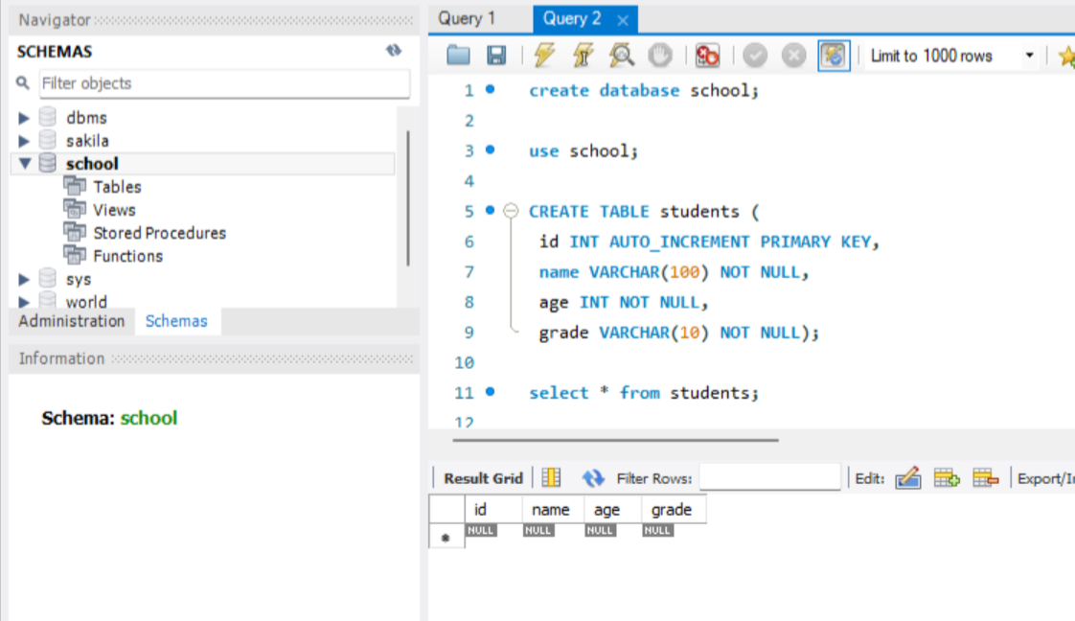

1. **Implement CRUD Wrapper Functions**
   1. Install mysql-connector-python: pip install mysql-connector-python
   2. Create a Python module database.py to implement the database connection and CRUD operations.
   3. Implement the CRUD Functions.

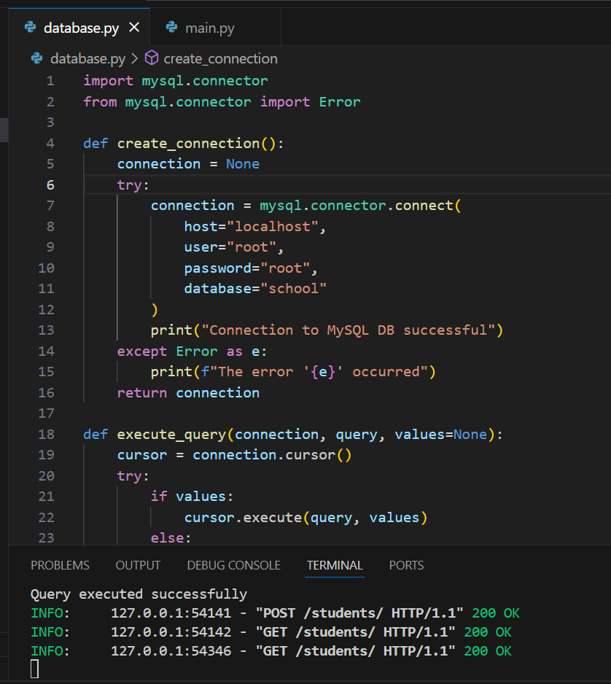

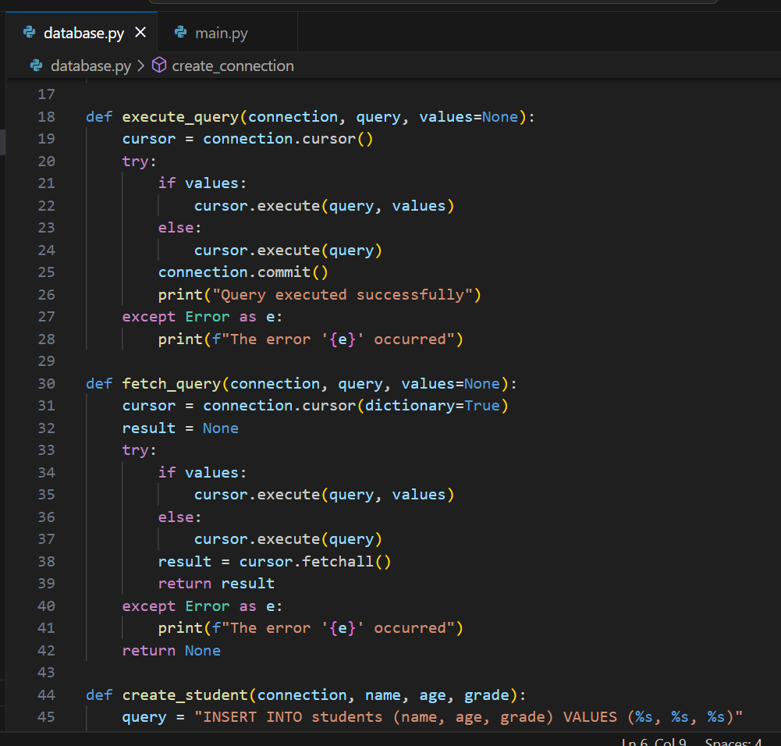

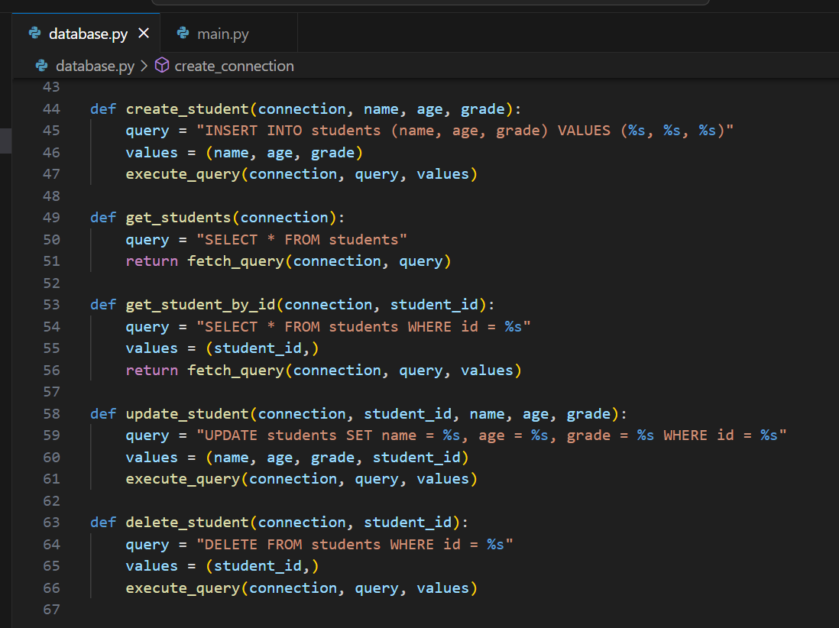

1. **Develop RESTful APIs with FastAPI**
   1. Install FastAPI and Uvicorn: pip install fastapi uvicorn
   2. Create FastAPI Application by Creating a file named main.py
   3. Run the FastAPI Application: uvicorn main:app –reload

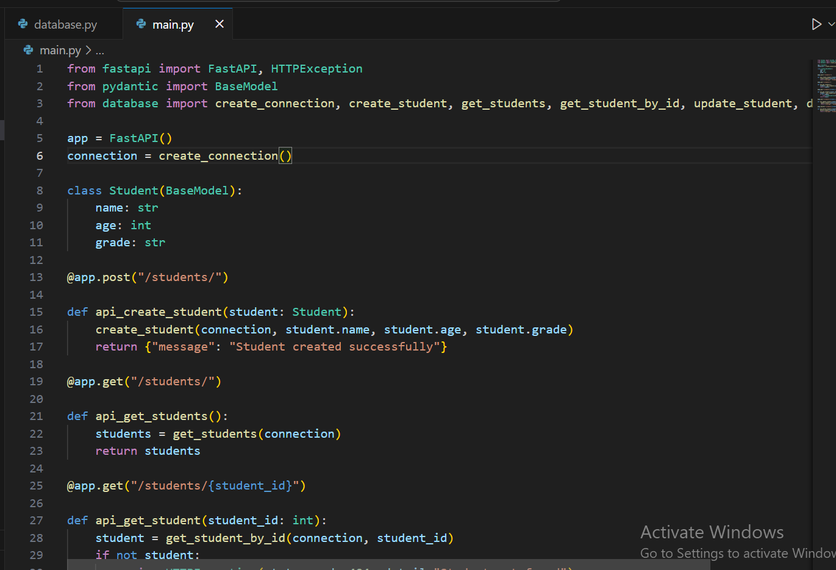

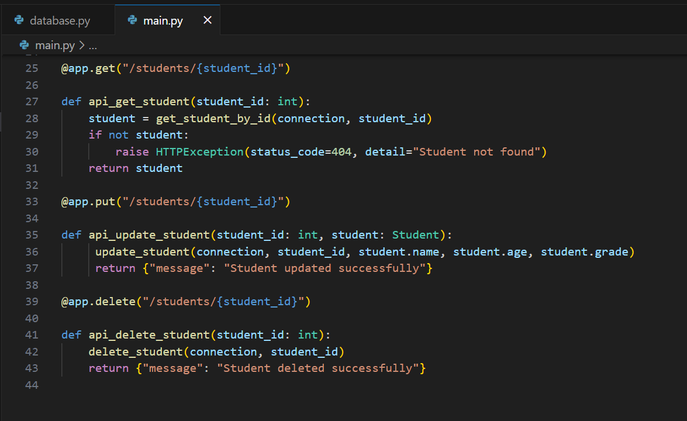

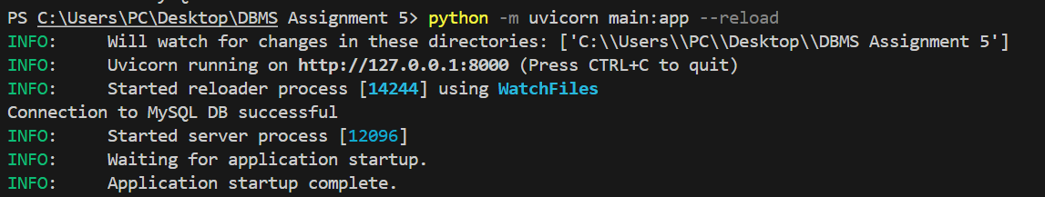

1. **Test the Application using cURL tool**
   1. Create a Student
   2. Get All Students
   3. Update a Student
   4. Delete a Student

