 | 
Project Report
on
AI-Based Sentiment Analysis System
in partial fulfillment for the award of the degree of
MASTER OF COMPUTER APPLICATIONS (AI & ML)
Subject: Natural Language Processing
Submitted by
Rahul Parmar
25MCI10280


Chandigarh University
University Institute of Computing
October 2026

BONAFIDE CERTIFICATE
Certified that this project report "AI-Based Sentiment Analysis System" is the bonafide work of "Rahul Parmar, UID: 25MCI10280" who carried out the project work under my supervision. The implementation, evaluation results, and application described in this report correspond to the Natural Language Processing project submitted for academic assessment.

SIGNATURE
________________________
Nikita Pathak
ACKNOWLEDGEMENT
I would like to express my sincere gratitude to my project supervisor, Nikita Pathak, for her guidance and encouragement during the development of this project. The work brought together text preprocessing, neural network training, model evaluation and a working web interface, and her feedback helped me keep these parts focused on the problem of movie-review sentiment classification.
I am thankful to the faculty of the University Institute of Computing, Chandigarh University, for the foundation in computer science and natural language processing that supported this work. I also appreciate the open-source communities behind TensorFlow, Keras, scikit-learn and Streamlit, whose tools made it possible to build and demonstrate the complete pipeline locally.
Finally, I thank my family and friends for their support throughout the project and report preparation.
Rahul Parmar
UID: 25MCI10280
ABSTRACT
This project develops an AI-based sentiment analysis system that classifies a movie review as positive or negative. It uses the IMDb movie-review benchmark distributed through Keras, with 25,000 labeled reviews for training and a separate 25,000 for final evaluation. Reviews are decoded to text, normalized by lowercasing and removing HTML breaks and non-alphanumeric characters, converted to integer sequences with a 10,000-word Keras tokenizer, and padded or truncated to 200 tokens.
The classifier is a compact neural network with a 128-dimensional embedding layer, a 64-unit Long Short-Term Memory (LSTM) layer, dropout at 0.5, and a sigmoid output. It is trained with Adam and binary cross-entropy, with a validation split and early stopping. The saved model and tokenizer are loaded by a Streamlit interface so that user-entered text follows the same preprocessing steps as the training data.
On the held-out test set the model achieved 76.60% accuracy, 80.10% precision, 70.79% recall, and 75.16% F1-score. The interface reports its raw sigmoid score and class confidence, displays evaluation metrics, and warns when a review is close to the decision threshold. The model is intended as an educational demonstration; it can misclassify reviews and its confidence is not a calibrated guarantee.
Keywords: Natural Language Processing, sentiment analysis, IMDb, LSTM, Keras, Streamlit

TABLE OF CONTENTS
Section | Page
List of Figures, Tables and Abbreviations | 4
CHAPTER 1: INTRODUCTION | 5
1.1 Project Scope and Planning | 5
1.2 Need and Stakeholders | 5
1.3 Contemporary Issues | 5
1.4 Task Identification | 5
1.5 Technologies Used | 5
1.6 Project Timeline | 5
CHAPTER 2: LITERATURE REVIEW / BACKGROUND STUDY | 6
2.1 Timeline of the Problem | 6
2.2 Existing Approaches | 6
2.3 Literature Summary and Bibliometric Note | 6
2.4 Problem Definition | 6
2.5 Goals and Objectives | 6
CHAPTER 3: DESIGN FLOW / PROCESS | 7
3.1 Feature Selection and Design Constraints | 7
3.2 Design Flow and Methodology | 7
CHAPTER 4: RESULTS ANALYSIS AND VALIDATION | 8
4.1 Implementation of the Solution | 8
4.2 Results and Validation | 9
4.3 Application Screenshots | 10
CHAPTER 5: CONCLUSION AND FUTURE WORK | 11
APPLICATION CODE OF PROJECT | 11
REFERENCES, APPENDIX AND USER MANUAL | 11

LIST OF FIGURES AND TABLES
Figure | Title | Page
Fig. 3.1 | Sentiment analysis pipeline | 7
Fig. 4.1 | Held-out test metrics | 9
Fig. 4.2 | Confusion matrix | 9
Fig. 4.3-4.4 | Positive and negative UI predictions | 10

LIST OF TABLES
Table | Title | Page
Table 1.1 | Stakeholders and needs | 5
Table 1.2 | Technology stack | 5
Table 3.1 | Design constraints | 7
Table 4.1 | Model and training configuration | 8
Table 4.2 | Held-out test performance | 9
Table 4.3 | Confusion matrix counts | 9
LIST OF ABBREVIATIONS
Abbreviation | Definition
AI | Artificial Intelligence
NLP | Natural Language Processing
IMDb | Internet Movie Database
LSTM | Long Short-Term Memory
RNN | Recurrent Neural Network
OOV | Out of Vocabulary
HTML | HyperText Markup Language
UI | User Interface
F1 | Harmonic mean of precision and recall

CHAPTER 1.
INTRODUCTION
People share opinions about films in long, informal reviews. Sorting those reviews by hand is slow, and simple keyword searches miss context, negation and combinations of words. Sentiment analysis applies natural language processing to estimate whether a text expresses a positive or negative opinion. In this project, a trained LSTM network learns patterns from labeled IMDb reviews and exposes the result through a small local web application.

1.1 Project Scope and Planning
The project covers data loading, text cleaning, tokenization, sequence padding, neural-model training, held-out evaluation, artifact storage and single-review inference. The Streamlit interface accepts review text, displays a positive or negative result with a confidence score, and shows the model's test metrics. Sample-review buttons and a low-confidence warning support quick demonstrations. The work excludes neutral or multi-class labels, multilingual input, production hosting, a real-time review feed, and human moderation.

1.2 Need and Stakeholders
Stakeholder | Need
Students | A complete, reproducible NLP project for learning.
Instructors | A demonstrable workflow with actual held-out metrics.
Demo users | A simple way to test positive and negative review text.
Developers | Saved artifacts and clear instructions for running locally.

1.3 Contemporary Issues
- Text is ambiguous: sarcasm, mixed opinions and negation can reverse a keyword's apparent meaning.
- A benchmark score does not guarantee performance on current, informal or out-of-domain reviews.
- Confidence is the model's sigmoid-derived score, not a calibrated probability of correctness.
- Reviews can contain personal or offensive material; this demo does not store submissions or moderate content.
CHAPTER 1. INTRODUCTION (CONTINUED)

1.4 Task Identification
- Load the labeled IMDb train and test splits from the Keras dataset utility.
- Decode review token IDs, normalize text, and fit the tokenizer only on training text.
- Convert reviews to sequences and pad or truncate them to a fixed length of 200.
- Train the embedding-LSTM classifier with validation monitoring and early stopping.
- Measure predictions on the untouched 25,000-review test split and save the artifacts.
- Build and manually exercise a Streamlit interface using the saved model and tokenizer.

1.5 Technologies Used
Layer | Technology | Purpose
Language | Python | Training and application code
Deep learning | TensorFlow / Keras | Dataset loading, tokenization, LSTM model
Evaluation | scikit-learn | Accuracy, precision, recall, F1 and confusion matrix
Interface | Streamlit | Local browser-based review analysis
Storage | Keras .keras + pickle + JSON | Model, tokenizer and evaluation metrics

1.6 Project Timeline
Phase | Main work | Deliverable
Planning | Define binary task and report layout | Scope and project plan
Data preparation | Decode, clean, tokenize and pad reviews | Train/test arrays
Model development | Train and validate LSTM | Saved classifier
Evaluation | Predict on held-out data and calculate metrics | metrics.json
Application | Connect model to Streamlit and refine UI | Local web app
Documentation | Prepare figures, report and user instructions | Final report

CHAPTER 2.
LITERATURE REVIEW / BACKGROUND STUDY

2.1 Timeline of the Reported Problem
Early sentiment-classification research commonly represented text through word counts or hand-built features and trained conventional classifiers. The IMDb large movie-review dataset helped establish a substantial benchmark for binary polarity classification. Later neural approaches learned word representations and sequence patterns directly from labeled text. Recurrent networks, including LSTMs, were designed to retain useful information across longer input sequences, which makes them a reasonable educational model for reviews.

2.2 Existing Approaches
Lexicon-based systems score words using polarity dictionaries and are easy to explain, but may miss context and negation. Classical machine-learning systems combine bag-of-words or TF-IDF features with models such as logistic regression or support-vector machines. Neural methods learn representations with embeddings and can use word order; an LSTM is the sequence-based approach selected here. More recent transformer systems can capture richer context but need more computation and are outside this project's lightweight scope.

2.3 Literature Summary and Bibliometric Note
The references used here comprise foundational work on the IMDb sentiment dataset and LSTM networks, plus official documentation for the software APIs used in implementation. This is a focused background review, not a quantitative bibliometric survey: no database-wide publication counts or citation statistics were collected. The distinction avoids presenting unsupported publication-frequency claims.

2.4 Problem Definition
Given a movie review as a sequence of words, predict one of two labels: positive or negative. The main engineering requirements are consistent preprocessing between training and inference, a clearly separated held-out test set, saved artifacts that can be loaded by the app, and a user interface that communicates uncertainty.

2.5 Goals and Objectives
- Build a reproducible preprocessing and training pipeline for binary review polarity.
- Evaluate the learned model on a held-out IMDb split using class-aware metrics.
- Provide a simple local interface for user-entered reviews and transparent metrics.
- Document limitations and avoid presenting the output as a certain or universal judgment.

CHAPTER 3.
DESIGN FLOW / PROCESS

3.1 Evaluation and Selection of Features
The input feature is the review itself. It is represented as an ordered list of integer token IDs from the 10,000-word vocabulary. The model sees at most 200 tokens per review; sequences are padded with zeros or truncated at the end. The label is binary, with 0 for negative and 1 for positive. The app applies the same tokenizer and sequence length used in training.

3.2 Design Constraints
Constraint | Design choice / effect
CPU-friendly coursework demo | Small single-layer LSTM and five-epoch maximum
Fixed input shape | 200-token sequences; longer reviews are truncated
Vocabulary limit | Words outside the top 10,000 map to OOV
Binary labels | No neutral class or emotion categories
Local demonstration | Streamlit process and model run on one machine

3.3 Design Flow
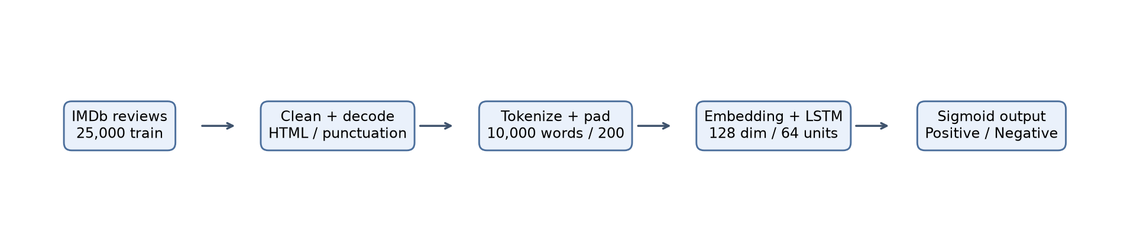
Fig. 3.1: Training and inference share the same review-normalization and sequence pipeline.

3.4 Design Selection
An embedding-LSTM network was selected because it combines learned word vectors with sequence order while remaining compact enough for local CPU execution. A single sigmoid unit directly represents the binary output score. Dropout reduces over-reliance on individual activations during training. Early stopping watches validation loss and restores the best weights seen during the run.

3.5 Implementation Plan / Methodology
The implementation is split between train.py, which builds and evaluates the model, and app.py, which loads the saved model and tokenizer for inference. Evaluation metrics are written to results/metrics.json. Keeping inference in the app on the same preprocessing path makes the model usable without repeating training.

CHAPTER 4.
RESULTS ANALYSIS AND VALIDATION

4.1 Implementation of the Solution
The training script loads 25,000 labeled training reviews and 25,000 test reviews. IMDb integer sequences are decoded with the dataset word index, cleaned, and passed to a Keras Tokenizer fitted on the training texts. Both splits are converted to padded arrays with a maximum length of 200. The model is trained with batch size 128 for up to five epochs, using 20% of the training portion for validation and early stopping with patience two.
The model has an Embedding layer (vocabulary 10,000, dimension 128), an LSTM layer with 64 units, Dropout (0.5), and a Dense sigmoid output. It uses Adam and binary cross-entropy. The 25,000 test reviews are used only after training to calculate final metrics. The resulting Keras model, tokenizer and JSON metrics are saved under model/ and results/.
Parameter | Value
Vocabulary / maximum length | 10,000 / 200 tokens
Embedding / LSTM | 128 dimensions / 64 units
Dropout | 0.5
Optimizer / loss | Adam / binary cross-entropy
Batch size / maximum epochs | 128 / 5
Validation / early stopping | 20% / patience 2

Inference and User Interface
At runtime, the Streamlit application loads the saved artifacts, cleans the entered text, tokenizes and pads it to the same length, and runs model.predict. Scores at or above 0.5 are labeled positive; lower scores are negative. Confidence is the score for the predicted class. The app also presents test metrics and a confusion matrix, supports sample review buttons, and warns when confidence is below 60%.

Input-to-Output Architecture
Browser text -> app.py cleaning -> saved tokenizer -> 200-token sequence -> Keras LSTM model -> label + score -> Streamlit result panel.

CHAPTER 4. RESULTS ANALYSIS AND VALIDATION (CONTINUED)

4.2 Results on the Held-Out Test Set
Metric | Value
Accuracy | 0.7660
Precision | 0.8010
Recall | 0.7079
F1-score | 0.7516
Table 4.1: Actual held-out test results, calculated on all 25,000 test reviews.
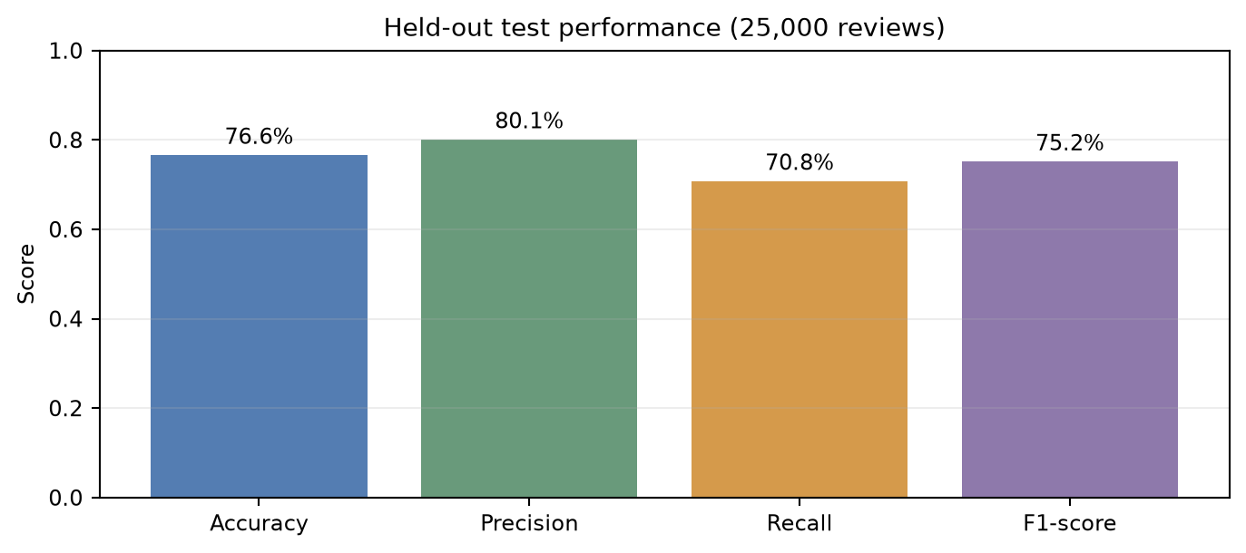 | 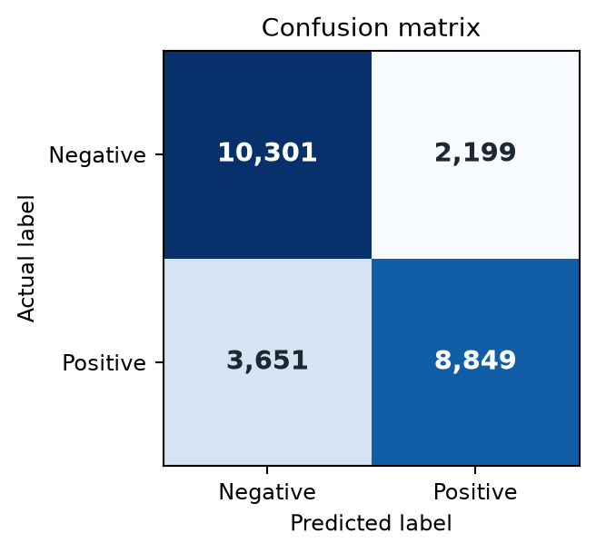
Fig. 4.1: Held-out metrics. Fig. 4.2: Confusion matrix (rows are actual labels; columns are predicted labels).
Actual / predicted | Negative | Positive
Negative | 10,301 true negatives | 2,199 false positives
Positive | 3,651 false negatives | 8,849 true positives

4.3 Validation and Discussion
The model correctly classified 19,150 of 25,000 reviews. Precision is higher than recall, indicating that some positive reviews are missed. The confusion matrix shows 3,651 false negatives and 2,199 false positives. Two example reviews were also run through the app; both were classified as expected, but their confidence values (51.4% and 58.4%) were close to the decision threshold and triggered the low-confidence notice. This confirms the warning is visible, while also showing that a correct class on a sample can still be uncertain.
The test score is evidence on this benchmark split only. It does not establish performance on reviews from other sources, languages or time periods. The training run uses one train/validation split and one final test evaluation; repeated splits and calibration would strengthen confidence in generalization.

4.4 APPLICATION SCREENSHOTS (WEB PAGES)
The running Streamlit interface accepts a movie review, returns a polarity label, and displays the raw score and confidence. The examples below are screenshots captured from the local application after applying the positive and negative sample buttons.
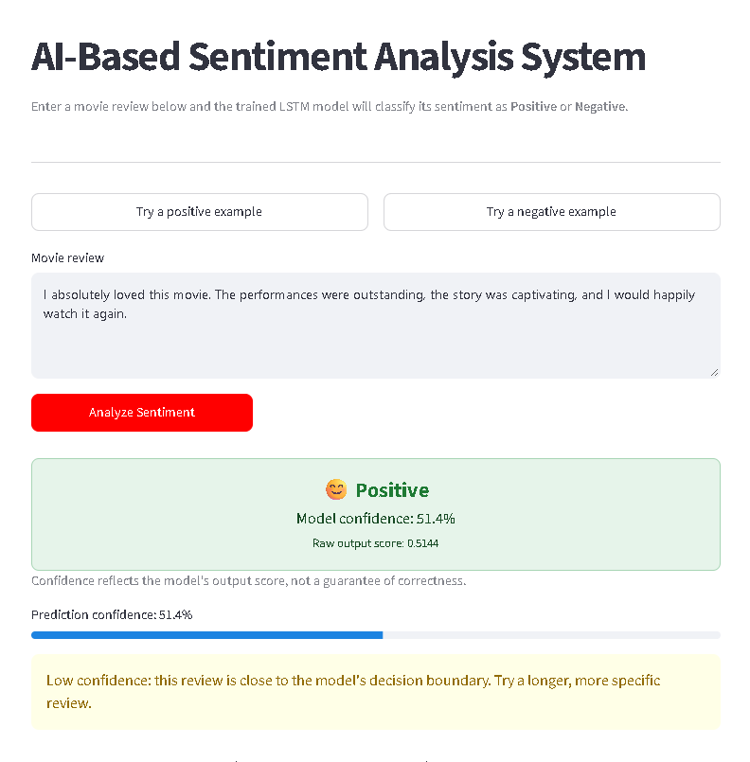 | 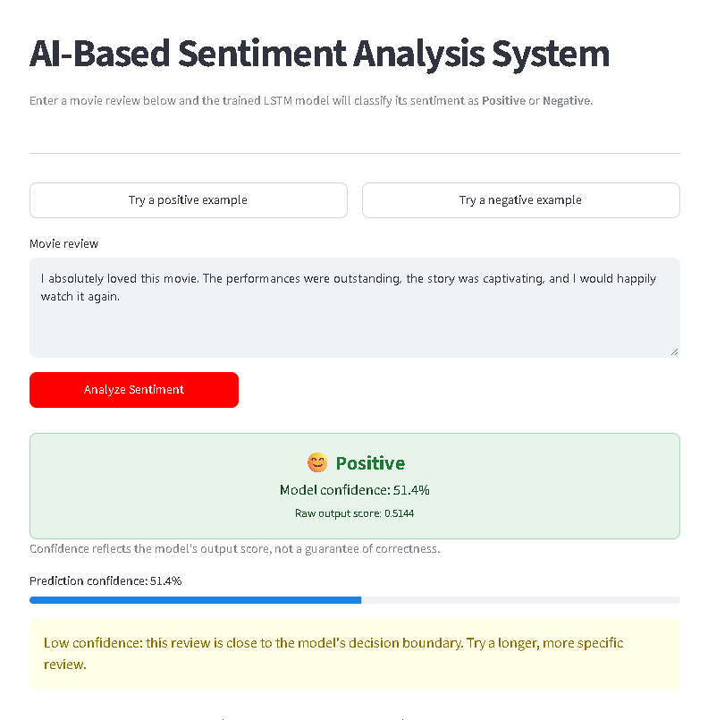
Fig. 4.3: Positive example (51.4% confidence; low-confidence warning). Fig. 4.4: Negative example (58.4% confidence; low-confidence warning).

Observed Interface Behavior
- The two sample buttons populate the review box without changing model artifacts.
- Analyze Sentiment runs the same cleaning, tokenizer and padding sequence used during training.
- The confidence bar and warning make borderline outputs visible to the user.
- Evaluation metrics remain available below the prediction result for context.
The examples are demonstration inputs, not a formal user study or a substitute for test-set evaluation.

CHAPTER 5.
CONCLUSION AND FUTURE WORK

5.1 Conclusion
This project implements an end-to-end binary movie-review sentiment classifier, from IMDb data loading and shared text preprocessing through LSTM training, test-set evaluation, saved artifacts and local Streamlit inference. On the 25,000-review held-out test set, it reached 76.60% accuracy and an F1-score of 75.16%. The app supports direct review entry, positive/negative examples, evaluation metrics and a low-confidence warning. The result demonstrates a working educational NLP pipeline, while the test score and low-confidence sample predictions show why individual outputs should be interpreted cautiously.

5.2 Future Scope
- Compare LSTM results with TF-IDF plus logistic regression and a compact transformer baseline.
- Use cross-validation, class-wise reporting, calibration and an external review dataset.
- Add batch CSV analysis, downloadable results and persistent user-controlled history.
- Explore multilingual support, neutral sentiment and explainability with careful validation.

APPLICATION CODE OF PROJECT
Core training configuration (train.py):
Embedding(10000, 128) -> LSTM(64) -> Dropout(0.5) -> Dense(1, sigmoid)
compile(optimizer='adam', loss='binary_crossentropy', metrics=['accuracy'])
Inference in app.py uses the saved Keras model and tokenizer, pads the token IDs to 200, and classifies the sigmoid output at a 0.5 threshold. The complete source files and trained artifacts accompany the project repository.
REFERENCES
1. Maas, A. L., Daly, R. E., Pham, P. T., Huang, D., Ng, A. Y., and Potts, C. (2011). Learning Word Vectors for Sentiment Analysis. ACL-HLT, 142-150. https://aclanthology.org/P11-1015/
2. Hochreiter, S., and Schmidhuber, J. (1997). Long Short-Term Memory. Neural Computation, 9(8), 1735-1780. https://doi.org/10.1162/neco.1997.9.8.1735
3. TensorFlow. IMDb Movie Reviews dataset API. https://www.tensorflow.org/api_docs/python/tf/keras/datasets/imdb/load_data
4. Keras. Tokenizer and sequence preprocessing API. https://keras.io/api/preprocessing/text/
5. Keras. Recurrent layers: LSTM. https://keras.io/api/layers/recurrent_layers/lstm/
6. Streamlit. API reference: text_area, button and progress. https://docs.streamlit.io/develop/api-reference
7. scikit-learn. Classification metrics: accuracy, precision, recall, F1 and confusion matrix. https://scikit-learn.org/stable/modules/model_evaluation.html

APPENDIX: DESIGN CHECKLIST
Stage | Evidence | Status
Dataset | IMDb train/test split, binary labels | Complete
Preprocessing | Cleaning, tokenizer and fixed-length padding | Complete
Model | Embedding-LSTM classifier trained and saved | Complete
Evaluation | Held-out metrics and confusion matrix | Complete
Application | Streamlit inference and confidence feedback | Complete

USER MANUAL
1. Install Python 3.10+ and the packages listed in requirements.txt.
2. In the project folder, run: python train.py (only if the saved model files are absent).
3. Start the app with: streamlit run app.py; open the local URL shown in the terminal.
4. Enter a review or choose an example, then select Analyze Sentiment. Interpret low-confidence notices cautiously.
Troubleshooting: if the model is missing, run train.py; if packages are missing, install requirements.txt. The app requires local model/ files and internet only for the first IMDb dataset download during training.
GitHub repository: https://github.com/rahulparmar0578-svg/Ai-sentiment-analysis

