2) We have morphed two images here. Below are the input images.


a)


b)

The resulting morphed image:
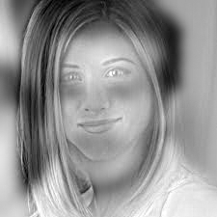

Here, the first image is passed through a low pass filter (gaussian filter with sigma 6), and the second image is passed through a high pass filter (gaussian filter with sigma 3). Note that, both the images must be of the same size for this code to work.

3.1)
The image spectograms of some of the images are presented below.

a)
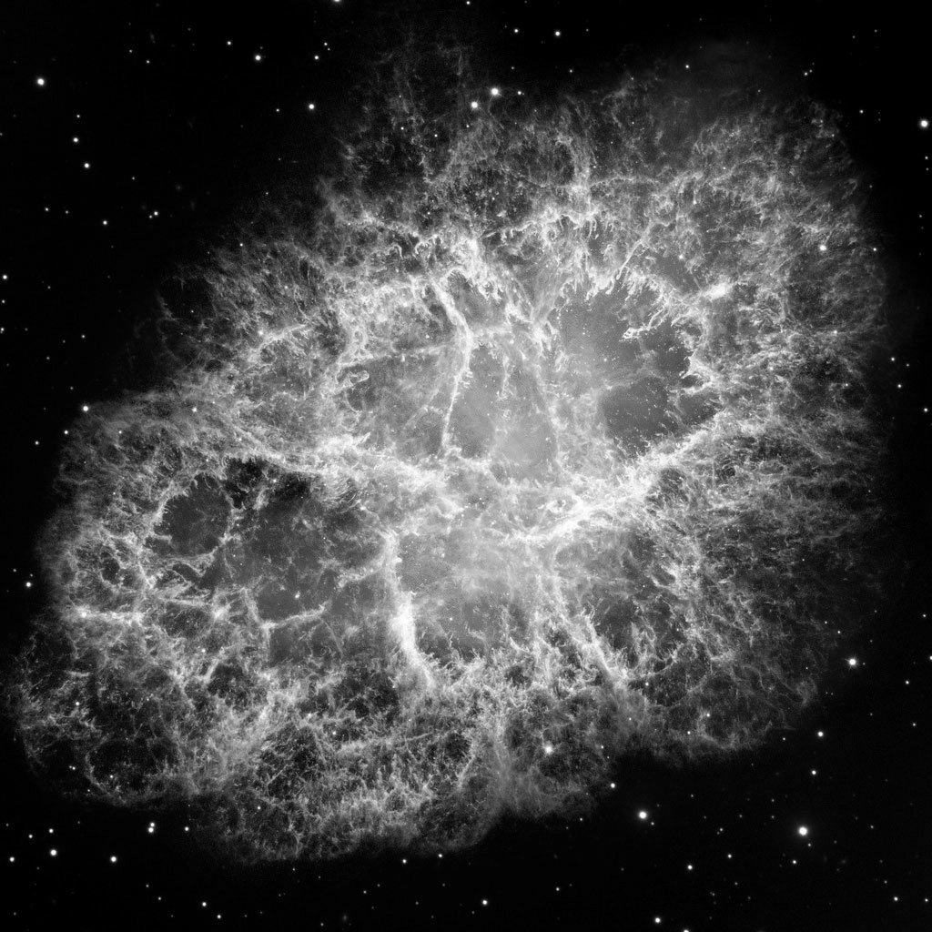


==>

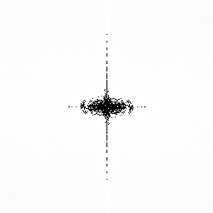
b)

==>

3.2)

The spectogram of the noisy image is shown below.


As, can be seen in the above spectogram, we can see two regions symmetric to origin, which is the added noise. We have identified those two areas, and removed the noise by making the “real” values at those places as zero. We get the below cleaned image.


3.3)

Below are some results of the code. In each example, the left hand side contains the original image, and the right hand side corresponds to the filtered image.

4. Watermarking:

For this implementation, we created two methods:

- mark_image(): Adds a watermark to the DFT of the image and generates a copy of the same image, given the key “N”. We generate a random binary sequence “V” of size “L = 10”, using the key “N”. We place this sequence on “L” bins along a circle with radius “r = 128” from the center of “R”, which is the real part of the input image obtained after applying DFT. We use the following formula to do this:

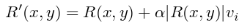

where R' is the real part of output image with the watermark, R is the real part of the original image, “α = 10” is a parameter and “v_{i}” is the i^{th} element of the binary sequence “V”.

- check_image(): Checks whether a watermark is present. This is done by generating the same binary sequence “V” using key “N” and obtaining the sequence “C” from the pixel values at the same positions where the watermark was added in the real part of the image. We the calculate the Pearson Correlation Coefficient to check whether the sequence “C” has any linear dependence on the sequence “V”. If the coefficient is greater than some threshold “t = 0.3”, the we consider the watermark to be present.

We tested our implementation on two 512x512 gray scale images and observed the following results:

Test Image – 1:



Before Watermarking After Watermarking (N = 8)

We proceeded to do some quantitative tests on Test Image – 1. We added the watermark by using key “N = 8”. We then used the check_image() function to see if the watermark is detected for the correct “N”, by trying values 1 to 25. We noticed that the watermark was detected 6 times:

There were 5 false positive among 25 tests. We speculate that this is dependent on the threshold value “t” since different threshold values produced different number of false positives. We use the threshold “t = 0.3” since it produced the least number of false positives, i.e. 5.


After Editing

Finally, we edited the watermarked image by adding some distortions and again used the check_image() function to see if the watermark is detected. We tried the values 1 to 25 for “N” and noticed that the watermark was detected 6 times, with the same number of false positives as detected on the original watermarked image.

Test Image – 2:



Before Watermarking After Watermarking (N = 25)

We did similar quantitative tests on Test Image – 2 as well. We marked this image with “N = 25” and noticed the following observations after trying values 1 to 25 for “N” in check_image(). This time, the watermark was detected 8 times, with 7 false positives:

We applied the same tests on the watermarked image after adding distortions to it:
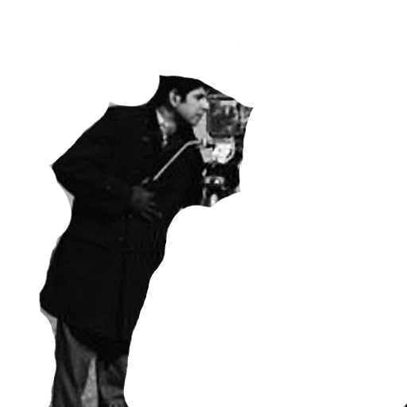

After Editing

This time, we noticed that the number of false positives decreased considerably to 4 from 7.

In both the cases, there were about 15 – 20% of false positives before and after distortion of the watermarked image. Hence we proceeded to change the values of the threshold “t”. We used the value “0.45” for the and conducted more quantitative analysis. This time, we tried the values 1 to 1000 for “N” and noticed that for both images there were about 11% false positive. This is a considerable decrease in the false positives. To further decrease the false positives, we can keep changing the values of threshold “t”, however, as we noticed with “N” values 8 and 65, there is a possibility that the actual watermark might not get detected, given high threshold value “t”.

