2) We have morphed two images here. Below are the input images.


a)

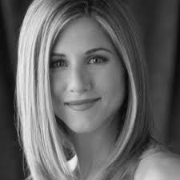
b)

The resulting morphed image:
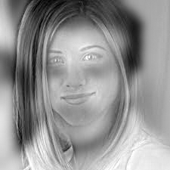

Here, the first image is passed through a low pass filter (gaussian filter with sigma 6), and the second image is passed through a high pass filter (gaussian filter with sigma 3). Note that, both the images must be of the same size for this code to work.

3.1)
The image spectograms of some of the images are presented below.

a)
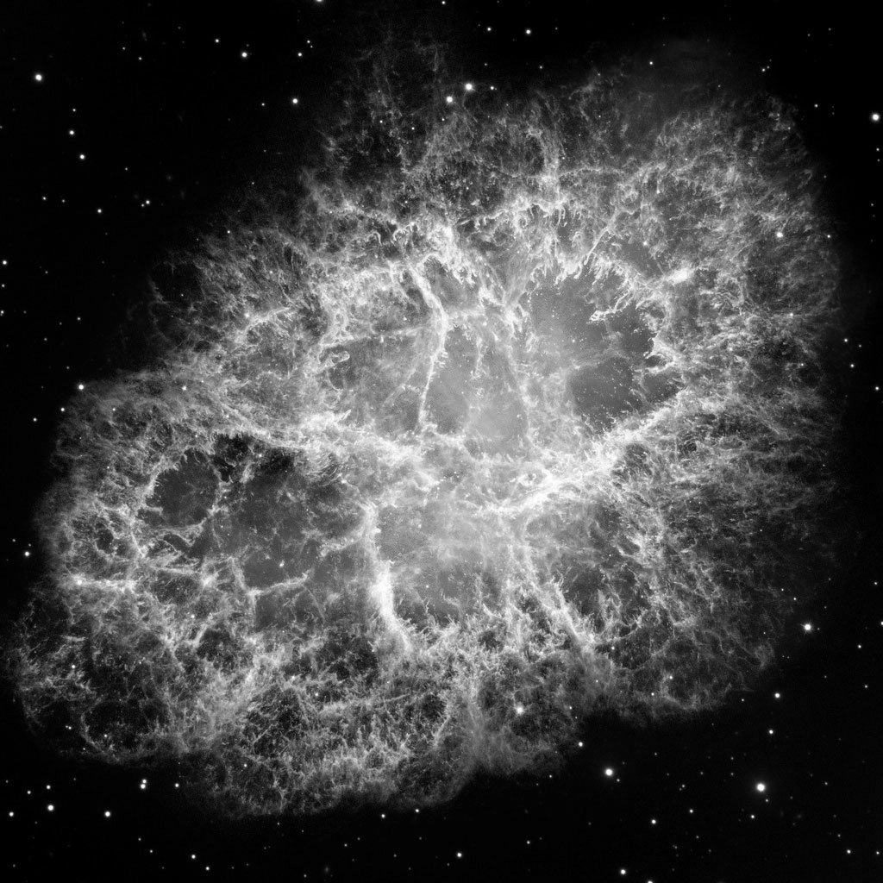
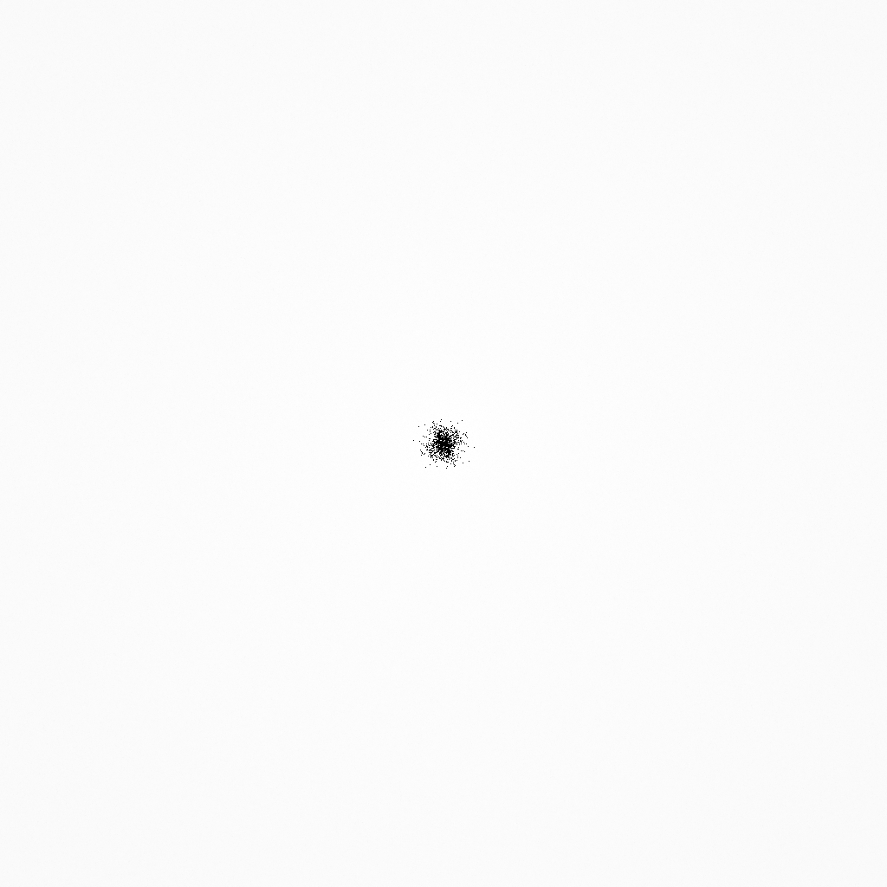

==>

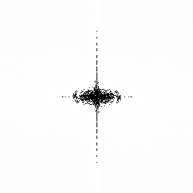
b)

==>

3.2)

The spectogram of the noisy image is shown below.
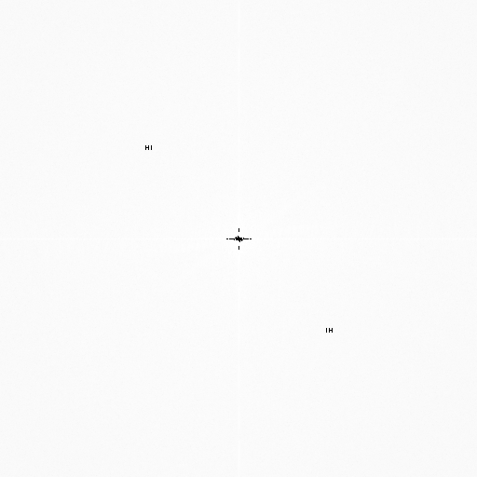

As, can be seen in the above spectogram, we can see two regions symmetric to origin, which is the added noise. We have identified those two areas, and removed the noise by making the “real” values at those places as zero. We get the below cleaned image.
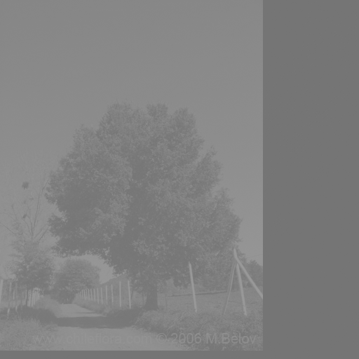

3.3)

Below are some results of the code. In each example, the left hand side contains the original image, and the right hand side corresponds to the filtered image.

