Stepper Motor Controller using RX63N

Contents

**1.** **Stepper Motor Basics:** 2

**2.** **Modes of Operation:** 2

***a.*** ***Wave Drive:*** 2

***b.*** ***Full Step:*** 3

***c.*** ***Half Step:*** 3

**3.** **Coil Definition:** 4

**4.** **Board layout and Pin Out Diagram:** 4

**5.** **Specifications:** 6

**6.** **Working:** 6

**7.** **Temperature Sensor:** 6

**8.** **Applications:** 7

References 7

1. **Stepper Motor Basics:**

A stepper motor is an electromechanical device which converts electrical pulses into discrete mechanical movements. The basic structure of the stepper motor begins with a look at its predecessor and still-popular cousin, the brushless-DC (BLDC) motor (Figure 1).

In the most-common BLDC motor design, permanent magnets are placed on the rotor, and electromagnets are located around the periphery of the stator. When the electromagnetic coils are energized, the rotor will line up accordingly due to the attraction between the rotor's permanent magnets and the stator's coils.

By reversing the current flowing to the coils, or switching some of the electromagnets off and on in rotational sequence (both techniques are used, for different applications), the rotor will spin as it follows the changing magnetic field that these coils generate.

By changing the switching frequency, the speed of the motor's revolutions will change as well. As with the BLDC motor, the frequency of the energizing sequence determines the rotational speed.

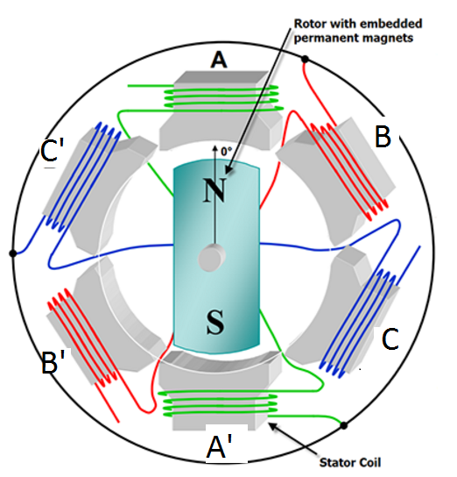

Fig 1. Illustration showing BLDC motor wiring

Instead of a single permanent magnet on the rotor, stepper motor uses a ring of electromagnetic poles that interact with an array of permanent magnets mounted on the rotor. As these poles are energized and de-energized, the rotor follows their magnetic field. As shown in Figure 2.

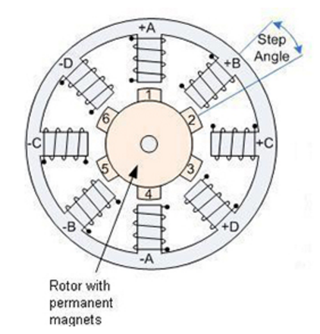

Figure 2. Stepper Motor

1. **Modes of Operation:**

Depending on how many of the electromagnets are activated at a time, different modes of operation are defined. They are as follows:

* 1. ***Wave Drive:***

In this mode, only one electromagnet is activated per input pulse. So if we consider a hypothetical 4 coil stepper motor, then when we energize the A phase a south pole, it attracts the north pole of the rotor. We turn off A and turn on B, the rotor rotates 90° and so on. Each time only one phase is energized.

This mode produces significantly less torque than the Full Stepping.

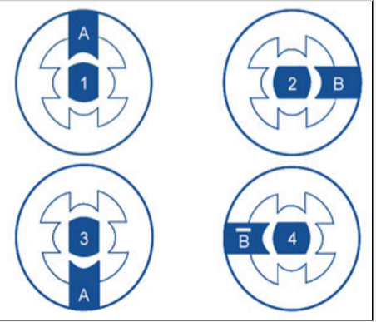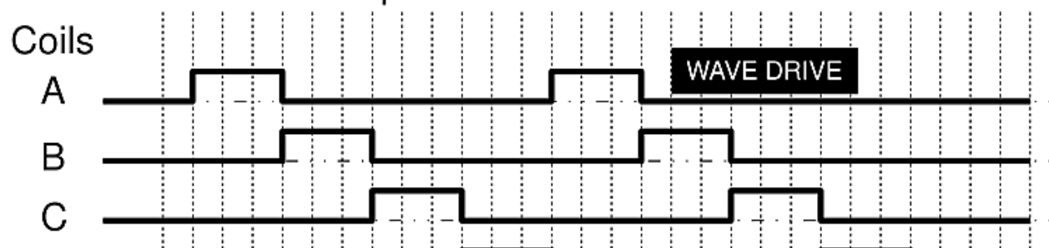

Figure 3. *Wave Drive*

* 1. ***Full Step:***

In this mode, two electromagnets are activated per input pulse. So if we consider a hypothetical 4 coil stepper motor, then if both phases A and B are energized as south poles, the north pole of the rotor will be equally attracted to both poles and line up directly in the middle. In sequence as the phases are energized, the rotor will rotate to line up between the two energized poles.

Since two coils are always energized, it produces the maximum rated torque.

As soon as one phase is turned off, another one is turned on. Wave drive and single phase full step are both one and the same, with same number of steps but difference in torque.

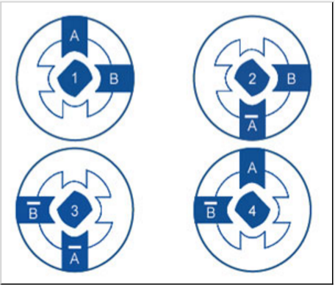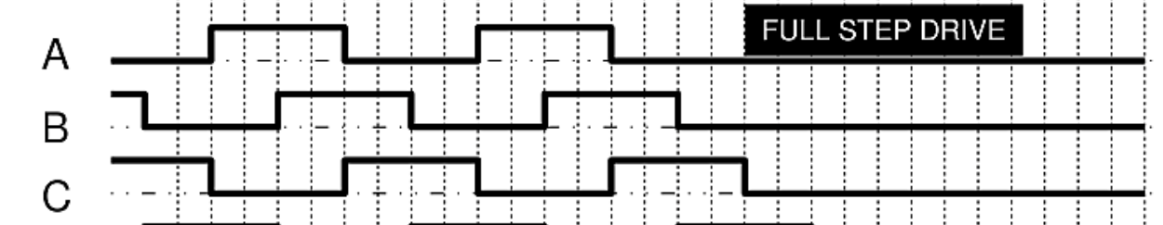

Figure 4. *Full Step*

* 1. ***Half Step:***

  In half stepping combine the two previous methods. In this case, we energize the A phase. The rotor lines up. For the 4 coil stepper motor, we keep the A phase on and energize the B phase. Now the rotor is equally attracted to both and lines up in the middle. The rotor has rotated 45°. Now we turn off phase A but leave on phase B. The motor makes another step. And so on and so forth. By alternating between one phase on and two phases on, we have cut the step angle in half. Remember that with a smaller step angle, the vibration is reduced.

Thus in this mode the resolution improves. There is a reduction in torque though. It is about 70% of the Full stepping mode.

This may be tackled by increasing the current in the active coils. Due to this mode, we can have a better resolution without changing any of the electronics.

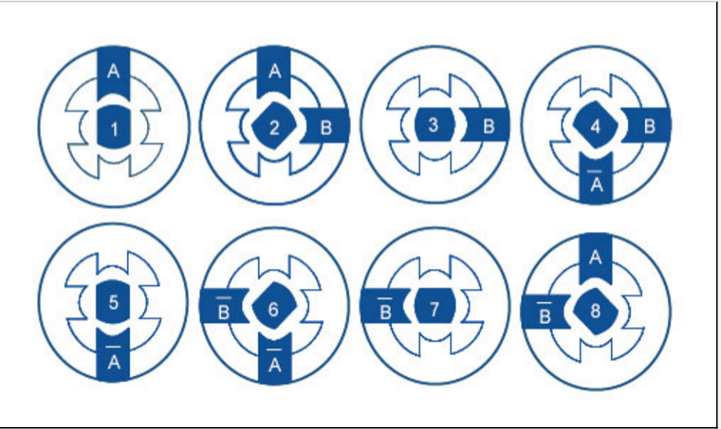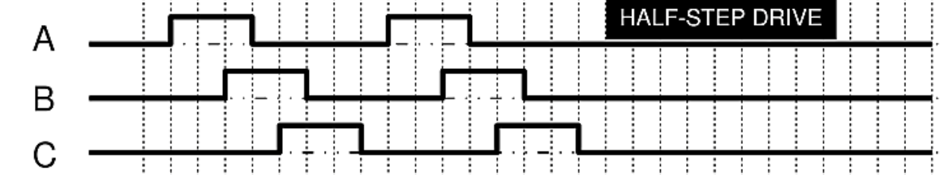

Figure 5. *Half Step*

1. **Coil Definition:**

The Development board YRDKRX63N consists of a ring of 12 LEDs as shown below. They are alternately colored Green and Red in pairs of two starting at LED4 till LED15.

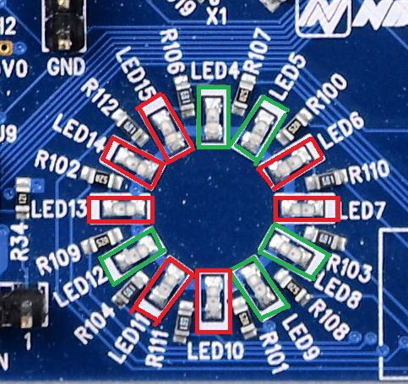

Figure 6. Coil Definiton

So, for visual clarity we choose each pair of same colored LEDs as a coil of the Stepper motor. Hence we have 6 coils.

We consider a unipolar stepper motor in which only a single pole is created by the electromagnetic coil to which the rotor gets aligned. So, only the coils on one side get activated at a time.

1. **Board layout and Pin Out Diagram:**

JN1 Header used to take external interrupts for drive and direction.

p

On-board Temperature Sensor

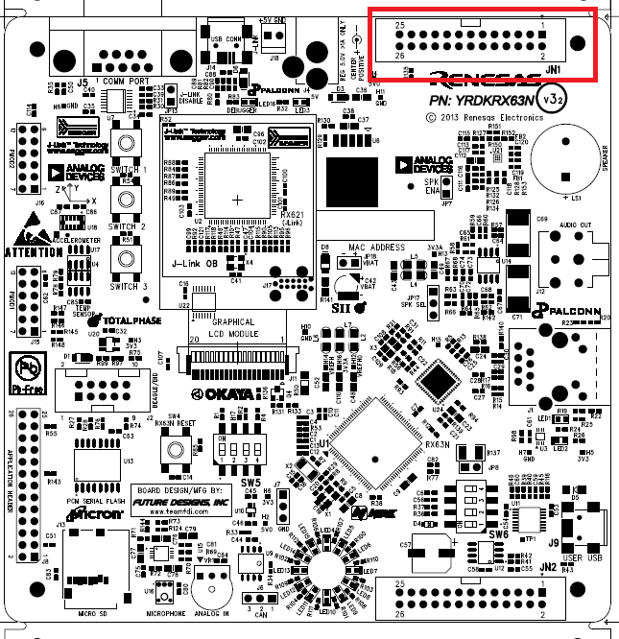

Figure 7. *Board Layout (Top View)*

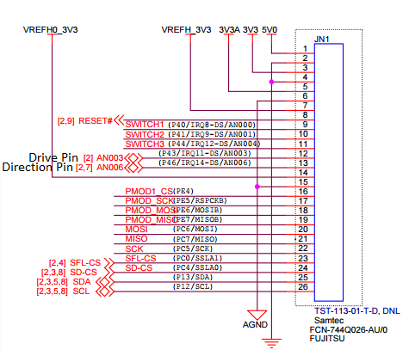

Figure 8. *JN1 Pinout*

1. **Specifications:**

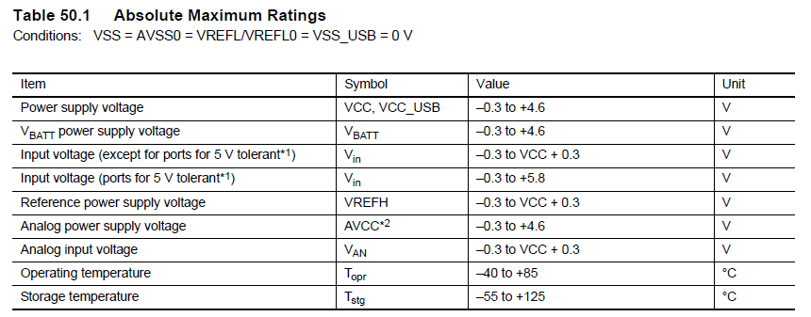

DC Characteristics for the Drive and Direction pins:

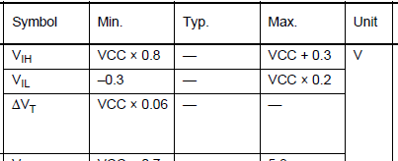

For detailed specifications refer the YRDKRX63N documentation.

1. **Working:**

* Connect the input to the Drive and Direction Pins as described in the pinout diagram .
* On each rising edge of the drive input, the motor will take a step.
* The direction of rotation is determined by the direction pin.
* Whenever the drive pin goes low, the direction toggles.
* The switches enable us to switch between the different modes as follows:
  + Wave Drive: Switch 1
  + Full Step: Switch 2
  + Half Step: Switch 3

1. **Temperature Sensor:**

The on-board temperature sensor is used to detect the motor temperature and shut down the motor when it overheats beyond the threshold. of 40 degrees.

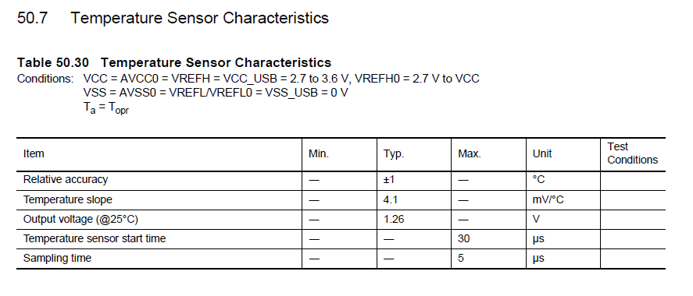

1. **Applications:**
   1. Printers,
   2. Scanners,
   3. Cash-dispensing ATMs,
   4. Small disk and tape drives,
   5. Camera pan/zoom tilt (PZT) controls

# References

*Basics of Motion Control.* . Retrieved from Oriental Motor: http://www.orientalmotor.com/technology/articles/step-motor-basics.html

Schweber, B. . *Stepper Motors Make the Right Moves with Precision, Ease and Smarter Drivers.* Retrieved from Mouser Electronics: http://www.mouser.com/publicrelations_techarticle_steppermotors_rightmoves_2015final/

*Stepper Motor Basics.* . Retrieved from solarbotics: http://www.solarbotics.net/library/pdflib/pdf/motorbas.pdf

(n.d.). *YRDKRX63N Designs.* Koto, Tokyo, Japan: Renesas Electronics.