Executive Report

1. Executive Summary
This report presents an end-to-end analysis of UAE retail sales performance across 7 emirates (including 2 stores in Dubai). The objective was to evaluate revenue drivers, profitability trends, customer behavior, discount effectiveness, and VAT compliance to support data-driven business decision-making.
Using Excel-based analytics, the project integrates data cleaning, validation, relational data modeling, exploratory analysis, and executive dashboarding. The insights generated highlight regional sales concentration, category dependency, margin behavior, and optimization opportunities.

2. Business Objective
Retail organizations require continuous monitoring of sales and profitability to understand business health and identify performance gaps.
The key objectives of this analysis were to:
- Measure sales and profit performance across emirates and stores
- Analyze product categories and sub-categories from both sales and margin perspectives
- Evaluate the impact of discounts on profitability
- Assess customer behavior and loyalty contribution
- Validate VAT consistency and regulatory compliance

3. Dataset Overview
The dataset was synthetically generated using Python (Pandas, Faker) to simulate real-world UAE retail operations and was created one time for analysis.
Dataset Characteristics:
- Sales Transactions: ~61,000 records
- Time Period: 2023–2025
- Format: Excel (.xlsx)
- Coverage: 7 emirates (2 stores in Dubai, 1 store in each remaining emirate)
Data Tables:
- Sales Transactions (Fact)
- Customer Master
- Product Master
- Store Master
- Employee Master

4. Data Cleaning, Validation & Quality Checks
Data quality checks were performed using Excel Power Query to ensure accuracy and reliability.
Key Validation Steps:
- Appended multiple raw transaction files into a single Final_Sales_Fact
- Removed duplicate transactions where full rows were duplicated
- Replaced null Discount values with zero
- Standardized Payment Mode text values
- Replaced missing Customer Age values using mode
- Created Discount_Band for discount impact analysis
- Validated VAT consistency across categories
A relational data model (Star Schema) was created using Excel Data Model (Power Pivot) to ensure correct aggregation and scalability.

5. Data Model & ERD
The data model follows a star schema design, where Sales Transactions act as the central fact table connected to Customer, Product, and Store dimension tables through one-to-many relationships.
Employee data is linked at the store level to avoid transaction-level granularity mismatch and to support future workforce analysis.
ERD Diagram
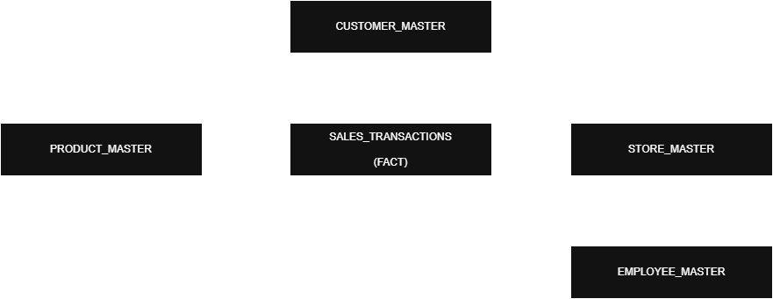

6. Exploratory Data Analysis (EDA)
EDA was conducted using Pivot Tables and Data Model measures, focusing on:
- Emirate-wise sales and profit analysis
- Store-level sales contribution
- Category and sub-category performance
- Customer loyalty behavior
- Discount and VAT impact
These analyses formed the foundation for KPI design and dashboard visualization.

7. Key Business Insights
- Dubai is the dominant revenue contributor, while Umm Al Quwain contributes the least; however, profit margins remain consistent (~25–26%) across emirates.
- Electronics accounts for the majority of total sales, indicating high dependency on a single category.
- Profit margins are stable across categories, with Grocery and Personal Care showing margins comparable to Electronics despite lower sales volumes.
- Non-discounted sales achieve the highest margins (~29%), confirming margin erosion due to discounting.
- Loyal customers do not significantly outperform non-loyal customers in terms of sales contribution, indicating an underperforming loyalty program.
- VAT contribution is consistent (~5%) across all categories and emirates, confirming regulatory compliance.

8. Dashboard Overview
An interactive executive dashboard was created in Excel to summarize insights and support decision-making.
Dashboard Components:
- KPI Cards: Total Sales, Total Profit, Profit Margin, Unique Customers, Average Bill Value
- Monthly Sales Trend
- Category Sales Contribution
- Emirate-wise Sales Performance
- Store Contribution Analysis
- Sub-Category Sales vs Profit Margin
Interactive slicers enable filtering by Year, Category, and Emirate.
Dashboard Preview
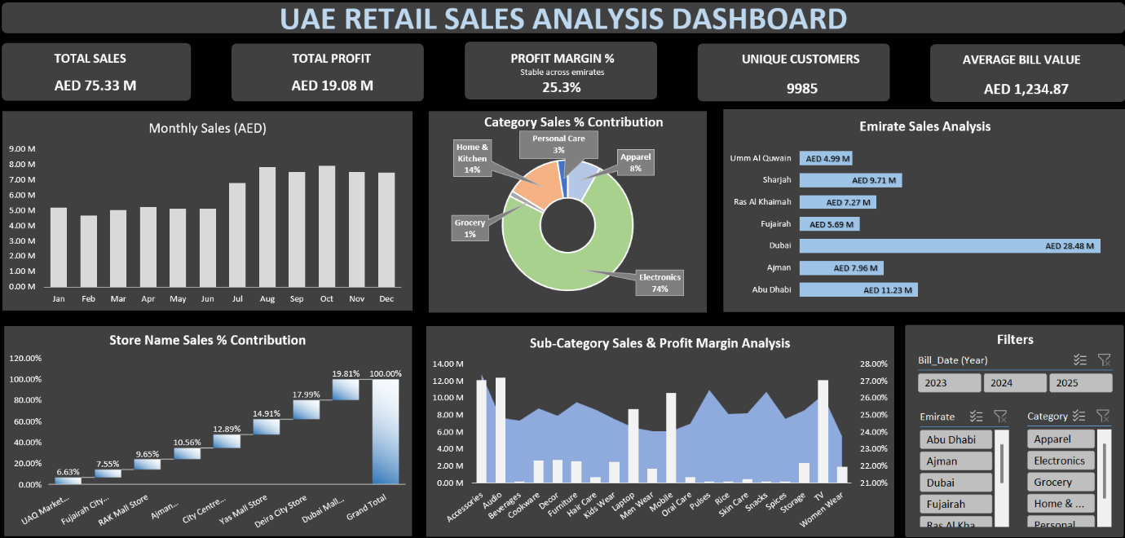

9. Strategic Recommendations
- Reduce dependency on Electronics by promoting other high-margin categories such as Grocery and Personal Care.
- Optimize discount strategies by limiting aggressive discounting and focusing on targeted promotions.
- Re-evaluate the loyalty program to improve repeat purchases and customer lifetime value.
- Expand growth initiatives beyond Dubai to reduce geographic concentration risk.
- Maintain current VAT practices, as compliance and consistency are strong.
- Shift focus from pure sales volume to margin-driven performance management.

10. Tools & Technologies Used
- Microsoft Excel (Power Query, Power Pivot, Data Model)
- DAX (KPI & Measure Design)
- Pivot Tables & Advanced Charts
- Python (Pandas, Faker – one-time data generation)
- Executive Dashboard Design
- Business Storytelling & Reporting

11. Conclusion
This project demonstrates a complete retail analytics lifecycle, from data generation and validation to modeling, analysis, and executive reporting.
The insights generated support strategic decision-making in pricing, promotions, category management, and regional growth, making the solution scalable and reusable for real-world business scenarios.

12. Author & Contact

Rahul Patel
Data Analyst
SQL | Excel | Python | Tableau | Power BI

GitHub: https://github.com/rahulpatel0890
LinkedIn: https://www.linkedin.com/in/rahul-patel-analyst/

