What is Indexing?
Indexing in SQL is a technique used to improve the speed of data retrieval from a database by creating a lookup table for faster access.
Key Points:
Works like a book index to find data quickly.
Reduces the time required for SELECT queries.
Automatically updated when data is inserted, updated, or deleted.
Indexes are created on columns frequently used in WHERE, JOIN, and ORDER BY clauses.
Types of Indexes:
1. Primary Index – Automatically created on Primary Key columns.
2. Unique Index – Ensures that values in a column are unique.
- Clustered Index – Sorts data rows physically based on key values (Only one per table).
4. Non-Clustered Index – Stores pointers to data rows (Multiple indexes allowed).
What is Primary Key?
A Primary Key is a column or a combination of columns in a table that uniquely identifies each row in that table. It does not allow NULL values and must always contain unique values.
Key Features:
Uniquely identifies each record
Cannot have duplicate values
Cannot contain NULL values
Only one primary key is allowed per table
What is Foreign Key?
A Foreign Key is a column or combination of columns in one table that refers to the Primary Key in another table. It is used to create a relationship between two tables and enforce referential integrity.
Key Features:
Establishes a relationship between two tables
Can contain duplicate values
Can accept NULL values
Helps maintain data consistency
What is UNIQUE Key?
A UNIQUE Key is a constraint that ensures all values in a column or combination of columns are distinct across all rows in the table. It prevents duplicate values but allows NULL values (only one NULL value in most databases).
Key Features:
Ensures uniqueness of each record in the column
Allows one NULL value (depending on the database)
Multiple UNIQUE keys can be defined in a table
Helps maintain data integrity
What is the Difference Between Primary Key and UNIQUE Key?
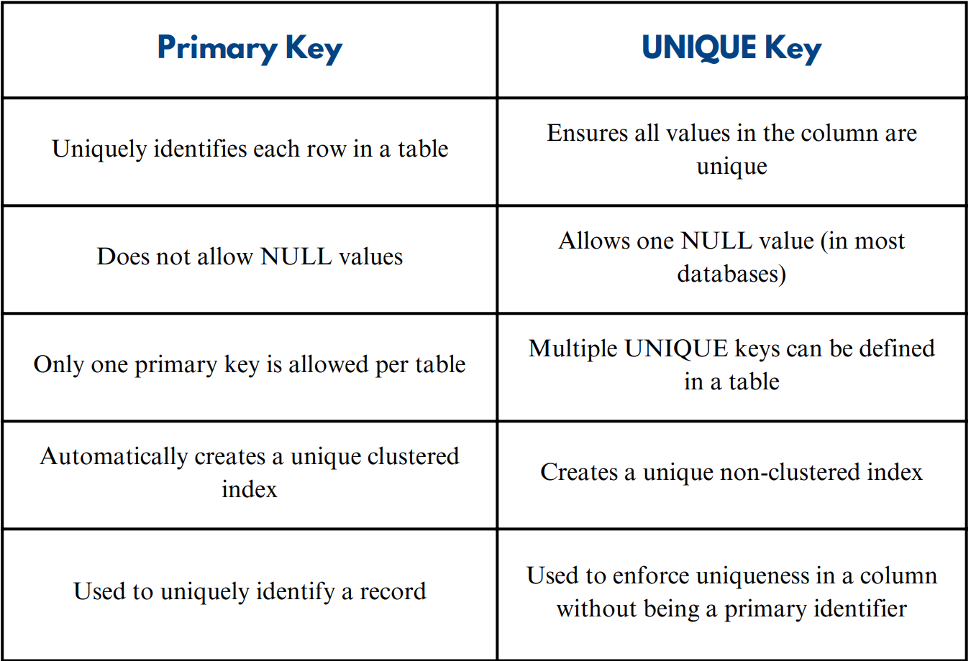

What is NOT NULL Constraint?
The NOT NULL constraint ensures that a column cannot have NULL values. It is used to enforce that every row must have a value in that column.
Key Features:
Prevents insertion of NULL values
Ensures mandatory fields have data
Can be applied to one or more columns

What is the Difference Between DELETE, TRUNCATE, and DROP?
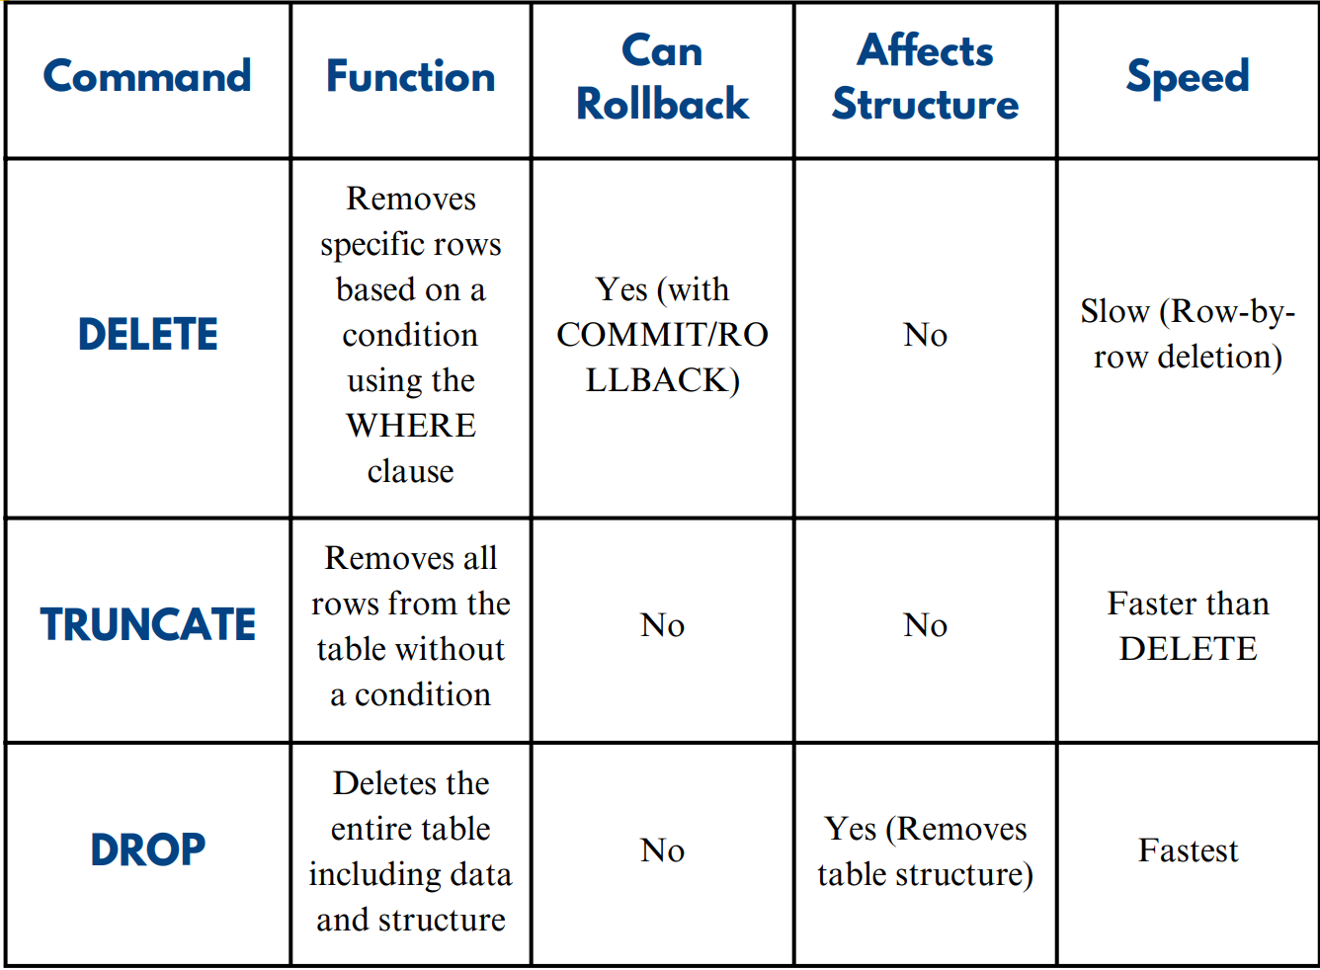

What is the Difference Between WHERE and HAVING?
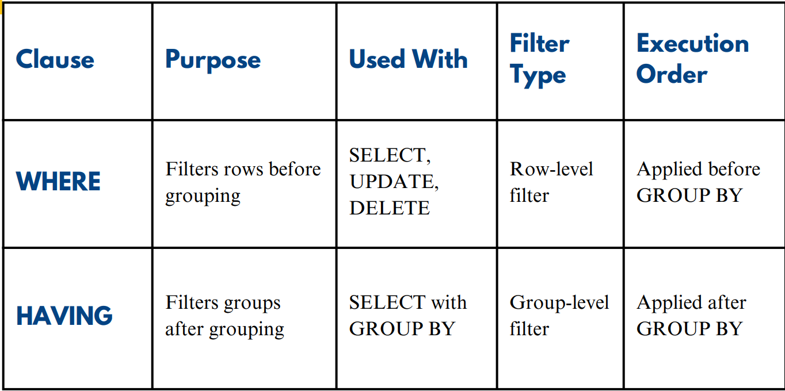

What is Normalization?
Normalization is the process of organizing data in a database to reduce redundancy and improve data integrity. It involves dividing large tables into smaller related tables and defining relationships between them.
Key Features:
Reduces data redundancy
Improves data consistency
Simplifies data maintenance
Increases data integrity
What is GROUP BY in SQL?
Groups data based on one or more columns. It is used to summarize data. Always used after the WHERE clause and before the ORDER BY clause.
What is Stored Procedure ?
A Stored Procedure is a group of predefined SQL statements stored in the database that can be executed multiple times.
Improves code re-usability.
Increases performance.
Supports input and output parameters.
Provides security by hiding SQL code.
How to find the Nth Highest Salary?


