SATISH PRADHAN DNYANASADHANA

COLLEGE
OF ARTS, SCIENCE AND COMMERCE

THANE

PROJECT REPORT

ON

ONLINE PRODUCT SHOPPING

WEBSITE

FOR SOLARTECH COMPUTERS

SUBMITTED BY

RUKSAR NISAR SHAIKH

PROJECT GUIDED BY

Mr. K. M. SATHE

T. Y. B. Sc. COMPUTER SCIENCE UNIVERSITY OF MUMBAI 2017 – 2018

1

CERTIFICATE

This is to certify that Miss. Ruksar Nisar Shaikh has completed

his Course USCSP602 (Project documentation and Project

Development)

“ONLINE PRODUCT SHOPPING

WEBSITE” for the T. Y. B. Sc. Computer Science

examination of University of Mumbai, held in March 2018. Under

our guidance and supervision and to our complete satisfaction.

Ms. V. Y. Rane Mr. K. M. Sathe

Professor And I/C Head Project Guide
Dept. Of Computer Science
Satish Pradhan Dnyanasadhana Date: ____________

College,Thane

2

 | INDEX
Sr. | TOPIC | PAGE
NO. | TOPIC | NO.
1 | Acknowledgement
2 | Preliminary Investigation
 | (i) Organizational Overview
 | (ii) Description of System
 | (iii) Limitations of present system
 | (iv) Proposed system and its adv.
 | [ For web project, URL can be mentioned]
 | (v) Feasibility Study
 | (vi) Stakeholders
 | (vi) Gantt Chart
3 | System Analysis
 | (i)Event List
 | (iii) Event Table
 | (iv) Use Case Diagram, Scenarios &
 | Use Case Description
 | (v) ERD
 | (vi) Activity Diagram
 | (viii) Class diagram
 | (x) Sequence diagram/Collaboration Diagram
4 | System Design
 | (i) Converting ERD to Tables
 | (ii) Component Diagram

3

 | (iii) Package Diagram
 | (iv)Deployment Diagram
5 | System Coding
 | (i) Menu Tree
 | (ii) List of tables with attributes and constraints
 | (iii) Validations
 | (iv) Test Cases, Test Data and Test Results
 | [Write test cases for all imp. programs]
 | (v) Screen Layouts & Report Layouts
6 | Future Enhancements
7 | References and Bibliography

4

1.Acknowledgement:

We are pleased to present “Online Product Shopping Website” project and take this opportunity to express our profound gratitude to all those people who helped us in completion of this project.

We thank our college for providing us with excellent facilities that helped us to complete and present this project. We would also like to thank the staff members and lab assistants for permitting us to use computers in the lab as and when required.

We express our deepest gratitude towards our project guide for her valuable and timely advice during the various phases in our project. We would also like to thank her for providing us with all proper facilities and support as the project co-coordinator. We would like to thank her for support, patience and faith in our capabilities and for giving us flexibility in terms of working and reporting schedules.

We would like to thank all our friends for their smiles and friendship making the college life enjoyable and memorable and family members who always stood beside us and provided the utmost important moral support. Finally we would like to thank everyone who has helped us directly or indirectly in our project.

5

- Preliminary Investigation

  - Organizational Overview

Introduction:

- A Website for managing a Himalaya Products. This is a fully equipped Online website that alone manages the entire functioning of a Product Booking.

- This system keeps track of user product booking and user data.

- Knowing when an item was saved or not saved in the shopping cart.

- Easy scanning and selecting items in a list

- Effective categorical organization of products.

- Simple navigation from home page to information and order links for specific products

6

(ii) Description of System

This module contains all the information about the authenticated users. User without his username and password can’t enter into the login if he is only the authenticated user then he can enter to his login and then he will have authorization based upon their roles.

Customer:

Customer is the registered User. He can login in to the system. After that he can modify his profile if needed. Through this he can book the Products. He can view the different types of category of products and add them into cart for future buying.
Admin:

Admin is super user of this application. He is owner of this application. The admin will authenticate through system. After that he will perform his functionalities. He will add the New Products Details; view the requested Product, Place order,make shipping, Update the user information . That it displays home page of system. He can view the feedback send by user . And also he can view the various reports generated by website like Product reports, Customer reports etc.

7

  - Limitations of present system

- The Existing System is manual system. Needs to be converted into automated System
- Risk Management of data.

- Less Security

- No proper co-ordination different applications and users.

- Fewer users-friendly.

- Not in reach of distant users.

- Accuracy not guaranteed.

- Records are more prone to getting lost or misplaced.

- Reports are produced by manual processing, that will be an unformatted manual and unreliable.

- The online shopping system (for watch) has a large customer database which cannot be deal with using files and paperwork methods.

8

  - Proposed system and its adv.

- Online shopping is a form of electronic commerce which allows consumers to directly buy goods or services from a seller over the Internet using a web browser

- This system keeps track of customer booking, inventory and customer data along with order history.
- It maintains stock of coming in availability data.

- It also manages individual customer information.

- Good and Trusted free delivery services products bought online will be delivered to the footsteps.

- Moreover the system also allows user to order product for particular time.

Software Requirement:

- Front End: Microsoft visual Studio 2010.

- Back End: SQL Server.

- Coding Language: Asp.net with c#.

Hardware Requirement:

- RAM: minimum 512 MB.

- HARD DISK: 20 GB.

- SYSTEM: CORE 2 DUO Processor or Above.

9

(v) Feasibility Study:

Preliminary investigation examine project feasibility, the likelihood the system will be useful to the organization. The main objective of the feasibility study is to test the Technical, Operational and Economical feasibility for adding new modules and debugging old running system. All system is feasible if they are unlimited resources and infinite time. There are aspects in the feasibility study portion of the preliminary investigation:

- Technical Feasibility

- Economical Feasibility

- Operation Feasibility

TECHINICAL FEASIBILITY:

In the feasibility study first step is that the organization or company has to decide that what technologies are suitable to develop by considering existing system.

Here in this application used the technologies like Visual Studio 2008 and SqlServer 2005. These are free software that would be downloaded from web.

Visual Studio 2008 –it is tool or technology.

OPERATIONAL FEASIBILITY:

10
Not only must an application make economic and technical sense, it must also make operational sense.

Issues to consider when determining the operational feasibility of a project.

Operations

Issues

- What tools are needed to support operations?

- What skills will operators need to be trained in?

- What processes need to be created and/or updated?

- What documentat ion does operations need?

Support Issues

- What documentat ion will users be given?

- What training will users be given?

- How will change requests be managed?

Very often you will need to improve the existing operations, maintenance, and support infrastructure to support the operation of the new application that you intend to develop. To determine what the impact will be you will need to understand both the

11

current operations and support infrastructure of your organization and the operations and support characteristics of your new application.

To operate this application Gas Agency system that the user no needs to require any technical knowledge that we are used to develop this project is. Asp.net, C#.net. That the application providing rich user interface by user can do the operation in flexible manner.

ECONOMIC FEASIBILITY:

It refers to the benefits or Outcomes we are deriving from the product as compared to the total cost we are spending for developing the product. If the benefits are more or less the same as the older system, then it is not feasible to develop the product.

In the present system, the development of new product greatly enhances the accuracy

of the system and cuts short the delay in the processing of Birth and Death application. The errors can be greatly reduced and at the same time providing a great level of security. Here we don’t need any additional equipment except memory of required capacity.

No need for spending money on client for maintenance because the database used is web enabled database.

12

(vi) Stakeholders

This module contains all the information about the authenticated users. User without his username and password can’t enter into the login if he is only the authenticated user then he can enter to his login and then he will have authorization based upon their roles.

Customer:

Customer is the registered User. He can login in to the system. After that he can modify his profile if needed. Through this he can book the Products. He can view the different types of category of products and add them into cart for future buying.

Admin:

Admin is super user of this application. He is owner of this application. The admin will authenticate through system. After that he will perform his functionalities. He will add the New Products Details; view the requested Product, Place order,make shipping, Update the user information . That it displays home page of system. He can view the feedback send by user . And also he can view the various reports generated by website like Product reports, Customer reports etc.

13

(vi) Gantt Chart

14

3. System Analysis

Diagrams:

i)Event List:

- Users register him/her to use the product and services.

- User can navigate through all tabs like home, watchescategory; view a product as per his/her choice.
- After choosing a product of his/her choice, the user must log in to add the products into the cart.

- Customer can also choose appropriate size from the size chart, Quantity.
- Customer login with correct credentials if already registered.

- Once the products are added into shopping bag the customer can remove the product if he/she wants from the cart.

- Once done with the shopping the customer is now ready to place the order .

- As per company rule, the order is delivered to a customer within a week.

15

- Admin manages the product i.e. Add product, View product, Remove product, update product, Manage customer orders.
- Admin will generate reports as needed.

16

ii)Event table:

Sr. | Event | Trigger | Source | Activity | Response | Destination
No.
1 | User | Adds new | User | Adding | New | User
 | Registration | User |  | New | User
 |  |  |  | User | added
2 | User view | Show the | User | Showing | Displayed the list | User
2 | product | product |  | list of | of
 | category | category list |  | category | Product category
3 | User view | Show the | User | Showing list of | Displayed list of | User
 | product | Product list |  | product | product
4 | User adds | Add a | User | Adding | Display cart | User
4 | product into | product into |  | product into
 | cart | cart |  | cart
5 | User places an | Order | User | Placing order | Display order | User
 | order | placed |  |  | summary.
6 | Admin cancel | Cancel order | Admin | Cancelling | Display order | Admin
6 | order |  |  | order | summary

17

iii)Use Case Diagrams:

Use case diagrams are considered for high level requirement analysis of a system. When the requirements of a system are analyzed, the functionalities are captured in use cases.

We can say that use cases are nothing but the system functionalities written in an organized manner. The second thing which is relevant to use cases are the actors. Actors can be defined as something that interacts with the system.

Actors can be a human user, some internal applications, or may be some external applications. When we are planning to draw a use case diagram, we should have the following items identified.

- Functionalities to be represented as use case

- Actors

- Relationships among the use cases and actors.

Use case diagrams are drawn to capture the functional requirements of a system. After identifying the above items, we have to use the following guidelines to draw an efficient use case diagram

- The name of a use case is very important. The name should be chosen in such a way so that it can identify the functionalities performed.

- Give a suitable name for actors.

- Show relationships and dependencies clearly in the diagram.

- Do not try to include all types of relationships, as the main purpose of the diagram is to identify the requirements.

- Use notes whenever required to clarify some important points.

Following is a sample use case diagram representing the order management system. Hence, if we look into the diagram then we

18

will find three use cases (Order, Special Order, and Normal Order) and one actor which is the customer.

The Special Order and Normal Order use cases are extended from Order use case. Hence, they have extended relationship. Another important point is to identify the system boundary, which is shown in the picture. The actor Customer lies outside the system as it is an external user of the system.

Buying Process :
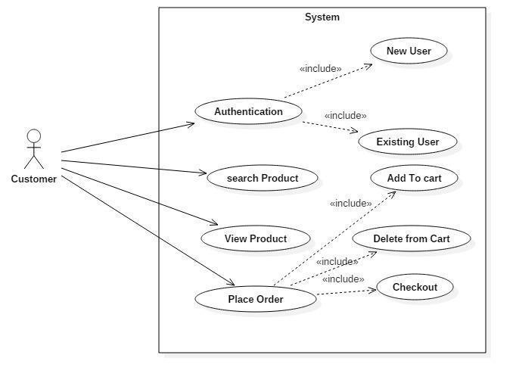

19

- Administration :
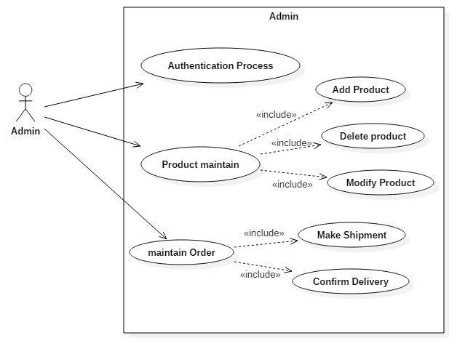

20

Use case

Use Case scenarios:

It is easy to mix up the definitions of use case and use case scenario. A use case represents the actions that are required to enable or abandon a goal. A use case has multiple “paths” that can be taken by any user at any one time. A use case scenario is a single path through the use case. This article provides an example use case and some diagrams to help visualize the concept.

Case Description –

- System - Draw your system’s boundaries using rectangles that contain use cases. Place actors outside the system’s
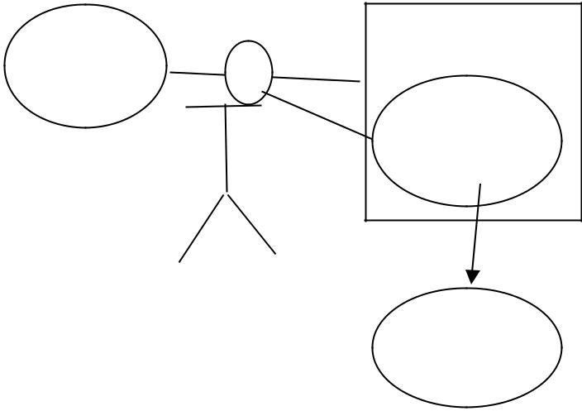
boundaries.

Use case

Use case

- Use case – Draw use cases using ovals. Label with ovals with verbs that represents the

system’s functions.
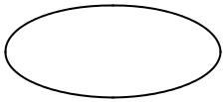

Print

21
- Actors – Actors are the users of a system. When one system is the actor of another system, label the actor system with the actor stereotype.
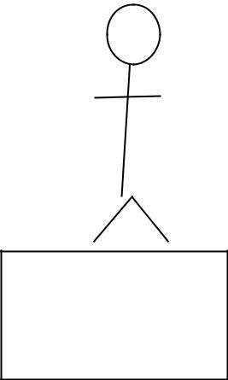

<<actor>>

System A

- Relationships – Illustrate relationships between an actor & a use cases with simple line. For relationship among use cases, use arrows labeled either “uses” or “extends”.
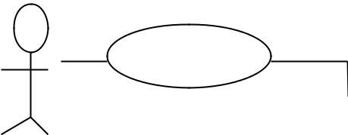

Use
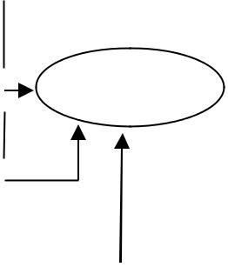

<<uses>>
Actor _{Use}

<<extends>>
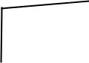

Use Use

22

iv)ER-D

- The relation upon the system is structure through a conceptual ER-Diagram, which not only specifics the existential entities but also the standard relations through which the system exists and the cardinalities that are necessary for the system state to continue.

- The entity Relationship Diagram (ERD) depicts the relationship between the data objects. The ERD is the notation that is used to conduct the date modeling activity the attributes of each data object noted is the ERD can be described resign a data object descriptions.

- The set of primary components that are identified by the ERD are

◆ Data object  Relationships

- Attributes  Various types of indicators.

The primary purpose of the ERD is to represent data objects and their relationships.

Entity–relationship model (ER model) in software engineering is an abstract way to describe a database.

An ER model is an abstract way to describe a database. Describing a database usually starts with a relational database, which stores data in tables. Some of the data in these tables point to data in

23

other tables - for instance, your entry in the database could point to several entries for each of the phone numbers that are yours. The ER model would say that you are an entity, and each phone number is an entity, and the relationship between you and the phone numbers is 'has a phone number'. Diagrams created to design these entities and relationships are called entity– relationship diagrams or ER diagrams.

Using the three schema approach to software engineering, there are

three levels of ER models that may be developed.

The conceptual data model: This is the highest level ER model in that it contains the least granular detail but establishes the overall scope of what is to be included within the model set. The conceptual ER model normally defines master reference data entities that are commonly used by the organization. Developing an enterprise-wide conceptual ER model is useful to support documenting the data architecture for an organization.

A conceptual ER model may be used as the foundation for one or more logical data models. The purpose of the conceptual ER model is then to establish structural metadata commonality for the master data entities between the set of logical ER models. The conceptual data model may be used to form commonality relationships between ER models as a basis for data model integration.

The logical data model: A logical ER model does not require a conceptual ER model especially if the scope of the logical ER model is to develop a single disparate information system. The

24

logical ER model contains more detail than the conceptual ER model. In addition to master data entities, operational and transactional data entities are now defined. The details of each data entity are developed and the entity relationships between these data entities are established. The logical ER model is however developed independent of technology into which it will be implemented.

The physical model: One or more physical ER models may be developed from each logical ER model. The physical ER model is normally developed to be instantiated as a database. Therefore, each physical ER model must contain enough detail to produce a database and each physical ER model is technology dependent since each database management system is somewhat different. The physical model is normally forward engineered to instantiate the structural metadata into a database management system as relational database objects such as database tables, database indexes such as unique key indexes, and database constraints such as a foreign key constraint or a commonality constraint. The ER model is also normally used to design modifications to the relational database objects and to maintain the structural metadata of the database.

An Entity Relationship (ER) Diagram is a type of flowchart that illustrates how “entities” such as people, objects or concepts relate to each other within a system. ER Diagrams are most often used to design or debug relational databases

25

in the fields of software engineering, business information systems, education and research. Also known as ERDs or ER Models, they use a defined set of symbols such as rectangles, diamonds, ovals and connecting lines to depict the interconnectedness of entities, relationships and their attributes. They mirror grammatical structure, with entities as nouns and relationships as verbs.

Entities, which are represented by rectangles. An entity is an object or concept about which you want to store
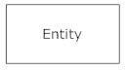

information. A weak entity is an entity that must defined by a foreign key relationship with another entity as it cannot be uniquely identified by its own attributes alone. 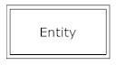

Actions, which are represented by diamond shapes, show how two entities share information in the database.

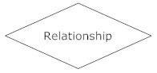In some cases, entities can be self-linked. For example, employees can supervise other

26

employees.
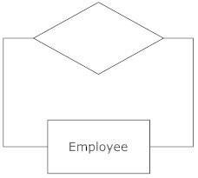

Attributes, which are represented by ovals. A key attribute is the unique, distinguishing characteristic of the entity. For example, an employee's social security number might be the employee's key attribute.
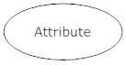

A multivalued attribute can have more than one value. For example, an employee entity can have multiple skill values.
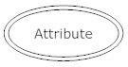

A derived attribute is based on another attribute. For example, an employee's monthly salary is based on the employee's annual salary. 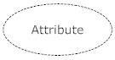

27

ERD Diagram
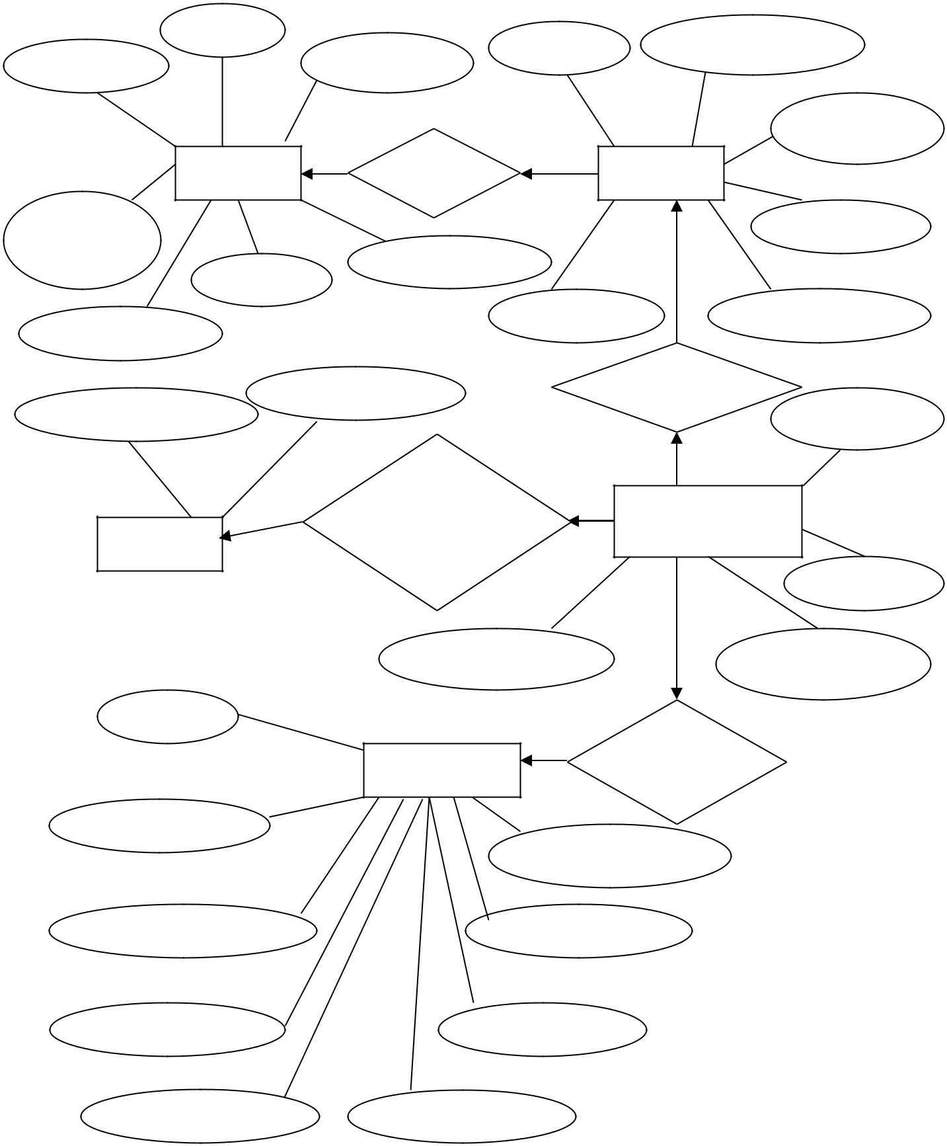

P_ID |  | U_ID | U_Username
P_Name | P_SizeID | U_ID | U_Username
 |  |  | U_Name
Product | Request |  | User
P_CatI |  |  | U_Email
D | PDescriptio
P_CO | PDescriptio
P_Quantity |  | U_BDate | U_Password
 | U_Password |  | Place
U_Username | U_Password |  | U_ID
 | Check the |  | Purchase
 | LoginID |  | Purchase
Login | LoginID |  | Details
 |  |  | PIDSize
 | PaymentType |  | PurchaseID
U_Na
 | Registration |  | Req. New
 | Registration |  | Member
U_Password
 |  | U_Address
U_CPassword |  | U_Phoneno
U_Gender | U_BDate
U_Username | U_Email

28

v)Activity Diagram:

An activity diagram illustrate the dynamic nature of a system by modeling the flow of control from activity to activity.

An activity represents an operation on some class in the system that results in a change in the state of the system.

Basic activity diagram symbols & notations-Action states

Action states represent the non interruptible actions of objects. You can draw an action state using a rectangle with rounded corners.
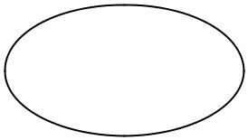

Activity

Action Flow

Action flow arrows illustrate the relationships among action
states.
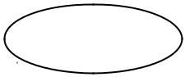
Activit
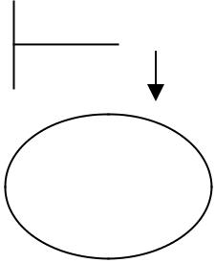

Activit
y

Initial State

A filled circle followed by an arrow represents the initial action state.
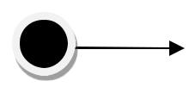

Final State

An arrow pointing to a filled circle nested inside another circle represents the final action states.
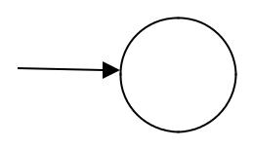

Branching

29

A diamond represents decision with alternate paths. The outgoing alternate should be labeled with a condition or guard expression. You can also label one of the paths “else”.
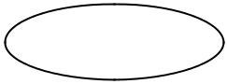

Activity
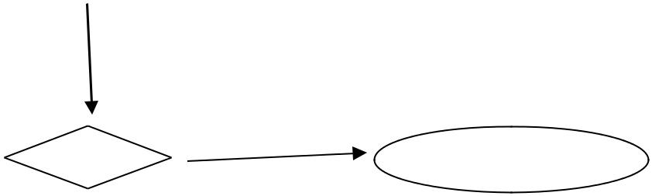

Activity

[ condition ]
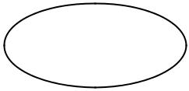

Activity

30

Activity Diagram
For Customer:
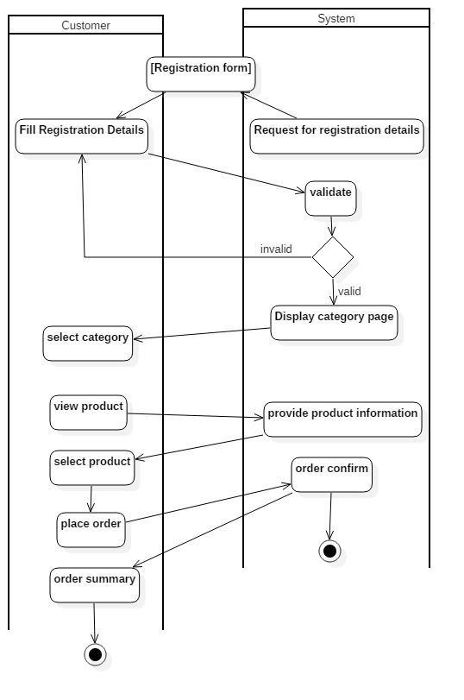

31
For Admin:
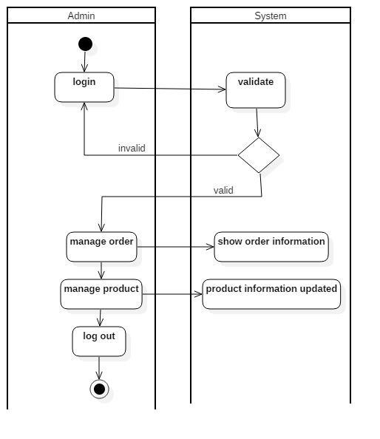

32

vi)Class Diagram:

A class diagram in the Unified Modeling

Language (UML) is a type of static structure diagram that

describes the structure of a system by showing the

system's classes, their attributes, operations (or methods), and

the relationships among the classes.

The class diagram is the main building block of object oriented modeling. It is used both for general conceptual modeling of the systematics of the application, and for detailed modeling translating the models into programming code. Class diagrams can also be used for data modeling. The classes in a class diagram represent both the main objects, interactions in the application and the classes to be programmed. A class with three sections. In the diagram, classes are represented with boxes which contain three parts:

- The upper part holds the name of the class

- The middle part contains the attributes of the class

- The bottom part gives the methods or operations the class can take or undertake.

Class Diagram Components:

Active Class :

33

Active classes initiate and control flow of activity, while passive classes store data and serve other classes. Illustrate active classes with a thicker border.
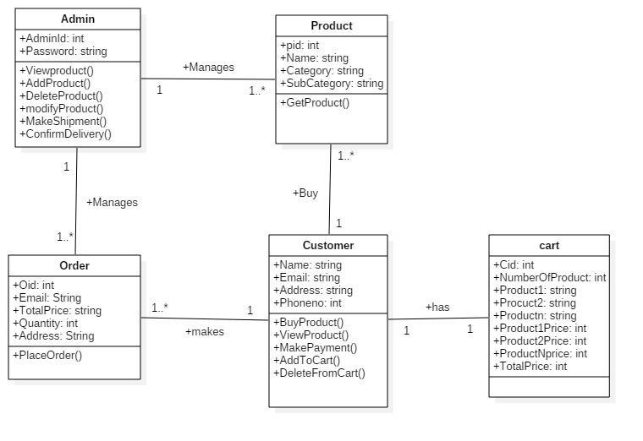

34

vii)Sequence Diagram:

System Sequence diagram (SSD) is a picture that shows, for a particular scenario of a use case, the events that external actors generate, their order, and possible inter-system events.

UML sequence diagrams are used to represent or model the flow of messages, events and actions between the objects or components of a system. Time is represented in the vertical direction showing the sequence of interactions of the header elements, which are displayed horizontally at the top of the diagram.

Sequence Diagrams are used primarily to design, document and validate the architecture, interfaces and logic of the system by describing the sequence of actions that need to be performed to complete a task or scenario. UML sequence diagrams are useful design tools because they provide a dynamic view of the system behavior which can be difficult to extract from static diagrams or specifications.

Although UML sequence diagrams are typically used to describe object-oriented software systems, they are a

Is extremely useful as system engineering tools to design system architectures, in business process engineering as process flow diagrams, as message sequence charts and call flows for telecom/wireless system design, and for protocol stack design and analysis.

See also common mistakes to avoid when using sequence diagrams.

Sequence Diagram Drawing Elements

This tutorial describes the basic drawing elements used in sequence diagrams and when they are used. These are the

35
diagram elements that are supported by the Sequence Diagram Editor tool. Some are not part of the UML specification and may not be supported by other UML tools.

Sequence Diagram Header Elements

The header portion of the sequence diagram represents the components or objects of the system being modeled and are laid out horizontally at the top of the diagram. See an example sequence diagram here.

Actor

Object

Unit

Represents an external person or entity that interacts with the system
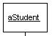

Represents an object in the system or one of its components

Represents a subsystem, component, unit, or other logical entity in the system (may or may not be implemented by objects)
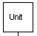

^{Separator} Represents an interface or boundary between subsystems, components or units (e.g., air interface, Internet, network)
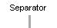

Group | Groups related header elements
 | into subsystems or components
Sequence Diagram Body Elements
Action | Represents an action
 | taken by an actor, object
 | or unit
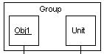

36

Asynchronous Message

Block

An asynchronous message between header elements

A block representing a loop or conditional for a particular header element
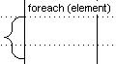

Call Message

Create Message

A call (procedure) message between header elements
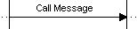

A "create" message that creates a header element (represented by lifeline going from dashed to solid pattern)
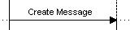

Destroy Element _{Represents the} destruction of a header element
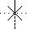

Destroy Message

Diagram Link

Represents the destruction of a header element as a result of a call from another element
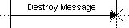

Represents a portion of a diagram being treated as a functional block. Similar to a procedure or function call that abstracts functionality or details not shown at this level. Can optionally be linked to another diagram for

37

 | elaboration.
Else Block | Represents an "else" block
 | portion of a diagram block
Flow Note | Documentation note that
 | is automatically formatted
 | to flow after previous
 | elements
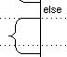

38

- For Admin:
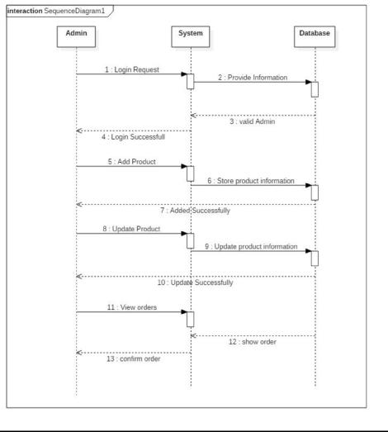

39

- For Customer :
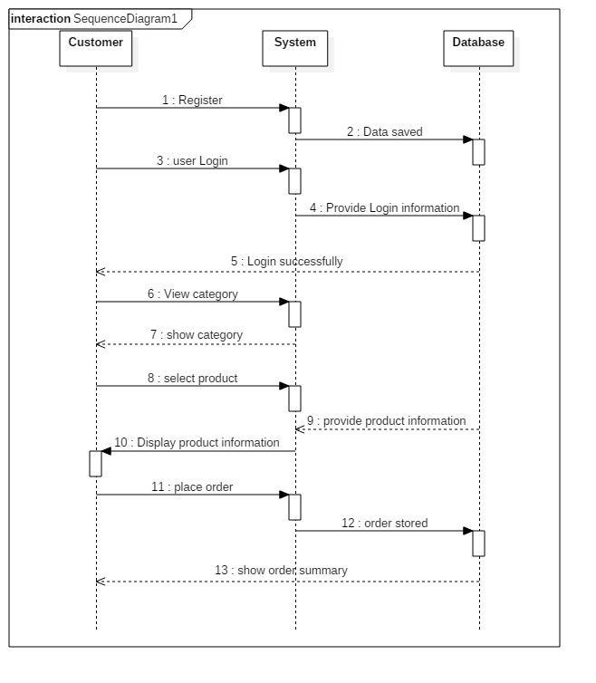

40
Collaboration Diagram:

The UML Collaboration diagram is used to model how objects involved in a scenario interact, with each object instantiating a particular class in the system. Objects are connected by links, each link representing an instance of an association between the respective classes involved. The link shows messages sent between the objects, and the type of message passed (synchronous, asynchronous, simple, balking, and timeout).

Collaboration diagrams offer a better view of a scenario than a Sequence diagram when the modeler is trying to understand all of the effects on a given object and are therefore good for procedural design.

Objects

Objects are depicted on a Collaboration diagram as rectangles. The object name is provided first, with the class name to the right; the two names are separated by a colon. You may specify the multiple occurrence of an object by opening its definition dialog, selecting its Symbol tab, and toggling on

the Multiple choice. You may also select theMultiple Object tool from the toolbar.

Links

Messages passed between objects are specified within the Link drawn between objects.

41

Collaboration Diagram:
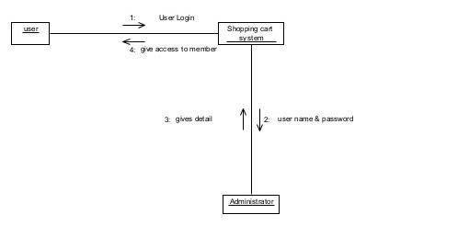

42
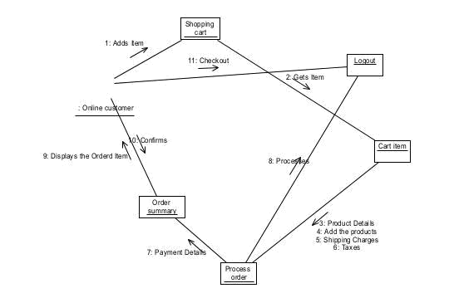

43
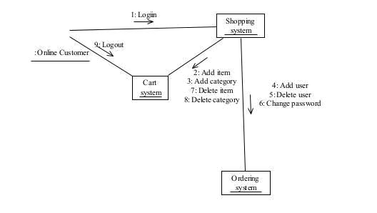

44
4.System Design

(i) Converting ERD to Tables

Table Name | Description
login | Contains login details
Customers | Contains Details of Customer
Customer Order | Contains Details of Customer
 | order
Products | Contains Product Details
Payment | Contains Order Details
Bill | Contains Bill Details

45

ii)Component Diagram

A component diagram describes the organization of the physical components in a system.

Basic Component Diagram Symbols and Notations:

Component

A component is a physical building block of the system. It is represented as a rectangle with tabs.
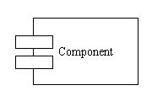

Interface

An interface describes a group of operations used or created by components.
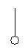

Dependencies

Draw dependencies among components using dashed arrows.
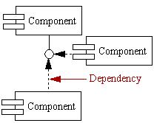

46

Component Diagram

Sign-up
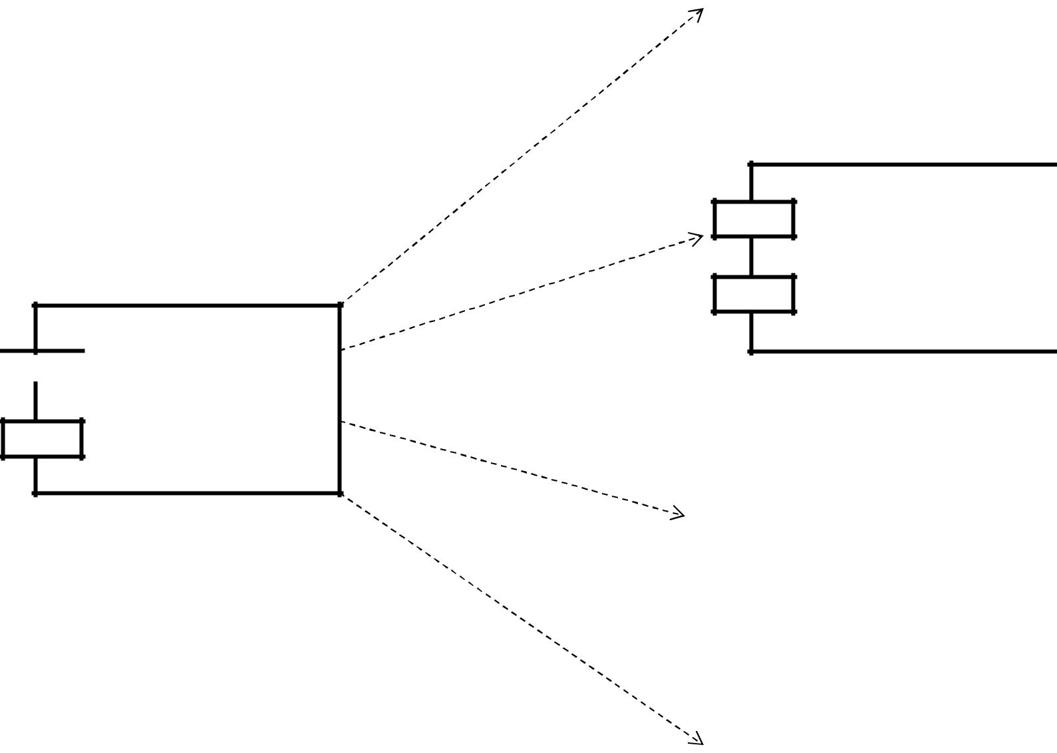

Sign-in

Online Product

Shopping

Products

Shopping Cart

47

iii)Package Diagram:
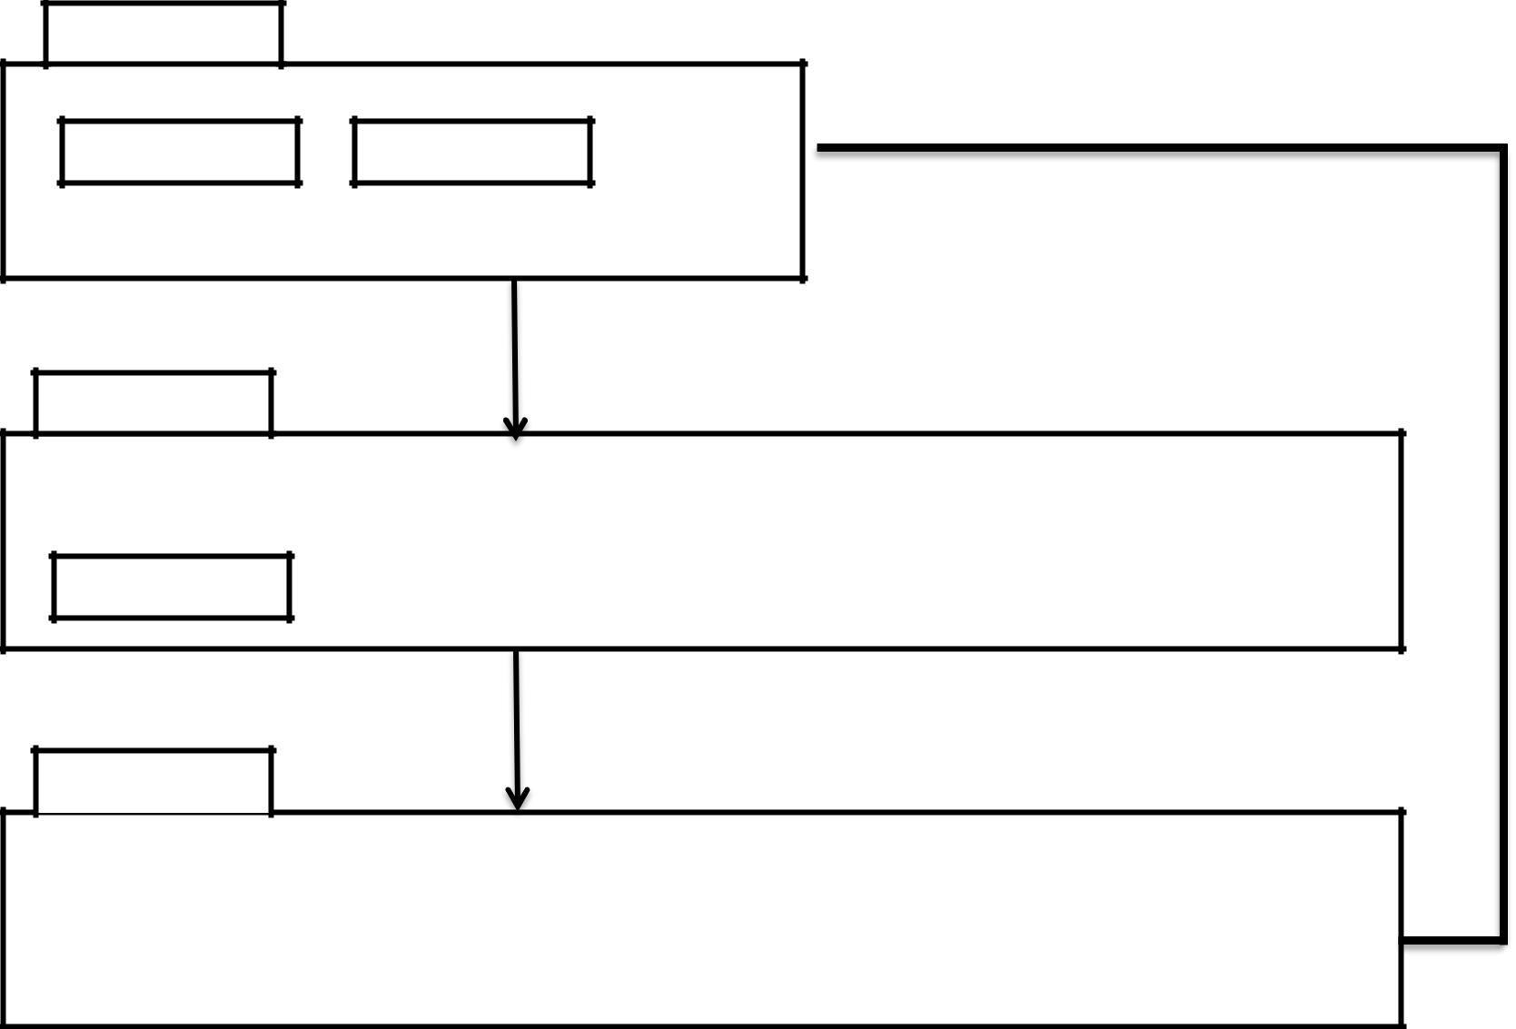

View layer

Login

Main Form

Domain layer

Product |  | Customer |  | Order |  | Bill

LogOut

Data layer

 |  |  |  | Customer
Product |  | Customer |  | Customer |  | Bill_details
Details |  | Details |  | Order |  | Bill_details

48

iv)Deployment Diagram:

Deployment diagrams depict the physical resources in a system including nodes, components, and connections.

- A deployment diagram shows the configuration of run time processing nodes & components that live on them.

- This involves modeling the topology of the h/w on which your system resides.

- Deployment diagram contains

– Nodes

Dependency & Association

Basic Deployment Diagram Symbols and Notations:

Component

A node is a physical resource that executes code components.
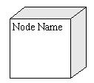

Association

Association refers to a physical connection between nodes, such as Ethernet.
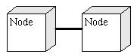

49

Deployment Diagram
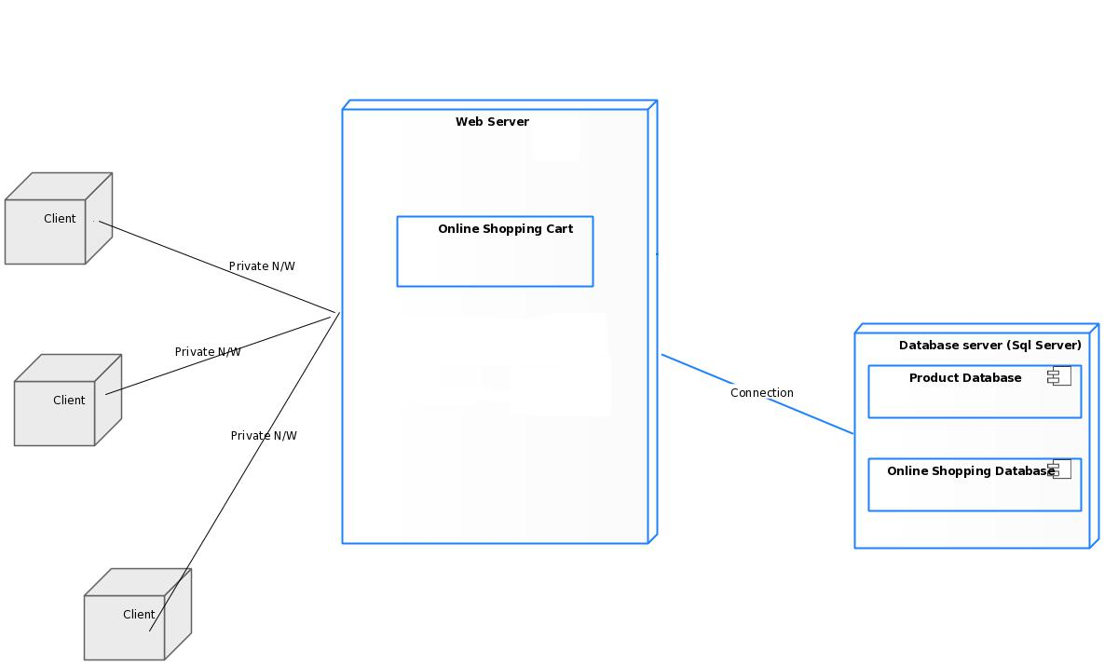

50

5.System Coding

i)Menu Tree


Online Product

Shooping

 |  |  |  |  |  |  | Register |  |  |  |  | Login |  | Feedback
Home |  |  | Product |  |  |  |  |  |  |  |  | Login
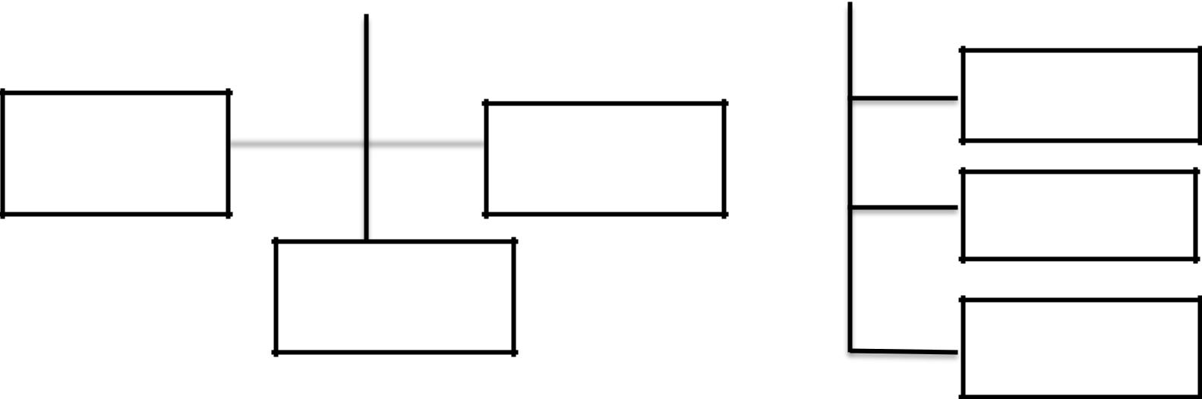

Cart

Shampoo |  | Soap

Logout

Cream

Chekout

51

ii) List of tables with attributes and constraints Table Name:Register

Description: This table stores information of user like Name, Address, Contact No and Email.

 | Column | Type |  | Description
 | U_ID | nchar(10) |  | Unchecked
 | U_Name | varchar(50) |  | Unchecked
 | U_Username | varchar(50) |  | Unchecked
 | U_Email | nvarchar(50) |  | Unchecked
 | U_Password | nvarchar(50) |  | Unchecked
 | U_CPassword | nvarchar(50) |  | Unchecked
 | U_BDate | date |  | Unchecked
 | U_Gender | nvarchar(50) |  | Unchecked
 | U_Phoneno | numeric(18, 0) |  | Unchecked
 | U_Address | nvarchar(MAX) |  | Unchecked
 | U_Usertype | nchar(10) |  | Unchecked

 | Table Name: Product
 | Description: This table stores information of |  | product.
 | Column | Type | Description
 | P_ID | bigint | Unchecked
 | P_Name | nvarchar(MAX) | Checked
 | P_Price | money | Checked
 | P_CatID | bigint | Checked
 | P_Quantity | int | Checked
 | P_SizeID | bigint | Checked
 | P_COD | int | Checked

52

 | Table Name: Orders
 | Description: This table stores information of |  | orders place by
 | user.
 | Column | Type | Description
 | PurchaseID | bigint | Unchecked
 | U_ID | bigint | Checked
 | PIDSizeID | bigint | Checked
 | CartAmount | int | Checked
 | CartDiscount | int | Checked
 | TotalPayed | int | Checked
 | PaymentType | int | Checked
 | Status | Varchar(50) | Checked
 | DateOfPurchase | datetime | Checked
 | Name | Varchar(50) | Checked
 | Address | Varchar(50) | Checked
 | Pincode | int | Checked
 | MobileNumber | int | Checked
 | Quantity | int | Checked
 | cancel_date | datetime | Checked

53
iii) Validations

FORM | FIELD NAME | VALIDATORS
NAME | FIELD NAME | VALIDATORS
Login | Email ID,Password | Required Field
 |  | Validation
 | First name, Last name,Email, | Required Field
 | First name, Last name,Email, | validation,PatternMatching,C
Registrati | Phone, | validation,PatternMatching,C
Registrati | Phone, | ompare validation, Custom
on | Password,ConfirmPassword,A | ompare validation, Custom
on | Password,ConfirmPassword,A | Validator(UserAvailability),
Page | ddress, Pincode | Regular Expression

54

iv) Test Cases

Software testing is a critical element of software quality

assurance and represents the ultimate review of specification,

design and coding. The increasing visibility of software as a

system element and attendant costs associated with a software

failure are motivating factors for we planned, through testing.

Testing is the process of executing a program with the intent of

finding an error. The design of tests for software and other

engineered products can be as challenging as the initial design of

the product itself.
 | There of basically two types of testing approaches.
 | One is Black-Box testing – the specified function |  |  |  |  |  |  | that | a
product |  | has |  |  | been designed to | perform, | tests | can | be
conducted |  |  | that | demonstrate each function is fully operated.
The | other |  | is | White-Box testing – knowing |  |  | the | internal
workings |  | of | the |  | product ,tests can be conducted to |  |  | ensure
that | the | internal operation of the |  |  |  | product performs according

to specifications and all internal components have been adequately exercised.

White box and Black box testing methods have been

used to test this package. The entire loop constructs have

55

been tested for their boundary and intermediate conditions. The test data was designed with a view to check for all the

conditions and logical decisions. Error handling has been taken care of by the use of exception handlers.

TESTING STRATEGIES:

Testing is a set of activities that can be planned in advanced and conducted systematically. A strategy for software testing must accommodation low-level tests that are necessary to verify that a small source code segment has been correctly implemented as well as high-level tests that validate major system functions against customer requirements.

Software testing is one element of verification and validation. Verification refers to the set of activities that ensure that software correctly implements as specific function. Validation refers to a different set of activities that ensure that the software that has been built is traceable to customer requirements.

The main objective of software is testing to uncover errors. To fulfill this objective, a series of test steps unit, integration, validation and system tests are planned and executed. Each test step is accomplished through a series of systematic test technique that assist in the design of test cases. With each testing step, the level of abstraction with which software is considered is broadened.

56

Testing is the only way to assure the quality of software and it is an umbrella activity rather than a separate phase. This is an activity to be preformed in parallel with the software effort and one that consists of its own phases of analysis, design, implementation, execution and maintenance.

UNIT TESTING:

This testing method considers a module as single unit and checks the unit at interfaces and communicates with other modules rather than getting into details at statement level. Here the module will be treated as a black box, which will take some input and generate output. Outputs for a given set of input combination are pre-calculated and are generated by the module.

SYSTEM TESTING:

Here all the pre tested individual modules will be assembled to create the larger system and tests are carried out at system level to make sure that all modules are working in synchronous with each other. This testing methodology helps in making sure that all modules which are running perfectly when checked individually are also running in cohesion with other modules. For this testing we create test cases to check all modules once and then generated test combinations of test paths

57
through out the system to make sure that no path is making its way into chaos.

INTEGRATED TESTING

Testing is a major quality control measure employed during software development. Its basic function is to detect errors. Sub functions when combined may not produce than it is desired. Global data structures can represent the problems. Integrated testing is a systematic technique for constructing the program structure while conducting the tests. To uncover errors that are associated with interfacing the objective is to make unit test modules and built a program structure that has been detected by design. In a non - incremental integration all the modules are combined in advance and the program is tested as a whole. Here errors will appear in an end less loop function. In incremental testing the program is constructed and tested in small segments where the errors are isolated and corrected.

Different incremental integration strategies are top – down integration, bottom – up integration, regression testing.

58

TOP-DOWN INTEGRATION TEST

Modules are integrated by moving downwards through the control hierarchy beginning with main program. The subordinate modules are incorporated into structure in either a breadth first manner or depth first manner. This process is done in five steps:

- Main control module is used as a test driver and steps are substituted or all modules directly to main program.

- Depending on the integration approach selected subordinate is replaced at a time with actual modules.
- Tests are conducted.

- On completion of each set of tests another stub is replaced with the real module

- Regression testing may be conducted to ensure trha5t new

errors have not been introduced.

This process continuous from step 2 until entire program structure is reached. In top down integration strategy decision making occurs at upper levels in the hierarchy and is encountered first. If major control problems do exists early recognitions is essential.

If depth first integration is selected a complete function of the software may be implemented and demonstrated.

Some problems occur when processing at low levels in hierarchy is required to adequately test upper level steps to

59

replace low-level modules at the beginning of the top down testing. So no data flows upward in the program structure.

BOTTOM-UP INTEGRATION TEST

Begins construction and testing with atomic modules. As modules are integrated from the bottom up, processing requirement for modules subordinate to a given level is always available and need for stubs is eliminated. The following steps implements this strategy.

- Low-level modules are combined in to clusters that perform a specific software sub function.
- A driver is written to coordinate test case input and output.

- Cluster is tested.

- Drivers are removed and moving upward in program structure combines clusters.

Integration moves upward, the need for separate test driver’s lesions.

If the top levels of program structures are integrated top down, the number of drivers can be reduced substantially and integration of clusters is greatly simplified.

REGRESSION TESTING

Each time a new module is added as a part of integration as the software changes. Regression testing is an actually that helps

60

to ensure changes that do not introduce unintended behavior as additional errors.

Regression testing maybe conducted manually by executing a subset of all test cases or using automated capture play back tools enables the software engineer to capture the test case and results for subsequent playback and compression. The regression suit contains different classes of test cases.

A representative sample to tests that will exercise all software functions.

Additional tests that focus on software functions that are likely to be affected by the change.

61

Test-cases:

Login Form:

No | Test Case | Excepted Result | Test Result
1. | On the click of ADD | At first user have to | Successful
 | button | fill all fields with
 |  | proper data, if any
 |  | error like entering text
 |  | data instead of
 |  | number or or entering
 |  | number instead of
 |  | text.. Is found then it
 |  | gives proper rest
 |  | message otherwise I
 |  | Adds record to the
 |  | database
2. | Button on the click of | This delete the details | Successful
 | update | of employee by using
 |  | userid
3. | Button on the click of | Modified version | Successful
 | search | record s are updated
 |  | in database by
 |  | clicking update
 |  | button.

62

Customer Form:

No | Test Case | Excepted Result | Test Result
1. | On the click of ADD | At first user have to | Successful
 | button | fill all fields with
 |  | proper data, if any
 |  | error like entering text
 |  | data instead of
 |  | number or entering
 |  | number instead of
 |  | text.. Is found then it
 |  | gives proper rest
 |  | message otherwise I
 |  | Adds record to the
 |  | database
2. | On the click of | This deletes the | Successful
 | DELETE button | details of customer by
 |  | using userid
3. | On the click of | Modified records are | Successful
 | UPDATE button | updated in database
 |  | by clicking UPDATE
 |  | button.

63

Product

No | Test Case | Excepted Result | Test Result
1. | On the click of ADD | At first user have to | Successful
 | button | fill all fields with
 |  | proper data, if any
 |  | error like entering text
 |  | data instead of
 |  | number or entering
 |  | number instead of
 |  | text.. Is found then it
 |  | gives proper rest
 |  | message otherwise I
 |  | Adds record to the
 |  | database
2. | On the click of | This deletes the
 | DELETE button | details of customer by | Successful
 |  | using userid
3. | On the click of | Modified records are | Successful
 | UPDATE button | updated in database
 |  | by clicking UPDATE
 |  | button.

64

Purchase Order

No |  |  |  | Test Case | Excepted Result | Test Result
1. |  |  |  | On the click of SAVE | At first user have to
 |  |  |  | button | fill all fields with | Successful
 |  |  |  |  | proper data, if any
 |  |  |  |  | error like entering text
 |  |  |  |  | data instead of
 |  |  |  |  | number or entering
 |  |  |  |  | number instead of
 |  |  |  |  | text.. Is found then it
 |  |  |  |  | gives proper rest
 |  |  |  |  | message otherwise I
 |  |  |  |  | Adds record to the
 |  |  |  |  | database
2. |  |  |  | On the click of | This deletes the | Successful
 |  |  |  | DELETE button | details of customer by
 |  |  |  |  | using userid
3. |  |  |  | On the click of | Modified records are | Successful
 |  |  |  | UPDATE button | updated in database
 |  |  |  |  | by clicking UPDATE
 |  |  |  |  | button.

65

v)Screen Layout & Reports

Home.aspx

C# code:
using System;
using System.Collections.Generic;

using System.Linq;

using System.Web;
using System.Web.UI;
using System.Web.UI.WebControls;

public partial class home1 : System.Web.UI.Page

{

protected void Page_Load(object sender, EventArgs e)

{

BindCartNumber();

if (Session["USERNAME"] != null)
{
btnSignup.Visible = false;

btnSignin.Visible = false;

btnSignOut.Visible = true;

}
else
{

btnSignup.Visible = true;

btnSignin.Visible = true;

btnSignOut.Visible = false;

}

}

public void BindCartNumber()

{
if (Request.Cookies["CartPID10"] != null)
{
string CookieP_ID10 =

Request.Cookies["CartPID10"].Value.Split('=')[1];

66

string[] ProductArray = CookieP_ID10.Split(','); int ProductCount = ProductArray.Length; pCount.InnerText = ProductCount.ToString();

}

else

{

pCount.InnerText = 0.ToString();
}
}

protected void btnSignOut_Click(object sender, EventArgs e)

{

Session["USERNAME"] = null; Response.Redirect("~/home1.aspx");

}

protected void btnSignin_Click(object sender, EventArgs e)

{

Response.Redirect("~/Sign-in.aspx");

}

protected void btnSignup_Click(object sender, EventArgs e)

{

Response.Redirect("~/Sign-Up.aspx");
}
protected void btnCart1_Click(object sender, EventArgs e)

{

Response.Redirect("~/CART1.aspx.");

}

}

67

Output:
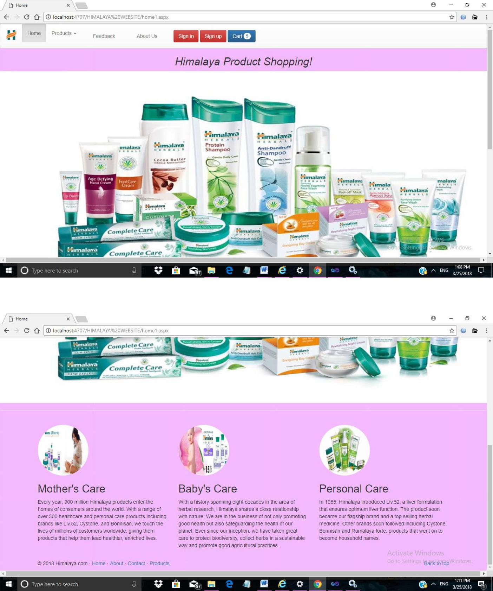

68

Sign-In.aspx

C# Code:

using System;
using System.Collections.Generic;
using System.Linq;

using System.Web;

using System.Web.UI;
using System.Web.UI.WebControls;
using System.Data.SqlClient;

using System.Data.Sql;

using System.Configuration;

using System.Data;

public partial class Sign_in : System.Web.UI.Page

{

protected void Page_Load(object sender, EventArgs e)
{
if (!IsPostBack)
{

if (Request.Cookies["U_Username"] != null && Request.Cookies["U_Password"] != null)
{
txtuname.Text =
Request.Cookies["U_Username"].Value;

txtpass.Attributes["value"] = Request.Cookies["U_Password"].Value; CheckBox1.Checked = true;

}

}

}

protected void LinkButton1_Click(object sender, EventArgs e)

69
{

}
protected void Button1_Click(object sender, EventArgs e)
{

String CS =

ConfigurationManager.ConnectionStrings["MyDatabaseConnection
String1"].ConnectionString;
using (SqlConnection con = new SqlConnection(CS))

{

SqlCommand cmd = new SqlCommand("select * from signup where U _Username='" + txtuname.Text + "' and U_Password='" + txtpass.Text + "'", con);

con.Open();

SqlDataAdapter sda = new SqlDataAdapter(cmd); DataTable dt = new DataTable(); sda.Fill(dt);

if (dt.Rows.Count != 0)

{

Session["U_ID"] = dt.Rows[0]["U_ID"].ToString(); Session["U_Email"] =

dt.Rows[0]["U_Email"].ToString();

if (CheckBox1.Checked)

{

Response.Cookies["U_Username"].Value = txtuname.Text;

Response.Cookies["U_Password"].Value =

txtpass.Text;

Response.Cookies["U_Username"].Expires =

DateTime.Now.AddDays(30);

Response.Cookies["U_Password"].Expires =

DateTime.Now.AddDays(30);
}
else
{

70

Response.Cookies["U_Username"].Expires =

DateTime.Now.AddDays(-1);
Response.Cookies["U_Password"].Expires =
DateTime.Now.AddDays(-1);

}

string Utype;
Utype = dt.Rows[0][10].ToString().Trim();
if (Utype == "U")

{

Session["USERNAME"] = txtuname.Text; if (Request.QueryString["rurl"] != null) {

if (Request.QueryString["rurl"] == "Cart")

{

Response.Redirect("~/Cart.aspx");

}

}

else

{
Response.Redirect("~/UserHome.aspx");
}
}

if (Utype == "A")

{

Session["USERNAME"] = txtuname.Text; Response.Redirect("~/AdminHome.aspx");

}

else

{

lblError.Text = "Invalid Username or Password !";

}

}

71

}
ClearTextBox();
}

private void ClearTextBox()

{
txtuname.Text = "";
txtpass.Text = "";

}

}
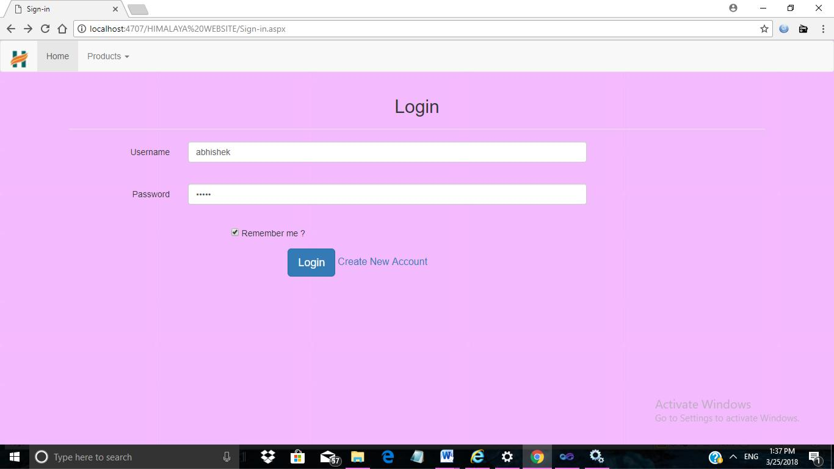

72
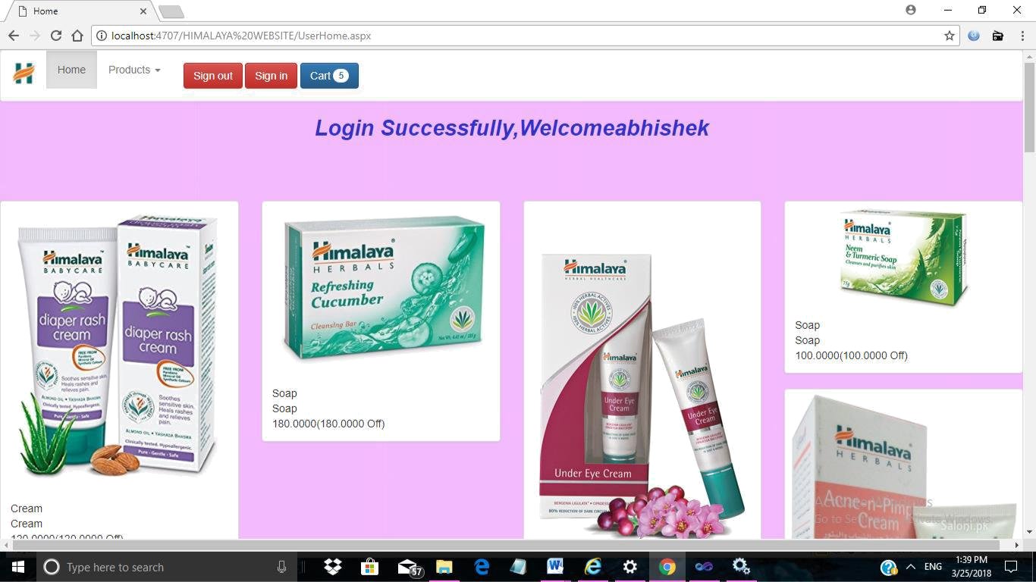

73

Products.aspx

C# code:

using System;

using System.Collections.Generic;
using System.Linq;
using System.Web;

using System.Web.UI;

using System.Web.UI.WebControls;
using System.Data.SqlClient;
using System.Data.Sql;

using System.Configuration;

using System.Data;

public partial class Products : System.Web.UI.Page

{

protected void Page_Load(object sender, EventArgs e)

{

if (!IsPostBack)

{

BindProductRepeater();

}

}

private void BindProductRepeater()
{
String CS =
ConfigurationManager.ConnectionStrings["MyDatabaseConnection

String1"].ConnectionString;

using (SqlConnection con = new SqlConnection(CS))
{
using (SqlCommand cmd = new SqlCommand("procBindAllProducts", con))

74
{

cmd.CommandType =
CommandType.StoredProcedure;
using (SqlDataAdapter sda = new SqlDataAdapter(cmd))

{

DataTable dttblCategory1 = new DataTable(); sda.Fill(dttblCategory1); rptrProducts.DataSource = dttblCategory1; rptrProducts.DataBind();

}

}

}

}

public DataTable dttblCategory { get; set; }

}

Output:
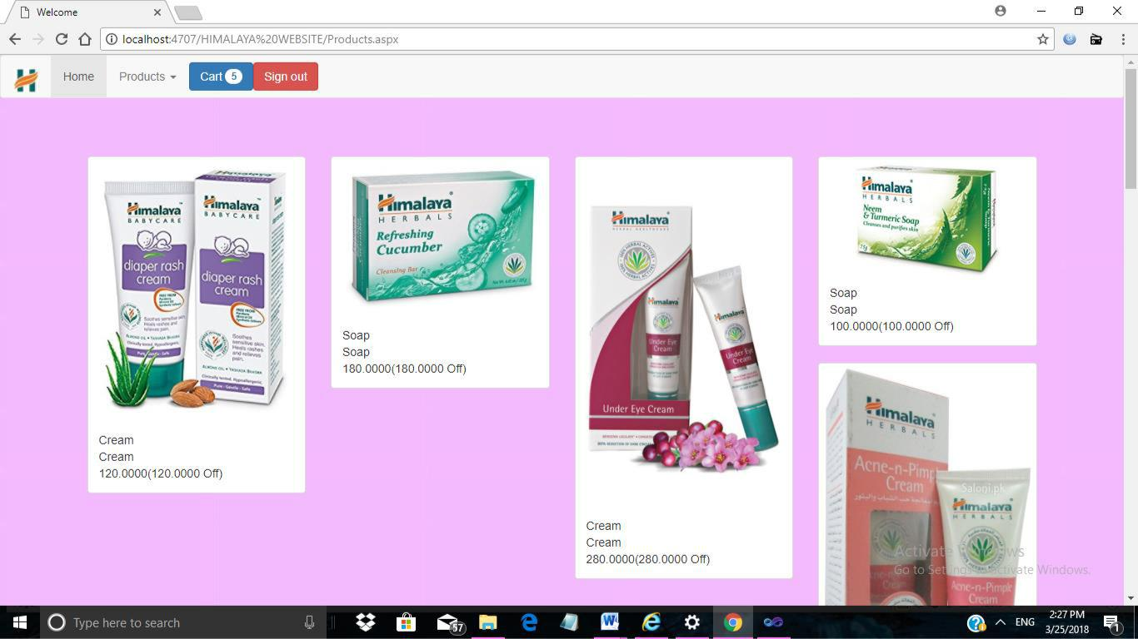

75

ProductView.aspx

C# code:

using System;

using System.Collections.Generic;

using System.Linq;
using System.Web;
using System.Web.UI;

using System.Web.UI.WebControls;

using System.Data;
using System.Data.Sql;
using System.Configuration;

using System.Data.SqlClient;

public partial class ProductView : System.Web.UI.Page
{
protected void Page_Load(object sender, EventArgs e)

{

if (Request.QueryString["P_ID"] != null)
{
if (!IsPostBack)
{

BindProductImages();

BindProductDetails();
}
}

else

{
Response.Redirect("~/Products.aspx");
}

}
private void BindProductImages()
{

76
Int64 P_ID =

Convert.ToInt64(Request.QueryString["P_ID"]);

String CS =

ConfigurationManager.ConnectionStrings["MyDatabaseConnection

String1"].ConnectionString;

using (SqlConnection con = new SqlConnection(CS))
{
using (SqlCommand cmd = new SqlCommand("select * from tblProductImages where P_ID=" + P_ID + "", con))

{

cmd.CommandType = CommandType.Text; using (SqlDataAdapter sda = new

SqlDataAdapter(cmd))

{

DataTable dtCategory1 = new DataTable(); sda.Fill(dtCategory1); rptrImages.DataSource = dtCategory1; rptrImages.DataBind();

}

}
}

}

private void BindProductDetails()
{
Int64 P_ID =

Convert.ToInt64(Request.QueryString["P_ID"]);

String CS =

ConfigurationManager.ConnectionStrings["MyDatabaseConnection

String1"].ConnectionString;

using (SqlConnection con = new SqlConnection(CS))
{
using (SqlCommand cmd = new SqlCommand("select * from tblProduct where P_ID=" + P_ID + "", con))

77

{

cmd.CommandType = CommandType.Text; using (SqlDataAdapter sda = new

SqlDataAdapter(cmd))

{

DataTable dtCategory1 = new DataTable();

sda.Fill(dtCategory1);
rptrProductDetails.DataSource = dtCategory1;
rptrProductDetails.DataBind();

}

}
}

}

protected void rptrProductDetails_ItemDataBound(object sender, RepeaterItemEventArgs e)

{

if (e.Item.ItemType == ListItemType.Item || e.Item.ItemType == ListItemType.AlternatingItem)

{

string CatID = (e.Item.FindControl("hfCatID") as HiddenField).Value;

DropDownList ddlSizes = e.Item.FindControl("ddlSizes") as DropDownList;

String CS =

ConfigurationManager.ConnectionStrings["MyDatabaseConnection
String1"].ConnectionString;
using (SqlConnection con = new SqlConnection(CS))
{

using (SqlCommand cmd = new SqlCommand("select

- from tblSizes2 where CatID=" + CatID + "", con))
{
cmd.CommandType = CommandType.Text;

78

using (SqlDataAdapter sda = new SqlDataAdapter(cmd))
{
DataTable dtCategory1 = new DataTable(); sda.Fill(dtCategory1); ddlSizes.DataSource = dtCategory1; ddlSizes.DataTextField = "SizeName"; ddlSizes.DataValueField = "P_SizeID"; ddlSizes.DataBind();

}

}
}

}

}
protected string GetActiveClass(int ItemIndex)
{

if (ItemIndex == 0)

{
return "active";
}
else

{

return "";
}
}

protected void btnCart1_Click(object sender, EventArgs e)

{
string SelectedSize = string.Empty;
foreach (RepeaterItem item in rptrProductDetails.Items)
{

if (item.ItemType == ListItemType.Item || item.ItemType == ListItemType.AlternatingItem)
{
var ddlList = item.FindControl("ddlSizes") as DropDownList;

79

SelectedSize = ddlList.SelectedValue;

var lblError = item.FindControl("lblError") as Label; lblError.Text = "";

}

}

if (SelectedSize != "")
{
Int64 P_ID =

Convert.ToInt64(Request.QueryString["P_ID"]);

if (Request.Cookies["CartPID10"] != null)

{

string CookieP_ID10 =

Request.Cookies["CartPID10"].Value.Split('=')[1];

CookieP_ID10 = CookieP_ID10 + "," + P_ID + "-" + SelectedSize;

HttpCookie CartProducts = new HttpCookie("CartPID10");

CartProducts.Values[ "CartPID10"] = CookieP_ID10; CartProducts.Expires = DateTime.Now.AddDays(30); Response.Cookies.Add(CartProducts);

}

else
{
HttpCookie CartProducts = new HttpCookie("CartPID10");

CartProducts.Values["CartPID10"] = P_ID.ToString() + "-" + SelectedSize;

CartProducts.Expires = DateTime.Now.AddDays(30); Response.Cookies.Add(CartProducts);

}

Response.Redirect("~/ProductView.aspx?P_ID=" +

P_ID);

80

}

else
{
foreach (RepeaterItem item in rptrProductDetails.Items)

{

if (item.ItemType == ListItemType.Item || item.ItemType == ListItemType.AlternatingItem)

{

var lblError = item.FindControl("lblError") as Label; lblError.Text = "Please select a size";
}
}
}

Response.Redirect("~/CART1.aspx");

}

public DataTable dtCategory1 { get; set; }

}

81

Output:
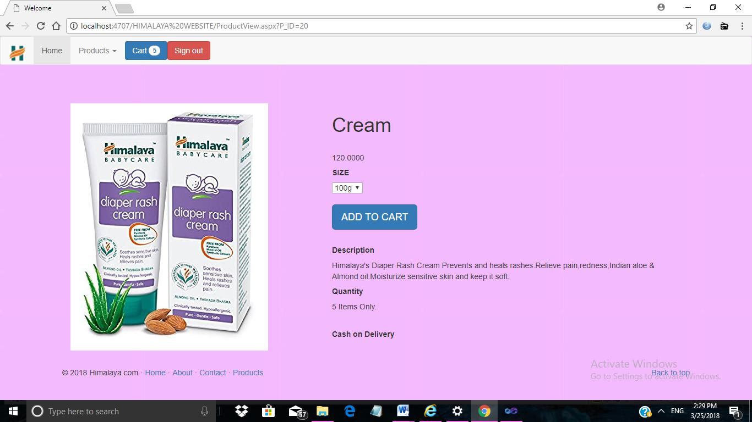

Cart.aspx

C# Code:
using System;
using System.Collections.Generic;

using System.Linq;

using System.Web;
using System.Web.UI;
using System.Web.UI.WebControls;
using System.Configuration;

using System.Data;

using System.Data.SqlClient;

82
public partial class CART1 : System.Web.UI.Page

{
protected void Page_Load(object sender, EventArgs e)
{

if (!IsPostBack)

{

BindCartProducts();

}

}

private void BindCartProducts()
{
if (Request.Cookies["CartPID10"] != null)

{

string CookieData10 =

Request.Cookies["CartPID10"].Value.Split('=')[1];

string[] CookieDataArray10 = CookieData10.Split(','); if (CookieDataArray10.Length > 0) {

h5NoItems.InnerText = "MY CART (" + CookieDataArray10.Length + " Items)";
DataTable dtCategory1 = new DataTable();
Int64 CartTotal = 0;
Int64 Total = 0;

for (int i = 0; i < CookieDataArray10.Length; i++)

{
string P_ID =
CookieDataArray10[i].ToString().Split('-')[0];

string P_SizeID =

CookieDataArray10[i].ToString().Split('-')[1];

String CS =

ConfigurationManager.ConnectionStrings["MyDatabaseConnection

String1"].ConnectionString;

using (SqlConnection con = new
SqlConnection(CS))
{

83

using (SqlCommand cmd = new

SqlCommand("select A.*,dbo.getSizeName1(" + P_SizeID + ") as

SizeNamee," + P_SizeID + " as
SizeIDD,SizeData.Name,SizeData.Extention from tblProduct A
cross apply( select top 1 B.Name,Extention from

tblProductImages B where B.P_ID=A.P_ID ) SizeData where

A.P_ID=" + P_ID + "", con))
{
cmd.CommandType = CommandType.Text; using (SqlDataAdapter sda = new

SqlDataAdapter(cmd))
{
sda.Fill(dtCategory1);

}

}
}
CartTotal +=

Convert.ToInt64(dtCategory1.Rows[i]["P_Price"]);

Total +=

Convert.ToInt64(dtCategory1.Rows[i]["P_Price"]);

}

rptrCartProducts.DataSource = dtCategory1; rptrCartProducts.DataBind(); divPriceDetails.Visible = true;

spanCartTotal.InnerText = CartTotal.ToString(); spanTotal.InnerText = "Rs. " + Total.ToString(); spanDiscount.InnerText = "- " + (CartTotal -

Total).ToString();

}

else

{

//TODO Show Empty Cart h5NoItems.InnerText = "Your Shopping Cart is

Empty";

divPriceDetails.Visible = false;

84

}

}
else
{

//TODO Show Empty Cart

h5NoItems.InnerText = "Your Shopping Cart is Empty"; divPriceDetails.Visible = false;

}

}

protected void btnRemoveItem_Click(object sender, EventArgs

e)

{

string CookieP_ID10 =
Request.Cookies["CartPID10"].Value.Split('=')[1];
Button btn = (Button)(sender);
string P_SizeID = btn.CommandArgument;

List<String> CookiePIDList =
CookieP_ID10.Split(',').Select(i => i.Trim()).Where(i => i !=
string.Empty).ToList();

CookiePIDList.Remove(P_SizeID);

string CookiePIDUpdated = String.Join(",", CookiePIDList.ToArray());

if (CookiePIDUpdated == "")

{

HttpCookie CartProducts =

Request.Cookies["CartPID10"];

CartProducts.Values["CartPID10"] = null; CartProducts.Expires = DateTime.Now.AddDays(-1); Response.Cookies.Add(CartProducts);

85

}
else
{

HttpCookie CartProducts =

Request.Cookies["CartPID10"];

CartProducts.Values["CartPID10"] = CookiePIDUpdated; CartProducts.Expires = DateTime.Now.AddDays(30); Response.Cookies.Add(CartProducts);

}
Response.Redirect("~/CART1.aspx");
}

protected void btnBuyNow_Click(object sender, EventArgs e)

{
if (Session["USERNAME"] != null)
{

Response.Redirect("~/Payment1.aspx");

}

else
{
Response.Redirect("~/Sign-in.aspx?rurl=cart");
}

}

public object dtCategory { get; set; }
}

86

Output:
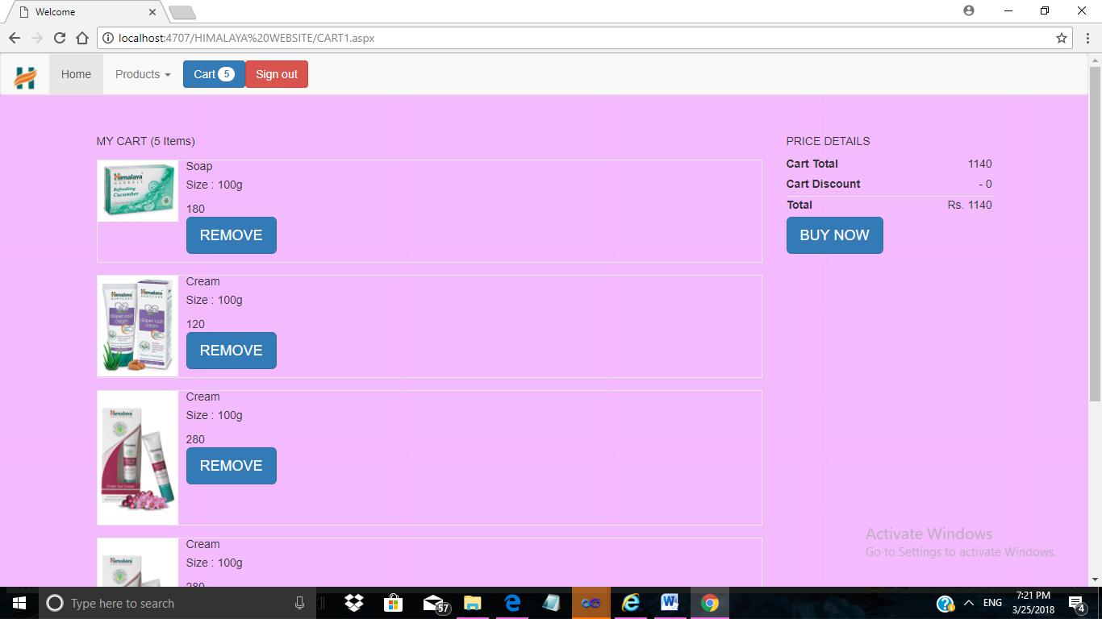

Payment.aspx

C# Code:
using System;
using System.Collections.Generic;
using System.Linq;

87
using System.Web;

using System.Web.UI;
using System.Web.UI.WebControls;
using System.Data;

using System.Configuration;

using System.Data.SqlClient;

public partial class Payment1 : System.Web.UI.Page

{

protected void Page_Load(object sender, EventArgs e)
{
if (Session["USERNAME"] != null)

{

if (!IsPostBack)

{
BindPriceData();
}

}

else

{
Response.Redirect("~/Sign-in.aspx");
}

}

private void BindPriceData()
{
if (Request.Cookies["CartPID10"] != null)

{
string CookieData10 =
Request.Cookies["CartPID10"].Value.Split('=')[1];

string[] CookieDataArray10 = CookieData10.Split(','); if (CookieDataArray10.Length > 0) {
DataTable dtCategory1 = new DataTable();
Int64 CartTotal = 0;
Int64 Total = 0;

88

for (int i = 0; i < CookieDataArray10.Length; i++)

{
string P_ID =
CookieDataArray10[i].ToString().Split('-')[0];

string P_SizeID =

CookieDataArray10[i].ToString().Split('-')[1];

if (hdPidSizeID.Value != null && hdPidSizeID.Value
!= "")
{

hdPidSizeID.Value += "," + P_ID + "-" +
P_SizeID;
}

else

{

hdPidSizeID.Value = P_ID + "-" + P_SizeID;

}

String CS =

ConfigurationManager.ConnectionStrings["MyDatabaseConnection

String1"].ConnectionString;
using (SqlConnection con = new
SqlConnection(CS))
{

using (SqlCommand cmd = new

SqlCommand("select A.*,dbo.getSizeName1(" + P_SizeID + ") as
SizeNamee,"
- P_SizeID + " as SizeIDD,SizeData.Name,SizeData.Extention from tblProduct A cross apply( select top 1 B.Name,Extention from tblProductImages B where B.P_ID=A.P_ID ) SizeData where A.P_ID=" + P_ID + " ", con))
{
cmd.CommandType = CommandType.Text; using (SqlDataAdapter sda = new
SqlDataAdapter(cmd))
{
sda.Fill(dtCategory1);

89

}

}
}
CartTotal +=

Convert.ToInt64(dtCategory1.Rows[i]["P_Price"]);

Total +=
Convert.ToInt64(dtCategory1.Rows[i]["P_Price"]);
}

divPriceDetails.Visible = true;

spanCartTotal.InnerText = CartTotal.ToString(); spanTotal.InnerText = "Rs. " + Total.ToString(); spanDiscount.InnerText = "- " + (CartTotal -

Total).ToString();

hdCartAmount.Value = CartTotal.ToString(); hdCartDiscount.Value = (CartTotal - Total).ToString(); hdTotalPayed.Value = Total.ToString();

}
else
{

//TODO Show Empty Cart Response.Redirect("~/Products.aspx");

}
}
else

{

//TODO Show Empty Cart Response.Redirect("~/Products.aspx");

}

}

protected void btncod_Click(object sender, EventArgs e)

{
if (Session["U_ID"] != null)
{
string U_ID = Session["U_ID"].ToString();

90

string PaymentType = "COD";

string Status = "Pending";

DateTime DateOfPurchase = DateTime.Now; string U_Email = Session["U_Email"].ToString(); DateTime cancel_date ;

//Insert Data to tblPurchase

String CS =

ConfigurationManager.ConnectionStrings["MyDatabaseConnection String1"].ConnectionString;

using (SqlConnection con = new SqlConnection(CS))

{

SqlCommand cmd = new SqlCommand("insert into tblPurchase values('" + U_ID + "','"

  - hdPidSizeID.Value + "','" + hdCartAmount.Value
- "','" + hdCartDiscount.Value + "','"
  - hdTotalPayed.Value + "','" + PaymentType + "','"
- Status + "','" + DateOfPurchase + "','"
  - txtName.Text + "','" + txtAddress.Text + "','" + txtPinCode.Text + "','" + txtMobileNumber.Text + "','" + ddlQuantity.SelectedValue + "','') select SCOPE_IDENTITY()", con);

con.Open();
Int64 PurchaseID = Convert.ToInt64(cmd.ExecuteScalar());
ClearTextBox();

}
Response.Redirect("~/Billing.aspx");
}

else

{
Response.Redirect("~/Sign-in.aspx");
}
}

91

private void ClearTextBox()

{
txtName.Text = "";
txtAddress.Text = "";

txtPinCode.Text = "";

txtMobileNumber.Text = "";

ddlQuantity.SelectedValue = "";

}

}

Output:
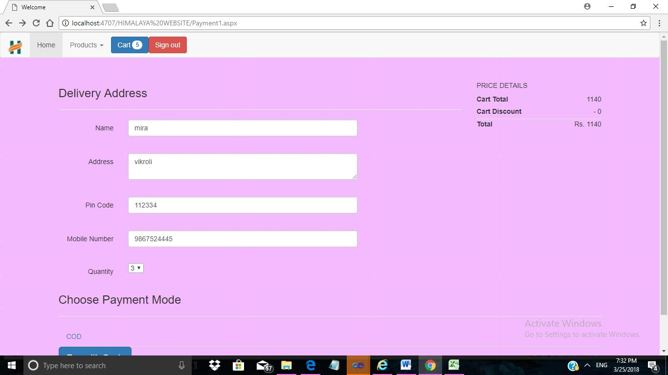

92

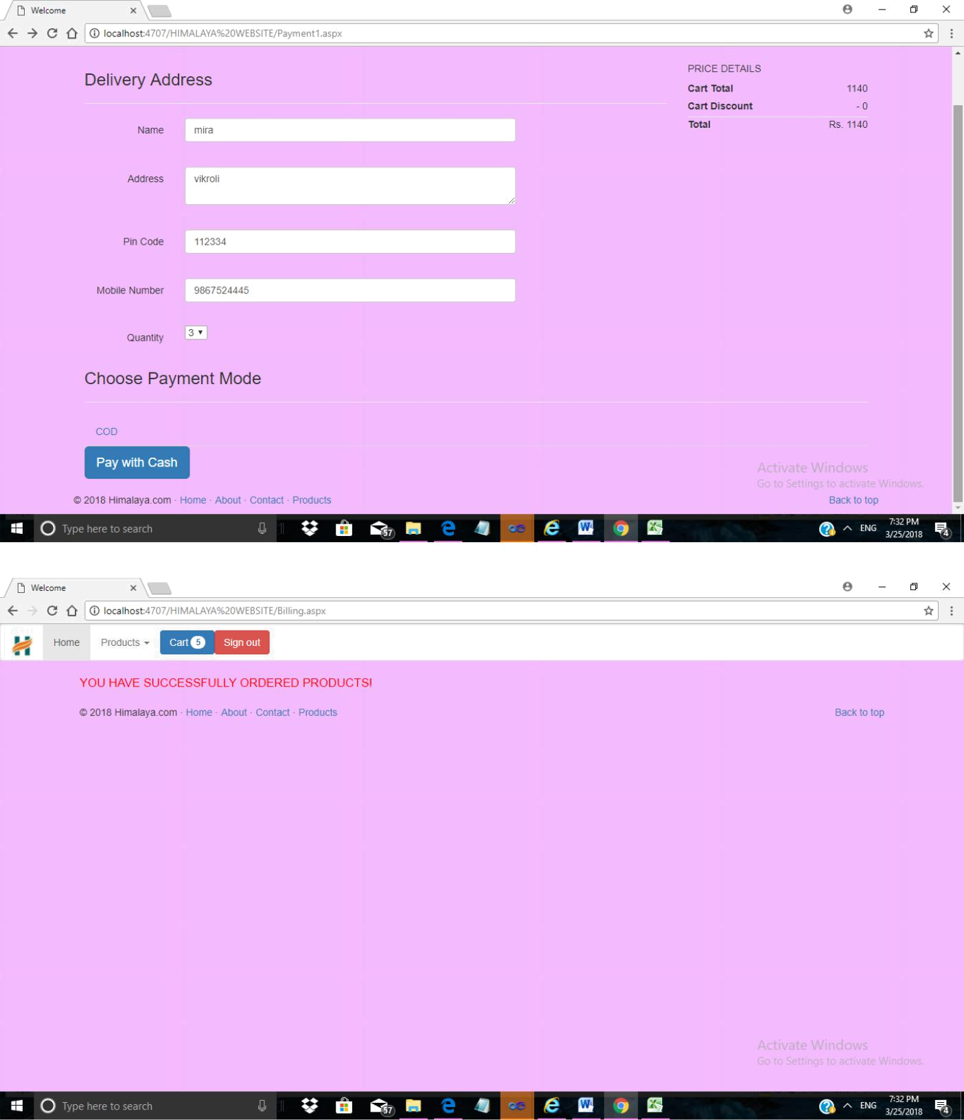

93
UserGrid1.aspx:

Source code:

<%@ Page Title="" Language="C#" MasterPageFile="~/AdminMaster.master" AutoEventWireup="true" CodeFile="UserGrid1.aspx.cs" Inherits="UserGrid" %>

<asp:Content ID="Content1" ContentPlaceHolderID="ContentPlaceHolder1" Runat="Server"> <form id="form1" runat="server">

<h1 align="UserGrid1.">User Profile</h1>

<asp:GridView ID="GridView1" runat="server" AutoGenerateColumns="False" AutoGenerateDeleteButton="True" AutoGenerateEditButton="True" BackColor="White" BorderColor="#E7E7FF" BorderStyle="None" BorderWidth="1px" CellPadding="10" DataKeyNames="U_ID" DataSourceID="SqlDataSource1" GridLines="Horizontal" CellSpacing="10" Font-Bold="True" PageSize="50" Height="100px" HorizontalAlign="Left" Width="100px">

<AlternatingRowStyle BackColor="#F7F7F7" />

<Columns>
<asp:BoundField DataField="U_ID" HeaderText="U_ID" ReadOnly="True"

SortExpression="U_ID" />

<asp:BoundField DataField="U_Name" HeaderText="U_Name"
SortExpression="U_Name" />

<asp:BoundField DataField="U_Username" HeaderText="U_Username"

SortExpression="U_Username" />

<asp:BoundField DataField="U_Email" HeaderText="U_Email"
SortExpression="U_Email" />

<asp:BoundField DataField="U_Password" HeaderText="U_Password"

SortExpression="U_Password" />
<asp:BoundField DataField="U_CPassword" HeaderText="U_CPassword"

SortExpression="U_CPassword" />

<asp:BoundField DataField="U_BDate" HeaderText="U_BDate"
SortExpression="U_BDate" />

<asp:BoundField DataField="U_Gender" HeaderText="U_Gender"

SortExpression="U_Gender" />
<asp:BoundField DataField="U_Phoneno" HeaderText="U_Phoneno"

SortExpression="U_Phoneno" />

<asp:BoundField DataField="U_Address" HeaderText="U_Address"

SortExpression="U_Address" />
<asp:BoundField DataField="U_Usertype" HeaderText="U_Usertype"

SortExpression="U_Usertype" />

<asp:HyperLinkField DataNavigateUrlFields="U_ID" DataNavigateUrlFormatString="UpdateSign-Up.aspx?U_ID={0}" HeaderText="Insert" Text="Insert" />

</Columns>
<FooterStyle BackColor="#B5C7DE" ForeColor="#4A3C8C" />

<HeaderStyle BackColor="#4A3C8C" Font-Bold="True" ForeColor="#F7F7F7" />

<PagerStyle BackColor="#E7E7FF" ForeColor="#4A3C8C" HorizontalAlign="Right" /> <RowStyle BackColor="#E7E7FF" ForeColor="#4A3C8C" />
<SelectedRowStyle BackColor="#738A9C" Font-Bold="True" ForeColor="#F7F7F7" />
<SortedAscendingCellStyle BackColor="#F4F4FD" />

<SortedAscendingHeaderStyle BackColor="#5A4C9D" />
<SortedDescendingCellStyle BackColor="#D8D8F0" />

<SortedDescendingHeaderStyle BackColor="#3E3277" />

</asp:GridView>
<br />

<br />

<br />
<br />

<br />

94

<br />

<br />
<br />

<br />

<br />
<br />

<br />

<br />

<br />
<asp:SqlDataSource ID="SqlDataSource1" runat="server"

ConnectionString="<%$ ConnectionStrings:RuksarConnectionString %>"

SelectCommand="SELECT * FROM [signup]" UpdateCommand="Update [signup]
Set[U_Name]=@U_Name, [U_Username]=@U_Username, [U_Email]=@U_Email,

[U_Password]=@U_Password, [U_CPassword]=@U_CPassword, [U_BDate]=@U_BDate,

[U_Gender]=@U_Gender, [U_Phoneno]=@U_Phoneno, [U_Address]=@U_Address,
[U_Usertype]=@U_Usertype where[U_ID]=@U_ID" DeleteCommand="Delete from [signup]

where[U_ID]=@U_ID"></asp:SqlDataSource>

</form>

</asp:Content>

Output:
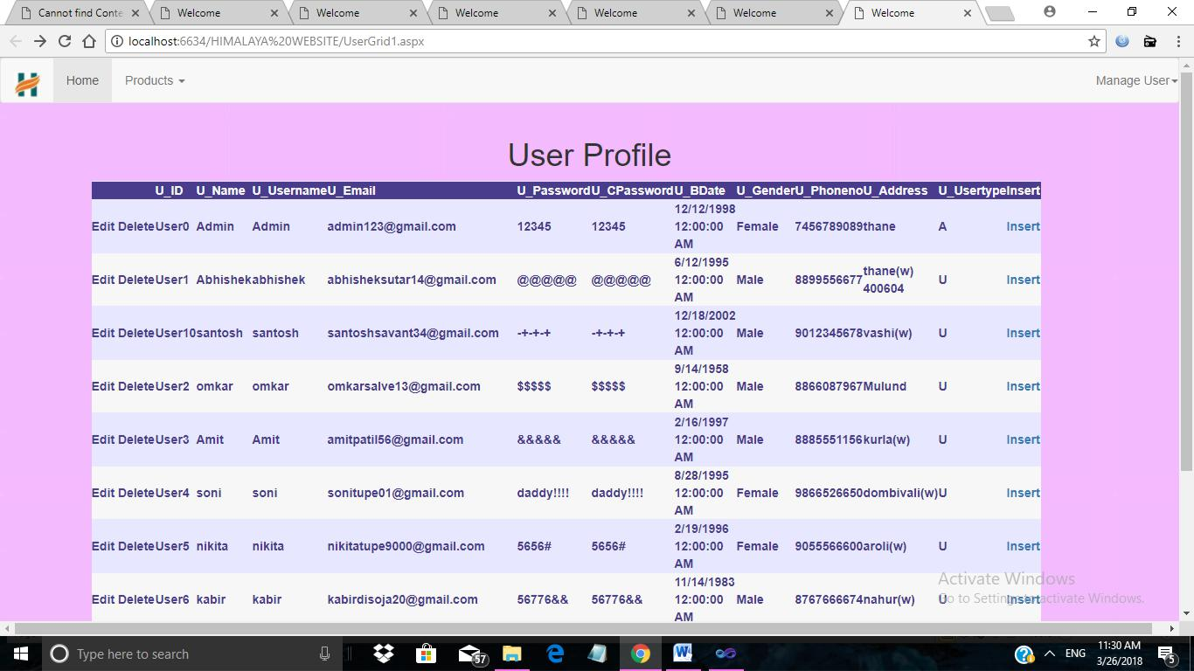

95

ProductGrid.aspx
Source Code:

<%@ Page Title="" Language="C#" MasterPageFile="~/AdminMaster.master" AutoEventWireup="true" CodeFile="ProductGrid.aspx.cs" Inherits="ProductGrid" %>

<asp:Content ID="Content1" ContentPlaceHolderID="ContentPlaceHolder1" Runat="Server">

<form id="form1" runat="server">
<h1 align="center"><b>Product Stock</b></h1>

<asp:GridView ID="GridView1" runat="server" AutoGenerateColumns="False" AutoGenerateDeleteButton="True" AutoGenerateEditButton="True" BackColor="White" BorderColor="#E7E7FF" BorderStyle="None" BorderWidth="1px" CellPadding="3" DataKeyNames="P_ID" DataSourceID="SqlDataSource1" GridLines="Horizontal"> <AlternatingRowStyle BackColor="#F7F7F7" />

<Columns>
<asp:BoundField DataField="P_ID" HeaderText="P_ID" InsertVisible="False"

ReadOnly="True" SortExpression="P_ID" />

<asp:BoundField DataField="P_Name" HeaderText="P_Name"
SortExpression="P_Name" />

<asp:BoundField DataField="P_Price" HeaderText="P_Price"

SortExpression="P_Price" />
<asp:BoundField DataField="P_CatID" HeaderText="P_CatID"

SortExpression="P_CatID" />

<asp:BoundField DataField="P_Quantity" HeaderText="P_Quantity"

SortExpression="P_Quantity" />
<asp:BoundField DataField="P_SizeID" HeaderText="P_SizeID"

SortExpression="P_SizeID" />

<asp:BoundField DataField="P_COD" HeaderText="P_COD" SortExpression="P_COD"
/>

<asp:BoundField DataField="PDescription" HeaderText="PDescription"

SortExpression="PDescription" />

<asp:HyperLinkField DataNavigateUrlFields="P_ID" DataNavigateUrlFormatString="AddProduct.aspx?P_ID={0}" HeaderText="Insert-Product" Text="Insert-Product" />

</Columns>
<FooterStyle BackColor="#B5C7DE" ForeColor="#4A3C8C" />

<HeaderStyle BackColor="#4A3C8C" Font-Bold="True" ForeColor="#F7F7F7" />

<PagerStyle BackColor="#E7E7FF" ForeColor="#4A3C8C" HorizontalAlign="Right" /> <RowStyle BackColor="#E7E7FF" ForeColor="#4A3C8C" />

<SelectedRowStyle BackColor="#738A9C" Font-Bold="True" ForeColor="#F7F7F7" />

<SortedAscendingCellStyle BackColor="#F4F4FD" />
<SortedAscendingHeaderStyle BackColor="#5A4C9D" />

<SortedDescendingCellStyle BackColor="#D8D8F0" />

<SortedDescendingHeaderStyle BackColor="#3E3277" />

</asp:GridView>
<asp:SqlDataSource ID="SqlDataSource1" runat="server"

ConnectionString="<%$ ConnectionStrings:RuksarConnectionString %>"

SelectCommand="SELECT * FROM [tblProduct]" UpdateCommand="Update [tblProduct]
Set[P_Name]=@P_Name, [P_Price]=@P_Price, [P_CatID]=@P_CatID, [P_Quantity]=@P_Quantity,

96

[P_SizeID]=@P_SizeID, [P_COD]=@P_COD, [PDescription]=@PDescription where[P_ID]=@P_ID" DeleteCommand="Delete from [tblProduct] where[P_ID]=@P_ID"></asp:SqlDataSource>
<br />

<br />

<asp:GridView ID="GridView2" runat="server" AutoGenerateColumns="False" AutoGenerateDeleteButton="True" AutoGenerateEditButton="True" BackColor="White" BorderColor="#E7E7FF" BorderStyle="None" BorderWidth="1px" CellPadding="3" DataKeyNames="P_IMGID" DataSourceID="SqlDataSource2" GridLines="Horizontal"> <AlternatingRowStyle BackColor="#F7F7F7" />

<Columns>

<asp:BoundField DataField="P_IMGID" HeaderText="P_IMGID"

InsertVisible="False"
ReadOnly="True" SortExpression="P_IMGID" />

<asp:BoundField DataField="P_ID" HeaderText="P_ID" SortExpression="P_ID" />

<asp:BoundField DataField="Name" HeaderText="Name" SortExpression="Name" />
<asp:BoundField DataField="Extention" HeaderText="Extention"

SortExpression="Extention" />

</Columns>

<FooterStyle BackColor="#B5C7DE" ForeColor="#4A3C8C" />
<HeaderStyle BackColor="#4A3C8C" Font-Bold="True" ForeColor="#F7F7F7" />

<PagerStyle BackColor="#E7E7FF" ForeColor="#4A3C8C" HorizontalAlign="Right" /> <RowStyle BackColor="#E7E7FF" ForeColor="#4A3C8C" />
<SelectedRowStyle BackColor="#738A9C" Font-Bold="True" ForeColor="#F7F7F7" />

<SortedAscendingCellStyle BackColor="#F4F4FD" />

<SortedAscendingHeaderStyle BackColor="#5A4C9D" />
<SortedDescendingCellStyle BackColor="#D8D8F0" />

<SortedDescendingHeaderStyle BackColor="#3E3277" />

</asp:GridView>
<asp:SqlDataSource ID="SqlDataSource2" runat="server"

ConnectionString="<%$ ConnectionStrings:RuksarConnectionString %>"

SelectCommand="SELECT * FROM [tblProductImages]"

UpdateCommand="Update[tblProductImages] Set[P_ID]=@P_ID, [Name]=@Name, [Extention]=@Extention where[P_IMGID]=@P_IMGID" DeleteCommand="Delete from [tblProductImages] where[P_IMGID]=@P_IMGID"></asp:SqlDataSource>

</form>

</asp:Content>

97

Output:
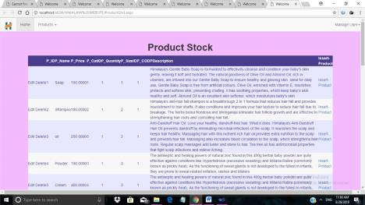

PurchaseProductGrid.aspx
Source code:

<%@ Page Title="" Language="C#" MasterPageFile="~/AdminMaster.master" AutoEventWireup="true" CodeFile="PurchaseProductGrid.aspx.cs" Inherits="PurchaseProductGrid" %>

<asp:Content ID="Content1" ContentPlaceHolderID="ContentPlaceHolder1" Runat="Server">

<form id="form1" runat="server">
<h1 align="center">Purchase List</h1>

<asp:GridView ID="GridView1" runat="server" AutoGenerateColumns="False"

AutoGenerateDeleteButton="True" BackColor="White"
BorderColor="#E7E7FF" BorderStyle="None" BorderWidth="1px" CellPadding="3"

DataKeyNames="PurchaseID" DataSourceID="SqlDataSource1"

GridLines="Horizontal">

98

<AlternatingRowStyle BackColor="#F7F7F7" />

<Columns>

<asp:BoundField DataField="PurchaseID" HeaderText="PurchaseID" InsertVisible="False" ReadOnly="True" SortExpression="PurchaseID" />

<asp:BoundField DataField="U_ID" HeaderText="U_ID" SortExpression="U_ID" />
<asp:BoundField DataField="PIDSizeID" HeaderText="PIDSizeID"

SortExpression="PIDSizeID" />

<asp:BoundField DataField="CartAmount" HeaderText="CartAmount"

SortExpression="CartAmount" />
<asp:BoundField DataField="CartDiscount" HeaderText="CartDiscount"

SortExpression="CartDiscount" />

<asp:BoundField DataField="TotalPayed" HeaderText="TotalPayed"
SortExpression="TotalPayed" />

<asp:BoundField DataField="PaymentType" HeaderText="PaymentType"

SortExpression="PaymentType" />
<asp:BoundField DataField="Status" HeaderText="Status"

SortExpression="Status" />

<asp:BoundField DataField="DateOfPurchase" HeaderText="DateOfPurchase"

SortExpression="DateOfPurchase" />

<asp:BoundField DataField="Name" HeaderText="Name" SortExpression="Name" />

<asp:BoundField DataField="Address" HeaderText="Address"

SortExpression="Address" />
<asp:BoundField DataField="Pincode" HeaderText="Pincode"

SortExpression="Pincode" />

<asp:BoundField DataField="MobileNumber" HeaderText="MobileNumber"
SortExpression="MobileNumber" />

<asp:BoundField DataField="Quantity" HeaderText="Quantity"

SortExpression="Quantity" />
<asp:BoundField DataField="cancel_date" HeaderText="cancel_date"

SortExpression="cancel_date" />

<asp:HyperLinkField DataNavigateUrlFields="PurchaseID" DataNavigateUrlFormatString="CancelOrder.aspx?PurchaseID={0}" HeaderText="Cancel" Text="Cancel" />

</Columns>

<FooterStyle BackColor="#B5C7DE" ForeColor="#4A3C8C" />
<HeaderStyle BackColor="#4A3C8C" Font-Bold="True" ForeColor="#F7F7F7" />

<PagerStyle BackColor="#E7E7FF" ForeColor="#4A3C8C" HorizontalAlign="Right" /> <RowStyle BackColor="#E7E7FF" ForeColor="#4A3C8C" />
<SelectedRowStyle BackColor="#738A9C" Font-Bold="True" ForeColor="#F7F7F7" />

<SortedAscendingCellStyle BackColor="#F4F4FD" />

<SortedAscendingHeaderStyle BackColor="#5A4C9D" />

<SortedDescendingCellStyle BackColor="#D8D8F0" />
<SortedDescendingHeaderStyle BackColor="#3E3277" />

</asp:GridView>

<asp:SqlDataSource ID="SqlDataSource1" runat="server"
ConnectionString="<%$ ConnectionStrings:RuksarConnectionString %>"

SelectCommand="SELECT * FROM [tblPurchase]" UpdateCommand="Update [tblPurchase]

Set[PurchaseID]=@PurchaseID, [U_ID]=@U_ID, [PIDSizeID]=@PIDSizeID, [CartAmount]=@CartAmount, [CartDiscount]=@CartDiscount, [TotalPayed]=@TotalPayed, [PaymentType]=@PaymentType, [Status]=@Status, [DateOfPurchase]=@DateOfPurchase, [Name]=@Name, [Address]=@Address, [Pincode]=@Pincode,[MobileNumber]=@MobileNumber, [Quantity]=@Quantity, [cancel_date]=@cancel_date where[PurchaseID]=@PurchaseID" DeleteCommand="Delete from [tblPurchase] where[PurchaseID]=@PurchaseID "></asp:SqlDataSource>

</form>
</asp:Content>

99

Output:
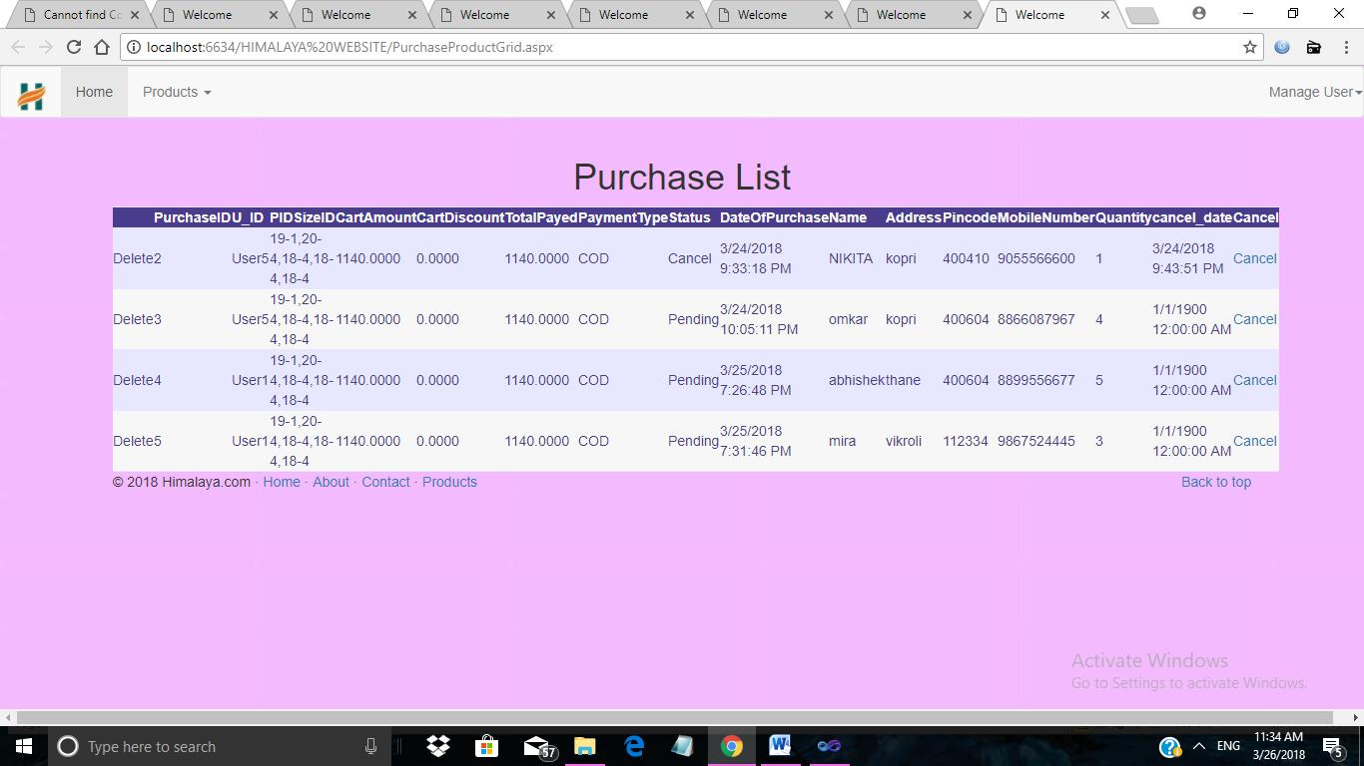

100

Reports Layout:

Customer Report:
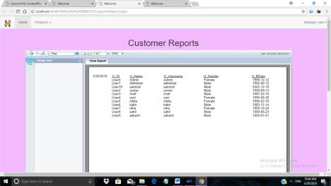

ProductReport:

101
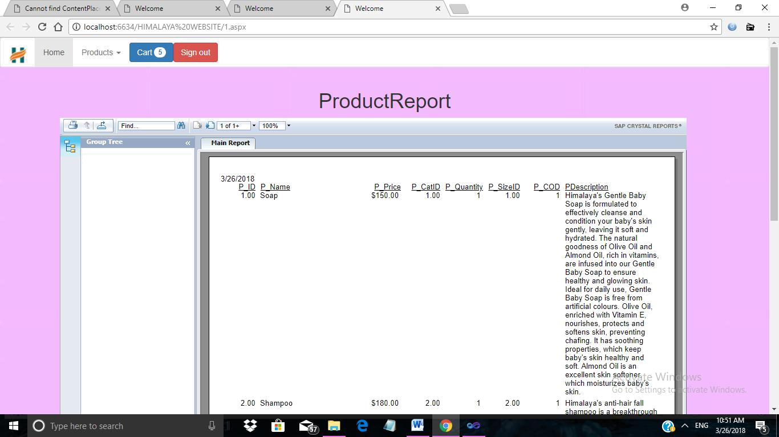

PurchaseReport:
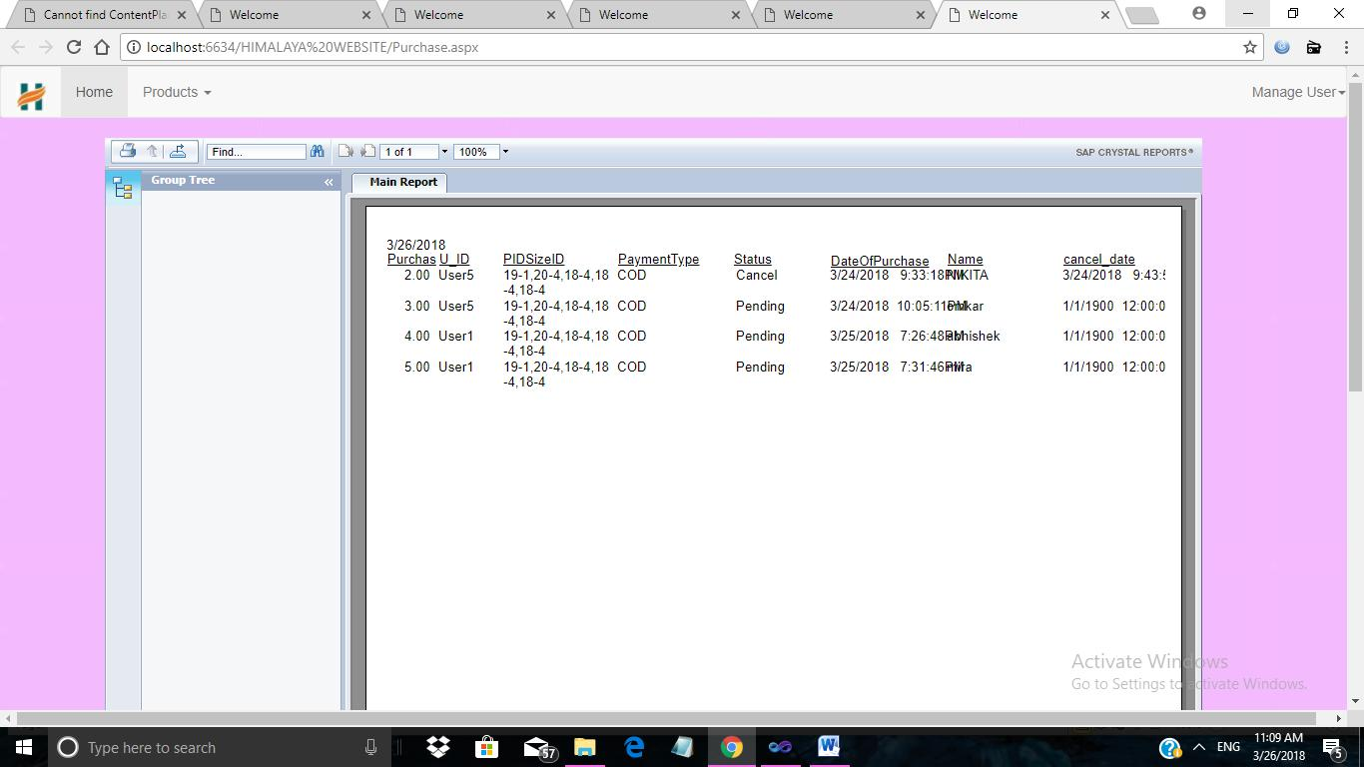

102
6.Future Enhancements

Electronic Commerce is exactly analogous to a marketplace on the Internet. Electronic Commerce (also referred to as EC, e-commerce eCommerce or ecommerce) consists primarily of the distributing, buying, selling, marketing and servicing of products or services over electronic systems such as the Internet and other computer networks.

Currently the software can only take payments through Cash on Delivery. In future the software can be upgraded so that it can be easily integrated with other online payment gateways like:

- Authorize.net

- WorldPay

- LinkPoint

- CCAvenue

Moreover, in future more products can also be added in the online shopping system. In future, the software can be used to process almost all major currencies. Different language support can also be added to it in future upgrades.The online shopping system requires more secure encryption to provide more secure transaction.Live support should be enabled.

103

7.References and Bibliography

To developed this web application of online shopping system we use Asp.net as front End and sql server as back end. We take some knowledge from that are given below:

- C# 6.0 and the .NET 4.6 Framework by AndrewTrorlsen

- Introducing Microsoft Sql server 2014 by Ross mistry

Web Reference:

- www.stackoverflow.com

- www.w3schools.com

- www.titan.co.in

- www.plus2net.com

104

