ReeferON DF Application
Project Report
Date: 05 Nov 2026
1. Purpose
This application is made to manage deep freezers placed at retail stores for ReeferON. Its purpose is to keep a clear record of which freezer is at which store, with store contact and location details. It also supports field checks so the team can confirm that the freezer is still at the outlet through KYC, photos, and GPS. Staff can open photos, fetch live device location, auto-fill map coordinates, and save that live location to the store profile. When a freezer moves to another store, the system keeps full history while the Unique Freezer ID stays the same. In short, this app gives one place for freezer identity, store link, QR scan, live location, and field verification.
2. Problem
Before this system, freezer tracking was hard and easy to get wrong. Freezers often move between stores, but paper or Excel records stay old or get lost. The same machine can receive different IDs in different sheets, so duplicate and mixed data grows over time. Field staff cannot quickly find the correct store profile when they are on site. There is also no strong proof that a visit or KYC was completed, such as photos, GPS, and date. Managers cannot see live numbers like total freezers, active stores, and KYC due list. Even if QR tags are used, they are not always linked to one stable Unique Freezer ID. Because of this, asset control stays weak, field work becomes slow, and audit trails remain poor.
3. Solution
We built a web application using PHP and MySQL that works on both phone and desktop. Every freezer gets one Unique Freezer ID, and this ID never changes. Blank QR tags are printed, stuck on the freezer, and then scanned in the field. If the tag is new, the staff creates the store and freezer profile. If the tag is already assigned, the app opens that freezer profile. Store details, photos, GPS, and contact information stay linked to the profile. Users can click store or map images, fetch the phone live location, see latitude and longitude auto-filled on the form and map, and save that live location for the store. KYC can be done from the profile, or after a scan when starting from the list. Photos and results are saved for each check. If a freezer moves, placement history is updated while the Freezer ID remains the same. The dashboard and system logs give managers a clear live view. The simple field flow is: print QR, scan, register or open profile, then complete KYC when due.
4. Features
The application supports secure login with roles for Super Admin, Technician, and Viewer. An operations dashboard shows freezer count, active outlets, and KYC done or due status. Unique Freezer IDs are generated automatically from type, brand, model, location, install date, and PIN. QR printing and camera scan are available so an unused tag creates a profile and an assigned tag opens the existing profile. Each store and freezer profile stores address, zone, city, PIN, photos, and contact details.
Image click and map view help staff check store photos and location on screen. Live location capture reads GPS from the user device, auto-fills latitude and longitude, shows the pin on the map, and lets the user save that live location to the store record. KYC verification captures photos, GPS, pass or fail result, and the check cycle. Store history shows placement and KYC records in an Excel-style table. When a freezer is transferred, history is kept and the Unique Freezer ID does not change. Import and export support CSV and Excel for bulk work. System logs record login and key actions for admin review. The interface is mobile friendly so field teams can use it on a phone.
— End of report —
LOGIN PAGE
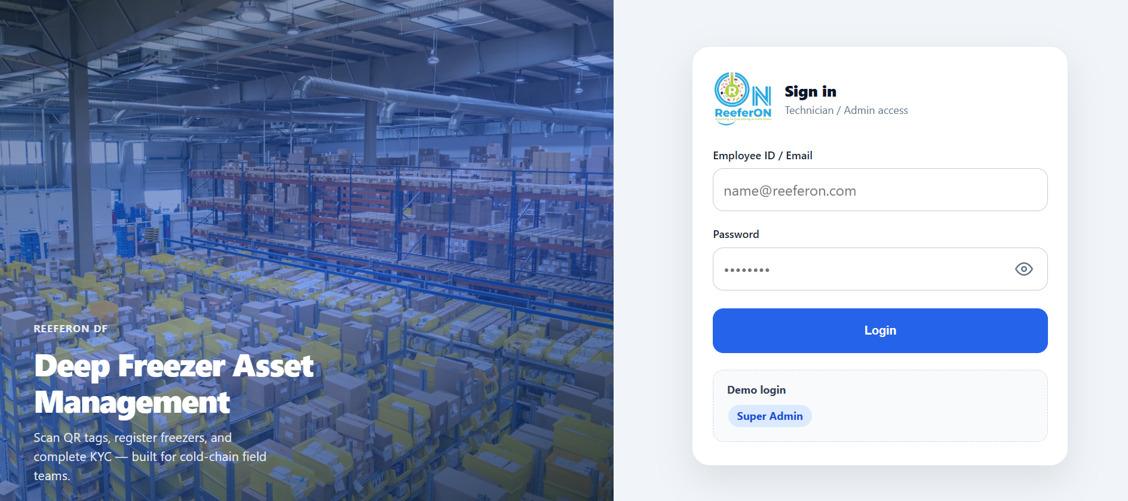
Dashboard
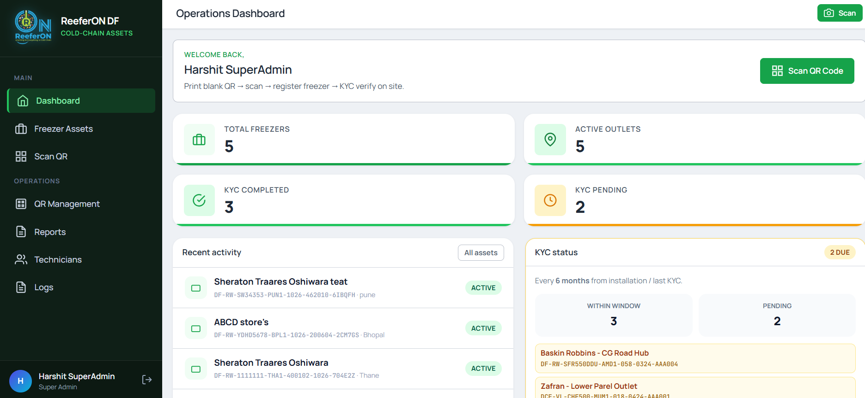
Freezer & Store Profiles
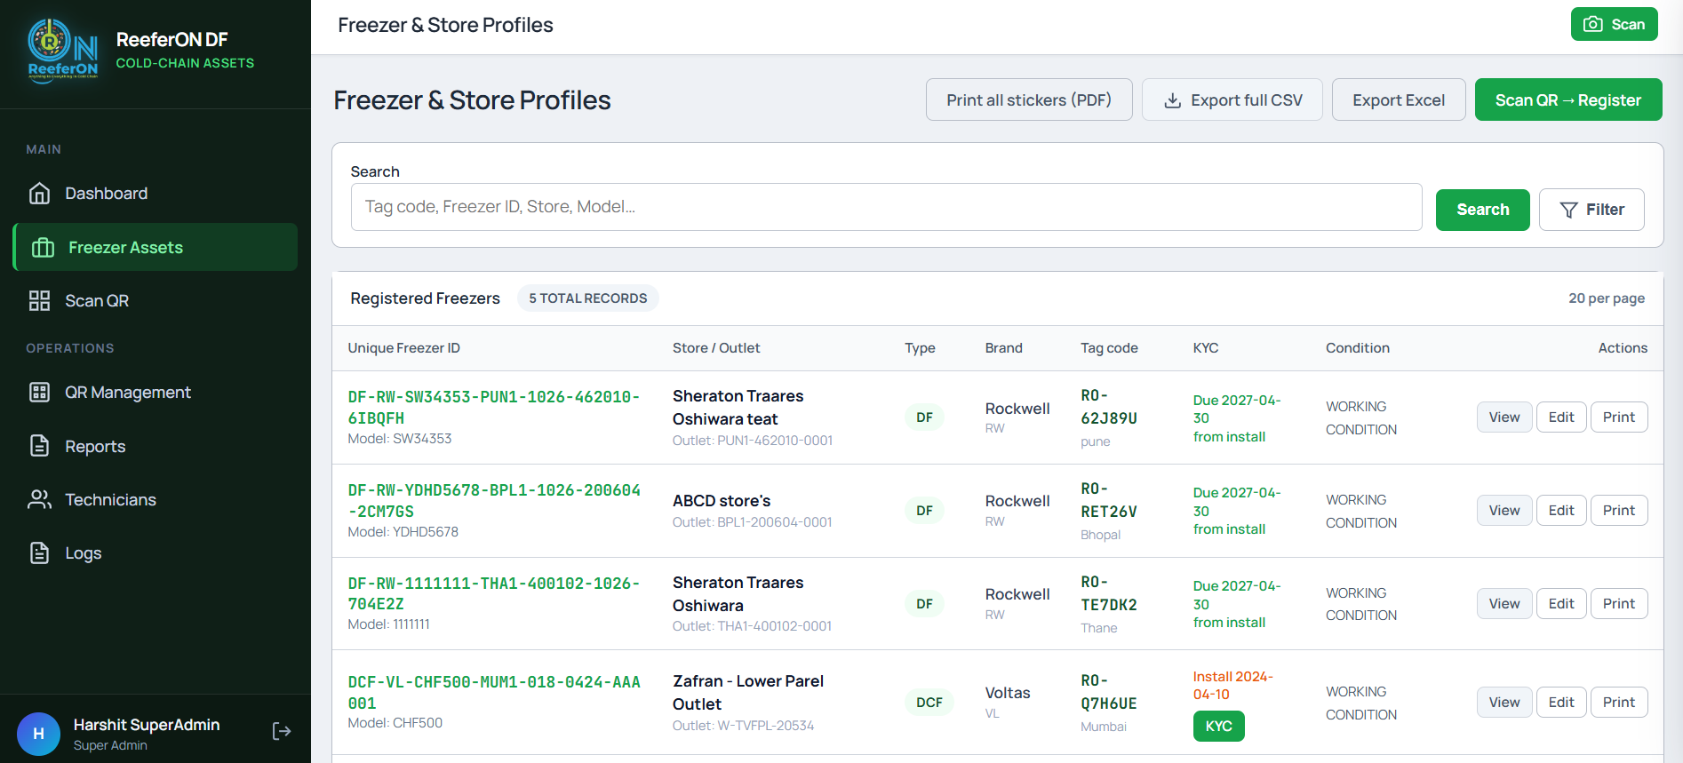
Scan Freezer QR Tag
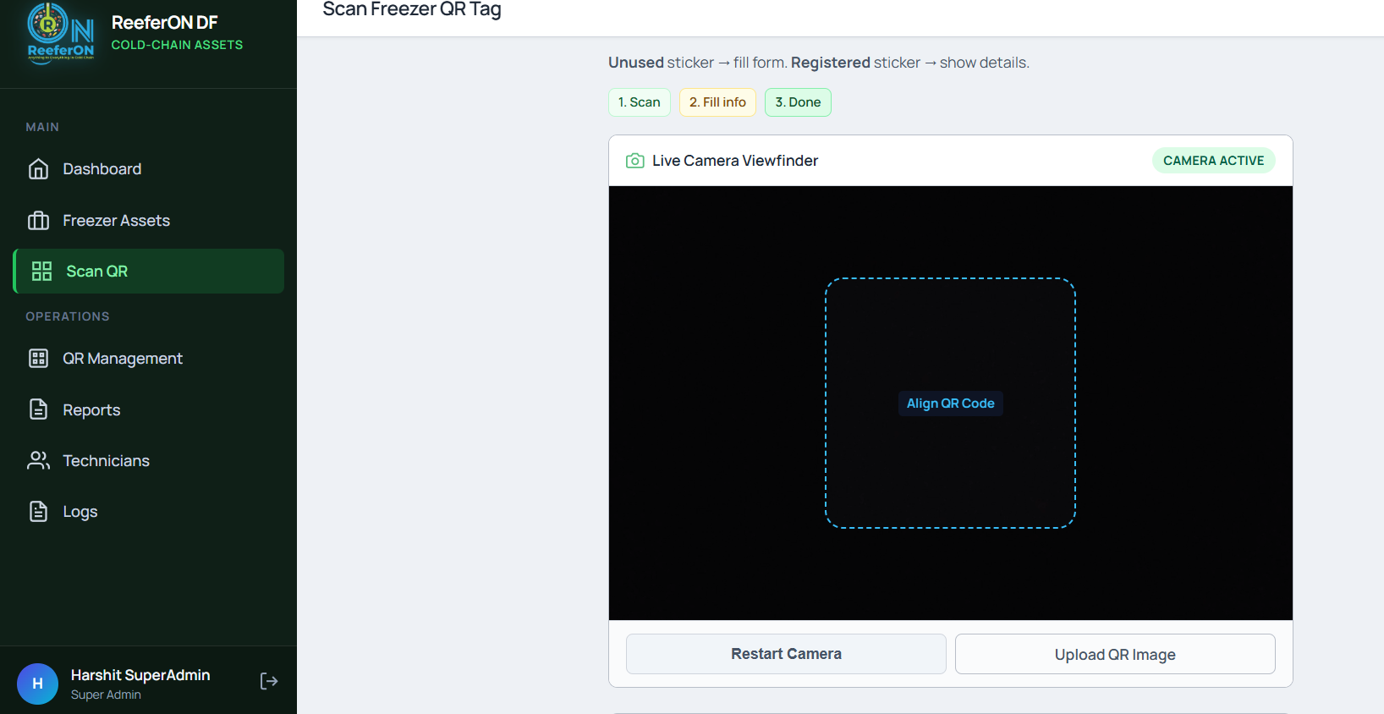
Blank QR Tags
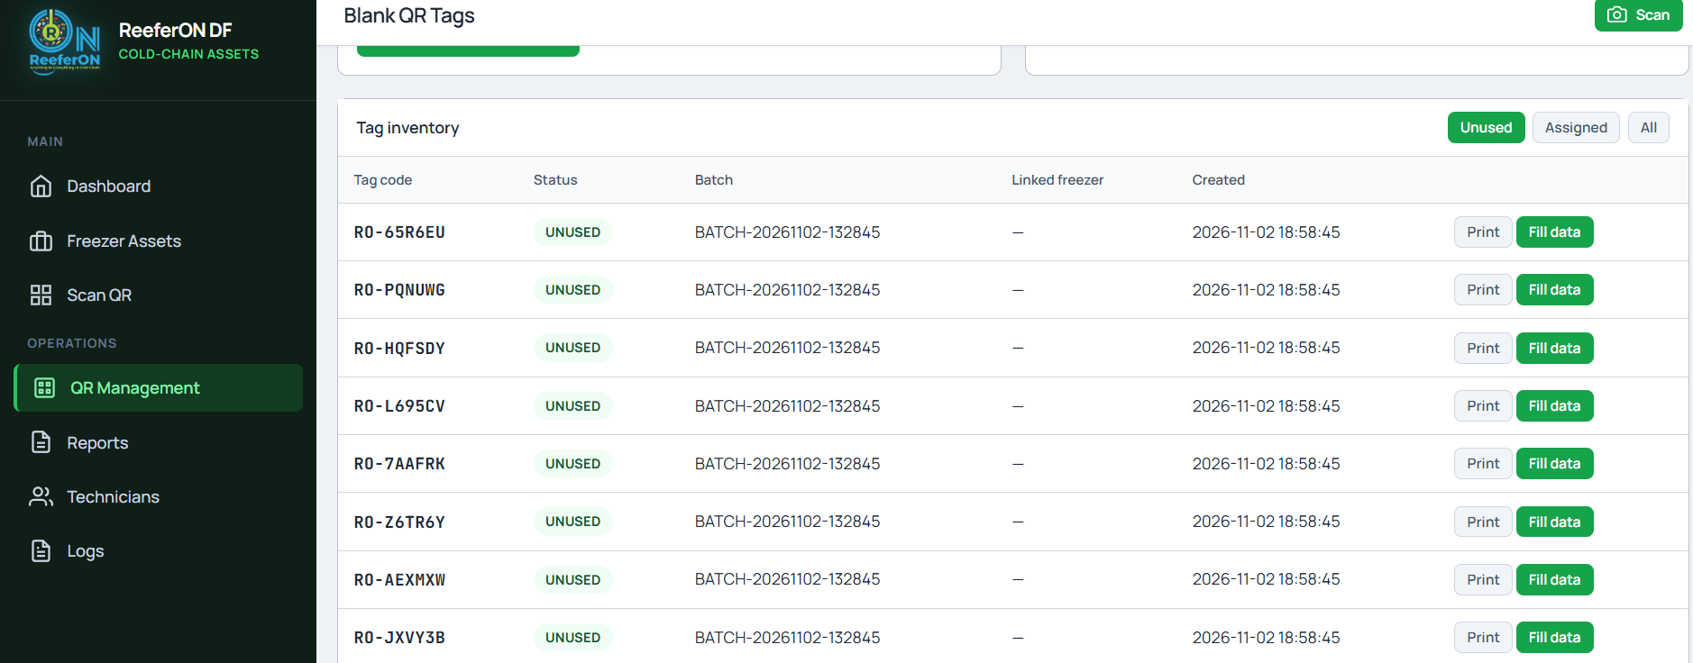
Role access details


