Project Description: Create a web application that allows an organization to create an online evaluation of performance. This should include the ability to create an evaluation template that contains topics, subtropics, and sub-subtropics (along with their descriptions), each of which can be evaluated according to a user-deﬁned scale,also allowing for comments. Once an evaluation template has been created, the system should allow an evaluator to use the template to evaluate a set of people, drawn from a database. The evaluation, along with the history of previous evaluations of the person, should be automatically emailed to those being evaluated, along with others that the evaluator would like to designate.
Sponsor: Greg Heileman, heileman@unm.edu

Team: Rahul Poddar (rahulp@unm.edu), Apoorva Sateesh (apoorva@unm.edu), Bhim
Subedi (vimu@unm.edu), Lakshmi Vadrevu (lsaisidd@unm.edu), Sigi Wang
(ang47@unm.edu), Ruicong Yuan (ruicong@unm.edu), Ruifu Zhou
(markzhou@unm.edu).

EVALUATOR
About
The project is about creating an evaluation/survey which would enable a user to create his own evaluation or select from existing evaluations and evaluate on the scale of 5. The user would be able to add his own set of questions in a predefined form and create a full-time survey. The result will be generated as a bar graph which is depicted at the evaluation results page. The bar graph is the function of the averages of all answers to a particular question. So this feature was included to let the user know what the average response of the people was towards the question he posted. This application was a small effort to show what’s shown generally on a survey site.
Structure of Application:
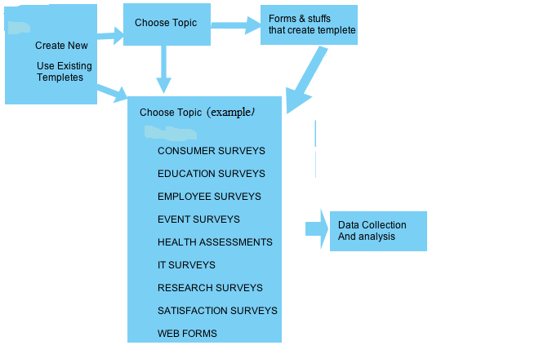

Database Model
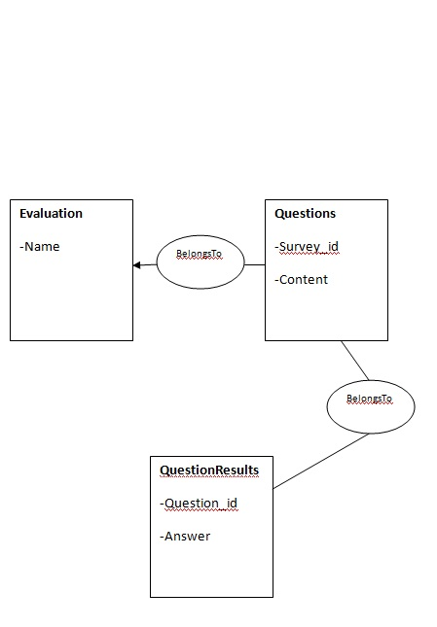
Team Members Contribution
Our team members in this project are:
- Rahul Poddar- He majorly did the front end and back end (structure and code ) of the project, along with some part of the CSS. Also did the documentation of the application.
- Vadrevu Lakshmi Sai Siddhartha- He majorly did all the styling part of the application and help in coding. Also did the documentation of the application.
- Apoorva Sateesh : General Testing and helped in CSS.
- Bhim Subedi : Test cases with Cucumber.
- Ruifu Zhou:Tried to apply star rating to graphs.
- Yuan Ruicong: Tried to apply draft CSS to sign-in and sign-out function.
- Sigi Wang: Tried to apply star rating to graphs.

References:
1) Railcast Tutorial.
2)Various threads and javascripts provided at stackoverflow.com.
3) Jquery website
4)W3schools.com and other websites for CSS.
5) Javascript for Bar chart Growth from stackoverflow.

