**CS551 Advanced Software Engineering**

**First Increment Report**

**Project Title: PickMeUp**

**Submitted by**

PG6 (SG14 and SG15)

Ponnada Rahul (Class ID-39)

Ghanta Surya Prabha (Class ID-19)

Tummala Anvesh (Class ID-48)

Anumolu Satish Chowdary (Class ID-2)

**Import Existing Services/API**

The project implements three web services each one for a different purpose. The web services are as follows Student and volunteer login, student registration and volunteer registration. There are no external API used as of now. The main purpose of these web services is to validate the student and volunteers then register their details to a centralized storage.

Login web service for students and volunteers to login

Registration web service for students and volunteers to register with the app

**Detail Design of Services**

**User Stories:**

We have four stories in iteration1

1. As a student/admin/volunteer I want to create an account so that I can log-in to access the services provided
2. As a student I want to log-in to my account so that I can access the services provided
3. As a volunteer I want to login to my account so that I can access the services provided
4. As an admin I want to login to my account so that I can access the services provided

**Service description:**

Login webservice takes *student id* and *password* as parameters. Then the service authenticates whether the specified student exists or not. If a student exists, then his password is authenticated against the password from his record from a centralized database. Hence, this service connects to the underlying database to fetch passwords of the respective users for validation. Student and volunteer registration webservice are pretty much similar except in the parameters they provide and underlying database table they access. It validates the data provided by these two users and records those data onto a database table for further accessing.

These web services return JSON data back to the client to verify the operation has successfully completed on the server side. REST uses JSON as it data exchange format so as in here for all the web services. Microsoft SQL server is the persistence storage that these services store data on to table and retrieve them for later verification, validation and population purposes.

**Sequence diagrams:**

Student/Volunteer Login sequence

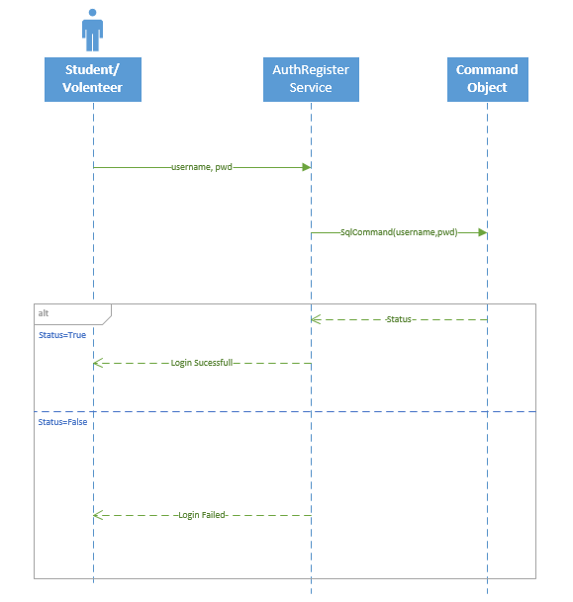

**Student/Volunteer registration:**

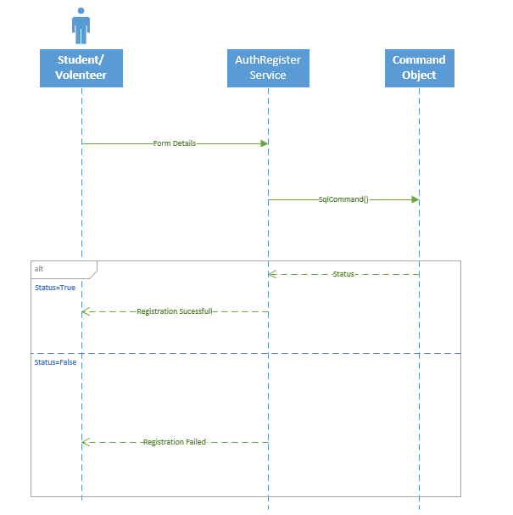

**Class Diagram:**

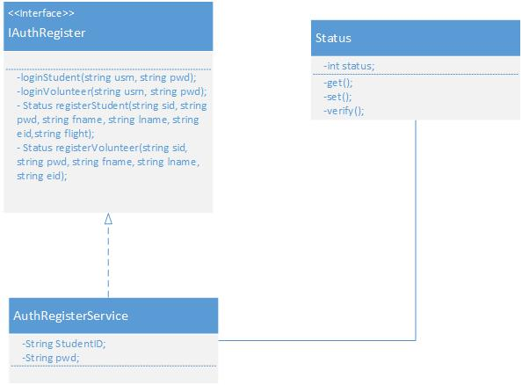

**Design of Mobile Client Interface:**

Mobile client interface is an Android application which is a rich client. An application is considered rich client if it has all the UI required on client’s side. As of now for the first iteration app consists of six different screens. One start up page which prompts user to select student or volunteer. A login page for student and volunteer. Two different registration pages each one for student and volunteer. Two home screens, one for student and one for volunteer. Overall UI design is developed using Android studio and is XML based.

User Interacts by a touch based smartphone there by navigating to other screens and perform operations on the server. Typical mobile client flow of operations is as follows. When the student or a volunteer install the app, they are asked to identify themselves (to distinguish between student and volunteer). Then they are redirected to a login page where already existing users can login and new users can register. On registration, user is prompted to login and the user either student or volunteer can see their respective welcome pages if the login is a success.

**Implementation**

**Implementation of REST services:**

WCF (Windows Communication Framework) is used to implement REST web services on Visual Studio 2010. Web service project has an endpoint IAuthRegister.cs, which is also called as contract and Implementation of these resources is in AuthRegister.svc.cs. The implementation has several resources implemented and are ready to be consumed from a client. Resources communicates directly to the underlying database. Login service validates the existing student and volunteer. Registration service saves both student and volunteer information in the system.

**Implementation of user interface (Mobile Apps):**

Android studio is being used to implement the Mobile App. User Interface of the app is XML based and is relatively changeable to the screen size. Different activities were included in the project for navigation to different screens. Validations are achieved using java coding. If all the validations are passed then the app makes a HTTP request to consume the web service by including several parameters in the URL of the web service. Basically the user interface include several widgets used from the tool box of Android Studio IDE.

**Implementation of test cases:**

**Testing: Perform Unit testing (using NUnit tool)**

**Report:**

**Screenshots**

**Project Management:**

ScrumDo Link: <http://www.scrumdo.com/projects/project/umkc_pg6/iteration/119777>

**Implementation status report:**

**Work Completed:**

1. **Description:** As a student/admin/volunteer I want to create an account so that I can log-in to access the services provided

Responsibility: Rahul

Time Taken: 20 hrs

Contribution: 100%

1. As a student I want to log-in to my account so that I can access the services provided

Responsibility: Satish

Time Taken: 20 hrs

Contribution: 100%

1. As a volunteer I want to login to my account so that I can access the services provided

Responsibility: Anvesh

Time Taken: 20 hrs

Contribution: 100%

1. As an admin I want to login to my account so that I can access the services provided

Responsibility: Prabha

Time Taken: 20 hrs

Contribution: 100%

**Work To be completed:** None

**Issues/Concerns:**

* There are few compatibility issues using Visual Studio 2010 & 2013
* Data type conversion issues when inserting data into the database
* Build issues were there