Complete Exercises 12.8 and 12.9 on page 550 in Deitel's *Java How to Program* (Early Objects), 10th Edition, and shown below:

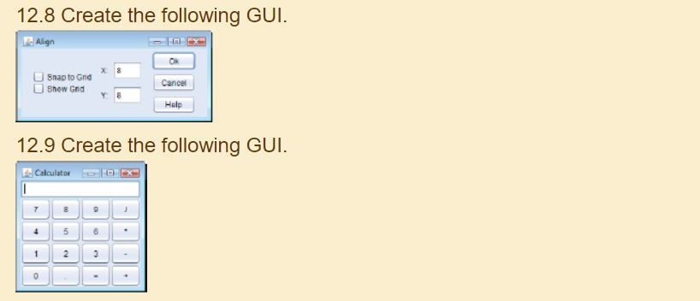

Even though the original exercise in the text says do not code functionality for either GUI, please add a minimum of event handling. Do NOT add any more functionality than described here, though, or you will earn 0 points.

Display the name of the component object on which the event occurred. If it is a check box, indicate if it was checked or unchecked. If it is an entry field, display what was entered in the form of a string. Note that it is important to name the component objects so that each is clearly indicated. Use JOptionPane's showMessageDialog for displaying all events.

Fully document your files and submit only four .java files, a GUI and test file for 12.8 and a GUI and test file for 12.9.