INSTITUTE OF COMPUTER TECHNOLOGY
B-TECH COMPUTER SCIENCE ENGINEERING 2025-26
SUBJECT:-MICROCONTROLLER & APPLICATIONs

NAME: Rahul Prajapati
ENRLL. NO: 23162171020
BRANCH: CYBER SECURITY
BATCH: 52

PRACTICAL_10
AIM: Write a program to convert a parallel data received on port 1 into serial data to be sent on P2.0 bit by bit with a delay of 500ms between each bit. Assume 11.0592 MHz crystal frequency. Connect the LED & CRO on output pin in proteus module to show the output bits.
CODE:
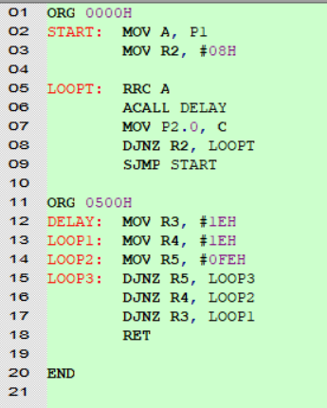

OUTPUT:
https://drive.google.com/file/d/1zMekRiTFKe3d2Kg6E_wn97pVH24uc8tc/view?usp=sharing
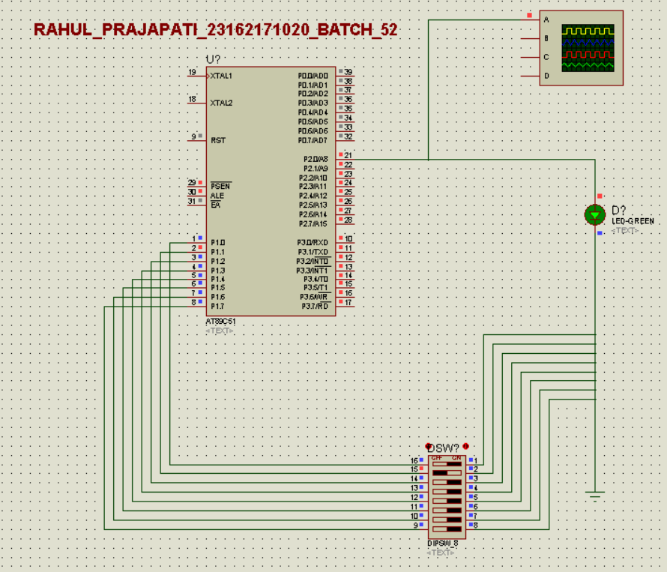
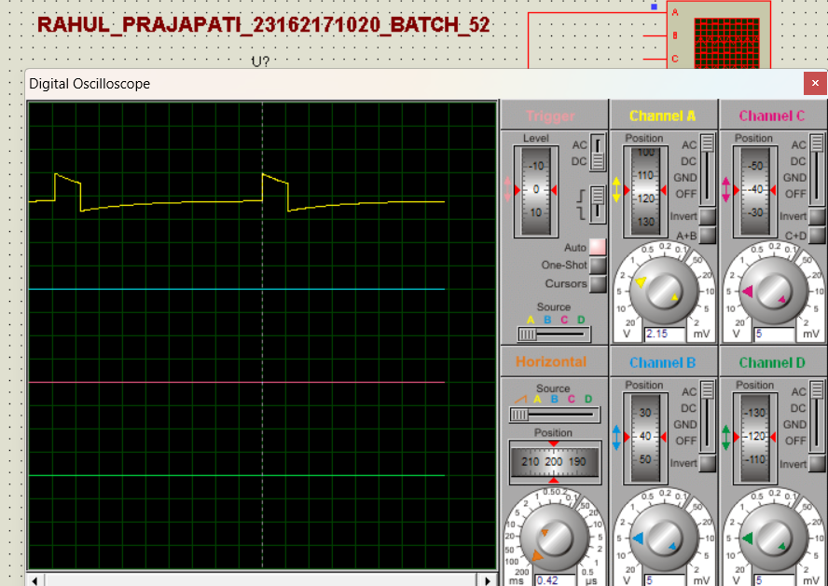
CALCULATION:
