Assignment Report

**Names:** Sai Rahul Prasad Nagumantri, Fernanda Oliveira

**Tech:** Python, Flask, SQL and Postman.

**GitHub Link:** <https://github.com/rahulprasadns/REST-calls>

**Work division:** Rahul worked on API creation and Fernanda worked on Database creation and Database Intent Creation with FeeDue Class. We took 4 hours to complete this assignment in total and we shared the work using GitHub

**Report:**

1. Creating Database:

1. Creating Flask Application:



1. Create:

1. Read data:

1. Update Data:

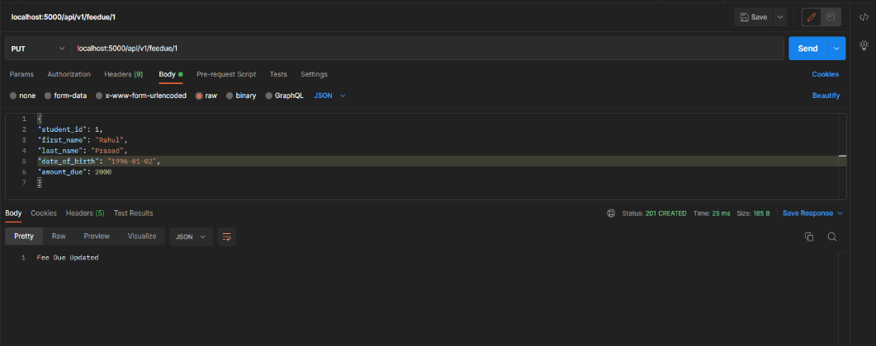

After update:

1. Delete Data:

After delete:

1. Showing all data:

1. Presentation – Postman (Screenshots attached above)
2. GitHub Link: <https://github.com/rahulprasadns/REST-calls>
3. Work Collaboration: Rahul worked on API creation and Fernanda worked on Database creation and Database Intent Creation with FeeDue Class. We took 4 hours to complete this assignment in total and we shared the work using GitHub