FINDING MISSING PEOPLE

RAHUL, MUKUL DIXIT AND ATUL PATEL

ABSTRACT

Facial recognition is an advanced application of Artificial intelligence that mathematically maps a particular person’s facial features and stores that information. Using the technique of facial recognition, the information regarding the face of a person is saved mathematically or in the format of graphs in the database, which is used for detecting the particular person’s face [5]. In our project, PEOPLE-FINDER, the recognition system will find a match for that person in the database. If a match is found for the unclaimed child or old person, it will be notified to the police, authorities, agencies, and guardian of that person.

In this paper, we will use FaceNet, which is based on deep learning and will detect faces with the maximum accuracy, to find the missing person.

This recognition system focuses on countless people who are missing, as well as children who remain unclaimed. Finding the missing person is the biggest advantage of any recognition technique. For this purpose, we will create a web application that will use FaceNet to recognize the missing person and search the database for facial prints; if successful, it will display the results and notify the authorities. [5]

KEYWORDS: FaceNet Pytorch, FaceNet, Face recognition, missing person, recognition

1. INTRODUCTION

Over the last decade, Facial recognition systems have tremendously developed. As far as we are concerned about legal proceedings, biometrics has become a very vital element. In today's world, where the headlines never fail to grab headlines about kidnapping, missing people, and human trafficking, biometrics comes into the light, where facial aspects of the person are found to be the most crucial. Whenever a suspicious person is found doing laborious tasks in a place where they should not belong, this ignites a spark of doubt in the minds of citizens about whether the person belongs to that occupation or not. Due to the lack of resources, the citizen fails to recognize and understand the whole scenario and fails to become a vigilant citizen of the nation. This led to the sacrifice of thousands of innocent people due to the negligence of the people. If there are resources that are easily accessible to help them and can identify those suspicious activities, then citizens will be able to help

and the world would have prospered with every citizen of the nation taking the charge.

Despite the efforts of government officials, non-governmental organizations (NGOs), and other societal authorities, 400 people remain unidentified after being reported missing. It is a big issue to worry about in a country where children and youth constitute 50% of the population. There is a need to put a stop to illegal activities like human trafficking, kidnapping, and prostitution, where children and innocent people are forced to participate with no hope of help. There is only this way through which these people could be tracked down quickly and safely. But when these issues arise, the matter directly falls into the hands of the police, who do not have the required resources and information for further proceeding. We can save these lives using our presence of mind and powerful resources such as social media by posting pictures on social platforms and becoming vigilant citizens. [5]

The unclaimed children remain the same as these issues, a survey states that, on average, 174 children go missing every day in India. Most of them do not know their way back home. So our project, People-Finder, focuses mainly on these unclaimed children who are unclaimed and do not know their way back home.

1. Literature Review

Every day, hundreds of people go missing throughout the world due to kidnapping and trafficking. They developed an Android application using Python and desktop software for common people as well as for police stations. They use a facial recognition algorithm based on KNN. These applications and software are used to safely trace missing people in less time [1]. According to M. Geetha, R.S. Latha, S.K. Nivetha, S. Hariprasath, S. Gowtham, and C.S. Deepak, after the pandemic situation, most schools and many other places used face recognition systems for the detection of people. The face recognition system captures images from a camera and analyses the patterns based on the person's facial details, such as eyes, nose, mouth, and chin. It also helps in monitoring the students during exams as well as the attendance system. A machine-learning approach is used to predict the faces of people from the video as input. Firstly, the model is trained for multiple face datasets, and after that, it searches the faces in the video to identify people. After procuring proper training, the approach could be utilized for the prediction of any person or list of persons from a video stream. Faces are also used in biometric authentication, so it is easy to match the faces from the video [2]. According to the research by Neha Gholape, Ashish Gour, and Shivam Mourya, facial feature extraction for tracking and face recognition is performed using machine learning, deep learning, and artificial intelligence. This paper demonstrates a brief survey of various techniques explored for face detection. This paper also shows a variety of difficulties and applications of face identification. Various databases for face identification are also mentioned in the later stages, along with their aspects [4]. According to Sankar Pawar, Lalit Bhadane, Amanullah Shaikh, Atharv Kumbhejkar, and Swati Jakkan, the information on the face of a person is saved mathematically or in the format of graphs in the database and further used for detecting the particular face. If a match for a missing person is found in the database, the police and the person's guardian will be notified. They use the ideas of the AWS facial recognition algorithm, which is based on artificial intelligence (AI)[5]. Sandeep Kukreja and Rekha Gupta have improved a face identification system using principal component analysis (PCA) to obtain features from the various facial images and minimize the dimensionality of each image and KNN to categorize data. When images are taken in low light, the competency of the color information is the most important factor [6]. In their research, Sharma S., Karthikeyan Shanmugasundaram, and Sathees Kumar Ramasamy use efficient techniques for face recognition systems based on convolutional neural networks (CNN). Face alignment with Dlib is used to improve the true acceptance rate (TAR) and decrease the false acceptance rate (FAR). The work has been done on the Face Recognition Grand Challenge (FRGC) dataset, giving an accuracy of 96% with a FAR of 0.1 [7]**.** Di Wang, Ding Wang, Hongzhi Yu, and Guanyu Li use CNN, which can effectively reduce the complexity of feedback neural networks. CNN can directly input the original image so that the image processing becomes simple. It also has distortion invariance and image translation rotation. Instead of using a standard manual feature extraction method, it uses the raw pixel strength of the input image as a flat vector so that it has excellent processing ability for two-dimensional data, such as voice and image [8]. An improved face recognition algorithm based on CNN with an extended local binary pattern (ELBP) and a deep convolutional generative adversarial network (DCGAN) is proposed. They use DCGAN to generate new face pictures from existing ones. They adopt an extended LBP feature value extraction method to reduce the impact of illumination and improve training efficiency. To reduce the amount of calculation, DCGAN replaces the connected layer of CNN with a pooling layer and uses deconvolution and convolution instead of pooling [9].A security system is designed and implemented based on machine-learning algorithms. As a result, it is suggested that a system that identifies and recognizes faces using effective techniques that are most effective for humanity be designed and implemented. The algorithm that best represents the faces economically is principal component analysis (PCA) [10]. Based on research by Yuxiang Zhou, Hongjun Ni, Fuji Ren, and Xin Kang, they proposed two modules: face recognition and gender recognition. Face recognition and gender recognition modules extract facial and gender features from images using pre-trained CNNs. In face recognition, the public datasets LFW and YTF are used to train CNN, which improves precision. For gender recognition, they used the public dataset Adience to train CNN and improved the accuracy from 91.80% to 93.22%. In this, they combine face recognition with gender recognition to be implemented simultaneously [11]. According to the research of Sudha Sharma, Mayank Bhatt, and Pratyush Sharma, face recognition systems compare face images with a set of multiple images called a dataset. Initially, the identification of faces was done by unique facial characteristics such as the nose, eyes, and forehead area. Face recognition systems are used on multiple devices, such as mobile. They increased recognition accuracy by using PCA and linear discriminant analysis [12].

1. Methodology
2. **MODEL-USED:**

FaceNet was proposed by Google researchers in 2015 and is widely used as a facial recognition system. It makes use of the dataset that has labelled faces in the wild.

FaceNet is a system that uses deep learning architectures such as ZF-Net and Inception Network to generate high-quality face mapping from input (images). It makes use of the method triplet loss function as a loss function to train this architecture. [13]

**Architecture:**

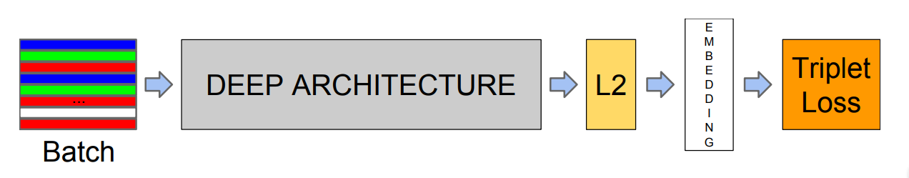

Its elementary infrastructure makes use of ZF-Net, or Inception Network. Several 1x1 convolutions are added to further reduce the number of parameters. This approach results in an embedding of the image f(x) with L2 normalization performed on it. then the loss function receives those embeddings from the previous phase. The loss function's ultimate goal is to create a squared distance between two image embeddings. [13]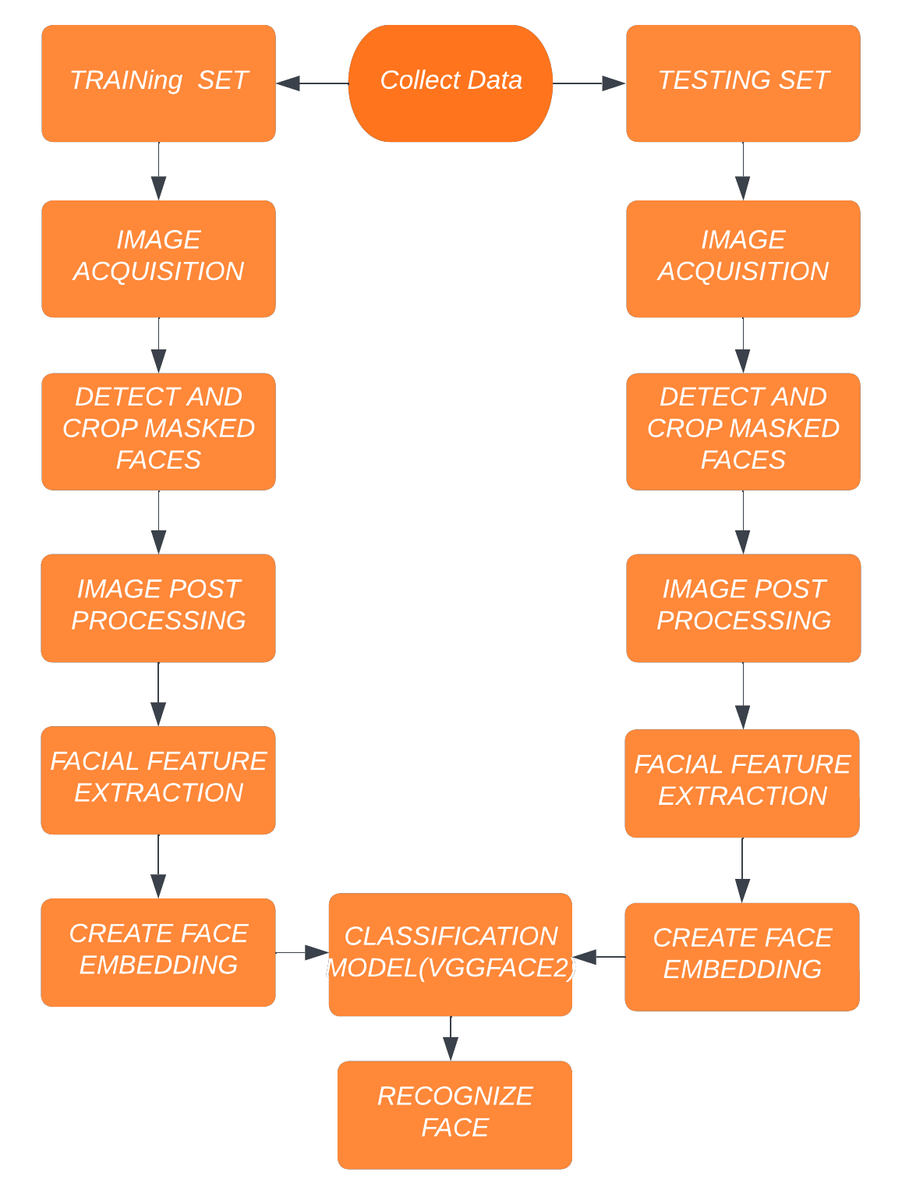.

Flowchart of the methodology

1. **Dataset**

The dataset was acquired from the Kaggle website, which was released by the Ministry of Environment and Forests and the Central Board of India under the National Data Sharing and Accessibility Policy (NDSAP) for the years 1900–2015. The dataset contains 4000+ images of 105 different people. The dataset contains different faces from different angles, and this dataset is divided into 70% for the training and 30% for the testing. The dataset is pre-processed and given to the model.

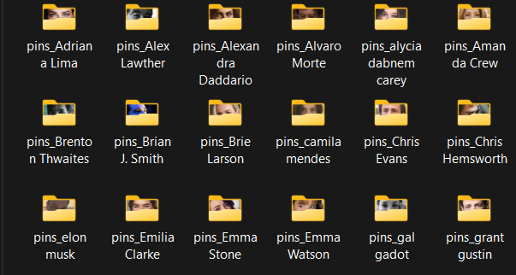

Fig: DataSet

1. **Tools and Technologies:**

Our People-Finder is a web application that is integrated using different technologies and tools, as mentioned below:

**HTML**: HTML stands for Hypertext Markup Language. It is the standard markup language used to create web pages and other information that can be displayed in a web browser. HTML uses a variety of tags and attributes to define the structure and content of a web page, such as headings, paragraphs, images, and links. HTML documents are often accompanied by CSS and JavaScript to create dynamic and interactive websites.

**CSS**: CSS stands for Cascading Style Sheets. It is a stylesheet language used to describe the presentation of a document written in HTML or XML. CSS is used to control the layout, color, font, and other visual elements of a web page.

**JavaScript**: JavaScript is a programming language that is commonly used to create interactive and dynamic websites. It enables web page developers to add behaviors such as responding to user input, creating animations, and updating content without having to reload the entire page.

**Python**: Python is a high-level general-purpose language that is widely used in data processing, data science, and data mining. Python is rich with various libraries like Numpy, Scipy, Matplotlib, FaceNet, Pandas, TensorFlow, Keras, etc.

**Flask**: Flask is a popular framework written in Python for building web applications.

**Visual Studio Code**: VSCode is a widely used code editor that is used for building and debugging modern web applications. It is free and aims to provide developers with the tools they need to complete the code-build-debug cycle.

**Anaconda Prompt: Anaconda is an open-source platform for developing and running Python scripts.** Anaconda allows for performing scientific computing, data science, and machine learning efficiently.

1. **Working:**

Initially, the person will reach the police station or agency to file a complaint about his or her missing loved one. Then the operator will upload the information such as images, contact,  number, name, and age of the person.

Then this information will get stored in the database with a unique ID.

Following this, two scenarios emerge if the person's details, as well as the location where she or he was discovered, exist in the database.

Otherwise, store it in a new case.

Whoever has the missing child or person will take him or her to the police station, or the operator will register it as a new case. There will be two scenarios.

If the guardian has registered a complaint for that missing one,

else, store it in a new case.

Then, if there is a match found in the database for the missing person, the operator will contact the guardian, and if there is a match found for a person, the operator can use the id to check more images of the person with whom the match has been found.

1. **Interfaces and administrator:**

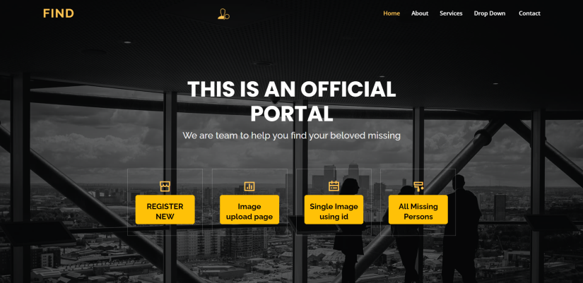

Fig 1.1

Fig 1.1 is the home page of the web application, from where the user can perform various operations like registering a new case, finding existing images, and searching images by ID.



Fig 1.2

Fig 1.2 is the interface through which the user can use the ID to search all images for the relevant ID.

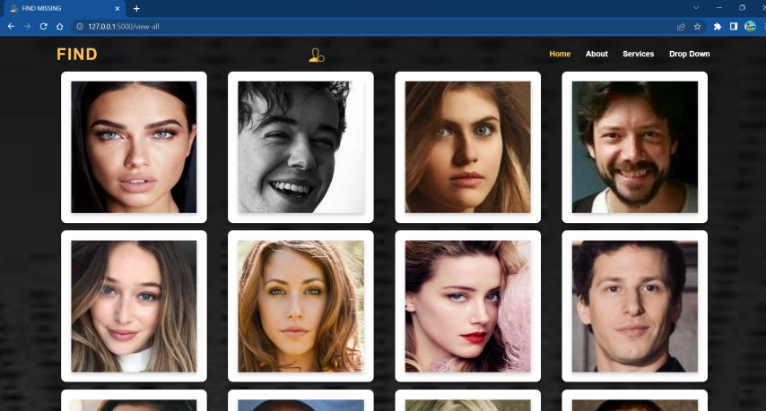

Fig 1.3

Fig 1.3 represent the interface where the operator can show all images and information of all users stored in the database.

1. Conclusion(Pending)

In this project, we have built a web application for The Guardian or the Parents of the Child. They will reach out to the nearest police or authority to make a complaint, and those authorities will have access to log in using the username and password. Then register the new case of the missing child or person, which will be stored in the database. After the submission of the details, it will show that you saved successfully. Then, after saving, the backend will check in the database to see if that image is stored there. If the child has been found and their information is in the database, the authorities will be notified of their children's location. This entire model makes the entire process of identifying the missing people easy and fast. Our system also eliminates the manual process of scanning through the database for each picture to find a match.

1. Future Scope

Our system is checking the images present in the database, and after getting the matched results, it gives the output. But we look forward to overcoming this in the future. We are planning to integrate the public cameras with our model, and we will be receiving the frames in real-time at our system using these cameras, and if the missing person is found in any of the frames, it will be notified to the concerned agency.

1. REFERENCES
2. VishakhaShelke, Gunjan Mehta, Prajakta Gomase, Trisha Bangera, “Locating missing people using an optimised face recognition algorithm” ,“International Conference on Computing Methodologies and Communication (ICCMC 2021)”.
3. M.Geetha, R.S.Latha, S.K.Nivetha, S.Hariprasath, S.Gowtham, C.S.Deepak, “Design of face detection and recognition system to monitor students during online examinations using Machine Learning algorithms” , “ International Conference on Computer Communication and Informatics (ICCCI -2021), Jan. 27 – 29, 2021”.
4. Vani Perumal, “Face Recognition in Video Streams and its Application in Freedom Fighters Discovery - A Machine Learning Approach” ,“International Conference on Machine Learning and Applied Network Technologies (ICMLANT)”.
5. Neha Gholape, Ashish Gour, ShivamMourya, “FINDING MISSING PERSON USING ML, AI”, “International Research Journal of Modernization in Engineering Technology and Science”.
6. Sanskar Pawar, Lalit Bhadane, Amanullah Shaikh, AtharvKumbhejkar, Swati Jakkan,“FIND MISSING PERSON USING ARTIFICIAL INTELLIGENCE”, “International Research Journal of Engineering and Technology (IRJET)”.
7. Sandeep Kukreja, Rekha Gupta, “COMPARATIVE STUDY OF DIFFERENT FACE RECOGNITION TECHNIQUES”, “International Conference on Computational Intelligence and Communication System”.
8. Sharma S , Karthikeyan Shanmugasundaram , Sathees Kumar Ramasamy, “CNN Based Efficient Face Recognition Technique using Dlib” , “International Conference on Advanced Communication Control and Computing Technologies (ICACCCT) 2016”.
9. . Di Wang, Ding Wang, Hongzhi Yu, Guanyu Li, “Face Recognition System Based On CNN” ,“International Conference on Computer Information and Big Data Applications (CIBDA) 2020”.
10. TaizhiLv, Chuanhao Wen, Jun Zhang, Yong Chen, “A face recognition algorithm based on CNN with ELBP and DCGAN” ,“International Symposium on Computer Engineering and Intelligent Communications(ISCEIC) 2020”.
11. Vaishnavi Chawda , Vandana Arya , Shuchi Pandey , Shristi , Manohar Valleti, “Unique Face Identification System using Machine Learning” , “International Conference on Inventive Research in Computing Applications (ICIRCA-2020)”.
12. Yuxiang Zhou and Hongjun Ni, Fuji Ren and Xin Kang, “Face and Gender Recognition System Based on Convolutional Neural networks” , “International Conference on Mechatronics and Automation”.
13. Sudha Sharma, Mayank Bhatt, Pratyush Sharma, “Face Recognition System Using Machine Learning Algorithm” ,“International Conference on Communication and Electronics Systems (ICCES 2020)”.
14. <https://www.geeksforgeeks.org/facenet-using-facial-recognition-system>