Finding Missing People Using Machine Learning

Rahul1,a), Atul Patel2, b), Mukul Dixit3, c), Saurav Chandra4, d)

1Department of Computer Science and Engineering, Krishna Institute of Engineering and Technology, Ghaziabad, India, 201206

2Department of Computer Science and Engineering, Krishna Institute of Engineering and Technology, Ghaziabad, India, 201206

3Department of Computer Science and Engineering, Krishna Institute of Engineering and Technology, Ghaziabad, India, 201206

4Department of Computer Science and Engineering, Krishna Institute of Engineering and Technology, Ghaziabad, India, 201206

a) Corresponding author: rahul.1923cs1012@kiet.edu  
b) [atul.1923cs1160@kiet.edu](mailto:atul.1923cs1160@kiet.edu)

*c)* [*mukul.1923cs1068@kiet.edu*](mailto:mukul.1923cs1068@kiet.edu)

*d) saurav.chandra@kiet.edu*

**Abstract.**Facial recognition is an advanced application of Artificial intelligence that mathematically maps a particular person’s facial features and stores that information. The data about a person's face is stored mathematically in the database using the facial recognition method, which is used for detecting a particular person’s face. In our project, PEOPLE-FINDER, the database will contain a match for that individual according to the recognition system. Police, government agencies, and the guardian of the unclaimed child or elderly individual will be informed if a match is discovered. In this project, we will use FaceNet, which is based on deep learning and will detect faces with the maximum accuracy, to find the missing person.

In this project, we will use FaceNet, which is based on deep learning and will detect faces with the maximum accuracy, to find the missing person.

This recognition system focuses on countless people who are missing, as well as children who remain unclaimed. Finding the missing person is the biggest advantage of any recognition technique. For this purpose, we will create a web application that will use FaceNet to recognize the missing person and search the database for facial prints; if successful, it will display the results and notify the authorities.

Keywords— FaceNetPytorch, FaceNet, Face recognition, Missing person, Recognition

# introduction

Over the last decade, facial recognition systems have tremendously developed. As far as we are concerned with legal proceedings, biometrics has become a very vital element. In today's world, where the headlines never fail to grab attention about kidnapping, missing persons, and human trafficking, biometrics comes into the light, where facial aspects of the person are found to be the most crucial. If any person is found doing suspicious activities, it helps citizens understand something is not right and raises suspicion about whether that person should belong to the occupation or not. The unavailability of resources is one of the reasons that hinder the citizen's ability to understand and help in those situations. If the citizens are aware, then the sacrifice of thousands of innocent people can be avoided. If there are resources that are easily accessible to help them and can identify those suspicious activities, then citizens will be able to help.

Despite the efforts of government officials, non-governmental organizations (NGOs), and other societal authorities, 400 people remain unidentified after being reported missing. It is a serious issue for the nation, where more than 50% of the population is under the age of 25, which means youth and children constitute most of the population. There is a need to put a stop to illegal activities like human trafficking, kidnapping, and prostitution, where children and innocent people are forced to participate with no hope of help. There is only this way through which these cases could be solved quickly and safely. Nevertheless, when these problems do occur, the police are immediately involved, who do not have the required resources and information for further proceeding. We can save these lives using our presence of mind and powerful resources such as social media by posting pictures on social platforms and becoming vigilant citizens.

The unclaimed children remain the same as these issues, a survey states that, on average, 174 children go missing every day in India. Most of them do not know their way back home. So, our project, People-Finder, focuses mainly on these unclaimed children who are unclaimed and do not know their way back home.

# Literature REVIEW

Every day, all around the world, hundreds of people go missing due to kidnapping and trafficking. They developed an Android application using Python and desktop software for common people as well as for police stations. They use a facial recognition algorithm based on KNN. These applications and software are used to safely trace missing people in less time [1].

According to the researchers, after the pandemic situation, most schools and many other places used face recognition systems for the detection of people. The face recognition system takes pictures with a digital camera and evaluates the patterns using the subject's facial features, including the chin, mouth, nose, and eyes. It also helps in monitoring the students during exams as well as the attendance system. The faces of the subjects are predicted using a machine-learning method using the video as input. Firstly, the model is trained for multiple face datasets, and after that, it searches the faces in the video to identify people. After procuring proper training, the technique could be applied to predict any individual or list of individuals from a video feed. The Faces are also used in biometric authentication, so it is easy to match the faces from the video [2].

To predict the faces from video streaming, One can employ a machine learning strategy. Firstly, the model should train on datasets that contain multiple faces, and afterward, it should search for faces in video streaming. After getting its hands on this approach, the model can predict any person from video streaming. Faces are also used in biometric authentication, so it is easy to match the faces from the video [3].

According to Neha Gholape, Ashish Gour, and Shivam Mourya, machine learning can be used to track individuals through the extraction of facial features and for face recognition using deep learning and artificial intelligence. This project gives a brief explanation of various techniques through which face detection and recognition can be explored. This project also shows a variety of difficulties and applications of face identification [4].

According to Sankar Pawar, Lalit Bhadane, Amanullah Shaikh, AtharvKumbhejkar, and Swati Jakkan, the data about a person's face is stored mathematically in the database using the facial recognition method. If a match for a missing person is found in the database, person's parents and the authorities will be contacted. They use the ideas of the AWS facial recognition algorithm, which is based on artificial intelligence (AI) [5].

A face recognition system that employs principle component analysis (PCA) to extract features from various face photos, reduce the dimensions of each image, and classify KNN data was enhanced by Sandeep Kukreja and Rekha Gupta. The veracity of color information is the most crucial consideration while photographing in dim light [6].

In this research, authors employ effective methods for convolutional neural network-based face recognition systems (CNN). To raise the true acceptance rate (TAR) and lower the false acceptance rate (FAR), face alignment with Dlib is used. The research was conducted using the Facial Recognition Grand Challenge (FRGC) dataset, which reveals an accuracy of 96% and a FAR of 0.1 [7].

CNN is an architecture used to efficiently minimize the sophistication of feedback neural networks. It can immediately enter the actual image, making image processing easier. Moreover, it features image translation rotation and distortion invariance. It provides superior processing capabilities for two-dimensional data, such as sound and picture, by utilizing the input image's raw pixel strength as a flat vector rather than the conventional manual feature extraction method [8].

An improved face recognition algorithm based on CNN with an extended local binary pattern (ELBP) and a deep convolutional generative adversarial network (DCGAN) is proposed. They use DCGAN to generate new face pictures from existing ones. They adopt an extended LBP feature value extraction method to reduce the impact of illumination and improve training efficiency. To reduce the amount of calculation, DCGAN replaces the connected layer of CNN with a pooling layer and uses deconvolution and convolution instead of pooling [9].

Machine learning algorithms are used to build and develop security systems. As a result, it is advised that a system be developed and put into use that can identify and recognize faces using the most efficient methods for humans. Principal component analysis (PCA) is the algorithm that most efficiently and economically describes the faces [10].

Based on one of the research proposed two modules: face recognition and gender recognition. Face recognition and gender recognition modules extract face and gender features from images using pre-trained CNNs. Face recognition uses public datasets LFW and YTF to train CNN, which improves accuracy. For gender detection, they used Adience's public set to train CNN and improved the accuracy from 91.80% to 93.22%. Here they combine facial recognition with gender recognition, which is implemented simultaneously [11].

Face recognition algorithms compare face shots with a dataset, which is a collection of many images, in one of the studies we found. Face identification at first relied on distinguishing facial characteristics such as the nose, eyes, and forehead area. Smartphones use face recognition systems, among other electronic devices [12].

According to this paper, a real-time facial recognition system is suggested to assure security. In contrast to other machine learning models, the CNN model produces better outcomes. The suggested approach uses a residual neural network for face recognition to increase accuracy. Future time savings could greatly benefit from the integration of traffic control systems, which will eliminate the need for data entry methods [13].

With the help of profile photos, this study intends to train and test the model. On the one hand, when implementing KNN for face recognition, the model performs well at detecting exposed frontal faces. On the other hand, when detecting and identifying faces that are partially covered, the algorithm experiences a considerable reduction in probability. These models are useless for pictures of frontal faces that are not covered [14].

In this study, two multi-stage face recognition algorithms that utilize biometric facial features to verify the user's claim are offered as a method for exploiting face images for biometric access. The suggested approaches gradually employ well-known classifiers and algorithms like EigenFaces, PCA, and LDA. The inaccuracy between the test picture and database images can be reduced with the aid of these hybrid models [15].

The system would try to extract an entry from the database using face encoding. It is performed by contrasting the face encodings of the uploaded image with those of the photographs in the database. If a match is discovered, the police, the family of the missing person, and the location where the person was discovered will be contacted [16].

# Methodology

## *Model used*

FaceNet was proposed by Google researchers in 2015 and is widely used as a facial recognition system. It makes use of the dataset that has labeled faces in the wild.

FaceNet is a system that uses deep learning architectures like ZF-Net and Inception Network to provide high-quality face mapping from the input(images). It trains this architecture using the triplet loss function technique as a loss function [13].

**Figure 1** Architecture

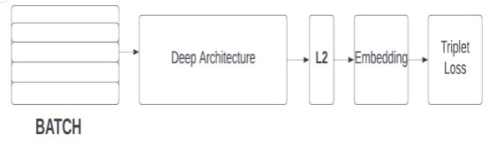

**Figure 2** Flowchart

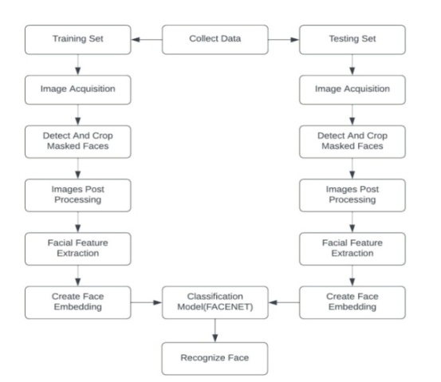

Its elementary infrastructure makes use of ZF-Net or Inception Network. Several 1x1 convolutions are added to further reduce the number of parameters. By using this method, the picture f(x) is embedded with L2 normalization applied to it. Then the loss function receives those embeddings from the previous phase. The loss function's ultimate goal is to create a squared distance between two image embeddings [17].

## *Dataset*

The dataset named ‘105_classes_pins_dataset’ is used for training and testing. It contains 17500+ images of 105 different people. The dataset contains different faces from different angles and contains different directories for training and testing. The dataset is pre-processed and given to the model.

## *Tools and Technologies*

People-Finder is a web application that is integrated using different technologies and tools, as mentioned below:

### HTML: Hypertext Markup Language is what HTML stands for. The creation of web pages and other sorts of information that can be viewed in a web browser uses this markup language as a standard. Headings, paragraphs, images, and links are just a few of the elements that can be defined using a variety of tags and properties in HTML.CSS: CSS, or cascading style sheets, is an acronym. It is a language for stylesheets that is used to specify how an HTML or XML page will look. Layout, colour, font, and other visual components of a web site can all be controlled using CSS.JavaScript: Websites that are interactive and dynamic frequently use the programming language JavaScript.Python: Python is a high-level general-purpose language that is widely used in data processing, data science, and data mining. Python is rich with various libraries like Numpy, Scipy, Matplotlib, FaceNet, Pandas, TensorFlow, Keras, etc.Flask: Flask is a popular framework written in Python for building web applications.

## *Working*

Whenever there is any unclaimed child/person found and taken to the police station, the case is registered and uploaded to the database. The person might be able to recall some details, we store them also in the database (with a new ID). The model should be trained again. On the other end, whenever there is any complaint filed for any missing person, we check whether the model is already trained on that face. If there is a match, the corresponding ID is displayed and details are fetched from the database.

If some person is missing and the details are not found in the database, we then register it as a new case. When there is any unclaimed person found with a similar face, the match will be reported.

## *Interfaces and Administrator*



**Figure 3** Homepage

Figure 3 is the home page of the web application, from where the user can perform various operations like registering a new case, finding existing images, and searching images by ID.

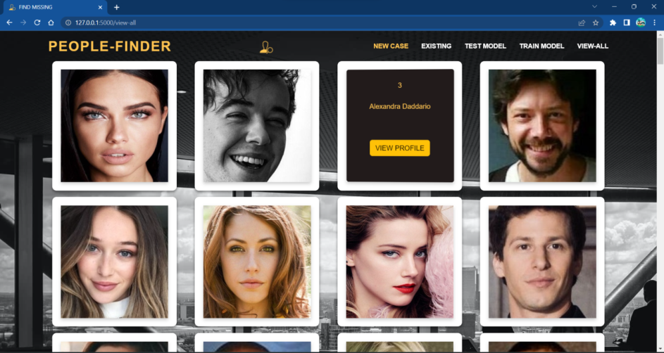

**Figure 4** Webpage for all images

Figure 4 is the interface through which the user can view the images and details of all missing people present in the database.

# conclusion

The web application People-finder can be used to find the missing people using machine learning, the authorities will have access to the portal. Whenever someone files a complaint about a missing person, the police will check if there is a matching case (using face recognition) already present. If not, then register the new case, which will be stored in the database. The entire process of finding the missing people is made simple and quick by this model. Additionally, our technology handles the need to manually search the database for each image in search of a match.

The model gives an accuracy of 87% over the dataset.

# Future scope

Our system is checking the images present in the database, and after getting the matched results, it gives the output. But We anticipate addressing this in the future. We are planning to integrate the public cameras with our model, and we will be receiving the frames in real-time at our system using these cameras, and If the missing individual is discovered in one of the frames, the relevant agency will be alerted.

# References

1. Shelke, Vishakha, et al. "Searchious: Locating missing people using an optimised face recognition algorithm." 2021 5th International Conference on Computing Methodologies and Communication (ICCMC). IEEE, 2021.
2. Geetha, M., et al. "Design of face detection and recognition system to monitor students during online examinations using Machine Learning algorithms." 2021 international conference on computer communication and informatics (ICCCI). IEEE, 2021.
3. Perumal, Vani. "Face Recognition in Video Streams and its Application in Freedom Fighters Discovery-A Machine Learning Approach." 2020 IEEE International Conference on Machine Learning and Applied Network Technologies (ICMLANT). IEEE, 2020.
4. Gholape, Neha, Ashish Gour, and Shivam Mourya. "Finding missing person using ML, AI." Int. Res. J. Mod. Eng. Technol. Sci 3 (2021): 1517-1520.
5. Pawar, Sanskar, et al. "Find Missing Person Using Artificial Intelligence." International Research Journal of Engineering and Technology (IRJET) 8.12 (2021).
6. Kukreja, Sandeep, and Rekha Gupta. "Comparative study of different face recognition techniques." 2011 International Conference on Computational Intelligence and Communication Networks. IEEE, 2011.
7. Sharma, S., Karthikeyan Shanmugasundaram, and Sathees Kumar Ramasamy. "FAREC—CNN based efficient face recognition technique using Dlib." 2016 international conference on advanced communication control and computing technologies (ICACCCT). IEEE, 2016.
8. Wang, Di, et al. "Face recognition system based on CNN." 2020 International Conference on Computer Information and Big Data Applications (CIBDA). IEEE, 2020.
9. Lv, Taizhi, et al. "A face recognition algorithm based on cnn with elbp and dcgan." 2020 International Symposium on Computer Engineering and Intelligent Communications (ISCEIC). IEEE, 2020.
10. Chawda, Vaishnavi, et al. "Unique Face Identification System using Machine Learning." 2020 Second International Conference on Inventive Research in Computing Applications (ICIRCA). IEEE, 2020.
11. Zhou, Yuxiang, et al. "Face and gender recognition system based on convolutional neural networks." 2019 IEEE International Conference on Mechatronics and Automation (ICMA). IEEE, 2019.
12. Sharma, Sudha, Mayank Bhatt, and Pratyush Sharma. "Face recognition system using machine learning algorithm." 2020 5th International Conference on Communication and Electronics Systems (ICCES). IEEE, 2020.
13. Jahan, Nusrat, et al. "Real time face recognition system with deep residual network and KNN." 2020 International Conference on Electronics and Sustainable Communication Systems (ICESC). IEEE, 2020.
14. Guo, Xinyu. "A KNN classifier for face recognition." 2021 International Conference on Communications, Information System and Computer Engineering (CISCE). IEEE, 2021.
15. Mishra, Ashutosh, et al. "Multi-stage face recognition for biometric access." 2015 Annual IEEE India Conference (INDICON). IEEE, 2015.
16. Balar, Bharath Darshan, et al. "Efficient face recognition system for identifying lost people." International Journal of Engineering and Advanced Technology (IJEAT) 8.5s (2019).
17. <https://www.geeksforgeeks.org/facenet-using-facial-recognition-system>.
18. https://www.kaggle.com/datasets/quangv/105-classes-pins-dataset