**A**



**Project Report**

on

**FINDING MISSING PEOPLE USING MACHINE LEARNING**

submitted as partial fulfillment for the award of

**BACHELOR OF TECHNOLOGY**

**DEGREE**

SESSION 2022-23

in

**COMPUTER SCIENCE & ENGINEERING**

By

Rahul(1900290100111)

Mukul Dixit(1900290100087)

Atul Patel (1900290100044)

**Under the supervision of**

Mr.Saurav Chandra

**KIET Group of Institutions, Ghaziabad**

Affiliated to

**Dr. A.P.J. Abdul Kalam Technical University, Lucknow**

(Formerly UPTU)

**May, 2023**

**DECLARATION**

We hereby declare that this submission is our own work and that, to the best of our knowledge and belief, it contains no material previously published or written by another person nor material which to a substantial extent has been accepted for the award of any other degree or diploma of the university or other institute of higher learning, except where due acknowledgment has been made in the text.

Rahul (1900290100111)

Mukul Dixit (1900290100087)

Atul Patel (1900290100044)

Date: 11/05/2023

## CERTIFICATE

This is to certify that Project Report entitled “Finding Missing People Using Machine Learning” which is submitted by Rahul, Mukul Dixit, Atul Patel in partial fulfillment of the requirement for the award of degree B. Tech. in Department of Computer Science & Engineering of Dr. A.P.J. Abdul Kalam Technical University, Lucknow is a record of the candidates own work carried out by them under my supervision. The matter embodied in this report is original and has not been submitted for the award of any other degree.

.

**Mr. Saurav Chandra Date:11/05/2023**

**Assistant Professor**

**KIET Group Of Institutions,**

**Ghaziabad**

ACKNOWLEDGEMENT

It gives us a great sense of pleasure to present the report of the B. Tech Project undertaken during B. Tech. Final Year. We owe special debt of gratitude to Mr. Saurav Chandra, Department of Computer Science & Engineering, KIET, Ghaziabad, for his constant support and guidance throughout the course of our work. His sincerity, thoroughness and perseverance have been a constant source of inspiration for us. It is only his cognizant efforts that our endeavors have seen light of the day.

We also take the opportunity to acknowledge the contribution of Dr. Vineet Sharma, Head of the Department of Computer Science & Engineering, KIET, Ghaziabad, for his full support and assistance during the development of the project.We also do not like to miss the opportunity to acknowledge the contribution of all the faculty members of the department for their kind assistance and cooperation during the development of our project.

We also do not like to miss the opportunity to acknowledge the contribution of all faculty members, especially faculty/industry person/any person, of the department for their kind assistance and cooperation during the development of our project. Last but not the least, we acknowledge our friends for their contribution in the completion of the project.

Date:11/05/2023

Rahul (1900290100111)

Mukul Dixit (1900290100087)

Atul Patel (1900290100044)

ABSTRACT

*Facial recognition is an advanced application of Artificial intelligence that mathematically maps a particular person’s facial features and stores that information. The data about a person's face is stored mathematically or in the form of graphs in the database using the facial recognition method, which is used for detecting the particular person’s face. In our project, PEOPLE-FINDER, database will contain a match for that individual according to the recognition system. Police, government agencies, and the guardian of the unclaimed child or elderly individual will be informed if a match is discovered.In this project, we will use FaceNet, which is based on deep learning and will detect faces with the maximum accuracy, to find the missing person.*

*In this project, we will use FaceNet, which is based on deep learning and will detect faces with the maximum accuracy, to find the missing person.*

*This recognition system focuses on countless people who are missing, as well as children who remain unclaimed. Finding the missing person is the biggest advantage of any recognition technique. For this purpose, we will create a web application that will use FaceNet to recognize the missing person and search the database for facial prints; if successful, it will display the results and notify the authorities.*

*Keywords—FaceNetPytorch, FaceNet, Face recognition, missing person, recognition*

|  |  |  |  |
| --- | --- | --- | --- |
| **TABLE OF CONTENTS** | | **Page No.** | |
| DECLARATION……………………………………………………………………. | | ii | |
| CERTIFICATE……………………………………………………………………… | | iii | |
| ACKNOWLEDGEMENTS…………………………………………………………. | | iv | |
| ABSTRACT………………………………………………………………………..... | | v | |
| LIST OF FIGURES…………………………………………………………………. | | viii | |
|  | |  | |
|  | |  | |
| CHAPTER 1(INTRODUCTION)…………………………………………………. | | 1-9 | |
| 1.1. Introduction……………………………………………………………………... | | 1 | |
| 1.2. Project Description……………………………………………………………… | | 2 | |
| CHAPTER 2 (LITERATURE RIVIEW)…………………………………………. | | 10-12 | |
| CHAPTER 3 (PROPOSED METHODOLOGY) ….................................................. | 13-17 | |
| 3.1. Model used ……................................................................................................ | | 13 | |
| 3.2. Dataset ……………………………………………………………………  3.3. Tools and Technologies ……………………………………………………….  3.4. Working ……………………………………………………………………….3.5. Interfaces and Administrator ………………………………………………….  CHAPTER 4 (RESULTS AND DISCUSSION)...................................................... | | 14  15  15  16  18 | |
| CHAPTER 5 (CONCLUSIONS AND FUTURE SCOPE).................................. | | 19 | |
| 5.1. Conclusion...................................................................................................... | |  | |
| 5.2. Future Scope................................................................................................... | |  | |
| CHAPTER 6 (Research Paper And Outcome) | |  | |
| REFERENCES…………………………………………………………………… | | 20-21 | |
|  | |  | |
|  | |  | |
|  | |  | |
|  | |  | |
|  | |  | |
|  | |  | |
|  | |  | |
|  | |  | |
|  | |  | |
|  | |  | |

**LIST OF FIGURES**

|  |  |  |
| --- | --- | --- |
| **Figure No.** | **Description** | **Page No.** |
| 1 | Architecture | 13 |

2 Flowchart 14

3 Homepage 16

4 Webpage for all images 16

5 Webpage to register new case 17

**CHAPTER 1**

**INTRODUCTION**

**1.1 INTRODUCTION**

Over the last decade, facial recognition systems have tremendously developed. As far as we are concerned with legal proceedings, biometrics has become a very vital element. In today's world, where the headlines never fail to grab attention about kidnapping, missing persons, and human trafficking, biometrics comes into the light, where facial aspects of the person are found to be the most crucial. If any person is found doing suspicious activities, it helps citizens understand something is not right and raises suspicion about whether that person should belong to the occupation or not. The unavailability of resources is one of the reasons that hinder the citizen's ability to understand and help in those situations. If the citizens are aware, then the sacrifice of thousands of innocent people can be avoided. If there are resources that are easily accessible to help them and can identify those suspicious activities, then citizens will be able to help.

Despite the efforts of government officials, non-governmental organizations (NGOs), and other societal authorities, 400 people remain unidentified after being reported missing. It is a serious issue for the nation, where more than 50% of the population is under the age of 25, which means youth and children constitute most of the population. There is a need to put a stop to illegal activities like human trafficking, kidnapping, and prostitution, where children and innocent people are forced to participate with no hope of help. There is only this way through which these cases could be solved quickly and safely. But when these issues arise, the matter directly falls into the hands of the police, who do not have the required resources and information for further proceeding. We can save these lives using our presence of mind and powerful resources such as social media by posting pictures on social platforms and becoming vigilant citizens.

The unclaimed children remain the same as these issues, a survey states that, on average, 174 children go missing every day in India. Most of them do not know their way back home. So, our project, People-Finder, focuses mainly on these unclaimed children who are unclaimed and do not know their way back home.

**1.2 PROJECT DESCRIPTION**

The web application “People-finder” is designed to help find missing persons by comparing their faces with known images of the missing person. The platform uses advanced face recognition algorithms to analyze facial features and compare them with known images to determine whether they belong to the same person or not. The application aims to assist law enforcement agencies, families of missing persons, and volunteers in identifying missing persons quickly and efficiently.

The application features an intuitive and easy-to-use interface that can be accessed through a web browser. Users can upload images of the missing person and known images to compare them.

The web application is designed for law enforcement agencies, families of missing persons, and volunteers who are interested in helping to identify missing persons. With its intuitive user interface, high accuracy, and privacy-focused approach, the platform will help users to identify missing persons quickly and efficiently, bringing hope and closure to families of missing persons, and assisting law enforcement agencies in their search efforts.

Our web application uses FaceNet for Face Recognition :

**FaceNet Model:**

FaceNet is a face recognition system that was described by [Florian Schroff](http://www.florian-schroff.de/), et al. at Google in their 2015 paper titled “[FaceNet: A Unified Embedding for Face Recognition and Clustering](https://arxiv.org/abs/1503.03832).”

It is a system that, given a picture of a face, will extract high-quality features from the face and predict a 128 element vector representation these features, called a face embedding.

FaceNet, that directly learns a mapping from face images to a compact Euclidean space where distances directly correspond to a measure of face similarity.

The model is a deep convolutional neural network trained via a triplet loss function that encourages vectors for the same identity to become more similar (smaller distance), whereas vectors for different identities are expected to become less similar (larger distance). The focus on training a model to create embeddings directly (rather than extracting them from an intermediate layer of a model) was an important innovation in this work.

Our method uses a deep convolutional network trained to directly optimize the embedding itself, rather than an intermediate bottleneck layer as in previous deep learning approaches.

These face embeddings were then used as the basis for training classifier systems on standard face recognition benchmark datasets, achieving then-state-of-the-art results.

It is a robust and effective face recognition system, and the general nature of the extracted face embeddings lends the approach to a range of applications.

**How to Detect Faces for Face Recognition**-

Before we can perform face recognition, we need to detect faces.

[Face detection](https://machinelearningmastery.com/how-to-perform-face-detection-with-classical-and-deep-learning-methods-in-python-with-keras/) is the process of automatically locating faces in a photograph and localizing them by drawing a bounding box around their extent.

In this, we will also use the Multi-Task Cascaded Convolutional Neural Network, or MTCNN, for face detection, e.g. finding and extracting faces from photos. This is a state-of-the-art deep learning model for face detection, described in the 2016 paper titled “[Joint Face Detection and Alignment Using Multitask Cascaded Convolutional Networks](https://arxiv.org/abs/1604.02878).”

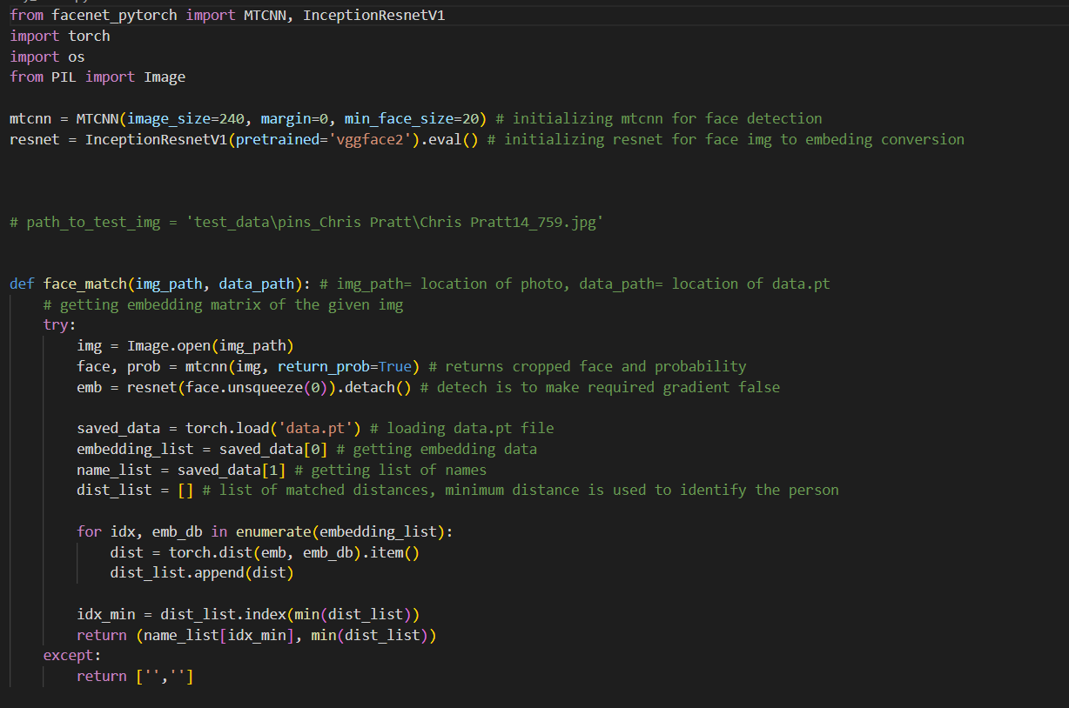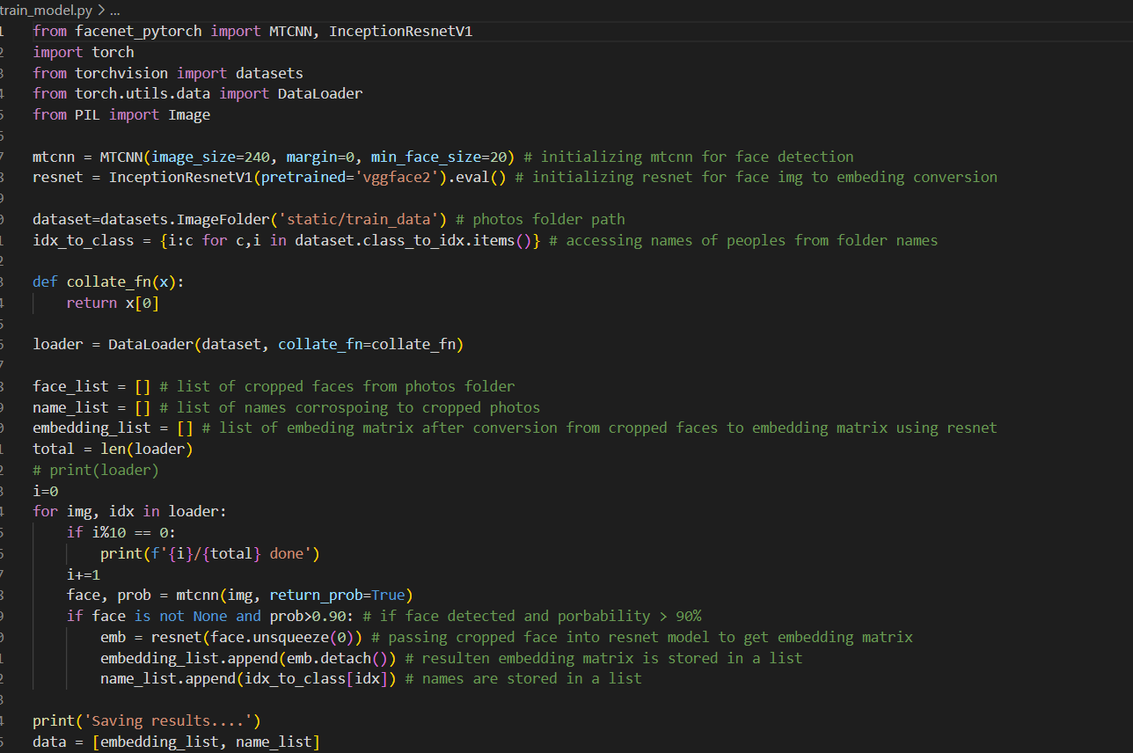

**HTML:**

The HyperText Markup Language or HTML is the standard [markup language](https://en.wikipedia.org/wiki/Markup_language) for documents designed to be displayed in a [web browser](https://en.wikipedia.org/wiki/Web_browser). It is often assisted by technologies such as [Cascading Style Sheets](https://en.wikipedia.org/wiki/Cascading_Style_Sheets) (CSS) and [scripting languages](https://en.wikipedia.org/wiki/Scripting_language) such as [JavaScript](https://en.wikipedia.org/wiki/JavaScript).

[Web browsers](https://en.wikipedia.org/wiki/Web_browser) receive HTML documents from a [web server](https://en.wikipedia.org/wiki/Web_server) or from local storage and [render](https://en.wikipedia.org/wiki/Browser_engine) the documents into multimedia web pages. HTML describes the structure of a [web page](https://en.wikipedia.org/wiki/Web_page) [semantically](https://en.wikipedia.org/wiki/Semantic_Web) and originally included cues for its appearance.

[HTML elements](https://en.wikipedia.org/wiki/HTML_element) are the building blocks of HTML pages. With HTML constructs, [images](https://en.wikipedia.org/wiki/HTML_element#Images_and_objects) and other objects such as [interactive forms](https://en.wikipedia.org/wiki/Fieldset) may be embedded into the rendered page. HTML provides a means to create [structured documents](https://en.wikipedia.org/wiki/Structured_document) by denoting structural [semantics](https://en.wikipedia.org/wiki/Semantics) for text such as headings, paragraphs, lists, [links](https://en.wikipedia.org/wiki/Hyperlink), quotes, and other items. HTML elements are delineated by tags, written using [angle brackets](https://en.wikipedia.org/wiki/Bracket#Angle_brackets). Tags such as <img /> and <input /> directly introduce content into the page. Other tags such as <p> and </p> surround and provide information about document text and may include sub-element tags. Browsers do not display the HTML tags but use them to interpret the content of the page.

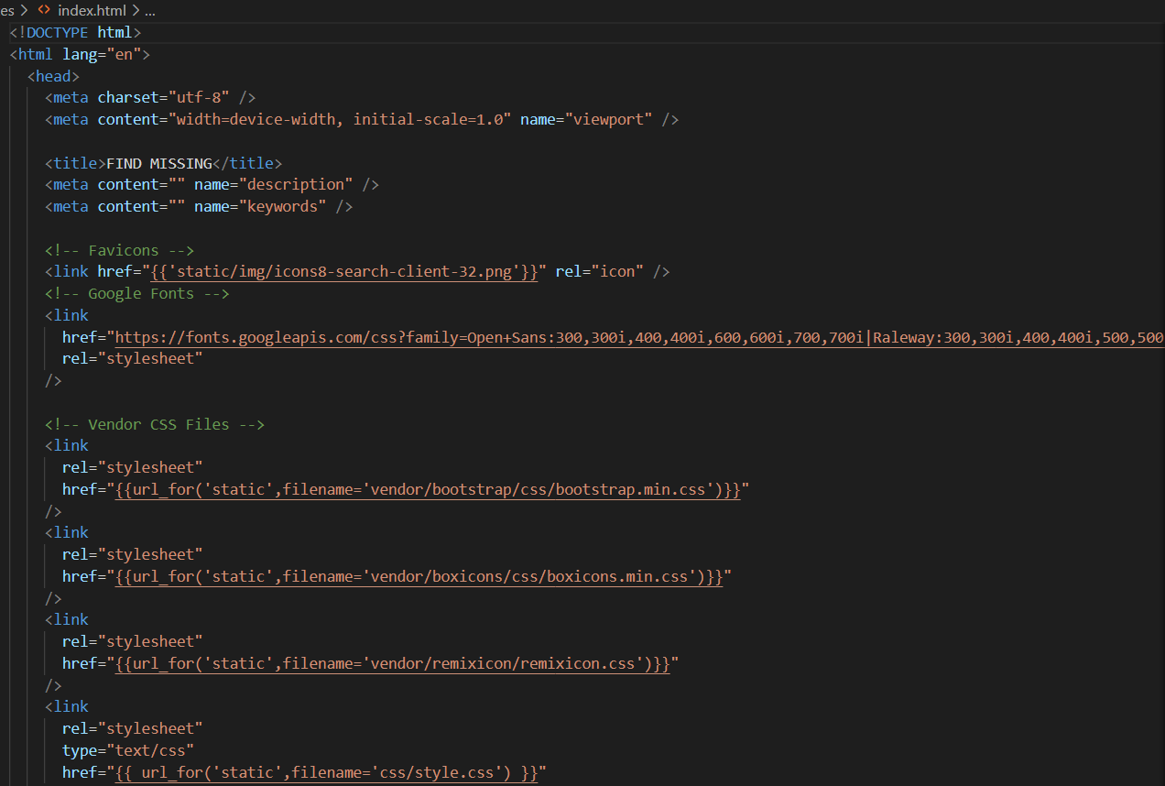

**CSS:**

Cascading Style Sheets (CSS) is a [style sheet language](https://en.wikipedia.org/wiki/Style_sheet_language) used for describing the [presentation](https://en.wikipedia.org/wiki/Presentation_semantics) of a document written in a [markup language](https://en.wikipedia.org/wiki/Markup_language) such as [HTML](https://en.wikipedia.org/wiki/HTML) or [XML](https://en.wikipedia.org/wiki/XML) (including XML dialects such as [SVG](https://en.wikipedia.org/wiki/SVG), [MathML](https://en.wikipedia.org/wiki/MathML) or [XHTML](https://en.wikipedia.org/wiki/XHTML)). CSS is a cornerstone technology of the [World Wide Web](https://en.wikipedia.org/wiki/World_Wide_Web), alongside HTML and [JavaScript](https://en.wikipedia.org/wiki/JavaScript).

CSS is designed to enable the [separation of content and presentation](https://en.wikipedia.org/wiki/Separation_of_content_and_presentation), including [layout](https://en.wikipedia.org/wiki/Page_layout), [colors](https://en.wikipedia.org/wiki/Color), and [fonts](https://en.wikipedia.org/wiki/Typeface). This separation can improve content [accessibility](https://en.wikipedia.org/wiki/Accessibility); provide more flexibility and control in the specification of presentation characteristics; enable multiple [web pages](https://en.wikipedia.org/wiki/Web_page) to share formatting by specifying the relevant CSS in a separate .css file, which reduces complexity and repetition in the structural content; and enable the .css file to be [cached](https://en.wikipedia.org/wiki/Cache_(computing)) to improve the page load speed between the pages that share the file and its formatting.

Separation of formatting and content also makes it feasible to present the same markup page in different styles for different rendering methods, such as on-screen, in print, by voice (via speech-based browser or [screen reader](https://en.wikipedia.org/wiki/Screen_reader)), and on [Braille-based](https://en.wikipedia.org/wiki/Braille_display) tactile devices. CSS also has rules for alternate formatting if the content is accessed on a [mobile device](https://en.wikipedia.org/wiki/Mobile_device).

The name cascading comes from the specified priority scheme to determine which style rule applies if more than one rule matches a particular element. This cascading priority scheme is predictable.

There are three ways of inserting a style sheet:

* External CSS
* Internal CSS
* Inline CSS

**Javascript:**

JavaScript, often abbreviated as JS, is a [programming language](https://en.wikipedia.org/wiki/Programming_language) that is one of the core technologies of the [World Wide Web](https://en.wikipedia.org/wiki/World_Wide_Web), alongside [HTML](https://en.wikipedia.org/wiki/HTML) and [CSS](https://en.wikipedia.org/wiki/CSS). As of 2022, 98% of [websites](https://en.wikipedia.org/wiki/Website) use JavaScript on the [client](https://en.wikipedia.org/wiki/Client_(computing)) side for [webpage](https://en.wikipedia.org/wiki/Web_page) behavior, often incorporating third-party [libraries](https://en.wikipedia.org/wiki/Library_(computing)). All major [web browsers](https://en.wikipedia.org/wiki/Web_browser) have a dedicated [JavaScript engine](https://en.wikipedia.org/wiki/JavaScript_engine) to execute the [code](https://en.wikipedia.org/wiki/Source_code) on [users](https://en.wikipedia.org/wiki/User_(computing))' devices.

JavaScript is a [high-level](https://en.wikipedia.org/wiki/High-level_programming_language), often [just-in-time compiled](https://en.wikipedia.org/wiki/Just-in-time_compilation) language that conforms to the [ECMAScript](https://en.wikipedia.org/wiki/ECMAScript) standard.[[10]](https://en.wikipedia.org/wiki/JavaScript#cite_note-tc39-10) It has [dynamic typing](https://en.wikipedia.org/wiki/Dynamic_typing), [prototype-based](https://en.wikipedia.org/wiki/Prototype-based_programming) [object-orientation](https://en.wikipedia.org/wiki/Object-oriented_programming), and [first-class functions](https://en.wikipedia.org/wiki/First-class_function). It is [multi-paradigm](https://en.wikipedia.org/wiki/Programming_paradigm), supporting [event-driven](https://en.wikipedia.org/wiki/Event-driven_programming), [functional](https://en.wikipedia.org/wiki/Functional_programming), and [imperative](https://en.wikipedia.org/wiki/Imperative_programming) [programming styles](https://en.wikipedia.org/wiki/Programming_paradigm). It has [application programming interfaces](https://en.wikipedia.org/wiki/Application_programming_interface) (APIs) for working with text, dates, [regular expressions](https://en.wikipedia.org/wiki/Regular_expression), standard [data structures](https://en.wikipedia.org/wiki/Data_structure), and the [Document Object Model](https://en.wikipedia.org/wiki/Document_Object_Model) (DOM).

The ECMAScript standard does not include any [input/output](https://en.wikipedia.org/wiki/Input/output) (I/O), such as [networking](https://en.wikipedia.org/wiki/Computer_network), [storage](https://en.wikipedia.org/wiki/Data_storage), or [graphics](https://en.wikipedia.org/wiki/Computer_graphics) facilities. In practice, the web browser or other [runtime system](https://en.wikipedia.org/wiki/Runtime_system) provides JavaScript APIs for I/O.

[JavaScript engines](https://en.wikipedia.org/wiki/JavaScript_engines) were originally used only in web browsers, but are now core components of some [servers](https://en.wikipedia.org/wiki/Server_(computing)) and a variety of [applications](https://en.wikipedia.org/wiki/Application_software). The most popular runtime system for this usage is [Node.js](https://en.wikipedia.org/wiki/Node.js).

Although [Java](https://en.wikipedia.org/wiki/Java_(programming_language)) and JavaScript are similar in name, [syntax](https://en.wikipedia.org/wiki/Syntax_(programming_languages)), and respective [standard libraries](https://en.wikipedia.org/wiki/Standard_library), the two languages are distinct and differ greatly in design.

**Python:**

Python is a [high-level](https://en.wikipedia.org/wiki/High-level_programming_language), [general-purpose programming language](https://en.wikipedia.org/wiki/General-purpose_programming_language). Its design philosophy emphasizes [code readability](https://en.wikipedia.org/wiki/Code_readability) with the use of significant indentation via the [off-side rule](https://en.wikipedia.org/wiki/Off-side_rule).

Python is [dynamically typed](https://en.wikipedia.org/wiki/Type_system#DYNAMIC) and [garbage-collected](https://en.wikipedia.org/wiki/Garbage_collection_(computer_science)). It supports multiple [programming paradigms](https://en.wikipedia.org/wiki/Programming_paradigm), including [structured](https://en.wikipedia.org/wiki/Structured_programming) (particularly [procedural](https://en.wikipedia.org/wiki/Procedural_programming)), [object-oriented](https://en.wikipedia.org/wiki/Object-oriented_programming) and [functional programming](https://en.wikipedia.org/wiki/Functional_programming). It is often described as a "batteries included" language due to its comprehensive [standard library](https://en.wikipedia.org/wiki/Standard_library).

[Guido van Rossum](https://en.wikipedia.org/wiki/Guido_van_Rossum) began working on Python in the late 1980s as a successor to the [ABC programming language](https://en.wikipedia.org/wiki/ABC_(programming_language)) and first released it in 1991 as Python 0.9.0. Python 2.0 was released in 2000. Python 3.0, released in 2008, was a major revision not completely [backward-compatible](https://en.wikipedia.org/wiki/Backward_compatibility) with earlier versions. Python 2.7.18, released in 2020, was the last release of Python 2.

Python consistently ranks as one of the most popular programming languages.

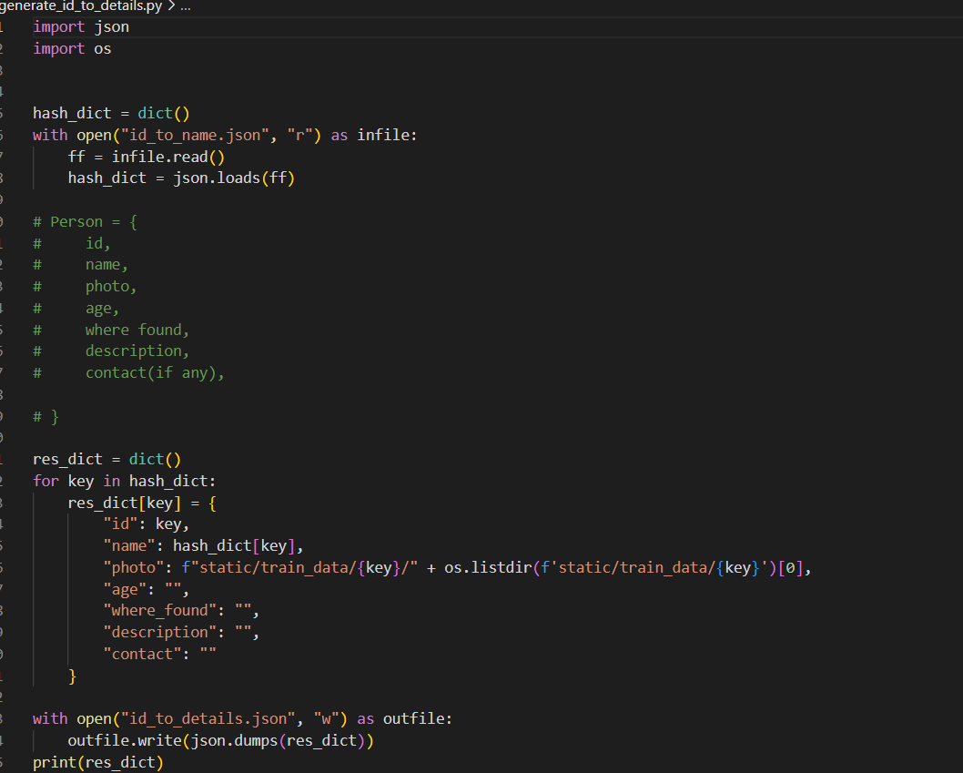

**Flask:**

Flask isa micro [web framework](https://en.wikipedia.org/wiki/Web_framework) written in [Python](https://en.wikipedia.org/wiki/Python_(programming_language)). It is classified as a [microframework](https://en.wikipedia.org/wiki/Microframework) because it does not require particular tools or libraries. It has

no [database](https://en.wikipedia.org/wiki/Database) abstraction layer, form validation, or any other components where pre-existing third-party libraries provide common functions. However, Flask supports extensions that can add application features as if they were implemented in Flask itself. Extensions exist for [object-relational mappers](https://en.wikipedia.org/wiki/Object%E2%80%93relational_mapping), form validation, upload handling, various open authentication technologies and several common framework related tools.

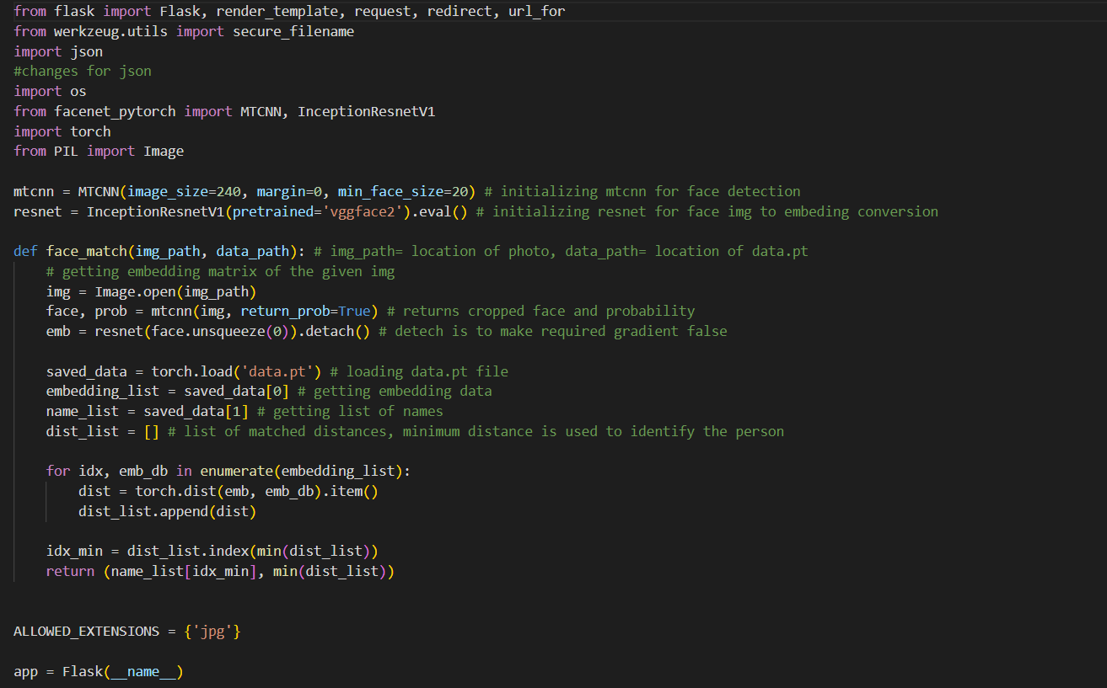

**Visual Studio Code:**

Visual Studio Code, also commonly referred to as VS Code, is a [source-code editor](https://en.wikipedia.org/wiki/Source-code_editor) made by [Microsoft](https://en.wikipedia.org/wiki/Microsoft) with the [Electron Framework](https://en.wikipedia.org/wiki/Electron_(software_framework)), for [Windows](https://en.wikipedia.org/wiki/Windows), [Linux](https://en.wikipedia.org/wiki/Linux) and [macOS](https://en.wikipedia.org/wiki/MacOS). Features include support for [debugging](https://en.wikipedia.org/wiki/Debugging), [syntax highlighting](https://en.wikipedia.org/wiki/Syntax_highlighting), [intelligent code completion](https://en.wikipedia.org/wiki/Intelligent_code_completion), [snippets](https://en.wikipedia.org/wiki/Snippet_(programming)), [code refactoring](https://en.wikipedia.org/wiki/Code_refactoring), and embedded [Git](https://en.wikipedia.org/wiki/Git). Users can change the [theme](https://en.wikipedia.org/wiki/Theme_(computing)), [keyboard shortcuts](https://en.wikipedia.org/wiki/Keyboard_shortcut), preferences, and install [extensions](https://en.wikipedia.org/wiki/Plug-in_(computing)) that add functionality.

In the [Stack Overflow](https://en.wikipedia.org/wiki/Stack_Overflow) 2022 Developer Survey, Visual Studio Code was ranked the most popular developer environment tool among 71,010 respondents, with 74.48% reporting that they use it.

Visual Studio Code is a source-code editor that can be used with a variety of programming languages,including [C](https://en.wikipedia.org/wiki/C_(programming_language)), [C#](https://en.wikipedia.org/wiki/C_Sharp_(programming_language)), [C++](https://en.wikipedia.org/wiki/C%2B%2B), [Fortran](https://en.wikipedia.org/wiki/Fortran), [Go](https://en.wikipedia.org/wiki/Go_(programming_language)), [Java](https://en.wikipedia.org/wiki/Java_(programming_language)), [JavaScript](https://en.wikipedia.org/wiki/JavaScript), [Node.js](https://en.wikipedia.org/wiki/Node.js), [Python](https://en.wikipedia.org/wiki/Python_(programming_language)), [Rust](https://en.wikipedia.org/wiki/Rust_(programming_language)). It is based on the [Electron](https://en.wikipedia.org/wiki/Electron_(software_framework)) framework, which is used to develop [Node.js](https://en.wikipedia.org/wiki/Node.js) [web applications](https://en.wikipedia.org/wiki/Web_application) that run on the [Blink layout engine](https://en.wikipedia.org/wiki/Blink_layout_engine). Visual Studio Code employs the same editor component (codenamed "Monaco") used in [Azure DevOps](https://en.wikipedia.org/wiki/Azure_DevOps_Server) (formerly called Visual Studio Online and Visual Studio Team Services).

Instead of a project system, it allows users to open one or more directories, which can then be saved in workspaces for future reuse. This allows it to operate as a [language-agnostic](https://en.wikipedia.org/wiki/Language-agnostic) code editor for any language. It supports many programming languages and a set of features that differs per language. Unwanted files and folders can be excluded from the project tree via the settings. Many Visual Studio Code features are not exposed through menus or the user interface but can be accessed via the command palette.

**CHAPTER 2**

**LITERATURE REVIEW**

Every day, all around the world, hundreds of people go missing due to kidnapping and trafficking. They developed an Android application using Python and desktop software for common people as well as for police stations. They use a facial recognition algorithm based on KNN. These applications and software are used to safely trace missing people in less time [1].

According to the researchers, after the pandemic situation, most schools and many other places used face recognition systems for the detection of people. The face recognition system takes pictures with a digital camera and evaluates the patterns using the subject's facial features, including the chin, mouth, nose, and eyes. It also helps in monitoring the students during exams as well as the attendance system. The faces of the subjects are predicted using a machine-learning method using the video as input. Firstly, the model is trained for multiple face datasets, and after that, it searches the faces in the video to identify people. After procuring proper training, the technique could be applied to predict any individual or list of individuals from a video feed. The Faces are also used in biometric authentication, so it is easy to match the faces from the video [2].

To predict the faces from video streaming, One can employ a machine learning strategy. Firstly, the model should train on datasets that contain multiple faces, and afterward, it should search for faces in video streaming. After getting its hands on this approach, the model can predict any person from video streaming. Faces are also used in biometric authentication, so it is easy to match the faces from the video [3].

According to Neha Gholape, Ashish Gour, and ShivamMourya, machine learning can be used to track individuals through the extraction of facial features and for face recognition using deep learning and artificial intelligence. This project gives a brief explanation of various techniques through which face detection and recognition can be explored. This project also shows a variety of difficulties and applications of face identification [4].

According to Sankar Pawar, Lalit Bhadane, Amanullah Shaikh, AtharvKumbhejkar, and Swati Jakkan, the data about a person's face is stored mathematically in the database using the facial recognition method. If a match for a missing person is found in the database, person's parents and the authorities will be contacted. They use the ideas of the AWS facial recognition algorithm, which is based on artificial intelligence (AI) [5].

A face recognition system that employs principle component analysis (PCA) to extract features from various face photos, reduce the dimensions of each image, and classify KNN data was enhanced by Sandeep Kukreja and Rekha Gupta. The veracity of color information is the most crucial consideration while photographing in dim light [6].

In this research, authors employ effective methods for convolutional neural network-based face recognition systems (CNN). To raise the true acceptance rate (TAR) and lower the false acceptance rate (FAR), face alignment with Dlib is used. The research was conducted using the Facial Recognition Grand Challenge (FRGC) dataset, which reveals an accuracy of 96% and a FAR of 0.1 [7].

CNN is an architecture used to efficiently minimize the sophistication of feedback neural networks. It can immediately enter the actual image, making image processing easier. Moreover, it features image translation rotation and distortion invariance. It provides superior processing capabilities for two-dimensional data, such as sound and picture, by utilizing the input image's raw pixel strength as a flat vector rather than the conventional manual feature extraction method [8].

An improved face recognition algorithm based on CNN with an extended local binary pattern (ELBP) and a deep convolutional generative adversarial network (DCGAN) is proposed. They use DCGAN to generate new face pictures from existing ones. They adopt an extended LBP feature value extraction method to reduce the impact of illumination and improve training efficiency. To reduce the amount of calculation, DCGAN replaces the connected layer of CNN with a pooling layer and uses deconvolution and convolution instead of pooling [9].

Machine learning algorithms are used to build and develop security systems. As a result, it is advised that a system be developed and put into use that can identify and recognize faces using the most efficient methods for humans. Principal component analysis (PCA) is the algorithm that most efficiently and economically describes the faces [10].

Based on one of the research proposed two modules: face recognition and gender recognition. Face recognition and gender recognition modules extract face and gender features from images using pre-trained CNNs. Face recognition uses public datasets LFW and YTF to train CNN, which improves accuracy. For gender detection, they used Adience's public set to train CNN and improved the accuracy from 91.80% to 93.22%. Here they combine facial recognition with gender recognition, which is implemented simultaneously [11].

Face recognition algorithms compare face shots with a dataset, which is a collection of many images, in one of the studies we found. Face identification at first relied on distinguishing facial characteristics such as the nose, eyes, and forehead area. Smartphones use face recognition systems, among other electronic devices [12].

According to this paper, a real-time facial recognition system is suggested to assure security. In contrast to other machine learning models, the CNN model produces better outcomes. The suggested approach uses a residual neural network for face recognition to increase accuracy. Future time savings could greatly benefit from the integration of traffic control systems, which will eliminate the need for data entry methods [13].

With the help of profile photos, this study intends to train and test the model. On the one hand, when implementing KNN for face recognition, the model performs well at detecting exposed frontal faces. On the other hand, when detecting and identifying faces that are partially covered, the algorithm experiences a considerable reduction in probability. These models are useless for pictures of frontal faces that are not covered [14].

In this study, two multi-stage face recognition algorithms that utilize biometric facial features to verify the user's claim are offered as a method for exploiting face images for biometric access. The suggested approaches gradually employ well-known classifiers and algorithms like EigenFaces, PCA, and LDA. The inaccuracy between the test picture and database images can be reduced with the aid of these hybrid models [15].

The system would try to extract an entry from the database using face encoding. It is performed by contrasting the face encodings of the uploaded image with those of the photographs in the database. If a match is discovered, the police, the family of the missing person, and the location where the person was discovered will be contacted [16].

**CHAPTER 3**

**PROPOSED METHODOLOGY**

Before you begin to format your paper, first write and save the content as a separate text file. Complete all content and organizational editing before formatting. Please note sections A-D below for more information on proofreading, spelling and grammar.

Keep your text and graphic files separate until after the text has been formatted and styled. Do not use hard tabs, and limit use of hard returns to only one return at the end of a paragraph. Do not add any kind of pagination anywhere in the paper. Do not number text heads-the template will do that for you.

## 3.1.Model used

FaceNet was proposed by Google researchers in 2015 and is widely used as a facial recognition system. It makes use ofthe dataset that has labeled faces in the wild.

FaceNet is a system that creates high-quality face mapping from the input using deep learning architectures like ZF-Net and Inception Network (images). It trains this architecture using the triplet loss function technique as a loss function [13].

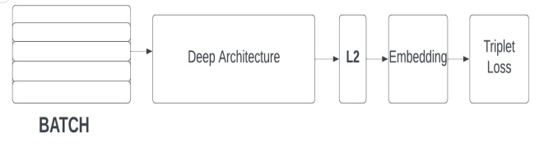

1. Architecture

Its elementary infrastructure makes use of ZF-Net or Inception Network Several 1x1 convolutions are added to further reduce the nmber of parameters. By using this method, the picture f(x) is embedded with L2 normalization applied to it. Then the loss function receives those embeddings from the previous phase.The loss function's ultimate goal is to create a squared distance between two image embeddings [13].

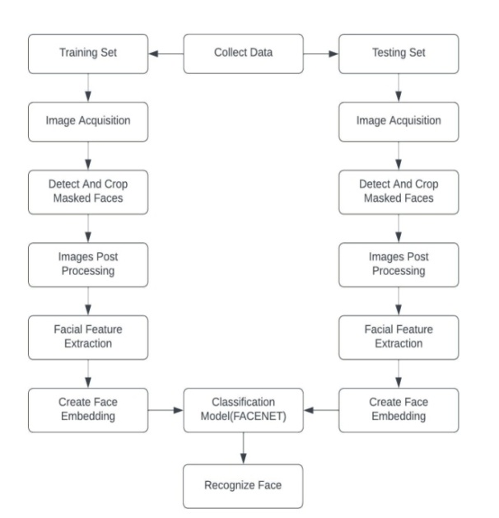

1. Flowchart

## 3.2.Dataset

The dataset named ‘105_classes_pins_dataset’ is used for training and testing. It contains 17500+ images of 105 different people. The dataset contains different faces from different angles and contains different directories for training and testing. The dataset is pre-processed and given to the model.

## 3.3. Tools and Technologies

People-Finder is a web application that is integrated using different technologies and tools, as mentioned below:

### 1). HTML: Hypertext Markup Language is what HTML stands for. The creation of web pages and other sorts of information that can be viewed in a web browser uses this markup language as a standard. Headings, paragraphs, images, and links are just a few of the elements that can be defined using a variety of tags and properties in HTML.

### 2).CSS: CSS, or cascading style sheets, is an acronym. It is a language for stylesheets that is used to define the presentation of an HTML or XML document. Layout, colour, font, and other visual components of a web site can all be controlled using CSS.

### 3). JavaScript: Websites that are interactive and dynamic frequently use the programming language JavaScript.

### 4). Python: Python is a high-level general-purpose language that is widely used in data processing, data science, and data mining. Python is rich with various libraries like Numpy, Scipy, Matplotlib, FaceNet, Pandas, TensorFlow, Keras, etc.

### 5). Flask: Flask is a popular framework written in Python for building web applications.

### 6). Visual Studio Code: Web applications are developed and debugged using the popular code editor VS Code. It is free and seeks to give programmers the resources they need to finish the cycle of code-build-debug.

## 3.4. Working

Whenever there is any unclaimed child/person found and taken to the police station, the case is registered and uploaded to the database. The person might be able to recall some details, we store them also in the database (with a new ID). The model should be trained again. On the other end, whenever there is any complaint filed for any missing person, we check whether the model is already trained on that face. If there is a match, the corresponding ID is displayed and details are fetched from the database.

If some person is missing and the details are not found in the database, we then register it as a new case. When there is any unclaimed person found with a similar face, the match will be reported.

## 3.5. Interfaces and Administrator

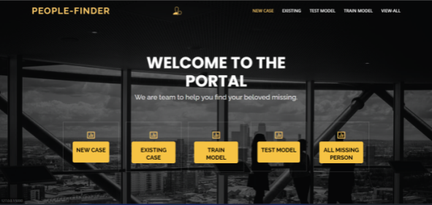

1. Homepage

Fig. 3 is the home page of the web application, from where the user can perform various operations like registering a new case, finding existing images, and searching images by ID.

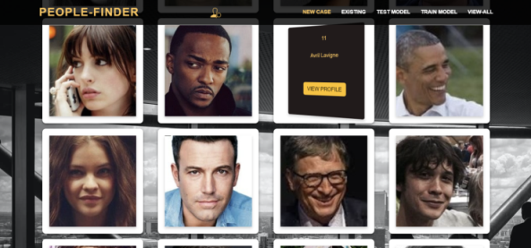

Webpage for all images

Fig. 4 is the interface through which the user can view the images and details of all missing people present in the database.

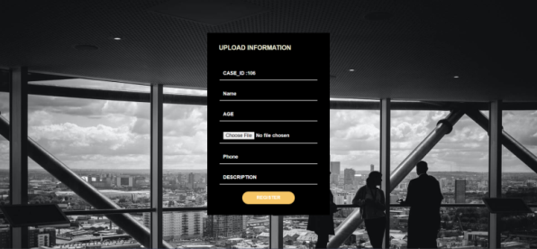

Webpage to register a new case

Fig. 5 represents the interface where the user can register a new case to the database.

**CHAPTER 4**

**RESULTS AND DISCUSSION**

Throughout the world, the number of missing people keeps on increasing every day and more than half of them remain untraced and become prey to various negatively impacting professions. In this project we have introduced Missing Person Identification which will help you to identify the missing person. We have proposed a Missing Person Identification system based on face detection and Classification algorithm. In this proposed system using the KNN we classify the data which helps to identify the missing person if the person found after some years and any changes are occur in founded person. A person who went missing years ago, can be easily recognized, found to a safe location. The time spent by the police and the people related to other photos. Once we capture the photo of founded person then it started encoding of face and face detection after that it will compare the captured photo with stored images and once the match is found update the status and if not the police will register it as new complaint and stored to new complaint .

Here the result works well and the application is also stable which meets the following:

1. Search missing people anytime from anywhere.

2. Less physical infrastructure.

3. Fast and easy to search missing people.

**CHAPTER 5**

**CONCLUSION AND FUTURE SCOPE**

5.1 CONCLUSION

The web application People-finder can be used to find the missing people using machine learning, the authorities will have access to the portal. Whenever someone files a complaint about a missing person, the police will check if there is a matching case (using face recognition) already present. If not, then register the new case, which will be stored in the database. The entire process of finding the missing people is made simple and quick by this model. Additionally, our technology handles the need to manually search the database for each image in search of a match.

The model gives an accuracy of 87% over the dataset.

5.2 FUTURE SCOPE

Our system is checking the images present in the database, and after getting the matched results, it gives the output. But We anticipate addressing this in the future. We are planning to integrate the public cameras with our model, and we will be receiving the frames in real-time at our system using these cameras, and If the missing individual is discovered in one of the frames, the relevant agency will be alerted.

**CHAPTER 6**

**RESEARCH PAPER AND OUTCOME**

Abstract.Facial recognition is an advanced application of Artificial intelligence that mathematically maps a particular person’s facial features and stores that information. The data about a person's face is stored mathematically in the database using the facial recognition method, which is used for detecting a particular person’s face. In our project, PEOPLE-FINDER, the database will contain a match for that individual according to the recognition system. Police, government agencies, and the guardian of the unclaimed child or elderly individual will be informed if a match is discovered. In this project, we will use FaceNet, which is based on deep learning and will detect faces with the maximum accuracy, to find the missing person.

In this project, we will use FaceNet, which is based on deep learning and will detect faces with the maximum accuracy, to find the missing person.

This recognition system focuses on countless people who are missing, as well as children who remain unclaimed. Finding the missing person is the biggest advantage of any recognition technique. For this purpose, we will create a web application that will use FaceNet to recognize the missing person and search the database for facial prints; if successful, it will display the results and notify the authorities.

Keywords— FaceNetPytorch, FaceNet, Face recognition, Missing person, Recognition

introduction

Over the last decade, facial recognition systems have tremendously developed. As far as we are concerned with legal proceedings, biometrics has become a very vital element. In today's world, where the headlines never fail to grab attention about kidnapping, missing persons, and human trafficking, biometrics comes into the light, where facial aspects of the person are found to be the most crucial. If any person is found doing suspicious activities, it helps citizens understand something is not right and raises suspicion about whether that person should belong to the occupation or not. The unavailability of resources is one of the reasons that hinder the citizen's ability to understand and help in those situations. If the citizens are aware, then the sacrifice of thousands of innocent people can be avoided. If there are resources that are easily accessible to help them and can identify those suspicious activities, then citizens will be able to help.

Despite the efforts of government officials, non-governmental organizations (NGOs), and other societal authorities, 400 people remain unidentified after being reported missing. It is a serious issue for the nation, where more than 50% of the population is under the age of 25, which means youth and children constitute most of the population. There is a need to put a stop to illegal activities like human trafficking, kidnapping, and prostitution, where children and innocent people are forced to participate with no hope of help. There is only this way through which these cases could be solved quickly and safely. Nevertheless, when these problems do occur, the police are immediately involved, who do not have the required resources and information for further proceeding. We can save these lives using our presence of mind and powerful resources such as social media by posting pictures on social platforms and becoming vigilant citizens.

The unclaimed children remain the same as these issues, a survey states that, on average, 174 children go missing every day in India. Most of them do not know their way back home. So, our project, People-Finder, focuses mainly on these unclaimed children who are unclaimed and do not know their way back home.

Literature REVIEW

Every day, all around the world, hundreds of people go missing due to kidnapping and trafficking. They developed an Android application using Python and desktop software for common people as well as for police stations. They use a facial recognition algorithm based on KNN. These applications and software are used to safely trace missing people in less time [1].

According to the researchers, after the pandemic situation, most schools and many other places used face recognition systems for the detection of people. The face recognition system takes pictures with a digital camera and evaluates the patterns using the subject's facial features, including the chin, mouth, nose, and eyes. It also helps in monitoring the students during exams as well as the attendance system. The faces of the subjects are predicted using a machine-learning method using the video as input. Firstly, the model is trained for multiple face datasets, and after that, it searches the faces in the video to identify people. After procuring proper training, the technique could be applied to predict any individual or list of individuals from a video feed. The Faces are also used in biometric authentication, so it is easy to match the faces from the video [2].

To predict the faces from video streaming, One can employ a machine learning strategy. Firstly, the model should train on datasets that contain multiple faces, and afterward, it should search for faces in video streaming. After getting its hands on this approach, the model can predict any person from video streaming. Faces are also used in biometric authentication, so it is easy to match the faces from the video [3].

According to Neha Gholape, Ashish Gour, and Shivam Mourya, machine learning can be used to track individuals through the extraction of facial features and for face recognition using deep learning and artificial intelligence. This project gives a brief explanation of various techniques through which face detection and recognition can be explored. This project also shows a variety of difficulties and applications of face identification [4].

According to Sankar Pawar, Lalit Bhadane, Amanullah Shaikh, AtharvKumbhejkar, and Swati Jakkan, the data about a person's face is stored mathematically in the database using the facial recognition method. If a match for a missing person is found in the database, person's parents and the authorities will be contacted. They use the ideas of the AWS facial recognition algorithm, which is based on artificial intelligence (AI) [5].

A face recognition system that employs principle component analysis (PCA) to extract features from various face photos, reduce the dimensions of each image, and classify KNN data was enhanced by Sandeep Kukreja and Rekha Gupta. The veracity of color information is the most crucial consideration while photographing in dim light [6].

In this research, authors employ effective methods for convolutional neural network-based face recognition systems (CNN). To raise the true acceptance rate (TAR) and lower the false acceptance rate (FAR), face alignment with Dlib is used. The research was conducted using the Facial Recognition Grand Challenge (FRGC) dataset, which reveals an accuracy of 96% and a FAR of 0.1 [7].

CNN is an architecture used to efficiently minimize the sophistication of feedback neural networks. It can immediately enter the actual image, making image processing easier. Moreover, it features image translation rotation and distortion invariance. It provides superior processing capabilities for two-dimensional data, such as sound and picture, by utilizing the input image's raw pixel strength as a flat vector rather than the conventional manual feature extraction method [8].

An improved face recognition algorithm based on CNN with an extended local binary pattern (ELBP) and a deep convolutional generative adversarial network (DCGAN) is proposed. They use DCGAN to generate new face pictures from existing ones. They adopt an extended LBP feature value extraction method to reduce the impact of illumination and improve training efficiency. To reduce the amount of calculation, DCGAN replaces the connected layer of CNN with a pooling layer and uses deconvolution and convolution instead of pooling [9].

Machine learning algorithms are used to build and develop security systems. As a result, it is advised that a system be developed and put into use that can identify and recognize faces using the most efficient methods for humans. Principal component analysis (PCA) is the algorithm that most efficiently and economically describes the faces [10].

Based on one of the research proposed two modules: face recognition and gender recognition. Face recognition and gender recognition modules extract face and gender features from images using pre-trained CNNs. Face recognition uses public datasets LFW and YTF to train CNN, which improves accuracy. For gender detection, they used Adience's public set to train CNN and improved the accuracy from 91.80% to 93.22%. Here they combine facial recognition with gender recognition, which is implemented simultaneously [11].

Face recognition algorithms compare face shots with a dataset, which is a collection of many images, in one of the studies we found. Face identification at first relied on distinguishing facial characteristics such as the nose, eyes, and forehead area. Smartphones use face recognition systems, among other electronic devices [12].

According to this paper, a real-time facial recognition system is suggested to assure security. In contrast to other machine learning models, the CNN model produces better outcomes. The suggested approach uses a residual neural network for face recognition to increase accuracy. Future time savings could greatly benefit from the integration of traffic control systems, which will eliminate the need for data entry methods [13].

With the help of profile photos, this study intends to train and test the model. On the one hand, when implementing KNN for face recognition, the model performs well at detecting exposed frontal faces. On the other hand, when detecting and identifying faces that are partially covered, the algorithm experiences a considerable reduction in probability. These models are useless for pictures of frontal faces that are not covered [14].

In this study, two multi-stage face recognition algorithms that utilize biometric facial features to verify the user's claim are offered as a method for exploiting face images for biometric access. The suggested approaches gradually employ well-known classifiers and algorithms like EigenFaces, PCA, and LDA. The inaccuracy between the test picture and database images can be reduced with the aid of these hybrid models [15].

The system would try to extract an entry from the database using face encoding. It is performed by contrasting the face encodings of the uploaded image with those of the photographs in the database. If a match is discovered, the police, the family of the missing person, and the location where the person was discovered will be contacted [16].

# Methodology

## *Model used*

FaceNet was proposed by Google researchers in 2015 and is widely used as a facial recognition system. It makes use of the dataset that has labeled faces in the wild.

FaceNet is a system that uses deep learning architectures like ZF-Net and Inception Network to provide high-quality face mapping from the input(images). It trains this architecture using the triplet loss function technique as a loss function [13].

**Figure 1** Architecture

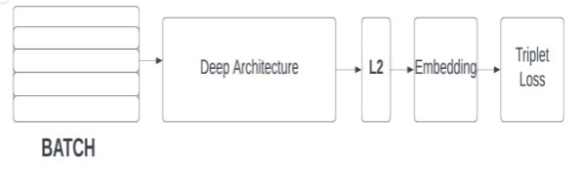

**Figure 2** Flowchart

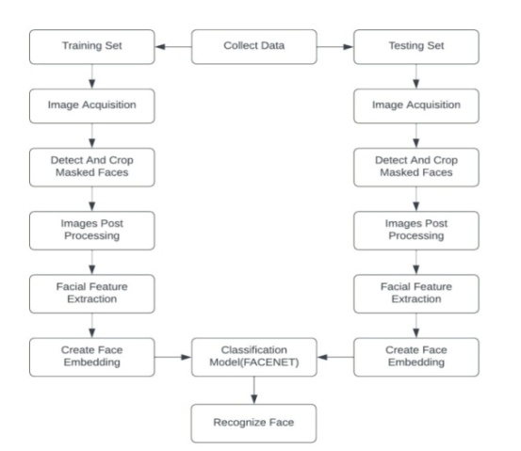

Its elementary infrastructure makes use of ZF-Net or Inception Network. Several 1x1 convolutions are added to further reduce the number of parameters. By using this method, the picture f(x) is embedded with L2 normalization applied to it. Then the loss function receives those embeddings from the previous phase. The loss function's ultimate goal is to create a squared distance between two image embeddings [17].

## *Dataset*

The dataset named ‘105_classes_pins_dataset’ is used for training and testing. It contains 17500+ images of 105 different people. The dataset contains different faces from different angles and contains different directories for training and testing. The dataset is pre-processed and given to the model.

## *Tools and Technologies*

People-Finder is a web application that is integrated using different technologies and tools, as mentioned below:

### HTML: Hypertext Markup Language is what HTML stands for. The creation of web pages and other sorts of information that can be viewed in a web browser uses this markup language as a standard. Headings, paragraphs, images, and links are just a few of the elements that can be defined using a variety of tags and properties in HTML.

### CSS: CSS, or cascading style sheets, is an acronym. It is a language for stylesheets that is used to specify how an HTML or XML page will look. Layout, colour, font, and other visual components of a web site can all be controlled using CSS.

### JavaScript: Websites that are interactive and dynamic frequently use the programming language JavaScript.

### Python: Python is a high-level general-purpose language that is widely used in data processing, data science, and data mining. Python is rich with various libraries like Numpy, Scipy, Matplotlib, FaceNet, Pandas, TensorFlow, Keras, etc.

### Flask: Flask is a popular framework written in Python for building web applications.

## *Working*

Whenever there is any unclaimed child/person found and taken to the police station, the case is registered and uploaded to the database. The person might be able to recall some details, we store them also in the database (with a new ID). The model should be trained again. On the other end, whenever there is any complaint filed for any missing person, we check whether the model is already trained on that face. If there is a match, the corresponding ID is displayed and details are fetched from the database.

If some person is missing and the details are not found in the database, we then register it as a new case. When there is any unclaimed person found with a similar face, the match will be reported.

## *Interfaces and Administrator*

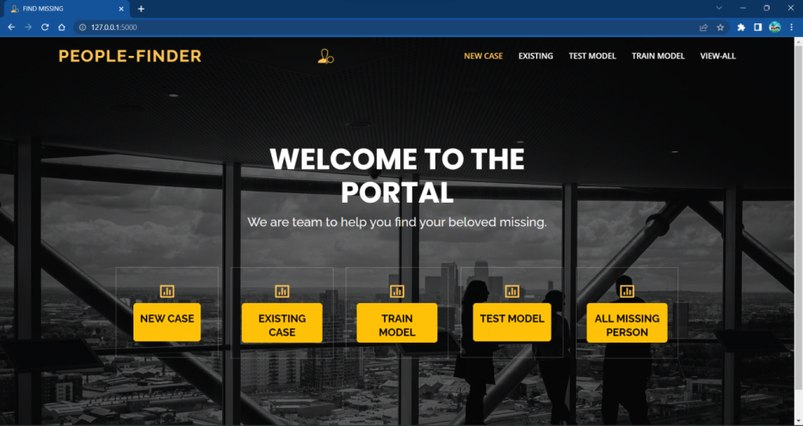

**Figure 3** Homepage

Figure 3 is the home page of the web application, from where the user can perform various operations like registering a new case, finding existing images, and searching images by ID.

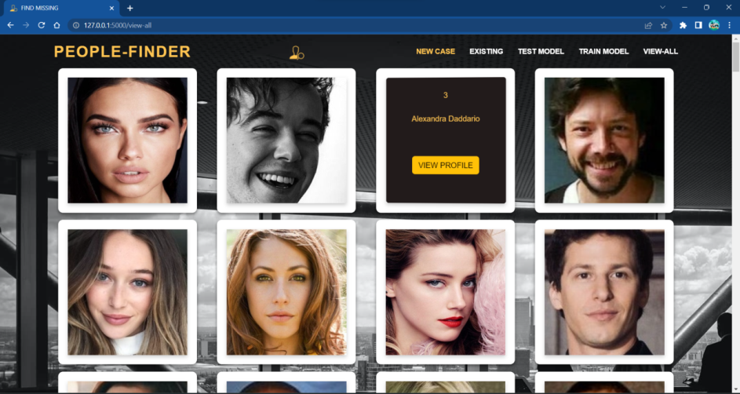

**Figure 4** Webpage for all images

Figure 4 is the interface through which the user can view the images and details of all missing people present in the database.

# conclusion

The web application People-finder can be used to find the missing people using machine learning, the authorities will have access to the portal. Whenever someone files a complaint about a missing person, the police will check if there is a matching case (using face recognition) already present. If not, then register the new case, which will be stored in the database. The entire process of finding the missing people is made simple and quick by this model. Additionally, our technology handles the need to manually search the database for each image in search of a match.

The model gives an accuracy of 87% over the dataset.

# Future scope

Our system is checking the images present in the database, and after getting the matched results, it gives the output. But we anticipate addressing this in the future. We are planning to integrate the public cameras with our model, and we will be receiving the frames in real-time at our system using these cameras, and If the missing individual is discovered in one of the frames, the relevant agency will be alerted.

**REFERENCES**

1. Shelke, Vishakha, et al. "Searchious: Locating missing people using an optimised face recognition algorithm." 2021 5th International Conference on Computing Methodologies and Communication (ICCMC). IEEE, 2021.
2. Geetha, M., et al. "Design of face detection and recognition system to monitor students during online examinations using Machine Learning algorithms." 2021 international conference on computer communication and informatics (ICCCI). IEEE, 2021.
3. Perumal, Vani. "Face Recognition in Video Streams and its Application in Freedom Fighters Discovery-A Machine Learning Approach." 2020 IEEE International Conference on Machine Learning and Applied Network Technologies (ICMLANT). IEEE, 2020.
4. Gholape, Neha, Ashish Gour, and Shivam Mourya. "Finding missing person using ML, AI." Int. Res. J. Mod. Eng. Technol. Sci 3 (2021): 1517-1520.
5. Pawar, Sanskar, et al. "Find Missing Person Using Artificial Intelligence." International Research Journal of Engineering and Technology (IRJET) 8.12 (2021).
6. Kukreja, Sandeep, and Rekha Gupta. "Comparative study of different face recognition techniques." 2011 International Conference on Computational Intelligence and Communication Networks. IEEE, 2011.
7. Sharma, S., Karthikeyan Shanmugasundaram, and Sathees Kumar Ramasamy. "FAREC—CNN based efficient face recognition technique using Dlib." 2016 international conference on advanced communication control and computing technologies (ICACCCT). IEEE, 2016.
8. Wang, Di, et al. "Face recognition system based on CNN." 2020 International Conference on Computer Information and Big Data Applications (CIBDA). IEEE, 2020.
9. Lv, Taizhi, et al. "A face recognition algorithm based on cnn with elbp and dcgan." 2020 International Symposium on Computer Engineering and Intelligent Communications (ISCEIC). IEEE, 2020.
10. Chawda, Vaishnavi, et al. "Unique Face Identification System using Machine Learning." 2020 Second International Conference on Inventive Research in Computing Applications (ICIRCA). IEEE, 2020.
11. Zhou, Yuxiang, et al. "Face and gender recognition system based on convolutional neural networks." 2019 IEEE International Conference on Mechatronics and Automation (ICMA). IEEE, 2019.
12. Sharma, Sudha, Mayank Bhatt, and Pratyush Sharma. "Face recognition system using machine learning algorithm." 2020 5th International Conference on Communication and Electronics Systems (ICCES). IEEE, 2020.
13. Jahan, Nusrat, et al. "Real time face recognition system with deep residual network and KNN." 2020 International Conference on Electronics and Sustainable Communication Systems (ICESC). IEEE, 2020.
14. Guo, Xinyu. "A KNN classifier for face recognition." 2021 International Conference on Communications, Information System and Computer Engineering (CISCE). IEEE, 2021.
15. Mishra, Ashutosh, et al. "Multi-stage face recognition for biometric access." 2015 Annual IEEE India Conference (INDICON). IEEE, 2015.
16. Balar, Bharath Darshan, et al. "Efficient face recognition system for identifying lost people." International Journal of Engineering and Advanced Technology (IJEAT) 8.5s (2019).
17. <https://www.geeksforgeeks.org/facenet-using-facial-recognition-system>.
18. https://www.kaggle.com/datasets/quangv/105-classes-pins-dataset