  - Final project submission

Role Aware Iterative Retrieval
  - A controlled comparison with Knowledge Aware Iterative Retrieval
Prepared for teacher assessment | 27 October 2026

Student or team names _______________________________________
Roll numbers _______________________________________
Department and programme _______________________________________
College or institution _______________________________________
Guide or supervisor _______________________________________
Presentation date _______________________________________

Project outcome
We built a working local system that answers multi-hop questions from supplied documents, shows its evidence and execution trace, and compares two retrieval strategies under shared limits. The deliverable includes both engines, a common evaluation pipeline and a live dashboard.
Updated RAIR achieved 40.5% exact match on the fresh benchmark. Its gain over the earlier RAIR core was 22.0 percentage points, with a 95% question-cluster interval of 15.0 to 29.5 points. Its 4.5-point lead over KAIR remains inconclusive.
Evidence boundary: one local model, supplied HotpotQA distractor pools, 100 fresh questions and two seeds. This is a research prototype whose answers can still be wrong.

Abstract and report outline
Multi-hop question answering requires connecting facts across documents. A plausible final answer can hide a missed relation, an unsupported intermediate claim or a failed search. This project makes those operations inspectable and measures their outcomes with the same evaluator.
Role-Aware Iterative Retrieval, abbreviated RAIR, separates decomposition, query planning, evidence selection, extraction, verification and final synthesis. Accepted facts enter a shared state that guides later searches. The baseline is a local adaptation of competitive Knowledge-Aware Iterative Retrieval, or KAIR, with two agents retaining private knowledge and sharing selected source context.
After diagnostic development on already exposed questions, the final experiment froze 100 further questions and ran three arms at seeds 42 and 43. The third arm used the earlier RAIR core with the same current final-answer policy. All 600 planned runs were retained, including errors and abstentions. Updated RAIR, the earlier-core control and KAIR scored 40.5%, 18.5% and 36.0% exact match respectively.
The primary result supports the bundle of RAIR core changes under this protocol. It does not isolate individual changes or establish superiority over KAIR. A subsequent dashboard demonstrates actual inference, source citations, internal traces and safe abstention on illustrative cases. Final checks passed 207 automated tests and reaudited all 600 benchmark records.
Section | Page
Problem and completed work | 3
RAIR architecture | 4
KAIR baseline | 5
Evaluation design | 6
Benchmark findings | 7
Resource use | 8
Remaining failures | 9
Trace examples and future work | 10
Dashboard and demonstration | 11
Verification and references | 12

Problem and completed work

Research question
Can explicit roles, a shared evidence-backed state and bounded iteration make a local multi-hop QA system more reliable than its earlier implementation, while supporting a fair comparison with competitive whole-question agents? The teacher should be able to inspect both the answer and the route used to obtain it.

Inputs and outputs
Each engine receives the same question and the same source documents. It can retrieve within that pool, create intermediate knowledge and return an answer with original source citations, abstain, or expose an explicit execution error. Gold answers and gold support annotations belong only to the scoring layer.
Step | Completed component
1 | RAIR roles, BM25 retrieval, bounded controller, citations and raw call traces
2 | Competitive KAIR baseline with private state and selected source context
3 | Shared evaluation, frozen sampling, budgets, scoring and resumable journals
4 | First untouched benchmark of 100 questions and two seeds
5 | RAIR repairs and a further fresh three-arm benchmark of 600 runs
6 | Working local dashboard connected to both actual engines
7 | Report, slides, demo notes, viva preparation and final evidence checks

Contribution and scope
The contribution is an implemented and evaluated role-based workflow with constrained source identifiers, conservative fact admission, gap scheduling and observable execution. Decomposition and shared knowledge alone are not a novelty claim because KAIR also describes a collaborative mode. This project implements its competitive mode as the baseline.
The application searches supplied text. It does not ingest arbitrary PDFs, browse the web, train a new language model or provide public hosting. These are possible extensions rather than unfinished requirements for this local prototype.

RAIR architecture
A single controller coordinates specialized prompts over one model. Roles describe responsibilities and validated interfaces, not separately trained models. Shared state contains the original question, information gaps, accepted source-backed facts and query history.
Operation | Responsibility and check
Decompose | Create the minimum information gaps with priorities and dependencies
Plan and retrieve | Choose an actionable gap, form a new query and retrieve the top three BM25 documents
Filter evidence | Choose sentence aliases drawn from retrieved documents and reconstruct original text
Extract facts | Propose useful facts citing available evidence; software assigns candidate IDs
Verify | Make one keyed decision per candidate and apply support, relevance, type and placeholder guards
Update state | Admit accepted facts and resolve only gaps whose requested information is supplied
Synthesize | Use accepted facts to answer with valid fact citations or abstain

Iteration and stopping
The scheduler prefers less-attempted actionable gaps. A repeated query can trigger one deterministic fallback to the original question, charged as a retrieval. A stalled gap need not halt another actionable gap. The shared comparison caps each engine at four retrievals and eighteen generation attempts, including a reserved final call.

What Step 5 changed
Short source aliases and software-assigned IDs reduce malformed references. Required keyed verifier decisions prevent omitted candidates. Supported bridge facts may enter memory without completing a gap. A rejected fact cannot resolve a gap, and unresolved planning hints alone cannot veto a complete supported final answer.
These protections enforce structure and provenance. The support decision remains model-based, so a valid citation can still accompany an unsupported inference or an answer to the wrong relation. The final failure review shows examples of both.

KAIR competitive baseline
Each of the two KAIR agents attempts the entire question. Agents use identical prompt templates with independent seed offsets and maintain private known facts, unresolved requirements, query history and working source context. The project maps the competition operations to Algorithm 3 of the journal reference [2]. The earlier preprint [3] provides additional background.
Stage | Local behavior
Agent cycle | Plan a query, retrieve, update knowledge, check claims and filter source context
Complete proposal | A successfully initialized agent with accepted knowledge and no remaining requirements can finish early
Partial proposal | Otherwise select a healthy initialized proposal with the fewest unresolved requirements
Context sharing | Share only the selected original source sentences for the next iteration
Private memory | Do not merge agents’ private facts, requirements or histories
Final output | Apply the same final synthesizer and citation policy used by RAIR

Documented adaptations
Execution is serial on one Ollama service. Starting order rotates between competition iterations. This changes scheduling and early termination relative to an asynchronous race. Each launch allows at most two retrieval cycles, with at most two competition iterations, all inside the shared comparison caps. The local model and supplied distractor pools also differ from the paper environment.
Malformed evidence or a failed generation retires the affected agent. Healthy competitors may continue, but a question becomes an error when no valid initialized proposal remains. There are no hidden retries or JSON repairs. Independent seeds allow diversity but do not guarantee different outputs.

Fair interpretation
The comparison concerns this documented local competitive baseline. It does not reproduce the paper’s reported absolute scores or claim that a serial implementation establishes conclusions about all KAIR variants. The architecture comparison is role specialization with a shared state versus competition among whole-question agents with private state.

Common evaluation design
HotpotQA [1] supplies questions, document pools and supporting-fact annotations. In the distractor setting each selected task has a small supplied document pool. BM25 [4] searches only that pool. This evaluates iterative retrieval and reasoning under controlled inputs, rather than open-web search.
Control | Frozen Step 5 protocol
Questions | 100 fresh questions, including 79 bridge and 21 comparison tasks
Exposure exclusion | 125 previously exposed IDs excluded before the final cohort was run
Repetitions | Seeds 42 and 43 for each question and arm
Arms | Updated RAIR, KAIR and earlier RAIR core with shared current final policy
Model | qwen3.5:4b through Ollama 0.40.6 with identity checked before and after
Retrieval and decoding | BM25 top 3; context 4096; output cap 512; temperature 0.7, final 0
Common caps | 4 retrievals and 18 LLM generation attempts per arm, including final
Order | Three-arm order rotates across questions and reverses for the second seed
Scoring | Gold consulted after inference; errors and abstentions stay in denominator

Metrics and statistical unit
Exact match checks normalized answer equality. Token F1 measures overlap with the reference answer. Coverage is answered runs divided by all runs. Citation F1 compares cited original sentence references with annotated supports. Retrieval recall measures the proportion of gold support titles retrieved across paid searches. Citation overlap is not a semantic entailment score.
The primary endpoint is updated RAIR minus the earlier-core control exact match. Confidence intervals use 10,000 paired percentile bootstrap resamples of the 100 question clusters, keeping both seeds together. The seeds are repeated observations of the same questions. RAIR versus KAIR and answer F1 are secondary, with pointwise approximate intervals and no multiple-comparison adjustment.

Final benchmark findings
System | EM | F1 | Coverage | Abstain | Errors
Updated RAIR | 40.5% | 47.1% | 69.5% | 61 | 0
Earlier RAIR core | 18.5% | 21.9% | 32.5% | 111 | 24
KAIR | 36.0% | 45.5% | 73.5% | 50 | 3

Denominator: 200 runs per arm. Exact matches were 81 for updated RAIR, 37 for the earlier-core control and 72 for KAIR. All 600 planned records are present. The earlier core uses the same current final-answer policy as the other arms.

Primary comparison
Updated RAIR gained 22.0 percentage points in exact match over the earlier-core control, with a 95% question-cluster interval of 15.0 to 29.5 points. Updated RAIR alone was correct in 47 seed-specific comparisons, the control alone in three, with 150 ties. Its question-level execution errors fell from 24 to zero and abstentions from 111 to 61 on this same cohort.
This estimates the bundle of RAIR core changes conditional on the shared final policy. It does not isolate the effect of any one repair or the final-policy change by itself.

Secondary comparison with KAIR
RAIR led KAIR by 4.5 exact-match percentage points, with a 95% interval from -3.0 to +12.0 points. The interval includes zero, so superiority over KAIR is not established. RAIR’s answer F1 was 47.1% versus KAIR’s 45.5%, a 1.6-point difference whose interval also includes zero.

Earlier benchmark context
Step 4 tested a different 100-question cohort before the repairs. Original RAIR scored 23.0% exact match and KAIR 36.0%. These historical figures motivated development but cannot be directly compared with Step 5 as a controlled estimate of improvement. The Step 5 earlier-core arm supplies the matched comparison.
Sources: results/step5_fresh_benchmark.summary.json and its 600-run journal. The raw predictions, errors and frozen denominator have not been altered for this report.

Resource use and evidence quality
System | LLM calls | Retrievals | Total tokens | Seconds
Updated RAIR | 12.27 | 2.69 | 9,657 | 14.90
Earlier RAIR core | 10.63 | 2.23 | 7,962 | 15.17
KAIR | 9.57 | 2.13 | 11,364 | 16.92

Values are means per run. Total tokens combine reported prompt and output counts. Latency is serial controller time on the recorded local setup, not a universal speed claim or a distributed scheduler benchmark. The project records complete token counts for all runs.
RAIR used more LLM calls and retrievals than KAIR on average, but fewer total tokens. This shows why equal round counts or call caps do not imply equal computation. The common caps were enforced, while actual usage was measured rather than assumed equal.
System | Citation F1 | Support title recall
Updated RAIR | 47.6% | 89.25%
Earlier RAIR core | 21.2% | 78.00%
KAIR | 49.1% | 84.00%

Interpretation
Updated RAIR had higher mean support-title retrieval recall than KAIR, while KAIR had slightly higher citation F1. Retrieving both support titles does not ensure selection of the necessary sentences or correct combination of their facts. A cited sentence can be structurally valid yet fail to support the generated claim.
No invalid original source citations or gold annotation reference issues were detected in the frozen run. That result validates source identity and indexing. It does not mean that every cited answer is factually correct, as the trace examples on page 10 show.

Remaining failures
The final review analyzed the existing frozen results without model inference or tuning. The outcome census covers every run. The twelve detailed examples were purposefully selected to illustrate distinct mechanisms, so their categories are not estimates of how common each root cause is.
Outcome out of 200 | RAIR | KAIR
Exact match | 81 | 72
Answered but not exact | 58 | 75
Zero token overlap among nonexact answers | 31 | 40
Partial token overlap among nonexact answers | 27 | 35
Abstained | 61 | 50
Question-level execution error | 0 | 3

The two indented overlap rows subdivide the answered-nonexact row. They are not additional outcomes. Token overlap alone cannot determine semantic correctness. Some failures are aliases or answer-span differences, while others answer the wrong relation or make an unsupported inference.

RAIR abstention detail
Of the 61 RAIR abstentions, 39 stopped at a resource limit, 15 at repeated queries and seven after all planned gaps were marked resolved. Twenty-nine had no accepted facts and 32 had some facts. In 42 of these 61 runs, both gold support titles had been retrieved. This points to evidence selection, bridge-fact admission and final completeness as worthwhile diagnostic targets, not proof that retrieval was otherwise sufficient.

KAIR validation detail
KAIR recorded 25 agent error events. These include 18 evidence errors during update or filtering, two empty-knowledge completion checks, two unavailable-context sentence selections and three truncated generations. Some runs survived an agent failure. Only three whole-question errors occurred, all NoValidProposal. Agent events must not be added to question errors as if they were separate questions.
The descriptive audit is saved as results/step7_build/failure_analysis.json and outcome_census.csv. The separate failure review in the delivery folder identifies every manually inspected question and seed.

Trace examples and future work
Example | Observed mechanism
Newcomers film, RAIR seed 42 | Decomposition asks only for cast members. The system returns Christopher McCoy although the question asks what a star is known for.
Jack Stephans, RAIR seed 42 | The coaching-at-Fordham bridge is rejected for not being a city. A city fact is accepted, but the final answer lacks the full chain and abstains.
Grant Nicholas, RAIR seed 43 | Welsh nationality is discarded as irrelevant to deciding American status. The final yes is based only on Danny Shirley and is wrong.
Nyaya books, both seed 42 | Both return 5 against five books. Source text supports the number, but EM and token F1 remain zero.
Stoffel Vandoorne, KAIR seed 43 | Both agents fail filtering on duplicate document selections. No valid initialized proposal remains.

The manual review also identifies valid aliases, answer-span differences, a missed second entity and checker false positives. These are post hoc observations of existing outputs, not a new semantic accuracy score. Full question IDs, sources and traces are retained in the audit.

Prioritized future work
First, test whether bridge-fact admission preserves useful relations without accepting unsupported claims. Add negative-evidence examples and explicit final checks for all compared entities. Second, test relation-complete decomposition and diverse queries for missing second entities. Third, strengthen KAIR source selection schemas while preserving strict validation. Develop these changes only on already exposed cases and reserve a new untouched cohort for the next measurement.
A separately declared semantic or alias-aware metric could supplement EM, applied consistently to both systems with documented human review. It must not silently replace the frozen primary score. Larger samples, additional model families, component ablations and more realistic retrieval pools would test generality. Public hosting and document ingestion are optional product extensions.

Presentation conclusion
The project is complete as a local research prototype and teacher demonstration. The supported claim is a substantial improvement over the earlier RAIR core under a controlled protocol. The KAIR comparison remains inconclusive, and the failure analysis explains why neither engine should be presented as a guarantee of factual correctness.

Working dashboard and demonstration
The browser dashboard runs the existing RAIR and KAIR controllers against identical editable inputs. It displays answer states, original source citations, execution traces, resource use and a downloadable JSON result. The recorded benchmark table is separate from live examples.
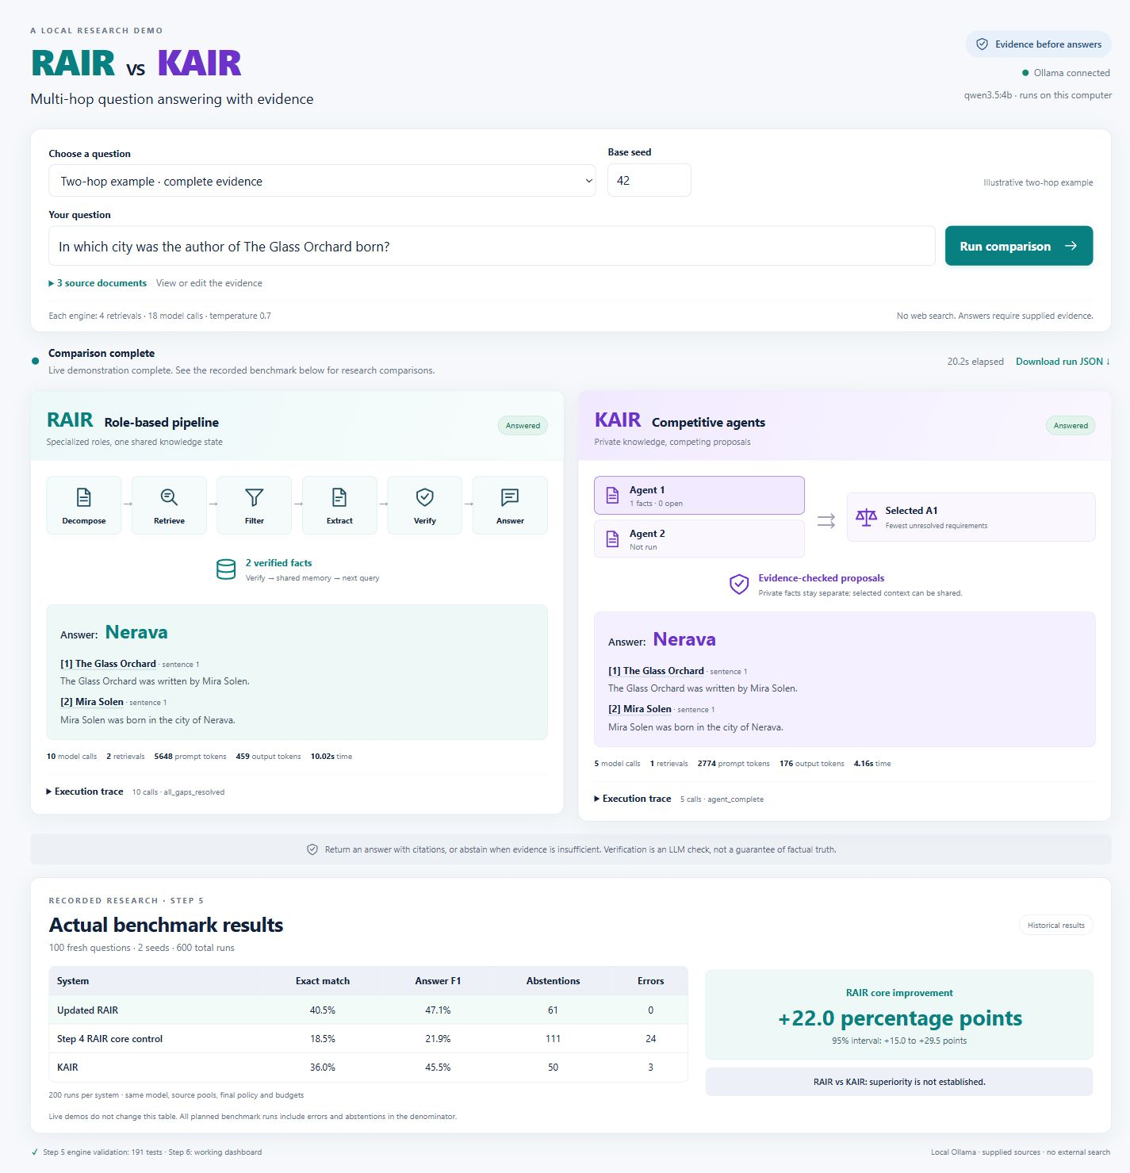
Figure 1. Actual Step 6 desktop screenshot with completed live outputs. This is a working application capture, not the earlier concept image.

Demonstration sequence
Open http://127.0.0.1:8765 with Ollama and the configured model running. Show the complete Glass Orchard example, inspect the book-to-author and author-to-city links, and run both engines. In validation both returned Nerava. Open a citation and the two execution traces. Then use the missing-evidence example to explain abstention. Finish with the frozen benchmark and its uncertainty.
Allow several minutes for real local inference. The demo script includes preflight commands, a short spoken explanation, optional custom sources, and a clearly labeled saved-evidence fallback. Live demonstrations do not change the research score or establish accuracy on new questions.

Verification and references

Release checks
The final source check matched the Step 5 verified engine hashes and Step 6 dashboard hashes. All 207 automated tests passed. A new offline audit checked every one of the 600 frozen records, recomputed its scores and resource checks, and reproduced both exact-match contrast intervals. Step 6 also retains five browser comparisons covering ten real engine runs across complete, missing, custom and labeled development scenarios.
The model and dataset identities are recorded in the manifest and journals. Model digest: 2a654d98e6fba55d452b7043684e9b57a947e393bbffa62485a7aac05ee4eefd. Ollama version: 0.40.6. Keep the frozen config/step5_benchmark.json with the raw results and source snapshot for reproduction.
A post-benchmark correction changed only a standalone call-ceiling estimate and its documentation. Existing proof replays all 200 RAIR transports with identical requests and results except wall timing. The frozen manifest correctly rejects the later metadata revision for a fresh run. Use the archived measured source for exact reproduction, or create a new manifest for a new experiment.

Selected references
[1] Yang, Z., Qi, P., Zhang, S., Bengio, Y., Cohen, W., Salakhutdinov, R., and Manning, C. D. (2018). HotpotQA: A Dataset for Diverse, Explainable Multi-hop Question Answering. EMNLP, pp. 2369-2380. https://aclanthology.org/D18-1259/
[2] Song, S., Chawla, S., and Madisetti, V. K. (2026). KAIR: Knowledge-Aware Iterative Retrieval for Multiagent Systems. IEEE Transactions on Computational Social Systems. https://doi.org/10.1109/TCSS.2026.3668728. Journal Algorithm 3 mapping is documented in docs/KAIR.md. Publisher access was blocked during the final link check; the project retains the earlier direct text verification.
[3] Song, S. (2025). Knowledge-Aware Iterative Retrieval for Multi-Agent Systems. arXiv:2503.13275v2. https://arxiv.org/abs/2503.13275v2. This earlier preprint has different author metadata and does not contain the journal Algorithm 3.
[4] Robertson, S., and Zaragoza, H. (2009). The Probabilistic Relevance Framework: BM25 and Beyond. Foundations and Trends in Information Retrieval, 3(4), 333-389. https://doi.org/10.1561/1500000019.
[5] Project evidence. docs/RAIR.md, docs/KAIR.md, docs/EVALUATION.md, docs/RAIR_IMPROVEMENTS.md, docs/DASHBOARD.md and results/step5_fresh_benchmark.summary.json. Final release checks are recorded in results/step7_verification.json.

