IoT – Fall 2017

Assignment 5: Android Car Simulator

**GROUP Assignment:**

Implement an Android App for a Car Simulator using the GUI template below:

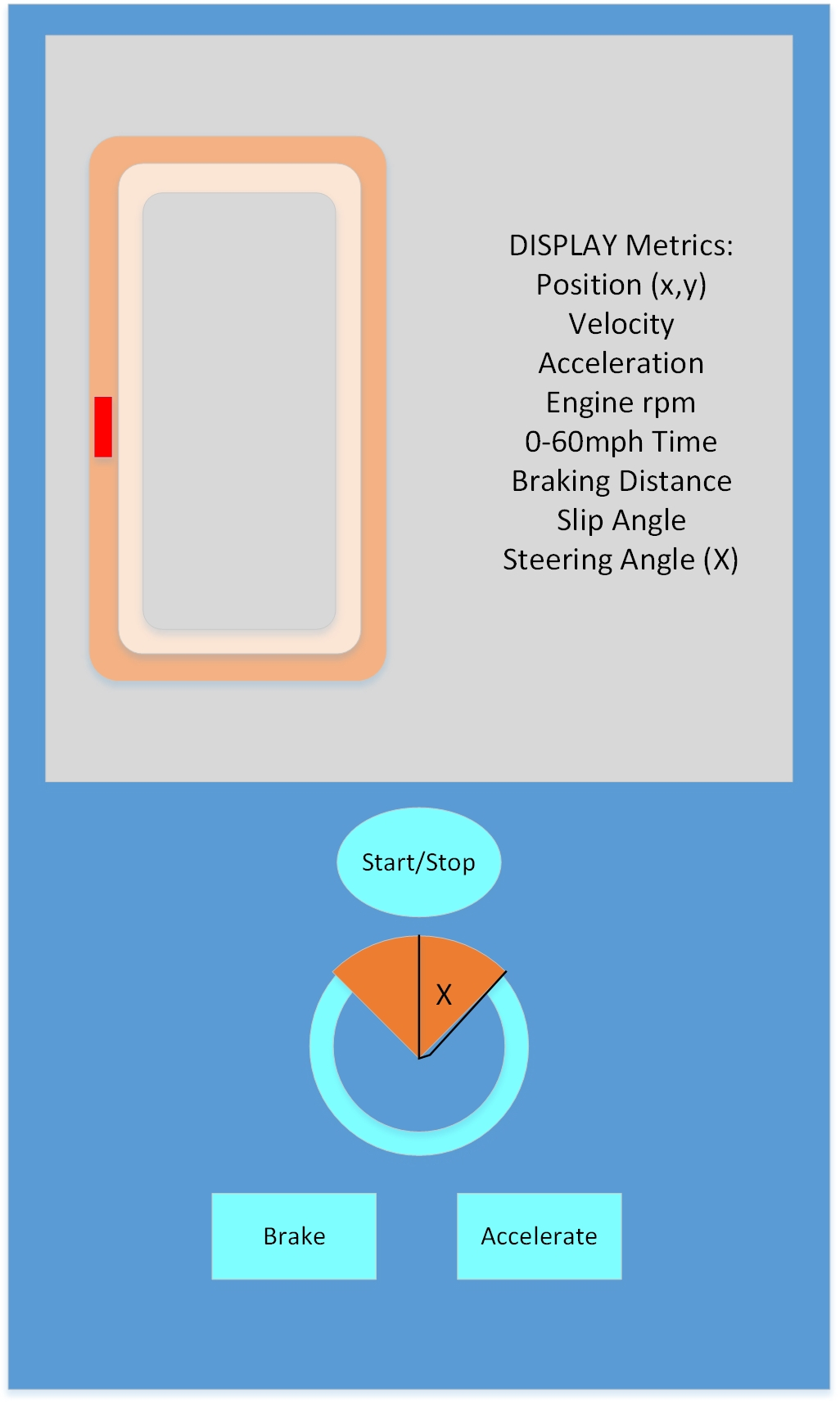

There are 3 main layout parts:

1. Top Left: a track with 2 lanes, on which the RED car moves in real time
2. Top Right: a dynamic display of the main metrics we are interested in as the car moves
3. Bottom: controls for the driver to Start/Stop engine, Accelerate (increase engine RPM), Brake (with friction against the rotating wheels), and a Steering Wheel (showing the Steering Angle with respect to the front of the car always). The Steering Wheel could be controlled by Touch, Tap, or Drag.

The physics of the car movement and response is described in the following webpage:

<http://www.asawicki.info/Mirror/Car%20Physics%20for%20Games/Car%20Physics%20for%20Games.html>

Deliverables:

1. Android App
2. Report file showing
   1. all your formulas
   2. all your assumptions
   3. individual contributions

Put the above in a directory with the name of your group, and upload the directory in Canvas.