Product learning from building a reuse marketplace app.

Executive Summary

This paper summarizes driver / purpose behind building a mobile reuse (Not For Profit) marketplace app, along with planning and execution details behind it.

The details include how we planned and delivered the product, what we tried across stakeholder engagement, marketing, and legal setup, and why adoption did not scale. Finally, it concludes with key learnings and what we would do differently if we were to attempt a similar civic marketplace again.

The Original Hypothesis
We had first hand experience claiming and re-purposing decent items (such as couch, table and TV) from curbside simply because we happened to see them at the right time. This was a trigger for a much broader thought to make these items and their condition with location details broadcast “just-in-time” so that they can be discovered and re-used.
Based on publicly available council and state reporting, curbside collections were on the rise, increasing collection cost pressure while causing environmental damage through landfills and factory recycling. Meanwhile, many functional items do not get a second life.
Our hypothesis was that making items location and condition available through a mobile app could shift outcomes incrementally:
- Friction-less re-use of items esp by tenants, students, families.
- Waste reduction through re-use and re-purpose.
- Reduce collection burden and associated cost pressure on council.

What we built

MVP (late 2020) and what “done” meant
Our MVP efforts can be summarized in the following sections:
- End Goal: Provide simplest possible, familiar looking purpose driven mobile interface, with an aggressive target of onboarding 1000 users in 3 months.
- Brainstorm on MVP features: Focused on absolute minimum functionality to drive the purpose which translates to creating an interface with no login or user verification and user directly navigating to the items recently posted. Additionally, providing them with functionality of posting new items.
- Functionality Development: We selected low cost serverless approach since it was easy to use, and familiar enough to get started with.
- FrontEnd development: Once we have functionality ready and tested, integration with user experience was required. Since we lacked skills on developing user interface, we had to hire a freelancer from a popular freelance portal with limited (bootstrap) funds. This turned out to be a big effort since we had to go through a number of freelancer profiles, interview them and finally selected one with right experience and knowledge. Driving the delivery was another challenge since it required regular cadence and with time differences and misaligned way of working, testing and collaborating efforts skyrocketed. It was not before a fair bit of discussions, brainstorms, test cycles, big fixing and in some cases complete re-design, that the interface was finalized, developed, and integrated that met our intended design and requirements.

Ask for funding, Creation of NFP Entity (2021) and Publishing App
- Marketing and presentation for funding: With a bunch of items in our product roadmap, including marketing and legal efforts, we needed funding. We approached 4 different councils and presented our MVP product, roadmap and how it can benefit the council and community. All, except one council, were risk-focused and cautious and did not want to move forward with any “endorsement” or funding. However, we got AUD 10k grant from that one council, which appreciated the problem and our effort in this direction. It was a big morale boost. We later applied at 3 more different grants (From private and public entities) which were denied. The 10k funding helped us in legal, marketing, roadmap items development, app publishing and ongoing operational costs.
- Legal: We hired lawyer (again a freelance lawyer to save on our budget) to create an org structure for NFP and register our NFP business.
- Publishing: We created developer accounts within the 2 widely used mobile platforms and with a few hiccups we were able to push and publish our apps for consumption.

2021–2023 improvements: login, maps, notifications
- With no traction and feedback from our close friends and family, we decided to build a few interesting items from our roadmap that can potentially get visibility and drive downloads. First we decided to build a login functionality only to verify a (human) user since the data was not private. It was an entirely B2C model with no restrictions on read and search functionality. For the compliance, safety and moderation purposes only we tracked phone number and user’s (random) ID from our engine.
- Once that’s successfully implemented, we integrated Google map in the app to show our users items location within a map.
- We also made use of Google’s Firebase to broadcast notifications if any users post an item. The notification was customizable with a toggle button allowing user to turn it off / on on-demand.

Go-to-market experiments (what we tried)
- Thanks to the council grant, we were also able to get credits for Google Ads and hired another set of freelancers for conversion to downloads. However, unfortunately, due to Google’s limitations on their offerings, only the org website clicks could be tracked and no way to put the ads in the app marketplace.
- Flyers: We also got the subscription from Canva which we used to design and create flyers. We ordered printouts with different sizes to put them into community libraries, college campuses, and on street manual distribution.
- Volunteer seeding: We tried 2 different waves of hiring volunteers to seed posts for general consumptions. However, this also went nowhere with apparently no interest from volunteer community. We also tried registering the company with various volunteering organizations for support but still got no visibility.
- Meetups / Webinar and council outreaches: I tried to talk about it in meetups and asked for presentation (with no response), conducted a webinar (well received but no conversion to downloads), and kept reaching out to councils with email requests.

Our Observations:
- Installs: Except for a few close friends and family members, installs were only in single digit / handful. These instances of installs seem to be aligned with any events such as addressing / briefing volunteer groups or a strong LinkedIn post.
- Supply: Even though we tried to seed with various different volunteer waves, more than 95% of the posts were done either by me or other co-founder.
- Engagement: Unfortunately, there was no visibility on install / uninstall of the app due to technical constraints.
- Funnel Reality: While most of the people are aware of the problem and even showed interest in our app, it was not translated to actions (i.e. install and retention with active usage).

Why did it not scale
- Cold start with limited liquidity: We bootstrapped with limited amount that we could afford at the time. This created pressure directly on us putting additional time and effort into building backend engine while also looking for a cheap but still a decent freelancer for frontend user experience layer. This was hectic since there were numerous to and fro with the freelancer and time difference, along with mis-alignment on the requirements added more complexity in collaboration.
- Lack of incentives for posts: Partly due to limited fund availability, we were unable to incentivize posts / uploads.
- Trust and logistics: The use case for our app was limited to the items specifically kepy on the curbside and hence there was no ownership of the items posted. There was no in-app messaging / claiming workflow. We relied on comments whether the items (or a subset of) were taken.
- Lack of marketing support for NFP: While one of the councils thankfully agreed for the funding, it (and others) was not ready to market the product even though this is likely benifit them.
- Comparison with other marketplaces: Perhaps not strong enough.
- Funding constraints: We could experiment with product, users, marketing, reach outs via different paid social channels but we seriously lacked funding that held us back.

What we’d do differently
- Start hyper-local (one campus/suburb): Pick a suburb or 2 which have the highest rate of items in the curbside and use our own downloaded app to post items, and demo door to door.
- Partner-first distribution (property managers, student unions, movers, hard rubbish days): Target audience to be collaborated closely with from the get-go, get their requirements, and show them the prototypes and MVP.
- Incentives for supply (posting) before demand (browsing): While volunteers may help, it always is a safe bet to incentivize the effort (with gift cards, or with monetary incentives).
- Loop marketing with continuous growth: A possible way to fail fast could have been a clear reinforced continuous cycle that clearly shows that the app / effort could sustain itself such as acquire and retain x users within y days/months so that monetization through either targeted advertisements and/or using the app can be achieved that in turn, will allow additional acquisition efforts.

Key Learnings

Cold start is a liquidity design problem
A reuse marketplace is a two-sided system. Until there is enough supply density (in a tightly bounded area), downloads won’t happen, regardless of awareness. In our case, even with ~200–1000 posts at peak, the supply (of posts) wasn’t organically crowd-sourced. These posts were seeded / generated by us at random, which didn’t create a sustainable loop.

Incentives matter, but they must be structured
Volunteers alone are unreliable for supplying into the system. If posting is an effort (For which volnteers were hired), early supply needs deliberate incentives (gift cards, partner rewards, community credits) and clear rules. The key is to start small and prove that incentives improve posting frequency and downstream engagement (i.e. downloads) before scaling spend.

Trust + logistics is the hidden tax in “free stuff”
Without a claiming mechanism and without ownership verification, you end up relying on comments to know whether an item still exists or its condition is accurate. That uncertainty results in low to no converstions i.e. retention / downloads since the users will not like “wasted trips” to the location. Trust, safety, and logistics need to be product features, but in our case (For right or wrong reasons), it was one of the biggest assumptions.

Councils can fund innovation, but they rarely drive distribution
A grant helps morale and runway, but councils often operate with legal and risk constraints and may avoid active promotion. Treat councils as enablers (policy support, visibility through official channels, access to hard-rubbish calendars, venues for pilot events), not as a promotional / marketing channel.

Offline awareness doesn’t equal installs
Flyers, libraries, word of mouth, and campuses create awareness, but app installs usually require an embedded moment: an event, a partner workflow, or a direct trigger (e.g., “Hard rubbish week - scan here, claim now, pickup window tonight” or finding out “garage sale” events at specific locations and put a QR code at the signage). If there is no urgency, the interest (which seem to be a “great idea” during a quick demo), becomes passive.

Build decisions were not aligned with adoption loops
We shipped an MVP and continued iterating (login, map view, notifications) based on feedback, but feature improvements don’t solve missing market loops. Product work must be directly tied to a measurable loop: post → discover → collect → confirm taken → repeat/referral.

Measurement is a must (even for NFP pilots)
We lacked end-to-end visibility on install/uninstall and retention, which limited our ability to diagnose where the funnel broke. For any future attempt, analytics needs to be part of MVP definition: installs, activation, retention, and “successful collection” confirmation.

If you can’t fund experiments, you must constrain scope aggressively
Funding constraints limited paid channels and incentives. The practical alternative is to go hyper-local, partner-first, and run short experiment cycles with hard success criteria (e.g., X active listers and Y weekly collections in a single suburb/campus) before expanding.

Be consistent in your messaging across channels
While we put efforts documenting and putting the pack together with peer reviews, we could have had the messaging reviewed with a more experienced professional in our circle esp the ones in the leadership / sales marketing positions. The feedback helps refining the messaging and make it more succinct aligned with the audience and delivery timing.

Key Achievements
- We took an idea to a real product. From concept (2019) to MVP launch (late 2020) and ongoing improvements through 2023: We shipped, iterated, and kept going.
- We created a legitimate operating entity and ran it responsibly. Entity formation, legal setup, and app store publishing were completed properly. It was a professional and formal setup with official business registrations and account.
- We secured external validation and funding. We pitched multiple councils, handled scrutiny, and won a ~$10k grant hence proving that the problem resonated with at least one decision-maker.
- We navigated real-world constraints. NFP marketing limitations, volunteer recruitment, and stakeholder risk posture are realities. We learned how these constraints shape product outcomes, not just product features.
- We generated reusable frameworks. The learnings translate into a repeatable playbook for other civic-tech and marketplace initiatives (cold start, incentives, trust/logistics, partner distribution).
The key learning was product market and distribution. That’s exactly why it’s worth documenting.

Appendix A
This appendix summarises the technical implementation at a level that is generalised and de-identified.

A1) System overview (high level)
Goal: low-cost, low-ops, and fast iteration: Optimised for early-stage adoption experiments where learning speed matters more than enterprise completeness.
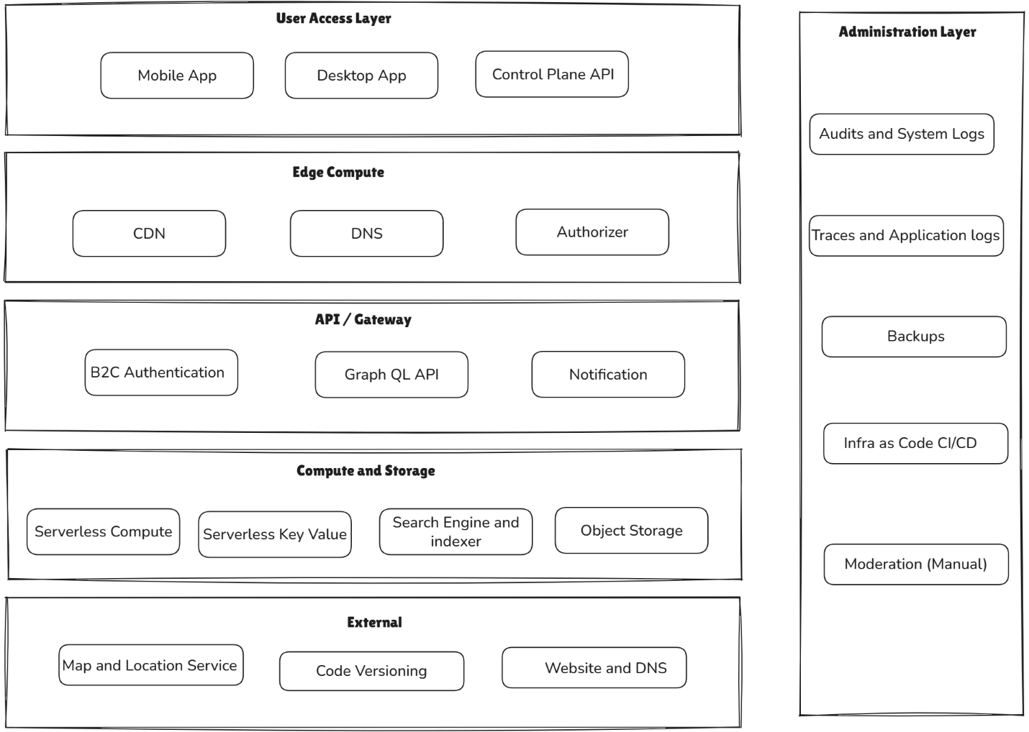
• Mobile client (cross-platform UI): browse nearby items, create a post with photo/location/description, and comment on posts.
• API layer (GraphQL): single endpoint to support flexible client queries and reduce mobile release dependencies.
• Business logic: lightweight server-side workflows for create/read/update of posts, basic moderation controls, and simple status updates.
• Data store: item metadata, minimal to no user identifiers, and manual moderation for safety and abuse control.
• Media storage: images stored separately from metadata, with controlled upload and retrieval.
• Notifications: opt-in push notifications for new posts and activity (toggle on/off).
• Observability: structured logs and basic metrics to troubleshoot failures and understand performance.

A2) Reference architecture (general)
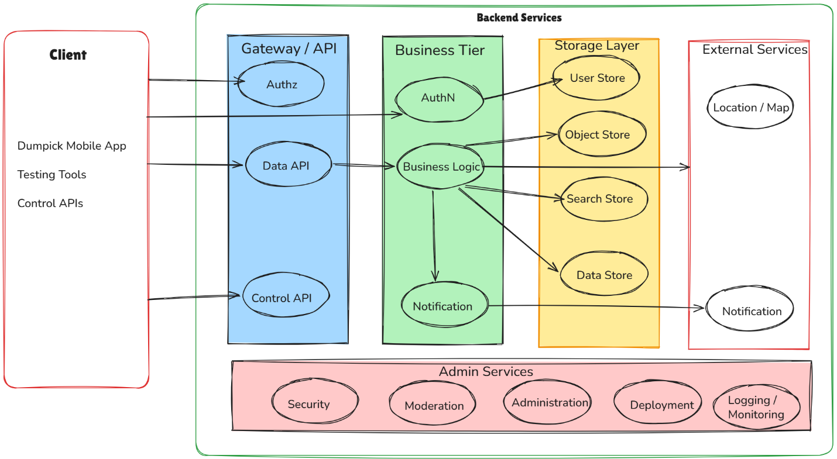

A3) Key architectural decisions (decision log)
# | Key Decision | Reason | Trade-pff
1 | Serverless first approach | Minimal Opex | Testing, debugging, trace logging.
2 | Graph QL API | Supports client driven APIs with flexible mobile queries | Disciplined in schema versioning
3 | No to minimal user verification | Reduce friction and onboarding overhead | Limited moderation without identity
4 | External Location and map service | Ease of use to automatically detect and show on map | May not necessarily be an accurate location
5 | Opt-In notification | For better user experience and engagement | To be carefully designed or else becomes a nuisance.
6 | Manual moderation with minimal PII capture | To minimize friction and latency with a better UX | Lack of accountability and hard to block “bad actors”

A4) Testing approach + Java desktop tool
To accelerate iteration and reduce reliance on the mobile UI for validation, we built a small Java desktop application that exercised the GraphQL endpoint directly.
• Purpose: simulate client calls and validate end-to-end behaviour for queries/mutations without waiting on mobile releases.
• Coverage: key workflows such as create post, fetch latest feed, query by area, comment/update, and status confirmation via comments.
• Benefit: faster regression testing during schema changes and quicker diagnosis via controlled request/response inspection.
For public release, the Java tool should be published in a sanitised form (no hard-coded endpoints, keys, IDs, or real sample data).

A5) GitHub publications (To be released sanitized)

