Workflow orchestration as the missing operational layer in enterprise agent systems
(A strategic guide for enterprise technology leaders)

Executive Summary
Enterprises are rapidly adopting AI, with agentic and multi-agent systems increasingly appearing on technology roadmaps. As enterprise AI systems evolve from isolated model calls to coordinated agent workflows, orchestration platforms are emerging as the operational backbone for production AI systems.
These orchestration platforms provide an essential operational layer required to coordinate multiple steps in workflows such as retrieval, reasoning, tool invocation, data enrichment, and validation while maintaining observability, retry semantics, and governance. Without a coordination layer, AI workflows quickly become difficult to monitor, govern, and scale. Workflow orchestration platforms provide the operational discipline required to move AI from experimentation into production environments.
With modern coding copilots capable of generating orchestration logic in Python / Java (or any comparable software language or framework), it is reasonable to question whether dedicated workflow platforms remain necessary. However, enterprise AI systems require far more than task sequencing. They require operational visibility, state management, retry semantics, governance, and rapid experimentation. These capabilities are typically provided by orchestration platforms out-of-the-box.
The paper examines architectural benefits, operational considerations, and trade-offs when adopting workflow orchestration platforms.
The intended audience includes enterprise business and technology leaders evaluating agentic AI and workflow-driven automation.
Key Takeaways:
- Workflow platforms can be effective for rapid experimentation when building agentic workflows.
  - Use Managed Cloud SaaS for a quick turnaround making sure you use masked/test data.
  - Use Embed SaaS for better protection but then the pricing is unclear.
  - Use self-hosted for the best protection with TCO analysis.
- The workflow orchestration ecosystem for AI systems is evolving rapidly. Platforms are increasingly adding native AI connectors, agent orchestration capabilities, and governance features to support enterprise AI adoption.

Architecture Context
The following diagram illustrates a typical architectural context for implementing orchestration within an enterprise environment. In this architecture, workflow orchestration acts as the coordination layer between agent frameworks, enterprise systems, and foundation models.
Security, governance, observability, and cost management act as cross-cutting concerns across all layers of the orchestration architecture.

Decision Framework for Orchestration
Aspects | Use Workflow | Use Code | Notes
High Orchestration Complexity | Often cheaper during experimentation | Often cheaper at very large scale | Highly complex processes involving branching, retries, and multiple integrations are easier to manage using workflow platforms.
Cost | YES (Usually at beginning) | NO (But cheap at extreme scale) | Total cost of ownership needs to be considered.
Fine-grained Performance Control | NO | YES | If there is a strict performance / latency requirement, consider code-based orchestration
Specialised runtime behaviour | NO | YES | Highly specialised behavior that cannot be addressed by the platform
Complex Integration | YES | NO | In case of complex flow and integration scenario, code-based orchestration is expensive.
Human in the Loop | YES | NO | Enterprise workflows frequently require human approvals, exception handling, or manual validation. Workflow platforms provide native support for human-in-the-loop patterns, which can be difficult to implement consistently in custom orchestration code.
Rapid Experimentation | YES | NO | Workflow platforms are well-suited for rapid experimentation and are typically free at entry tier.
Coupled with enterprise engineering framework | NO | YES | Where a firm requirement exists to align with the enterprise’s existing engineering framework
Extreme scale | NO | YES | Cost for running on a platform at extreme scale can be a deal breaker.
Developer Experience | Strong for rapid assembly | Strong for deep customisation | Workflow platforms accelerate development by reducing orchestration boilerplate, while code-based approaches provide deeper customisation.

Enterprise Adoption Guide
As enterprises move from isolated model calls to multi-step agent workflows, workflow orchestration increasingly becomes the operational control plane for enterprise AI systems.
- Define business goals you are trying to achieve with multiagent architecture and document them to establish clear success criteria.
- Use your enterprise policies and frameworks to decide how to choose an orchestration tool. Bear in mind that:
  - High orchestration complexity often strengthens the case for workflow platforms.
  - Workflow platforms can reduce the need for a larger engineering effort to manage orchestration code.
  - Cost advantage is strongest in experimentation and moderate scale delivery but should not be stated as universal.
- Establish a structured capability framework when evaluating orchestration platforms.
- If you are committed to a cloud provider, evaluate their multi-agent orchestration capabilities. Hyperscalers are investing aggressively in this space. Their AI capabilities increasingly offer essential building blocks, such as compute, events, databases, object storage, and AI tooling etc that integrate with their respective eco-systems. Consequently, architectural complexity along with total cost of ownership may be reduced.
A multi-agent system can fulfil strategic objectives for the enterprise but may not justify return on investment. Crafting a careful approach and failing fast is necessary and that’s where dedicated orchestration platforms demonstrate clear value.

Appendix – Practitioner Comparison
The evaluation involved embedding user documents, storing them with metadata in a vector database, and enabling search to find the closest matching documents between two sets. The workflow tested can be summarised with the following diagram:
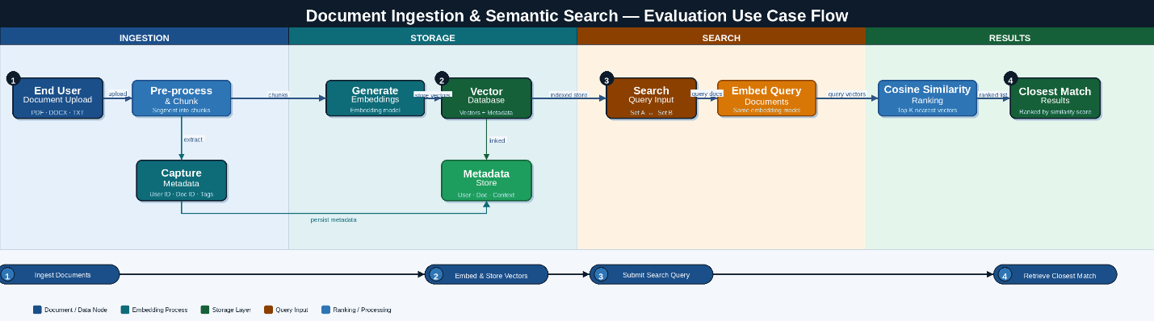

Traits | N8N | ActivePieces | Notes
Cost | Expensive but better transparency | Free or low cost for early experimentation but with less transparent feature tiering.  Many security aspects and connectors are hidden and require customisation with additional pricing. | Compare pricing depending on # of workflows. Start experimentation with AP.
Enterprise Readiness | Yes overall | Yes overall | Both are good at identity management, security, reliability, etc. However, most of the features are available at reasonable pricing in their respective SaaS environment, for self-hosted, there are limitations. Check documentation.
Ease of Use | Easy | Moderate | ActivePieces required additional JavaScript functions between out-of-the-box workflow steps.
Security / Option to secure | Great | Good | As reported above, AP’s lack of transparency resulted in “Good” and not “Great”
Reliability | Acceptable for prototype workloads. | Adequate for the evaluated use case. | For the evaluated use case reliability was sufficient, with minor intermittent issues observed. Behaviour at scale remains to be validated.
Integration | Great | Good enough | Despite limited native connectors, REST-based integrations proved sufficient for the evaluated workflows.
Observability | Great | Great | Both platforms produce tracing at deep level with each stage’s request response and testing ability.
Agentic Development | Great | Good | n8n demonstrated richer agentic capabilities during evaluation.

References
https://aws.amazon.com/solutions/guidance/multi-agent-orchestration-on-aws/
https://n8n.io/enterprise/
https://www.activepieces.com/blog/ai-agents-for-enterprise

About the Author

Rahul | Principal Architect & Founder | Melbourne, Australia | https://rahulrahul.com.au
Rahul is an independent Principal Architect specialising in enterprise cloud platforms and agentic AI systems, with over 25 years of experience leading architecture and technology strategy across regulated industries. He works at the intersection of multi-cloud infrastructure, enterprise integration, and AI-driven automation. He helps organisations move from isolated model experiments to governed, production-grade agentic systems. Most recently, he designed and delivered a generative AI adoption platform on public cloud infrastructure, now supporting thousands of bankers in improving customer outcomes at scale. Rahul is an active contributor to enterprise architecture and AI communities and can be reached via LinkedIn at linkedin.com/in/iamrahulus.

