AI – Enterprise TCO: One of the most important considerations for enterprises before scaling

Executive Summary
Benefit from AI technology within an enterprise is well-known. However, it needs to be carefully evaluated against each organisation's process, policy, priorities and objectives. Business benefit needs to include return on investment on AI applications. A visibility on different stages / layers of application and what they cost is absolutely essential for leadership to estimate TCO and assess ROI.
This paper is meant for executives (CFO, Head-Ofs, Principals), architects and anyone who is interested in getting an overview of key AI development lifecycle stages. It discusses, architectural aspects, TCO (and its components: Opex and Capex) with an example.

Architectural context
Enterprise use case can vary from utilising a LLM model call to orchestrating via multiple agents and everything in between.
Choosing components from reference architecture below will depend on the complexity of use cases. Usually the use case starts with something simple / less complex, low risk but significant impact such as chatbot / Q&A / Customer support. It provides an opportunity to create a foundation level of platform. Its an opportunity to create components like Model gateway along with a preferred hosting provider.
As the AI landscape increases, more models are added with the same provider (preferable), different providers or self hosted. This can be fronted with agents and / or agent orchestration as the automated workflow capabilities are included in the AI roadmap.
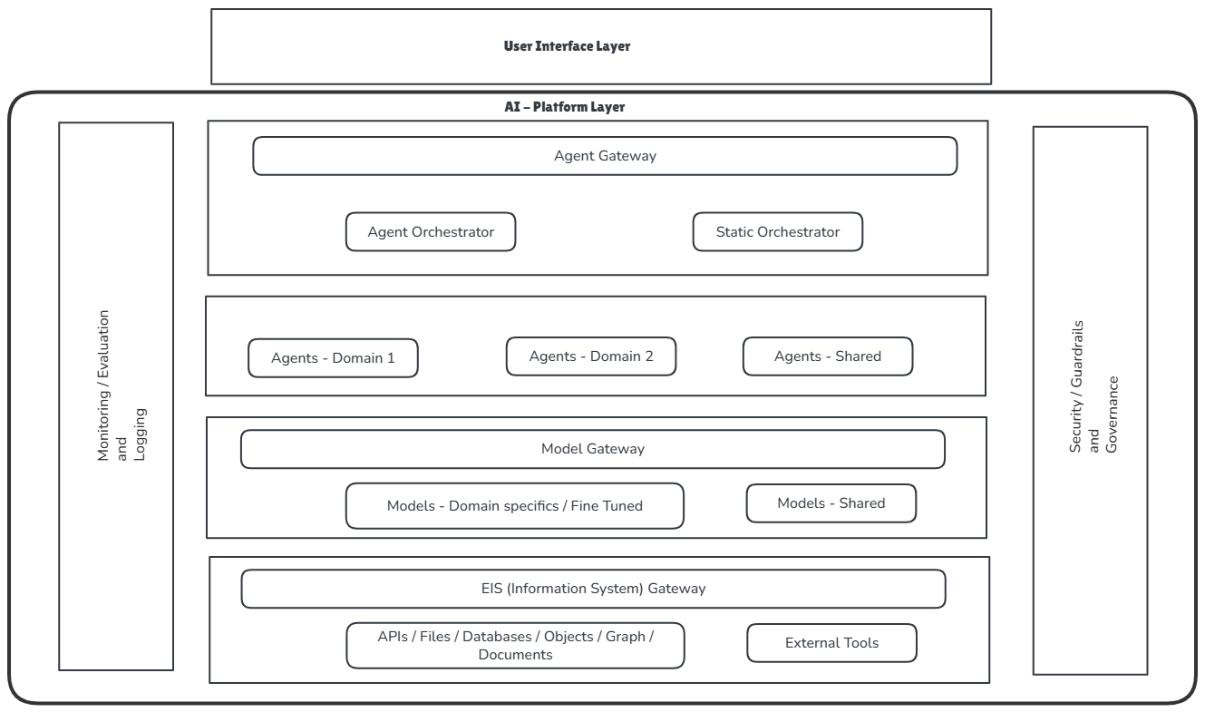
While this paper focuses on TCO components, there are specific ways to optimise spend on each layer.

Why TCO Consideration
Only 1% of CEO is getting ROI from AI based on 2025 report from McKinsey. The problem that most of these CEO have encountered is 1. They do not have clear objective to achieve with AI, 2. The value does not justify the expenses incurred.
A TCO analysis with appropriate trade offs will assist C-levels to appropriately estimate the return based on the KPI / AI objectives.

Cost Impact of Architectural lens
Lens | Impact | Notes / Considerations
Availability | Usually providers take care of it. In general, higher availability may need a redundancy, which could mean failover to a different provider or in case of self hosted model, switch to alternate GPU compute | - Start with clear NFR requirement, take your entire business process into account. Can a manual failover work?  - Consider managed services to start with.
Performance | Depends. A small model, trained on specific context can cost much lesser than a general purpose model. If a GP model is prompt-optimised then it can perform well but may incur higher cost | - Start with your performance requirements.  - Test different models optimising prompts. With different combinations, select one that’s best performing for your use case with least cost.
Security and Privacy | With regulatory requirements, self-hosting model will cost much more than the managed services / SaaS based model consumption | - Whats your minimum security requirements. Break them into “must have” and “should have”.  - Evaluate enterprise capability from model provider / SaaS based consumption. If it works for your organisation without increasing risk surface, prefer that to self-hosting.
Reliability | Reliable response needs more groundedness, better promoting and in some cases Fine-Tuning. Usually the cost is higher for a better reliable output | Evaluate your use case. How much reliable output you need. Can you just do parameter settings of the model, or optimise the prompt or provide tooling and ground truths before considering Fine-Tuning?

Opex vs Capex considerations against layers
Key Financial Considerations Before Committing Investment
Model your AI application costs across a 3–5 year TCO horizon, not just initial build cost. Three factors drive the split:
CapEx-intensive phases are project initiation, data pipeline build, and fine-tuning - where work produces a long-lived, capitalisable asset under IAS 38 / ASC 350.
OpEx-dominant ongoing costs include monitoring, auditing, security operations, and inference consumption - frequently underestimated in initial business cases.
Hosting model is the primary swing point: Self-hosted infrastructure = CapEx (procurement) + OpEx (operations). SaaS/cloud = OpEx (subscription and consumption). This decision has material balance sheet implications and should be modelled explicitly before architecture commitment.
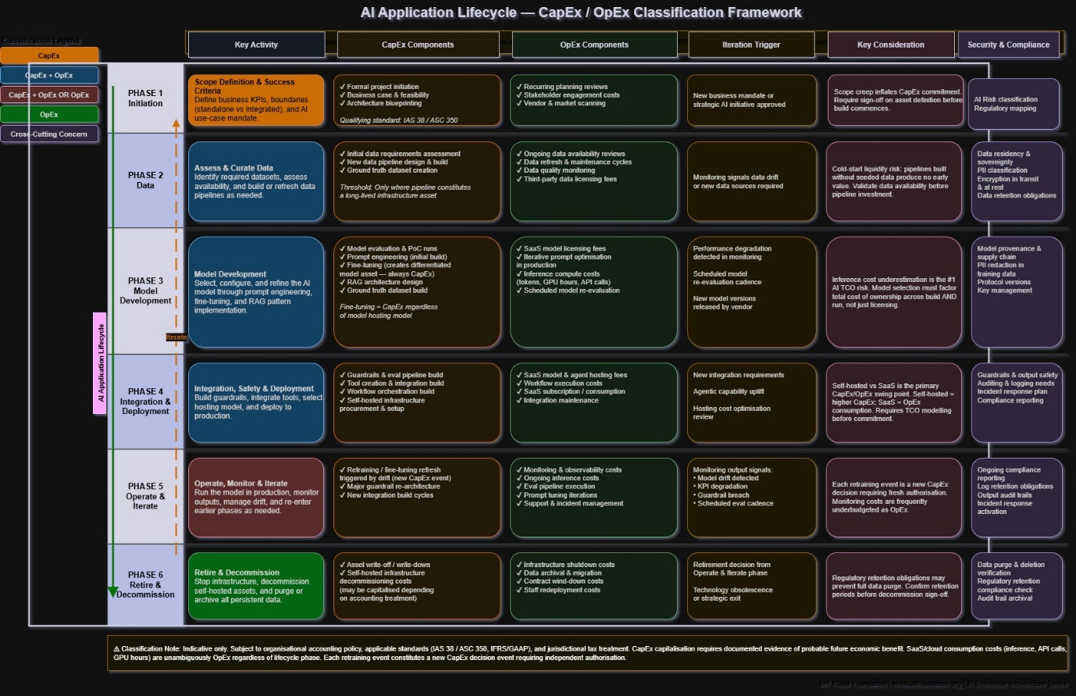

Phase 1: Initiation

Conclusion
While 92% of enterprises plan to increase AI investment, a substantial number of AI projects face severe budgetary challenges. Some findings suggest 80% of enterprise AI projects fail to deliver tangible ROI and drain budgets, largely due to hidden costs.
While majority of executives account for upfront expenses, they tend to ignore long term operational expenses, which keep climbing with data requirements / refresh, model capability re-evaluations, continuous monitoring and hiring and retaining right talent.

References
https://xenoss.io/blog/total-cost-of-ownership-for-enterprise-ai#:~:text=However%2C%20on%2Dpremises%20setups%20require,direction%20without%20any%20extra%20fees.
https://www.mckinsey.com/featured-insights/themes/the-takers-shapers-and-makers-of-gen-ai
https://smartdev.com/how-much-does-it-cost-to-develop-generative-ai-chatbots-for-customer-service-in-banking/
https://www.mckinsey.com/~/media/mckinsey/industries/financial%20services/our%20insights/scaling%20gen%20ai%20in%20banking%20choosing%20the%20best%20operating%20model/scaling-gen-ai-in-banking-choosing-the-best-operating-model.pdf?shouldIndex=false
https://getdx.com/blog/ai-roi-enterprise/

Appendix
Let’s take an example of a lifecycle of Chatbot for a scale comparable to one of the big 4 Australian banks (Shaper):

Key assumptions
RAG source: 100k+ documents, multiple data sources.
Activity | Capex | Opex (annual) | Metrics | Risk
Initiation | 100k | 72k | Business case and scope approved for at least 1 use case. | Weak / irrelevant KPIs may not justify the investment.
Data preparation
Model Development
Integration Safety and Deployment
Operate, Monitor and Iterate
Retire and Decommission

