DATA CLEANING AND PREPARATION
Project Report

A Python-based data cleaning, validation,
preparation and analysis project

Technology Stack
Python • Pandas • NumPy • Matplotlib

GitHub Repository
https://github.com/rahulraj2007k-pixel/Data-Cleaning-and-Preparation

1. Introduction
Data cleaning and preparation is an important stage of the data analysis process. Real-world datasets often contain missing values, invalid records, inconsistent formatting, duplicate records and incorrect data types. If these problems are not addressed, they can produce unreliable analysis results.
This project demonstrates a complete data cleaning and preparation workflow using Python. A synthetic customer sales dataset was created with realistic data-quality problems. The dataset was then cleaned, validated and prepared for analysis.

2. Project Objectives
- Load and inspect a raw CSV dataset.
- Identify missing, invalid and inconsistent data.
- Standardize text fields and column names.
- Validate email addresses.
- Convert multiple date formats into a consistent format.
- Handle invalid negative quantity and price values.
- Detect and remove business-key duplicate records.
- Fill missing values using appropriate strategies.
- Create a calculated total_amount field.
- Validate the cleaned dataset.
- Perform basic sales analysis and generate visualizations.

3. Dataset Description
The project uses a synthetic customer sales dataset created specifically for demonstrating data cleaning techniques. It does not contain private customer information or confidential records.
Property | Value
Original rows | 30
Original columns | 8
Final rows | 29
Final columns | 9
Input format | CSV
Output format | CSV

Dataset Columns
Column | Description
order_id | Unique order identifier
customer_name | Customer name
email | Customer email address
city | Customer city
order_date | Date of order
product | Purchased product
quantity | Quantity purchased
unit_price | Price per unit
total_amount | Calculated total sales amount

4. Identified Data Quality Issues
Issue | Count / Scope | Action Taken
Missing email | 2 | Handled using a placeholder
Missing order date | 1 | Filled using median date
Missing quantity | 1 | Filled using median
Missing unit price | 1 | Filled using median
Invalid email format | 1 | Converted to missing and handled
Negative quantity | 1 | Converted to missing
Negative unit price | 1 | Converted to missing
Inconsistent text formatting | Multiple | Standardized
Multiple date formats | Multiple | Converted to standard date
Business-key duplicate | 1 | Removed

5. Data Cleaning Methodology
- Load the raw CSV dataset using Pandas.
- Inspect dataset shape, columns, data types and missing values.
- Standardize column names.
- Remove leading and trailing spaces from text values.
- Standardize city and product capitalization.
- Convert email addresses to lowercase.
- Validate email addresses using a regular expression.
- Parse multiple date formats using Pandas.
- Convert quantity and unit price into numeric data types.
- Convert negative quantities and prices into missing values.
- Detect business-key duplicates.
- Remove duplicate business records while preserving the first occurrence.
- Fill missing quantity and price values using the median.
- Fill missing emails using a safe placeholder.
- Fill missing order dates using the median date.
- Create the total_amount calculated field.
- Perform final validation and save the cleaned dataset.

6. Implementation
The implementation is divided into two Python scripts. The first script performs cleaning and preparation, while the second script performs analysis and visualization.

6.1 Data Cleaning Script
File: src/data_cleaning.py
- Loads data/raw_dataset.csv.
- Performs validation and transformation.
- Generates cleaning_log.txt.
- Creates data/cleaned_dataset.csv.
- Reports final missing values and duplicate counts.

6.2 Data Analysis Script
File: src/data_analysis.py
- Compares raw and cleaned datasets.
- Compares missing values before and after cleaning.
- Calculates descriptive statistics.
- Calculates product-wise sales.
- Calculates city-wise sales.
- Generates charts using Matplotlib.
- Creates analysis_summary.txt.

7. Cleaning Results
Metric | Before Cleaning | After Cleaning
Rows | 30 | 29
Columns | 8 | 9
Missing values | Present | 0
Exact duplicate rows | 0 | 0
Business-key duplicates | 1 | 0
Invalid emails | 1 | 0
Invalid negative values | 2 | 0

The final dataset contains 29 rows and 9 columns. All missing values were handled, invalid values were corrected, and duplicate business records were removed.

8. Data Analysis and Visualization
After cleaning, the prepared dataset was analyzed to demonstrate that the resulting data can be used reliably for basic business analysis.

8.1 Product-wise Sales
Product | Total Sales
Laptop | 439,000
Tablet | 256,500
Mobile Phone | 211,500
Headphones | 20,800

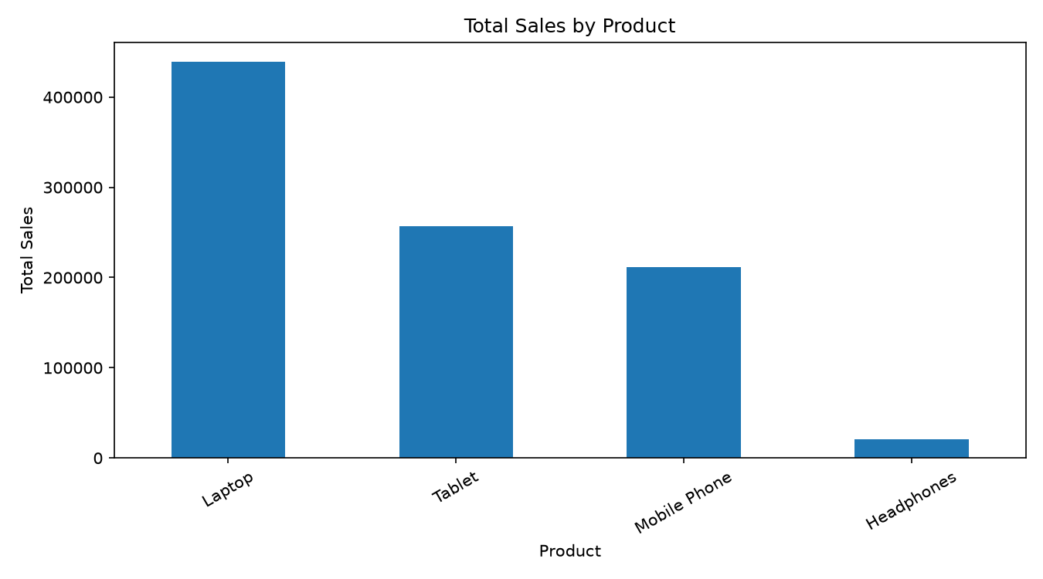
Figure 1: Product-wise sales visualization

8.2 City-wise Sales
City | Total Sales
Delhi | 397,800
Bangalore | 229,000
Mumbai | 195,100
Kolkata | 105,900

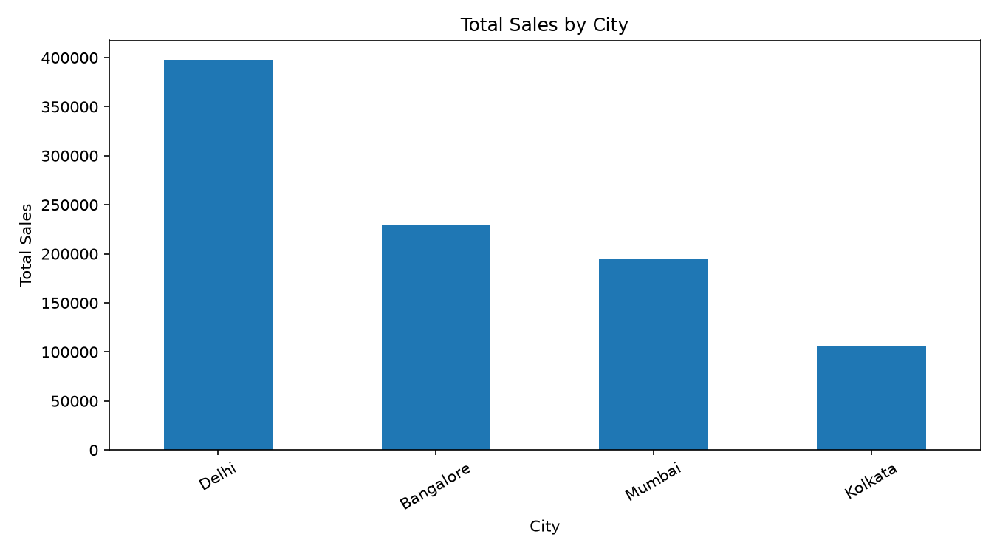
Figure 2: City-wise sales visualization

9. Data Quality Comparison
The following visualization compares missing values in the raw and cleaned datasets.
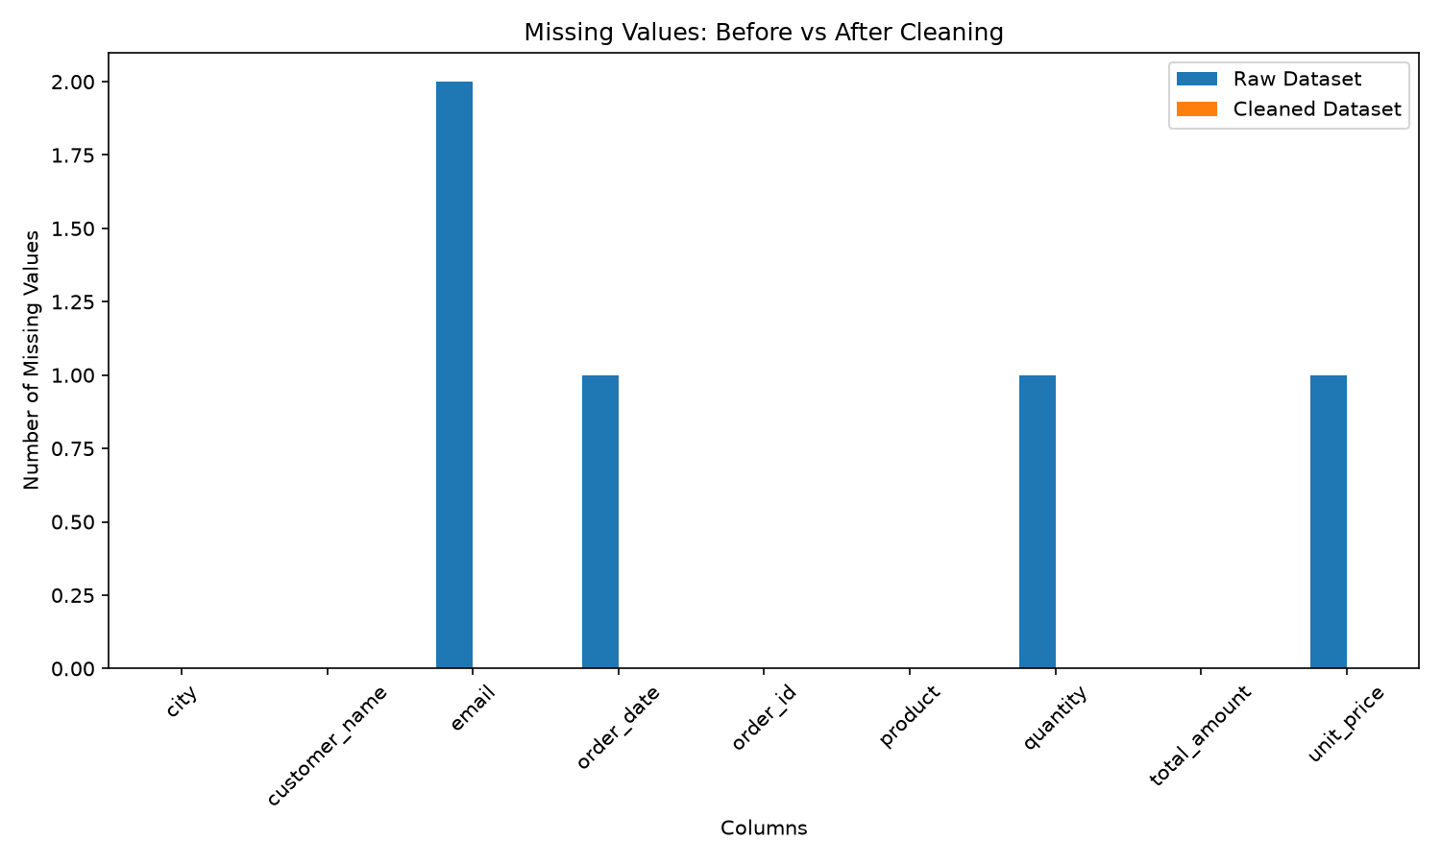
Figure 3: Missing values before and after cleaning

10. Cleaning Execution Output
The cleaning process was executed successfully from the terminal. The following screenshot records the execution and validation output.
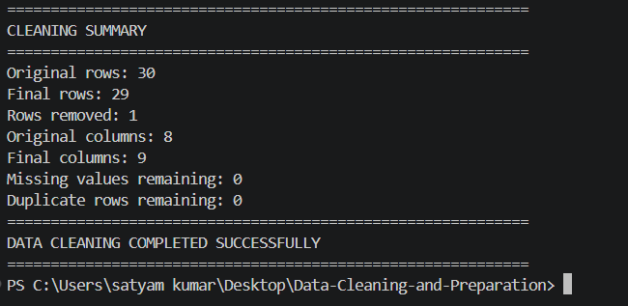
Figure 4: Data cleaning execution output

11. Validation
- Final missing value count: 0.
- Final exact duplicate count: 0.
- Final dataset shape: 29 rows × 9 columns.
- Quantity values are stored as integers.
- Unit prices are stored as floating-point numbers.
- The total_amount field is calculated from quantity × unit_price.
- Dates are standardized to YYYY-MM-DD format.
- Invalid email records are handled safely.

12. Tools and Libraries
Tool / Library | Purpose
Python | Programming language
Pandas | Data loading, cleaning and analysis
NumPy | Numerical operations
Matplotlib | Data visualization
python-docx | Report generation
Git | Version control
GitHub | Source code hosting
VS Code / Terminal | Development environment

13. Project Structure
Data-Cleaning-and-Preparation/
│
├── data/
│ ├── raw_dataset.csv
│ └── cleaned_dataset.csv
│
├── report/
│ └── Data_Cleaning_Report.docx
│
├── screenshots/
│ ├── cleaning_output.png
│ ├── missing_values_comparison.png
│ ├── product_sales.png
│ └── city_sales.png
│
├── src/
│ ├── data_cleaning.py
│ └── data_analysis.py
│
├── analysis_summary.txt
├── cleaning_log.txt
├── README.md
├── requirements.txt
└── .gitignore

14. Setup and Usage
Install the required Python libraries using:
pip install -r requirements.txt
Run the data cleaning process:
python src/data_cleaning.py
Run the analysis and visualization process:
python src/data_analysis.py

15. External Libraries, APIs, Datasets and Resources
- Dataset: Synthetic customer sales dataset created specifically for this project.
- Pandas: Used for data manipulation and cleaning.
- NumPy: Used for numerical data processing.
- Matplotlib: Used for charts and visualizations.
- python-docx: Used to generate this project report.
- No external API is required for this project.
- No private credentials, passwords or API keys are included.

16. Security and Privacy
The dataset used in this project is synthetic and does not represent real customer records. The repository does not contain passwords, API keys, private credentials or other sensitive authentication data.

17. Conclusion
This project demonstrates a complete data cleaning and preparation workflow using Python. The raw dataset contained realistic data-quality issues such as missing values, invalid emails, inconsistent formatting, multiple date formats, negative numerical values and a business-key duplicate.
After applying systematic cleaning and validation techniques, the dataset was transformed into a consistent 29-row, 9-column dataset with zero remaining missing values and zero exact duplicate rows. The cleaned data was then used to produce product-wise and city-wise sales analysis.
The project provides a reproducible foundation for further analytics and demonstrates practical data preparation skills using Python.

18. GitHub Repository
https://github.com/rahulraj2007k-pixel/Data-Cleaning-and-Preparation

19. Author
Student Project — Data Cleaning and Preparation
The project source code, datasets, analysis files, screenshots and documentation are maintained in the GitHub repository listed above.

