Angular

npm install -g @angular/cli

ng new my-app

ng serve –open

Reference:

<https://material.io/guidelines>

<https://material.angular.io>

<https://github.com/angular/material2>

<https://www.youtube.com/c/AjdenTowfeek>

<https://twitter.com/ajtowf>

<https://tburleson-layouts-demos.firebaseapp.com/#/docs>

<https://klarsys.github.io/angular-material-icons/>

<https://materialdesignicons.com/getting-started>

John papa plural sight – Angular CLI

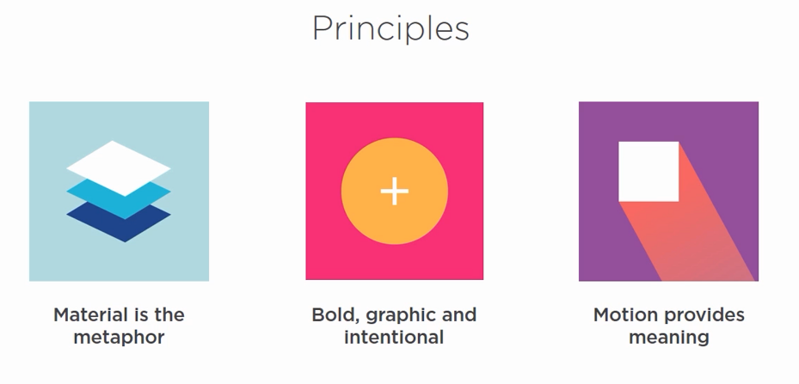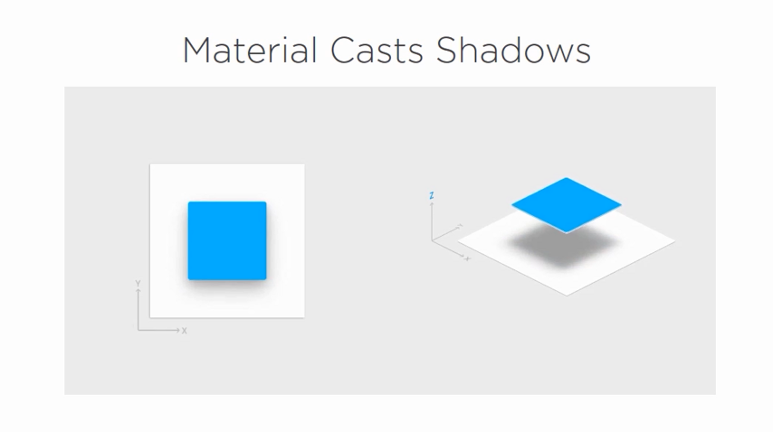

Transition:

How things move 🡪 motion provides meaning

Natural Accleration and Decelertaion

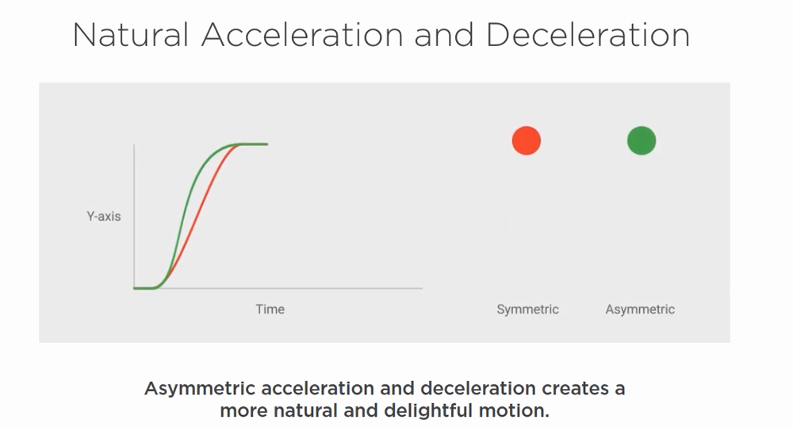

Requirements:

Node JS  
Type Script

Visual Studio Code

Angular CLI

Google.github.io/material-design-icons

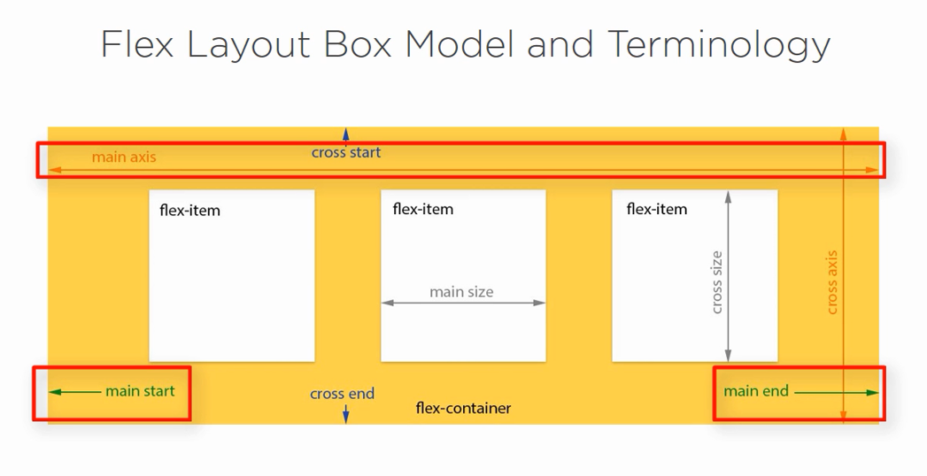

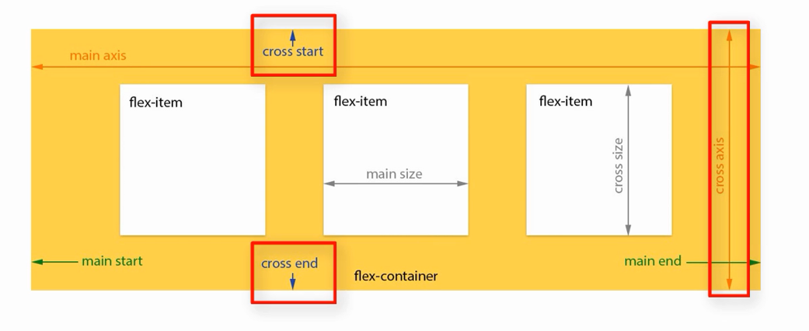

Angular Flex Layout 🡪 FlexBox Css and media query

