EXERSISE--2 PYTHON

Q.1-Write a python program that accepts user inputs (name and age),prints a formatted massege and displays the data

type of each input

# Taking user input
name = input("Enter your name: ")
age = input("Enter your age: ")

# Displaying formatted message
print("\n--- User Details ---")
print(f"Hello {name}, you are {age} years old.")

# Displaying data types
print("\nData Types:")
print("Type of name:", type(name))
print("Type of age:", type(age))

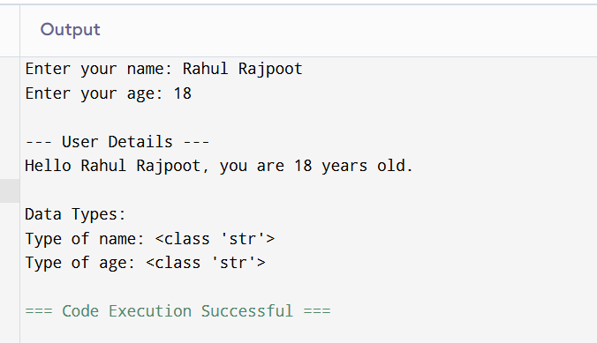

Q.2-Develop python program that takes a number as input and determines whether it is positive, negative, or zero.

# Taking input from user
num = float(input("Enter a number: "))

# Checking the number
if num > 0:
print("The number is Positive.")

elif num < 0:
print("The number is Negative.")

else:
print("The number is Zero.")

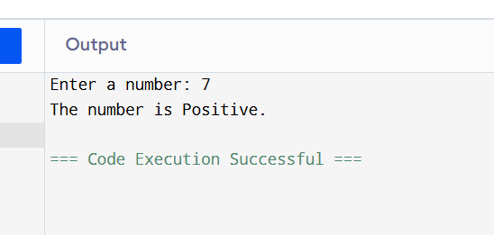

Q.3-Create a python program to calculate the sum of the first N natural numbers using a loop.

# Taking input from user
n = int(input("Enter the value of N: "))

# Initializing sum
total = 0

# Using loop to calculate sum
for i in range(1, n + 1):
total = total + i

# Display result

print("Sum of first", n, "natural numbers is:", total)

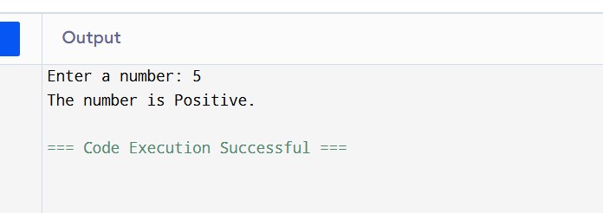

Q.4-Write a python program demonstrating the use of arithmetic, comparison and logical operators.

# Taking input from user
a = int(input("Enter first number: "))
b = int(input("Enter second number: "))

# Arithmetic Operators
print("\n--- Arithmetic Operators ---")
print("Addition:", a + b)
print("Subtraction:", a - b)
print("Multiplication:", a * b)
print("Division:", a / b)

# Comparison Operators
print("\n--- Comparison Operators ---")
print("a > b :", a > b)
print("a < b :", a < b)
print("a == b :", a == b)
print("a != b :", a != b)

# Logical Operators
print("\n--- Logical Operators ---")
print("(a > 0 and b > 0):", a > 0 and b > 0)
print("(a > 0 or b > 0):", a > 0 or b > 0)
print("not(a > b):", not(a > b))

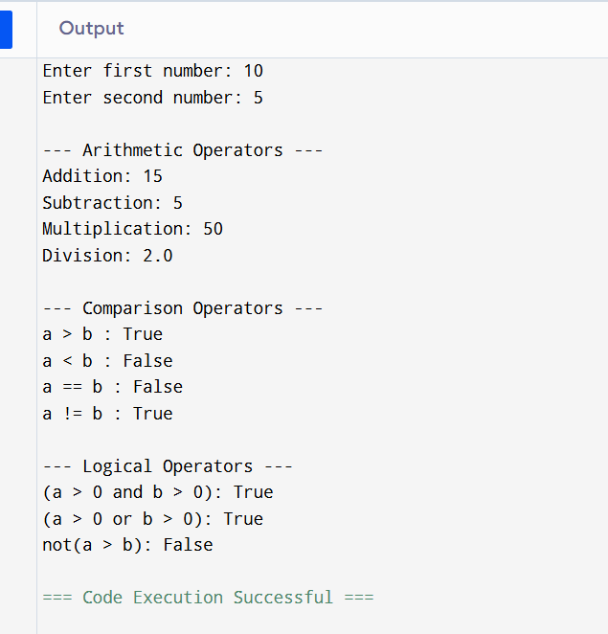

Q.5-Write a python program that reads a list of numbers from the user, finds that maximum, minimum,and , sum, and sorts the list.

# Taking list input from user
numbers = list(map(int, input("Enter numbers separated by spaces: ").split()))

# Finding maximum number
maximum = max(numbers)

# Finding minimum number
minimum = min(numbers)

# Finding sum
total = sum(numbers)

# Sorting the list
numbers.sort()

# Displaying results
print("\nSorted List:", numbers)
print("Maximum Number:", maximum)
print("Minimum Number:", minimum)
print("Sum of Numbers:", total)

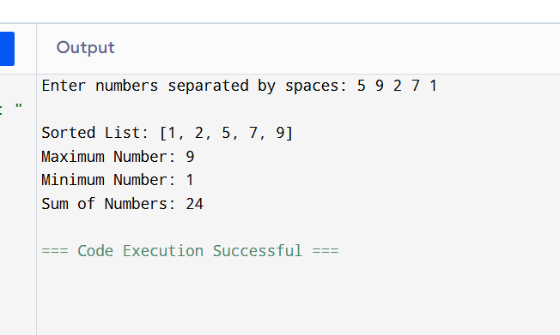

Q.6-Develop a python program that accepts a string and performs multiple operations such as counting vowels, reversing the string and checking for palindrome.

# Taking string input from user
text = input("Enter a string: ")

# Counting vowels
vowels = "aeiouAEIOU"
count = 0

for ch in text:
if ch in vowels:
count += 1

# Reversing the string
reverse_text = text[::-1]

# Checking palindrome
if text == reverse_text:
palindrome = True
else:
palindrome = False

# Displaying results
print("\nNumber of vowels:", count)
print("Reversed string:", reverse_text)

if palindrome:
print("The string is a Palindrome.")
else:
print("The string is NOT a Palindrome.")

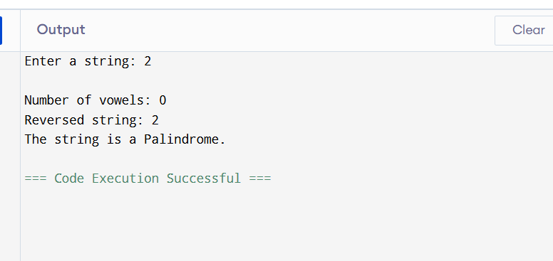

Q.7-Write a python program using functions to perform operations like factorial and Fibonacci sequence.

# Function to calculate factorial
def factorial(n):
fact = 1

for i in range(1, n + 1):
fact = fact * i

return fact

# Function to generate Fibonacci sequence
def fibonacci(n):
a = 0
b = 1

print("\nFibonacci Sequence:")

for i in range(n):
print(a, end=" ")
a, b = b, a + b

# Main Program
num = int(input("Enter a number: "))

# Calling factorial function
print("\nFactorial =", factorial(num))

# Calling fibonacci function
fibonacci(num)

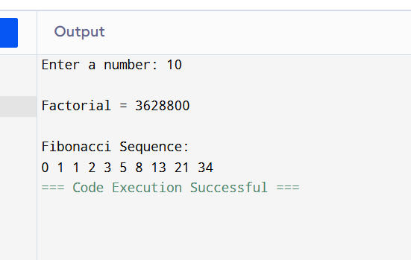

Q.8-Create a program that uses dictionaries to store student names and marks, then finds and displays the highest and lowest scorer.

# Creating dictionary to store student names and marks
students = {}

# Taking input from user
n = int(input("Enter number of students: "))

for i in range(n):
name = input("Enter student name: ")
marks = int(input("Enter marks: "))

students[name] = marks

# Finding highest scorer
highest = max(students, key=students.get)

# Finding lowest scorer
lowest = min(students, key=students.get)

# Displaying results
print("\nStudent Records:", students)

print("\nHighest Scorer:")
print(highest, "-", students[highest])

print("\nLowest Scorer:")
print(lowest, "-", students[lowest])

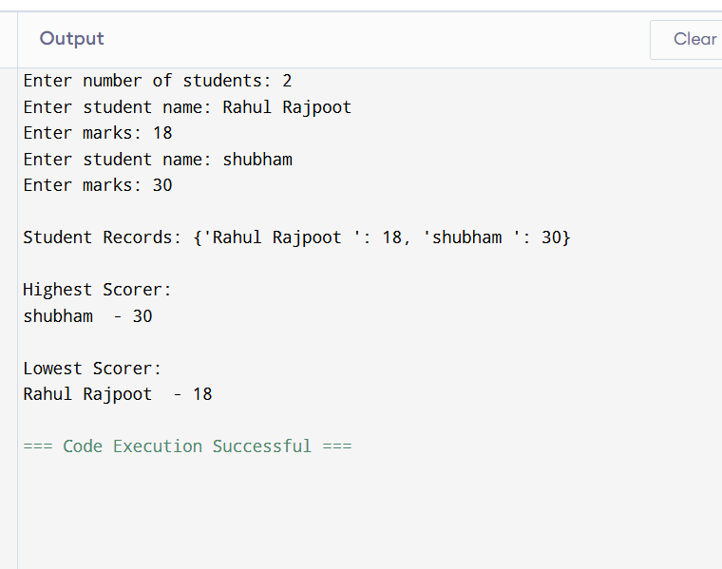

Q.9-Write a python program that reads data from A file processes the content (such as counting words and lines),and handles possible errors using exception handling .

