Exercise --Embedded C Programming

.

Q.1-Write a program to set (enable)the bit of a 32-bit register.

#include <iostream>
using namespace std;

int main()
{
unsigned int reg;

cout << "Enter the register value: ";
cin >> reg;

reg = reg | (1 << 5);

cout << "Updated register value: " << reg << endl;

return 0;
}

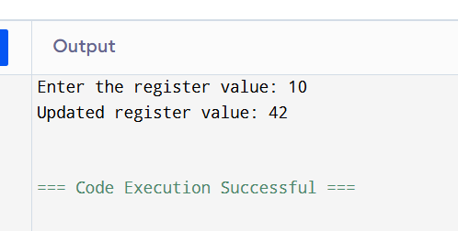

Q-2Write a program to clear the 2nd bit of a 16-bit register

#include <iostream>
using namespace std;

int main()
{
unsigned short reg;

cout << "Enter the register value: ";
cin >> reg;

reg = reg & ~(1 << 2);

cout << "Updated register value: " << reg << endl;

return 0;
}

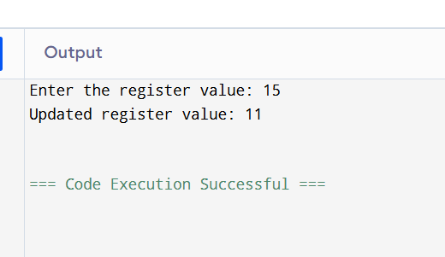

Q-3 Write a program to toggle the 7th bit of an 8-bit register.

#include <iostream>
using namespace std;

int main()
{
unsigned char reg;

cout << "Enter the register value: ";
cin >> reg;

// Toggle the 7th bit
reg = reg ^ (1 << 7);

cout << "Updated register value: " << (int)reg << endl;

return 0;
}

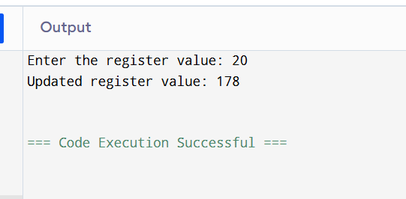

Q.4- Write a program to check whether a given bit position is set or not.(4th bit)
#include <iostream>
using namespace std;

int main()
{
unsigned int num;

cout << "Enter a number: ";
cin >> num;

if (num & (1 << 4))
{
cout << "4th bit is SET." << endl;
}
else
{
cout << "4th bit is NOT SET." << endl;
}

return 0;
}

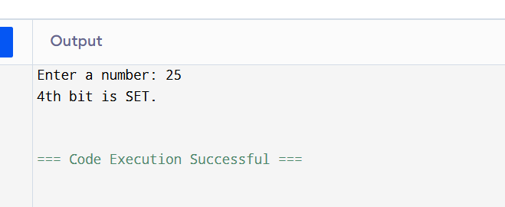

Q.5-Write a program to count the number of set bits (1s) in a number.

#include <iostream>
using namespace std;

int main()
{
unsigned int num, count = 0;

cout << "Enter a number: ";
cin >> num;

while (num > 0)
{
if (num & 1)
{
count++;
}

num = num >> 1;
}

cout << "Number of set bits: " << count << endl;

return 0;
}

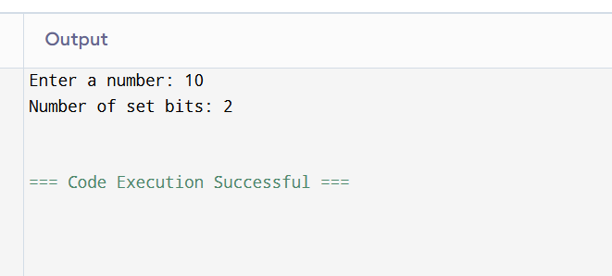

Q.6-Write a program to perform left shift and right shift operations on a number and display result.

#include <iostream>
using namespace std;

int main()
{
int num, shift;

cout << "Enter a number: ";
cin >> num;

cout << "Enter number of shifts: ";
cin >> shift;

int leftShift = num << shift;

int rightShift = num >> shift;

cout << "\nAfter Left Shift: " << leftShift << endl;
cout << "After Right Shift: " << rightShift << endl;

return 0;
}

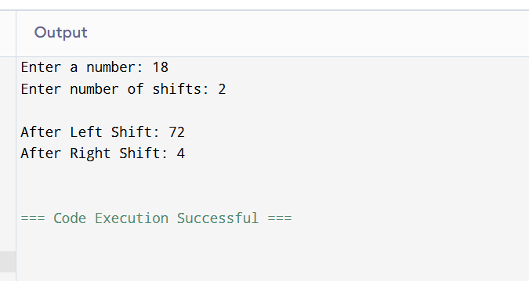

Q.7-Write a program to swap two numbers using bitwise XOR.

#include <iostream>
using namespace std;

int main()
{
int a, b;

cout << "Enter first number: ";
cin >> a;

cout << "Enter second number: ";
cin >> b;

cout << "\nBefore Swapping:";
cout << "\na = " << a;
cout << "\nb = " << b;

a = a ^ b;
b = a ^ b;
a = a ^ b;

cout << "\n\nAfter Swapping:";
cout << "\na = " << a;
cout << "\nb = " << b;

return 0;
}

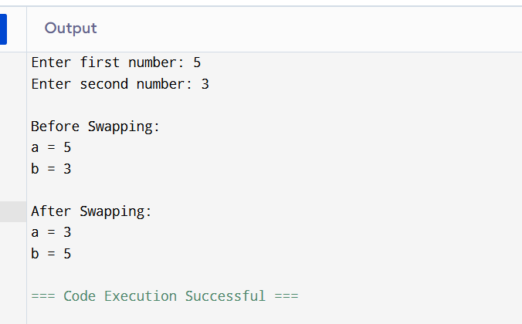

Q.8- Write a program to clear all bits except a specific bit position.

#include <iostream>
using namespace std;

int main()
{
unsigned int num, pos;

cout << "Enter a number: ";
cin >> num;

cout << "Enter bit position to keep: ";
cin >> pos;

num = num & (1 << pos);

cout << "Result after clearing all other bits: " << num << endl;

return 0;
}

