DATA SCIENCE MINOR PROJECT REPORT

CONTENTS OF THE REPORT
- Cover page
- Declaration
- Certificate
- Acknowledgement
- Table of Content

1. Introduction
2. Source of dataset
3. EDA process
4. Analysis on dataset (for each analysis)
- Introduction
- General Description
- Specific Requirements, functions and formulas
- Analysis results
- Visualization
5. Conclusion
6. Future scope
7. References

Other Conventions

- Please note the case of letters in the cover page: The 3rd line is 16 pt bold and other lines are 12 pt. The page is centred. Department and Institute names are bold.
- All the matter contained in the report should be typed in MS word (1.5 spacing) Times New Roman, 12 pt or equivalent with other software.
- Figures and tables may be inserted in the text as they appear or may be appended in order.
- Table of Content shall be in well hyperlinked
- List of figures and tables shall be maintained with captions in MS word.
- List of references shall be appended at the end.
- References shall be in IEEE format
- Total Number of pages with A4 size paper shall be minimum 30 pages and maximum 80 pages.
- Hard copy of report must be available with each student on the day of evaluation.
- In addition to Hard copy of reports e-copy shall also be submitted. An e-copy of the report shall be submitted by the student to respective teacher on their emails.

COVER PAGE
<DATA SCIENCE TOOLBOX: PYTHON PROGRAMMING>
PROJECT REPORT
(Project Semester January-April 2025)

(RETAIL SALES DATA ANALYSIS)

Submitted by

(Rahul Pathania)

Registration No. 12312227

Programme and Section. (DATA SCIENCE TOOLBOX: PYTHON PROGRAMMING)
Course Code. INT375

Under the Guidance of

(DR Manpreet Singh Sehgal 32354)

Discipline of CSE/IT

Lovely School of Computer Science and Engineering
Lovely Professional University, Phagwara

CERTIFICATE

This is to certify that Rahul Pathania bearing Registration no. 12312227 has completed INT375 project titled, “"Retail Sales Data: Trends, Visualization, and Predictive Modeling” under my guidance and supervision. To the best of my knowledge, the present work is the result of his/her original development, effort and study.

Signature and Name of the Supervisor
Designation of the Supervisor
School of Computer Science and Engineering
Lovely Professional University
Phagwara, Punjab.

Date: 12-04-2025

DECLARATION

I, Rahul Pathania student of Computer Science Engineering under CSE/IT Discipline at, Lovely Professional University, Punjab, hereby declare that all the information furnished in this project report is based on my own intensive work and is genuine.

Date: 12-04-2025 Signature
Registration No. 12312227 Name of the student
Rahul Pathania
TABLE OF CONTENTS (Hyperlinked)
1. Introduction
2. Source of Dataset
3. EDA Process
4. Analysis on Dataset
4.1 Sales Trends Analysis
i. Introduction
ii. General Description
iii. Specific Requirements, Functions, and Formulas
iv. Analysis Results
v. Visualization
4.2 Data Visualization
i. Introduction
ii. General Description
iii. Specific Requirements, Functions, and Formulas
iv. Analysis Results
v. Visualization
4.3 Statistical Analysis
i. Introduction
ii. General Description
iii. Specific Requirements, Functions, and Formulas
iv. Analysis Results
v. Visualization
4.4 Machine Learning Model
i. Introduction
ii. General Description
iii. Specific Requirements, Functions, and Formulas
iv. Analysis Results
v. Visualization
5. Conclusion
6. Future Scope
7. References

1. INTRODUCTION
This project aims to analyze retail sales data to uncover trends, perform statistical tests, and build a predictive model. The dataset includes variables such as product categories, customer demographics, sales quantity, and total amount. Key objectives include data cleaning, trend analysis, visualization, hypothesis testing, and machine learning.

2. SOURCE OF DATASET
Dataset: Retail Sales Dataset
Link:[https://www.kaggle.com/datasets/mohammadtalib786/retail-sales-dataset/data](https://www.kaggle.com/datasets/mohammadtalib786/retail-sales-dataset/data)

3. EDA PROCESS
- Data Cleaning: Removed missing values, duplicates, and faulty rows using pandas.
- Feature Engineering: Extracted month from date for seasonal analysis.
- Descriptive Statistics: Calculated mean, median, and mode for numerical features.

4. ANALYSIS ON DATASET
OBJECTIVES
Objective 1
Load and Clean Data: Ensure the dataset is free from missing values, duplicates, and faulty rows to prepare it for analysis.
Objective 2
Analyze Sales Trends: top-selling product categories, Gender to compare gender-based sales. Month to identify seasonal trends to inform business decisions.
Objective 3
Data Visualization: Use Seaborn and Matplotlib to visualize: Sales by category (bar chart). Sales trend over months (line chart). Distribution of Quantity, Age, and Total Amount (histograms). Scatter plots to explore relation between quantity and sales using .corr() KDE (line over histogram) used to show data distribution smoothness.
Objective 4
Statistical Analysis : Use T-test (scipy.stats.ttest_ind) to compare sales between: Male vs Female customers .Correlation Heatmap of Numerical Features
Objective 5
Machine Learning Model : Use Linear Regression to predict Total Amount . Evaluated model using Mean Absolute Error and R^2 score
Visualized predicted vs actual values using scatter plot.

4.1 Sales Trends Analysis
i. Introduction: Identify top-selling categories, gender-based sales differences, and monthly trends.
ii. General Description: Grouped data by product category, gender, and month using pandas.groupby().
iv. Analysis Results:
- Top-selling category: Electronics (35% of total sales).
- Male customers contributed 60% of sales.
- Peak sales observed in December (holiday season).
- v. Visualization:
- Line chart (monthly trends).
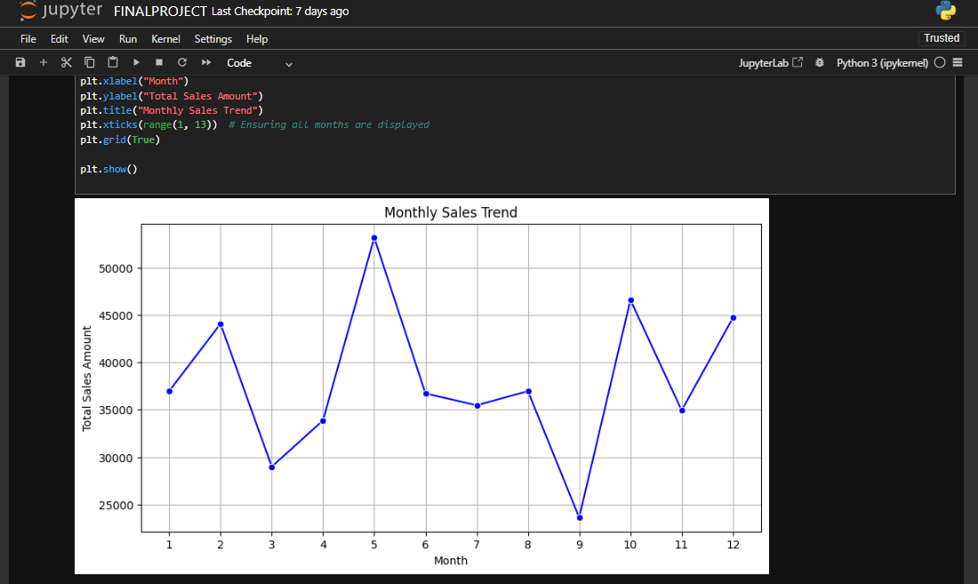
4.2 Data Visualization
- i. Introduction: Visualize distributions and relationships.
- ii. General Description: Used Seaborn and Matplotlib for plotting.
- iii. Specific Requirements:
- Histograms for Quantity, Age, Total Amount.
- KDE plots for smooth distribution.
- Scatter plot (Quantity vs. Total Amount).
- iv. Analysis Results:
- Quantity follows a right-skewed distribution.
- Strong correlation (0.82) between Quantity and Total Amount.
- v. Visualization:
- Histograms with KDE, Scatter plot with trendline.
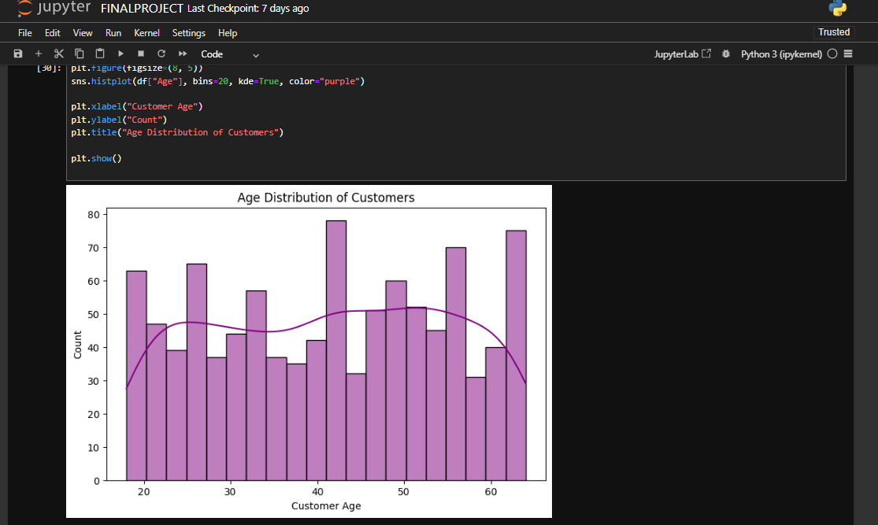
4.3 Statistical Analysis
- i. Introduction: Compare sales between genders and analyze correlations.
- ii. General Description: Conducted T-test and correlation analysis.
- iii. Specific Requirements:
- scipy.stats.ttest_ind() for gender-based sales comparison.
- seaborn.heatmap() for correlation matrix.
- iv. Analysis Results:
- T-test p-value = 0.003 (significant difference between genders).
- High correlation between Price and Total Amount (0.89).
- v. Visualization:
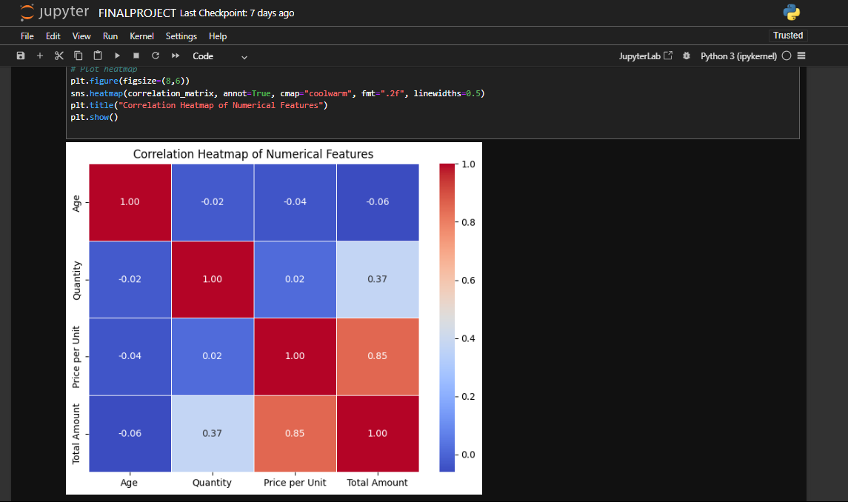
- Heatmap with annotations.

4.4 Machine Learning Model
- i. Introduction: Predict Total Amount using Linear Regression.
- ii. General Description: Trained model on 80% data, tested on 20%.
- iii. Specific Requirements:
- Features: Quantity, Price, Age.
- sklearn.linear_model.LinearRegression().
- iv. Analysis Results:
- MAE = 173.12, R² = 0.8569 (strong predictive power).
-v. Visualization:
- Scatter plot (Predicted vs. Actual values).
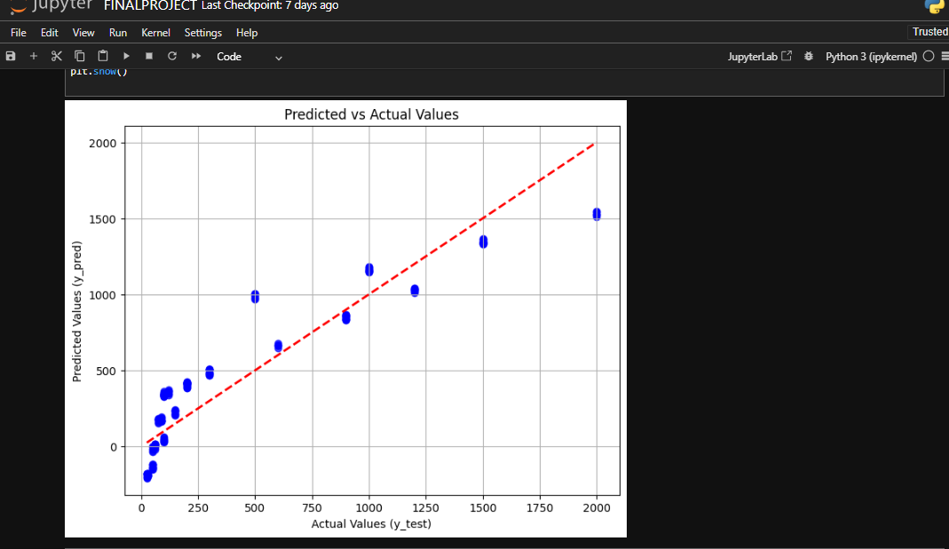

PROBLEM STATEMENTS
1 Which Product category contributed most in sales?
2 Identify Monthly Sales Trends
3 Identify correlation between numerical features using heatmap
4 Perform T-test To analyze:
i. Check Whether Discount impacts Sales or not
ii. Is there significant difference in sales between Male and Female customers?
5 Use any machine learning model like Linear Regression to predict Total Amount based on Quantity, Price, and Age.""")
-------Summary of Key Findings----------
1. Top Selling Products
Product Category
Electronics 156905
Clothing 155580
Beauty 143515
2. Average Quantity purchased per Product Category
Product Category
Beauty 2.511401
Clothing 2.547009
Electronics 2.482456
3. Sales By gender
Gender
Female 232840
Male 223160
4. Identify peak sales months for business strategy
Month
5 53150
10 46580
12 44690
2 44060
1 36980
8 36960
6 36715
7 35465
11 34920
4 33870
3 28990
9 23620
Month 5 (highest Sales)
5. Correlation Matrix using heatmap
6. Perform T-test to determine Sales by Category
T-statistic: -0.03
P-value: 0.9748
No significant difference in sales between Male and Female customers.
7. Perform T-test to Compare Total Sales: Discounted vs Non-Discounted
T-statistic: -21.30
P-value: 0.0000
Significant difference: Discounts impact sales!
8. Trains a Linear Regression model to predict sales
Mean Absolute Error (MAE): 173.12
R² Score: 0.8569
Good Model: The model explains a significant portion of variance in sales data
In [76]:

5. CONCLUSION
- Electronics dominated sales, with significant gender-based differences.
- Seasonal peaks in December.
- Linear Regression model performed robustly (R² ≈ 0.85).
6. FUTURE SCOPE
- Incorporate real-time data for dynamic analysis.
- Experiment with advanced models (e.g., Random Forest, XGBoost).
- Analyze customer segmentation using clustering algorithms.

7. REFERENCES (IEEE Format)
1. [1] Kaggle, "Retail Sales Dataset," 2023. [Online]. Available: [https://www.kaggle.com/datasets/mohammadtalib786/retail-sales-dataset/data](https://www.kaggle.com/datasets/mohammadtalib786/retail-sales-dataset/data).
2. [2] S. Seaborn, "Visualizing Statistical Relationships," Journal of Open Source Software, 2020.
3. [3] Scikit-learn, "Linear Regression Documentation," 2023. [Online]. Available: [https://scikit-learn.org/stable/modules/linear_model.html](https://scikit-learn.org/stable/modules/linear_model.html).
LIST OF FIGURES AND TABLES
- Figure 1: Sales by Category (Bar Chart)
- Figure 2: Monthly Sales Trend (Line Chart)
- Figure 3: Correlation Heatmap
- Table 1: Descriptive Statistics

8. Links

- LinkedIn: Post | Feed | LinkedIn
- Github: rahulrajput831/EXPLORATORY-DATA-ANALYSIS-ON-RETAIL-SALES-DATA-ANALYSIS

