|  |  |  |
| --- | --- | --- |
| FSM | December 8  2016 | |
|  | | Admin_M3 |

Contents

1. Invoice 2

1.1. Jobs 2

1.1.1. Create invoice 2

Manage items 3

Add Stock to Purchase to job 4

1.2. Invoice 5

2. Time sheet 5

Preview report 7

3. Purchase order 7

# Invoice

On selecting the option ‘Invoice’ from the side menu, below screen will be displayed:

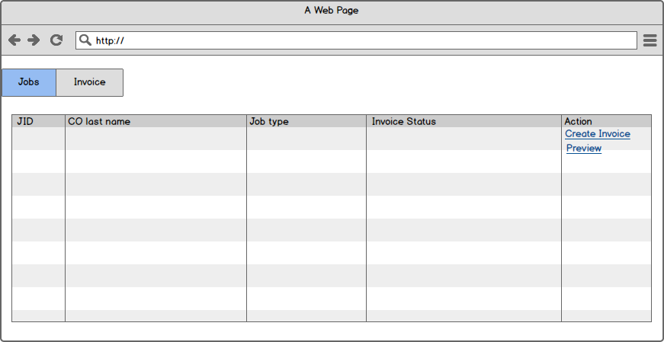

## Jobs

This screen will have two tabs which are as following:

* Jobs
* Invoice

Invoice can be created with respect to the job Id, so on tapping the create invoice button the information will get populated into the ‘Create Invoice form’.

### Create invoice

On clicking ‘Create Invoice’ from the above mentioned screen, the screen is displayed as below:

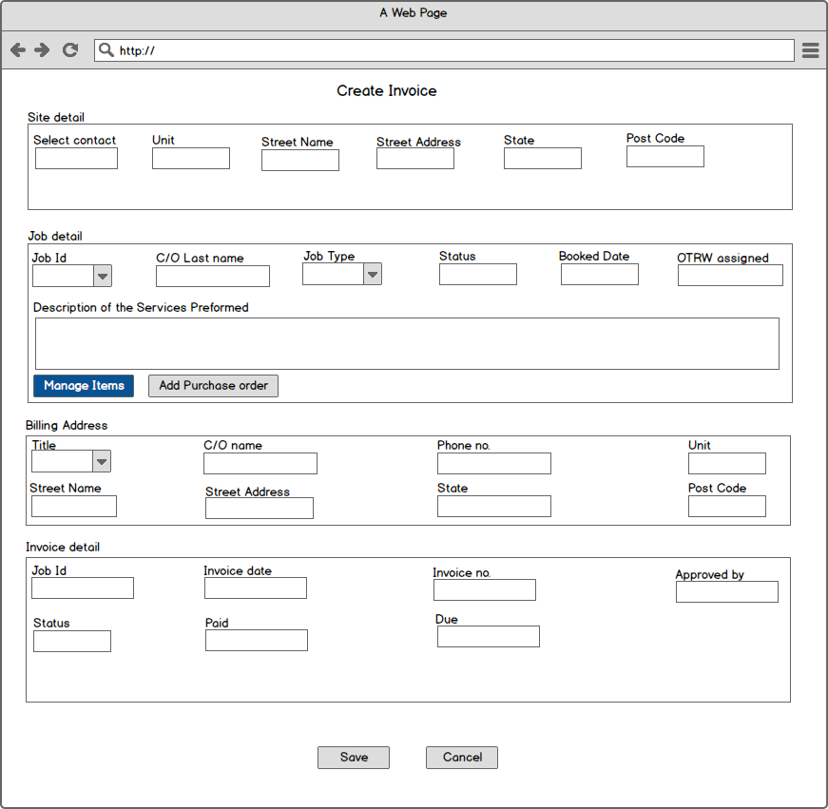

Create invoice form consist of following sections:

* Site detail
* Job detail
* Billing Address
* Invoice detail

### Manage items

On clicking ‘Manage items’, the user is displayed with all the stock items related to the job.

### Add Stock to Purchase to job

On clicking ‘Add purchase order’ button, the screen displayed is as below:

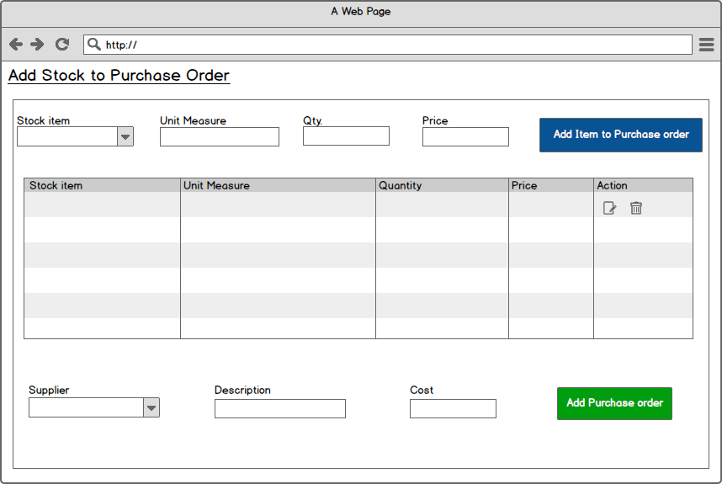

## Invoice

The screen is displayed as below:

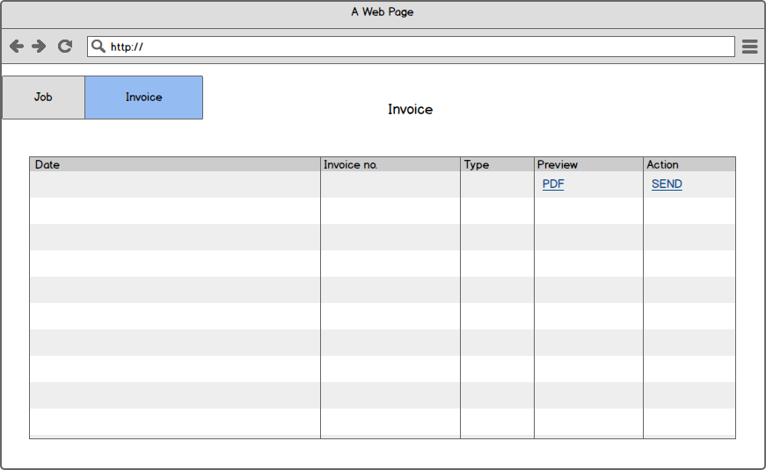

The complete detail in the form of an invoice will be sent on clicking the ‘Send’ button.

# Time sheet

The “Time Sheet” will be used to view and edit an employees work hours.

The screen is displayed as below:

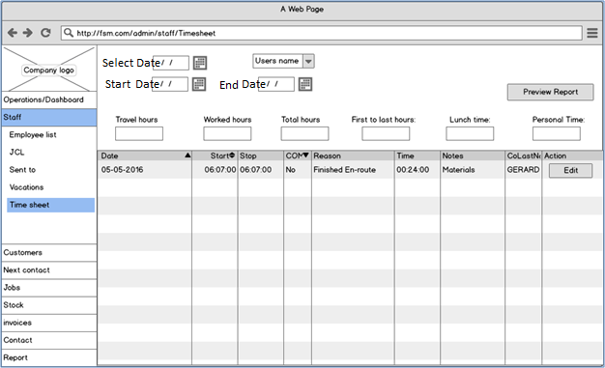

On clicking the ‘Edit’ button a pop-up will be displayed:

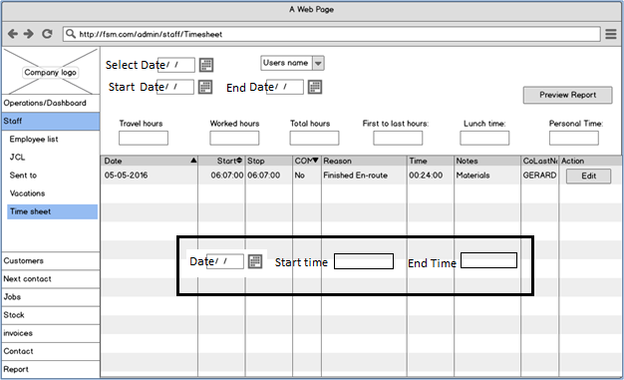

All travels hours and hours worked will be automated from the app into the system. So if an employee spent 40 hours doing work and 10 hours travelling during the week, that would all will be totaled in a weekly timesheet

All times are editable by the admin.

## Preview report

On tapping ‘Preview Report’ button, pdf will be generated which is displayed as below:

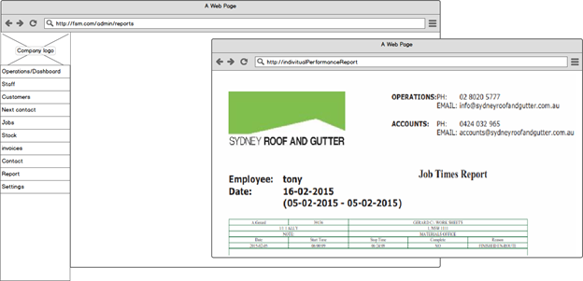

# Purchase order

The screen is displayed as below:

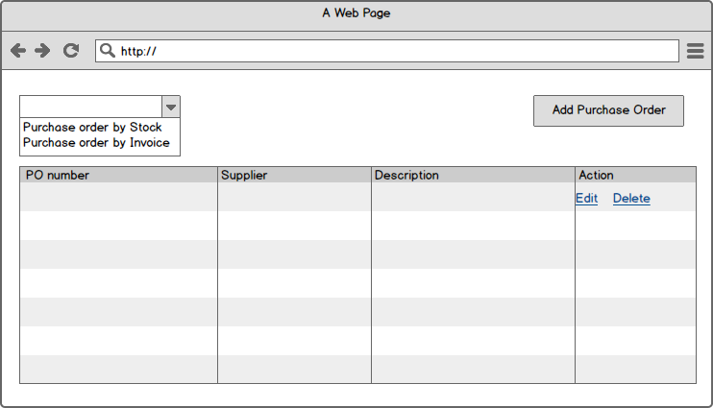

On clicking **‘Add purchase order’**, the screen displayed is as below:

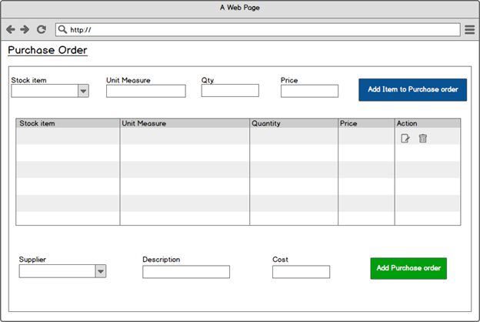

**Note:** The user can add the purchase order from invoice as well.