RIJO Software
User Manual

Version 1.0

Introduction:

This document will give you a brief overview of some of the control and functions of the RIJO software.
System Requirements:

- Computer with MYOB access
- Computer with MySQL

Getting Started:

To log in to the system, double click on one of the following icons.
OPS is the most recent stable version of the RIJO software.
OPS – Testing is the early access version of the RIJO software and is less stable.

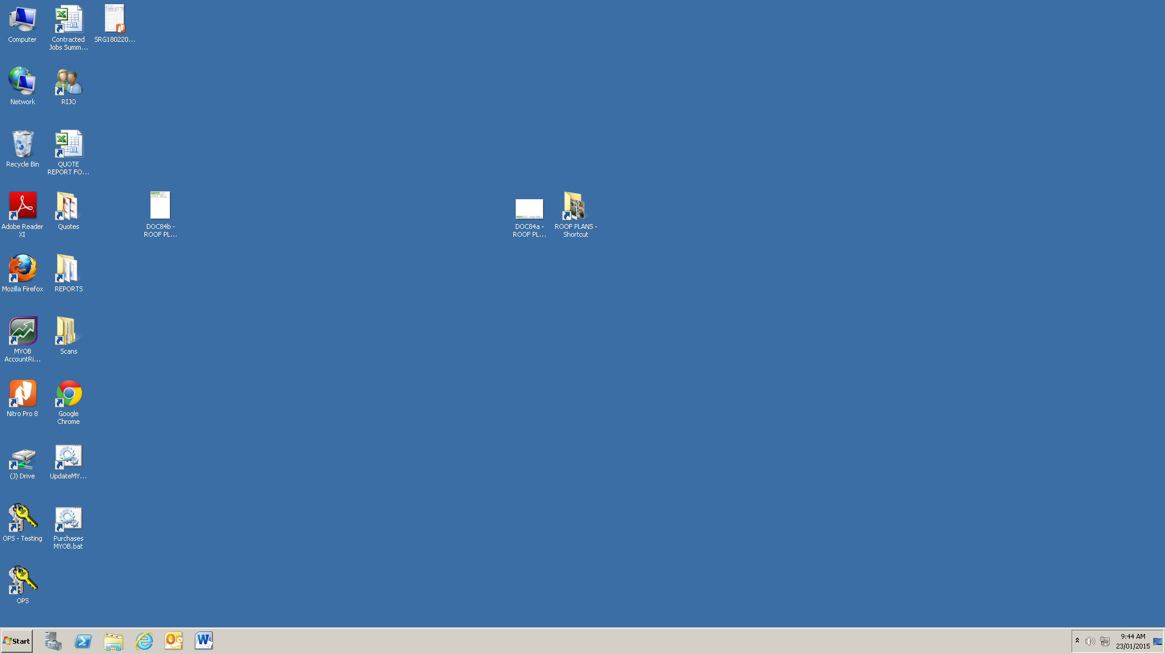

Now enter your username.

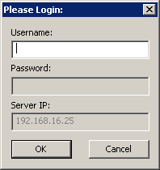

You may receive some notifications such as the ones below. Click OK to continue opening the software.

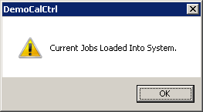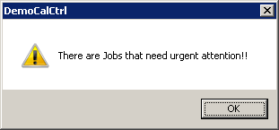

Getting Familiar with the System:

From the main screen, several operations can be performed. Up the top left corner, there are six different tabs.

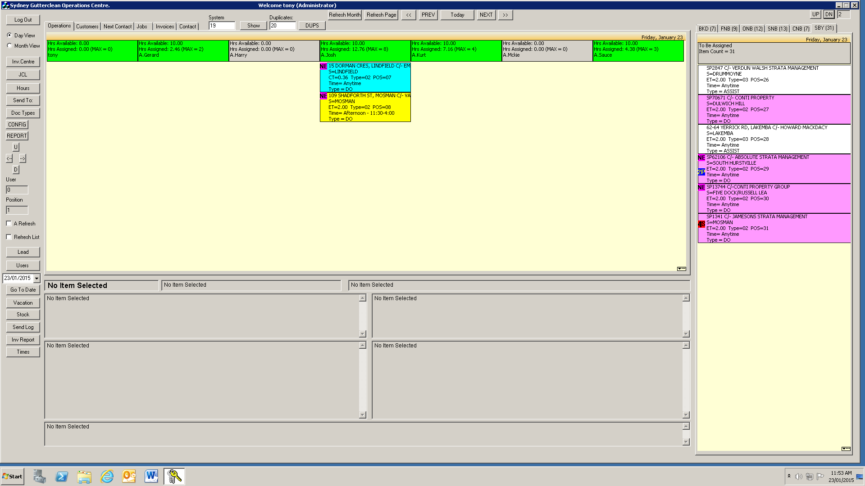

- Operations
- Customers
- Next Contact
- Jobs
- Invoices
- Contact

Each of these tabs and their various functions will be explained, there will also be other documents giving detailed explanation of how to use the various functions of each tab. But first, the Operations tab and its various functions will be explained.

Operations Panel

The large light brown space with coloured tiles is the operations panel. The top row of tiles represent OTRWs, if the tile is green that OTRW is working that day. If grey, it means that OTRW is not working that day.

- Hours Available - Hours the OTRW is available to work.
- Hours Assigned - Hours the OTRW is estimated to be working.
- (MAX=#) – Number of jobs assigned to OTRW.

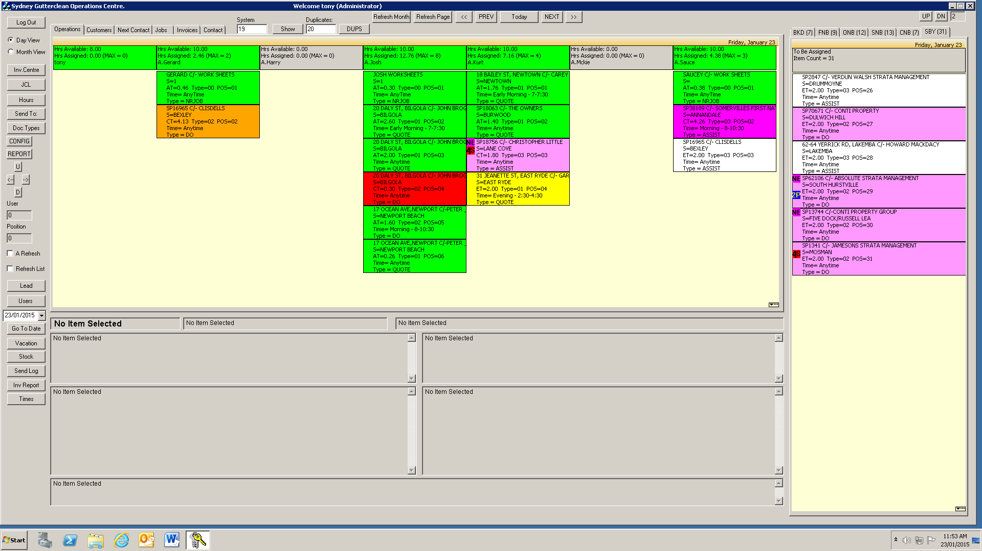

Each tile under the OTRW’s header represents one of the OTRW's jobs. You will find the following information on one of these tiles. The colour of the tile tells you the status of the job.

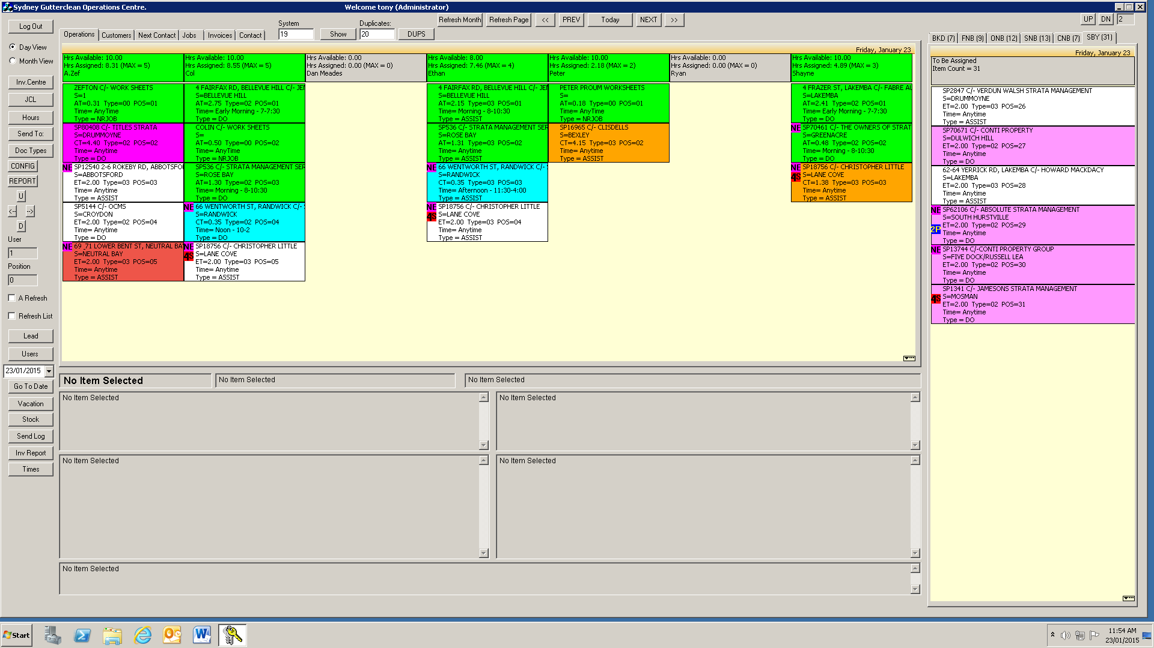

- 1st Line – COLastname
- 2nd Line – Suburb
- 3rd Line – Time spent on job
  - ET= Estimated Time
  - CT = Current Time
  - AT = Actual Time
- 4th Line – Time of day job can be done
- 5th Line – Type of job
  - NRJOB = Non-Revenue Job
  - QUOTE
  - DO
  - SUPPORT

Some jobs may have special requirements to be completed, so some job tiles will look like this:

The small symbols in the top left corner of the job tiles inform you of special needs for that specific job.

 2 Persons - This symbol means that the job requires two OTRWs.
 Not Early – This means the job cannot be done early.
4 Storey Ladder – This means a 4 Storey Ladder is required on this job.

List of tile colour meanings (Operations Panel)

- White – Assigned
  - Guava - Rain SMS sent to customer
- Yellow – Confirmed
- Blue – En-Route
- Magenta – In-Progress (Standard)
  - Orange – In-Progress (Last job of the day)
  - Purple – Job is overtime
- Light Grey – On-Hold
  - Red – On-Hold (Left not complete)
- Green - Completed

The “System” and “Duplicates” boxes at the top of the screen tells you how many jobs there are that need to be done as well as how many jobs there are that are duplicated. Clicking on “Show” or “DUPS” will display these jobs.

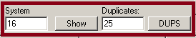

Unassigned Jobs Panel

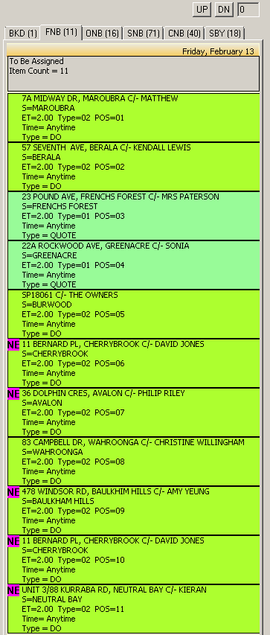

The unassigned jobs panel (above) is located to the right of the screen. It has 6 different tabs on it.

- BKD (Booked) – Unassigned jobs booked
- FNB (Front Desk Not Booked) – Unbooked jobs with no category
- ONB (Operations Not Booked) – Set to Operations category
- SNB (Sales Not Booked) – Unbooked Sales jobs
- CNB (Contracted Not Booked) – Unbooked contracted jobs
- SBY (Standby) – Jobs set to standby status

At the very top of this panel there are 2 buttons used for navigation.

The “UP” button scrolls one page up and the “DN” (down) button will scroll one page down.

The colour of the job tiles in this panel have a different meaning to the one mentioned before in the operations panel.
List of tile colour meanings (Unassigned Jobs Panel)

- 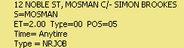 Khaki – Non Revenue Jobs
- 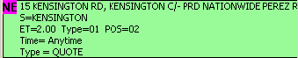 Pale Green – Quote
- 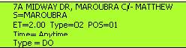 GreenYellow – Do
- 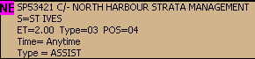 Tan – Support
- Guava - Rain SMS sent to customer

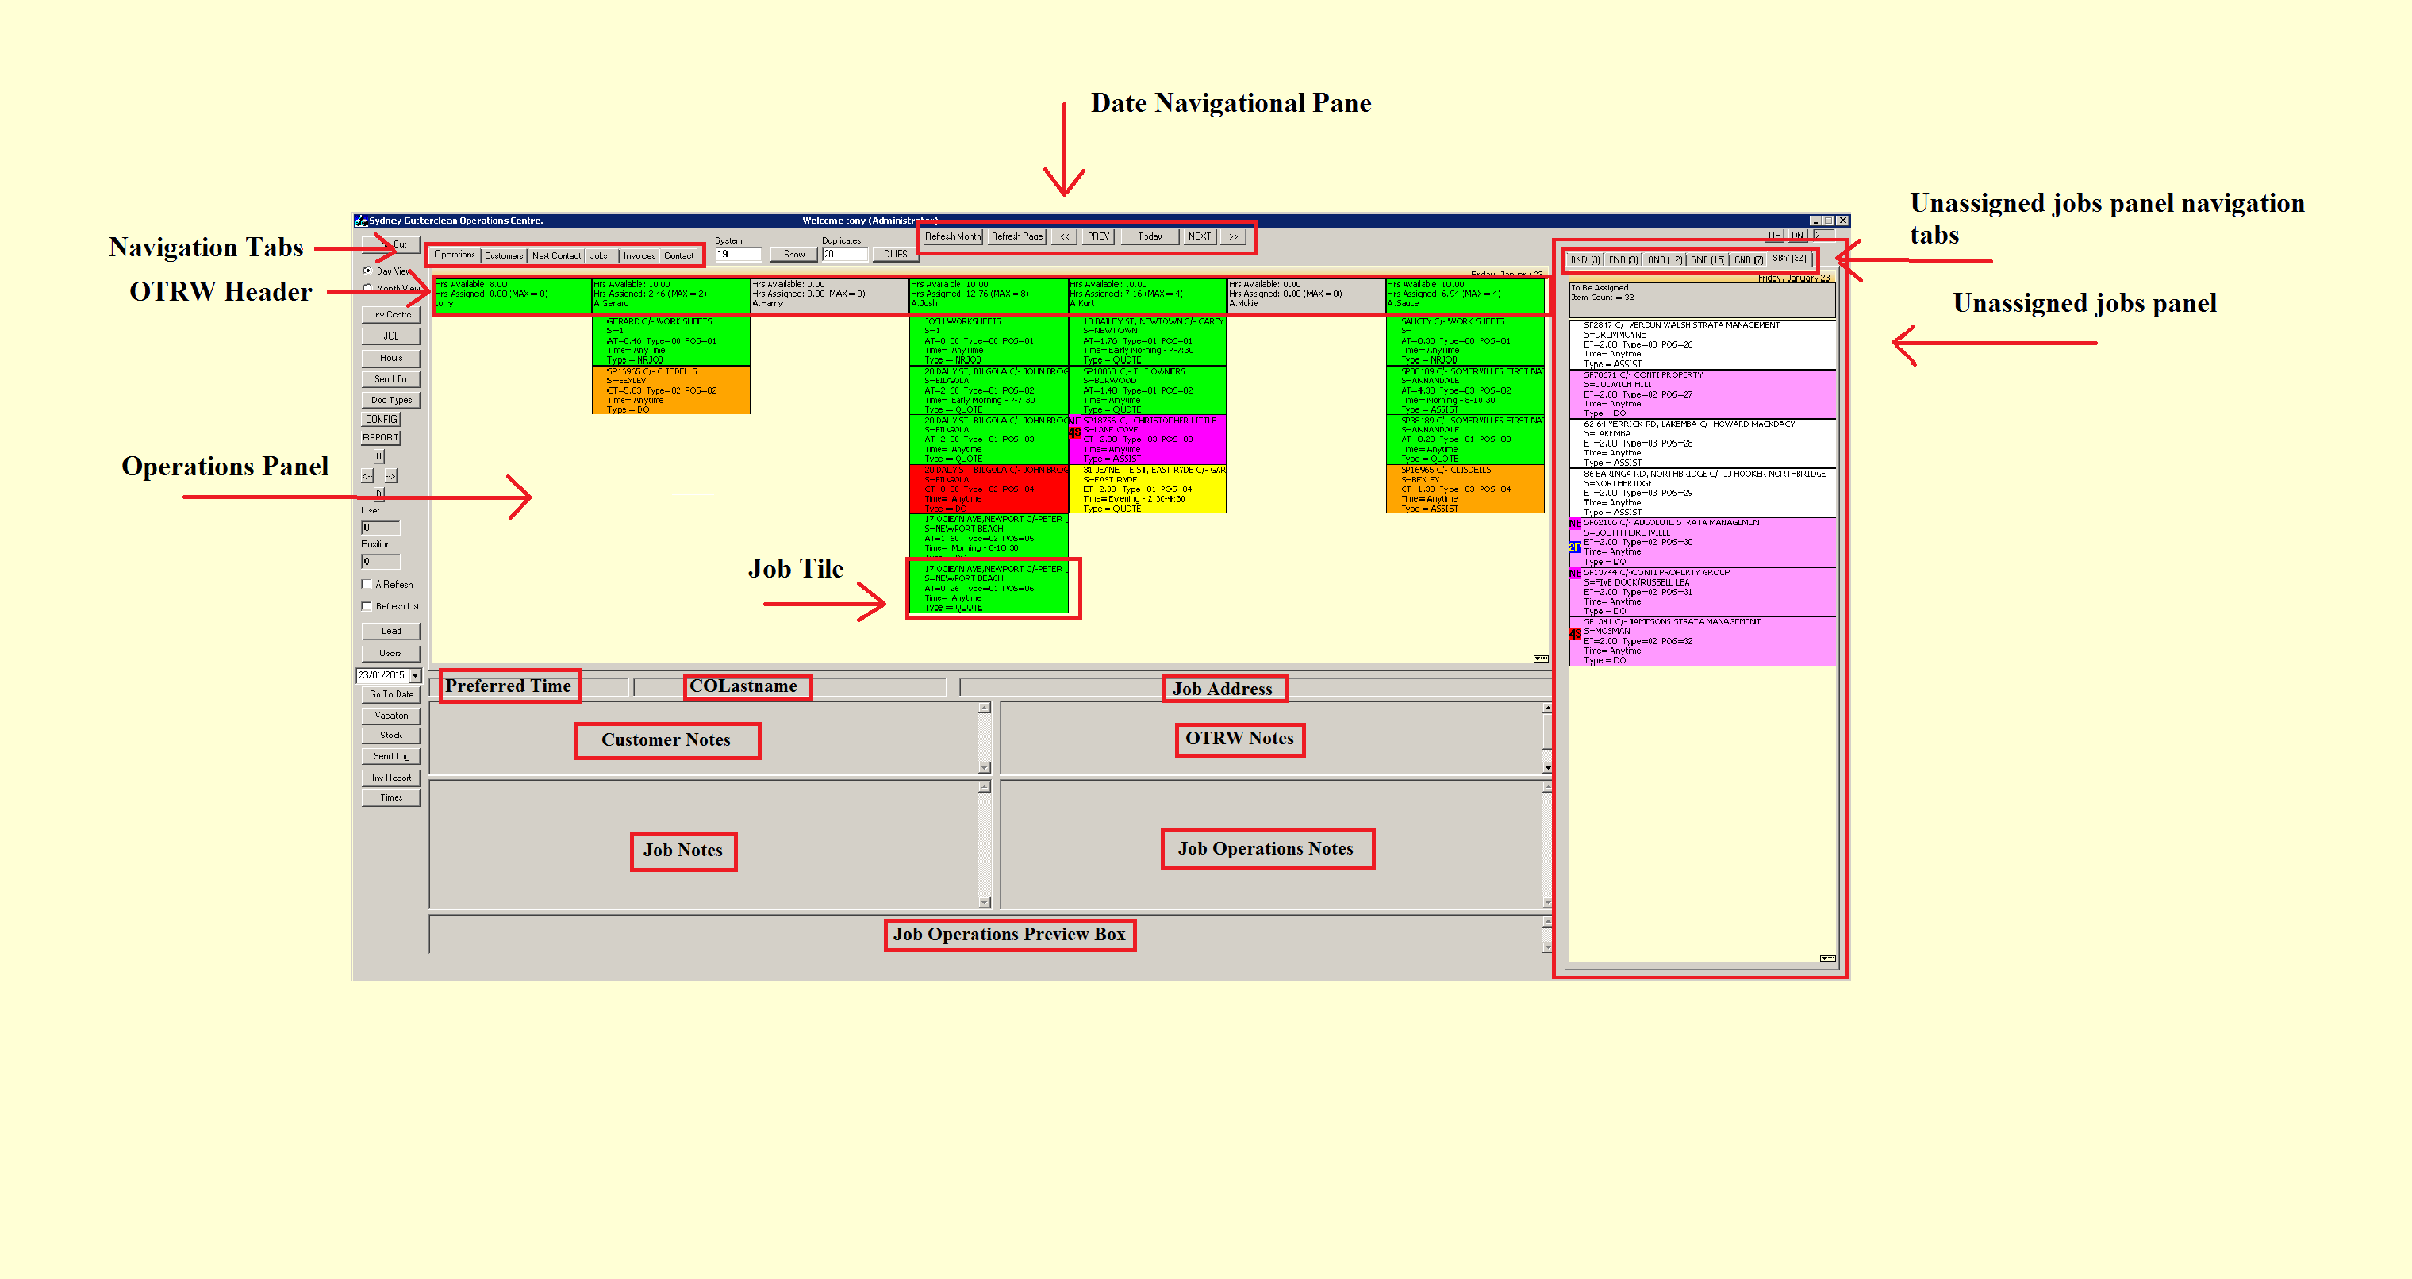

Side Panel

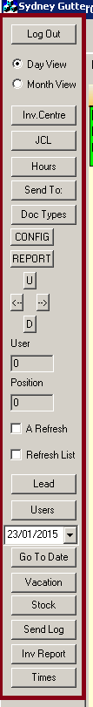

The side panel works as a quick access toolbar, each button allowing you to perform a specific action no matter which tab you have selected.

The following pages will briefly describe the function of each button on this quick access toolbar.

The Inv. Centre button, (Invoice Centre) opens the invoicing centre, which allows you to manage the invoices for the system.

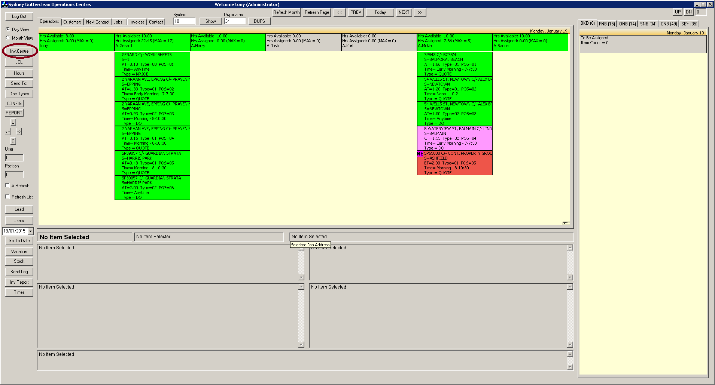

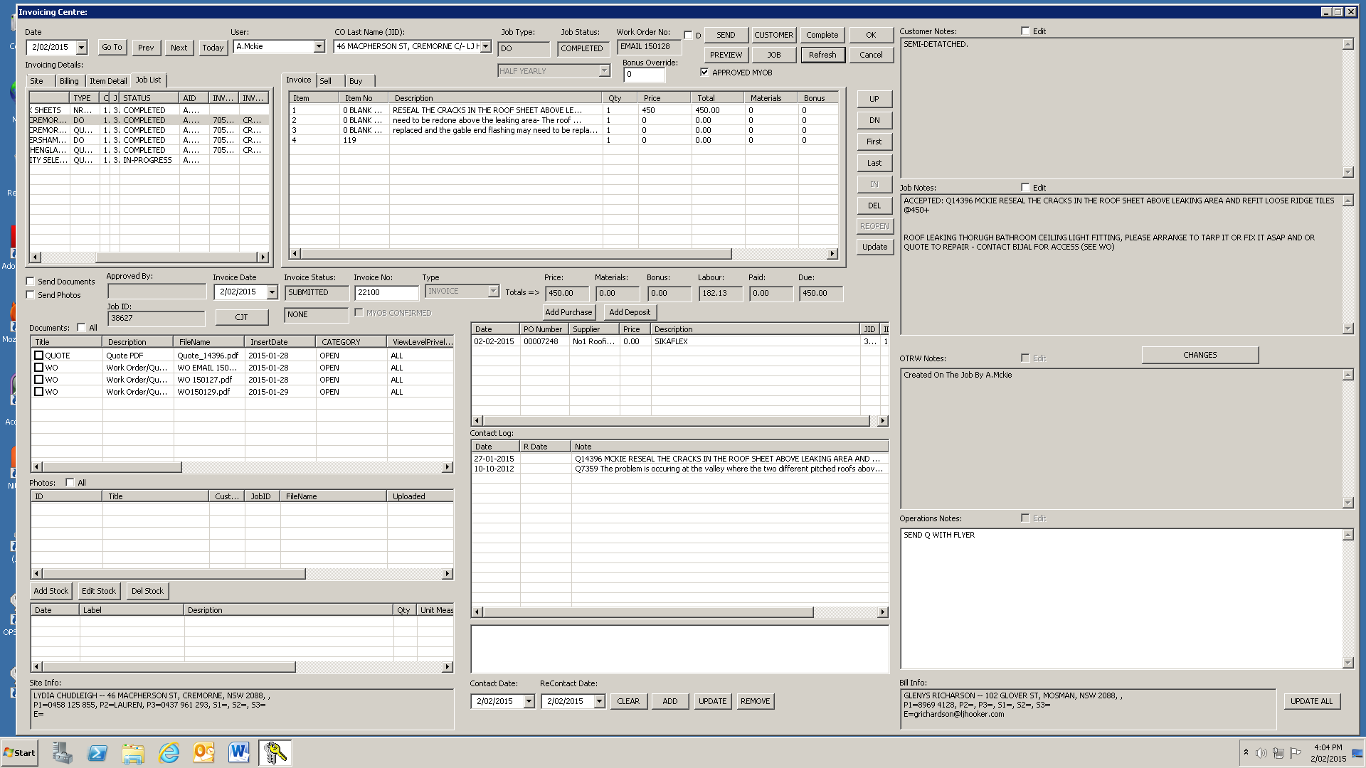

For more information on how to use the invoicing centre, refer to the document “Invoicing Centre.pdf”

The JCL button (Job Condition Items List) allows you to manage the items the can be used for invoicing from the website and the desktop.

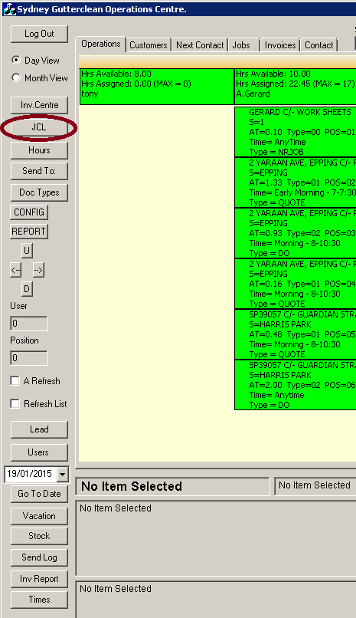

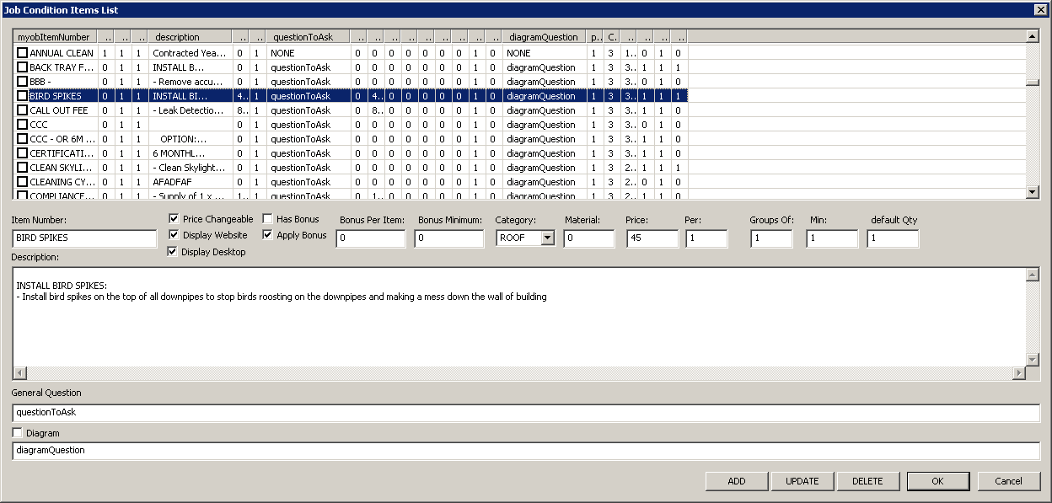

For more information on the “Job Condition Items List”, see the Appendix at the end of this document.

The Hours button allows you to generate the hours an employee works over a specific time period.

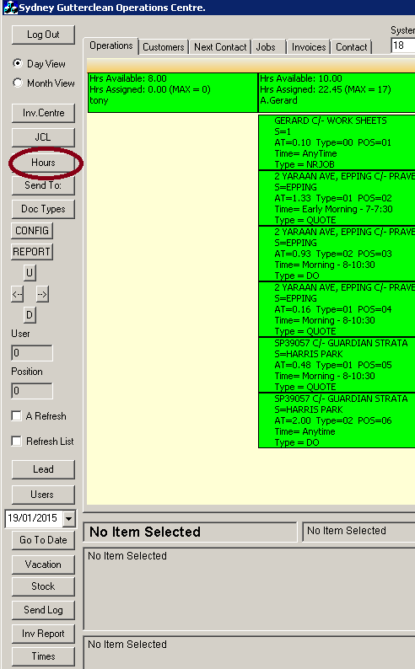

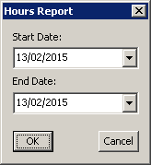

For more information on the “Hours Report” box, see the Appendix at the end of this document.

The “Send To:” button allows you to send job cards to OTRWs.

Times

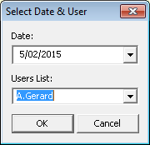

After selecting the date and user click “OK” to bring up the employees timesheet:

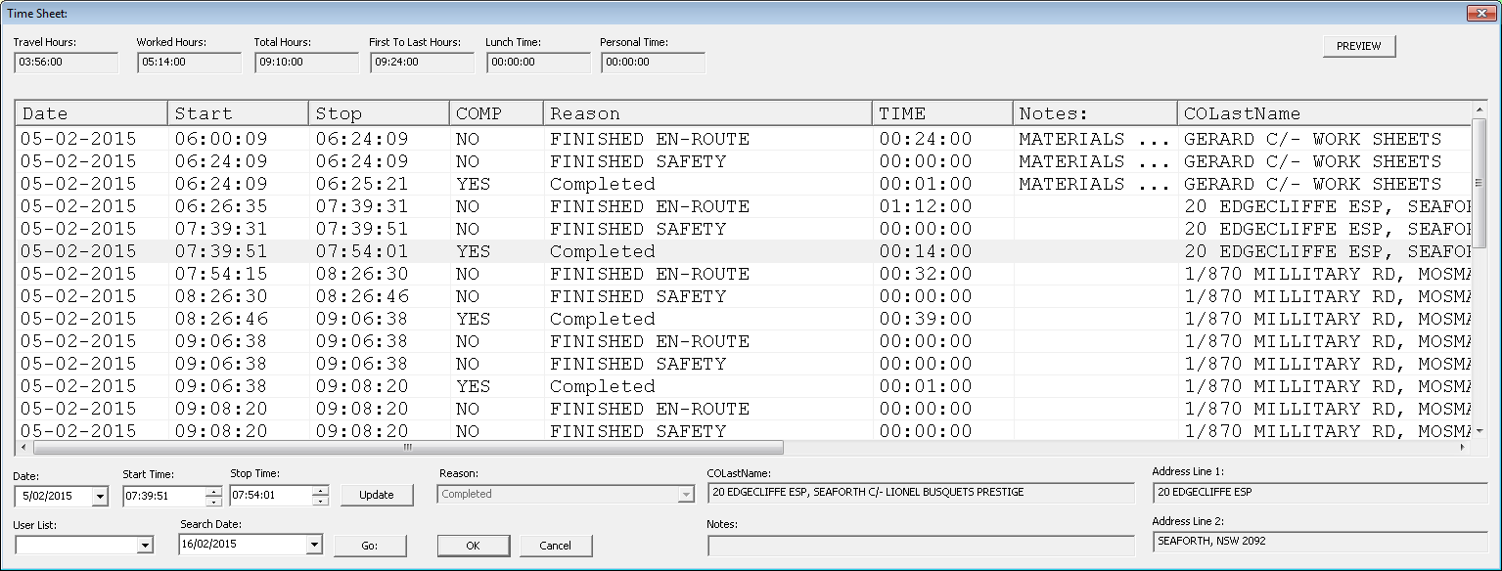

The “Time Sheet” can be used to view and edit an employees work hours.
- The “Date” drop down calendar will allow you to change the date of the selected time.
- The “Start Time” and “Stop Time” will let you set the start/stop time of the selected time.
- Click “Update” to save changes made to the job time.
- The “User List” drop down list lets you choose a different user.
- The “Search Date” drop down calendar allows you to select date to search times for.
- Clicking “Go” will search for times on the specified day for the specified user.
- Clicking “OK” will save and exit the window.
- Clicking “Cancel” will exit without saving.
- Clicking “PREVIEW” will preview the Time Sheet as a pdf:

