- The best resolution/size for banner, product picture, project picture?
- All product title should in the middle
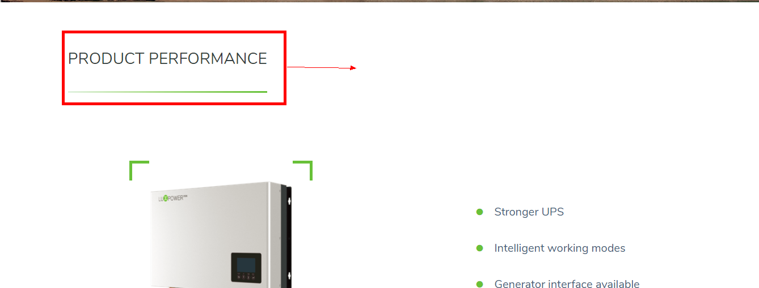
- DCDC100k, use the there are two picture same
- Download function has not been finished
Can not download now, how to put the download file, we may change the download file or add download file, how can we manage it? There are many certificates need to be download, how to download different certificate?
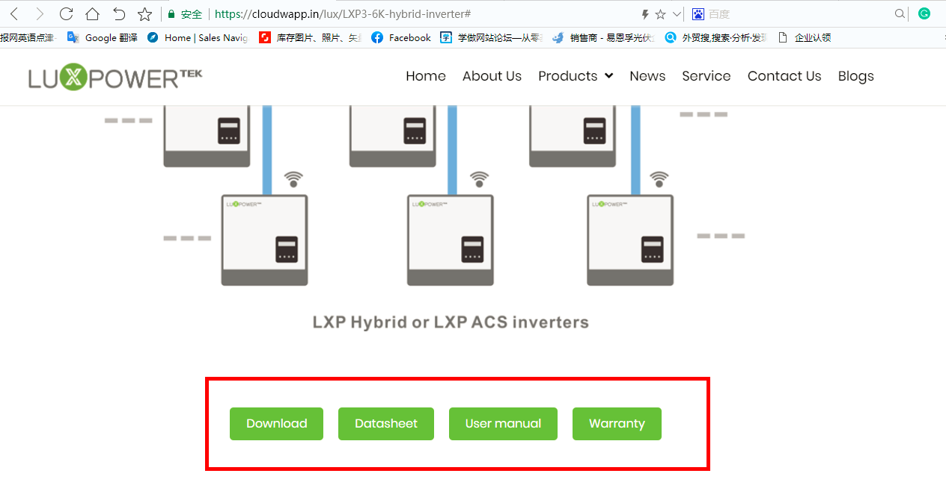

- Can not add news by admin account
- Can not add product picture
- Can not add Q&A after adding 20 questions
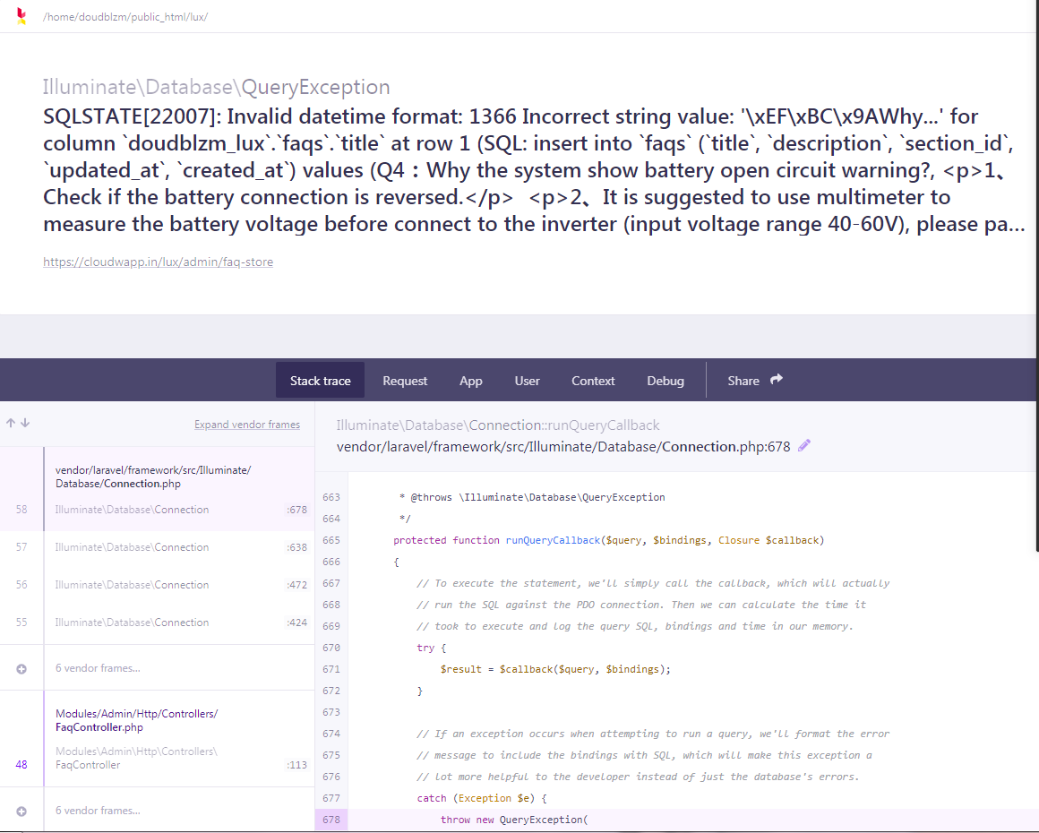
- Mobile compatible
- Speed up

