EDVENT — Complete Backend Development Master Syllabus

Node.js + Express.js + MongoDB | Beginner to Advanced
This curriculum is structured for teaching students how to build real-world backend applications, starting from programming fundamentals and HTTP concepts and progressing to REST APIs, database design, authentication, security, testing, deployment, and production-grade architecture.
The goal is not just to teach students how to write backend code. By the end, they should be able to design, build, test, secure, deploy, and maintain a complete backend for a MERN-stack application.

1. Course overview
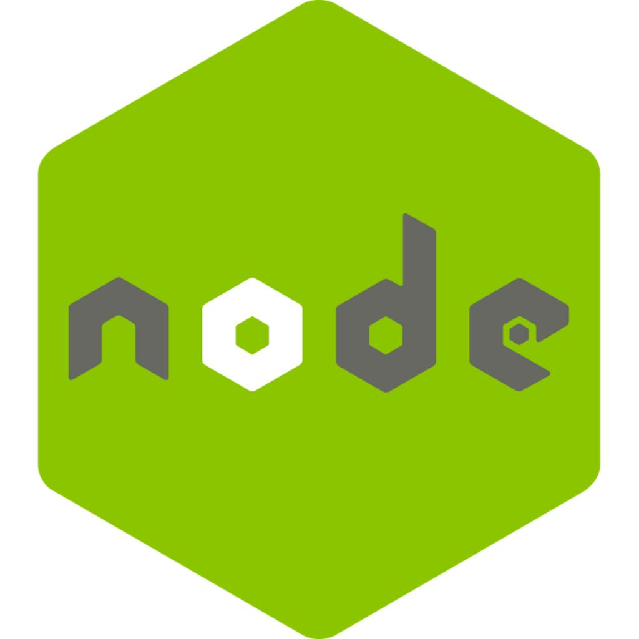
Node.js — JavaScript runtime
Execute JavaScript outside the browser; handle files, processes, asynchronous operations, networking, and backend services.

Express.js — Web framework
Build HTTP servers, REST APIs, middleware pipelines, routing, validation, and error-handling systems.

MongoDB — NoSQL database
Design collections and documents, query data, model relationships, create indexes, use aggregation, and manage database performance.
Course detail | Recommendation
Target audience | Beginners learning backend development
Prerequisites | HTML, CSS, JavaScript fundamentals
Teaching approach | Theory + live coding + assignments + projects
Suggested duration | 20–28 weeks part-time, or 12–16 weeks intensive
Final outcome | Production-oriented backend developer foundation
Main API style | REST API
Primary stack | Node.js, Express.js, MongoDB, Mongoose
Supporting tools | Git, GitHub, Postman, npm, environment variables, testing tools
Recommended teaching order: JavaScript for backend → Node.js → HTTP and REST → Express.js → MongoDB → Mongoose → authentication and security → testing → deployment → advanced architecture.
Use a supported, current Node.js LTS release and compatible versions of Express and MongoDB. Pin dependency versions in course projects and check the official documentation when APIs or defaults change.

Level 0 — Prerequisites and backend fundamentals

Module 1. JavaScript prerequisites for backend development
Students should understand the following JavaScript concepts before beginning Node.js.

1.1 Core JavaScript
- Variables: let, const, and scope
- Primitive and reference types
- Operators and expressions
- Conditional statements
- Loops and iteration
- Functions, arrow functions, parameters, and return values
- Arrays and objects
- Array methods: map(), filter(), find(), reduce(), some(), every()
- Object destructuring and array destructuring
- Spread and rest syntax
- Template literals
- Optional chaining and nullish coalescing
- Modules and imports/exports

1.2 Advanced JavaScript concepts
- Lexical scope and closures
- Higher-order functions
- Callback functions
- this and binding
- Prototypes and classes
- Error handling with try, catch, and finally
- JSON parsing and serialization
- Promises
- async and await
- Promise chaining and error propagation
- Event loop fundamentals
- Shallow versus deep copying
- Basic immutability principles

1.3 Practical exercises
- Create a student records processor using arrays and objects.
- Read, filter, and summarize JSON data.
- Write asynchronous functions using promises.
- Build a small validation utility.
- Create reusable modules and import them into another file.
Module outcome: Students can write modular, asynchronous JavaScript and understand the syntax used throughout the backend stack.

Module 2. How the web and backend work

2.1 Client-server architecture
- Frontend versus backend
- Browser, client, server, and database roles
- Request-response lifecycle
- Web servers and application servers
- Static versus dynamic content
- APIs and service communication
- Monolithic versus distributed applications

2.2 HTTP and HTTPS
- HTTP request structure
- HTTP response structure
- Methods: GET, POST, PUT, PATCH, DELETE, OPTIONS, HEAD
- Headers and request bodies
- URL, path, query parameters, and fragments
- Common status codes: 200, 201, 204, 301, 400, 401, 403, 404, 409, 422, 429, 500, 503
- Cookies and sessions
- HTTPS and TLS basics
- Content types and JSON
- CORS and browser-origin rules
- Idempotency and safe HTTP methods
- HTTP caching fundamentals

2.3 REST API fundamentals
- Resources and resource naming
- CRUD operations
- REST conventions
- Stateless requests
- Filtering, sorting, pagination, and searching
- Request validation
- Consistent response structures
- API versioning
- API documentation
- REST versus GraphQL and RPC: conceptual comparison

2.4 Practical exercises
- Inspect requests and responses in browser developer tools.
- Test public APIs using Postman.
- Design endpoints for a student management application.
- Map CRUD operations to HTTP methods and status codes.

Level 1 — Node.js fundamentals

Module 3. Introduction to Node.js

3.1 Node.js architecture
- What Node.js is and is not
- JavaScript runtime versus programming language
- V8 JavaScript engine
- Node.js runtime architecture
- Event-driven programming
- Non-blocking I/O
- Single JavaScript thread and background work
- libuv and the thread pool
- Concurrency versus parallelism
- CPU-bound versus I/O-bound tasks
- When Node.js is a good fit
- Limitations and when to consider other approaches

3.2 Installation and development environment
- Installing a Node.js LTS version
- Using node --version and npm --version
- Node.js REPL
- Running JavaScript files
- VS Code setup
- Terminal and command-line basics
- Using node --watch where supported
- Environment management with a version manager
- Project initialization with npm init
- Understanding package.json and package-lock.json

3.3 First Node.js application
- Running a script
- Importing core modules
- Reading command-line arguments
- Process exit codes
- Writing output to the terminal
- Creating a simple HTTP server
- Understanding the request listener
- Starting and stopping a server

3.4 npm and dependency management
- npm registry
- Installing and removing packages
- Dependencies versus dev dependencies
- Semantic versioning
- Version ranges and lockfiles
- npm scripts
- npm install versus npm ci
- Updating and auditing dependencies
- Package maintenance and supply-chain risks
- .gitignore
- Reproducible development environments
Practical assignment: Create a command-line calculator and a basic HTTP server without Express.

Module 4. Node.js core modules

4.1 File system — fs
- Synchronous versus asynchronous file operations
- Callback, promise, and synchronous APIs
- Reading and writing files
- Appending data
- Renaming and deleting files
- Creating and removing directories
- File metadata and permissions
- Working with JSON files
- File streams
- Handling file system errors

4.2 Paths and operating-system utilities
- path.join(), path.resolve(), and path normalization
- Absolute versus relative paths
- Platform-specific path handling
- os module
- Environment and platform information
- Process working directory

4.3 Process and environment
- process.argv
- process.env
- Process exit codes
- Signals and graceful shutdown
- Environment configuration
- Configuration validation
- Never committing secrets to Git

4.4 Other useful core modules
- http and https
- url
- events
- crypto
- stream
- buffer
- util
- timers
- readline
- zlib
- assert
- worker_threads
- child_process
- perf_hooks

4.5 Streams and buffers
- What streams solve
- Readable, writable, duplex, and transform streams
- Piping and backpressure
- Buffer creation and manipulation
- Handling large files efficiently
- Streaming uploads and downloads
- Stream error handling

4.6 Events and asynchronous operations
- Event emitters
- Event listeners
- Promise-based APIs
- Error-first callbacks
- async/await
- Sequential versus parallel tasks
- Promise.all(), Promise.allSettled(), Promise.race(), and Promise.any()
- Event loop phases at a conceptual level
- Microtasks and timers
- Avoiding blocking operations
- Avoiding unhandled promise rejections
Practical project: Build a file-processing utility that reads a large file, processes records, reports errors, and writes a summary.

Module 5. Building a server with Node.js HTTP

5.1 HTTP server development
- Creating a server using http.createServer()
- Listening on a port
- Handling request methods
- Parsing URLs and query parameters
- Reading request streams
- Parsing JSON request bodies safely
- Writing headers and status codes
- Sending JSON and text responses
- Serving basic static files
- Handling unsupported methods and routes
- Managing server errors

5.2 Build a mini API without Express
- In-memory CRUD operations
- Route matching
- Input validation
- Centralized response helpers
- Error responses
- Basic request logging
- Separation of routing and business logic
Milestone project: A mini REST API using only Node.js core modules. Students should understand what Express abstracts away.

Level 2 — Express.js fundamentals

Module 6. Introduction to Express.js

6.1 Express setup
- What Express.js is
- Express versus the native Node.js HTTP module
- Creating an Express project
- Installing Express
- Setting up the application entry point
- Starting a development server
- Using npm scripts
- Understanding the application lifecycle
- Development versus production configuration

6.2 Creating routes
- app.get()
- app.post()
- app.put()
- app.patch()
- app.delete()
- app.all()
- Route paths and route parameters
- Query parameters
- Reading req.params
- Reading req.query
- Reading req.body
- Reading request headers
- Using req.get()
- Handling unmatched routes
- Returning appropriate HTTP status codes

6.3 Sending responses
- res.send()
- res.json()
- res.status()
- res.end()
- res.redirect()
- res.set() and response headers
- Sending files
- Downloading files
- Response status and body conventions
- Avoiding multiple responses for one request
- Understanding res.headersSent

6.4 Express application configuration
- express()
- app.listen()
- app.set() and app.get() for application settings
- JSON body parsing with express.json()
- URL-encoded body parsing
- Static assets using express.static()
- Trust proxy configuration
- Environment-specific configuration
- Development logging

6.5 Practical assignment
Create a Student Management API with endpoints to:
- Add a student
- List all students
- Get one student by ID
- Update student information
- Delete a student
- Search by name or course
- Return correct status codes for success and failure
Initially, use an in-memory array; later, replace it with MongoDB.

Module 7. Express middleware
Middleware is one of the most important concepts in Express. Students must understand it deeply because authentication, logging, validation, security, and error handling depend on middleware.

7.1 Middleware fundamentals
- What middleware is
- Request-response middleware pipeline
- req, res, and next
- Application-level middleware
- Router-level middleware
- Built-in middleware
- Third-party middleware
- Custom middleware
- Middleware execution order
- Conditional middleware
- Skipping middleware
- Avoiding requests that never finish

7.2 Custom middleware development
- Request logging
- Request timing
- Request ID generation
- Authentication checks
- Authorization checks
- Input validation
- Request body size restrictions
- API key validation
- Rate-limit handling
- Response headers
- Maintenance-mode middleware

7.3 Error-handling middleware
- Four-argument error middleware
- Passing errors using next(err)
- Handling synchronous errors
- Handling rejected promises
- Async route error propagation
- Centralized error-handling architecture
- Custom error classes
- Development versus production error responses
- Avoiding disclosure of stack traces or internal details
- Not leaking secrets through error messages

7.4 Common middleware packages
- cors
- helmet
- morgan or a structured logger
- express-rate-limit
- Request validation libraries such as Zod or Joi
- Cookie parsing where needed
- Compression middleware
- Multipart upload middleware such as Multer
Students should learn what each package does, its limitations, and how to configure it safely rather than installing packages without understanding them.

7.5 Practical assignment
Build reusable middleware for logging, request validation, error handling, and rate limiting. Demonstrate how changing middleware order changes the request lifecycle.

Module 8. Express routing and project organization

8.1 Router fundamentals
- express.Router()
- Creating separate route files
- Mounting routers with app.use()
- Route prefixes
- Nested routers
- Route parameters and parameter middleware
- Route matching order
- Route conflicts
- Versioned routes such as /api/v1
- Route-specific middleware

8.2 Organizing backend code
- Entry point and app configuration
- Routes
- Controllers
- Services
- Models
- Middleware
- Validators
- Configuration
- Utilities
- Error classes
- Database connection
- Tests
- API documentation

8.3 Common architecture patterns
- Simple layered architecture
- MVC pattern
- Controller-service-repository separation
- Dependency injection fundamentals
- Keeping business logic out of routes
- Avoiding unnecessarily complex abstractions
- Managing dependencies between modules

8.4 Example folder structure
backend/
├── src/
│ ├── app.js
│ ├── server.js
│ ├── config/
│ │ ├── env.js
│ │ └── database.js
│ ├── routes/
│ │ └── user.routes.js
│ ├── controllers/
│ │ └── user.controller.js
│ ├── services/
│ │ └── user.service.js
│ ├── models/
│ │ └── user.model.js
│ ├── middleware/
│ │ ├── auth.js
│ │ └── error-handler.js
│ ├── validators/
│ ├── utils/
│ └── tests/
├── .env.example
├── .gitignore
├── package.json
└── README.md
This is a teaching structure, not a mandatory standard. For small projects, a simpler structure is appropriate; for larger projects, feature-based modules may be easier to maintain.
Milestone: Students can create a modular Express application with clean routing, reusable middleware, and centralized error handling.

Level 3 — MongoDB database development

Module 9. Database and NoSQL fundamentals

9.1 Database concepts
- What a database is
- Database server versus application server
- SQL versus NoSQL
- Relational tables versus document collections
- Records, rows, documents, and fields
- Schema and schema flexibility
- Primary keys and identifiers
- Relationships and references
- Transactions and consistency
- Choosing a database based on application requirements

9.2 MongoDB concepts
- MongoDB architecture at a high level
- Database, collection, and document
- BSON versus JSON
- The _id field and ObjectId
- Embedded documents
- Arrays inside documents
- Flexible schemas
- Document size considerations
- Basic CRUD operations
- MongoDB Atlas versus self-hosted MongoDB

9.3 Installation and setup
- MongoDB Atlas account and cluster
- Database users and authentication
- Network access configuration
- Connection strings
- Database tools and shell
- MongoDB Compass
- Creating databases and collections
- Environment variable configuration
- Local versus cloud development
- Least-privilege access

Module 10. MongoDB CRUD operations
Teach the native MongoDB query language before moving into Mongoose.

10.1 Create operations
- insertOne()
- insertMany()
- Automatic and explicit _id
- Insert validation
- Duplicate-key errors
- Bulk writes

10.2 Read operations
- find()
- findOne()
- Query filters
- Projection
- Sorting
- Limiting results
- Skipping records
- Counting documents
- Distinct values
- Nested-field queries
- Array queries

10.3 Update operations
- updateOne()
- updateMany()
- replaceOne()
- $set
- $unset
- $inc
- $min and $max
- $rename
- $push and $pull
- $addToSet
- $pop
- Upserts
- Update filters and matched versus modified counts

10.4 Delete operations
- deleteOne()
- deleteMany()
- Delete filters
- Safe deletion patterns
- Soft deletion versus permanent deletion
- Bulk deletion considerations

10.5 Query operators
- Comparison: $eq, $ne, $gt, $gte, $lt, $lte
- Logical: $and, $or, $not, $nor
- Element: $exists, $type
- Evaluation: $regex and its limitations
- Array: $in, $nin, $all, $elemMatch, $size
- Working with nested objects
- Querying embedded documents
- Combining multiple operators
- Avoiding unbounded queries

10.6 Practical exercises
- Create a student collection.
- Filter students by course, age, or enrollment status.
- Update student records using operators.
- Find students whose marks exceed a threshold.
- Query arrays and nested address fields.
- Handle invalid IDs and missing records.

Module 11. MongoDB data modeling and relationships

11.1 Data modeling principles
- Start from application access patterns
- Identify entities and relationships
- Embed versus reference
- One-to-one relationships
- One-to-many relationships
- Many-to-many relationships
- Denormalization and duplication
- Avoiding excessive document growth
- Avoiding unbounded arrays
- Handling frequently changing related data
- Schema evolution

11.2 Relationship design
- Embedded address in a user document
- Orders embedded within a small bounded record
- Referencing users from orders
- Referencing courses from enrollments
- Many-to-many student-course relationships
- Modeling comments and posts
- Modeling categories and products
- Handling deleted or missing referenced records

11.3 Data integrity
- Required fields
- Unique constraints
- Application-level validation
- Database validation rules
- Duplicate records
- Referential consistency in a document database
- Handling concurrent updates
- Idempotent writes

11.4 Practical modeling task
Design collections for a computer institute management system:
- Students
- Courses
- Batches
- Enrollments
- Attendance
- Payments
- Instructors
- Assessments
Students should justify whether each relationship should be embedded or referenced.

Module 12. MongoDB indexes and performance

12.1 Index fundamentals
- Why indexes exist
- Query performance and trade-offs
- Single-field indexes
- Compound indexes
- Unique indexes
- Multikey indexes
- Text indexes
- TTL indexes
- Partial indexes
- Sparse indexes
- Indexes on nested fields
- Index ordering and field prefixes

12.2 Query optimization
- explain() and execution plans
- COLLSCAN versus index scans
- Selectivity
- Covered queries
- Sort performance
- Pagination performance
- Avoiding unnecessary indexes
- Write overhead from excessive indexes
- Profiling slow queries
- Measuring performance instead of guessing

12.3 Practical exercises
- Compare a query before and after indexing.
- Build a compound index for a common filter and sort.
- Diagnose a slow query using an execution plan.
- Measure the impact of an index on writes.

Module 13. MongoDB aggregation framework
Aggregation is essential for analytics, reports, dashboards, and complex data transformations.

13.1 Pipeline fundamentals
- Aggregation pipeline
- Stage ordering
- Filtering with $match
- Projection with $project
- Grouping with $group
- Sorting with $sort
- Limiting with $limit
- Skipping with $skip
- Counting with $count
- Reshaping with $set and $addFields
- Removing fields with $unset

13.2 Grouping and calculations
- $sum
- $avg
- $min
- $max
- $first
- $last
- $push
- $addToSet
- Conditional calculations with $cond
- Multi-field grouping
- Date-based grouping
- Null and missing-value handling

13.3 Advanced aggregation
- $unwind
- $lookup
- $facet
- $bucket and $bucketAuto
- $replaceRoot and $replaceWith
- $map, $filter, and $reduce
- Date operators
- String operators
- Conditional expressions
- Pagination and count facets
- Aggregation performance considerations

13.4 Real-world reporting exercises
- Monthly revenue by course
- Number of active students per batch
- Attendance percentage by student
- Most popular courses
- Outstanding fee reports
- Enrollment trends by month
- Average marks by assessment
- Revenue grouped by payment method

Module 14. Advanced MongoDB operations

14.1 Transactions and atomicity
- Single-document atomicity
- Multi-document transactions
- Sessions
- Commit and abort
- Transaction boundaries
- Transaction costs
- When a transaction is unnecessary
- Retry considerations

14.2 Replication and availability
- Replica sets
- Primary and secondary members
- Replication basics
- Read preferences
- Write concern
- Read concern
- Failover
- High availability concepts

14.3 Sharding and scaling
- Sharded clusters
- Shard keys
- Cardinality and distribution
- Hot shards and hotspots
- Horizontal scaling
- Balancing
- Operational complexity
- When sharding is appropriate

14.4 Operational database management
- Backups and restore testing
- Import and export
- Data migrations
- Schema-version management
- Database monitoring
- Connection limits
- Connection pooling
- Least-privilege database roles
- Network restrictions
- Encryption in transit and at rest
- Retention and deletion policies
Milestone: Students can model MongoDB data, write advanced queries, build aggregation pipelines, optimize indexes, and understand database operations.

Level 4 — Mongoose and database integration

Module 15. Mongoose fundamentals
Mongoose is an Object Data Modeling (ODM) library for MongoDB and Node.js. Teach it after students understand native MongoDB operations.

15.1 Setup and connections
- Installing Mongoose
- Connecting with mongoose.connect()
- Connection lifecycle
- Connection events
- Connection errors and retries
- Connection pooling
- Separating database configuration
- Graceful shutdown
- Managing connections in development and production

15.2 Schemas and models
- Schema definition
- Creating models
- Schema types
- Strings, numbers, booleans, dates
- Arrays and nested objects
- ObjectId references
- Required fields
- Defaults
- Enums
- Minimum and maximum values
- String length and trimming
- Custom setters and getters
- Timestamps
- Schema-level options
- Strict mode

15.3 Validation
- Built-in validators
- Custom validators
- Synchronous and asynchronous validation
- Validation errors
- validate() and validateSync()
- Document validation versus update validation
- runValidators in update operations
- Why Mongoose validation is not a replacement for request validation
- Database-level constraints where appropriate

15.4 CRUD with Mongoose
- Model.create()
- Model.insertMany()
- Model.find()
- Model.findOne()
- Model.findById()
- Model.findByIdAndUpdate()
- Model.findOneAndUpdate()
- Model.updateMany()
- Model.deleteOne()
- Model.findByIdAndDelete()
- save()
- Query chaining
- .select()
- .sort()
- .limit()
- .skip()
- .lean()
- .exec()
- Handling null results and exceptions

15.5 Relationships and population
- ObjectId references
- ref
- populate()
- Selecting populated fields
- Nested population
- Population limitations
- Avoiding excessive database queries
- Embedding versus referencing with Mongoose
- Virtual populate
- Avoiding unnecessary population in list endpoints

15.6 Middleware, methods, and virtuals
- Document middleware
- Query middleware
- Model middleware
- Aggregate middleware
- Instance methods
- Static methods
- Virtual properties
- Transforming documents into API responses
- Avoiding sensitive fields in serialized output
- Middleware ordering and limitations

15.7 Advanced Mongoose
- Discriminators
- Transactions with sessions
- Optimistic concurrency
- Version keys
- Bulk writes
- Index declarations
- Index synchronization considerations
- Schema migrations
- Handling duplicate-key errors
- Model reuse and hot-reload concerns
- TypeScript integration
Practical assignment: Convert the earlier Student Management API from in-memory arrays to MongoDB using Mongoose.

Module 16. Connecting Express, Mongoose, and application logic

16.1 Full request lifecycle
Students should be able to explain this flow:
Client / React frontend
Express route
Middleware and validation
Controller
Service / business logic
Mongoose model
MongoDB database
Responses and errors travel back through the application to the client.

16.2 Implementation topics
- Loading configuration before startup
- Establishing database connections
- Starting the server only after required initialization succeeds
- Defining schemas and models
- Writing controllers
- Separating business rules into services
- Handling database errors
- Returning consistent JSON responses
- Validating route parameters
- Handling invalid MongoDB ObjectIds
- Distinguishing not-found errors from server failures
- Preventing duplicate submissions
- Avoiding database calls inside unnecessary loops
- Using pagination for list endpoints

16.3 CRUD API implementation
Build the following endpoints:
Method | Endpoint | Purpose
POST | /api/v1/students | Create a student
GET | /api/v1/students | List students
GET | /api/v1/students/:id | Get one student
PATCH | /api/v1/students/:id | Update selected fields
DELETE | /api/v1/students/:id | Delete or archive a student
Extend the API with filtering, sorting, pagination, search, validation, authentication, and role-based access.

Level 5 — REST API engineering

Module 17. API design and implementation

17.1 API conventions
- Resource-oriented endpoint naming
- Plural resource names
- HTTP method semantics
- Appropriate status codes
- Consistent error formats
- Request and response contracts
- API versioning
- Backward compatibility
- Deprecation strategies
- Date and time formats
- Numeric precision and currency representation
- Null, missing, and optional fields
- Idempotency and safe retries

17.2 Pagination, filtering, and sorting
- Page-based pagination
- Limit and offset
- Cursor-based pagination
- Stable sorting
- Filtering by multiple fields
- Search endpoints
- Date-range filters
- Validation of page sizes
- Maximum page-size limits
- Avoiding expensive full-collection searches
- Designing pagination metadata

17.3 Search
- Case-insensitive search
- Exact versus partial matching
- Regular-expression risks
- Text indexes
- MongoDB Atlas Search where available
- Search relevance and ranking
- Search performance
- Search result pagination

17.4 File and data handling
- JSON body parsing
- URL-encoded forms
- Multipart requests
- File upload limits
- File metadata
- Download endpoints
- CSV import/export
- Streaming large responses
- Handling large request bodies
- Input encoding and data normalization

17.5 API documentation
- OpenAPI specification
- Swagger UI
- Documenting routes, parameters, and schemas
- Authentication schemes
- Error response documentation
- Example requests and responses
- Maintaining documentation alongside code
- Generating API clients conceptually

17.6 Practical assignment
Build a versioned REST API for an online course platform, with pagination, filters, search, documented contracts, and standardized errors.

Module 18. Validation and data integrity

18.1 Request validation
- Validate path parameters
- Validate query parameters
- Validate request bodies
- Required versus optional fields
- Type conversion
- Length and range restrictions
- Allowlisted fields
- Nested object validation
- Array validation
- Date and email validation
- Sanitization where appropriate

18.2 Validation libraries
Choose one primary library for teaching:
- Zod
- Joi
- Express-validator
Teach the concepts first; then compare syntax and trade-offs.

18.3 Data integrity rules
- Preventing mass assignment
- Preventing unexpected field updates
- Handling duplicate email addresses
- Unique index errors
- Cross-field validation
- Business-rule validation
- Concurrency conflicts
- Idempotent create operations
- Consistency between related documents
- Avoiding trust in frontend validation alone
Practical assignment: Create reusable schemas for registration, login, course creation, enrollment, payment initiation, and student updates.

Level 6 — Authentication and authorization

Module 19. Authentication fundamentals

19.1 Core concepts
- Authentication versus authorization
- Identity and access management
- User registration
- Login and logout
- Password storage
- Password hashing versus encryption
- Sessions and tokens
- Access control
- Identity providers
- Authentication failure responses
- Account lifecycle and recovery

19.2 Password security
- Why plaintext passwords must never be stored
- Password hashing with Argon2id or bcrypt
- Salt and work factor
- Password policy
- Password confirmation
- Preventing account enumeration
- Login rate limiting
- Secure password reset flows
- Reset token generation, expiry, and single use
- Changing passwords
- Revoking sessions after sensitive changes

19.3 JWT authentication
- JWT structure: header, payload, signature
- Signing and verifying tokens
- Claims and expiration
- Access-token lifecycle
- Refresh-token lifecycle
- Token rotation and revocation
- Secret and key management
- Token storage trade-offs
- Why decoded JWT data is not automatically trusted
- Avoiding sensitive information in token payloads
- Correct algorithm and issuer/audience validation

19.4 Cookie-based authentication
- HTTP-only cookies
- Secure cookies
- SameSite policies
- Cookie expiry
- Session identifiers
- Session storage
- CSRF considerations
- Cross-origin credential configuration
- Session invalidation
- Cookie-domain and path configuration

19.5 Session versus JWT
Students should compare both approaches and choose based on the application’s needs, rather than assuming JWT is always better.

Module 20. Implementing authentication

20.1 Registration and login
- User schema
- Registration validation
- Duplicate-account handling
- Password hashing
- Login verification
- Token or session creation
- Authentication middleware
- Current-user endpoint
- Logout
- Protected routes
- Error handling

20.2 Account security features
- Email verification
- Password reset
- Refresh tokens
- Session management
- Logout from all devices
- Account deactivation
- Optional multi-factor authentication
- OAuth 2.0 and OpenID Connect concepts
- Social login integration
- Secure redirect validation

20.3 Authorization
- Role-based access control (RBAC)
- Permissions
- Admin, instructor, and student roles
- Resource ownership
- Role and permission middleware
- Object-level authorization
- Preventing insecure direct object references
- Deny-by-default design
- Least privilege
- Tenant and organization boundaries

20.4 Practical assignment
Build a complete authentication module with registration, login, logout, password reset, protected endpoints, and role-based access.
Security requirement: Authentication is not complete until students test unauthorized requests, expired tokens or sessions, privilege escalation attempts, and cross-user data access.

Level 7 — Backend security

Module 21. OWASP and common backend vulnerabilities
Students should learn to identify, reproduce safely in a local test environment, prevent, and test for common vulnerabilities.

21.1 Input and injection security
- NoSQL injection
- SQL injection concepts for comparison
- Untrusted object keys and query operators
- Unsafe query construction
- Validation and allowlisting
- Avoiding direct use of request objects in database queries
- Regular-expression denial-of-service risks
- Command injection
- Path traversal
- Unsafe file paths
- Output encoding

21.2 API security
- Broken authentication
- Broken authorization
- Broken object-level authorization
- Broken function-level authorization
- Excessive data exposure
- Mass assignment
- Unrestricted resource consumption
- Rate limiting
- Brute-force protection
- Account enumeration
- Request-size limits
- API key security
- API abuse and scraping
- Sensitive business-flow protection

21.3 Browser and transport security
- HTTPS and TLS
- CORS configuration
- Cross-site scripting (XSS) fundamentals
- Cross-site request forgery (CSRF)
- Content Security Policy concepts
- Secure cookie settings
- Security-related HTTP headers
- Origin and referer validation where appropriate
- Redirect validation
- Mixed-content risks

21.4 Secrets and dependency security
- Environment variables
- Secret managers
- Secret rotation
- .env files and .gitignore
- Dependency vulnerability audits
- Lockfile integrity
- Supply-chain risks
- Removing secrets from logs
- Safe error responses
- Production debug settings
- Least-privilege database credentials

21.5 File-upload security
- MIME type versus file extension
- File-size restrictions
- File signature checks
- Randomized storage names
- Malware scanning concepts
- Avoiding execution of uploaded files
- Private versus public storage
- Signed download URLs
- Access control for files
- Preventing path traversal

21.6 Security testing exercises
- Attempt to access another user's records.
- Try updating fields that a normal user should not control.
- Test malformed and oversized payloads.
- Test rate limits on login endpoints.
- Test expired and revoked credentials.
- Verify that secrets and stack traces are absent from production responses.
- Check that uploaded files cannot be used to execute code.
Use a current OWASP API Security Top 10 reference as a teaching checklist, and update the material when the published edition changes.

Level 8 — Advanced Node.js

Module 22. Asynchronous programming and concurrency

22.1 Deep event-loop understanding
- Call stack
- Task queues and microtasks
- Promise scheduling
- Timers and I/O callbacks
- process.nextTick() considerations
- Event-loop phases
- Blocking versus non-blocking execution
- I/O concurrency
- Common misconceptions about the single-threaded model

22.2 Async error handling
- Rejected promises
- try/catch with await
- Async middleware
- Promise chains
- Error propagation
- Timeouts
- Cancellation with AbortController
- Handling external service failures
- Retries with exponential backoff
- Jitter and retry limits
- Avoiding retry storms

22.3 Parallelism and background work
- Promise.all() versus sequential execution
- Limiting concurrent operations
- Worker threads
- Child processes
- CPU-intensive workloads
- Message passing
- Process isolation
- Background jobs
- Job queues
- Scheduling tasks
- Idempotent job handlers

22.4 Practical exercises
- Compare sequential and parallel API calls.
- Simulate a slow external service.
- Implement timeouts and controlled retries.
- Move CPU-intensive work to a worker thread.
- Build a background job that processes student report data.

Module 23. Streams, memory, and resource management

23.1 Streams in production
- Streaming large downloads
- Streaming file uploads
- Transform streams
- Backpressure
- Pipeline error handling
- Compression
- Stream cancellation
- Efficient CSV processing
- Avoiding loading entire files into memory

23.2 Memory management
- Heap and stack concepts
- Garbage collection fundamentals
- Memory leaks
- Retained references
- Large in-memory caches
- Event listener leaks
- Buffer memory
- Memory profiling
- Heap snapshots
- Diagnosing increasing memory usage

23.3 Resource lifecycle
- Database connection pools
- HTTP connection handling
- Timeouts
- Graceful shutdown
- Closing database connections
- Stopping background workers
- Signal handling
- Readiness during startup and shutdown
- Avoiding premature process termination

Module 24. Logging, debugging, and observability

24.1 Debugging
- Node.js inspector
- VS Code debugger
- Breakpoints
- Watch expressions
- Call stacks
- Inspecting asynchronous code
- Reproducing bugs
- Source maps
- Diagnosing uncaught errors

24.2 Logging
- console versus structured logging
- Log levels
- Structured JSON logs
- Request IDs
- Correlation IDs
- Redacting sensitive information
- Log retention
- Centralized log collection
- Avoiding excessive logging

24.3 Monitoring and observability
- Metrics, logs, and traces
- Latency percentiles
- Request throughput
- Error rates
- Event-loop delay
- Memory and CPU usage
- Database query latency
- External service latency
- Health endpoints
- Readiness and liveness checks
- Alert thresholds
- Incident investigation

24.4 Practical assignment
Instrument an Express API with request IDs, structured logs, timing metrics, error tracking, and health endpoints.

Level 9 — Advanced API architecture

Module 25. Service-layer architecture and clean code

25.1 Separation of concerns
- Routes versus controllers
- Controllers versus services
- Services versus repositories
- Models versus domain rules
- Dependency boundaries
- Reusable validation
- Shared error handling
- Avoiding circular dependencies
- Managing module size
- Feature-based organization

25.2 Design principles
- SOLID fundamentals
- Single responsibility
- Dependency inversion
- Composition over inheritance
- Separation of concerns
- DRY without premature abstraction
- Avoiding giant controllers
- Avoiding overengineering
- Consistent naming
- Code review practices

25.3 Design patterns for backend applications
- Repository pattern
- Service pattern
- Factory pattern
- Adapter pattern
- Strategy pattern
- Middleware and decorator concepts
- Dependency injection
- Domain events
- When not to use a pattern

25.4 Practical assignment
Refactor a monolithic Express application into a maintainable layered application. Add unit tests around business logic and integration tests around database operations.

Module 26. Caching and performance optimization

26.1 Caching fundamentals
- Why caching is used
- In-memory cache
- Redis introduction
- Cache-aside pattern
- Read-through and write-through concepts
- Time-to-live (TTL)
- Cache invalidation
- Stale data
- Cache consistency
- Cache stampede
- Cache keys and namespacing

26.2 Backend performance
- Request latency
- Database query optimization
- Index selection
- Pagination
- Avoiding N+1 query patterns
- Payload-size reduction
- Compression
- Connection reuse
- Avoiding synchronous file operations in request handlers
- Load testing
- Profiling before optimization

26.3 HTTP caching
- Cache-Control
- ETag
- Conditional requests
- Last-Modified
- Public versus private caching
- Browser versus CDN caching
- Cache invalidation after updates

26.4 Practical assignment
Measure a slow API, identify the bottleneck, add the appropriate index or cache, and report before-and-after performance. Students must explain any trade-off in freshness or consistency.

Module 27. Background jobs, queues, and scheduled tasks

27.1 Background processing
- Why not every task belongs in a request handler
- Job producers and consumers
- Redis-backed queue concepts
- BullMQ or an equivalent queue library
- Job states
- Retry and backoff policies
- Failed-job handling
- Dead-letter concepts
- Job deduplication
- Idempotent processing
- Scheduled jobs
- Worker concurrency
- Queue monitoring

27.2 Common use cases
- Sending emails
- Generating PDF certificates
- Processing uploaded files
- Generating large reports
- Sending reminders
- Expiring temporary records
- Processing webhooks
- Importing CSV files
- Scheduled cleanup

27.3 Practical assignment
Create a background worker that generates student certificates and emails them without blocking the API request.

Module 28. Real-time backend development

28.1 WebSocket concepts
- HTTP request-response versus persistent connections
- WebSocket handshake
- Full-duplex communication
- Connection lifecycle
- Client and server events
- Reconnection strategies
- Heartbeats
- Authentication
- Authorization for rooms and channels

28.2 Socket.IO
- Installing and configuring Socket.IO
- Client-server events
- Namespaces
- Rooms
- Broadcasting
- Acknowledgements
- Connection middleware
- Scaling across multiple server instances
- Redis adapter concepts
- Handling disconnected users

28.3 Real-time applications
- Live notifications
- Chat systems
- Real-time attendance
- Admin dashboards
- Live status updates
- Presence indicators
- Rate limiting real-time events
Practical assignment: Create a real-time student support chat or live classroom notification service.

Module 29. Third-party API integrations

29.1 External service communication
- Using fetch or a suitable HTTP client
- Request headers and authentication
- API keys and OAuth credentials
- Timeouts
- Retries and backoff
- Rate limits
- Pagination from external APIs
- Parsing external responses
- Error normalization
- Circuit-breaker concepts
- Graceful degradation

29.2 Common integrations
- Email service
- SMS or OTP service
- Cloud file storage
- Payment gateway
- Maps or geolocation APIs
- Analytics service
- OAuth login provider
- Webhook provider

29.3 Webhooks
- Receiving webhook requests
- Verifying signatures
- Replay protection
- Idempotency
- Event IDs
- Duplicate deliveries
- Fast acknowledgement
- Asynchronous processing
- Failure recovery and retries

29.4 Payment integration
- Payment order creation
- Server-side amount verification
- Payment signature verification
- Payment status reconciliation
- Webhook processing
- Idempotent payment handling
- Refunds
- Failure and pending states
- Audit records
- Never trusting the frontend alone for payment confirmation

Level 10 — Testing and quality assurance

Module 30. Backend testing fundamentals

30.1 Testing concepts
- Why backend testing matters
- Unit tests
- Integration tests
- End-to-end tests
- Contract testing concepts
- Test pyramid
- Test coverage and its limitations
- Test data management
- Test isolation
- Deterministic tests
- Test environments versus production

30.2 Testing tools
Teach one primary testing stack, such as:
- Vitest or Jest for test execution
- Supertest for HTTP endpoint testing
- MongoDB test instances or isolated test databases
- Mocking and stubbing tools
- Coverage reporting
- Postman for exploratory testing

30.3 Unit testing
- Testing pure functions
- Testing validators
- Testing utility functions
- Testing business rules
- Mocking dependencies
- Testing success and failure cases
- Testing edge cases
- Avoiding excessive mocking

30.4 Integration testing
- Testing Express endpoints
- Testing database operations
- Testing validation middleware
- Testing authentication
- Testing authorization
- Testing pagination and filters
- Testing duplicate records
- Testing error responses
- Cleaning up test data
- Isolating test databases

30.5 End-to-end testing
- Registration and login flow
- Course creation
- Student enrollment
- Payment workflow
- Password reset
- Permission enforcement
- Failure and retry scenarios

30.6 Essential test cases
Every API endpoint should be tested for:
- Valid input and successful response.
- Missing required fields.
- Invalid field formats.
- Invalid resource identifiers.
- Resource not found.
- Duplicate or conflicting data.
- Unauthenticated access.
- Insufficient permissions.
- Database or external-service failure.
- Unexpected fields and malformed requests.
Practical assignment: Create a repeatable automated test suite for the complete Student Management API.

Module 31. API testing and contract quality
- Postman collections and environments
- Environment variables in API tests
- Automated request sequences
- Positive and negative tests
- Authentication token management in test environments
- API response assertions
- Schema and contract validation
- OpenAPI documentation validation
- Regression testing
- Smoke testing
- Load testing fundamentals
- Avoiding accidental tests against production data

Level 11 — TypeScript for backend development

Module 32. TypeScript with Node.js and Express
TypeScript is strongly recommended for students who intend to build maintainable, larger backend systems.

32.1 TypeScript foundations
- Primitive types
- Arrays and tuples
- Object types
- Type aliases and interfaces
- Union and intersection types
- Literal types
- Optional properties
- Enums and alternatives
- Type narrowing
- Type guards
- Generics
- Utility types
- unknown versus any
- Type assertions
- Strict mode

32.2 Backend-specific TypeScript
- Typing Express request and response objects
- Typing route parameters and query strings
- Typing request bodies
- Typed service return values
- Typed custom errors
- Typing middleware
- Async function return types
- Type-safe environment configuration
- Type-safe database models
- Runtime validation versus compile-time types
- Type-safe API response contracts

32.3 MongoDB and Mongoose with TypeScript
- Model and document types
- Typed schema definitions
- ObjectId types
- Lean query results
- Optional versus nullable fields
- Validation and type alignment
- Avoiding unsafe casts
- Keeping runtime validation aligned with types

32.4 TypeScript project configuration
- tsconfig.json
- Compiler options
- Source and output directories
- Development execution
- Build scripts
- Production execution
- Source maps
- Module-system compatibility
- Type-checking in CI
Practical assignment: Convert the Student Management API from JavaScript to TypeScript without losing validation, testing, or maintainability.

Level 12 — Deployment and DevOps

Module 33. Production configuration

33.1 Environment management
- Development, testing, staging, and production
- Environment-specific configuration
- Configuration validation at startup
- Secrets management
- .env.example
- Avoiding secrets in source control
- Managing database URLs
- Port configuration
- Logging configuration
- Feature flags
- Secure defaults

33.2 Production readiness
- Correct production start command
- Process failure handling
- Graceful shutdown
- Database connection lifecycle
- Request timeouts
- Health checks
- Error reporting
- Log redaction
- Dependency review
- Database backups
- Recovery procedures
- Capacity planning

Module 34. Deployment platforms

34.1 Deploying Node.js APIs
- Deploying to a Node.js-compatible hosting platform
- Deploying to a virtual private server
- Managed application hosting
- Managed MongoDB with Atlas
- Setting production environment variables
- Connecting the API to the database securely
- Configuring domains
- HTTPS certificates
- Reverse proxies
- Deploying from Git
- Logs and troubleshooting
- Rollbacks

34.2 Process management
- Process managers such as PM2 where appropriate
- Automatic restart policies
- Startup configuration
- Log management
- Graceful restarts
- Multiple application instances
- Load balancing fundamentals

34.3 Deployment models
- Traditional server deployment
- Containers
- Serverless functions
- Managed platforms
- Trade-offs in cold starts, execution limits, state, and connection reuse
- Choosing an appropriate hosting model

Module 35. Docker and containerization

35.1 Docker fundamentals
- Images and containers
- Dockerfile
- Base images
- Build layers
- Ports
- Environment variables
- Container networking
- Volumes
- .dockerignore
- Container logs
- Container lifecycle

35.2 Backend Dockerization
- Creating a Dockerfile for Node.js
- Multi-stage builds
- Installing production dependencies
- Running as a non-root user
- Health checks
- Container environment configuration
- Connecting to MongoDB
- Docker Compose for local development
- Avoiding secrets in image layers

35.3 Practical assignment
Containerize an Express API and MongoDB development environment. Document how to run the application from a clean machine.

Module 36. CI/CD and Git workflows

36.1 Version control workflow
- Git fundamentals
- Branching and merging
- Pull requests
- Code review
- Commit quality
- Resolving conflicts
- .gitignore
- Environment files
- Release tags

36.2 Continuous integration and deployment
- Automated linting
- Formatting checks
- Type checking
- Unit and integration tests
- Build verification
- Dependency auditing
- Environment-specific deployment
- Database migration strategy
- Deployment approvals
- Rollback plans
- Post-deployment smoke tests

36.3 Practical assignment
Create a CI workflow that installs dependencies, runs checks and tests, builds the application, and deploys only after the required checks pass.

Level 13 — Advanced database architecture

Module 37. Database migrations and schema evolution
- Why schemas evolve
- Backward-compatible changes
- Adding and removing fields
- Data backfills
- Migration scripts
- Idempotent migrations
- Safe index creation
- Rolling deployments
- Application compatibility with old and new schemas
- Backup before risky changes
- Migration verification
- Rollback limitations
- Data cleanup and retention

Module 38. Multi-tenancy and data isolation
- Single-tenant versus multi-tenant applications
- Tenant identifiers
- Tenant-scoped queries
- Tenant-aware middleware
- Data isolation
- Authorization across tenant boundaries
- Compound indexes with tenant identifiers
- Tenant-level configuration
- Tenant-specific quotas
- Avoiding cross-tenant data leakage
- Testing isolation guarantees
Practical assignment: Add multiple institutes to the Student Management API, ensuring one institute cannot access another institute's students, payments, or reports.

Module 39. Advanced MongoDB design decisions
- Choosing between embedding and referencing at scale
- Handling high-volume collections
- Time-series data concepts
- Event records and audit logs
- Soft deletion
- Data retention policies
- Archival strategies
- Change streams
- Event-driven updates
- Read and write patterns
- Consistency requirements
- Denormalization trade-offs
- Choosing a shard key conceptually
- Read replicas and analytical workloads
- MongoDB versus relational databases for specific use cases

Module 40. Distributed systems fundamentals
This is an advanced conceptual module; students should understand the ideas before attempting distributed architectures.
- Monolith versus modular monolith versus microservices
- Service boundaries
- Synchronous versus asynchronous communication
- Message brokers and queues
- Event-driven architecture
- Eventual consistency
- Distributed transactions
- Saga pattern concepts
- Idempotency
- Duplicate message handling
- Retries and backoff
- Circuit breakers
- Service discovery concepts
- Centralized logging and tracing
- Failure isolation
- When a monolith is the better choice

Module 41. Scaling backend applications
- Vertical and horizontal scaling
- Stateless application design
- Load balancers
- Multiple application instances
- Shared session stores
- Redis for shared state and caching
- Database connection-pool limits
- Rate limiting across instances
- Background worker scaling
- Queue backlogs
- Database bottlenecks
- CDN and reverse-proxy fundamentals
- Capacity planning
- Load and stress testing
- Cost and reliability trade-offs

Level 14 — Advanced professional topics

Module 42. API reliability and resilience
- Request and connection timeouts
- Graceful degradation
- Retry policies and exponential backoff
- Circuit breakers
- Bulkhead isolation
- Rate limiting by IP, user, and API key
- Distributed rate limiting
- Idempotency keys
- Duplicate request prevention
- Graceful shutdown and deployment draining
- Handling database outages
- Handling third-party API outages
- Service health and readiness
- Retry storms and cascading failures
- Recovery objectives: RTO and RPO
- Incident response and post-incident reviews

Module 43. Auditability and business workflows
- Audit logs
- Who performed an action and when
- Immutable event history concepts
- Tracking status transitions
- Approval workflows
- Payment and refund states
- Transactional consistency
- Optimistic concurrency
- Record versioning
- Soft deletion and recovery
- Data retention and privacy
- Administrative action tracking
- Reconciliation jobs
- Reporting and exports
Practical assignment: Implement an auditable fee-payment workflow with pending, successful, failed, and refunded states. Ensure repeated payment notifications do not produce duplicate records.

Module 44. Advanced API patterns
- Bulk API operations
- Batch processing
- File import and export
- Long-running operations and job status endpoints
- Webhook subscriptions
- API keys and service-to-service authentication
- Request signing concepts
- Rate-limit headers
- Conditional updates
- Optimistic locking
- Deprecation and version compatibility
- GraphQL fundamentals as an alternative API style
- WebSocket APIs versus REST APIs
- API gateways and their purpose

Module 45. Professional backend engineering practices
- Code readability and maintainability
- Naming conventions
- ESLint and Prettier
- Code review
- Technical documentation
- Architecture decision records
- Dependency upgrades
- Semantic versioning
- Secure package management
- Environment reproducibility
- Refactoring without breaking contracts
- Debugging production incidents
- Technical debt management
- Performance regression prevention
- Writing maintainable tests
- Project estimation and task breakdown

Level 15 — Capstone projects
Students should build projects in increasing order of difficulty. Each project should include a GitHub repository, documented API, database schema, validation, error handling, automated tests, and deployment instructions.
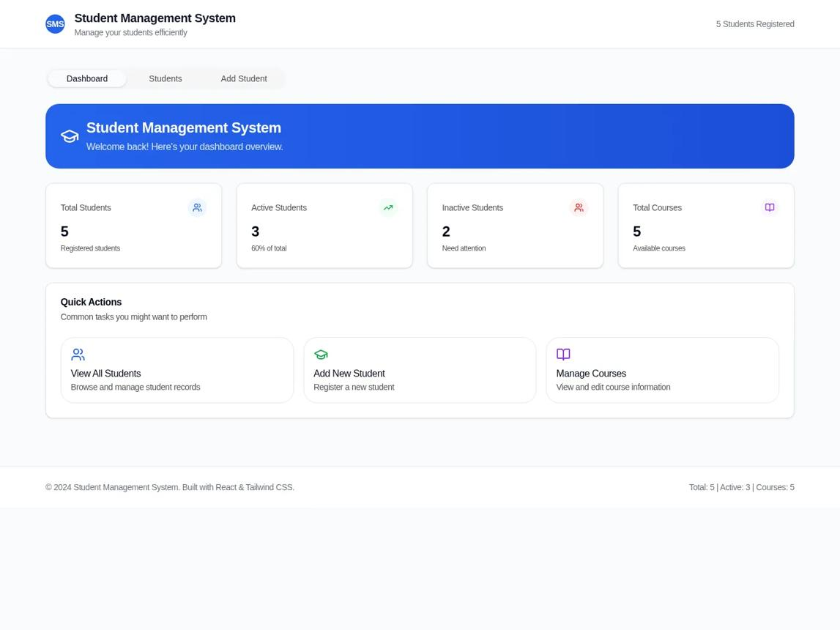
Project 1 — Student Management REST API
Beginner
Features
- Student CRUD
- Course assignment
- Search, filters, and pagination
- Mongoose validation
- Standardized errors
- Postman collection
Skills assessed: Node.js, Express routing, MongoDB CRUD, and Mongoose.
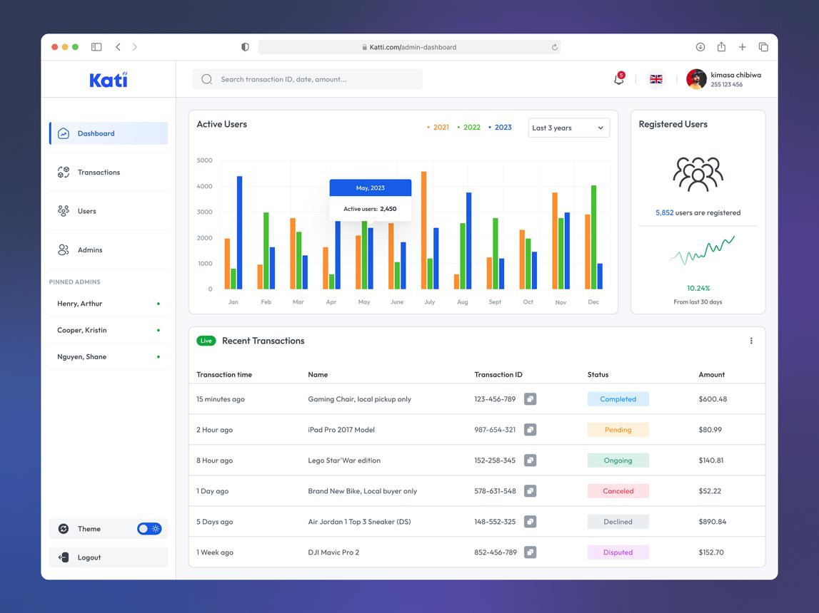
Project 2 — Authentication and Authorization API
Beginner–Intermediate
Features
- Registration and login
- Secure password hashing
- Session or token-based authentication
- Password reset
- Roles and permissions
- Protected endpoints
Skills assessed: authentication, security, validation, and access control.
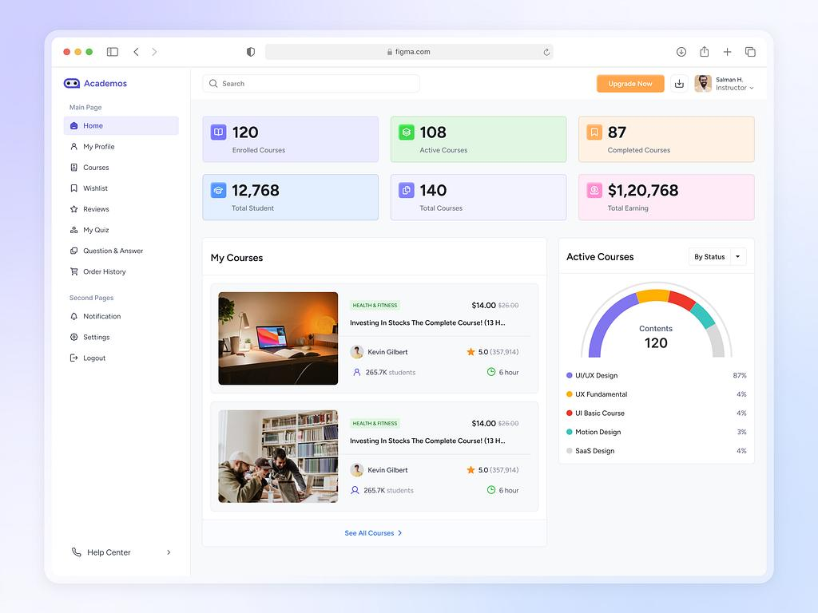
Project 3 — Learning Management System (LMS) API
Intermediate
Features
- Students, instructors, and courses
- Enrollment management
- Lessons and assessments
- Progress tracking
- File or media integration
- Role-based permissions
Skills assessed: data modeling, service architecture, aggregation, and API design.

Project 4 — E-commerce Backend
Intermediate–Advanced
Features
- Products and categories
- Inventory management
- Cart and order processing
- Payment gateway integration
- Verified payment webhooks
- Order history and refunds
- Audit trail and idempotency
Skills assessed: business logic, transaction design, payment safety, and integration reliability.
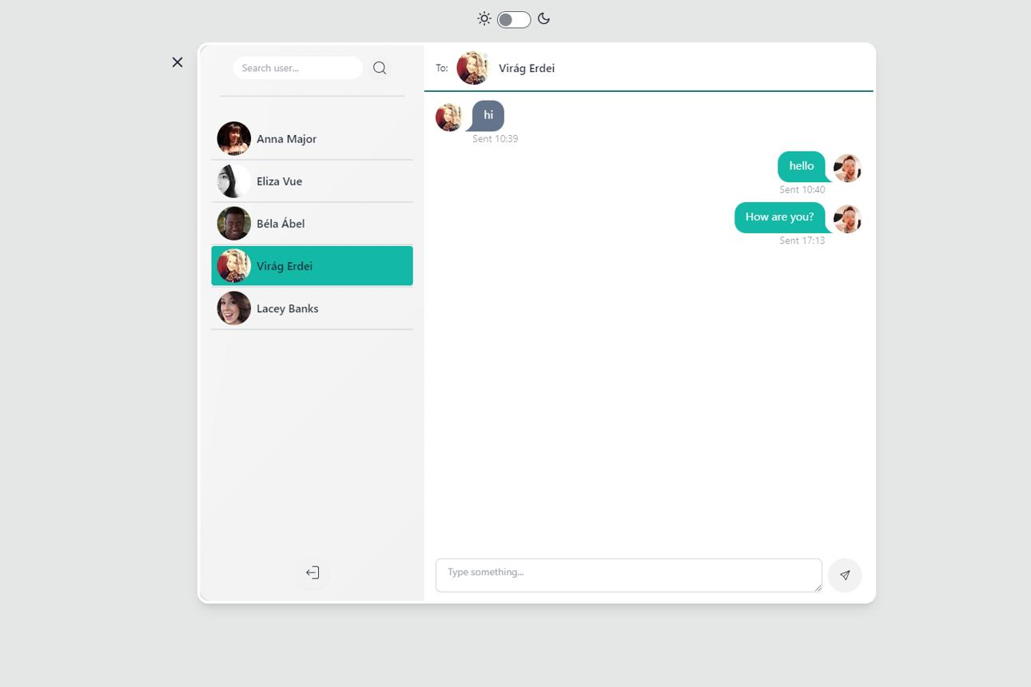
Project 5 — Real-time Chat and Notification API
Advanced
Features
- Socket.IO
- Private conversations and rooms
- Real-time notifications
- User presence
- Message persistence
- Access control and rate limiting
Skills assessed: WebSockets, event-driven programming, and connection management.
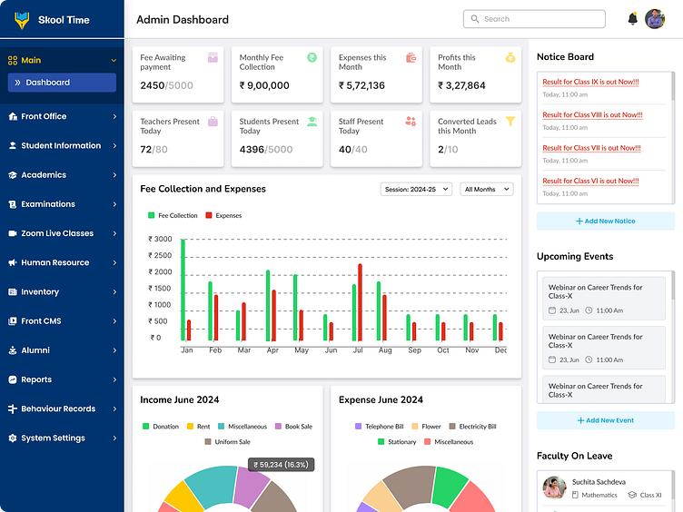
Project 6 — EDVENT Institute Management Backend
Final capstone
Features
- Multiple institutes or branches
- Student and instructor management
- Courses, batches, and enrollment
- Attendance and assessments
- Fees, receipts, and payment reconciliation
- Reports and aggregation pipelines
- Role-based access
- Audit logs
- Background certificate generation
- Automated tests and deployment
Skills assessed: full-stack backend design, database architecture, security, reporting, and production readiness.

Capstone acceptance criteria
Every advanced project should meet these minimum requirements:
- Clear folder structure and separation of concerns
- Input validation on all relevant endpoints
- Appropriate HTTP status codes
- Centralized error handling
- Database indexes justified by query patterns
- Pagination on potentially large list endpoints
- Authentication and authorization where needed
- No committed credentials or production secrets
- Unit and integration tests
- API documentation and example requests
- GitHub README with setup instructions
- Deployed application with environment configuration
- Logging, health checks, and a backup/recovery plan appropriate to the project

Recommended course duration and teaching plan
For EDVENT, I recommend a 24-week structured course, assuming students already know basic JavaScript and can study or practise around 8–12 hours per week. Students starting JavaScript from zero will need additional preparation time.
Weeks 1–2
Backend foundations and Node.js
HTTP, REST, JavaScript for backend, npm, core modules, async programming.
Weeks 3–4
Node.js server development
HTTP module, filesystem, streams, events, error handling, native mini API.
Weeks 5–7
Express.js
Routing, middleware, controllers, services, validation, error handling.
Weeks 8–10
MongoDB and Mongoose
CRUD, schema design, relationships, queries, aggregation, indexes.
Weeks 11–12
REST API engineering
Pagination, search, filtering, documentation, API contracts.
Weeks 13–14
Authentication and security
Passwords, sessions or JWT, permissions, common API vulnerabilities.
Weeks 15–16
Advanced Node.js
Event loop, concurrency, streams, debugging, logging, observability.
Weeks 17–18
Architecture and integrations
Caching, queues, real-time events, payments, webhooks, external services.
Weeks 19–20
Testing and TypeScript
Unit, integration and end-to-end tests; TypeScript fundamentals.
Weeks 21–22
Deployment and DevOps
Production configuration, Docker, CI/CD, monitoring and recovery.
Weeks 23–24
Capstone and assessment
Build, test, document, deploy and demonstrate a complete backend.

Weekly classroom routine
A repeatable structure will help students learn concepts and practise independently.
Session | Focus
Session 1 | Concept explanation and diagrams
Session 2 | Instructor-led coding demonstration
Session 3 | Guided practical exercises
Session 4 | Independent assignment and debugging
Weekly review | Quiz, code review, and mini-project
Allocate roughly 30% of the time to concepts, 50% to hands-on coding, and 20% to assignments, testing, revision, and assessment.

Student mastery tracker
Use this checklist to monitor progress during the course.

Backend course progress
0 of 24 competencies completed

0%
Foundation
JavaScript asynchronous programming
HTTP and REST fundamentals
Node.js environment and npm
Node.js core modules and native HTTP server
Express.js
Routes and request/response handling
Middleware and centralized errors
Controllers, services, and validation
MongoDB
Native CRUD operations
Data modeling and relationships
Indexes and query optimization
Aggregation pipelines
Mongoose schemas and models
API security
Authentication and session/token management
Role and resource-based authorization
Input validation and NoSQL injection prevention
Rate limiting and secure file uploads
Advanced engineering
Testing and API documentation
TypeScript fundamentals
Caching and background jobs
Logging, monitoring, and performance
Production
Deployment and environment configuration
Docker and CI/CD basics
Database backup and recovery
Complete deployed capstone project
Copy checklistReset
Mark a topic complete after you can explain it, implement it independently, and debug a relevant exercise.

Official documentation and learning resources
Start with the official documentation below. It should be the primary reference for lessons, demonstrations, and assignments.

Node.js
Runtime, core modules, HTTP, streams, testing, and command-line usage.
Node.js documentation
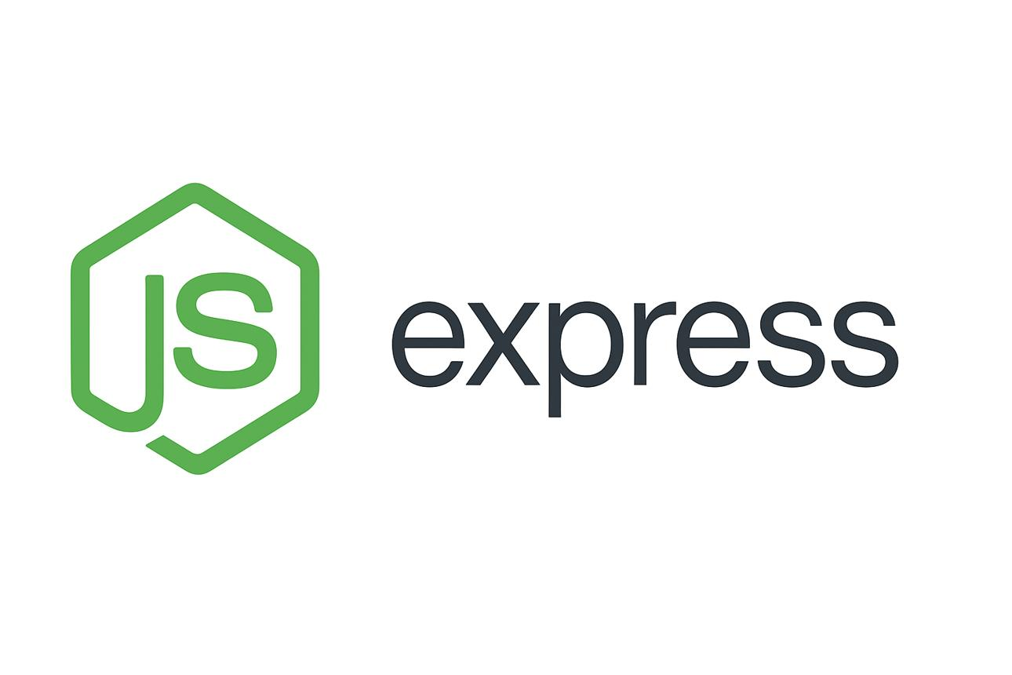
Express.js
Routing, middleware, error handling, and production best practices.
Express documentation
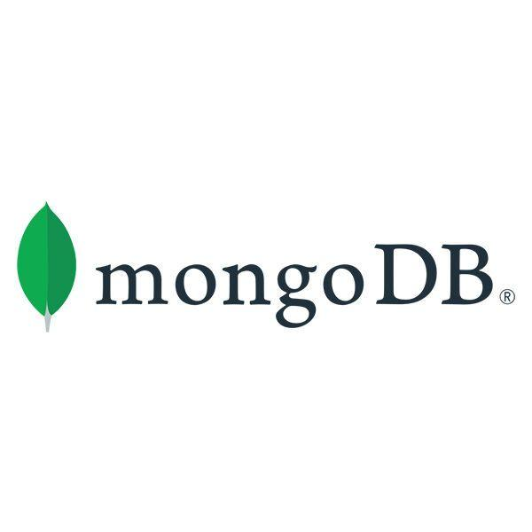
MongoDB
CRUD, aggregation, data modeling, indexes, transactions, and operations.
MongoDB manual
MongoDB University

Mongoose
Schemas, models, validation, population, queries, and transactions.
Mongoose documentation

TypeScript
Type system, strict mode, and application architecture.
TypeScript handbook

OWASP
Web application and API security risks and defensive practices.
OWASP API Security Project
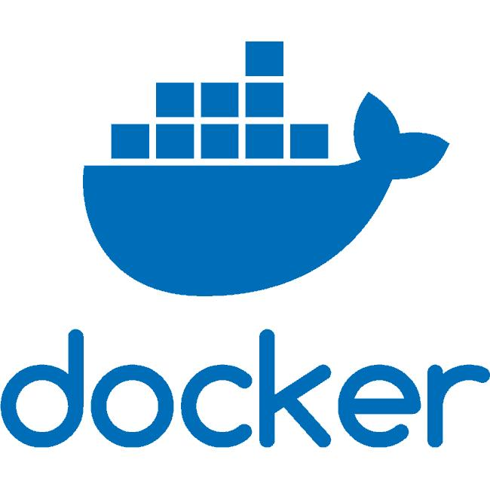
Docker
Containers, Dockerfiles, images, networking, and Compose.
Docker documentation

Final recommendation for EDVENT
Structure this as three teachable milestones, rather than presenting every advanced topic to beginners at once.
- Backend Developer Foundation: Node.js, Express, MongoDB, Mongoose, REST APIs, CRUD, and validation.
- Job-Ready Backend Development: Authentication, authorization, security, testing, TypeScript, Git, deployment, and complete projects.
- Advanced Backend Engineering: Performance, caching, queues, real-time communication, observability, distributed systems, and production architecture.
The most important outcome is independent implementation. A student who has memorized 45 modules but cannot design a data model, debug a failing API, write tests, or deploy a secure application is not yet job-ready. Use the capstone projects and mastery checklist to assess actual skills, not just syllabus completion.

