EDVENT — Complete C Programming Master Syllabus

Beginner to Advanced | Structured Curriculum
This syllabus is designed to take students from zero programming experience to a strong understanding of C programming, memory management, data structures, debugging, and systems-level programming.
C should be taught not just as a language for writing programs, but as a way to understand how computers execute instructions, represent data in memory, manage resources, and interact with the operating system.

1. Course overview

C Programming Language
Procedural programming, algorithms, memory, pointers, data structures, files, and systems programming.
Target audience
Complete beginners
Suggested duration
16–22 weeks
Practice time
8–12 hours/week
Final outcome
Independent C programmer

Recommended development environment
Students should learn to compile and run C programs using both an IDE and the command line.
- Compiler: GCC or Clang
- Editor: VS Code or another suitable code editor
- Debugger: GDB or LLDB
- Build tools: Make, followed by CMake at an advanced level
- Version control: Git and GitHub
- Standards: Start with widely supported C17 features, then introduce relevant C23 additions where the chosen compiler supports them.
Avoid teaching only through an online compiler. Students need to understand compilation, warnings, executable files, debugging, and project organization on their own machines.

2. Complete learning roadmap
Level 0 — Computer and programming fundamentals
Level 1 — C setup and first programs
Level 2 — Variables, data types, and operators
Level 3 — Input, output, and control flow
Level 4 — Functions and modular programming
Level 5 — Arrays and strings
Level 6 — Pointers and memory fundamentals
Level 7 — Structures, unions, enums, and typedef
Level 8 — Dynamic memory management
Level 9 — File handling and preprocessing
Level 10 — Data structures and algorithms
Level 11 — Advanced C and systems concepts
Level 12 — Testing, debugging, build systems, and security
Level 13 — Real-world projects and final assessment

Level 0 — Computer and programming fundamentals

Module 1. Introduction to programming

1.1 What is programming?
- Meaning of programming
- Programs, instructions, and algorithms
- Programming languages and their purposes
- Source code versus machine code
- High-level versus low-level languages
- Compiled versus interpreted execution models
- Procedural, object-oriented, and functional programming concepts
- Where C is used: operating systems, embedded systems, compilers, networking, and performance-sensitive software

1.2 How a computer executes a program
- CPU, memory, storage, and input/output devices
- Instructions and execution
- Bits, bytes, and binary representation
- RAM versus permanent storage
- Source files and executable files
- Compiler, assembler, and linker
- Runtime execution
- Basic process and operating-system concepts

1.3 Problem-solving fundamentals
- Understanding a problem statement
- Identifying inputs and outputs
- Breaking a problem into smaller steps
- Writing pseudocode
- Flowcharts
- Tracing program execution
- Identifying edge cases
- Testing sample inputs manually

1.4 Algorithm fundamentals
- Sequential execution
- Selection
- Iteration
- Input-process-output model
- Correctness
- Efficiency
- Time and space complexity: introductory concepts

Practical exercises
- Write an algorithm to calculate the sum of two numbers.
- Draw a flowchart to determine whether a number is even or odd.
- Write pseudocode to find the largest of three numbers.
- Trace a sequence of arithmetic operations manually.
Learning outcome: Students can convert simple problems into algorithms before writing C code.

Level 1 — Getting started with C

Module 2. Introduction to C

2.1 History and characteristics
- Origins and evolution of C
- C and the UNIX operating system
- Procedural programming
- Portability
- Efficiency
- Standard library
- C compared with C++, Java, and Python
- Common use cases and limitations

2.2 C standards
- ANSI C and ISO C
- C89/C90
- C99
- C11
- C17/C18
- C23 overview
- Standard language features versus compiler extensions
- Why compiler compatibility matters

2.3 Setting up the environment
- Installing GCC or Clang
- Configuring a compiler
- Installing an editor or IDE
- Creating .c source files
- Opening a terminal
- Compiling and running programs
- Understanding the working directory
- Reading compiler output
- Compiler warnings and errors

2.4 The first C program
#include <stdio.h>

int main(void)
{
printf("Hello, World!\n");
return 0;
}
Teach every part:
- #include
- stdio.h
- main()
- Opening and closing braces
- Statements and semicolons
- printf()
- Escape sequences
- Return values
- Program entry point

2.5 Compilation process
- Preprocessing
- Compilation
- Assembly
- Linking
- Executable generation
- Compile-time errors
- Linker errors
- Runtime errors
- Logic errors
Example:
gcc -std=c17 -Wall -Wextra -Wpedantic \
-g main.c -o main
Explain that these options select the language standard, enable useful diagnostics, add debugging information, and specify the output executable.

Practical exercises
- Print your name and course details.
- Display a formatted student introduction.
- Print multiple lines using escape sequences.
- Compile a program from the terminal.
- Intentionally introduce syntax errors and correct them.

Level 2 — C language fundamentals

Module 3. Tokens, keywords, identifiers, and program structure

3.1 C tokens
- Keywords
- Identifiers
- Constants
- String literals
- Operators
- Punctuators
- Comments
- Whitespace and token separation

3.2 Keywords and identifiers
- Reserved keywords
- Naming rules
- Case sensitivity
- Valid and invalid identifiers
- Naming conventions
- Scope-related naming considerations
- Avoiding confusing names

3.3 Comments and code formatting
- Single-line comments: //
- Multiline comments: /* ... */
- Meaningful comments
- Avoiding redundant comments
- Indentation
- Brace placement
- Readable code
- Consistent formatting

3.4 Constants and literals
- Integer literals
- Floating-point literals
- Character constants
- String literals
- Escape sequences
- Integer suffixes such as U, L, and LL
- Hexadecimal and octal literals
- Symbolic constants using #define
- Read-only objects using const

Practical assignment
Write a program that displays a formatted student profile using integer, floating-point, character, and string values.

Module 4. Variables and data types

4.1 Variables
- Declaration
- Definition
- Initialization
- Assignment
- Updating values
- Scope and lifetime introduction
- Uninitialized variables
- Local versus global variables
- Naming conventions

4.2 Fundamental data types
- char
- int
- float
- double
- _Bool and bool through stdbool.h
- void
- Signed and unsigned integer types

4.3 Integer type variations
- short
- int
- long
- long long
- signed
- unsigned
- Type ranges and implementation dependence
- Integer overflow considerations
- Using <limits.h> to inspect limits
- Using sizeof to inspect object sizes

4.4 Floating-point types
- float
- double
- long double
- Precision and rounding
- Floating-point representation
- Scientific notation
- Floating-point comparison pitfalls
- NaN and infinity concepts
- Using <float.h>

4.5 Type qualifiers and modifiers
- const
- volatile
- restrict
- signed and unsigned
- Basic meaning of type qualifiers
- Why volatile does not provide thread synchronization
- Why const does not automatically make all referenced data immutable

4.6 Type conversion
- Implicit conversions
- Explicit casts
- Integer promotions
- Usual arithmetic conversions
- Narrowing conversions
- Signed versus unsigned comparisons
- Integer division
- Floating-point division
- Conversion warnings

Practical exercises
- Convert Celsius to Fahrenheit.
- Calculate simple interest.
- Calculate a student's average marks.
- Explore sizeof across data types.
- Demonstrate integer division versus floating-point division.

Module 5. Operators and expressions

5.1 Arithmetic operators
- +, -, *, /, %
- Integer division
- Remainder operator
- Unary plus and minus
- Increment and decrement
- Overflow and undefined behavior

5.2 Relational operators
- ==
- !=
- <
- >
- <=
- >=
- Boolean results
- Common comparison mistakes

5.3 Logical operators
- &&
- ||
- !
- Truth tables
- Short-circuit evaluation
- Combining conditions

5.4 Assignment operators
- =
- +=
- -=
- *=
- /=
- %=
- Compound assignment behavior

5.5 Bitwise operators
- &
- |
- ^
- ~
- <<
- >>
- Bit masks
- Setting, clearing, toggling, and testing bits
- Shift-width and signed-shift hazards
- Bitwise versus logical operations

5.6 Conditional and other operators
- Ternary operator ?:
- sizeof
- Comma operator
- Address-of operator &
- Dereference operator *
- Member access . and ->
- Subscript operator []
- Cast operator
- Operator precedence
- Associativity
- Parentheses for clarity

Practical exercises
- Build a calculator.
- Check divisibility.
- Swap two values using a temporary variable.
- Determine whether a bit is set.
- Build a simple permission-flag system using bit masks.

Module 6. Input and output

6.1 Standard I/O
- Standard input, output, and error
- stdin, stdout, and stderr
- Formatted versus unformatted input/output
- Output buffering basics
- Newline handling

6.2 Output using printf()
- %d and %i
- %u
- %ld and %lld
- %f
- %lf in relevant formatted input contexts
- %c
- %s
- %x and %X
- %o
- %p
- Width and precision
- Alignment
- Escape sequences
- Correct format specifiers
- <inttypes.h> macros for portable fixed-width integer formatting

6.3 Input using scanf()
- Reading integers
- Reading floating-point numbers
- Reading characters
- Reading words
- Format strings
- Address-of operator
- Checking the return value
- Whitespace in format strings
- Buffer-size limitations
- Why scanf("%s", ...) needs a width limit

6.4 Safer input techniques
- Reading a line with fgets()
- Removing the trailing newline
- Parsing numbers with strtol(), strtoul(), and strtod()
- Validating input
- Detecting invalid input
- Handling long input lines
- Dealing with leftover input
- Why gets() must never be used

Practical assignment
Create a menu-driven calculator that validates input, handles invalid entries, and supports repeated calculations.

Level 3 — Decision-making and loops

Module 7. Conditional statements

7.1 if statements
- Simple if
- if-else
- else if
- Nested conditions
- Multiple conditions
- Logical operators in conditions

7.2 switch statement
- case labels
- default
- break
- Fall-through behavior
- Multiple case labels
- Integer and enumeration-based switches
- Differences between switch and if-else

7.3 Nested and compound logic
- Validating ranges
- Combining multiple criteria
- Boundary conditions
- Truth tables
- Simplifying complex conditions
- Avoiding accidental assignment in conditions

Practical exercises
- Check positive, negative, or zero.
- Find the largest of three numbers.
- Check leap years.
- Calculate grades from marks.
- Build a menu-based unit converter.

Module 8. Loops and iteration

8.1 while loop
- Entry-controlled loops
- Loop conditions
- Counters
- Accumulators
- Infinite-loop causes
- Input-controlled loops

8.2 do-while loop
- Exit-controlled loops
- Menu-driven applications
- Differences from while

8.3 for loop
- Initialization
- Condition
- Update expression
- Multiple expressions
- Nested loops
- Omitting loop components
- Scope of loop variables

8.4 Loop-control statements
- break
- continue
- Nested-loop behavior
- Avoiding unnecessary control-flow jumps

8.5 Common loop patterns
- Counting
- Summation
- Product accumulation
- Searching
- Minimum and maximum
- Digit extraction
- Reversing a number
- Sentinel-controlled loops
- Input validation loops
- Nested iteration

Practical exercises
- Print multiplication tables.
- Calculate factorials.
- Check prime numbers.
- Reverse an integer.
- Calculate the sum of digits.
- Generate numeric patterns.
- Build a number-guessing game.

Module 9. Problem-solving with C

9.1 Algorithm design
- Stepwise refinement
- Decomposition into functions
- Flowchart interpretation
- Pseudocode
- Boundary cases
- Input constraints
- Correctness reasoning

9.2 Common problem-solving patterns
- Counter and accumulator
- Running minimum and maximum
- Flag variables
- Sentinel values
- Frequency counting
- Linear search
- Digit-based algorithms
- Nested-loop patterns
- Basic simulation

9.3 Introductory complexity
- What time complexity means
- What space complexity means
- Constant, linear, and quadratic growth
- Big-O notation
- Comparing simple algorithms
- Why correctness comes before optimization

Practical assignment
Solve a set of 20 problems progressing from simple conditions to nested loops, documenting the algorithm and test cases for each.

Level 4 — Functions and modular programming

Module 10. Functions

10.1 Function fundamentals
- Purpose of functions
- Function declaration and prototype
- Function definition
- Function call
- Return type
- Parameters and arguments
- Returning values
- void functions
- Function naming
- Reusability and decomposition

10.2 Function parameters
- Passing values
- Passing pointers
- Input parameters versus output parameters
- Multiple parameters
- Return values
- Why C uses pass-by-value
- Modifying caller-owned objects through pointers
- Array parameters
- Pointer parameters

10.3 Scope and lifetime
- Block scope
- File scope
- Function scope for labels
- Function prototype scope
- Local variables
- Global variables
- Shadowing
- Automatic storage duration
- Static storage duration
- External linkage
- Internal linkage
- Scope versus lifetime versus linkage

10.4 Storage-class specifiers
- auto
- register as a historical and modern-language concept
- static
- extern
- Block-scope versus file-scope static
- Static local variables
- External declarations
- Multi-file program organization

10.5 Advanced function concepts
- Recursion
- Base cases
- Recursive calls
- Call stack
- Recursion versus iteration
- Tail recursion concept
- Function pointers introduction
- Callback functions
- Variadic functions
- stdarg.h
- Limitations and risks of recursive algorithms

10.6 Header files and modular code
- Function declarations in headers
- Definitions in source files
- Header guards
- #pragma once as a widely supported extension rather than a C-standard feature
- Avoiding multiple definitions
- Separate compilation
- Linking multiple object files
- Public versus private interfaces
- Organizing small projects into modules

Practical exercises
- Create reusable functions for arithmetic operations.
- Write a recursive factorial function.
- Implement a function that swaps two values using pointers.
- Separate a calculator into header and source files.

Module 11. Recursion and mathematical problem solving

11.1 Recursion fundamentals
- Base condition
- Recursive step
- Call stack
- Stack frames
- Recursive tracing
- Multiple recursive calls
- Termination
- Stack overflow risks

11.2 Recursive algorithms
- Factorial
- Fibonacci sequence
- Greatest common divisor
- Sum of digits
- Binary search
- Recursive array processing
- Tower of Hanoi
- Tree traversal introduction

11.3 Recursion analysis
- Recurrence relations at an introductory level
- Time complexity
- Space complexity
- Comparing recursion with iteration
- Repeated computation
- Memoization concept
- Choosing the clearest and safest approach

Practical assignment
Implement factorial, Fibonacci, GCD, and binary search using both recursive and iterative approaches, then compare their behavior.

Level 5 — Arrays, strings, and multidimensional data

Module 12. One-dimensional arrays

12.1 Array fundamentals
- What arrays are
- Array declaration
- Initialization
- Indexing
- Zero-based indexing
- Array bounds
- Reading and writing elements
- Array size
- Fixed-size arrays
- Array traversal
- Array copying
- Common out-of-bounds errors

12.2 Array operations
- Sum and average
- Minimum and maximum
- Linear search
- Reversing an array
- Rotating an array
- Inserting and deleting elements in a logical array
- Counting occurrences
- Removing duplicates from a sorted array
- Merging arrays
- Comparing arrays element by element

12.3 Sorting algorithms
- Bubble sort
- Selection sort
- Insertion sort
- Sorting in ascending and descending order
- Stable versus unstable sorting
- Time complexity comparison
- Best, average, and worst cases
- Why simple sorting algorithms are educational but not always suitable for production

12.4 Searching algorithms
- Linear search
- Binary search
- Preconditions for binary search
- Iterative versus recursive binary search
- Time complexity
- Search failure handling

Practical assignment
Build a marks-analysis program that calculates average marks, finds the highest and lowest marks, searches for a score, and sorts the results.

Module 13. Multidimensional arrays

13.1 Two-dimensional arrays
- Row and column representation
- Declaration and initialization
- Nested loops
- Accessing elements
- Matrix input and output
- Memory layout
- Row-major storage

13.2 Matrix operations
- Matrix addition
- Matrix subtraction
- Matrix multiplication
- Transpose
- Diagonal elements
- Row and column sums
- Identity matrix
- Symmetric matrix
- Searching within a matrix

13.3 Higher-dimensional arrays
- Three-dimensional arrays
- Multidimensional initialization
- Passing multidimensional arrays to functions
- Specifying dimensions in function parameters
- Limitations of fixed dimensions
- Relationship between arrays and pointers

Practical assignment
Create a matrix calculator with addition, multiplication, transpose, and diagonal analysis.

Module 14. Character arrays and strings

14.1 Strings in C
- Character arrays
- Null terminator '\0'
- String literals
- String storage
- Array size versus string length
- String initialization
- Character-by-character processing
- Mutable character arrays versus string literals
- Avoiding writes to string literals

14.2 Standard string functions
Teach functions from <string.h>:
- strlen()
- strcmp()
- strncmp()
- strcpy()
- strncpy() and its limitations
- strcat()
- strncat()
- strchr()
- strrchr()
- strstr()
- strtok() and its limitations
Emphasize buffer sizes, null termination, and the fact that some commonly used string functions do not automatically make an operation safe.

14.3 String input
- fgets()
- Reading a line with spaces
- Removing a newline
- Input-buffer handling
- Length validation
- Parsing tokens
- Handling empty strings
- Handling long input
- Avoiding buffer overflows

14.4 String algorithms
- Reverse a string
- Palindrome checking
- Count vowels and consonants
- Count words
- Count characters
- Find a substring
- Compare strings
- Convert case for basic ASCII input
- Remove spaces
- Remove duplicate characters
- Frequency table for characters

14.5 Character classification and conversion
Using <ctype.h>:
- isalpha()
- isdigit()
- isalnum()
- isspace()
- islower()
- isupper()
- tolower()
- toupper()
Teach that the argument to these functions must be EOF or a value representable as unsigned char. Also explain that these functions are not a complete solution for Unicode text processing.

Practical assignment
Build a text analyzer that counts words, lines, characters, vowels, digits, whitespace, and word frequencies for supported input.

Level 6 — Pointers and memory fundamentals

Module 15. Introduction to pointers
Pointers are a central topic in C. Give students substantial time for diagrams, memory tracing, and hands-on debugging.

15.1 Pointer fundamentals
- What a pointer is
- Memory addresses
- Declaring pointer variables
- Address-of operator &
- Dereference operator *
- Reading and writing through pointers
- Pointer initialization
- Null pointers
- Pointer types
- Pointer size versus pointed-to object size
- Why pointer types matter

15.2 Pointer operations
- Assigning addresses
- Dereferencing
- Pointer comparison
- Pointer arithmetic
- Incrementing and decrementing pointers
- Pointer differences within the same array
- Pointer arithmetic constraints
- One-past-the-end pointer concept
- Why dereferencing invalid pointers causes undefined behavior

15.3 Pointers and functions
- Passing an address to a function
- Modifying caller-owned variables
- Output parameters
- Swapping two values
- Passing large objects by pointer
- const pointers and pointers to const
- Read-only access through pointers
- Pointer ownership concepts

15.4 Pointer declaration patterns
- Pointer to an integer
- Pointer to a character
- Pointer to an array
- Array of pointers
- Pointer to pointer
- Function pointer
- void *
- const int *
- int *const
- const int *const

Practical exercises
- Swap values using pointers.
- Traverse an array using pointer arithmetic.
- Find the maximum array element using a pointer parameter.
- Draw memory diagrams for each exercise.

Module 16. Arrays and pointers

16.1 Relationship between arrays and pointers
- Array expressions and pointer conversion
- Array indexing equivalence
- Array name versus pointer variable
- sizeof(array) versus sizeof(pointer)
- Passing arrays to functions
- Why array parameters are adjusted to pointer parameters
- Losing array-length information at function boundaries
- Passing array length explicitly

16.2 Pointer arithmetic
- Moving through arrays
- Increment and decrement
- Pointer subtraction
- Pointer comparisons within valid bounds
- One-past-the-end pointer
- Why pointer arithmetic outside the same array object is unsafe
- Avoiding out-of-bounds access

16.3 Multidimensional arrays and pointers
- Pointer to an array
- Array of pointers
- Differences in memory layout
- Function parameters for multidimensional arrays
- Variable Length Arrays (VLAs) where supported
- C standard differences affecting VLA availability
- When to use dynamically allocated row structures instead

16.4 Pointer safety
- Null pointers
- Uninitialized pointers
- Dangling pointers
- Use-after-free
- Out-of-bounds pointers
- Double-free errors
- Invalid pointer arithmetic
- Ownership and lifetime
- Avoiding returning pointers to expired automatic local objects

Practical assignment
Implement array utilities using pointer parameters, then use a debugger and memory diagrams to trace each pointer operation.

Level 7 — Structures, unions, enumerations, and custom data types

Module 17. Structures (struct)

17.1 Structure fundamentals
- Why structures are needed
- Declaring a structure type
- Defining structure variables
- Initializing structures
- Accessing members using .
- Assigning structures
- Structure size and padding introduction
- Nested structures
- Arrays of structures

17.2 Structures with functions
- Passing structures by value
- Passing pointers to structures
- Returning structures
- Modifying members through pointers
- const structure pointers
- Pointer-to-structure operator ->
- Avoiding unnecessary copying of large structures

17.3 Advanced structure topics
- Self-referential structures
- Structure padding and alignment
- Bit-fields
- Flexible array members
- Designated initializers
- Compound literals
- Structure compatibility and initialization rules
- Portability concerns with binary structure layouts

Practical assignment
Create a student records program containing roll number, name, course, and marks. Add functions to insert, display, search, and update records.

Module 18. Unions and enumerations

18.1 Unions
- What a union is
- Union declaration and initialization
- Shared storage among members
- Union size and alignment
- Accessing members
- Valid interpretation of the stored member
- Tagged unions
- Unions versus structures
- Use cases and limitations

18.2 Enumerations
- Declaring an enum
- Enumerator constants
- Explicit enum values
- Default enumerator values
- Using enums in functions and structures
- Enums for states and categories
- switch with enumerations
- Type and representation considerations

18.3 typedef
- Creating type aliases
- Aliases for structures
- Aliases for enums
- Aliases for pointers
- Readability benefits
- Potential confusion with pointer declarations
- Naming conventions for custom types

Practical assignment
Design an order-management program using enumerated order states and a tagged union for different types of payment details.

Module 19. Function pointers and callbacks

19.1 Function pointers
- Declaring a function pointer
- Assigning a function address
- Calling a function through a pointer
- Matching function signatures
- Passing function pointers to functions
- Arrays of function pointers

19.2 Callback patterns
- Callback functions
- Passing behavior as an argument
- Sorting with qsort()
- Generic comparison functions
- Menu dispatch tables
- Event-handler concepts
- Function-pointer interfaces

19.3 Practical applications
- Build a calculator using function pointers.
- Implement a menu dispatch table.
- Sort structures with qsort().
- Create a generic processing function that accepts a callback.

Level 8 — Dynamic memory management

Module 20. Memory layout and storage duration

20.1 Memory concepts
- Program code and static data
- Automatic storage duration
- Static storage duration
- Allocated storage duration
- Thread storage duration introduction
- Stack and heap as common implementation concepts
- Scope versus lifetime
- Linkage versus storage duration
- Object representation and alignment

20.2 Understanding memory diagrams
- Variables and their addresses
- Arrays in memory
- Pointers and pointed-to objects
- Structure layout
- Dynamic allocation
- Function call frames conceptually
- Stack growth as an implementation detail rather than a universal guarantee
- Identifying invalid memory access

Module 21. Dynamic memory allocation

21.1 Standard allocation functions
From <stdlib.h>:
- malloc()
- calloc()
- realloc()
- free()

21.2 malloc()
- Allocating memory
- Return value
- Casting considerations in C
- Allocation failure
- Initializing allocated memory
- Tracking allocated size
- Releasing memory

21.3 calloc()
- Allocating arrays of objects
- Zero-initialized bytes
- Allocation-size overflow considerations
- Differences from malloc()

21.4 realloc()
- Resizing an allocation
- Preserving existing contents within the permitted range
- Handling allocation failure safely
- Why a temporary pointer is important
- Zero-size behavior and portability considerations
- Avoiding use of stale pointers after successful reallocation

21.5 free()
- Releasing memory
- Avoiding memory leaks
- Avoiding double-free
- Avoiding use-after-free
- Nulling pointers as a local defensive technique
- Understanding that setting one pointer to NULL does not invalidate other aliases
- Ownership rules

21.6 Dynamic arrays
- Allocating arrays at runtime
- Tracking capacity and length
- Growing arrays
- Shrinking arrays
- Inserting and deleting elements
- Capacity management
- Handling allocation failure
- Cleanup paths

Practical assignment
Create a dynamic student list that grows when new students are added and frees all allocated memory before exit.

Module 22. Advanced memory management

22.1 Common memory errors
- Memory leaks
- Buffer overflows
- Out-of-bounds access
- Use-after-free
- Double-free
- Uninitialized memory
- Dangling pointers
- Invalid pointer arithmetic
- Integer overflow during allocation-size calculations

22.2 Memory-management strategies
- Clear ownership rules
- Single-owner design
- Borrowed pointers
- Allocation and cleanup responsibilities
- Error-path cleanup
- Resource acquisition and release patterns
- Centralized cleanup labels where appropriate
- Avoiding hidden ownership transfers

22.3 Memory debugging
- AddressSanitizer
- UndefinedBehaviorSanitizer
- Leak detection where supported
- Valgrind where available
- Compiler diagnostics
- Debugger inspection
- Reproducing crashes
- Reading stack traces
- Distinguishing symptoms from root causes

22.4 Practical assignment
Intentionally introduce a leak, an out-of-bounds access, and a use-after-free in separate test programs. Detect and correct each with appropriate tools.

Level 9 — File handling and data persistence

Module 23. File I/O fundamentals

23.1 File concepts
- Why files are needed
- Text versus binary files
- File paths
- Relative versus absolute paths
- File permissions
- File streams
- End-of-file concepts
- Error handling

23.2 Opening and closing files
From <stdio.h>:
- fopen()
- fclose()
- FILE *
- File opening modes: r, w, a
- Update modes: r+, w+, a+
- Binary mode indicators such as rb and wb
- Truncation behavior
- Checking whether a file opened successfully

23.3 Reading and writing text
- fgetc()
- fputc()
- fgets()
- fputs()
- fprintf()
- fscanf()
- Reading lines
- Writing formatted records
- Handling whitespace
- Detecting malformed input
- Checking read and write errors

23.4 File positioning
- fseek()
- ftell()
- rewind()
- Stream position
- Sequential versus random access
- Restrictions on text-stream positioning
- Binary-file positioning considerations

23.5 Binary file operations
- fread()
- fwrite()
- Reading and writing arrays
- Binary record storage
- Portability of binary data
- Structure padding
- Endianness
- Why writing a raw structure is not a portable file format by itself
- Handling incomplete reads and writes

23.6 File error handling
- feof()
- ferror()
- perror()
- clearerr()
- Checking return values
- Detecting disk-full and permission failures
- Flushing buffered output
- Avoiding incorrect end-of-file loops

Practical assignment
Build a student record system that stores, retrieves, searches, updates, and deletes records in a file.

Module 24. File systems and practical data formats

24.1 Directory and path concepts
- Working directory
- Path handling
- File metadata concepts
- Directory traversal
- Platform differences
- File permissions and access errors
- Portable versus platform-specific operations

24.2 CSV and structured text
- CSV structure
- Delimiters and quoting
- Escaped fields
- Reading CSV records
- Writing CSV output
- Handling commas and newlines inside fields
- Parsing limitations of simplistic CSV implementations

24.3 Data serialization
- Serialization versus binary memory layout
- Text-based formats
- JSON concepts
- External JSON libraries
- Schema and versioning
- Input validation
- Avoiding unsafe assumptions about file content

Practical assignment
Import student marks from a CSV file, validate the data, calculate summaries, and export a report.

Level 10 — Preprocessor, headers, and multi-file projects

Module 25. C preprocessor

25.1 Preprocessor fundamentals
- What preprocessing does
- #include
- #define
- #undef
- #if
- #ifdef
- #ifndef
- #elif
- #else
- #endif
- #error
- #line
- #pragma
- Predefined macros such as __FILE__, __LINE__, and __DATE__
- Conditional compilation
- Compiler-specific extensions

25.2 Macros
- Object-like macros
- Function-like macros
- Macro parameters
- Parenthesizing macro arguments
- Operator precedence hazards
- Side effects in macro arguments
- Stringification using #
- Token pasting using ##
- Variadic macros
- When an inline function is safer than a macro

25.3 Header files
- System headers
- User-defined headers
- Header guards
- Declaration versus definition
- Avoiding duplicate definitions
- Include dependencies
- Self-contained headers
- Forward declarations
- Public APIs
- Internal implementation details

25.4 Conditional compilation
- Platform-specific code
- Compiler-specific features
- Debug versus release configuration
- Feature flags
- Portable fallback implementations
- Detecting supported compiler features

Practical assignment
Create a small math library with a header, implementation file, tests, and conditional debug logging.

Module 26. Separate compilation and linking

26.1 Multi-file C projects
- Multiple .c files
- Header declarations
- Object files
- Compilation units
- Linking
- External symbols
- Undefined references
- Duplicate symbol errors
- Declaration-definition consistency

26.2 Linkage
- External linkage
- Internal linkage
- No linkage
- File-scope static
- extern declarations
- Global variable management
- Avoiding unnecessary global state
- Symbol visibility concepts

26.3 Build process
- Compile source files separately
- Link object files
- Compiler and linker options
- Include search paths
- Library search paths
- Static libraries
- Shared libraries
- Debug and release builds

Practical assignment
Build a modular calculator using separate files for arithmetic operations, input validation, and the program entry point.

Level 11 — Data structures and algorithms in C
This level connects C fundamentals to interview preparation and real software development. Students should understand each data structure's operations, memory requirements, and complexity.

Module 27. Algorithm analysis

27.1 Complexity
- Time complexity
- Space complexity
- Big-O notation
- Best, average, and worst cases
- Constant, logarithmic, linear, linearithmic, quadratic, and exponential growth
- Input size
- Auxiliary space
- Trade-offs between time and memory

27.2 Algorithm design techniques
- Brute force
- Divide and conquer
- Greedy algorithms
- Recursion
- Backtracking
- Dynamic programming introduction
- Choosing suitable data structures
- Testing correctness and edge cases

Module 28. Searching and sorting algorithms

28.1 Searching
- Linear search
- Binary search
- Recursive binary search
- Searching in sorted arrays
- Search complexity
- Duplicate values
- Lower-bound and upper-bound concepts

28.2 Sorting
- Bubble sort
- Selection sort
- Insertion sort
- Merge sort
- Quicksort
- Heap sort
- Counting sort overview
- Stability
- In-place versus out-of-place algorithms
- Average and worst-case complexity
- qsort() from the standard library
- Writing safe comparison functions

Practical assignment
Implement and benchmark at least four sorting algorithms using the same datasets.

Module 29. Linked lists

29.1 Singly linked lists
- Node structure
- Data and next pointer
- Creating nodes dynamically
- Traversal
- Insertion at the beginning
- Insertion at the end
- Insertion at a position
- Deletion
- Searching
- Counting nodes
- Reversing a list
- Freeing the complete list

29.2 Doubly linked lists
- Previous and next pointers
- Forward and backward traversal
- Insertion and deletion
- Head and tail management
- Memory cleanup

29.3 Circular linked lists
- Circular singly linked lists
- Circular doubly linked lists
- Traversal termination
- Common pointer mistakes
- Use cases and trade-offs

Practical assignment
Create a contact list using a linked list, with add, search, update, delete, display, and cleanup operations.

Module 30. Stacks and queues

30.1 Stacks
- LIFO principle
- Push and pop
- Peek
- Overflow and underflow
- Array-based stack
- Linked-list-based stack
- Stack applications
- Expression evaluation concepts
- Balanced parentheses checking

30.2 Queues
- FIFO principle
- Enqueue and dequeue
- Front and rear
- Circular queue
- Array-based queue
- Linked-list queue
- Queue capacity
- Overflow and underflow
- Priority queue concept
- Deque concept

30.3 Applications
- Undo operations
- Expression parsing
- Task scheduling
- Buffering
- Breadth-first traversal
- Basic job queues

Practical assignment
Build a browser-history-style stack simulator and a ticket queue system.

Module 31. Trees and binary search trees

31.1 Tree fundamentals
- Root, parent, child, leaf, and subtree
- Height and depth
- Binary trees
- Node representation
- Recursive structure
- Tree memory management

31.2 Binary search trees
- Insertion
- Searching
- Minimum and maximum
- Deletion
- Duplicate-key policy
- Tree traversal
- In-order traversal
- Pre-order traversal
- Post-order traversal
- Level-order traversal concepts
- Average versus worst-case behavior

31.3 Advanced tree concepts
- Balanced-tree concepts
- AVL tree overview
- Red-black tree overview
- Heaps
- Tries
- B-trees as a conceptual topic
- When a tree is more suitable than an array or linked list

Practical assignment
Build a binary search tree for storing and searching student roll numbers, with insertion, traversal, search, deletion, and cleanup.

Module 32. Hash tables and graphs

32.1 Hash tables
- Hash functions
- Hash collisions
- Separate chaining
- Open addressing
- Linear probing
- Load factor
- Resizing
- Hash-table performance
- Key equality and hash consistency
- String-key handling
- Memory cleanup

32.2 Graph fundamentals
- Vertices and edges
- Directed and undirected graphs
- Weighted graphs
- Adjacency matrix
- Adjacency list
- Graph traversal
- Breadth-first search
- Depth-first search
- Cycle detection concepts
- Shortest-path concepts
- Graph representation trade-offs

Practical assignment
Implement a small dictionary or student lookup table using a hash table, then build a graph representing routes between locations.

Level 12 — Advanced C programming

Module 33. Advanced pointers and type system

33.1 Pointer combinations
- Pointer to pointer
- Arrays of pointers
- Pointers to arrays
- Function pointers
- Pointer to structure
- void * and generic interfaces
- const placement and pointer qualification
- Qualified pointer types
- Pointer conversions
- Null pointer constants
- Object pointers versus function pointers
- Why not every pointer conversion is valid

33.2 Declarators and complex types
- Reading complex declarations
- Pointer to function
- Function returning a pointer
- Array of pointers to functions
- Typedef for complex types
- Abstract declarators
- Type compatibility
- Function prototypes
- Variadic functions and their limitations

33.3 Object representation
- sizeof
- _Alignof in supported C standards
- Alignment requirements
- Padding
- Structure layout
- Object representations
- memcpy() for object representations
- Strict aliasing concepts
- Effective type
- Why type-punning through incompatible pointer types can be undefined behavior
- Endianness
- Portable versus implementation-specific code

Module 34. Advanced language features and standard library

34.1 Advanced C features
- Compound literals
- Designated initializers
- Flexible array members
- _Static_assert
- _Generic in C11 and later
- _Atomic concepts
- _Thread_local
- _Alignas and _Alignof
- Complex-number types
- Variable Length Arrays where supported
- C23 additions overview
- Compiler extensions versus standard features

34.2 Standard library mastery
Teach practical use of these headers:
Header | Important topics
<stdio.h> | Standard and file I/O
<stdlib.h> | Allocation, conversions, sorting, searching, process utilities
<string.h> | Memory and string operations
<ctype.h> | Character classification and conversion
<math.h> | Mathematical functions
<time.h> | Time representation and conversion
<limits.h> | Integer limits
<float.h> | Floating-point characteristics
<stdint.h> | Fixed-width and related integer types
<inttypes.h> | Portable integer format macros
<stdbool.h> | Boolean convenience macros in applicable standards
<stddef.h> | size_t, ptrdiff_t, offsetof, and related definitions
<errno.h> | Error-reporting conventions
<assert.h> | Assertions
<signal.h> | Signal handling
<setjmp.h> | Non-local jumps
<stdarg.h> | Variadic functions
<locale.h> | Locale handling
<wchar.h> and <wctype.h> | Wide-character facilities
<complex.h> | Complex arithmetic
<fenv.h> | Floating-point environment
<stdatomic.h> | Atomic operations in supported implementations
<threads.h> | C11 threads where implemented
Students should understand the purpose, common functions, failure modes, and portability concerns for each relevant header. They do not need to memorize every library function.

Module 35. Error handling and defensive programming

35.1 Error-handling patterns
- Return codes
- Error values and sentinel values
- errno
- perror()
- strerror()
- Assertions
- Precondition and postcondition concepts
- Error propagation
- Cleanup on failure
- Designing clear API contracts

35.2 Defensive programming
- Validate input
- Check every relevant return value
- Validate array bounds
- Check allocation-size arithmetic
- Avoid uninitialized data
- Handle file errors
- Avoid assumptions about user input
- Avoid silent data truncation
- Document ownership and lifetime
- Fail safely

35.3 Error-handling architecture
- Centralized cleanup
- Resource ownership
- Consistent return conventions
- Error messages for users versus diagnostics for developers
- Avoiding undefined behavior during error handling
- Testing failure paths

Module 36. Undefined behavior and implementation-defined behavior
This module is essential for advanced C. A program that appears to work on one compiler is not necessarily correct or portable.

36.1 Undefined behavior
- Signed integer overflow
- Out-of-bounds access
- Invalid pointer dereference
- Use-after-free
- Uninitialized automatic values
- Invalid shifts
- Violating alignment requirements
- Data races in multithreaded code
- Modifying string literals
- Invalid format specifiers
- Some forms of incompatible-pointer access

36.2 Related concepts
- Unspecified behavior
- Implementation-defined behavior
- Unspecified evaluation order
- Sequence-point history and modern sequencing rules
- Compiler optimization assumptions
- Why undefined behavior is not simply a runtime error

36.3 Practical exercises
- Compile small examples with different optimization levels.
- Enable compiler warnings.
- Use sanitizers to detect common errors.
- Compare correct and incorrect versions of pointer arithmetic.
- Explain why a program that works in one run may still be invalid.

Level 13 — Systems programming and platform concepts

Module 37. Operating-system interfaces
The exact content depends on the target platform. Teach portable C first, then introduce operating-system-specific APIs.

37.1 Process and system concepts
- Processes and threads
- System calls versus library functions
- Environment variables
- Command-line arguments
- Exit codes
- Standard input/output/error
- Signals
- Resource handles
- Process termination
- Platform-specific behavior

37.2 POSIX concepts
For students using Linux or macOS:
- File descriptors
- open(), read(), write(), and close()
- Permissions
- stat() and file metadata
- Directories
- Pipes
- Process creation using fork() where available
- Program execution with exec family functions
- Process waiting
- Signals
- Basic inter-process communication
- POSIX threads (pthreads)
These are POSIX interfaces, not part of ISO C itself.

37.3 Windows-specific concepts
For students targeting Windows:
- Windows API overview
- File handles
- Process and thread concepts
- System error reporting
- Console input/output
- Windows-specific build and debugging tools
- Differences between Windows and POSIX APIs

Module 38. Multithreading and concurrency

38.1 Threading fundamentals
- What a thread is
- Concurrency versus parallelism
- Shared versus thread-local state
- Race conditions
- Data races
- Critical sections
- Deadlocks
- Starvation
- Synchronization concepts

38.2 C11 threads and atomics
Where the implementation supports them:
- <threads.h>
- Thread creation and joining
- Mutexes
- Condition variables
- Thread-local storage
- <stdatomic.h>
- Atomic variables
- Memory-order concepts
- Synchronization and happens-before relationships
- Avoiding data races

38.3 Practical exercises
- Run a multithreaded counter.
- Demonstrate a race condition.
- Correct the problem with synchronization.
- Implement a producer-consumer pattern.
- Compare single-threaded and multithreaded results.

38.4 Important limitations
C11 thread support is not uniformly available in every toolchain. POSIX threads and Windows threading APIs are platform-specific alternatives. Teach the concurrency concepts independently of a particular API.

Module 39. Embedded and low-level C concepts

39.1 Embedded programming fundamentals
- Microcontrollers
- Memory-mapped I/O
- Registers
- Hardware datasheets
- Interrupts
- Polling
- Real-time constraints
- Resource-constrained systems
- Cross-compilation
- Firmware build concepts

39.2 Low-level language features
- Fixed-width integer types
- Bit masks
- Bit-fields and portability limitations
- volatile for appropriate hardware or externally changed objects
- Memory alignment
- Endianness
- Linker scripts conceptually
- Startup code
- Stack and heap constraints
- Compiler optimization and debugging

39.3 Practical project options
- Simulate hardware registers using normal variables.
- Build a bit-mask-based device configuration utility.
- Read a sensor through a supported development board.
- Create a simple state machine for an embedded application.
Note: volatile is not a general-purpose synchronization primitive and does not make shared data thread-safe.

Level 14 — Debugging, testing, and professional development

Module 40. Debugging with GDB or LLDB

40.1 Debugging fundamentals
- Syntax, compile-time, link-time, runtime, and logic errors
- Reproducing bugs
- Minimal test cases
- Debugging systematically
- Reading compiler diagnostics
- Using debug symbols
- Debug versus optimized builds

40.2 Debugger operations
- Setting breakpoints
- Running a program
- Stepping over and into functions
- Continuing execution
- Inspecting variables
- Examining memory
- Viewing the call stack
- Watching expressions
- Conditional breakpoints
- Inspecting pointer values
- Debugging crashes
- Core dumps where supported

40.3 Common debugging cases
- Infinite loops
- Incorrect conditions
- Off-by-one errors
- Invalid pointers
- Memory corruption
- Incorrect input parsing
- File-handling failures
- Unexpected function return values
- Crashes in linked-list and tree implementations

Practical assignment
Debug five broken C programs and submit a short report explaining the root cause, correction, and regression test for each.

Module 41. Testing C programs

41.1 Testing fundamentals
- Unit testing
- Integration testing
- System testing
- Regression testing
- Boundary-value testing
- Negative testing
- Test cases and expected results
- Deterministic tests
- Test coverage and its limitations

41.2 Test design
- Normal inputs
- Boundary inputs
- Empty inputs
- Invalid input
- Large input
- Allocation failure paths
- File access failures
- Duplicate values
- Null-pointer handling
- Integer limits

41.3 Testing tools and techniques
- Assertions
- Test harnesses
- Lightweight C testing frameworks
- Compiler sanitizers
- Static analysis
- Fuzz testing introduction
- Valgrind where supported
- Regression test suites
- Continuous testing

41.4 Practical assignment
Write tests for a string library and a dynamic-array implementation, including allocation failures and boundary conditions where these can be reliably simulated.

Module 42. Compiler warnings, sanitizers, and static analysis

42.1 Compiler diagnostics
- -Wall
- -Wextra
- -Wpedantic
- Additional compiler-specific warning options
- Treating warnings as errors in controlled projects
- Understanding false positives
- Fixing the underlying issue rather than suppressing warnings blindly

42.2 Runtime instrumentation
- AddressSanitizer (ASan)
- UndefinedBehaviorSanitizer (UBSan)
- Leak detection where supported
- ThreadSanitizer (TSan) where supported
- Debug builds
- Sanitizer limitations

42.3 Static analysis
- Compiler static analyzers
- Clang Static Analyzer
- clang-tidy where appropriate
- Cppcheck
- Code review
- Security-focused analysis
- Handling warnings responsibly

42.4 Practical assignment
Run a small project through warnings, static analysis, and sanitizers. Correct the findings and document which issues each tool can and cannot detect.

Module 43. Secure C programming

43.1 Memory and input security
- Buffer overflow prevention
- Bounds checking
- Integer overflow in size calculations
- Unsafe string operations
- Input validation
- Format-string vulnerabilities
- Untrusted file contents
- Path traversal risks in file-handling applications
- Use-after-free
- Double-free
- Uninitialized memory
- Null-pointer dereference

43.2 Safer coding practices
- Check allocation results
- Validate all external input
- Check return values
- Use appropriate buffer sizes
- Track object lifetimes
- Establish ownership rules
- Avoid undefined behavior
- Prefer clear code over clever pointer tricks
- Use compiler diagnostics and sanitizers
- Keep dependencies updated

43.3 Security review exercises
- Identify unsafe input handling.
- Correct a format-string vulnerability.
- Fix an integer overflow in allocation logic.
- Review a linked-list implementation for memory errors.
- Add tests for invalid and adversarial input.

Module 44. Build systems and project engineering

44.1 Make
- What a build system does
- Makefiles
- Targets and prerequisites
- Recipes
- Variables
- Pattern rules
- Header dependencies
- Incremental builds
- Debug and release targets
- Cleaning build artifacts

44.2 CMake
- Project declaration
- Minimum CMake version
- Source files and targets
- Executables and libraries
- Include directories
- Target-based configuration
- Compiler requirements
- Build directories
- Debug and release configurations
- Testing integration
- Cross-platform project configuration

44.3 Libraries
- Static libraries
- Shared libraries
- Linking
- Public headers
- Library versioning
- Symbol visibility concepts
- Build configuration
- Dependency management
- Packaging and installation

44.4 Git and collaborative development
- Repository structure
- .gitignore for C projects
- Commit messages
- Feature branches
- Code review
- Pull requests
- Automated builds
- Test workflows
- Documentation
- Releases

Practical assignment
Convert a multi-file C application into a project with a Makefile or CMake configuration, a test suite, and an automated build workflow.

Level 15 — Real-world projects and capstone
The best way to assess C programming is to require students to build complete applications that use multiple language concepts together.
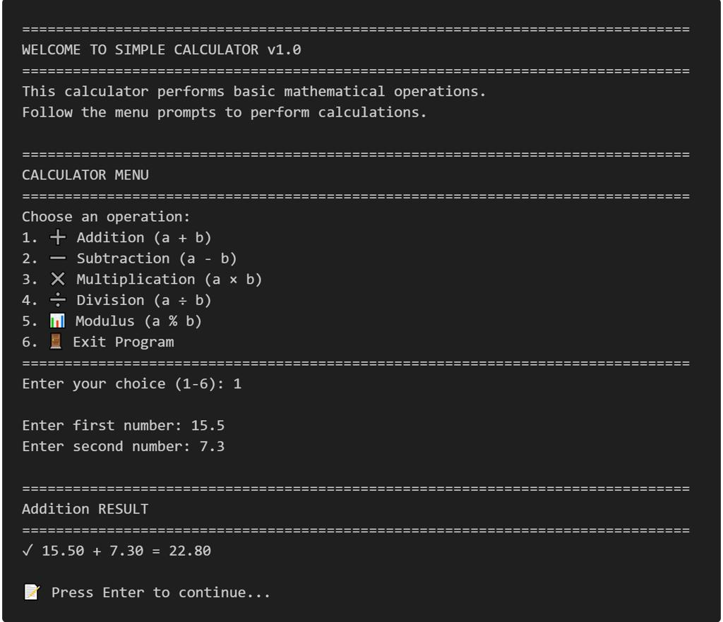
Project 1 — Command-line calculator
Beginner
Features: Arithmetic operations, menu system, input validation, reusable functions, error handling, and unit tests.
Skills: Variables, operators, conditions, loops, functions.
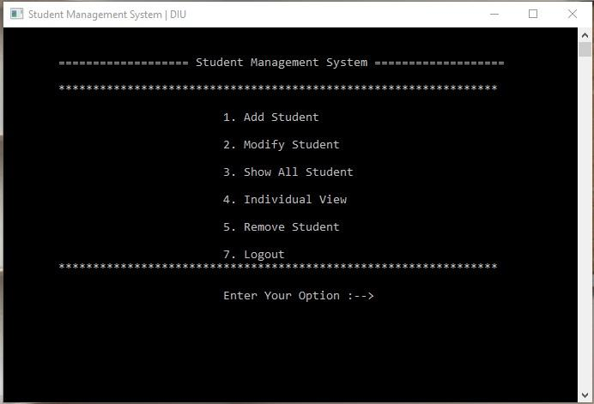
Project 2 — Student record management system
Beginner–Intermediate
Features: Add, search, update, delete, sort, and display student records.
Skills: Structures, arrays, functions, strings, validation.
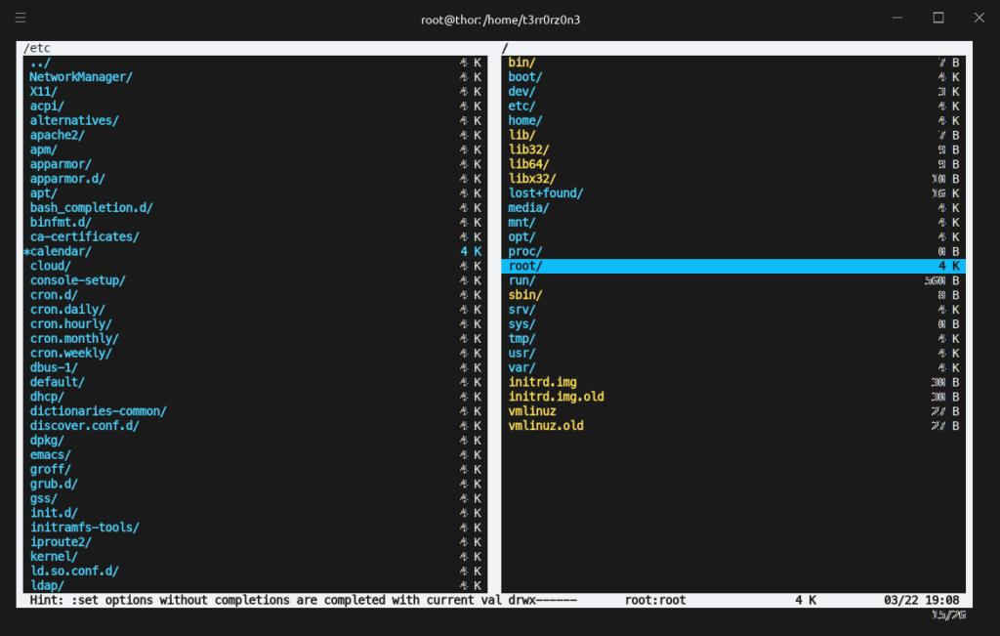
Project 3 — File-based inventory system
Intermediate
Features: Product records, file persistence, search, stock updates, and summary reports.
Skills: Structures, file handling, modular programming, error handling.
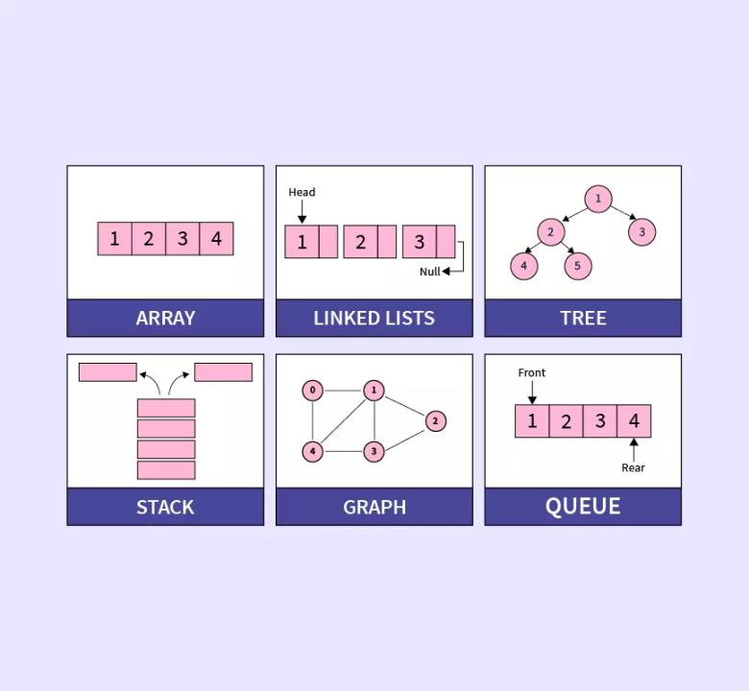
Project 4 — Data structure library
Intermediate–Advanced
Features: Dynamic array, linked list, stack, queue, and binary search tree.
Skills: Pointers, dynamic memory, algorithms, testing, complexity analysis.
Project 5 — Text and log analyzer
Advanced
Features: Parse files, count events, filter records, report statistics, and handle malformed input.
Skills: Strings, file I/O, dynamic memory, error handling, performance analysis.
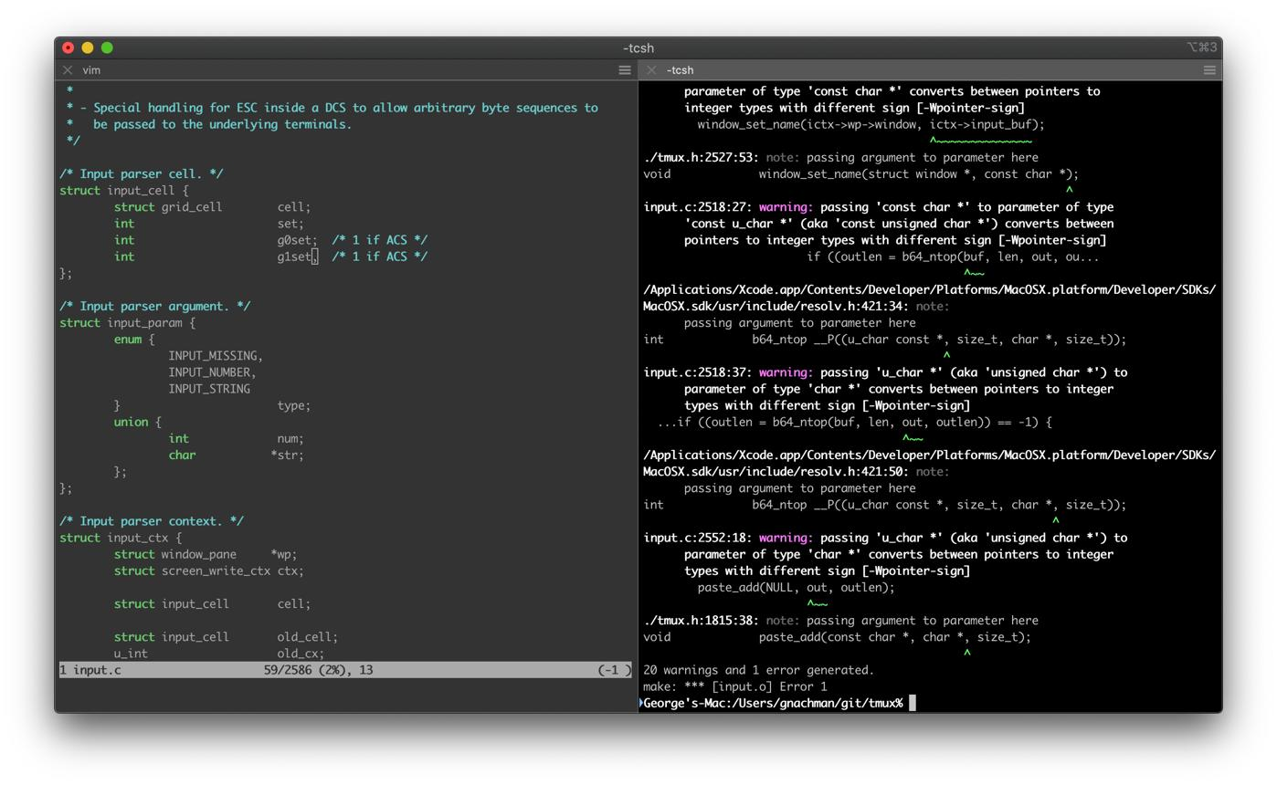
Project 6 — EDVENT Library Management System
Final capstone
Features: Books, members, issue and return records, overdue calculations, search, file persistence, reporting, and administrative menus.
Skills: Structures, pointers, dynamic allocation, file handling, modular code, data structures, testing, debugging, and build systems.

Capstone requirements
Each project should include:
- Problem statement and feature list
- Algorithm or pseudocode
- Modular source files and headers
- Meaningful variable and function names
- Input validation and error handling
- No avoidable memory leaks or invalid memory access
- Tests for normal, boundary, and invalid cases
- Compiler warnings enabled
- README with build and run instructions
- Git history with meaningful commits
- A demonstration and explanation of design choices

Recommended 20-week teaching roadmap
This schedule assumes students are learning C as their first programming language and can devote approximately 8–12 hours per week to classes and independent practice.
Weeks 1–2

Programming fundamentals and C setup
Algorithms, flowcharts, compiler setup, first programs, tokens, variables, data types.
Weeks 3–4

Operators, input/output, and control flow
Expressions, conversions, formatted I/O, conditions, switch statements, loops.
Weeks 5–6

Functions and recursion
Parameters, return values, scope, storage duration, recursion, multi-file introduction.
Weeks 7–8

Arrays, strings, and matrices
Array operations, sorting, searching, string handling, multidimensional arrays.
Weeks 9–10

Pointers and memory
Pointer arithmetic, arrays and pointers, function pointers, memory diagrams, pointer safety.
Weeks 11–12

Structures and dynamic allocation
Structures, unions, enums, typedef, malloc, calloc, realloc, free, memory debugging.
Weeks 13–14

Files and preprocessing
Text and binary files, CSV, headers, macros, separate compilation, linking.
Weeks 15–16

Data structures and algorithms
Linked lists, stacks, queues, trees, hash tables, graphs, sorting, searching.
Weeks 17–18

Advanced C and quality engineering
Undefined behavior, standard library, debugging, testing, sanitizers, secure programming.
Week 19

Build systems and systems concepts
Make, CMake, libraries, platform-specific APIs, concurrency introduction.
Week 20

Capstone and assessment
Build, test, document, debug, and demonstrate a complete C application.

Daily classroom and practice routine
For a 90-minute session:
- 15 minutes: Review the previous lesson.
- 20 minutes: Explain the new concept with diagrams and examples.
- 25 minutes: Instructor-led coding.
- 25 minutes: Student exercises and debugging.
- 5 minutes: Recap and assignment.
For C, spend additional practice time on pointers, arrays, strings, and dynamic memory. These concepts often require repeated implementation and debugging before students become comfortable with them.

Student mastery tracker

C programming progress
0 of 25 skills mastered

0%
Foundation
Explain how C programs are compiled and linked
Install and use a C compiler
Understand variables, types, and conversions
Write conditions and loops independently
Functions and arrays
Create reusable functions
Trace recursive calls
Process one-dimensional arrays
Manipulate matrices and strings safely
Pointers and structures
Explain addresses and dereferencing
Use pointers with functions and arrays
Create structures and enums
Implement function pointers and callbacks
Memory and files
Allocate and free dynamic memory correctly
Handle allocation failures
Read and write text files
Understand binary file portability limitations
Algorithms and advanced C
Implement sorting and searching
Implement linked lists and stacks
Understand trees and hash tables
Recognize undefined behavior and unsafe pointer use
Professional development
Debug with GDB or LLDB
Use warnings and sanitizers
Write tests for normal and invalid cases
Build a multi-file project
Complete and document the capstone
Copy checklistReset
Mark a topic complete only after writing, compiling, testing, and explaining a relevant program independently.

Official learning resources

GCC compiler
GCC documentation
Compiler options, diagnostics, language standards, and optimization.
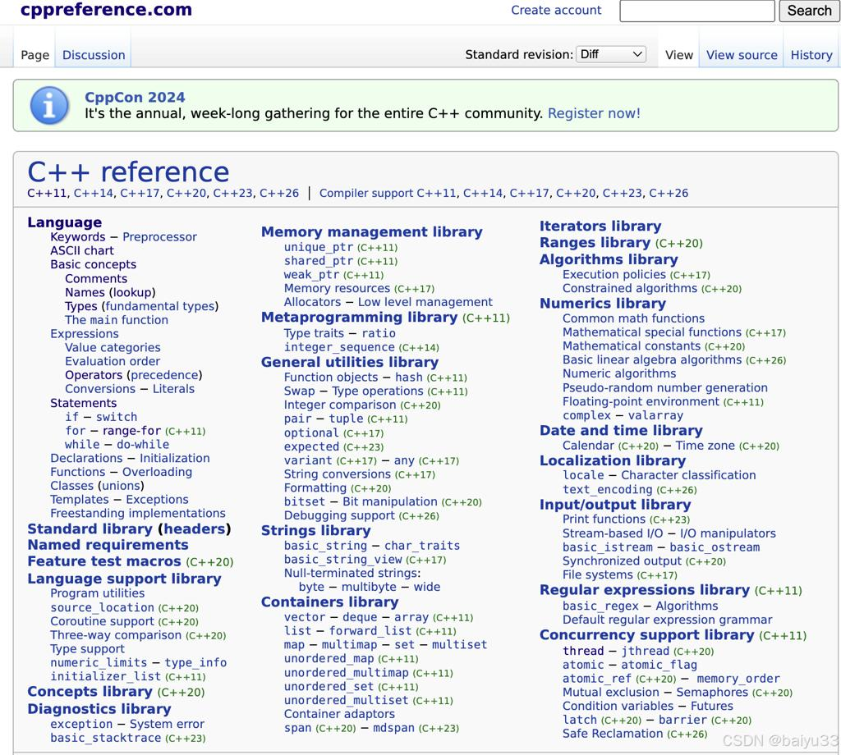
C language reference
C language reference on cppreference
Language features, standard library functions, and version differences.

Clang and LLVM
Clang documentation
Compiler diagnostics, sanitizers, and static analysis tools.
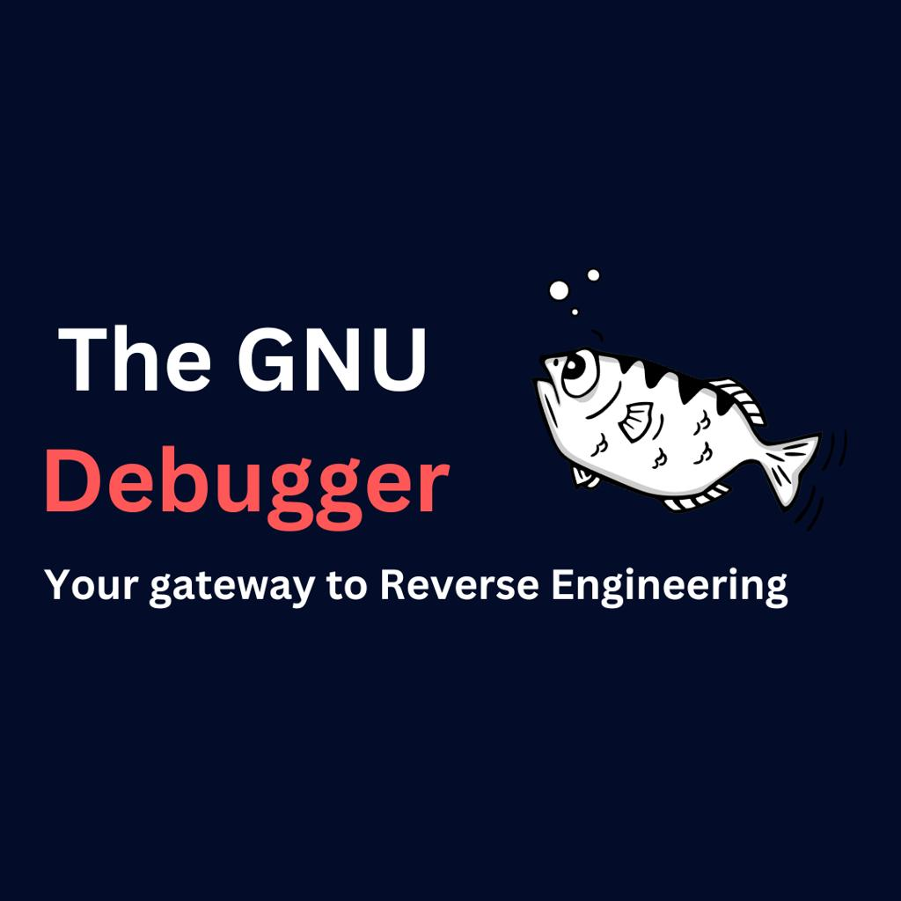
Debugging
GDB documentation
Breakpoints, variable inspection, stack traces, and memory debugging.

Build systems
CMake tutorial
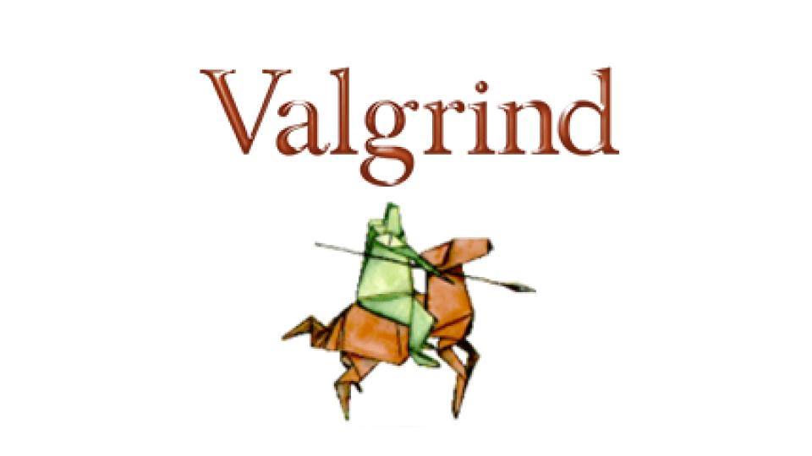
Memory debugging
Valgrind documentation

Final recommendation for EDVENT
Teach C in three stages:
- C Programming Foundation: Syntax, variables, operators, conditions, loops, functions, arrays, and strings.
- Core and Advanced C: Pointers, structures, dynamic memory, files, preprocessing, data structures, and algorithms.
- Professional C Development: Debugging, testing, security, build systems, platform-specific concepts, concurrency, and capstone projects.
The most important teaching principle is to make students understand why their code works, how memory is used, and how to diagnose errors. Do not assess students only on whether a program produces the correct output for one sample input. Assess whether it handles invalid input, boundary cases, memory safely, and can be compiled and maintained as a complete project.

