EDVENT — Complete C++ Programming Master Syllabus

Beginner to Advanced | Structured Learning Path
This curriculum is designed to take students from zero programming experience to advanced C++ development, covering programming fundamentals, object-oriented programming, memory management, the Standard Template Library (STL), data structures and algorithms, modern C++, concurrency, testing, and professional software development.
The objective is to teach students not only how to write C++ programs, but also how to design reusable software, understand object lifetimes, use abstractions correctly, and build reliable applications.

1. Course overview

C++ Programming Language
Procedural programming, object-oriented programming, generic programming, memory management, STL, and systems development.
Target audience
Complete beginners
Suggested duration
24–30 weeks
Practice time
8–12 hours/week
Final outcome
Independent C++ developer

Recommended technology stack
- Compiler: GCC or Clang; MSVC for Windows-specific development where appropriate.
- Editor/IDE: VS Code, Visual Studio, or CLion.
- Debugger: GDB, LLDB, or the Visual Studio debugger.
- Build system: Start with compiler commands, then learn CMake.
- Version control: Git and GitHub.
- Testing: A framework such as GoogleTest or Catch2.
- Language version: Start with C++17, then progress to C++20 and selected C++23 features supported by the toolchain.
C++ is a multi-paradigm language. Teach procedural programming first, introduce object-oriented programming next, and then focus heavily on modern C++ practices such as RAII, standard containers, smart pointers, move semantics, and generic programming.

2. Complete learning roadmap
Level 0 — Computer and programming fundamentals
Level 1 — C++ setup and first programs
Level 2 — Variables, data types, and operators
Level 3 — Input/output and control flow
Level 4 — Functions and modular programming
Level 5 — Arrays, strings, and pointers
Level 6 — Object-oriented programming
Level 7 — Constructors, destructors, and object lifetime
Level 8 — Inheritance and polymorphism
Level 9 — Operator overloading and advanced OOP
Level 10 — STL containers, iterators, and algorithms
Level 11 — Templates and generic programming
Level 12 — Modern C++ and resource management
Level 13 — File handling and exceptions
Level 14 — Data structures and algorithms
Level 15 — Advanced C++ and concurrency
Level 16 — Testing, debugging, build systems, and security
Level 17 — Projects, portfolio, and final assessment

Level 0 — Programming and computer fundamentals

Module 1. Introduction to programming

1.1 Programming concepts
- What programming is
- Programs, instructions, and algorithms
- Source code and machine code
- High-level and low-level languages
- Compiled and interpreted execution models
- Procedural, object-oriented, and generic programming
- Problem decomposition
- Pseudocode and flowcharts
- Input-process-output model
- Correctness and efficiency

1.2 Computer architecture basics
- CPU, RAM, storage, and input/output
- Bits, bytes, and binary representation
- Registers and machine instructions conceptually
- Memory addresses
- Stack and heap as common implementation concepts
- Operating-system and application roles
- Executable files and program execution

1.3 Algorithm fundamentals
- Sequential execution
- Selection and iteration
- Breaking problems into functions
- Boundary cases
- Test cases
- Time and space complexity introduction
- Big-O notation introduction

Practical exercises
- Write an algorithm to calculate the average of three numbers.
- Draw a flowchart to check whether a number is even.
- Write pseudocode to find the largest of three numbers.
- Trace a loop manually and predict its output.
Learning outcome: Students can design a basic algorithm before implementing it in C++.

Level 1 — Getting started with C++

Module 2. Introduction to C++

2.1 Language overview
- History and evolution of C++
- Relationship between C and C++
- Major C++ standards
- C++98/03, C++11, C++14, C++17, C++20, and C++23
- Where C++ is used: games, desktop applications, embedded systems, performance-sensitive applications, finance, and systems software
- C++ strengths and trade-offs
- C++ versus C, Java, Python, and C#

2.2 Development environment
- Installing GCC or Clang
- Installing Visual Studio where appropriate
- Setting up VS Code or another editor
- Configuring compiler paths
- Creating .cpp files
- Running commands in a terminal
- Compiling and executing programs
- Understanding compiler errors and warnings
- Using an IDE versus the command line

2.3 First C++ program
#include <iostream>

int main()
{
std::cout << "Hello, World!\n";
return 0;
}
Teach each component:
- #include
- <iostream>
- int main()
- Braces and statements
- std::cout
- Stream insertion operator <<
- Newline output
- Return values
- Namespace qualification

2.4 Compilation process
- Preprocessing
- Compilation
- Assembly
- Linking
- Object files
- Executable generation
- Compile-time errors
- Linker errors
- Runtime errors
- Logic errors
Example command:
g++ -std=c++17 -Wall -Wextra -Wpedantic -g main.cpp -o main
Explain the language standard, warnings, debugging symbols, and output filename.

Practical exercises
- Print student details.
- Display formatted text on multiple lines.
- Compile and run a program from the terminal.
- Fix syntax errors and missing declarations.
- Compile a program using two source files.

Level 2 — C++ language fundamentals

Module 3. Tokens, keywords, identifiers, and constants

3.1 Tokens
- Keywords
- Identifiers
- Literals
- Operators
- Punctuators
- Comments
- Whitespace and tokenization

3.2 Identifiers and naming
- Naming rules
- Case sensitivity
- Reserved words
- Naming conventions
- Meaningful variable and function names
- Avoiding ambiguous identifiers

3.3 Constants and literals
- Integer literals
- Floating-point literals
- Character literals
- String literals
- Boolean literals
- Escape sequences
- Numeric suffixes
- Hexadecimal and binary literals
- const
- constexpr
- #define and why typed constants are usually preferable
- Constant expressions

3.4 Comments and formatting
- Single-line and multiline comments
- Documentation comments
- Indentation
- Brace placement
- Consistent code formatting
- Avoiding redundant comments

Module 4. Variables and data types

4.1 Variables
- Declaration and initialization
- Assignment and reassignment
- Local variables
- Global variables
- Scope and lifetime introduction
- Uninitialized variables
- Naming conventions
- Type inference using auto

4.2 Fundamental data types
- bool
- char
- wchar_t
- char8_t, char16_t, and char32_t
- short
- int
- long
- long long
- float
- double
- long double
- void
- Signed and unsigned integers

4.3 Type sizes and representation
- sizeof
- std::size_t
- Integer ranges
- std::numeric_limits
- Signed versus unsigned arithmetic
- Integer overflow
- Floating-point precision
- Rounding errors
- Character encoding concepts
- Implementation-dependent type sizes

4.4 Type conversion
- Implicit conversion
- Explicit casting
- static_cast
- const_cast overview
- reinterpret_cast overview
- dynamic_cast introduction
- Narrowing conversions
- Integer promotions
- Usual arithmetic conversions
- Type deduction with auto
- decltype

4.5 Initialization styles
- Copy initialization
- Direct initialization
- Brace initialization
- Default initialization
- Value initialization
- Aggregate initialization
- Avoiding unintended narrowing with braces
- Initialization order and uninitialized-state risks

Practical exercises
- Convert Celsius to Fahrenheit.
- Calculate simple and compound interest.
- Calculate student marks and percentages.
- Compare integer and floating-point division.
- Inspect types using sizeof and std::numeric_limits.

Module 5. Operators and expressions

5.1 Arithmetic operators
- +, -, *, /, %
- Unary plus and minus
- Increment and decrement
- Integer division
- Remainder
- Overflow considerations
- Floating-point arithmetic

5.2 Relational operators
- ==
- !=
- <
- >
- <=
- >=
- Boolean expressions
- Chained comparisons and common mistakes

5.3 Logical operators
- &&
- ||
- !
- Truth tables
- Short-circuit evaluation
- Combining conditions

5.4 Assignment operators
- =
- +=
- -=
- *=
- /=
- %=
- Compound assignment

5.5 Bitwise operators
- &
- |
- ^
- ~
- <<
- >>
- Bit masks
- Setting, clearing, and toggling bits
- Signed-shift and shift-width hazards
- Logical versus bitwise operators

5.6 Other operators
- Ternary operator ?:
- sizeof
- Scope resolution ::
- Member access . and ->
- Pointer operators
- Array subscript []
- Function call ()
- Comma operator
- Operator precedence
- Associativity
- Parentheses for clarity

Practical exercises
- Build a calculator.
- Create a basic tax calculator.
- Check divisibility and number ranges.
- Build a bit-flag permission example.
- Write expressions and explain their evaluation order.

Module 6. Input and output

6.1 Standard streams
- std::cin
- std::cout
- std::cerr
- std::clog
- Stream insertion and extraction
- Newline using '\n'
- Flushing using std::flush and std::endl
- Why unnecessary flushing can reduce performance

6.2 Formatted output
- Integer output
- Floating-point output
- Precision
- Width and alignment
- std::fixed
- std::scientific
- std::setprecision
- std::setw
- std::left and std::right
- std::boolalpha
- Formatting with <iomanip>

6.3 Input techniques
- Reading numbers with std::cin
- Reading multiple values
- Reading a full line with std::getline
- Handling spaces in strings
- Stream state
- fail(), bad(), and eof()
- Clearing failed input with clear()
- Removing unwanted input using ignore()
- Mixing std::cin and std::getline
- Input validation
- Handling invalid numeric input

6.4 Practical applications
- Menu-driven calculator
- Student marks entry
- Currency converter
- Formatted invoice
- Input validation utility

Level 3 — Decision-making, loops, and problem-solving

Module 7. Conditional statements

7.1 if and else
- Simple if
- if-else
- else if
- Nested conditions
- Compound conditions
- Boundary cases
- Avoiding accidental assignment in conditions

7.2 switch
- case
- default
- break
- Fall-through behavior
- Multiple case labels
- Enumerations with switch
- Switch statement versus conditional chains
- [[fallthrough]] where appropriate

7.3 Conditional expressions
- Ternary operator
- Boolean expressions
- Combining comparisons
- Simplifying complex conditions
- Guard clauses
- Validation order

Practical exercises
- Grade calculator
- Leap-year checker
- Largest of three numbers
- Electricity bill calculator
- Menu-based unit converter

Module 8. Loops and iteration

8.1 Loop types
- while
- do-while
- for
- Range-based for
- Nested loops
- Infinite loops
- Counter-controlled loops
- Sentinel-controlled loops

8.2 Loop control
- break
- continue
- Early termination
- Loop invariants introduction
- Avoiding unnecessary jumps
- Common off-by-one errors

8.3 Common algorithms
- Summation
- Factorial
- Prime-number checking
- Digit extraction
- Reversing an integer
- Palindrome number
- Fibonacci sequence
- GCD and LCM
- Pattern printing
- Frequency counting
- Minimum and maximum
- Linear search

Practical assignment
Build a menu-driven mathematical toolkit that runs repeatedly until the user chooses to exit.

Module 9. Problem-solving and algorithm analysis

9.1 Problem-solving process
- Read and clarify requirements
- Identify inputs, outputs, and constraints
- Break problems into smaller functions
- Write pseudocode
- Draw flowcharts where useful
- Identify boundary conditions
- Test examples manually
- Refine the algorithm

9.2 Algorithm complexity
- Time complexity
- Space complexity
- Big-O notation
- Constant, logarithmic, linear, linearithmic, quadratic, and exponential growth
- Best, average, and worst cases
- Auxiliary space
- Comparing two approaches

9.3 Practical problem-solving patterns
- Counter and accumulator
- Two-pointer technique
- Sliding-window introduction
- Frequency tables
- Prefix sums
- Binary search patterns
- Recursion introduction
- Brute force versus optimized solutions

Practical assignment
Solve 20–30 programming problems, documenting the approach, complexity, and edge cases for each.

Level 4 — Functions and modular programming

Module 10. Functions

10.1 Function fundamentals
- Function declaration and definition
- Function prototypes
- Parameters and arguments
- Return types
- void functions
- Calling functions
- Function overloading
- Default arguments
- Function signatures
- Pass-by-value
- Passing by reference
- Passing by pointer
- Returning values

10.2 Parameter passing
- Copying values
- Reference parameters
- const reference parameters
- Pointer parameters
- Output parameters
- Avoiding unnecessary copies
- Choosing value, reference, or pointer
- Return-by-value
- Returning references and pointer-lifetime risks

10.3 Scope and lifetime
- Local scope
- Global scope
- Block scope
- Namespace scope
- Shadowing
- Static local variables
- Static data members introduction
- Automatic and dynamic storage duration
- Linkage
- Scope versus lifetime

10.4 Function overloading
- Overloading by parameter types
- Different parameter counts
- Overload resolution
- Ambiguous overloads
- Conversion ranking
- Overloading versus default arguments
- Why return type alone cannot distinguish overloads

10.5 Recursion
- Base case
- Recursive case
- Call stack
- Stack overflow risks
- Recursive factorial
- Fibonacci
- GCD
- Binary search
- Recursive tree traversal introduction
- Recursion versus iteration

10.6 Inline functions and constexpr
- Inline functions
- One Definition Rule basics
- constexpr functions
- Compile-time versus runtime evaluation
- consteval overview in C++20
- Limits of compile-time evaluation

Practical exercises
- Create a reusable mathematical library.
- Implement factorial recursively and iteratively.
- Build a function-overloaded calculator.
- Write functions that operate on arrays and vectors.
- Design a header file with function declarations.

Module 11. Namespaces and program organization

11.1 Namespaces
- Namespace declaration
- Namespace members
- Scope resolution operator ::
- Namespace aliases
- Nested namespaces
- Anonymous namespaces
- Namespace-level functions and variables
- Avoiding naming conflicts
- Why using namespace std; should generally be avoided in headers

11.2 Header and source files
- .hpp and .cpp conventions
- Header guards
- #pragma once as a common non-standard directive
- Declarations versus definitions
- Include dependencies
- Forward declarations
- Separate compilation
- Linking multiple translation units
- Avoiding multiple-definition errors

11.3 Build fundamentals
- Compiling multiple source files
- Object files
- Static libraries
- Shared libraries
- Linker errors
- Debug and release builds
- Compiler flags
- Project structure

Practical assignment
Create a multi-file calculator with separate modules for input, arithmetic, validation, and output.

Module 12. Arrays, strings, and collections

12.1 C-style arrays
- Array declaration and initialization
- Indexing
- Bounds and invalid access
- Multidimensional arrays
- Array size
- Passing arrays to functions
- Array-to-pointer conversion
- sizeof versus array length
- Limitations of raw arrays

12.2 std::string
- String construction
- Concatenation
- Length and size
- Accessing characters
- Substrings
- Searching
- Comparing strings
- Replacing text
- Insertion and erasure
- String conversion
- std::string_view introduction
- String lifetime and dangling views
- Character encoding considerations

12.3 C++ input and text processing
- std::getline
- Parsing text
- Character classification
- Whitespace handling
- Splitting strings
- Tokenization
- Validation
- Avoiding unsafe assumptions about user input

12.4 std::array and std::vector
- Fixed-size std::array
- Dynamic std::vector
- Size and capacity
- push_back()
- emplace_back()
- at() versus operator[]
- Iteration
- Resizing
- Insertion and deletion
- Bounds and invalidation rules
- Choosing arrays versus vectors

Practical assignment
Create a student marks analyzer using std::vector and std::string, with search, sorting, and reporting.

Level 5 — Pointers, references, and memory fundamentals

Module 13. Pointers and references

13.1 Pointers
- What pointers are
- Memory addresses
- Pointer declaration and initialization
- Address-of operator &
- Dereference operator *
- Null pointers
- nullptr
- Pointer arithmetic
- Pointer comparisons
- Pointer-to-pointer
- void* and its limitations
- Pointer size versus object size
- Pointer safety

13.2 References
- Lvalue references
- Reference initialization
- Reference parameters
- Reference return types
- Const references
- Rvalue references introduction
- References versus pointers
- References cannot be reseated
- Reference lifetime and dangling references
- Reference collapsing concepts for later study

13.3 const and pointers
- Pointer to const data
- Const pointer
- Const pointer to const data
- Passing read-only references
- Const correctness
- Choosing suitable function parameter types

13.4 Pointer arithmetic and arrays
- Array-to-pointer conversion
- Traversing arrays with pointers
- Pointer differences
- One-past-the-end pointer
- Pointer bounds
- Invalid pointer arithmetic
- Why pointer arithmetic is restricted to the same array object and its one-past-the-end position

Practical exercises
- Swap values using references and pointers.
- Traverse an array using pointer arithmetic.
- Implement a function that finds the maximum element.
- Compare pointer-based and container-based approaches.

Module 14. Dynamic memory and resource management

14.1 Dynamic allocation
- Stack and heap concepts
- new and delete
- new[] and delete[]
- Allocation failure
- std::bad_alloc
- Constructor execution during allocation
- Destructor execution during deletion
- Mismatched allocation and deallocation
- Memory leaks
- Dangling pointers
- Double deletion
- Exception safety during allocation

14.2 Smart pointers
Teach smart pointers as the preferred approach for most dynamically managed objects.
- std::unique_ptr
- std::make_unique
- std::shared_ptr
- std::make_shared
- std::weak_ptr
- Ownership semantics
- Unique ownership
- Shared ownership
- Reference counting
- Breaking circular references
- Custom deleters
- Avoiding unnecessary shared ownership
- Why raw owning pointers are usually a poor default

14.3 RAII
- Resource Acquisition Is Initialization
- Resource ownership
- Deterministic cleanup
- Constructor and destructor responsibilities
- File and lock management
- Exception safety
- Scope-bound resource management
- RAII versus manual cleanup

14.4 Resource types
- Dynamic memory
- File handles
- Database connections conceptually
- Mutex locks
- Network resources
- Custom resource wrappers
- Rule of Zero
- Rule of Three
- Rule of Five

Practical assignment
Create a resource-management demo that uses std::unique_ptr, safely manages resources, and demonstrates automatic cleanup when exceptions occur.

Level 6 — Object-oriented programming

Module 15. Classes and objects

15.1 OOP fundamentals
- What object-oriented programming is
- Classes and objects
- State and behavior
- Data abstraction
- Encapsulation
- Inheritance
- Polymorphism
- Composition
- Object identity and lifetime

15.2 Defining classes
- Class declaration
- Data members
- Member functions
- Access specifiers: public, private, and protected
- Member access
- Object creation
- Dot operator
- this pointer
- Member function definitions inside and outside the class
- Class invariants
- Header and implementation separation

15.3 Encapsulation
- Hiding internal state
- Public interfaces
- Private data
- Getters and setters
- Validation within class methods
- Avoiding unnecessary setters
- Maintaining valid object state
- Designing meaningful public APIs

15.4 Static members
- Static data members
- Static member functions
- Class-wide state
- Accessing static members
- Inline static data members in modern C++
- Avoiding unnecessary global or shared mutable state

Practical assignment
Build a BankAccount class with deposit, withdrawal, balance inquiry, and transaction validation.

Module 16. Constructors and destructors

16.1 Constructors
- Default constructor
- Parameterized constructor
- Constructor overloading
- Member initializer lists
- Default member initializers
- Delegating constructors
- explicit constructors
- Conversion constructors
- Aggregate initialization
- Defaulted constructors
- Deleted constructors

16.2 Destructors
- Destructor syntax
- Object destruction
- Scope-based lifetime
- Destruction order
- Resource cleanup
- Destructor exception rules
- Virtual destructors introduction
- Why destructors should generally not throw

16.3 Special member functions
- Copy constructor
- Copy assignment operator
- Move constructor
- Move assignment operator
- Defaulted functions
- Deleted functions
- Rule of Zero
- Rule of Three
- Rule of Five
- Shallow versus deep copying
- Ownership-aware class design

16.4 Object lifetime
- Automatic objects
- Static objects
- Dynamic objects
- Temporary objects
- Temporary lifetime extension
- Lifetime of references
- Dangling references
- Lifetime of std::string_view
- Initialization and destruction order
- Static initialization order concerns

Practical assignment
Create a class that owns a dynamic resource, then implement or explicitly prohibit copying as appropriate. Compare manual ownership with an RAII-based implementation.

Module 17. Inheritance

17.1 Inheritance fundamentals
- Base class
- Derived class
- Public inheritance
- Protected inheritance
- Private inheritance
- Inherited members
- Access control
- Constructor and destructor order
- Base-class initialization
- protected members
- Inheritance versus composition

17.2 Types of inheritance
- Single inheritance
- Multilevel inheritance
- Hierarchical inheritance
- Multiple inheritance
- Diamond inheritance
- Virtual inheritance
- Ambiguous member access
- Base-class conversion

17.3 Design principles
- Is-a versus has-a relationships
- Substitutability
- Avoiding deep inheritance hierarchies
- Composition over inheritance
- Interface-oriented design
- Base-class invariants
- Access-control design

Practical assignment
Create a payroll system with employee types, shared base behavior, and separate role-specific calculations.

Module 18. Polymorphism and virtual functions

18.1 Compile-time polymorphism
- Function overloading
- Operator overloading introduction
- Templates introduction
- Static dispatch

18.2 Runtime polymorphism
- Virtual functions
- Function overriding
- override
- final
- Virtual dispatch
- Base pointers and references
- Dynamic binding
- Virtual destructors
- Object slicing
- Abstract classes
- Pure virtual functions
- Interfaces through abstract base classes

18.3 Runtime type information
- dynamic_cast
- typeid
- RTTI
- Downcasting
- Safe versus unsafe casts
- When virtual functions eliminate the need for casting

18.4 Polymorphic design
- Interface segregation concepts
- Base class contracts
- Ownership of polymorphic objects
- Smart pointers to base classes
- Avoiding slicing
- Testing derived implementations

Practical assignment
Build a shape system with a common interface and derived classes for circles, rectangles, and triangles. Calculate area and perimeter polymorphically.

Level 7 — Advanced object-oriented programming

Module 19. Operator overloading

19.1 Operator overloading fundamentals
- Why operators can be overloaded
- Member operator functions
- Non-member operator functions
- Friend functions
- Return types
- Const correctness
- Parameter conventions
- Operators that cannot be overloaded
- Operators that must be overloaded as member functions
- Preserving expected operator semantics

19.2 Common operators
- Arithmetic: +, -, *, /
- Comparison: ==, !=, <, <=, >, >=
- Assignment: =
- Compound assignment: +=, -=
- Increment and decrement
- Subscript operator []
- Function-call operator ()
- Stream insertion <<
- Stream extraction >>
- Three-way comparison <=> in C++20

19.3 Conversion operators
- Conversion constructors
- Conversion functions
- explicit conversions
- Preventing unintended conversions
- Type safety
- Avoiding surprising operator behavior

Practical assignment
Create a ComplexNumber class with arithmetic operators, equality comparison, and formatted input/output.

Module 20. Friend functions and advanced class design

20.1 Friend declarations
- Friend functions
- Friend classes
- Access to private members
- Appropriate use cases
- Encapsulation trade-offs
- Friend operators

20.2 Nested and local types
- Nested classes
- Local classes
- Access rules
- Using nested types to group related concepts
- Avoiding unnecessary complexity

20.3 Class design principles
- Single responsibility
- Cohesion and coupling
- Dependency injection introduction
- Interface-based design
- Composition
- Invariants
- Immutable objects
- Value types versus entity types
- Pimpl idiom introduction
- API stability and implementation hiding

Practical assignment
Refactor a large class into smaller components with clearly defined responsibilities.

Module 21. Modern C++ language features

21.1 C++11 and C++14
- auto
- Range-based for
- nullptr
- enum class
- Uniform initialization
- Move semantics introduction
- Rvalue references
- Lambda expressions
- Smart pointers
- constexpr
- noexcept
- override and final
- decltype
- Type aliases using using
- Variadic templates introduction
- std::thread
- std::chrono
- Generic lambdas in C++14
- Return type deduction in C++14

21.2 C++17
- Structured bindings
- if constexpr
- Inline variables
- std::optional
- std::variant
- std::any
- std::string_view
- std::filesystem
- Fold expressions
- Class template argument deduction
- std::invoke
- Parallel algorithms overview

21.3 C++20
- Concepts
- Ranges
- Coroutines introduction
- Modules introduction
- Three-way comparison
- Designated initializers with C++ limitations compared with C
- consteval
- constinit
- std::span
- std::jthread
- Stop tokens
- Calendar and time-zone facilities overview
- Atomic and synchronization enhancements

21.4 C++23 overview
- std::expected
- std::print where supported
- std::mdspan
- Ranges enhancements
- Multidimensional subscript support
- Deducing this
- Additional library improvements
- Toolchain support and compatibility

Practical assignment
Take an older C++ program and modernize it using auto, range-based loops, smart pointers, structured bindings, and suitable standard-library types.

Level 8 — Standard Template Library (STL)

Module 22. Introduction to the C++ standard library

22.1 Library fundamentals
- What the C++ standard library provides
- Standard containers
- Iterators
- Algorithms
- Function objects
- Allocators overview
- Utility types
- Complexity guarantees
- Header organization
- Namespace std

22.2 Container categories
- Sequence containers
- Associative containers
- Unordered associative containers
- Container adaptors
- Container selection based on access patterns
- Memory and performance trade-offs

Module 23. Sequence containers

23.1 std::vector
- Dynamic arrays
- Size and capacity
- push_back() and emplace_back()
- pop_back()
- insert() and erase()
- resize() and reserve()
- Element access
- Iterators
- Iterator invalidation
- Complexity and memory considerations

23.2 std::array
- Fixed-size arrays
- Compile-time size
- Iteration
- Comparison
- Integration with algorithms

23.3 std::deque
- Double-ended queue
- Front and back operations
- Random access
- Iterator invalidation
- Comparison with vectors

23.4 std::list and std::forward_list
- Doubly and singly linked lists
- Insertion and removal
- Iterator stability
- Complexity
- Memory overhead
- Why linked lists are not automatically faster than vectors

23.5 std::basic_string
- std::string
- String storage
- Searching and modification
- Iterators
- Comparison and conversion
- std::string_view
- Lifetime and invalidation

Practical assignment
Implement a task manager using std::vector, then compare its behavior with a linked-list-based version.

Module 24. Associative and unordered containers

24.1 Ordered associative containers
- std::set
- std::multiset
- std::map
- std::multimap
- Unique versus duplicate keys
- Ordering
- Custom comparators
- Lookup operations
- lower_bound() and upper_bound()
- Complexity guarantees

24.2 Unordered containers
- std::unordered_set
- std::unordered_multiset
- std::unordered_map
- std::unordered_multimap
- Hash functions
- Equality functions
- Collisions
- Load factor
- Rehashing
- Average versus worst-case complexity
- Custom hash functions

24.3 Container adaptors
- std::stack
- std::queue
- std::priority_queue
- Underlying containers
- Common operations
- Use cases and limitations

Practical assignment
Build a word-frequency analyzer using std::unordered_map, then produce an ordered report using std::map.

Module 25. Iterators

25.1 Iterator fundamentals
- What iterators are
- begin() and end()
- cbegin() and cend()
- Forward and reverse iteration
- Iterator dereferencing
- Incrementing iterators
- Iterator invalidation
- Range-based loops

25.2 Iterator categories
- Input iterators
- Output iterators
- Forward iterators
- Bidirectional iterators
- Random-access iterators
- Contiguous iterators
- Iterator category requirements

25.3 Iterator operations
- std::advance
- std::distance
- std::next
- std::prev
- std::inserter
- std::back_inserter
- std::front_inserter

Practical assignment
Implement generic functions that operate on containers through iterators rather than depending on a particular container type.

Module 26. STL algorithms

26.1 Searching and counting
- std::find
- std::find_if
- std::count
- std::count_if
- std::binary_search
- std::lower_bound
- std::upper_bound
- std::equal_range

26.2 Sorting and rearrangement
- std::sort
- std::stable_sort
- std::partial_sort
- std::nth_element
- std::reverse
- std::rotate
- std::shuffle
- std::partition
- std::stable_partition

26.3 Transformation and aggregation
- std::transform
- std::for_each
- std::accumulate
- std::reduce
- std::inner_product
- std::min_element
- std::max_element
- std::minmax_element
- std::all_of
- std::any_of
- std::none_of

26.4 Set and heap algorithms
- std::merge
- std::set_union
- std::set_intersection
- std::set_difference
- std::make_heap
- std::push_heap
- std::pop_heap
- std::sort_heap

26.5 Algorithm design
- Using lambdas as predicates
- Custom sorting
- Complexity requirements
- Iterator validity
- Algorithm preconditions
- Avoiding unnecessary loops
- Understanding algorithm return values

Practical assignment
Build an employee analytics program using STL algorithms to filter, sort, search, and summarize employee records.

Level 9 — Templates and generic programming

Module 27. Function templates

27.1 Template fundamentals
- Why templates exist
- Generic functions
- Template parameters
- Template arguments
- Type deduction
- Explicit template arguments
- Multiple template parameters
- Template instantiation
- Compile-time type checking

27.2 Function-template techniques
- Generic minimum and maximum
- Generic swapping
- Generic searching
- Template parameter deduction
- Overloaded function templates
- Template specialization introduction
- Non-type template parameters
- Dependent names
- typename in dependent contexts

Practical assignment
Create a reusable utility library with generic functions for finding minimums, maximums, and searching through ranges.

Module 28. Class templates

28.1 Class-template fundamentals
- Class templates
- Template parameters
- Member functions
- Template definitions in headers
- Multiple template parameters
- Default template arguments
- Template argument deduction where supported
- Class template argument deduction
- Non-type template parameters

28.2 Specialization
- Full specialization
- Partial specialization
- Primary templates
- Specialization selection
- Template aliases
- Avoiding unnecessary specialization
- Compile-time selection

28.3 Variadic templates
- Parameter packs
- Pack expansion
- Recursive variadic templates
- Fold expressions
- Forwarding parameter packs
- Modern alternatives to recursive template patterns

Practical assignment
Create a generic fixed-size matrix class and a type-safe key-value container.

Module 29. Concepts and constraints

29.1 Generic-programming design
- Generic algorithms
- Type requirements
- Compile-time constraints
- SFINAE introduction
- Type traits
- std::enable_if overview
- Concepts and requires in C++20
- Standard concepts such as std::integral and std::sortable
- Custom concepts
- Constrained function templates
- Constrained class templates

29.2 Practical applications
- Restrict a function to arithmetic types.
- Build a constrained sorting utility.
- Produce clearer compiler errors with concepts.
- Compare concepts with older SFINAE-based techniques.

Module 30. Type traits and compile-time programming

30.1 Type traits
- std::is_integral
- std::is_floating_point
- std::is_same
- std::is_pointer
- std::is_base_of
- std::is_constructible
- std::is_trivially_copyable
- std::remove_reference
- std::remove_cv
- std::decay
- std::conditional

30.2 Compile-time techniques
- constexpr
- consteval
- constinit
- Compile-time constants
- static_assert
- if constexpr
- Template metaprogramming introduction
- Recursive template computation
- Fold expressions
- Compile-time validation
- Balancing compile-time complexity with maintainability

Practical assignment
Build a generic numeric utility library that checks type requirements at compile time and provides useful diagnostic messages.

Level 10 — Modern C++ resource management and semantics

Module 31. Value categories and move semantics

31.1 Value categories
- Lvalues
- Prvalues
- Xvalues
- Glvalues
- Rvalues
- Object identity
- Temporary objects
- Lifetime extension
- Reference binding rules

31.2 Move semantics
- Why move semantics exist
- Copy versus move
- Move constructors
- Move assignment
- std::move
- std::forward
- Rvalue references
- Moved-from object states
- Move-enabled standard containers
- Return-value optimization
- Copy elision
- When explicit moves are unnecessary

31.3 Perfect forwarding
- Forwarding references
- Reference collapsing
- std::forward
- Generic wrappers
- Forwarding constructors
- Avoiding overly broad constructors
- Forwarding and overload resolution

Practical assignment
Create a resource-owning class, measure copying and moving behavior, and modernize it using RAII and move semantics.

Module 32. Exception handling and error management

32.1 Exceptions
- try
- throw
- catch
- Catching by reference
- Standard exception hierarchy
- Custom exception types
- Rethrowing exceptions
- Exception propagation
- Stack unwinding
- Exceptions and object destruction

32.2 Exception-safety guarantees
- No-throw guarantee
- Strong guarantee
- Basic guarantee
- Resource cleanup
- RAII and exception safety
- Exception-safe constructors
- Exception-safe assignment
- noexcept
- Why destructors should not allow exceptions to escape

32.3 Alternatives to exceptions
- Return codes
- std::optional
- std::expected in C++23
- std::variant for alternative outcomes
- std::error_code
- Choosing an error-handling strategy
- Avoiding silent failure

Practical assignment
Design an input-validation and file-processing module that handles failures without leaking resources or leaving objects in invalid states.

Module 33. File handling and serialization

33.1 File streams
- std::ifstream
- std::ofstream
- std::fstream
- Opening and closing files
- Text and binary modes
- File stream states
- Error checking
- Reading lines
- Formatted extraction
- Writing reports
- Appending data
- Seeking and positioning

33.2 File-system operations
Using <filesystem>:
- Paths
- Directory creation
- Directory iteration
- File existence
- File sizes
- File copying
- File moving
- File deletion
- File metadata
- Portable path handling

33.3 Serialization
- Serialization versus raw memory dumps
- CSV
- JSON libraries
- Binary format design
- Schema versioning
- Endianness
- Portable file formats
- Data validation
- Handling corrupted files
- Avoiding raw object serialization when types contain pointers or implementation-dependent layouts

Practical assignment
Create a file-backed inventory system with data validation, import/export, error reporting, and backup support.

Level 11 — Data structures and algorithms

Module 34. Algorithm analysis and design patterns

34.1 Complexity analysis
- Big-O, Big-Theta, and Big-Omega concepts
- Best, average, and worst cases
- Time and auxiliary-space complexity
- Amortized analysis
- Recurrence relations
- Complexity of STL containers
- Complexity of STL algorithms
- Measuring performance versus theoretical analysis

34.2 Algorithmic techniques
- Brute force
- Divide and conquer
- Greedy algorithms
- Backtracking
- Dynamic programming
- Memoization
- Tabulation
- Two-pointer technique
- Sliding window
- Prefix sums
- Binary search on answer
- Graph traversal
- Shortest-path algorithms introduction

Module 35. Searching and sorting

35.1 Searching
- Linear search
- Binary search
- Binary search with iterators
- std::find and std::find_if
- std::lower_bound
- std::upper_bound
- std::equal_range
- Searching sorted versus unsorted data

35.2 Sorting
- Bubble sort
- Selection sort
- Insertion sort
- Merge sort
- Quicksort
- Heap sort
- Counting sort overview
- std::sort
- std::stable_sort
- Custom comparators
- Sorting structures and classes
- Stability and complexity
- Benchmarking

Practical assignment
Implement multiple sorting algorithms and compare them with std::sort across datasets of different sizes.

Module 36. Linked lists, stacks, and queues

36.1 Linked lists
- Singly linked list
- Doubly linked list
- Circular linked list
- Node ownership
- Insertion and deletion
- Traversal
- Reversing a list
- Detecting cycles
- Memory cleanup
- Iterator design introduction

36.2 Stacks
- LIFO principle
- Push, pop, and top
- Array-based and linked-list implementations
- std::stack
- Expression parsing
- Balanced parentheses
- Undo history

36.3 Queues
- FIFO principle
- Enqueue and dequeue
- Circular queues
- Priority queues
- std::queue
- std::priority_queue
- Producer-consumer introduction
- Scheduling and buffering

Practical assignment
Create a task scheduler that supports priorities, queue operations, and cancellation.

Module 37. Trees, heaps, and hash tables

37.1 Trees
- Binary trees
- Binary search trees
- Tree traversal
- Insertion and deletion
- Balanced trees
- AVL tree concepts
- Red-black tree concepts
- Heaps
- Tries
- B-tree concepts
- Tree-based STL containers

37.2 Heaps
- Min-heap and max-heap
- Heap construction
- Insert and extract
- Heap sort
- std::make_heap
- std::push_heap
- std::pop_heap
- std::priority_queue

37.3 Hash tables
- Hash functions
- Collisions
- Chaining
- Open addressing
- Load factor
- Rehashing
- std::unordered_map
- std::unordered_set
- Custom hash functions
- Hash/equality consistency
- Average versus worst-case performance

Practical assignment
Build a product lookup and ranking system using maps, unordered maps, and priority queues.

Module 38. Graphs and advanced algorithms

38.1 Graph fundamentals
- Vertices and edges
- Directed and undirected graphs
- Weighted graphs
- Adjacency matrix
- Adjacency list
- Graph traversal
- BFS
- DFS
- Cycle detection
- Connected components
- Topological sorting

38.2 Graph algorithms
- Dijkstra's shortest-path algorithm
- Bellman-Ford overview
- Floyd-Warshall overview
- Minimum spanning tree
- Prim's algorithm
- Kruskal's algorithm
- Disjoint-set union
- Complexity and constraints

38.3 Dynamic programming
- Optimal substructure
- Overlapping subproblems
- Memoization
- Tabulation
- Knapsack problem
- Longest common subsequence
- Longest increasing subsequence
- Coin change
- Grid path problems

Practical assignment
Build a route-planning simulator that represents locations as a graph and computes shortest paths.

Level 12 — Advanced C++ and systems programming

Module 39. Lambdas and functional-style programming

39.1 Lambda expressions
- Lambda syntax
- Capture by value
- Capture by reference
- Capture lists
- Generic lambdas
- Mutable lambdas
- Explicit return types
- Init-capture
- Capturing this
- Lifetime risks in captured references
- Stateless lambdas
- Conversion to function pointers where applicable

39.2 Function objects
- Function objects (functors)
- Overloading operator()
- Stateful function objects
- std::function
- std::invoke
- std::bind and modern alternatives
- Callbacks
- Predicates and comparators

39.3 Functional programming techniques
- Pure functions
- Immutability concepts
- Higher-order functions
- Transformation pipelines
- Composing operations
- Side-effect management
- Applying STL algorithms effectively

Practical assignment
Build a transaction-analysis utility using lambdas to filter, sort, group, and calculate summaries.

Module 40. Ranges and views in C++20

40.1 Range fundamentals
- Ranges versus iterator pairs
- Range concepts
- Views
- Lazy evaluation
- Range pipelines
- std::views::filter
- std::views::transform
- std::views::take
- std::views::drop
- std::views::reverse
- std::ranges::sort
- Range constraints

40.2 View lifetime and correctness
- Lazy evaluation trade-offs
- Dangling views
- Temporary-range considerations
- Iterator validity
- Borrowed ranges
- Range ownership
- Avoiding unnecessary intermediate containers

Practical assignment
Build a data-processing pipeline that filters records, transforms values, and produces summary output using ranges.

Module 41. Concurrency and multithreading

41.1 Threading fundamentals
- Processes versus threads
- Concurrency versus parallelism
- Shared memory
- Race conditions
- Data races
- Critical sections
- Deadlocks
- Starvation
- Synchronization
- Thread-safe design

41.2 C++ threading library
From <thread> and related headers:
- std::thread
- join()
- detach() and its risks
- std::jthread in C++20
- std::mutex
- std::lock_guard
- std::unique_lock
- std::scoped_lock
- std::condition_variable
- std::future
- std::promise
- std::async
- Stop tokens
- Thread-local storage

41.3 Atomic operations
- std::atomic
- Atomic loads and stores
- Compare-and-exchange
- Atomic counters
- Memory-order basics
- Sequential consistency
- Acquire and release
- Synchronization versus mere atomicity
- When mutexes are more appropriate

41.4 Parallel programming
- Work partitioning
- Thread pools conceptually
- Parallel algorithms
- False sharing
- Contention
- Synchronization overhead
- Measuring parallel speedup
- Avoiding oversubscription

Practical assignment
Create a multithreaded task processor and compare it with a single-threaded implementation. Test for race conditions and measure performance.

Module 42. Coroutines and asynchronous programming

42.1 Coroutine fundamentals
- What a coroutine is
- Ordinary functions versus coroutines
- Suspension and resumption
- co_await
- co_yield
- co_return
- Coroutine promise types
- Coroutine handles
- Lifetime management
- Compiler and library support

42.2 Asynchronous concepts
- Futures and promises
- Event loops conceptually
- I/O-bound versus CPU-bound tasks
- Cooperative scheduling
- Cancellation
- Error propagation
- Backpressure
- Asynchronous library integration

42.3 Practical applications
- Lazy generators
- Streaming data
- Asynchronous task coordination
- State-machine simplification
- Coroutine-based libraries
Important: C++20 introduced coroutine language support, but it does not by itself provide a universal asynchronous networking runtime. Real applications generally use a suitable library or framework.

Module 43. Low-level and performance-oriented C++

43.1 Memory and object representation
- Alignment
- Padding
- Object lifetime
- Placement new concepts
- Allocator-aware containers
- Strict aliasing
- Undefined behavior
- Cache locality
- Contiguous versus node-based containers
- Data-oriented design

43.2 Performance optimization
- Profiling before optimization
- Algorithmic improvements
- Avoiding unnecessary copies
- Move semantics
- Cache-friendly data layouts
- Branch prediction concepts
- Inlining
- Compiler optimization levels
- Link-time optimization
- Benchmark design
- Measuring allocation overhead
- Avoiding premature optimization

43.3 Memory and resource safety
- AddressSanitizer
- UndefinedBehaviorSanitizer
- ThreadSanitizer
- Leak detection
- Ownership analysis
- Smart-pointer overhead and trade-offs
- Allocation strategies
- Resource exhaustion
- Defensive programming

Practical assignment
Profile a data-processing application, identify bottlenecks, optimize the algorithm or data layout, and document measured results.

Level 13 — Testing, debugging, security, and build systems

Module 44. Debugging with GDB, LLDB, or Visual Studio

44.1 Debugging fundamentals
- Syntax, compilation, linking, runtime, and logic errors
- Reproducing bugs
- Minimal test cases
- Debug and release builds
- Debug symbols
- Compiler warnings
- Reading stack traces

44.2 Debugger skills
- Setting breakpoints
- Stepping into and over functions
- Continuing execution
- Inspecting variables and expressions
- Examining pointers and memory
- Viewing call stacks
- Conditional breakpoints
- Watching expressions
- Debugging exceptions
- Investigating crashes

44.3 Practical debugging exercises
- Find an off-by-one error.
- Diagnose a dangling reference.
- Fix an invalid iterator.
- Investigate a memory leak.
- Diagnose a race condition.
- Compare debug and optimized builds.

Module 45. Testing C++ applications

45.1 Testing concepts
- Unit testing
- Integration testing
- System testing
- Regression testing
- Boundary-value testing
- Negative testing
- Test fixtures
- Assertions
- Test coverage and its limitations
- Deterministic tests

45.2 Testing frameworks
Choose one primary framework for the course:
- GoogleTest
- Catch2
- Doctest

45.3 Test design
- Testing functions
- Testing classes and invariants
- Testing exception behavior
- Testing invalid input
- Testing empty containers
- Testing boundary conditions
- Testing algorithms
- Testing resource cleanup
- Mocking dependencies when appropriate

45.4 Practical assignment
Build a test suite for a student-record library and an inventory-management module, including failure cases and boundary conditions.

Module 46. Compiler warnings, sanitizers, and static analysis

46.1 Compiler diagnostics
- -Wall
- -Wextra
- -Wpedantic
- Additional compiler-specific warnings
- Warnings as errors in controlled projects
- Understanding diagnostics
- Avoiding indiscriminate warning suppression

46.2 Runtime analysis tools
- AddressSanitizer (ASan)
- UndefinedBehaviorSanitizer (UBSan)
- ThreadSanitizer (TSan)
- Leak detection
- Valgrind where supported
- Debug symbols
- Performance profiling

46.3 Static analysis
- Clang-Tidy
- Cppcheck
- Compiler static analysis
- Code review
- Security checks
- Maintaining a consistent analysis configuration

Practical assignment
Run a C++ project through compiler diagnostics, static analysis, and sanitizers. Fix the findings and document the remaining limitations.

Module 47. Secure C++ programming

47.1 Common risks
- Buffer overflows
- Out-of-bounds access
- Use-after-free
- Dangling pointers and references
- Integer overflow
- Unsafe casts
- Iterator invalidation
- Data races
- Resource exhaustion
- Untrusted file parsing
- Injection risks when invoking external processes

47.2 Secure coding practices
- Prefer standard containers and RAII
- Use smart pointers for ownership
- Validate input
- Avoid unsafe memory operations
- Understand object lifetimes
- Check return values and exceptions
- Avoid undefined behavior
- Use compiler and sanitizer tools
- Review dependencies
- Avoid logging secrets
- Design clear ownership and error-handling contracts

Module 48. Build systems and project engineering

48.1 Make
- Build-system fundamentals
- Targets and prerequisites
- Variables and recipes
- Header dependencies
- Incremental builds
- Debug and release targets
- Cleaning build artifacts

48.2 CMake
- Project configuration
- Source files and targets
- Executables and libraries
- Include directories
- Target-based settings
- Compiler standard requirements
- Build directories
- Debug and release configurations
- Testing integration
- External dependencies
- Cross-platform builds

48.3 Libraries and linking
- Static libraries
- Shared libraries
- Symbol visibility
- Linker errors
- Public interfaces
- ABI concepts
- Library versioning
- Dependency management
- Packaging and installation

48.4 Git and GitHub workflow
- Repository organization
- .gitignore for C++ projects
- Meaningful commits
- Feature branches
- Pull requests
- Code review
- CI builds
- Automated tests
- Documentation
- Version tags and releases

Practical assignment
Create a multi-file C++ library with CMake, unit tests, documentation, and an automated build workflow.

Level 14 — Advanced architecture and professional C++

Module 49. Software design principles

49.1 Design fundamentals
- Separation of concerns
- High cohesion and low coupling
- Single responsibility
- Dependency inversion
- Composition over inheritance
- Interface-based design
- Encapsulation and invariants
- Avoiding global mutable state
- Avoiding unnecessary abstractions

49.2 SOLID principles
- Single Responsibility Principle
- Open/Closed Principle
- Liskov Substitution Principle
- Interface Segregation Principle
- Dependency Inversion Principle
Teach these as design guidelines with examples and trade-offs, not rigid rules.

49.3 Common design patterns
- Factory
- Abstract Factory
- Builder
- Strategy
- Observer
- Adapter
- Decorator
- Command
- State
- Singleton and its limitations
- RAII as an idiomatic C++ resource-management pattern

49.4 Architecture concepts
- Layered architecture
- Model-view-controller introduction
- Dependency injection
- Plugin architecture
- Library design
- API boundaries
- Testability
- Managing technical debt

Module 50. C++ modules and modern project structure

50.1 Modules
- Header-based compilation
- Header inclusion costs
- Module interfaces
- Module implementation units
- Importing modules
- Module partitions
- Exported declarations
- Header units overview
- Build-system integration
- Compiler support and portability limitations

50.2 Advanced project organization
- Public versus private headers
- Source directory layout
- Library boundaries
- Dependency management
- Configuration headers
- Platform abstraction
- API stability
- Versioning
- Documentation generation

50.3 Professional development workflow
- Code reviews
- Automated formatting
- Static analysis
- Continuous integration
- Release branches
- Semantic versioning
- Changelogs
- Reproducible builds
- Performance regression tests
- Issue tracking

Level 15 — Capstone projects and real-world applications
Students should complete progressively harder projects that combine multiple parts of the syllabus.
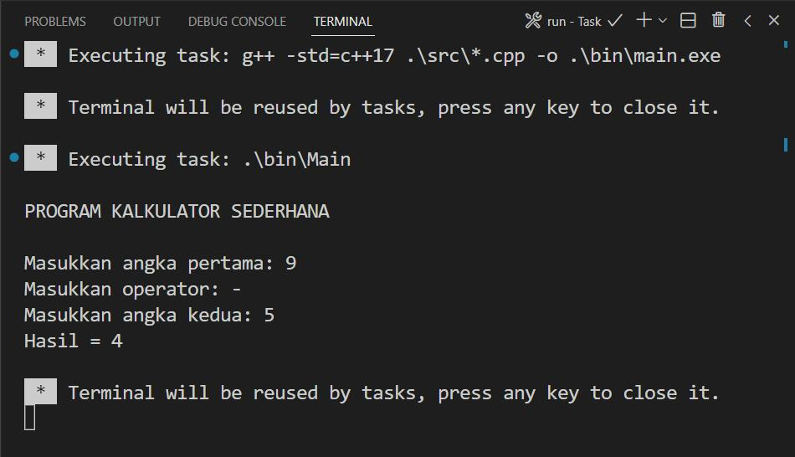
Project 1 — Scientific Calculator
Beginner
Features: Arithmetic, mathematical functions, menus, input validation, and error handling.
Skills: Variables, operators, functions, conditions, loops.
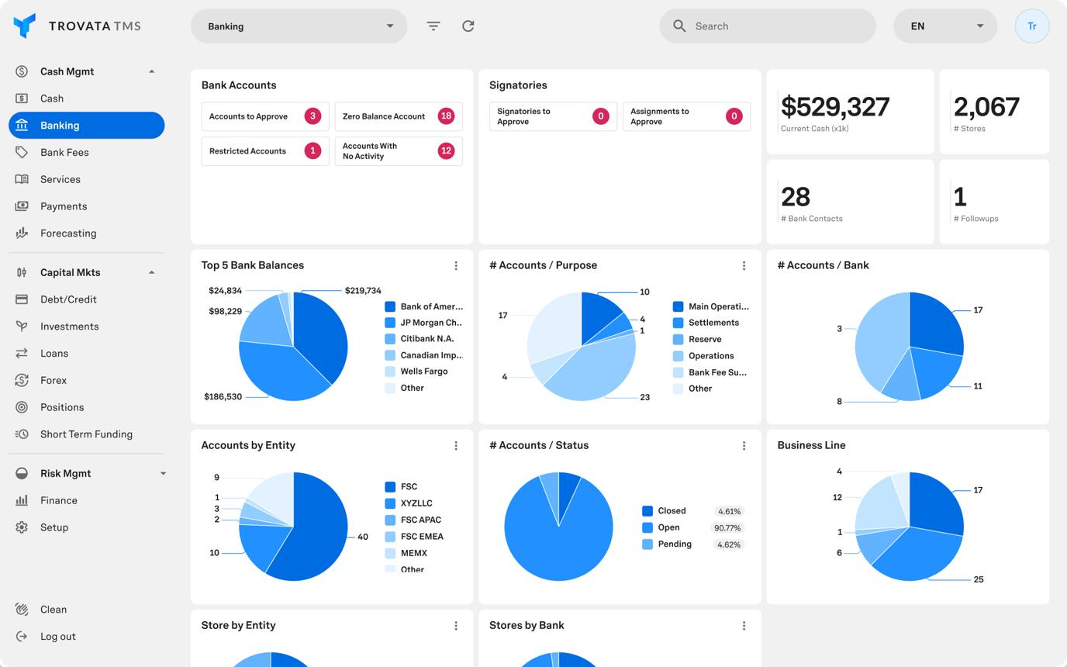
Project 2 — Banking Management System
Beginner–Intermediate
Features: Accounts, deposits, withdrawals, transaction history, and validation.
Skills: Classes, encapsulation, constructors, file handling, and error management.
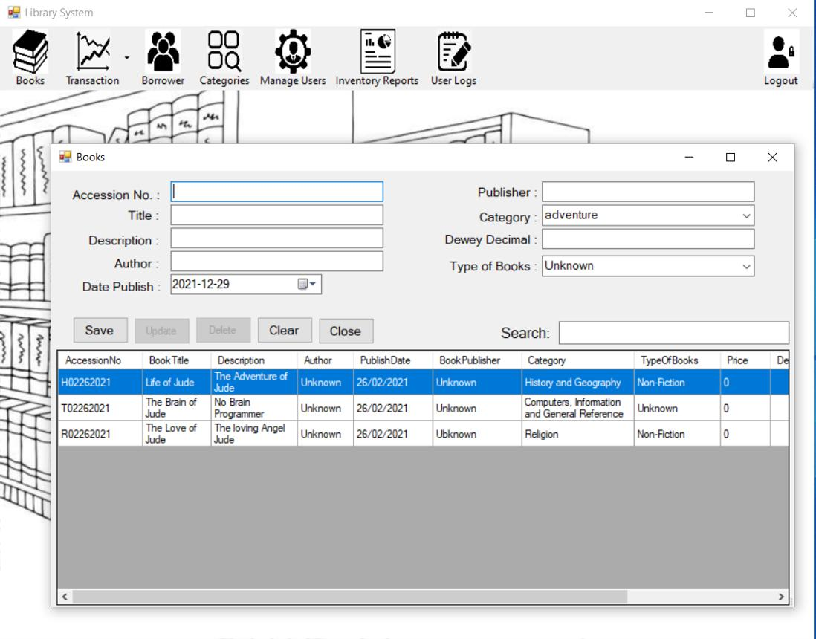
Project 3 — Library Management System
Intermediate
Features: Books, members, issue and return records, search, fines, and persistence.
Skills: OOP, STL containers, file streams, classes, and modular architecture.
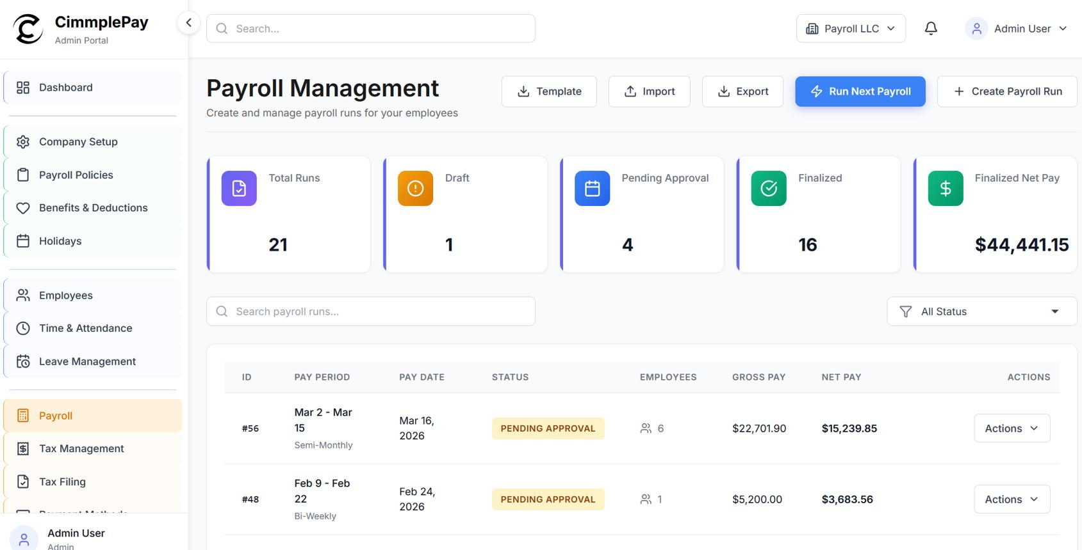
Project 4 — Employee Payroll System
Intermediate
Features: Employee categories, salary calculation, deductions, reports, and file exports.
Skills: Inheritance, polymorphism, operator overloading where appropriate, and testing.
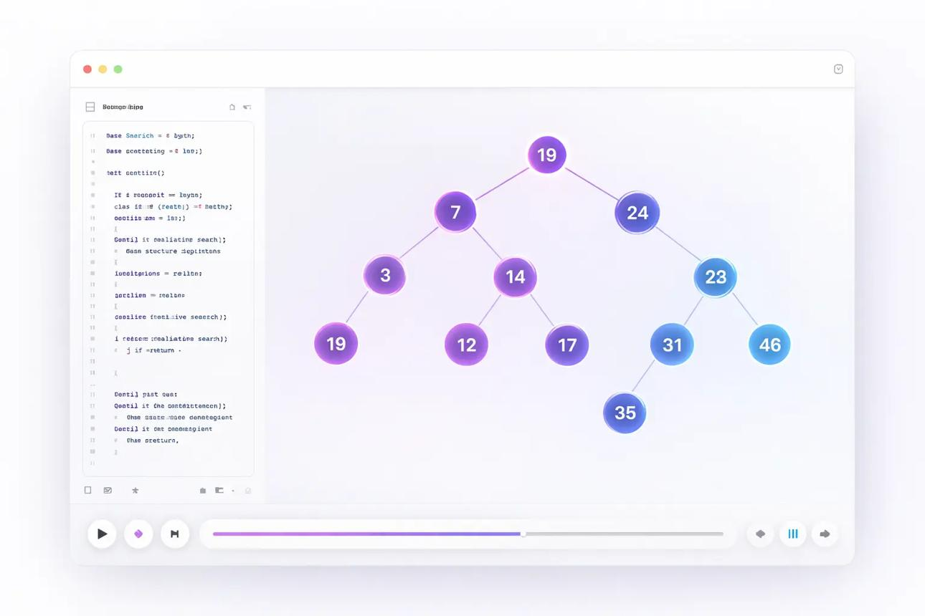
Project 5 — Data Structures and Algorithms Library
Advanced
Features: Reusable containers, search and sorting algorithms, graph traversal, tests, and benchmarks.
Skills: Templates, STL, iterators, algorithms, memory management, and complexity analysis.
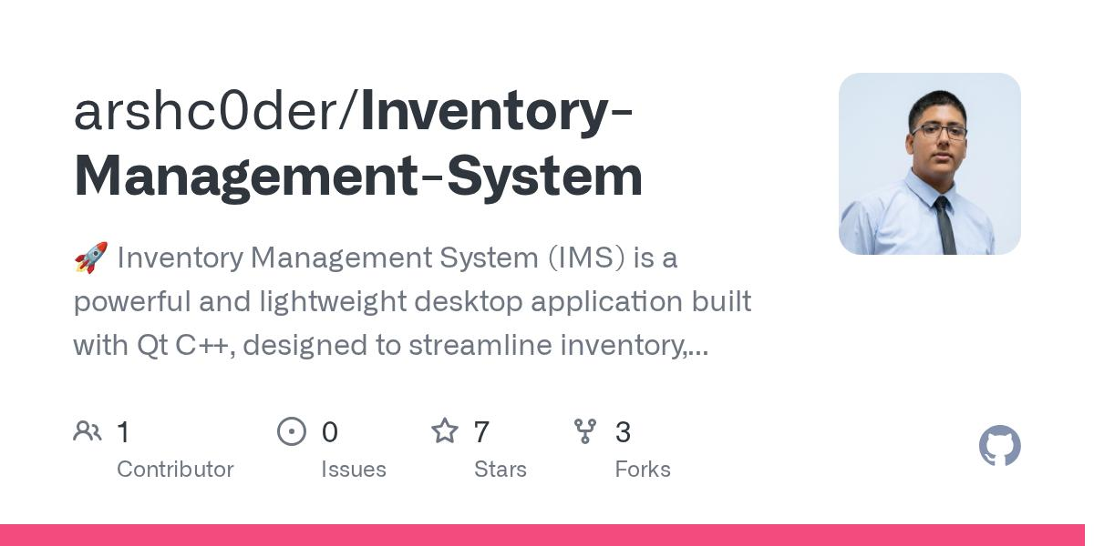
Project 6 — EDVENT Inventory and Institute Management System
Final capstone
Features: Students, courses, products, stock, payments, reports, data persistence, and administrative workflows.
Skills: OOP, STL, resource management, data structures, testing, CMake, Git, and project documentation.

Additional advanced project options
- Text editor: File operations, searching, and text manipulation.
- Log analyzer: File parsing, frequency counting, and reporting.
- Expression evaluator: Tokenization, stacks, operator precedence, and parsing.
- Route planner: Graph representation and shortest-path algorithms.
- Multithreaded task processor: Thread synchronization, queues, and performance measurement.
- Mini memory-managed container library: Dynamic arrays, iterators, allocators, and exception safety.

Capstone acceptance checklist
- Clear problem statement and requirements
- Modular source code and headers
- Appropriate classes, functions, and data structures
- Correct ownership and resource management
- Input validation and meaningful error handling
- Unit tests and relevant integration tests
- Compiler warnings enabled
- No known memory-safety errors
- CMake or Make build instructions
- README and documented usage
- GitHub repository with meaningful commits
- Demonstration and explanation of design decisions

Recommended 28-week learning roadmap
This timeline assumes students are beginners and can dedicate approximately 8–12 hours each week to classes and independent coding.
Weeks 1–2

Fundamentals and setup
Programming logic, compiler installation, basic syntax, variables, data types, and operators.
Weeks 3–4

Input/output and control flow
Streams, conditions, loops, validation, and algorithmic problem-solving.
Weeks 5–6

Functions and modular programming
Parameters, references, recursion, namespaces, headers, and separate compilation.
Weeks 7–8

Arrays and strings
C-style arrays, std::string, std::array, std::vector, and text processing.
Weeks 9–11

Pointers and memory
Pointers, references, dynamic allocation, smart pointers, RAII, and object lifetime.
Weeks 12–14

Object-oriented programming
Classes, constructors, destructors, inheritance, polymorphism, and operator overloading.
Weeks 15–17

STL mastery
Containers, iterators, algorithms, lambdas, custom comparators, and complexity.
Weeks 18–20

Templates and modern C++
Function and class templates, concepts, move semantics, type traits, and C++17/20 features.
Weeks 21–22

Files and error handling
File streams, serialization, exceptions, RAII, and error-handling strategies.
Weeks 23–24

Data structures and algorithms
Linked lists, stacks, queues, trees, hash tables, graphs, and dynamic programming.
Weeks 25–26

Advanced engineering
Concurrency, debugging, testing, security, performance, and CMake.
Weeks 27–28

Capstone and assessment
Build, test, document, demonstrate, and review a complete C++ application.

Student mastery tracker

C++ learning progress
0 of 24 competencies mastered

0%
Fundamentals
Compile and run C++ programs independently
Use data types, operators, and conversions correctly
Write conditions, loops, and functions
Solve basic algorithmic problems
Memory and OOP
Use arrays, strings, and vectors
Understand pointers and references
Design classes with invariants
Use constructors and destructors correctly
Explain inheritance and runtime polymorphism
Modern C++
Use RAII and smart pointers
Understand copy and move semantics
Use STL containers and algorithms
Write and use templates
Use lambdas and modern C++ features
Algorithms
Analyze time and space complexity
Implement sorting and searching
Implement linked lists, stacks, and queues
Understand trees, hash tables, and graphs
Professional development
Handle errors and exceptions safely
Work with files and serialization
Debug with a debugger and sanitizers
Write unit tests
Build a multi-file project with CMake
Complete and document a capstone project
Copy checklistReset
Mark a skill complete after implementing it independently, testing relevant edge cases, and explaining the design decisions.

Official documentation and learning resources
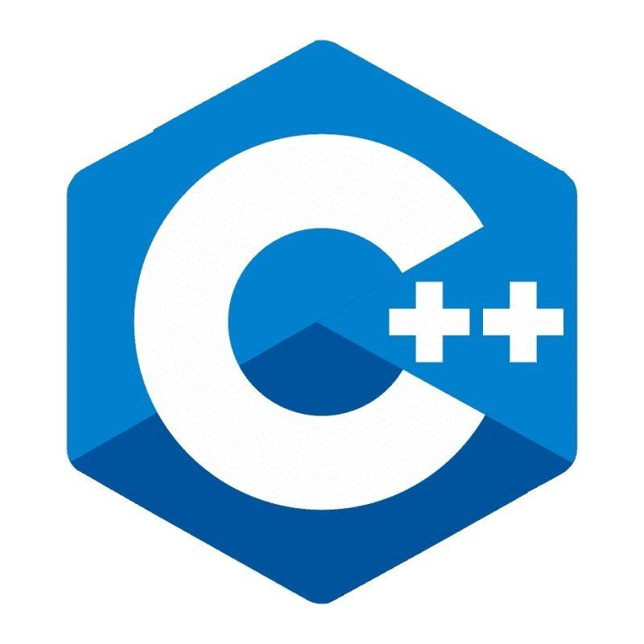
C++ language reference
cppreference — C++
Language features, standard library, examples, and version differences.

GCC
GCC documentation
Compiler options, diagnostics, standards, and optimization.

Microsoft C++
MSVC documentation
C++ development on Windows, language support, and debugging.

Build systems
CMake tutorial

Testing
GoogleTest documentation

Diagnostics and analysis
Clang documentation

Final recommendation for EDVENT
Structure the course around three milestones:
- C++ Programming Foundation: Syntax, control flow, functions, arrays, strings, and basic problem-solving.
- Core and Modern C++: OOP, pointers, RAII, smart pointers, STL, templates, exceptions, and data structures.
- Advanced C++ Development: Modern language features, concurrency, performance, testing, debugging, build systems, and capstone projects.
Give special attention to object lifetime, resource ownership, STL, and modern C++ practices. These are the areas that distinguish contemporary C++ development from simply writing C-style code with classes added. Students should finish with working projects, automated tests, clean Git history, and the ability to explain why their designs are correct—not just programs that produce the expected output.

