EDVENT — Complete Git and GitHub Master Syllabus

Beginner to Advanced | Structured Learning Path
This syllabus is designed for students learning web development, backend development, data analytics, and professional software engineering. It progresses from version-control fundamentals to advanced Git workflows, collaborative GitHub development, code reviews, automation, release management, and portfolio projects.
The objective is for students to confidently manage real projects, collaborate with teams, resolve conflicts, recover from mistakes, and maintain professional GitHub repositories.

1. Course overview

Git — Version control system
Track changes, create branches, merge work, inspect history, recover files, and manage code across different versions.

GitHub — Collaborative development platform
Host Git repositories, collaborate through pull requests, review code, manage issues, automate workflows, and publish project documentation.
Course detail | Recommendation
Target audience | Complete beginners through intermediate developers
Prerequisites | Basic computer usage and file management
Programming prerequisite | None for Git fundamentals
Recommended duration | 8–10 weeks
Practice time | 5–8 hours per week
Tools | Git, GitHub, terminal, VS Code
Primary outcome | Independent Git user and confident GitHub collaborator
Final project | Professional repository with branches, pull requests, releases, and automated checks
Important distinction: Git and GitHub are not the same. Git is the version-control system; GitHub is a platform that hosts Git repositories and adds collaboration, project-management, security, and automation features.

2. Recommended learning sequence
1. Version-control fundamentals
2. Terminal and Git installation
3. Repositories and basic commands
4. Staging, commits, and history
5. Branching and merging
6. GitHub repositories and remotes
7. Collaboration and pull requests
8. Conflict resolution and recovery
9. Advanced Git workflows
10. GitHub Actions, releases, and security
11. Portfolio projects and assessment

Level 0 — Foundations and setup

Module 1. Introduction to version control

1.1 Why version control is needed
- Problems with manually saving files such as final.html, final2.html, and final-final.html
- Tracking changes over time
- Recovering previous versions
- Collaborating without overwriting each other's work
- Understanding project history
- Keeping a record of who changed what and when
- Supporting experimentation without risking the main project

1.2 Types of version control
- Local version control
- Centralized version control
- Distributed version control
- Examples: Git, Subversion (SVN), Mercurial
- Why Git is widely used in software development

1.3 Git terminology
- Repository
- Working directory
- Staging area
- Commit
- Branch
- Merge
- Remote
- Clone
- Fetch
- Pull
- Push
- HEAD
- Hash
- Tag
- Conflict
- Pull request

1.4 Git versus GitHub
- Git as a local version-control tool
- GitHub as a hosted collaboration platform
- Local versus remote repositories
- GitHub alternatives: GitLab and Bitbucket
- GitHub website versus GitHub CLI versus Git integration in editors

Practical exercise
Create a folder with a few sample files and manually change them. Discuss why manually managing versions becomes difficult as the project grows.
Learning outcome: Students can explain why Git exists and distinguish Git from GitHub.

Module 2. Terminal and command-line fundamentals
Git is primarily operated through a command-line interface, so students should learn basic terminal navigation before learning Git commands.

2.1 Essential terminal commands
Command | Purpose
pwd | Show current directory
ls | List files and directories
cd | Change directory
mkdir | Create a directory
touch | Create an empty file on supported systems
cat | Display file contents
cp | Copy files
mv | Move or rename files
rm | Delete files
clear | Clear the terminal screen
Also teach:
- Absolute versus relative paths
- Hidden files
- File extensions
- Paths containing spaces
- Command arguments and flags
- Tab completion
- Quoting paths
- Command history
- Standard output and error at a basic level
Safety lesson: Explain destructive commands before asking students to use rm, git reset --hard, or other commands that can discard work.

Module 3. Installing and configuring Git

3.1 Installation
- Installing Git on Windows
- Installing Git on macOS
- Installing Git on Linux
- Verifying the installation with git --version
- Git Bash versus PowerShell versus Terminal
- Understanding the Git executable

3.2 Initial configuration
- git config
- Setting the user name
- Setting the email address
- Checking configuration values
- System, global, and repository-level configuration
- Configuration precedence
- Default branch name
- Line-ending configuration
- Choosing an editor for commit messages
- Viewing configuration with git config --list
Example:
git config --global user.name "Your Name"
git config --global user.email "you@example.com"
git config --global init.defaultBranch main
Use an email address appropriate for the student's GitHub commits. Students who prefer not to expose their personal email can configure a GitHub-provided private commit email.

3.3 Identity and authentication
- Commit identity versus GitHub account identity
- HTTPS authentication
- Personal access tokens
- SSH keys
- Credential managers
- GitHub CLI authentication
- Why GitHub account passwords should not be used as ordinary Git HTTPS passwords
- Never sharing access tokens or private SSH keys

Practical exercise
Install Git, configure the author identity, verify settings, and make a test commit.

Level 1 — Git fundamentals

Module 4. Creating repositories and understanding Git's workflow

4.1 Creating a repository
- What a repository contains
- Initializing a repository using git init
- Understanding the .git directory
- Cloning an existing repository using git clone
- Initializing Git in an existing project
- Understanding the default branch
- Repository root and subdirectories
- Working with nested folders

4.2 The three main areas in Git
Working directory
Files you create or modify
Staging area / index
Changes selected for the next commit
Local repository
Committed snapshots and history
Remote repositories, such as GitHub, are separate and are synchronized using commands such as fetch, pull, and push.

4.3 Essential commands
- git init
- git clone
- git status
- git add
- git commit
- git diff
- git log
- git show
- git help

4.4 Understanding git status
- Untracked files
- Modified files
- Staged changes
- Unmodified files
- Changes ahead of or behind a remote branch
- Interpreting Git's suggested next steps

4.5 First repository exercise
mkdir git-practice
cd git-practice

git init
echo "# Git Practice" > README.md

git status
git add README.md
git commit -m "Add project README"
git log --oneline
Students should repeat this exercise without looking at the instructions and explain each command in their own words.

Module 5. Staging, commits, and change tracking

5.1 The staging area
- Why Git uses staging
- Staging a new file
- Staging a modified file
- Staging multiple files
- Staging selected changes
- Unstaging files
- Staging versus committing
- Reviewing staged and unstaged changes separately

5.2 Commit fundamentals
- What a commit represents
- Commit messages
- Commit hashes
- Parent commits
- Commit history
- Author and committer information
- Snapshot-based version control
- Why a commit is not simply a list of changed lines

5.3 Essential commit commands
- git add filename
- git add .
- git add -A
- git add -p
- git commit -m "message"
- git commit
- git commit --amend
- git status --short
Teach students to inspect the repository before staging. They should understand what git add . will include rather than running it automatically.

5.4 Commit message conventions
- Clear and specific messages
- Imperative phrasing
- Short subject lines
- Optional detailed commit descriptions
- Avoiding messages such as changes, final, or fix
- Conventional Commits basics:
  - feat:
  - fix:
  - docs:
  - style:
  - refactor:
  - test:
  - chore:
Conventional Commits is a convention, not a requirement imposed by Git.

5.5 Viewing changes
- git diff
- git diff --staged
- git diff HEAD
- git show
- git log -p
- git log --stat
- Comparing files before committing
- Understanding additions, deletions, and context lines

Practical assignment
Create a small HTML/CSS project. Make five meaningful commits, inspect each diff, amend a mistaken commit message, and explain the final history.

Module 6. .gitignore and repository hygiene

6.1 Ignore rules
- What .gitignore does
- Ignore file patterns
- Wildcards and directory patterns
- Ignoring files by extension
- Ignoring generated files
- Root-relative patterns
- Exceptions using !
- Global Git ignore configuration
- OS-specific and editor-specific files

6.2 What should usually be ignored
- node_modules/
- Build output such as dist/
- Temporary files
- Log files
- Local editor settings when not shared
- Local environment files such as .env
- Generated caches
- Operating-system metadata files

6.3 Important limitations
- .gitignore does not remove a file already tracked by Git.
- If a secret is committed, ignoring it later does not erase it from repository history.
- Use git rm --cached when a tracked file should stop being tracked while remaining on disk.
- Exposed credentials must be revoked or rotated, not merely deleted from the latest commit.

Practical assignment
Create a Node.js sample repository with a correct .gitignore, a safe .env.example, and no real credentials.

Level 2 — Git history and branches

Module 7. Understanding Git history

7.1 History inspection
- git log
- git log --oneline
- git log --graph --oneline --all
- git show
- git diff commit1 commit2
- git blame
- git reflog
- git log --author
- git log --since
- git log -- path/to/file

7.2 Git references
- Commit hashes
- Branch names
- Tags
- HEAD
- Parent references
- HEAD~1
- HEAD~2
- HEAD^
- Symbolic references
- Local references versus remote-tracking references

7.3 Comparing versions
- Comparing two commits
- Comparing branches
- Inspecting a specific file's history
- Identifying when a bug was introduced
- Reviewing changes before merging
- Understanding commit ancestry

Practical assignment
Given a repository with several commits, identify which commit introduced a bug and show the exact changed lines.

Module 8. Branching fundamentals

8.1 What branches are
- Branches as movable references to commits
- Why teams use branches
- Main branch versus feature branches
- Isolated experimentation
- Branch naming conventions
- Short-lived versus long-lived branches

8.2 Branch commands
- git branch
- git branch branch-name
- git switch branch-name
- git switch -c branch-name
- git checkout branch-name
- git branch -d branch-name
- git branch -D branch-name
- git branch -m old-name new-name
- git branch --all
- git branch --merged
Prefer git switch for switching branches and git restore for restoring files when teaching modern Git; git checkout remains useful to recognize in existing documentation and repositories.

8.3 Feature-branch workflow
- Start from an up-to-date base branch.
- Create a feature branch.
- Make a small set of changes.
- Stage and commit the work.
- Review the diff.
- Merge or submit a pull request.
- Delete the feature branch when no longer needed.

8.4 Branch naming
Examples:
- feature/student-registration
- fix/login-validation
- docs/setup-guide
- refactor/user-service
- test/payment-api

Practical assignment
Create three feature branches for an existing website. Make separate changes, switch between branches, and explain how each branch maintains its own history.

Module 9. Merging branches

9.1 Merge fundamentals
- What merging means
- Fast-forward merges
- Three-way merges
- Merge commits
- Common ancestors
- Branch divergence
- Merging feature branches into the main branch
- Deleting merged branches

9.2 Merge commands
- git merge branch-name
- git merge --no-ff branch-name
- git merge --abort
- git branch --merged

9.3 Merge conflicts
- Why conflicts occur
- Conflict markers
- <<<<<<<, =======, and >>>>>>>
- Resolving conflicts manually
- Choosing one side versus combining both changes
- Removing conflict markers
- Staging the resolved file
- Completing the merge
- Aborting a merge safely
- Testing after conflict resolution

9.4 Conflict-resolution procedure
- Read git status.
- Open each conflicted file.
- Understand both changes before editing.
- Produce the correct combined result.
- Remove all conflict markers.
- Run relevant tests.
- Stage the resolved files.
- Complete the merge.
- Review the resulting history.

Practical assignment
Have two students change the same lines in separate branches, then merge the branches and resolve the conflict collaboratively.

Level 3 — GitHub fundamentals

Module 10. Introduction to GitHub

10.1 GitHub account and profile
- Creating a GitHub account
- Username and profile URL
- Profile README
- Public versus private repositories
- GitHub profile settings
- Email privacy settings
- Two-factor authentication
- Recovery codes
- Passkeys and other supported authentication options
- Personal access tokens and their permissions

10.2 GitHub interface
- Dashboard
- Repository home page
- Code tab
- Issues
- Pull requests
- Actions
- Projects
- Wiki
- Releases
- Insights
- Settings
- Notifications
- Search and navigation

10.3 Repository creation
- Creating a repository on GitHub
- Repository name and description
- Public versus private visibility
- Initializing with a README
- Adding a .gitignore
- Choosing a license
- Creating a repository with no initial files
- Repository naming conventions
- Repository settings and permissions

10.4 README writing
- Project title
- Project purpose
- Feature list
- Screenshots
- Installation instructions
- Configuration requirements
- Usage examples
- API documentation
- Technology stack
- Contribution guidelines
- License
- Contact or support information

10.5 Markdown for GitHub
- Headings
- Paragraphs and line breaks
- Bold and italic formatting
- Ordered and unordered lists
- Links and images
- Code spans and code blocks
- Tables
- Task lists
- Blockquotes
- Relative links
- Anchors
- Alerts where supported
- Mermaid diagrams where supported
- Basic HTML support and its limitations

Practical assignment
Create a public repository for a small project with a professional README, screenshots, installation steps, and a license appropriate to the project.

Module 11. Connecting Git to GitHub

11.1 Local repository to remote repository
- What a remote is
- origin
- Adding a remote
- Inspecting remote URLs
- HTTPS versus SSH
- Authentication
- Pushing an existing repository
- Cloning a remote repository
- Changing a remote URL

11.2 Essential commands
git remote -v
git remote add origin <repository-url>
git remote set-url origin <repository-url>

git push -u origin main
git clone <repository-url>
git fetch origin
git pull origin main
Students should replace the placeholder URL with their own repository URL.

11.3 Understanding remotes
- Local branch versus remote branch
- Remote-tracking branches such as origin/main
- Upstream tracking
- First push with -u
- Push versus fetch
- Fetch versus pull
- Push rejection
- Non-fast-forward errors
- Diverged branches
- Synchronizing safely

11.4 Common mistakes
- Pushing the wrong branch
- Creating unrelated local and remote histories
- Forgetting to fetch recent changes
- Using force-push without understanding its impact
- Authentication failures
- Pushing secrets or generated files
- Accidentally making a private project public

Practical assignment
Create a repository locally, connect it to GitHub, push the main branch, clone it into another directory, make a change, and synchronize both copies.

Module 12. GitHub collaboration and permissions

12.1 Collaboration models
- Working alone
- Collaborator-based access
- Organization repositories
- Team-based permissions
- Fork-based collaboration
- Open-source contribution workflow
- Repository ownership and responsibility

12.2 Permissions
- Read
- Triage
- Write
- Maintain
- Admin
- Organization roles
- Team permissions
- Repository visibility
- Branch protection and rulesets
- Least-privilege access

12.3 Forking
- What a fork is
- Fork versus clone
- Forking a public repository
- Cloning a fork
- Configuring origin and upstream
- Fetching upstream changes
- Synchronizing a fork
- Contributing back through a pull request

Practical assignment
One student creates a repository and another contributes through a fork. Both students should explain which repository is their origin and which is upstream.

Level 4 — Professional collaboration workflow

Module 13. Pull requests

13.1 Pull request fundamentals
- What a pull request (PR) is
- Why teams use pull requests
- Source and target branches
- Opening a PR
- PR titles and descriptions
- Draft pull requests
- Reviewers and assignees
- Labels
- Linking issues
- Reviewing changed files
- Updating a PR after feedback
- Merging a PR
- Closing a PR without merging

13.2 Pull request review process
- Reviewing the diff
- Understanding context before commenting
- Leaving inline comments
- Requesting changes
- Approving changes
- Resolving review conversations
- Re-requesting reviews after updates
- Handling stale approvals according to repository rules
- Testing changes locally
- Giving constructive feedback

13.3 Merge methods on GitHub
- Merge commit
- Squash and merge
- Rebase and merge
- Choosing a merge strategy
- Preserving meaningful history
- Branch deletion after merge
- Keeping the base branch up to date

13.4 PR best practices
- Small, focused pull requests
- Clear scope and motivation
- Screenshots for UI changes
- Test instructions
- Breaking-change notes
- Security considerations
- Linking issues
- Avoiding unrelated formatting changes
- Waiting for required checks
- Keeping review conversations professional

Practical assignment
Students submit a feature through a pull request. A reviewer checks the code, requests one change, and approves the updated PR.

Module 14. Issues and project management

14.1 GitHub Issues
- Creating an issue
- Writing a reproducible bug report
- Feature requests
- Tasks and technical debt
- Labels
- Assignees
- Milestones
- Issue templates
- Closing issues automatically through supported keywords in commits or PRs

14.2 GitHub Projects
- Boards and tables
- Status fields
- Priority and estimates
- Views and filters
- Grouping and sorting
- Iterations and milestones
- Linking issues and PRs
- Tracking project progress
- Basic sprint planning

14.3 Project workflow
- Breaking features into issues
- Assigning ownership
- Branching from an issue
- Linking the PR to the issue
- Testing and review
- Closing the issue
- Tracking incomplete work

Practical assignment
Create a project board for a student management application, add 10 issues, assign owners, and close issues through completed pull requests.

Module 15. Team workflows and branching strategies

15.1 GitHub Flow
- Main branch kept deployable
- Short-lived feature branches
- Pull requests
- Automated checks
- Review and merge
- Deployment after merge
- When GitHub Flow is suitable

15.2 Git Flow
- Main and develop branches
- Feature branches
- Release branches
- Hotfix branches
- Release tagging
- Workflow complexity
- When this model is appropriate and when it is unnecessarily complicated

15.3 Trunk-based development
- Small changes
- Short-lived branches
- Frequent integration
- Feature flags
- Automated testing
- Minimizing long-running divergence

15.4 Choosing a workflow
- Team size
- Release frequency
- Testing maturity
- Product risk
- Support for multiple versions
- Continuous delivery requirements
Teaching recommendation: Start with GitHub Flow. Introduce Git Flow and trunk-based development as alternatives, not mandatory steps every team must adopt.

Level 5 — Recovering from mistakes and advanced Git

Module 16. Undoing changes safely
This is one of the most important modules. Students should learn the difference between modifying the working directory, changing the staging area, and rewriting committed history.

16.1 Undoing uncommitted changes
- Discarding changes in one file
- Unstaging a file
- Restoring a deleted file
- Discarding all local changes
- Understanding destructive operations
- Recovering an accidentally overwritten file where possible
Commands to learn:
- git restore filename
- git restore --staged filename
- git diff
- git status

16.2 Undoing commits
- git commit --amend
- git revert
- git reset --soft
- git reset --mixed
- git reset --hard
- Understanding what each operation changes
- Recovering commits with git reflog
- Public history versus private local history

16.3 Reset versus revert
Operation | Main purpose | Effect on history
git reset --soft | Move branch pointer while keeping changes staged | Rewrites local branch history
git reset --mixed | Move branch pointer and leave changes unstaged | Rewrites local branch history
git reset --hard | Move branch pointer and discard tracked working-tree changes | Rewrites local branch history; potentially destructive
git revert | Create a new commit that reverses an earlier commit | Preserves existing history
Teach students to prefer git revert when undoing changes already shared with a team, unless the team has explicitly agreed on a different history-rewriting procedure.

16.4 Recovering mistakes
- Accidentally deleting a branch
- Losing a commit after reset
- Reflog basics
- Recovering a previous branch position
- Aborting a merge
- Aborting a rebase
- Recovering a stashed change
- When recovery may be impossible
- Avoiding risky cleanup commands until work is backed up

Practical assignment
Create a test repository, intentionally make five mistakes, and recover from each using the correct command. Students must explain the difference between undoing a change and rewriting history.

Module 17. Stashing changes

17.1 Stash fundamentals
- What a stash is
- Temporarily setting work aside
- Stashing tracked changes
- Including untracked files
- Naming stashes
- Listing stashes
- Applying a stash
- Popping a stash
- Dropping a stash
- Clearing stashes and the risks involved

17.2 Stash commands
git stash
git stash push -m "Work in progress"
git stash list
git stash show -p
git stash apply
git stash pop
git stash drop

17.3 Practical scenarios
- Switching branches while work is incomplete
- Applying a stash to another branch
- Resolving conflicts when applying a stash
- Recovering from an accidental stash drop where possible
- When a temporary commit is better than a stash

Module 18. Rebasing and rewriting history

18.1 Rebase fundamentals
- What rebasing does
- Replaying commits onto a new base
- Rebase versus merge
- Linear history
- Commit ancestry
- Why commit hashes change during rewriting
- Rebase conflicts
- Continuing and aborting a rebase

18.2 Essential commands
git fetch origin
git rebase origin/main
git rebase --continue
git rebase --abort

18.3 Interactive rebase
- git rebase -i
- Reordering commits
- Squashing commits
- Fixing up commits
- Rewording messages
- Dropping commits
- Editing commits
- Splitting commits conceptually
- Cleaning up local feature-branch history

18.4 Important safety rules
- Avoid rebasing shared commits without team agreement.
- Rebase is not a substitute for understanding merge conflicts.
- Do not force-push to shared branches casually.
- If rewriting your own remote feature branch is necessary, understand --force-with-lease before using it.
- Protect important work before performing history-rewriting operations.

Practical assignment
Create a feature branch with poorly organized commits, clean up its local history through interactive rebase, and merge the resulting branch into the main branch.

Module 19. Cherry-picking commits

19.1 Concepts
- What cherry-picking does
- Applying a specific commit to another branch
- Cherry-picking one commit
- Cherry-picking multiple commits
- Resolving conflicts
- Continuing or aborting a cherry-pick
- Avoiding duplicate or confusing history

19.2 Commands
git cherry-pick <commit-hash>
git cherry-pick --continue
git cherry-pick --abort

19.3 Real-world use cases
- Applying a bug fix to a release branch
- Moving a small fix between branches
- Backporting security fixes
- Why merging or rebasing the whole branch may be more appropriate in other cases

Module 20. Tags and releases

20.1 Git tags
- Lightweight tags
- Annotated tags
- Semantic versioning
- Version numbering
- Creating tags
- Listing tags
- Inspecting tags
- Deleting tags
- Pushing tags to a remote
- Checking out a tagged version

20.2 GitHub Releases
- Creating a release from a tag
- Release title and description
- Release notes
- Draft releases
- Pre-releases
- Attaching binaries and artifacts
- Linking changes to merged pull requests
- Release history
- Versioning a project
- Rollback planning

Practical assignment
Release version v1.0.0 of a sample project with a changelog, tag, and GitHub Release page.

Level 6 — Git internals and advanced workflows

Module 21. How Git works internally

21.1 Git object model
- Blob objects
- Tree objects
- Commit objects
- Annotated tag objects
- Object hashes
- Object relationships
- Snapshot model
- Content-addressable storage
- Object database
- .git/objects
- References and branch pointers

21.2 Internal inspection commands
- git cat-file
- git ls-tree
- git rev-parse
- git show-ref
- git count-objects
- git fsck
- git reflog
Students should understand these commands conceptually and use them in practice exercises rather than memorize them all.

21.3 Git's index
- What the index stores
- Staging entries
- Staged content versus working-tree content
- Partial staging
- Index and commit snapshots
- Inspecting the index conceptually

21.4 Git storage and maintenance
- Loose objects and packfiles
- Compression
- Garbage collection
- Object reachability
- Dangling objects
- Repository integrity
- Why .git should not be manually edited

Module 22. Fetching, pulling, and synchronizing

22.1 Remote synchronization
- git fetch
- git pull
- git push
- Remote-tracking branches
- Upstream tracking
- Local versus remote history
- Divergent branches
- Fast-forward updates
- Fetching a specific branch
- Pruning deleted remote-tracking branches

22.2 Pull strategies
- Pull using merge
- Pull using rebase
- Fast-forward-only pulls
- Configuring default pull behavior
- Resolving divergence
- Reviewing remote changes before integration

22.3 Practical workflow
git status
git fetch origin
git log --oneline --graph --all
git diff main origin/main
git pull --ff-only origin main
Explain that the last command succeeds only when a fast-forward is possible. If local and remote histories have diverged, students should inspect the situation before choosing a merge or rebase strategy.

Module 23. Advanced repository management

23.1 Multiple repositories and branches
- Multiple remotes
- Forks and upstream repositories
- Tracking branches
- Branch pruning
- Renaming branches
- Deleting local and remote branches
- Recovering deleted branches
- Working with multiple versions of a project

23.2 Special Git features
- Submodules
- Subtrees
- Sparse checkout
- Partial clone concepts
- Shallow clones
- Worktrees
- Large File Storage (Git LFS)
- Monorepos versus multiple repositories
- When these features are useful and when they introduce unnecessary complexity

23.3 Git worktrees
- Why worktrees are useful
- Adding a worktree
- Switching between branches without repeatedly changing one working directory
- Removing a worktree
- Worktree limitations
- Avoiding duplicate worktree management mistakes

23.4 Large repositories
- Large files and binary assets
- Why large files can slow cloning
- Git LFS fundamentals
- Ignoring generated assets
- Repository size management
- Shallow clones in CI
- Build artifacts versus source files

Module 24. Advanced conflict resolution

24.1 Complex conflicts
- Conflicts during merge
- Conflicts during rebase
- Conflicts during cherry-pick
- Rename conflicts
- Delete/modify conflicts
- File mode conflicts
- Binary file conflicts
- Multiple conflict regions
- Understanding the common ancestor

24.2 Advanced tools
- git mergetool
- git diff --merge
- git diff --ours
- git diff --theirs
- git rerere (reuse recorded resolution)
- Three-way comparison tools
- VS Code merge editor
- Testing after conflict resolution

24.3 Team conflict-management practices
- Communicating before overlapping changes
- Keeping feature branches current
- Breaking work into smaller pull requests
- Avoiding unrelated changes in a branch
- Documenting non-obvious conflict decisions

Level 7 — GitHub Actions and automation

Module 25. GitHub Actions fundamentals

25.1 Core concepts
- What CI/CD means
- Workflows
- Workflow YAML
- Events and triggers
- Jobs
- Steps
- Runners
- Actions
- Artifacts
- Workflow logs
- Workflow permissions
- Secrets and variables

25.2 Common triggers
- Push
- Pull request
- Manual execution using workflow_dispatch
- Scheduled workflows
- Release publication
- Issues and other GitHub events

25.3 Workflow syntax
- .github/workflows/
- Workflow names
- on
- jobs
- runs-on
- steps
- uses
- run
- with
- env
- Job dependencies
- Conditional execution
- Matrix builds
- Reusable workflows
- Workflow concurrency

25.4 First CI workflow
Example: a basic Node.js workflow that installs dependencies and runs the project's test script.
name: Node.js CI

on:
push:
branches: [main]
pull_request:
branches: [main]

permissions:
contents: read

jobs:
test:
runs-on: ubuntu-latest

steps:
- name: Checkout repository
uses: actions/checkout@v4

- name: Set up Node.js
uses: actions/setup-node@v4
with:
node-version: 22
cache: npm

- name: Install dependencies
run: npm ci

- name: Run tests
run: npm test
This is an instructional example. For production course material, use current supported action versions and the Node.js version selected for the project. The workflow also assumes that the repository has a valid lockfile and a working test script.

Module 26. CI/CD pipelines

26.1 Continuous integration
- Automatic linting
- Formatting checks
- Unit tests
- Integration tests
- Build verification
- Type checking
- Dependency auditing
- Pull request status checks
- Required checks before merge

26.2 Continuous delivery and deployment
- Build artifacts
- Deployment environments
- Staging versus production
- Environment protection rules
- Approval requirements
- Deployment secrets
- Release-based deployment
- Rollback planning
- Smoke tests
- Deployment status reporting

26.3 Practical assignment
Create a workflow that runs tests on pull requests, blocks merging when required checks fail, and publishes a release artifact after a successful release process.

Module 27. GitHub Actions security and optimization
- Least-privilege workflow permissions
- Pinning third-party actions to verified commit SHAs for stronger supply-chain control
- Avoiding untrusted input in shell commands
- Secrets versus ordinary variables
- Preventing secret exposure in logs
- Dependabot for dependency updates
- Avoiding unsafe pull_request_target patterns
- Protecting deployment credentials
- Reusable workflows
- Caching dependencies
- Matrix testing across versions
- Workflow concurrency and cancellation
- Monitoring failed workflows
- Cost and execution limits

Level 8 — GitHub security and open-source contribution

Module 28. Repository security

28.1 Account and repository security
- Two-factor authentication
- Passkeys and recovery options
- Personal access token permissions
- SSH key management
- Organization access controls
- Repository visibility
- Branch protection rules
- Rulesets
- Required reviews
- Required status checks
- Signed commits as an optional integrity measure

28.2 Secret management
- Recognizing secrets
- .env and configuration files
- GitHub secret scanning
- Push protection where available
- Removing credentials from the current working tree
- Revoking leaked credentials
- History rewriting for sensitive-data cleanup
- Coordinating history rewrites with collaborators
- Why rewriting history alone does not guarantee a leaked secret is safe

28.3 Dependency security
- Dependency review
- Dependabot alerts
- Dependabot security updates
- Dependency lockfiles
- Vulnerability remediation
- Software supply-chain risks
- Reviewing third-party GitHub Actions
- Software bill of materials (SBOM) concepts
- License compatibility

Module 29. Open-source contribution workflow

29.1 Finding projects
- GitHub search
- Repository topics
- Labels such as good first issue
- help wanted issues
- Contribution guidelines
- Project activity
- License and code of conduct
- Selecting an appropriate beginner task

29.2 Making a contribution
- Read the README and contribution guide.
- Find an appropriate issue or discuss a proposed change.
- Fork the repository if required.
- Clone your fork.
- Create a feature branch.
- Make a focused change.
- Run tests and checks.
- Commit with a clear message.
- Push the branch to your fork.
- Open a pull request.
- Respond to review feedback.
- Update the PR until it is accepted or closed.

29.3 Open-source etiquette
- Avoid duplicate issues
- Explain the problem before proposing a solution
- Follow project conventions
- Keep contributions focused
- Respect maintainers' time
- Be professional in discussions
- Respect licenses and attribution
- Do not claim someone else's work as your own

Practical assignment
Submit a documentation improvement or small code contribution to a suitable public repository. If an external PR is not accepted, students can still demonstrate the full workflow in a practice repository.

Level 9 — Professional GitHub portfolio and repository administration

Module 30. Professional repository standards

30.1 Repository documentation
- Writing a clear README
- Adding a license
- Contribution guidelines
- Code of conduct
- Security policy
- Changelog
- Release notes
- Installation and setup instructions
- Configuration examples
- Architecture diagrams
- API documentation
- Troubleshooting section

30.2 Repository templates and conventions
- Issue templates
- Pull request templates
- CONTRIBUTING.md
- CODE_OF_CONDUCT.md
- SECURITY.md
- CHANGELOG.md
- .github/ directory
- Commit message conventions
- Branch naming standards
- Code review checklist

30.3 GitHub Pages
- What GitHub Pages is
- Publishing static websites
- Repository and user/organization sites
- Selecting the publishing source
- Custom domains
- HTTPS
- Build and deployment options
- Static-site limitations
- Why GitHub Pages is not a general-purpose Node.js backend host
- Avoiding accidental publication of sensitive files

30.4 GitHub Packages and container registry
- Package registry concepts
- Publishing packages
- Package visibility and permissions
- Versioning
- Package documentation
- Container images
- GitHub Container Registry
- Basic image publishing through Actions
- Using packages in CI/CD

Module 31. GitHub administration and collaboration at scale

31.1 Organizations and teams
- Personal repositories versus organization repositories
- Organization membership
- Team creation
- Team permissions
- Repository access
- Outside collaborators
- Organization policies
- Access reviews
- Least-privilege administration

31.2 Repository governance
- Branch protection
- Rulesets
- Required approvals
- CODEOWNERS
- Required checks
- Merge restrictions
- Signed commit requirements where appropriate
- Restricting force pushes
- Preventing branch deletion
- Repository archiving
- Transfer of repository ownership

31.3 GitHub Discussions and Wiki
- When to use Issues versus Discussions
- Q&A and community discussions
- Wiki pages
- Documentation ownership
- Knowledge sharing
- Moderation basics
- Keeping documentation current

31.4 Insights and repository analytics
- Commit activity
- Contributors
- Traffic data where available
- Forks and stars
- Pull request metrics
- Issue activity
- Release cadence
- Code frequency
- Limitations of popularity metrics
- Measuring project health rather than vanity metrics

Level 10 — Git for different development careers
This module helps EDVENT students apply Git and GitHub to the specific field they are learning.

Module 32. Git for frontend development
- Branching for UI features
- Tracking HTML, CSS, JavaScript, React, and Next.js code
- Managing assets
- .gitignore for frontend frameworks
- Lockfiles and reproducible installations
- Reviewing UI changes through PRs
- Screenshots and preview deployments
- Environment variables for frontend applications
- Keeping API keys out of browser-exposed code
- CI for linting, tests, and builds
- Managing generated build output
Project: Develop an EDVENT website with feature branches, code reviews, a README, and a deployment workflow.

Module 33. Git for backend development
- Managing Node.js and Express applications
- Tracking MongoDB schema and migration scripts
- .env.example versus .env
- Dependency lockfiles
- API tests
- Branches for endpoint development
- Pull requests for security-sensitive changes
- GitHub Actions for testing
- Deployment workflows
- Database migration considerations
- Secret rotation and incident response
Project: Develop a REST API with branches for authentication, database integration, and testing. Require CI checks before merging.

Module 34. Git for data analytics and Python
- Tracking Python scripts and notebooks
- Using .gitignore for virtual environments
- Managing requirements.txt or pyproject.toml
- Tracking data-cleaning scripts
- Keeping sensitive data out of repositories
- Handling large datasets
- Git LFS concepts
- Data versioning concepts and tools
- Notebook diffs and review limitations
- Tracking SQL queries and dashboard documentation
- Reproducibility and project READMEs
Project: Publish a data analytics project with documented datasets, cleaning scripts, requirements, and reproducible steps.

Practical projects and assessments
Students should demonstrate skills through progressively harder tasks.

Project 1 — Personal portfolio repository
Beginner
Create a repository, commit HTML/CSS files, maintain a README, publish a static site, and practise recovering a deleted file.
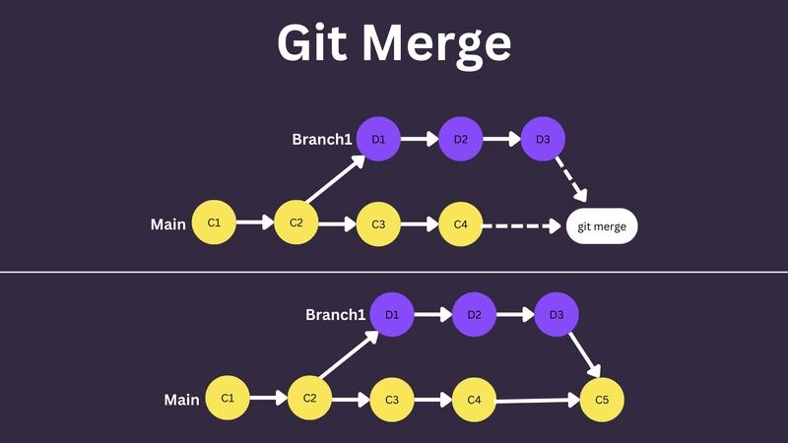
Project 2 — Branching and merge-conflict lab
Beginner–Intermediate
Simulate two developers changing the same files, resolve conflicts, inspect history, and merge the changes safely.
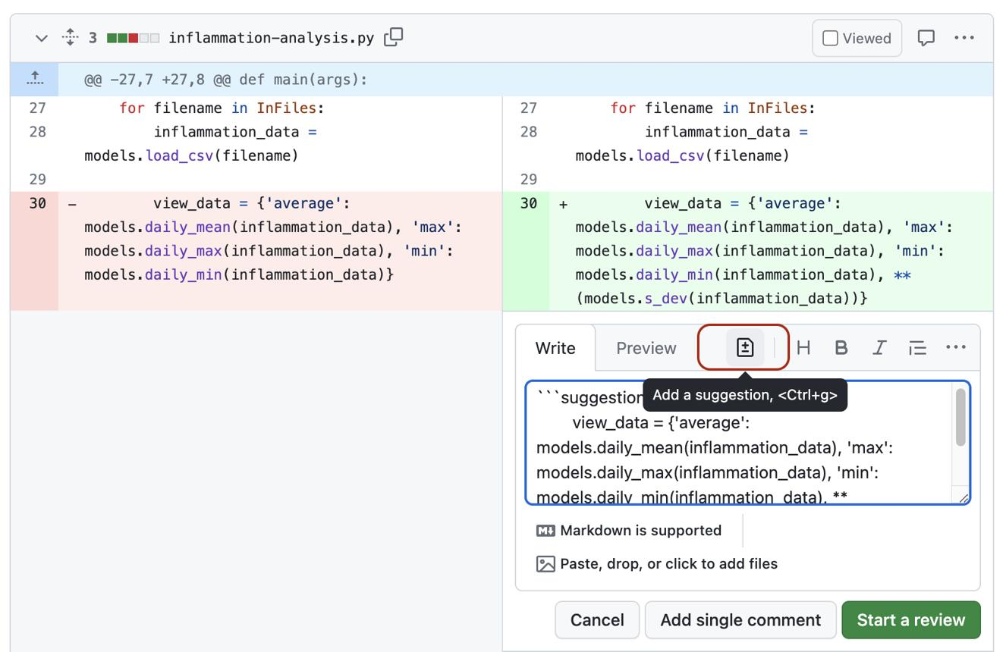
Project 3 — Collaborative web application
Intermediate
Use separate feature branches, GitHub Issues, pull requests, code reviews, labels, and required CI checks.
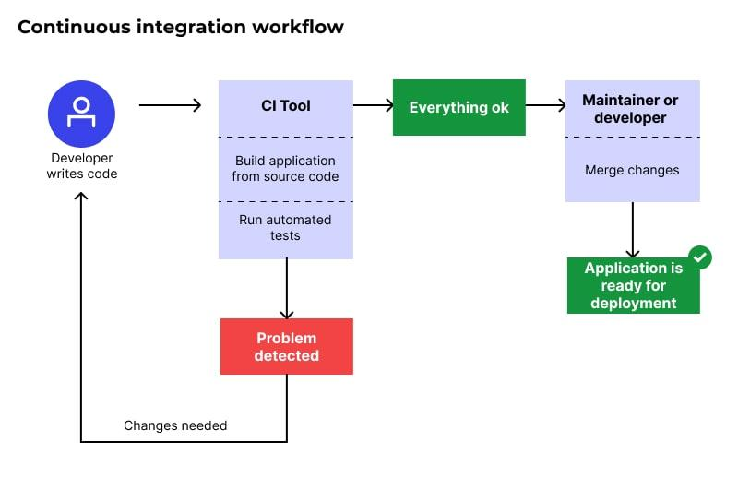
Project 4 — Automated testing pipeline
Intermediate–Advanced
Configure GitHub Actions to install dependencies, run tests, check code quality, and report failed builds.
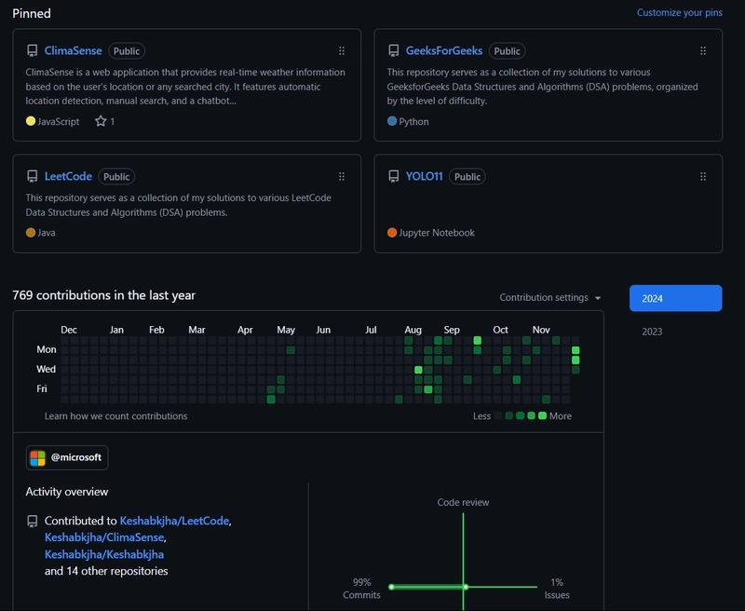
Project 5 — Professional GitHub portfolio
Final assessment
Publish three polished repositories, create tagged releases, document setup instructions, configure security features, and demonstrate a collaborative workflow.

Final assessment rubric
Assessment area | Weight
Git commands and repository fundamentals | 15%
Staging, commits, and history | 10%
Branching, merging, and conflict resolution | 15%
GitHub repositories and remotes | 10%
Pull requests and collaboration | 15%
Recovery and advanced Git operations | 10%
GitHub Actions and security | 10%
Documentation and final project | 15%
Total | 100%
Recommended pass standard: 70%, with practical demonstrations required for conflict resolution, safe recovery, pull requests, and repository security.

Recommended 10-week learning roadmap
For EDVENT, use this sequence so that students master the fundamentals before moving into advanced commands and GitHub automation.
Week 1

Version control and setup
Version-control concepts, terminal basics, installation, Git configuration, repository initialization.
Deliverable: Create the first local repository.
Week 2

Staging and commits
Working tree, staging, commits, diffs, history, `.gitignore`, commit messages.
Deliverable: Build a project with meaningful commit history.
Week 3

Branches and merges
Branch creation, switching, merging, fast-forward and three-way merges, conflict resolution.
Deliverable: Complete a branching and conflict lab.
Week 4

GitHub fundamentals
Account security, repositories, remotes, clone, push, pull, fetch, README and Markdown.
Deliverable: Publish a documented project.
Week 5

Collaboration
Forks, upstream, pull requests, reviews, Issues, Projects, GitHub Flow.
Deliverable: Complete a collaborative pull request.
Week 6

Recovery and advanced Git
Restore, reset, revert, stash, reflog, cherry-pick, rebase, tags.
Deliverable: Recover from deliberately introduced mistakes.
Week 7

Professional workflow
Branching strategies, releases, changelogs, repository standards, code review.
Deliverable: Prepare a versioned release.
Week 8

GitHub Actions
YAML, workflows, runners, CI, automated tests, secrets and workflow permissions.
Deliverable: Automate checks on pull requests.
Week 9

Security and advanced GitHub
Branch protection, rulesets, dependency security, open-source contribution, organization permissions.
Deliverable: Harden a practice repository.
Week 10

Portfolio and final assessment
End-to-end collaborative workflow, documentation, release, testing, presentation.
Deliverable: Submit the final GitHub portfolio.

Daily practice routine
For a 60–90 minute session:
- 15 minutes: Review previously learned commands.
- 20 minutes: Learn one new concept.
- 30–40 minutes: Perform hands-on exercises.
- 10 minutes: Explain what happened and document mistakes.
Do not make students memorize every command. Make them predict what a command will do, inspect the repository state, execute it, and verify the result.

Interactive student mastery checklist

Git and GitHub progress
0 of 29 skills mastered

0%
Foundation
Explain Git versus GitHub
Use terminal navigation commands
Install and configure Git
Create and clone repositories
Core Git
Understand working tree, staging area, and commits
Stage selected changes and review diffs
Write meaningful commit messages
Configure .gitignore correctly
Inspect and compare repository history
Branches
Create and switch branches
Merge branches
Resolve merge conflicts
Explain merge versus rebase
Use stash, revert, reset, and reflog safely
GitHub
Create and publish repositories
Configure remotes and synchronize branches
Fork and contribute through a pull request
Review code and respond to feedback
Use Issues, Projects, and Markdown
Advanced workflow
Use tags and create releases
Use cherry-pick and interactive rebase
Explain Git internals at a basic level
Set up GitHub Actions CI
Configure repository rules and security
Portfolio
Publish a professional README
Maintain a clean commit history
Demonstrate a collaborative workflow
Complete a project with automated checks
Explain and demonstrate recovery from mistakes
Copy checklistReset
Mark a skill complete only after demonstrating it in a repository, not just watching a tutorial.

Official resources

Git documentation
Official Git reference
Pro Git book — free online

GitHub learning
GitHub Docs
GitHub Skills interactive courses
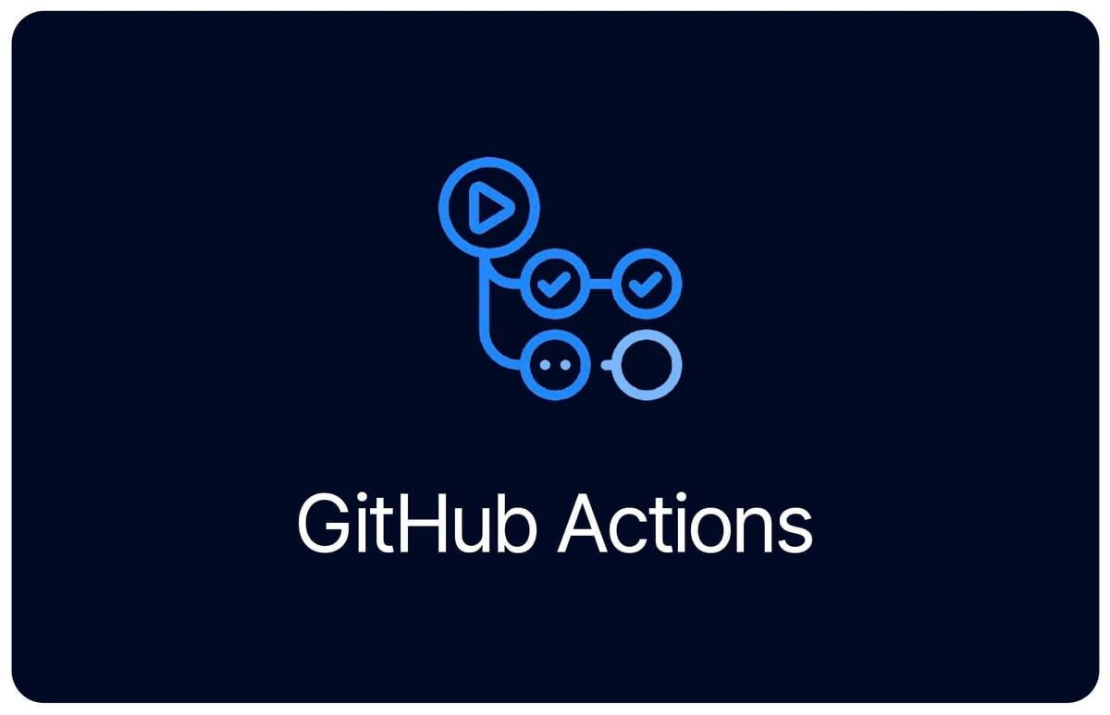
Automation
GitHub Actions documentation
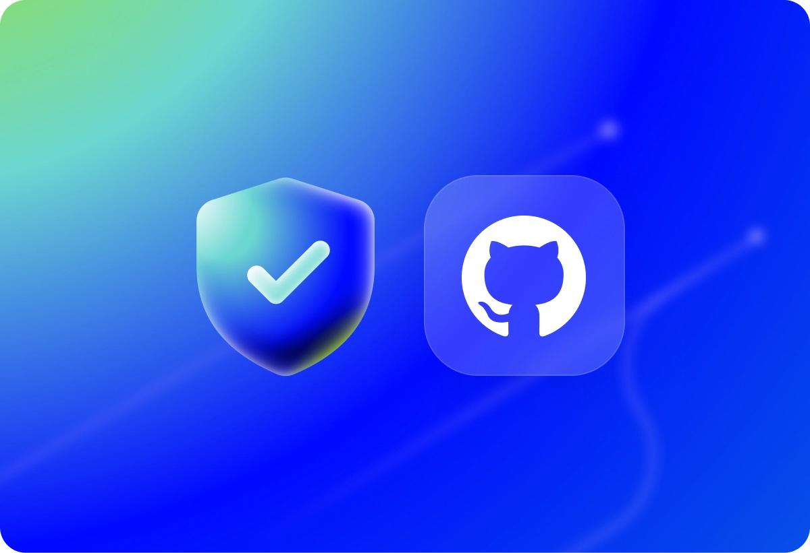
Security
GitHub security documentation

Final recommendation
For EDVENT's students, make Git fundamentals and collaborative GitHub workflows compulsory before students begin serious React, Node.js, or data analytics projects. Teach advanced Git internals, interactive rebase, submodules, and complex CI/CD only after students can confidently create branches, commit changes, resolve conflicts, open pull requests, and recover from mistakes.
The course is successful when students can independently contribute to a shared repository and explain exactly how their changes move from a local working directory to a reviewed, tested, and released project.

