HTML — Complete In-Depth Master Syllabus
This syllabus takes you from absolute beginner to advanced HTML developer. It covers HTML document structure, every major category of HTML elements, semantic markup, forms, tables, media, accessibility, SEO fundamentals, modern HTML APIs, validation, and professional website-building projects.
HTML is the foundation of frontend development. Since you're building your computer education curriculum under EDVENT, this structure can also serve as a teaching syllabus for students learning web development.
Important: HTML is a markup language, not a programming language. Learn it alongside CSS for styling and JavaScript for interactivity. The syllabus focuses on modern HTML, primarily HTML Living Standard features supported by current browsers. Some APIs and elements have varying browser support.

Complete learning roadmap

01
Web Fundamentals
Internet, browsers, URLs, HTTP and how HTML works

02
HTML Setup & Structure
Editors, files, document structure, elements and attributes

03
Text & Content Elements
Headings, paragraphs, formatting, quotations and code

04
Links & Navigation
Hyperlinks, paths, anchors and navigation structures

05
Lists, Tables & Media
Lists, data tables, images, audio, video and embedded content

06
Forms & User Input
Input types, labels, validation, selection controls and submission

07
Semantic HTML
Page structure, landmarks and meaningful content organization

08
Metadata & SEO
Head elements, descriptions, social previews and indexing basics

09
Accessibility
Accessible names, keyboard access, captions and assistive technology

10
Advanced HTML
Responsive images, templates, custom data attributes and browser APIs

11
Validation & Performance
HTML validation, debugging, security basics and optimization

12
Professional Projects
Build complete, accessible multi-page websites

Part 1 — Web fundamentals and setup

1. Understand the web
- What is the World Wide Web?
- Difference between the Internet and the Web.
- What is a website, webpage and web application?
- Client-server architecture.
- How a browser requests and renders a webpage.
- What are HTML, CSS and JavaScript?
- Difference between frontend and backend development.
- What are domains, URLs, IP addresses and DNS?
- Basics of HTTP and HTTPS.
- What are HTTP requests and responses?
- Common status codes: 200, 301, 404 and 500.
- Difference between static and dynamic websites.
- Understand browser rendering at a basic level.

2. Development environment
- Install or configure a code editor such as Visual Studio Code.
- Create project folders and HTML files.
- Understand file extensions such as .html and .htm.
- Open an HTML file in a browser.
- Use Live Server or another local development server.
- Use browser Developer Tools.
- Inspect elements using the Elements panel.
- Read errors and warnings in the Console.
- Use the Network panel to inspect loaded resources.
- Understand relative and absolute file paths.
- Learn indentation and consistent code formatting.
- Understand comments and readable code structure.

3. HTML document structure
Learn the standard document skeleton before moving to individual elements.
<!DOCTYPE html>
<html lang="en">
<head>
<meta charset="UTF-8">
<meta name="viewport" content="width=device-width, initial-scale=1.0">
<title>My First Webpage</title>
</head>
<body>
<h1>Hello, World!</h1>
<p>My first HTML webpage.</p>
</body>
</html>
- <!DOCTYPE html> — declare modern HTML.
- <html> — root element.
- lang — specify the document language.
- <head> — metadata and resource references.
- <meta charset="UTF-8"> — character encoding.
- Viewport metadata for mobile layouts.
- <title> — document title shown in browser interfaces.
- <body> — visible page content.
- Opening tags, closing tags and void elements.
- Nested elements and parent-child relationships.
- Attributes and attribute values.
- Comments using <!-- ... -->.
- Whitespace and indentation.
- Understand the DOM (Document Object Model) conceptually.

Part 2 — HTML elements, text and content

4. Headings and paragraphs
- <h1> through <h6> — six heading levels.
- <p> — paragraph.
- <br> — line break.
- <hr> — thematic break.
- Understand heading hierarchy and document outline.
- Avoid using headings only to change text size.
- Understand whitespace collapsing in HTML.
- Learn when to use paragraphs versus line breaks.

5. Text formatting and meaning
Learn the difference between elements that convey meaning and elements that primarily change presentation.
- <strong> — strong importance.
- <em> — emphasis.
- <b> — stylistically offset text.
- <i> — text in an alternate voice or mood.
- <u> — non-textual annotation.
- <s> — content that is no longer accurate or relevant.
- <del> — deleted content.
- <ins> — inserted content.
- <mark> — highlighted or relevant text.
- <small> — side comments or fine print.
- <sub> — subscript.
- <sup> — superscript.
- <abbr> — abbreviation.
- <dfn> — defining instance of a term.
- <q> — inline quotation.
- <blockquote> — block quotation.
- <cite> — title of a cited creative work.
- <time> — date or time information.
- <data> — machine-readable value associated with content.
- <span> — generic inline container.
- Understand deprecated elements such as <font>, <center> and <strike> and learn their modern alternatives.

6. Code, computer output and special text
- <code> — code fragments.
- <pre> — preformatted text.
- <samp> — sample computer output.
- <kbd> — keyboard input.
- <var> — variable name.
- Combine <pre> and <code> for code examples.
- <wbr> — optional line-break opportunity.
- HTML character references such as &amp;, &lt;, &gt;, &quot; and &nbsp;.
- Unicode characters and emoji.
- Escaping reserved HTML characters.
- Understand why HTML source code must be escaped when displayed as text.

7. Quotations, addresses and directional text
- <address> — contact information for the relevant page or article.
- <bdi> — isolate text with its own bidirectional direction.
- <bdo> — override text direction.
- dir="ltr", dir="rtl" and dir="auto".
- Display Hindi, English and mixed-language content correctly.
- Understand language declarations for multilingual content.
- Use quotation elements semantically rather than only for indentation.

Part 3 — Links, lists and navigation

8. Hyperlinks and anchor elements
- <a> — create a hyperlink.
- href — destination URL.
- Absolute URLs versus relative URLs.
- Link to another page in the same website.
- Link to another section using fragment identifiers such as #contact.
- Link to external websites.
- Link to email addresses with mailto:.
- Link to phone numbers with tel:.
- Link to downloadable resources using download where appropriate.
- target="_blank" and safe external-link practices.
- rel values such as noopener, noreferrer and nofollow where appropriate.
- Link titles and meaningful link text.
- Build navigation menus using links and lists.
- Understand broken links and redirects.
- Distinguish navigation links from buttons that perform actions.

9. Lists
- <ul> — unordered list.
- <ol> — ordered list.
- <li> — list item.
- <dl> — description list.
- <dt> — term or name.
- <dd> — description or value.
- Nested lists.
- Ordered-list attributes: start, reversed and type.
- List-item attribute value.
- Use lists for menus, instructions, features and grouped information.
- Understand when a description list is more suitable than a table.

10. Navigation and page structure
- <nav> — major navigation section.
- Build a primary navigation bar.
- Build secondary navigation and breadcrumb structures.
- Create skip links for keyboard users.
- Link to page sections using IDs.
- Avoid duplicate IDs.
- Understand navigation landmarks and accessible labels.
- Build multi-page navigation with working links.

Part 4 — Images, media and embedded content

11. Images
- <img> — embed an image.
- src and alt attributes.
- Meaningful alternative text.
- Empty alt="" for decorative images.
- width and height attributes.
- Image file formats: JPEG, PNG, GIF, SVG, WebP and AVIF.
- Relative and absolute image paths.
- Understand intrinsic image dimensions and aspect ratio.
- loading="lazy" for suitable below-the-fold images.
- decoding and fetchpriority where appropriate.
- Understand responsive image selection.
- Avoid oversized image files.
- Distinguish an HTML image from a CSS background image.

12. Responsive images and captions
- <picture> — provide alternative image sources.
- <source> — specify image sources and conditions.
- srcset — provide alternative image candidates.
- sizes — describe expected image display widths.
- Art direction for different screen sizes.
- Pixel density and responsive image selection.
- <figure> — self-contained content such as an image or diagram.
- <figcaption> — caption for a figure.
- Use figures for images, charts, diagrams and code examples where appropriate.
- Understand image loading and layout shifts.

13. Audio and video
- <audio> — embed audio.
- <video> — embed video.
- <source> — provide alternative media sources.
- <track> — add timed text tracks.
- controls, autoplay, muted, loop and preload.
- poster for video preview images.
- width and height for video.
- Use appropriate audio and video formats.
- Add captions and subtitles.
- Provide transcripts for relevant audio content.
- Understand autoplay restrictions in browsers.
- Avoid autoplaying audio unexpectedly.
- Understand media accessibility and keyboard controls.

14. Embedded content
- <iframe> — embed another webpage or supported external content.
- src, title, width and height.
- loading="lazy" for suitable embedded content.
- sandbox and its restrictions.
- allow and feature permissions where supported.
- referrerpolicy.
- Embed maps, videos and other supported services.
- Understand same-origin restrictions.
- Understand privacy and security implications of third-party embeds.
- <object> and <embed> for supported embedded resources.
- Understand legacy and less-common embedding workflows.
- Use responsive containers for embedded media.

Part 5 — Tables and structured data

15. HTML tables
- <table> — table container.
- <caption> — table title or caption.
- <thead> — header rows.
- <tbody> — main table body.
- <tfoot> — footer rows.
- <tr> — table row.
- <th> — header cell.
- <td> — data cell.
- colspan — span multiple columns.
- rowspan — span multiple rows.
- scope="col", scope="row", scope="colgroup" and scope="rowgroup".
- headers for complex header associations.
- <colgroup> and <col> for column grouping.
- Build accessible data tables.
- Create multi-level table headers.
- Understand table structure versus page layout.
- Use CSS for borders, spacing, alignment and responsive presentation.
- Understand the deprecated border, cellpadding, cellspacing and align attributes and their CSS replacements.

Part 6 — Forms and user input
Forms are one of the most important HTML topics for real websites. Learn each control, its attributes, validation behavior and how submitted data is represented.

16. Form structure and submission
- <form> — form container.
- action — submission destination.
- method="get" and method="post".
- enctype — encoding for submitted form data.
- application/x-www-form-urlencoded.
- multipart/form-data for file uploads.
- text/plain and its limited appropriate use.
- target for the submission response.
- autocomplete.
- accept-charset.
- novalidate and name.
- Submit forms with a submit button.
- Understand the difference between a client-side form and a working backend endpoint.
- Learn how browsers serialize form values.
- Understand GET query parameters versus POST request bodies.

17. Labels, grouping and form layout
- <label> — associate a label with a control.
- for and matching element IDs.
- Implicit labels by nesting controls.
- <fieldset> — group related controls.
- <legend> — label a group of controls.
- <output> — display a calculated result.
- <datalist> — provide suggested input values.
- <select> and <option>.
- <optgroup> — group select options.
- Required fields and clear instructions.
- Accessible error messages and descriptions.
- Use CSS for consistent form spacing and responsive layouts.

18. All major input types
Learn the behavior, appropriate use and supported attributes of each input type.
- type="text" — general text.
- type="password" — password input.
- type="email" — email address.
- type="url" — URL.
- type="tel" — telephone number.
- type="search" — search field.
- type="number" — numeric input.
- type="range" — slider.
- type="date" — date picker.
- type="time" — time input.
- type="datetime-local" — local date and time.
- type="month" — month and year.
- type="week" — week and year.
- type="checkbox" — independent selection.
- type="radio" — mutually exclusive choices.
- type="file" — file selection.
- type="hidden" — hidden form value.
- type="submit" — submit the form.
- type="reset" — reset controls.
- type="button" — generic button.
- type="image" — image-based submit button.

19. Input attributes
- name — submitted field name.
- value — current or default value, depending on the control.
- id — unique element identifier.
- placeholder — brief input hint.
- required.
- readonly.
- disabled.
- checked.
- selected.
- multiple.
- min, max and step.
- minlength and maxlength.
- pattern for supported text validation.
- accept for file selection hints.
- capture where supported.
- autocomplete tokens.
- autofocus and its usability implications.
- list to associate an input with a datalist.
- form to associate a control with a form.
- dirname for text direction submission.
- inputmode for virtual keyboard hints.
- enterkeyhint for virtual keyboard action hints.
- spellcheck.
- multiple for supported email and file inputs.
- Understand which attributes apply to which input types.

20. Form validation
- Required-field validation.
- Email and URL validation.
- Minimum and maximum values.
- Minimum and maximum text length.
- Step validation.
- Pattern validation.
- :valid and :invalid CSS pseudo-classes.
- :required and :optional.
- Understand browser validation messages.
- checkValidity() and reportValidity() as browser APIs.
- setCustomValidity() for custom validation messages.
- Validate data again on the server.
- Understand that client-side validation is not a security boundary.

21. Buttons, file uploads and advanced form controls
- <button> and its type attribute.
- Default button behavior inside forms.
- Submit versus reset versus ordinary buttons.
- <textarea> — multi-line text.
- Rows and columns for textareas.
- <select> with single or multiple selection.
- File uploads and the multipart encoding.
- File selection restrictions and MIME type hints.
- Accessible upload instructions.
- formaction, formenctype, formmethod, formnovalidate and formtarget on supported submit controls.
- Understand form-associated controls and their ownership.
- Understand that uploading a file requires a receiving server to actually process it.

22. Practical form projects
- Contact form.
- Student registration form.
- Login form.
- Feedback form.
- Job application form.
- Product search form.
- Survey with radio buttons and checkboxes.
- Date and appointment booking form.
- File upload form.
- Accessible form with labels, instructions, validation and error handling.

Part 7 — Semantic HTML and page architecture

23. Semantic structural elements
Learn the purpose of each element and when it is appropriate.
- <header> — introductory content or section header.
- <nav> — major navigation.
- <main> — primary page content.
- <section> — thematic grouping of content.
- <article> — self-contained content.
- <aside> — complementary content.
- <footer> — footer for a page or section.
- <address> — relevant contact information.
- <search> — search-related section in modern HTML implementations.
- <div> — generic block container without inherent semantics.
- <span> — generic inline container.
- Understand the difference between semantic and generic containers.
- Learn when not to use a semantic element.
- Build reusable page structures using semantic HTML.

24. Page layout patterns
- Build a website header.
- Build primary and secondary navigation.
- Create a main content area.
- Structure a sidebar with <aside>.
- Create article pages.
- Create a footer with contact and navigation links.
- Structure blog posts and news articles.
- Build landing pages.
- Create product and service pages.
- Structure FAQ and documentation pages.
- Build a consistent multi-page site.
- Understand that CSS controls visual layout; semantic HTML defines structure and meaning.

25. Interactive and disclosure elements
- <details> — expandable disclosure widget.
- <summary> — label for a disclosure widget.
- <dialog> — dialog box or modal dialog.
- open attribute for supported disclosure elements.
- Open and close dialogs using supported methods.
- Understand modal versus non-modal dialogs.
- Understand keyboard focus and dialog accessibility.
- Use native HTML interactions where they meet the requirement.
- Learn when JavaScript is needed for custom interaction.

Part 8 — The HTML head, metadata and SEO

26. Metadata and document resources
- <head> and its purpose.
- <title> — page title.
- <meta charset="UTF-8">.
- Viewport metadata.
- Meta description.
- Author and other relevant metadata.
- Theme-color metadata where supported.
- Robots directives where appropriate.
- <link> for external resources and relationships.
- <link rel="stylesheet"> for CSS.
- <link rel="icon"> for favicons.
- <link rel="canonical"> for canonical URLs where appropriate.
- <link rel="preload">, prefetch and preconnect when justified.
- <style> for embedded CSS.
- <script> for JavaScript.
- Script attributes: src, defer, async, type="module" and nomodule.
- <noscript> for appropriate fallback content.
- <base> and its effect on relative URLs.
- Understand the difference between metadata and visible page content.
- Learn resource loading order and its performance implications.

27. SEO fundamentals
- Write a meaningful, unique page title.
- Create useful meta descriptions.
- Use headings in a logical hierarchy.
- Use descriptive URLs and link text.
- Add useful alternative text to meaningful images.
- Create crawlable internal links.
- Understand canonical URLs.
- Understand indexing directives and robots.txt.
- Learn XML sitemaps conceptually.
- Understand structured data and Schema.org basics.
- Learn when JSON-LD is used for structured data.
- Understand social-sharing metadata, including Open Graph.
- Avoid duplicate content and misleading metadata.
- Understand that correct HTML does not guarantee high search rankings.

28. Icons, favicons and social previews
- Create and link a favicon.
- Understand favicon formats and sizes.
- Set page titles and descriptions for sharing.
- Use Open Graph metadata such as title, description, image and URL.
- Understand social preview image dimensions.
- Test previews with supported platform tools.
- Avoid broken image paths and inaccessible assets.

Part 9 — Accessibility and inclusive HTML

29. Accessibility foundations
- Understand WCAG principles: perceivable, operable, understandable and robust.
- Use semantic HTML before reaching for ARIA.
- Create a logical heading hierarchy.
- Use descriptive links.
- Provide labels for form controls.
- Add meaningful alternative text to images.
- Use empty alternative text for decorative images.
- Ensure controls work with a keyboard.
- Preserve a visible focus indicator through CSS.
- Provide captions and transcripts for appropriate media.
- Use table headers and appropriate associations.
- Declare the page language.
- Ensure content remains usable at zoomed text sizes.
- Understand screen readers and assistive technologies.
- Test pages using keyboard navigation.

30. ARIA and accessible names
- Understand Accessible Rich Internet Applications (ARIA).
- role — define semantics when necessary.
- aria-label.
- aria-labelledby.
- aria-describedby.
- aria-hidden.
- aria-expanded.
- aria-controls.
- aria-live.
- aria-current.
- aria-pressed.
- aria-required and aria-invalid where appropriate.
- Understand native HTML semantics versus ARIA.
- Avoid redundant or contradictory ARIA.
- Understand that ARIA alone does not create behavior.
- Test accessible names and keyboard interaction.

Part 10 — Attributes, custom data and advanced HTML

31. Global attributes
Learn the common attributes that can apply to many HTML elements.
- id — unique element identifier.
- class — reusable classification.
- style — inline CSS.
- title — advisory information in supported contexts.
- lang and dir.
- hidden.
- tabindex.
- contenteditable.
- draggable.
- spellcheck.
- translate.
- accesskey and its usability implications.
- autofocus and its accessibility implications.
- inert — make a subtree inactive for interaction.
- inputmode and enterkeyhint where applicable.
- data-* custom data attributes.
- Understand boolean attributes and why disabled="false" does not mean false.
- Understand the difference between an absent attribute and an empty attribute.
- Understand attribute quoting and valid syntax.

32. Custom data attributes and IDs
- Create attributes such as data-product-id.
- Store custom metadata in data-* attributes.
- Read custom data using JavaScript's dataset API.
- Use IDs for fragment navigation and DOM selection.
- Use classes for reusable styling and selection.
- Avoid duplicate IDs.
- Avoid storing secrets in HTML or data-* attributes.
- Understand that data attributes are visible to users inspecting the page.

33. Templates and reusable content
- <template> — hold content not rendered immediately.
- Understand template content and cloning.
- Use templates with JavaScript to generate repeated UI.
- <slot> — define insertion points in Web Components.
- Understand the basics of custom elements.
- Understand Shadow DOM conceptually.
- Know that templates and slots generally need JavaScript or a Web Component context to provide their intended behavior.

Part 11 — Graphics, specialized content and browser APIs

34. Canvas and SVG
- <canvas> — a drawing surface controlled primarily by JavaScript.
- Canvas width and height attributes.
- Provide fallback content for unsupported or inaccessible canvas experiences.
- Understand the difference between canvas and SVG.
- <svg> — scalable vector graphics.
- Common SVG elements: <circle>, <rect>, <line>, <path>, <polygon>, <polyline> and <text>.
- Embed SVG inline or reference an SVG file.
- Understand viewBox and coordinate systems.
- Provide accessible names and descriptions for meaningful graphics.
- Understand when to use an image, SVG or canvas.
- Learn that canvas drawing and interaction require JavaScript.

35. Advanced native elements
- <progress> — completion progress.
- <meter> — scalar measurement within a known range.
- <output> — result of a calculation or action.
- <template> — reusable, initially inert markup.
- <slot> — insertion point in a Web Component.
- <dialog> — dialog interface.
- <details> and <summary> — native disclosure controls.
- <ruby>, <rt> and <rp> — ruby annotations used in East Asian typography.
- <math> and MathML for mathematical notation where supported.
- Understand the specialized use of each element rather than using it as a generic container.

36. Browser APIs commonly used with HTML
These are not all HTML elements; they are browser APIs used to add functionality to HTML pages.
- DOM selection and manipulation.
- Form APIs and constraint validation.
- Clipboard API and its permissions.
- Drag-and-drop API.
- File API and reading user-selected files.
- Geolocation API and permission handling.
- Web Storage: localStorage and sessionStorage.
- History API for navigation.
- Fetch API for network requests.
- Web Workers conceptually.
- Web Components and Custom Elements.
- Notifications and permissions where appropriate.
- Understand secure-context requirements for certain APIs.
- Understand privacy, user consent and browser compatibility.

37. Deprecated, obsolete and nonstandard HTML
Learn to recognize old code so you can maintain websites without repeating outdated practices.
- <font> — replace with CSS.
- <center> — replace with CSS.
- <marquee> — obsolete; replace with appropriate CSS animation if necessary.
- <big> — use CSS or semantic alternatives.
- <strike> — use <s> or <del> depending on meaning.
- <tt> — use <code> or CSS depending on purpose.
- <frame>, <frameset> and <noframes> — obsolete.
- <acronym> — use <abbr> where appropriate.
- <applet> — obsolete.
- Presentational HTML attributes such as bgcolor, align and cellpadding.
- Understand the difference between deprecated elements and valid elements with limited or specialized uses.
- Recognize browser-specific or nonstandard markup.
- Use the HTML Living Standard and compatibility references to verify unfamiliar elements.

Part 12 — HTML validation, debugging and quality

38. Writing valid HTML
- Match opening and closing tags correctly.
- Understand void elements such as <img>, <br>, <hr>, <meta>, <link>, <input> and <source>.
- Nest elements according to the content model.
- Quote attribute values consistently.
- Use unique IDs.
- Avoid duplicate attributes.
- Avoid nesting interactive controls improperly.
- Understand permitted content inside links, buttons, paragraphs and lists.
- Understand browser error recovery and why malformed markup can still render.
- Validate code using the Nu HTML Checker or another reputable validator.
- Fix structural errors and relevant warnings.
- Test in more than one browser.

39. Debugging and browser testing
- Inspect HTML using Developer Tools.
- Distinguish source HTML from the live DOM.
- Diagnose missing images and broken paths.
- Diagnose incorrect links and fragment IDs.
- Inspect form submissions.
- Check network requests and response status codes.
- Inspect media loading and playback failures.
- Use Console errors to identify JavaScript-related issues.
- Test forms with missing and invalid values.
- Check keyboard navigation and focus order.
- Test responsive behavior on different viewport sizes.
- Validate external links and embeds.
- Understand browser differences and progressive enhancement.

40. Performance and security basics
- Optimize image sizes and formats.
- Use appropriate image dimensions.
- Lazy-load suitable images and embedded content.
- Avoid lazy-loading the main above-the-fold image indiscriminately.
- Use defer or module scripts appropriately.
- Avoid unnecessary render-blocking resources.
- Use meaningful resource-loading priorities.
- Understand Content Security Policy (CSP) conceptually.
- Understand cross-site scripting (XSS) and unsafe HTML injection.
- Treat user-generated HTML as untrusted.
- Use secure contexts for sensitive browser features.
- Understand iframe sandboxing and permissions.
- Never put API secrets or passwords in HTML.
- Understand that HTML validation is not a substitute for security testing.

Part 13 — HTML keyboard shortcuts and productivity
Shortcuts depend on the editor and operating system. These are common Visual Studio Code shortcuts for Windows.
Shortcut | Function
Ctrl + N | New file
Ctrl + S | Save file
Ctrl + Shift + S | Save As
Ctrl + P | Quickly open a file
Ctrl + Shift + P | Open Command Palette
Ctrl + / | Toggle line comment
Alt + Shift + F | Format document
Ctrl + D | Select next matching occurrence
Ctrl + F | Find text
Ctrl + H | Find and replace
Alt + Up/Down | Move the current line
Shift + Alt + Up/Down | Duplicate a line
Ctrl + Shift + K | Delete the current line
Ctrl + Space | Trigger suggestions
Ctrl + Shift + E | Open Explorer
F12 | Go to definition where supported
Ctrl + B | Toggle sidebar
Ctrl + Shift + V | Open Markdown preview in supported contexts
Also learn Emmet abbreviations, multi-cursor editing, code folding, automatic formatting and editor snippets.
Example Emmet abbreviation:
ul>li*5
In an Emmet-enabled editor, this expands into an unordered list with five list items.

Part 14 — Recommended order to master HTML
Follow this sequence so that each topic builds on the previous one.
Stage | Topics to learn | Practical project
1. Fundamentals | Web basics, editor setup, document structure, elements and attributes | First HTML webpage
2. Text & Navigation | Headings, paragraphs, text formatting, links and lists | Personal profile page
3. Tables & Media | Tables, images, responsive images, audio and video | Product or course information page
4. Forms | Input types, labels, attributes, validation and submission | Student registration form
5. Semantic HTML | Header, nav, main, section, article, aside and footer | Multi-page educational website
6. Metadata & SEO | Head metadata, page titles, descriptions, canonical links and social previews | Search-friendly landing page
7. Accessibility | Labels, alternative text, keyboard navigation, ARIA and accessible tables | Accessible contact and registration forms
8. Advanced HTML | Templates, custom data attributes, SVG, canvas and browser APIs | Interactive content page
9. Validation & Quality | HTML validation, debugging, compatibility, performance and security basics | Audit and fix an existing website
10. Professional Projects | Integrate all topics and prepare content for CSS and JavaScript | Complete multi-page website

Part 15 — Practical projects to complete
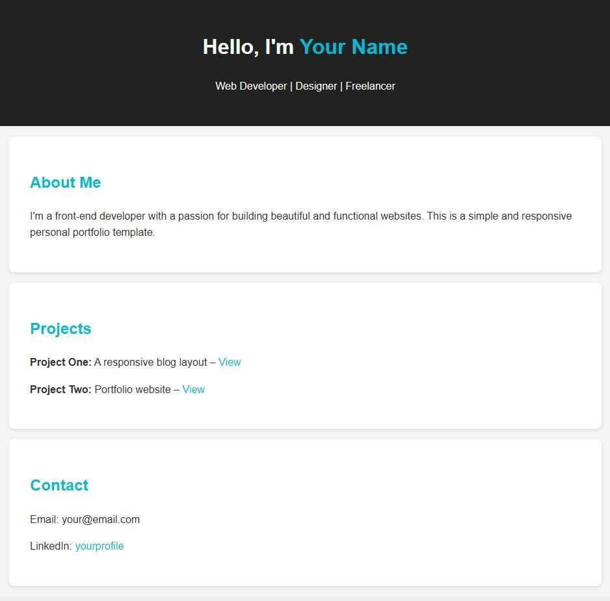
1. Personal portfolio website
Document structure, headings, images, links, lists, semantic sections and metadata.
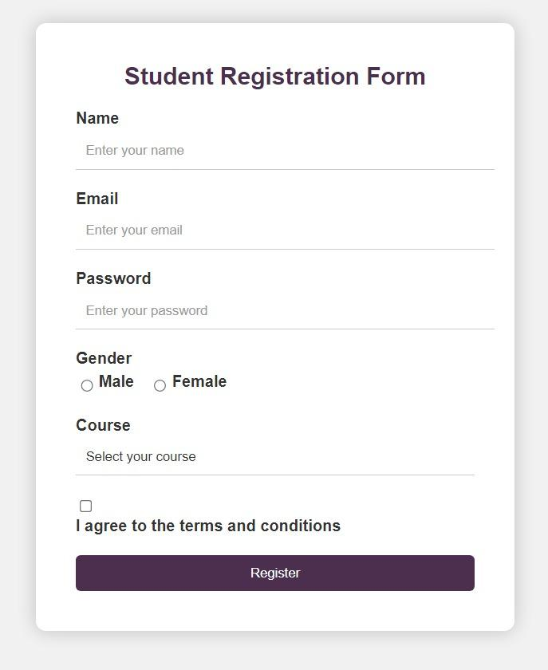
2. Student registration system interface
Labels, text inputs, dropdowns, radio buttons, checkboxes, date inputs, validation and file uploads.
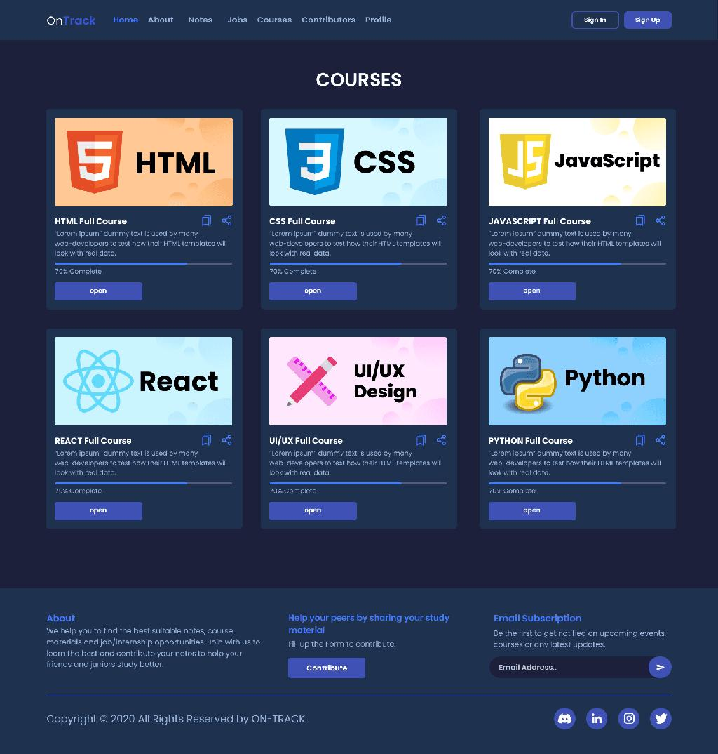
3. Computer institute website
Home, About, Courses, Contact, navigation, images, tables and course registration forms.
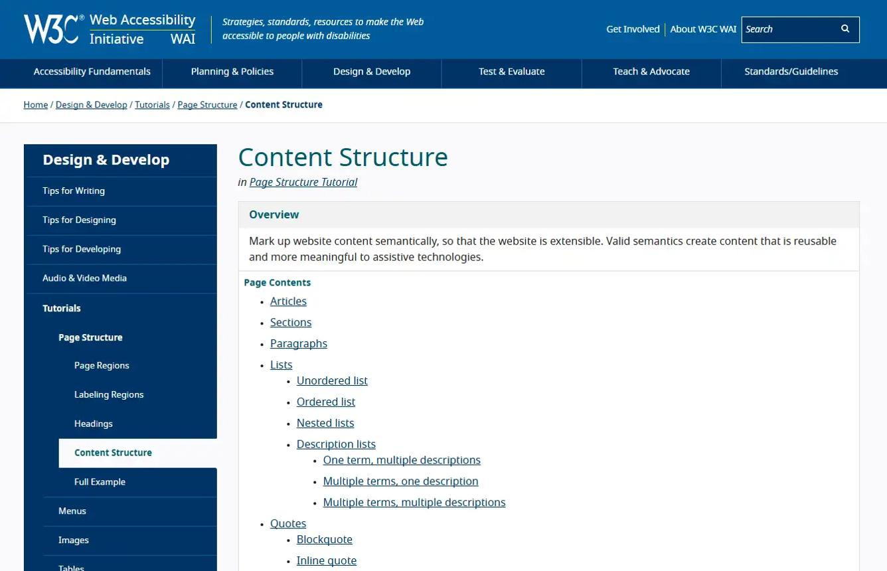
4. Documentation website
Semantic articles, headings, navigation, code examples, tables, accessibility and internal links.

5. Complete multi-page educational website
Combine semantic HTML, accessible forms, metadata, responsive images, navigation and validation across several pages.

Part 16 — HTML mastery tracker
Mark each section complete only when you can use it independently and explain when it should be used.
Your learning progress

0/34

Fundamentals
Web fundamentals
Development environment
HTML document structure
Elements and attributes
Text and formatting
Code and special text

Content and navigation
Links and navigation
Lists
Tables
Images and responsive images
Audio and video
Embedded content

Forms and structure
Form structure
Input types and attributes
Validation
Buttons and file uploads
Semantic HTML
Page layout patterns
Interactive elements

Advanced HTML
Head and metadata
SEO fundamentals
Global attributes
Custom data attributes
Templates and reusable content
SVG and canvas
Browser APIs
Deprecated HTML

Quality and projects
Accessibility and ARIA
HTML validation
Browser debugging
Performance basics
Security basics
Keyboard shortcuts and Emmet
Practical projects
Reset progress

Final recommendation
For frontend development, prioritize your learning in this order:
- HTML fundamentals: document structure, elements, attributes, headings, paragraphs and links.
- Content: lists, tables, images, media and semantic HTML.
- Forms: input types, labels, validation and form submission.
- Professional HTML: accessibility, metadata, SEO and responsive images.
- Advanced topics: templates, SVG, browser APIs, validation and security.
- Projects: build complete webpages and then style them with CSS and add functionality with JavaScript.
A key distinction: HTML defines content and structure, CSS controls presentation and layout, and JavaScript adds behavior. You do not need to master every specialized browser API before starting CSS.
This syllabus covers the major standard HTML elements, attributes, forms, semantics and professional workflows. For the authoritative reference on individual elements and browser compatibility, use MDN's HTML documentation and the Nu HTML Checker.

Complete CSS Master Syllabus — Beginner to Advanced
This is a comprehensive, topic-by-topic CSS syllabus designed for EDVENT’s computer education and frontend development curriculum. It follows naturally from your HTML syllabus and progresses from fundamentals to responsive design, professional UI development, animations, accessibility, and modern CSS architecture.
The goal is not just to learn CSS properties, but to become capable of building responsive, visually polished, maintainable websites without depending entirely on frameworks.

1. CSS fundamentals and setup
Level: Beginner

1.1 Introduction to CSS
- What CSS is and why it is used
- Relationship between HTML, CSS, and JavaScript
- CSS syntax: selectors, declarations, properties, and values
- CSS rulesets and stylesheets
- How browsers apply styles
- CSS specifications, browser support, and compatibility

1.2 Ways to add CSS
- Inline CSS using the style attribute
- Internal CSS using the <style> element
- External CSS using a .css file
- Linking CSS with <link rel="stylesheet">
- Multiple stylesheets and import basics
- Advantages and disadvantages of each method
- Why external stylesheets are preferred for most projects

1.3 Development environment
- VS Code setup
- Creating HTML and CSS files
- Connecting HTML to CSS
- Browser Developer Tools
- Inspecting and editing CSS live
- Understanding the Styles, Computed, and Layout panels
- Using Live Server or an equivalent local development server
- Emmet and CSS autocomplete
- Basic project folder structure

2. CSS syntax, comments, and values

2.1 CSS syntax
- Selectors and declaration blocks
- Property-value pairs
- Semicolons and braces
- Multiple declarations
- Multiple selectors sharing a rule
- Whitespace and formatting conventions
- CSS comments using /* ... */

2.2 CSS value types
- Keywords: auto, none, inherit, initial, unset
- Numbers and integers
- Lengths and percentages
- Colors
- URLs
- Strings
- Functions
- Lists and comma-separated values
- CSS custom properties and var()
- Fallback values

2.3 Common CSS functions
- calc()
- min()
- max()
- clamp()
- var()
- rgb() and rgba()
- hsl() and hsla()
- url()
- attr() basics
- minmax()
- repeat()
- fit-content()
- min-content and max-content

3. CSS selectors — complete coverage
Selectors determine which HTML elements receive a style.
Selector type | Examples
Universal | *
Element/type | p, h1, button
Class | .card, .primary-btn
ID | #header
Grouping | h1, h2, p
Descendant | .card p
Child | .menu > li
Adjacent sibling | h2 + p
General sibling | h2 ~ p
Attribute | [disabled], [type="email"]

3.1 Attribute selectors
- [attribute]
- [attribute="value"]
- [attribute~="value"]
- [attribute|="value"]
- [attribute^="value"]
- [attribute$="value"]
- [attribute*="value"]
- Case-sensitive and case-insensitive matching flags

3.2 Pseudo-classes
- Link states: :link, :visited, :hover, :active
- Form states: :focus, :focus-visible, :focus-within
- Structural selectors: :first-child, :last-child, :nth-child(), :nth-of-type()
- Negation: :not()
- Matching: :is(), :where()
- Relational selector: :has()
- Form states: :checked, :disabled, :enabled, :required, :optional
- Validation states: :valid, :invalid, :in-range, :out-of-range
- Content states: :empty, :root
- Target state: :target
- Read-only states: :read-only, :read-write
- Additional states: :default, :indeterminate, :placeholder-shown, :user-invalid

3.3 Pseudo-elements
- ::before
- ::after
- ::first-letter
- ::first-line
- ::selection
- ::marker
- ::placeholder
- ::file-selector-button
- ::backdrop
- ::first-line and ::first-letter styling limitations

3.4 Selector best practices
- Writing readable selectors
- Avoiding unnecessarily long selectors
- Choosing classes over excessive IDs for styling
- Selector specificity and maintainability
- Using pseudo-elements for decorative content
- Understanding browser support for advanced selectors

4. The cascade, inheritance, and specificity
This is one of the most important CSS topics. Many styling bugs occur because developers do not understand how the browser chooses between competing declarations.

4.1 The cascade
- Origin of styles: browser, user, and author
- Normal declarations versus !important
- Cascade layers
- Specificity
- Scoping proximity
- Source order
- Inline styles and stylesheet rules
- How conflicting declarations are resolved

4.2 Specificity
- Selector specificity calculation
- ID, class, attribute, pseudo-class, element, and pseudo-element weights
- Specificity of combined selectors
- Specificity of :is(), :not(), :has(), and :where()
- Why !important should not be a routine solution
- Debugging specificity conflicts

4.3 Inheritance and special keywords
- Inherited versus non-inherited properties
- inherit
- initial
- unset
- revert
- revert-layer
- Using all carefully

4.4 Cascade layers
- @layer
- Declaring layers
- Layer ordering
- Organizing reset, base, components, and utilities
- Managing third-party styles

5. Colors, backgrounds, and opacity

5.1 Color systems
- Named colors
- Hexadecimal colors: #RRGGBB and alpha variants
- RGB and RGBA
- HSL and HSLA
- Modern color syntax
- currentColor
- Transparent colors
- Introduction to color contrast and accessible palettes

5.2 Background properties
- background-color
- background-image
- background-repeat
- background-position
- background-size
- background-attachment
- background-origin
- background-clip
- background-blend-mode
- Multiple background layers
- Gradients as backgrounds

5.3 Gradients
- linear-gradient()
- radial-gradient()
- conic-gradient()
- Repeating gradients
- Gradient direction and color stops
- Gradient overlays for text readability

5.4 Opacity and blending
- opacity
- mix-blend-mode
- background-blend-mode
- Difference between transparent colors and element opacity
- Stacking and blending effects

6. CSS units and sizing

6.1 Absolute units
- px
- cm, mm, in
- pt, pc
- When absolute units are appropriate

6.2 Relative units
- %
- em
- rem
- vw, vh
- vmin, vmax
- svh, lvh, dvh
- svw, lvw, dvw
- ch, ex
- lh, rlh
- Container query units: cqw, cqh, cqi, cqb, cqmin, cqmax

6.3 Width and height
- width, height
- min-width, max-width
- min-height, max-height
- aspect-ratio
- auto sizing
- Intrinsic sizing
- Responsive image dimensions
- Overflow and content clipping

6.4 Modern sizing functions
- min()
- max()
- clamp()
- fit-content()
- min-content
- max-content
- stretch where supported
- Responsive width formulas

7. The CSS box model
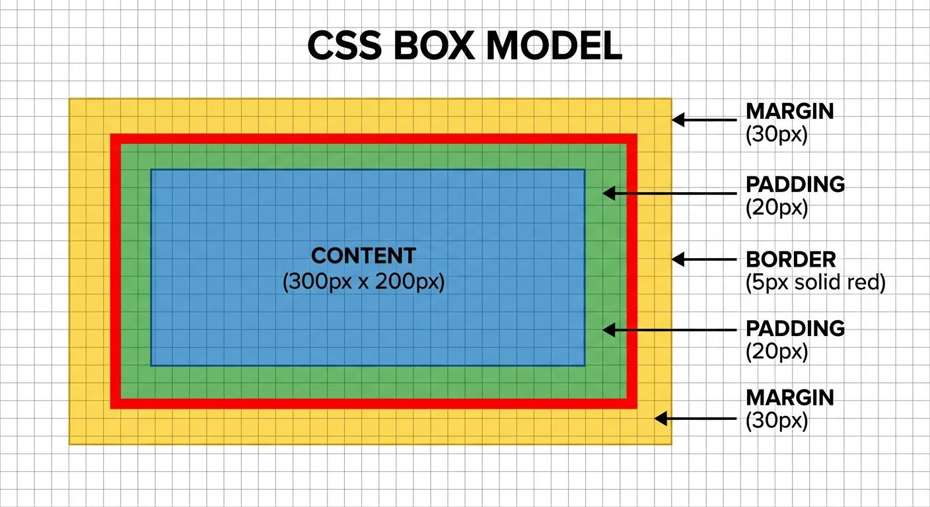
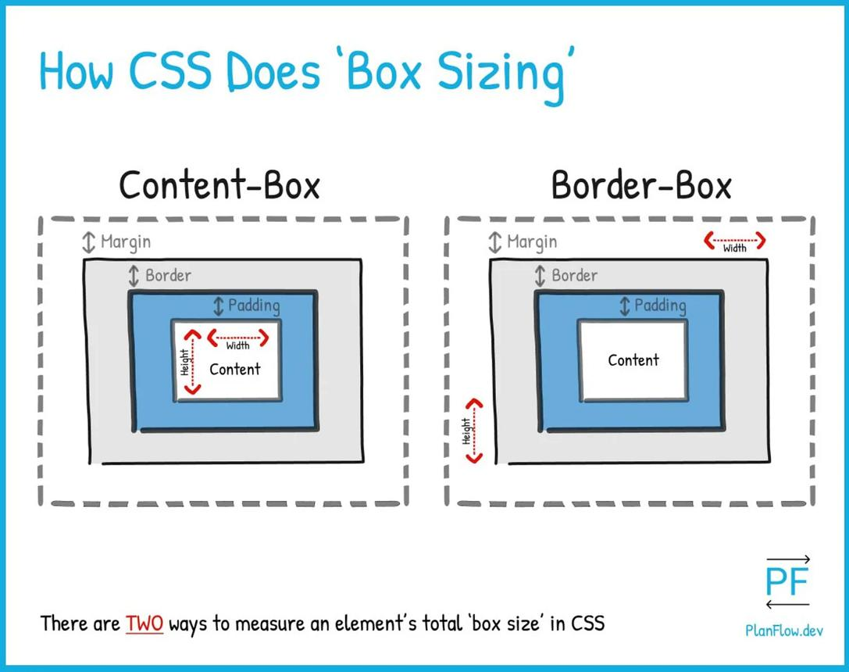

7.1 Box model fundamentals
- Content area
- Padding
- Border
- Margin
- Total element width and height
- Horizontal and vertical spacing
- Margin collapsing
- Negative margins
- Auto margins
- Padding versus margin
- Border versus outline

7.2 box-sizing
- content-box
- border-box
- How box-sizing affects dimensions
- Universal border-box reset
- Debugging unexpected element sizes

7.3 Borders and outlines
- border
- border-width
- border-style
- border-color
- Individual side borders
- border-radius
- Elliptical border radius
- outline
- outline-offset
- Rounded cards, buttons, inputs, and containers

7.4 Shadows
- box-shadow
- Multiple shadows
- Inset shadows
- text-shadow
- Elevation systems
- Focus shadows
- Soft versus hard shadows
Practical exercise: Build three cards with different padding, borders, margins, and shadow effects.

8. Typography and text styling

8.1 Font properties
- font-family
- font-size
- font-weight
- font-style
- font-stretch
- font-variant
- font
- System font stacks
- Generic families: serif, sans-serif, monospace, cursive, fantasy
- Web-safe fonts
- Font fallbacks

8.2 Web fonts
- @font-face
- WOFF and WOFF2
- Font weight ranges
- Variable fonts
- Local fonts versus hosted fonts
- Font loading and performance
- Fallback font behavior

8.3 Text formatting
- color
- text-align
- text-align-last
- text-decoration
- text-decoration-color
- text-decoration-style
- text-decoration-thickness
- text-transform
- text-indent
- text-shadow
- letter-spacing
- word-spacing
- line-height
- white-space
- overflow-wrap
- word-break
- hyphens
- text-overflow
- text-wrap
- text-justify

8.4 Advanced typography
- writing-mode
- direction
- unicode-bidi
- text-orientation
- font-feature-settings
- font-kerning
- font-optical-sizing
- font-variation-settings
- font-size-adjust
- line-clamp and multi-line truncation
- Responsive typography
- Fluid type scales with clamp()

8.5 Lists and markers
- list-style
- list-style-type
- list-style-position
- list-style-image
- Styling ::marker
- Custom list markers
- Numbered lists and nested lists
Practical project: Create a typography style guide with headings, paragraphs, links, quotations, lists, and code snippets.

9. Display, visibility, and overflow

9.1 Display values
- display: block
- display: inline
- display: inline-block
- display: none
- display: flow-root
- display: contents and accessibility considerations
- display: list-item
- display: flex
- display: grid
- display: inline-flex
- display: inline-grid
- Table display values

9.2 Visibility
- visibility: visible
- visibility: hidden
- opacity: 0
- display: none
- Differences in layout, rendering, and interaction
- Why hiding an element visually does not always remove it from keyboard or accessibility workflows

9.3 Overflow
- overflow
- overflow-x
- overflow-y
- overflow: visible
- overflow: hidden
- overflow: clip
- overflow: scroll
- overflow: auto
- Scroll containers
- Scrollbars and clipping
- Text overflow
- Scrollable tables and sidebars

9.4 Other display-related properties
- vertical-align
- float
- clear
- isolation
- contain
- content-visibility
- When to use modern layout systems instead of floats

10. Positioning and stacking

10.1 Position properties
- position: static
- position: relative
- position: absolute
- position: fixed
- position: sticky
- top, right, bottom, left
- Inset shorthand
- inset-block and inset-inline

10.2 Positioning concepts
- Normal document flow
- Containing blocks
- Positioning relative to a parent
- Absolute positioning inside cards
- Fixed navigation bars
- Sticky headers
- Sticky sidebars
- Centering with positioning
- Overlay panels and badges
- Common positioning bugs

10.3 Stacking and layering
- z-index
- Stacking contexts
- Positioned elements
- opacity and stacking contexts
- Transforms and stacking contexts
- isolation: isolate
- Modal and dropdown layering
- Why a high z-index may not work as expected
Practical project: Build a sticky header, fixed help button, image badge, and dropdown panel.

11. Flexbox — complete layout system
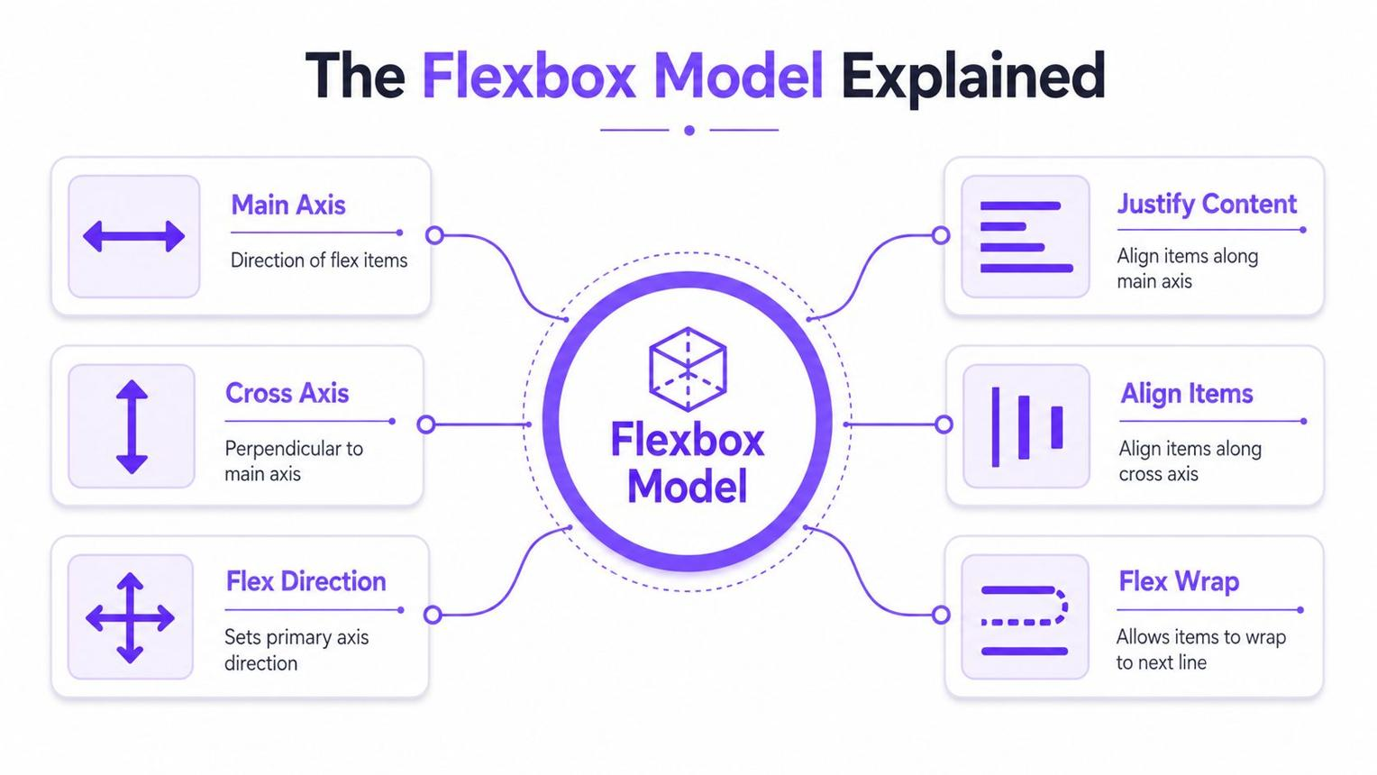
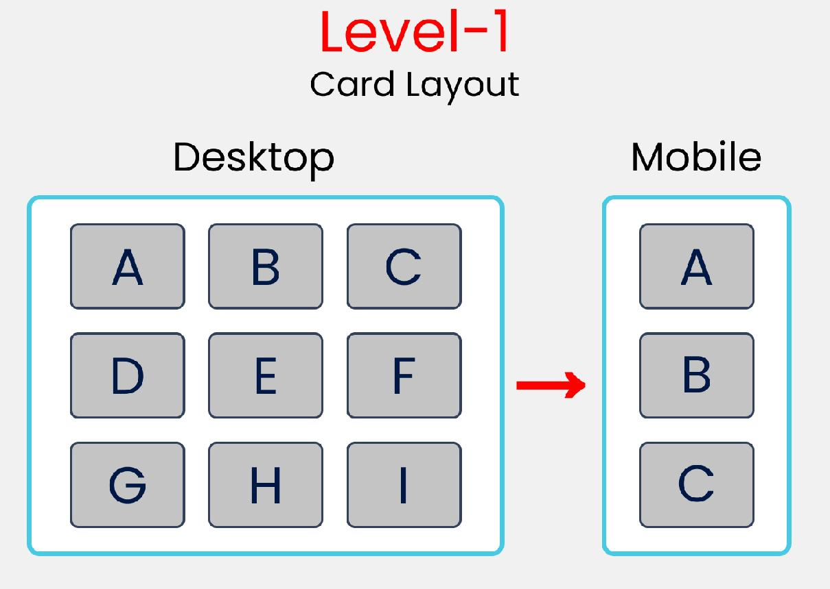
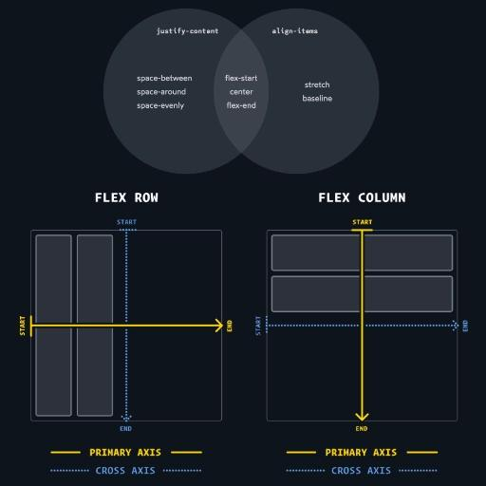
10
Flexbox is primarily designed for arranging items along one dimension at a time: a row or a column.

11.1 Flex container
- display: flex
- display: inline-flex
- Main axis and cross axis
- flex-direction
- flex-wrap
- flex-flow
- justify-content
- align-items
- align-content
- gap, row-gap, column-gap

11.2 Flex items
- flex-grow
- flex-shrink
- flex-basis
- flex shorthand
- align-self
- order
- Automatic minimum sizes
- Flex item sizing and overflow
- Equal-width columns
- Unequal columns
- Flexible navigation bars

11.3 Alignment techniques
- Horizontal and vertical centering
- Centering with margin: auto
- Space between navigation items
- Aligning icons and text
- Sticky footer layout
- Wrapping card layouts
- Responsive navigation patterns

11.4 Flexbox debugging
- Understanding unexpected wrapping
- Why flex-shrink changes item widths
- Why min-width: 0 can matter
- gap versus margins
- Nested flex containers
- Flexbox DevTools inspection
Practical projects
- Navigation bar
- Profile card
- Pricing cards
- Responsive feature section
- Header with logo, links, and action buttons

12. CSS Grid — complete layout system
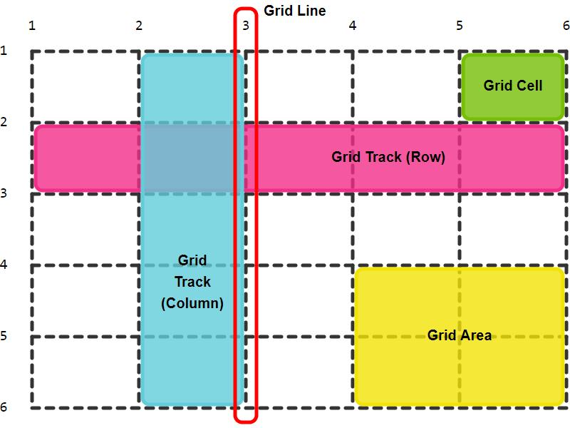
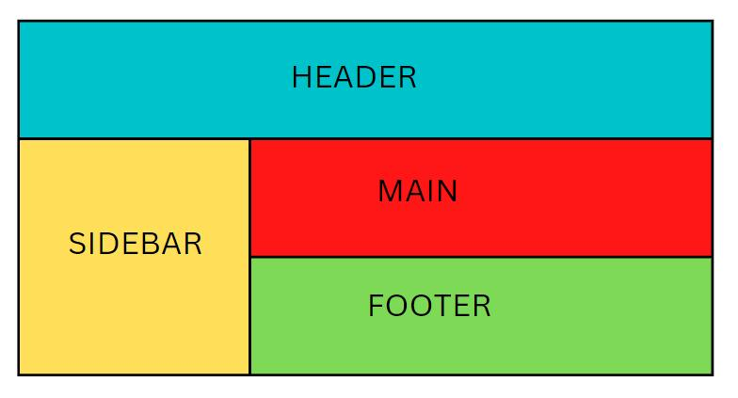
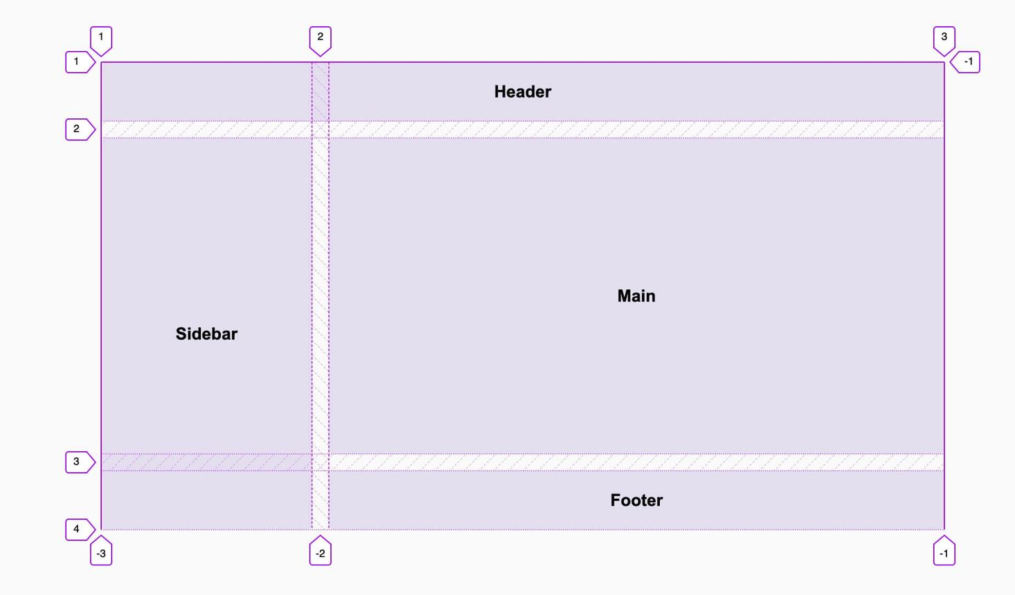
8
Grid is designed for two-dimensional layouts involving rows and columns.

12.1 Grid container
- display: grid
- display: inline-grid
- grid-template-columns
- grid-template-rows
- grid-template-areas
- grid-template
- grid-auto-columns
- grid-auto-rows
- grid-auto-flow
- gap

12.2 Grid sizing
- Fixed tracks
- Fractional units: fr
- repeat()
- minmax()
- auto
- auto-fit
- auto-fill
- Intrinsic track sizing
- min-content and max-content
- fit-content()
- Explicit versus implicit grids

12.3 Grid item placement
- grid-column
- grid-row
- grid-area
- grid-column-start
- grid-column-end
- grid-row-start
- grid-row-end
- Grid line numbering
- Named grid lines
- Spanning multiple rows or columns
- Placement and overlap

12.4 Alignment in Grid
- justify-items
- align-items
- place-items
- justify-content
- align-content
- place-content
- justify-self
- align-self
- place-self

12.5 Advanced Grid
- Responsive auto-fit card layouts
- Named grid areas
- Nested grids
- Subgrid
- Masonry-style layouts and current support considerations
- Grid versus Flexbox
- Grid DevTools debugging
Practical projects
- Photo gallery
- Dashboard layout
- Blog homepage
- Admin panel
- Product listing page

13. Responsive web design

13.1 Responsive design fundamentals
- Responsive versus fixed-width design
- Mobile-first development
- Desktop-first development
- Fluid layouts
- Flexible images
- Responsive containers
- Content-driven breakpoints
- Responsive navigation
- Common device widths and why breakpoints should depend on content

13.2 Media queries
- @media
- min-width
- max-width
- Range syntax
- Orientation queries
- Resolution queries
- Hover and pointer capability queries
- Color scheme queries
- Reduced motion queries
- Print styles
- Combining conditions
- Mobile, tablet, laptop, and desktop layouts

13.3 Responsive components
- Navigation bars
- Responsive hero sections
- Cards and card grids
- Images and galleries
- Tables
- Forms
- Sidebars
- Dashboards
- Typography
- Footer layouts

13.4 Responsive images and embeds
- max-width: 100%
- height: auto
- object-fit
- object-position
- aspect-ratio
- Responsive video containers
- Avoiding layout shifts
- Handling very wide tables and long text

13.5 Container queries
- container-type
- container-name
- @container
- Size queries
- Inline-size queries
- Container query units
- Component-level responsiveness
- When container queries are more suitable than media queries

13.6 Modern responsive patterns
- Fluid spacing with clamp()
- Fluid typography
- Intrinsic grids
- minmax()
- auto-fit and auto-fill
- max-width containers
- Logical properties
- Safe-area insets for notched devices
Practical project: Make the EDVENT website adapt to mobile, tablet, and desktop screens without horizontal overflow.

14. CSS transformations

14.1 Transform properties
- transform
- transform-origin
- transform-box
- translate
- rotate
- scale

14.2 Two-dimensional transforms
- translate()
- rotate()
- scale()
- skew()
- Combining transform functions
- Transform order
- Hover effects
- Card tilt effects

14.3 Three-dimensional transforms
- perspective
- perspective-origin
- translateZ()
- rotateX()
- rotateY()
- rotateZ()
- scale3d()
- transform-style
- backface-visibility
- translate3d()
- 3D card flips
- Understanding the limitations of complex 3D effects

15. Transitions and animations

15.1 CSS transitions
- transition
- transition-property
- transition-duration
- transition-timing-function
- transition-delay
- Timing functions: ease, linear, ease-in, ease-out, ease-in-out
- cubic-bezier()
- steps()
- Multiple transitions
- Hover and focus transitions

15.2 CSS animations
- @keyframes
- animation-name
- animation-duration
- animation-timing-function
- animation-delay
- animation-iteration-count
- animation-direction
- animation-fill-mode
- animation-play-state
- animation shorthand
- Percentage keyframes
- Infinite animations
- Pausing and restarting animations

15.3 Animation projects
- Loading spinner
- Pulsing button
- Sliding menu
- Fade-in section
- Animated underline
- Card hover animation
- Notification badge
- Hero text reveal

15.4 Animation performance and accessibility
- Prefer animating transform and opacity when appropriate
- Avoid unnecessary layout-triggering animation
- prefers-reduced-motion
- Avoiding distracting animations
- Animation timing and usability
- Performance inspection in DevTools

16. CSS images, filters, and visual effects

16.1 Image fitting
- object-fit: cover
- object-fit: contain
- object-fit: fill
- object-fit: none
- object-position
- Image crops and thumbnails
- Portrait and landscape image cards

16.2 Filters
- filter
- blur()
- brightness()
- contrast()
- grayscale()
- hue-rotate()
- invert()
- opacity()
- saturate()
- sepia()
- drop-shadow()

16.3 Clipping and masks
- clip-path
- Circle, ellipse, polygon, and inset clipping
- CSS masks
- mask-image
- mask-size
- mask-position
- mask-repeat
- mask-composite basics
- Image overlays and decorative shapes

16.4 Advanced effects
- backdrop-filter
- Glassmorphism
- Gradient overlays
- Blend modes
- Decorative borders
- Image hover zoom
- Text overlays
- Browser support and graceful fallbacks

17. Forms and interactive UI styling

17.1 Form controls
- Text inputs
- Password inputs
- Email and telephone inputs
- Search inputs
- Number and range inputs
- Checkboxes
- Radio buttons
- Select menus
- Textareas
- File upload buttons
- Submit and reset buttons
- Labels and fieldsets

17.2 Form states
- :focus
- :focus-visible
- :focus-within
- :hover
- :active
- :checked
- :disabled
- :enabled
- :required
- :optional
- :valid
- :invalid
- :placeholder-shown
- :read-only

17.3 Form styling properties
- accent-color
- appearance
- caret-color
- resize
- cursor
- outline
- outline-offset
- ::placeholder
- ::file-selector-button
- :focus-visible styling
- Custom checkbox and radio designs
- Input sizing and spacing
- Error and success states

17.4 Professional form design
- Consistent input heights
- Clear labels and instructions
- Accessible focus indicators
- Error messages and validation styling
- Required field indicators
- Disabled versus read-only appearance
- Responsive multi-column forms
- Login and registration pages
Practical projects: Login form, student registration form, contact form, and EDVENT course enquiry form.

18. Navigation, buttons, cards, and common components

18.1 Navigation systems
- Horizontal navigation
- Vertical navigation
- Dropdown menus
- Mega-menu layouts
- Mobile navigation
- Active link styling
- Sticky navigation
- Breadcrumbs
- Pagination

18.2 Buttons
- Primary, secondary, and tertiary buttons
- Outline buttons
- Icon buttons
- Button sizes
- Hover, focus, active, and disabled states
- Loading appearance
- Consistent button systems

18.3 Cards
- Profile cards
- Course cards
- Product cards
- Pricing cards
- Blog cards
- Image cards
- Horizontal cards
- Card grids
- Hover elevation
- Responsive card sizing

18.4 Additional UI components
- Badges and labels
- Alerts and notifications
- Tooltips
- Tabs
- Accordions
- Modal overlays
- Progress bars
- Breadcrumbs
- Search bars
- Dropdowns
- Skeleton loading placeholders
- Empty states
Note: CSS can style these components, but interactive behavior such as opening a modal or switching tabs often requires JavaScript or native HTML functionality.

19. Tables, lists, and data presentation
- Table borders and spacing
- border-collapse
- border-spacing
- table-layout
- caption-side
- empty-cells
- Table row hover effects
- Zebra-striped rows
- Sticky table headers
- Responsive table wrappers
- Scrollable tables
- Styling ordered and unordered lists
- Custom markers
- Definition lists
- Data-heavy dashboard tables
- Accessible visual contrast for tabular data

20. CSS custom properties and design tokens

20.1 CSS variables
- Declaring custom properties with --name
- Using var()
- Fallback values
- Scope and inheritance
- Variables on :root
- Overriding variables at component level
- Theme-specific variables

20.2 Design tokens
- Color tokens
- Typography tokens
- Spacing tokens
- Border radius tokens
- Shadow tokens
- Breakpoint conventions
- Layout width tokens
- Component-specific tokens

20.3 Theme systems
- Light and dark themes
- prefers-color-scheme
- Theme variables
- Semantic color naming
- High-contrast considerations
- Consistent branding
- Reducing duplicate declarations
Example:
:root {
--color-primary: #2563eb;
--color-text: #1f2937;
--color-surface: #ffffff;
--space-md: 1rem;
--radius-md: 0.75rem;
}

.course-card {
color: var(--color-text);
background: var(--color-surface);
padding: var(--space-md);
border-radius: var(--radius-md);
}

21. Advanced CSS properties and modern features

21.1 Logical properties
- margin-inline
- margin-block
- padding-inline
- padding-block
- border-inline
- border-block
- inset-inline
- inset-block
- inline-size
- block-size
- min-inline-size
- max-inline-size
- Left-to-right and right-to-left layouts

21.2 Scroll-related CSS
- scroll-behavior
- scroll-margin
- scroll-padding
- scroll-snap-type
- scroll-snap-align
- scroll-snap-stop
- Scrollable carousels
- Sticky headers and anchor navigation
- overscroll-behavior

21.3 Additional advanced properties
- aspect-ratio
- object-fit
- object-position
- pointer-events
- user-select
- touch-action
- cursor
- resize
- caret-color
- accent-color
- appearance
- will-change and why it should be used sparingly

21.4 Modern CSS capabilities
- @supports feature queries
- @layer cascade layers
- @container container queries
- :has() relational selector
- :is() and :where()
- Native nesting
- Subgrid
- Scroll-state and view-transition features where supported
- Graceful fallback strategies
- Progressive enhancement

22. CSS at-rules
Learn the purpose and syntax of the major at-rules.
- @charset — character encoding declaration, where relevant
- @import — importing stylesheets
- @media — media queries
- @supports — feature detection
- @container — container queries
- @font-face — custom fonts
- @keyframes — animations
- @layer — cascade layers
- @namespace — namespaced selectors
- @page — printed page styling
- @property — registering custom properties
- @counter-style — custom counter styles
- @scope — scoped styling where supported
- @starting-style — entry transitions where supported
- @view-transition — view transition styling where supported
Understand which features are broadly supported and which require progressive enhancement.

23. CSS counters, generated content, and decorative layouts
- content
- counter-reset
- counter-increment
- counter()
- counters()
- ::before and ::after
- Custom numbering
- Decorative icons and separators
- Quotation marks
- Step-by-step numbering
- Timeline designs
- CSS-generated content limitations
Do not use generated content as the sole source of essential information, and do not assume that a CSS pseudo-element is a substitute for semantic HTML.

24. CSS architecture and maintainable code

24.1 CSS organization
- Reset stylesheets
- Normalize stylesheets
- Base styles
- Layout styles
- Component styles
- Utility classes
- Theme styles
- Responsive styles
- Folder organization
- Naming conventions

24.2 CSS methodologies
- BEM: Block, Element, Modifier
- OOCSS
- SMACSS
- Atomic CSS concepts
- Utility-first CSS concepts
- Component-scoped CSS
- CSS Modules concepts
- When to use each approach

24.3 Writing maintainable CSS
- Avoiding unnecessary specificity
- Avoiding excessive !important
- Reusing shared styles
- Keeping selectors understandable
- Removing dead CSS
- Avoiding duplicated declarations
- Using design tokens
- Establishing consistent spacing and typography
- Separating layout from component styling

24.4 Native CSS nesting
- Nesting selectors
- Parent selector &
- Nested pseudo-classes
- Nesting media queries
- Readability and specificity considerations
- Browser compatibility and build-tool requirements

25. CSS accessibility

25.1 Accessible styling principles
- Color contrast
- Readable font sizes
- Text resizing
- Visible focus indicators
- Keyboard navigation
- Hover versus focus
- Avoiding color-only communication
- Reduced motion preferences
- Accessible responsive layouts

25.2 Accessibility-related CSS
- :focus-visible
- :focus-within
- prefers-reduced-motion
- prefers-color-scheme
- forced-colors
- contrast media feature where supported
- pointer and hover media features
- scroll-margin-top for anchored headings
- Focus styles that are not removed without replacement

25.3 Common mistakes
- Using display: none for content that must remain available
- Hiding focus outlines
- Making links indistinguishable from ordinary text
- Using tiny text
- Poor contrast on gradients and images
- Animations that cause discomfort
- Incorrectly styling disabled and invalid states
CSS accessibility must be tested alongside semantic HTML, keyboard behavior, and screen-reader output.

26. CSS performance and browser rendering

26.1 Browser rendering basics
- DOM and CSSOM
- Render tree
- Layout
- Paint
- Compositing
- How CSS changes affect rendering
- Reflow and repaint concepts

26.2 Performance optimization
- Avoiding excessive DOM-dependent styling complexity
- Efficient selector design
- Avoiding unnecessary animations
- Optimizing web fonts
- Reducing unused CSS
- Critical CSS concepts
- Loading stylesheets efficiently
- Avoiding layout shifts
- Using content-visibility where appropriate
- Using contain when beneficial
- Avoiding indiscriminate will-change

26.3 Debugging tools
- Chrome or browser DevTools
- Computed styles
- Box model inspection
- Flexbox and Grid overlays
- Responsive viewport testing
- CSS coverage
- Performance profiling
- Lighthouse audits
- Cross-browser testing

27. CSS security and robustness
- CSS injection as a broader web security concern
- Avoiding unsafe dynamic stylesheet construction
- Understanding the limits of CSS-based hiding
- Why CSS is not an authorization mechanism
- Preventing layout breakage from untrusted or very long text
- Handling missing images and font failures
- Safe external resource loading practices
- Avoiding sensitive information in stylesheets
- Progressive enhancement and robust fallbacks
Security must be enforced by application logic and server-side controls, not by visual styling.

28. CSS frameworks and related tools
Learn core CSS first, then use frameworks to accelerate production.

28.1 Bootstrap
- Grid system
- Containers and breakpoints
- Utility classes
- Buttons and forms
- Cards and navigation
- Responsive components
- Customization and theme overrides

28.2 Tailwind CSS
- Utility-first styling
- Responsive prefixes
- Spacing and sizing utilities
- Flexbox and Grid utilities
- Colors and typography
- State variants
- Theme customization
- Build and content scanning concepts

28.3 Other tools and concepts
- Sass/SCSS
- CSS preprocessors
- PostCSS concepts
- Autoprefixer
- CSS minification
- CSS linting
- Design systems
- Component libraries
- CSS-in-JS concepts
- Framework styling in React applications

29. CSS for printing and specialized layouts
- @media print
- @page
- Page margins
- Page size
- Page breaks
- break-before
- break-after
- break-inside
- Hiding navigation and interactive controls in print
- Printing tables and invoices
- Print-friendly reports and certificates
- Multi-column text with column-count, column-width, column-gap, and column-rule
- Basic pagination considerations
Practical project: Design a printable student certificate, invoice, or course completion report.

30. CSS for real-world frontend projects
Build projects in increasing difficulty. Each project should include a responsive layout, reusable components, accessibility checks, and clean CSS organization.

Project 1 — Personal portfolio
Beginner
Practice typography, colors, spacing, navigation, sections, buttons, and responsive layout.

Project 2 — EDVENT course website
Beginner to intermediate
Create a header, hero section, course cards, instructor profiles, testimonials, enquiry form, and footer.
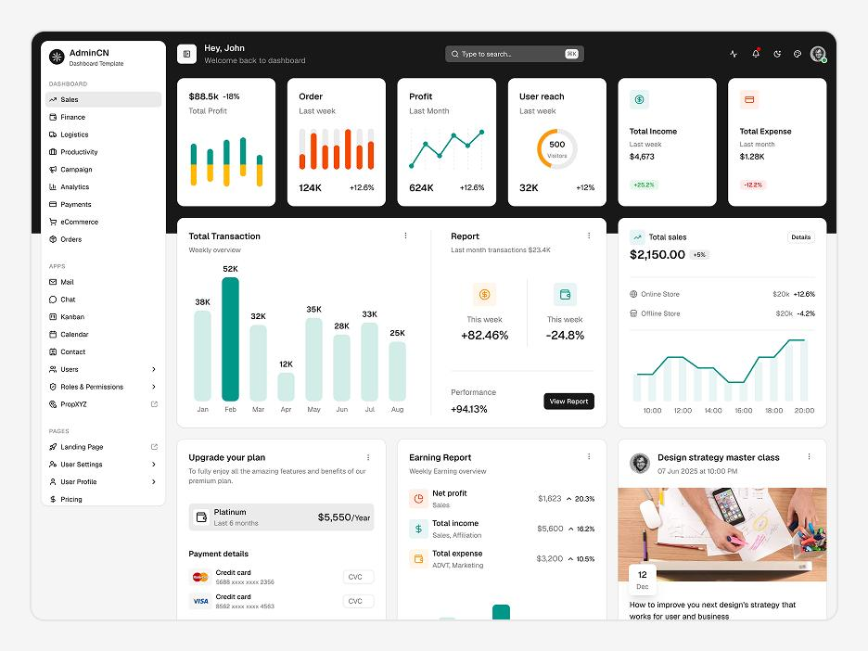
Project 3 — Admin dashboard
Intermediate
Practice Grid, Flexbox, tables, sidebar navigation, responsive cards, and theme variables.

Project 4 — E-commerce storefront
Intermediate
Build product grids, filter panels, buttons, badges, image cropping, and responsive layouts.
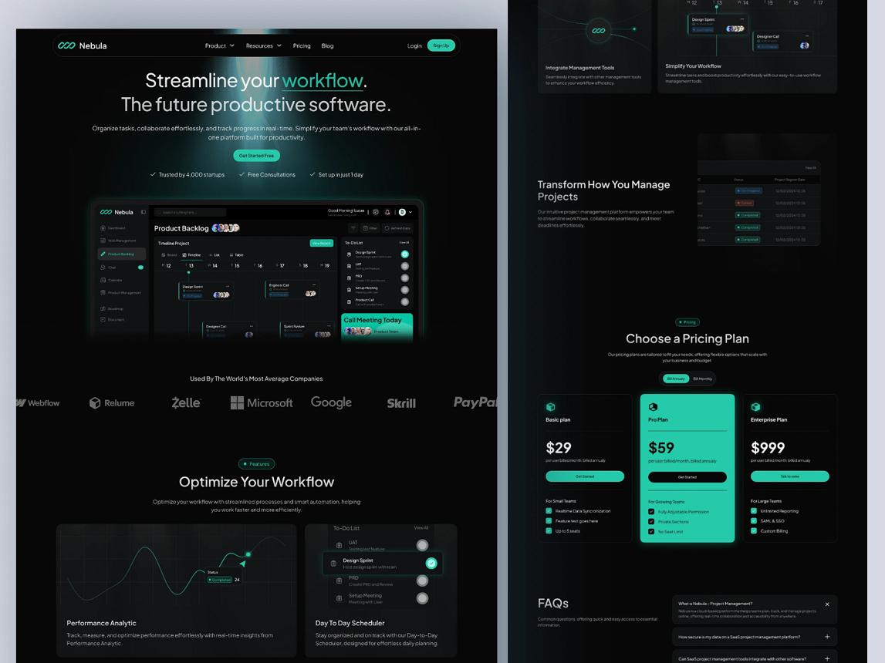
Project 5 — Professional SaaS landing page
Advanced
Use fluid typography, custom properties, gradients, animations, responsive sections, and reusable design tokens.

Additional project ideas
- Responsive login and registration page
- Restaurant website
- Blog and article layout
- Image gallery
- Pricing comparison page
- Student management dashboard
- Animated product landing page
- Responsive documentation website
- Light/dark theme interface
- Full multipage computer institute website

31. Recommended learning roadmap
Stage | Topics | Suggested duration
1 | Fundamentals, syntax, selectors | 1 week
2 | Cascade, box model, units, typography | 1 week
3 | Display, positioning, overflow | 1 week
4 | Flexbox and Grid | 1–2 weeks
5 | Responsive design and media queries | 1 week
6 | Forms, navigation, reusable UI | 1 week
7 | Transforms, transitions, animations | 1 week
8 | Custom properties and modern CSS | 1 week
9 | Accessibility, debugging, performance | 1 week
10 | Projects and revision | 2–3 weeks
Estimated total: 11–13 weeks at a steady learning pace. The actual duration depends on daily practice and how much time you spend building projects.

32. CSS mastery tracker
Use this checklist to monitor progress while studying or teaching.

Learning progress
0 of 28 topics completed

0%

Foundations
CSS syntax and stylesheet linking
Selectors and combinators
Pseudo-classes and pseudo-elements
Cascade, inheritance, and specificity
Colors, units, and functions

Styling and layout
Box model and sizing
Typography and backgrounds
Display and overflow
Positioning and stacking contexts
Flexbox
CSS Grid

Responsive design
Media queries
Responsive images and typography
Container queries
Logical properties
Mobile-first layouts

Advanced CSS
Transforms and transitions
Keyframe animations
Filters and clipping
Custom properties and design tokens
At-rules and modern CSS
CSS architecture and nesting

Production skills
Forms and component styling
Accessibility
Browser DevTools and debugging
Performance optimization
Cross-browser testing
Complete responsive projects
Reset checklistCopy checklist

33. Official learning resources
- MDN CSS Reference — Complete CSS reference
- MDN Learn CSS — CSS learning modules
- W3C CSS — CSS standards and specifications
- Can I Use — Check browser compatibility
- WebAIM Contrast Checker — Check text and background contrast

Final recommendation for your institute
For a practical CSS course, organize the syllabus into three levels:
- CSS Foundation: selectors, typography, colors, box model, spacing, display, positioning.
- CSS Layout and Responsive Design: Flexbox, Grid, media queries, responsive UI, forms, reusable components.
- Advanced CSS and Projects: animations, modern CSS, accessibility, performance, architecture, and complete website builds.
Students should build something after every major topic rather than completing the entire theory first. Before moving to React or a full-stack MERN course, they should be able to reproduce a responsive multi-section website from a reference design using HTML and CSS alone.

Complete JavaScript Master Syllabus — Beginner to Advanced
This syllabus is designed for EDVENT’s computer education and frontend development curriculum, continuing from HTML and CSS. It takes learners from JavaScript fundamentals to DOM manipulation, asynchronous programming, APIs, modern ES features, object-oriented programming, debugging, and production-ready frontend development.
The goal is to enable students to build interactive websites independently and prepare for React, Node.js, and full-stack MERN development.

1. Introduction to JavaScript
Level: Beginner

1.1 JavaScript fundamentals
- What JavaScript is
- History and evolution of JavaScript
- JavaScript versus Java
- JavaScript versus HTML and CSS
- ECMAScript and the JavaScript language standard
- Common uses: frontend, backend, mobile, desktop, automation
- JavaScript engines and runtime environments
- Client-side versus server-side JavaScript
- What browsers can and cannot do with JavaScript

1.2 JavaScript execution environments
- Browser JavaScript
- Browser Developer Console
- Node.js introduction
- JavaScript runtime versus JavaScript engine
- V8 and other JavaScript engines
- Browser APIs versus language features
- Introduction to npm and package management

1.3 Setting up the development environment
- Installing VS Code
- Creating HTML, CSS, and JavaScript files
- Connecting JavaScript using the <script> element
- Inline, internal, and external JavaScript
- Using defer and async
- JavaScript modules using type="module"
- Browser DevTools
- Console, Sources, Network, and Application panels
- Using Live Server or a local development server
- Basic Node.js installation and terminal usage

1.4 Your first JavaScript program
- console.log()
- console.error()
- console.warn()
- console.table()
- alert()
- prompt()
- confirm()
- Reading errors in the console
- Writing comments
- Formatting and indentation

2. Variables and data types

2.1 Declaring variables
- var
- let
- const
- Declaration versus initialization
- Assignment and reassignment
- Naming conventions
- Valid and invalid identifiers
- Reserved keywords
- Camel case and meaningful variable names
- Constants and immutable bindings

2.2 Scope and variable behavior
- Global scope
- Function scope
- Block scope
- Lexical scope
- Shadowing
- Hoisting
- Temporal Dead Zone
- Differences between var, let, and const
- Global object properties and global declarations

2.3 Primitive data types
- Number
- String
- Boolean
- undefined
- null
- BigInt
- Symbol

2.4 Non-primitive values
- Objects
- Arrays
- Functions
- Reference types and object identity
- Primitive values versus object references
- Copying and sharing references
- Mutable versus immutable data concepts

2.5 Type checking
- typeof
- Array.isArray()
- instanceof
- Checking for null
- Understanding typeof null
- Detecting NaN with Number.isNaN()
- Type-checking pitfalls

3. Operators and expressions

3.1 Arithmetic operators
- Addition +
- Subtraction -
- Multiplication *
- Division /
- Remainder %
- Exponentiation **
- Increment ++
- Decrement --
- Operator precedence
- Floating-point precision

3.2 Assignment operators
- =
- +=, -=, *=, /=
- %=, **=
- Logical assignment: &&=, ||=, ??=
- Assignment evaluation and chaining

3.3 Comparison operators
- == and ===
- != and !==
- Greater than and less than
- >= and <=
- Type coercion during comparisons
- Why strict equality is usually preferred
- Comparing objects and arrays

3.4 Logical operators
- AND &&
- OR ||
- NOT !
- Short-circuit evaluation
- Truthy and falsy values
- Nullish coalescing ??
- Logical OR versus nullish coalescing

3.5 Other operators
- Ternary operator condition ? a : b
- typeof
- instanceof
- in
- delete
- void
- Optional chaining ?.
- Spread syntax ...
- Rest syntax ...
- Comma operator
- new
- Operator precedence and associativity

4. Type conversion and coercion

4.1 Explicit conversion
- Number()
- String()
- Boolean()
- BigInt()
- parseInt()
- parseFloat()
- Number.isFinite()
- Number.isInteger()
- Number.isNaN()

4.2 Implicit conversion
- String concatenation
- Numeric coercion
- Boolean coercion
- Comparison coercion
- Truthy and falsy values
- null versus undefined
- Empty strings and whitespace
- NaN behavior
- Equality edge cases

4.3 Practical conversion exercises
- Convert form input to a number
- Validate numeric input
- Calculate percentages
- Format values for display
- Handle missing values safely

5. Strings and string methods

5.1 String fundamentals
- Single quotes, double quotes, and backticks
- String immutability
- Escape characters
- Newline and tab characters
- Unicode and emoji
- Template literals
- String interpolation
- Multiline strings

5.2 String properties and methods
- length
- at()
- charAt()
- charCodeAt()
- codePointAt()
- indexOf()
- lastIndexOf()
- includes()
- startsWith()
- endsWith()
- slice()
- substring()
- toUpperCase()
- toLowerCase()
- trim()
- trimStart()
- trimEnd()
- replace()
- replaceAll()
- split()
- concat()
- padStart()
- padEnd()
- repeat()
- match()
- matchAll()
- search()

5.3 String processing projects
- Count characters and words
- Reverse a string
- Check for a palindrome
- Capitalize names
- Extract initials
- Normalize search text
- Validate simple input patterns
- Build a text analyzer

6. Numbers, Math, and dates

6.1 Number handling
- Integers and floating-point numbers
- NaN
- Infinity and -Infinity
- Number.MAX_SAFE_INTEGER
- Number.MIN_SAFE_INTEGER
- Number.EPSILON
- toFixed()
- toPrecision()
- toString()
- Number() and parsing methods
- Floating-point rounding errors

6.2 Math object
- Math.round()
- Math.floor()
- Math.ceil()
- Math.trunc()
- Math.abs()
- Math.max()
- Math.min()
- Math.random()
- Math.pow()
- Math.sqrt()
- Math.cbrt()
- Math.sign()
- Math.log()
- Math.exp()
- Math.sin(), Math.cos(), and Math.tan()
- Random integer generation
- Rounding and percentage calculations

6.3 Date and time
- Creating dates with new Date()
- Timestamps
- Date.now()
- getFullYear(), getMonth(), getDate()
- getDay() and time getters
- UTC getters
- Setting date and time values
- Parsing date strings
- Date arithmetic
- Comparing dates
- Formatting dates using Intl.DateTimeFormat
- Time zones and UTC
- Invalid dates and date parsing pitfalls
- Introduction to the Temporal API and its support status

7. Conditional statements and decision-making

7.1 if statements
- if
- if...else
- if...else if...else
- Nested conditions
- Compound conditions
- Boolean expressions
- Truthy and falsy checks
- Guard clauses
- Early returns

7.2 switch statements
- switch
- case
- break
- default
- Fall-through behavior
- Strict comparison in switch cases
- When to use switch versus if...else

7.3 Ternary operator
- Basic ternary expressions
- Nested ternaries and readability
- Conditional assignment
- Rendering conditional text
- Choosing between ternary expressions and regular conditionals

7.4 Practical exercises
- Pass/fail calculator
- Grade calculator
- Even/odd checker
- Age eligibility checker
- Electricity bill calculator
- Discount calculator
- Login validation
- Menu-based calculator

8. Loops and iteration

8.1 Basic loops
- for
- while
- do...while
- Initialization, condition, and update
- Infinite loops and how to avoid them
- Nested loops
- Loop counters

8.2 Loop control
- break
- continue
- Labeled statements
- Early termination
- Skipping invalid records

8.3 Iterating through collections
- for...of
- for...in
- forEach()
- Iterating through strings
- Iterating through arrays
- Iterating through object properties
- Iterating through Map and Set
- Iterable and iterator concepts
- Why for...in is usually not the right choice for array values

8.4 Practical loop exercises
- Multiplication tables
- Sum of natural numbers
- Factorial
- Fibonacci sequence
- Prime number checker
- Pattern printing
- Count vowels and consonants
- Find maximum and minimum
- Generate a number series
- Build a number guessing game

9. Functions — complete coverage
Functions are a core JavaScript skill. Students should understand both how to write functions and how functions behave when passed around as values.

9.1 Function fundamentals
- What functions are
- Function declarations
- Function expressions
- Named and anonymous functions
- Parameters and arguments
- Return values
- Functions without return values
- Calling and invoking functions
- Reusable logic
- Function naming conventions

9.2 Function parameters
- Default parameters
- Multiple parameters
- Missing arguments
- Rest parameters
- Destructured parameters
- Argument validation
- Optional arguments
- Functions accepting other functions

9.3 Arrow functions
- Arrow function syntax
- Single-expression returns
- Block-body arrow functions
- Implicit return
- Parentheses around parameters
- Arrow functions versus regular functions
- Lexical this
- Why arrow functions cannot be used as constructors

9.4 Scope and closures
- Global, function, and block scope
- Lexical scope
- Scope chains
- Closures
- Private state through closures
- Closure-based counters
- Closures in callbacks
- Common loop-and-closure pitfalls

9.5 Advanced function concepts
- First-class functions
- Higher-order functions
- Callback functions
- Pure functions
- Side effects
- Recursion
- IIFEs (Immediately Invoked Function Expressions)
- Function composition
- Currying basics
- Partial application
- Memoization basics
- call(), apply(), and bind()
- Function this behavior
- arguments object
- Function properties and methods

9.6 Practical function projects
- Calculator using functions
- Reusable validation functions
- Temperature converter
- Tax and discount calculator
- Recursive factorial
- Closure-based counter
- Higher-order array utilities

10. Arrays — complete coverage

10.1 Array fundamentals
- Creating arrays
- Array literals
- Array() constructor
- Indexes and length
- Accessing and updating elements
- Sparse arrays
- Arrays containing mixed data types
- Nested arrays
- Arrays of objects
- Copying versus sharing an array reference

10.2 Adding, removing, and combining
- push()
- pop()
- shift()
- unshift()
- splice()
- slice()
- concat()
- join()
- fill()
- copyWithin()
- flat()
- flatMap()

10.3 Searching and checking
- indexOf()
- lastIndexOf()
- includes()
- find()
- findIndex()
- findLast()
- findLastIndex()
- some()
- every()

10.4 Array iteration and transformation
- forEach()
- map()
- filter()
- reduce()
- reduceRight()
- sort()
- reverse()
- toSorted()
- toReversed()
- toSpliced()
- with()
- Mutation versus non-mutating methods
- Sorting numbers correctly
- Sorting strings and objects
- Chaining array methods

10.5 Array destructuring and spread
- Destructuring arrays
- Default values
- Skipping elements
- Rest elements
- Spread syntax
- Copying arrays
- Merging arrays
- Swapping variables
- Shallow copies and nested references

10.6 Practical array exercises
- Find duplicates
- Remove duplicate values
- Find the second-largest number
- Count occurrences
- Sort student records
- Filter products by price
- Calculate average marks
- Group records by category
- Build a shopping cart
- Create a student marks management program

11. Objects and object-oriented data

11.1 Object fundamentals
- Object literals
- Properties and values
- Methods
- Dot notation
- Bracket notation
- Computed property names
- Adding, updating, and deleting properties
- Nested objects
- Objects inside arrays
- Optional chaining
- Property existence checks

11.2 Object utilities
- Object.keys()
- Object.values()
- Object.entries()
- Object.fromEntries()
- Object.assign()
- Object.hasOwn()
- Object.freeze()
- Object.seal()
- Object.create()
- Property descriptors
- Enumerable and own properties
- Object.defineProperty()

11.3 Destructuring and copying
- Object destructuring
- Renaming variables during destructuring
- Default values
- Nested destructuring
- Rest properties
- Spread syntax
- Shallow copy limitations
- Deep-copy concepts
- structuredClone() and its limitations
- Reference equality

11.4 this keyword
- this in regular functions
- this in object methods
- this in arrow functions
- this in event handlers
- this in constructors
- Explicit binding with call(), apply(), and bind()
- How execution context affects this

11.5 Practical object exercises
- Student record system
- Employee records
- Product inventory
- Nested course data
- Shopping cart objects
- Transform and summarize JSON data

12. Sets, Maps, and advanced collections

12.1 Set
- Creating a Set
- Adding values with add()
- Removing values with delete()
- Checking values with has()
- Iterating through a set
- size
- Converting arrays to sets
- Removing duplicate values
- Set operations and compatibility considerations

12.2 Map
- Creating a Map
- set(), get(), has(), delete(), clear()
- size
- Iterating through keys and values
- Using objects as keys
- Map versus ordinary objects
- Grouping and counting records with maps

12.3 Weak collections
- WeakMap
- WeakSet
- Weak references and garbage collection concepts
- Use cases for object-associated metadata
- Limitations on iteration

12.4 Other collection concepts
- Iterables
- Iterators
- Generators
- Typed arrays
- ArrayBuffer
- DataView
- When specialized collections are useful

13. Error handling and debugging

13.1 JavaScript errors
- Syntax errors
- Reference errors
- Type errors
- Range errors
- URI errors
- Runtime errors
- Logical errors
- Understanding error messages and stack traces

13.2 Exception handling
- try
- catch
- finally
- throw
- Creating Error objects
- Custom error classes
- Error causes
- Rethrowing errors
- Handling expected versus unexpected errors

13.3 Debugging skills
- console.log() debugging
- console.table()
- Breakpoints
- Conditional breakpoints
- Step over, step into, and step out
- Watch expressions
- Call stack inspection
- Scope inspection
- Source maps
- Debugging asynchronous code
- Reading network and console errors

13.4 Defensive programming
- Input validation
- Guard clauses
- Handling missing properties
- Avoiding silent failures
- Validating API responses
- Handling invalid user input
- Avoiding overly broad try...catch blocks

14. DOM manipulation
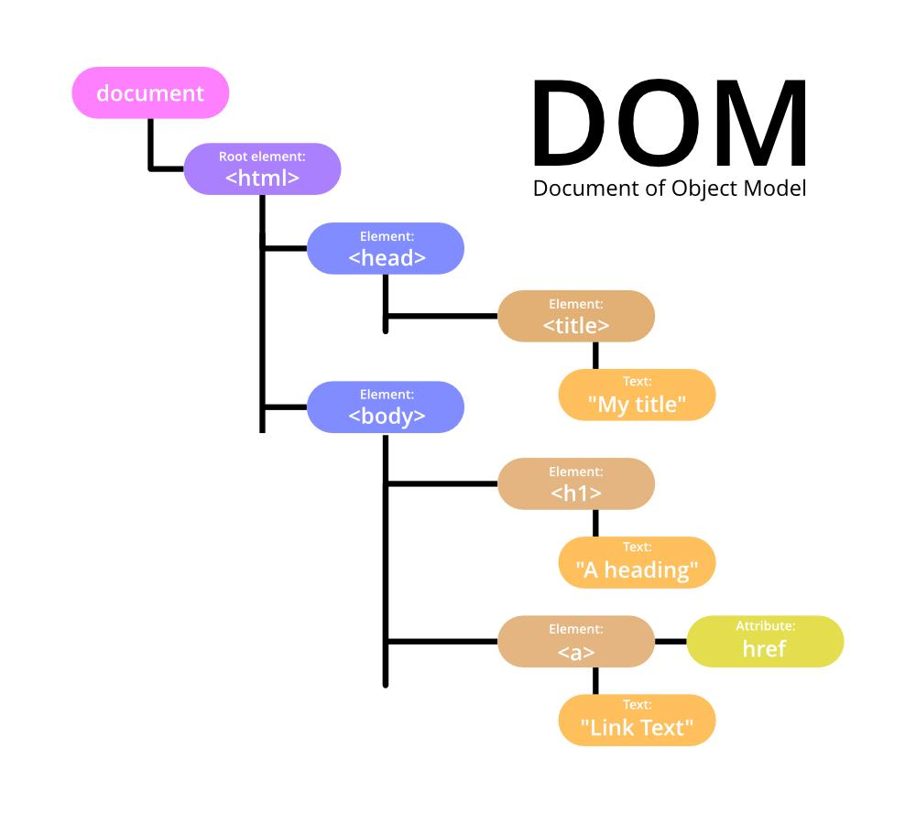
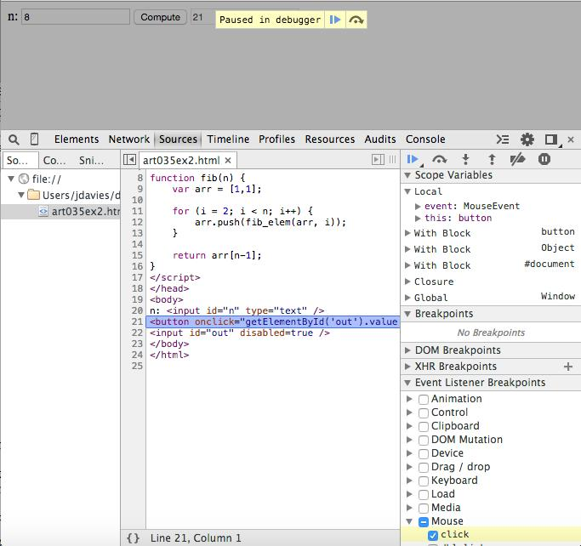
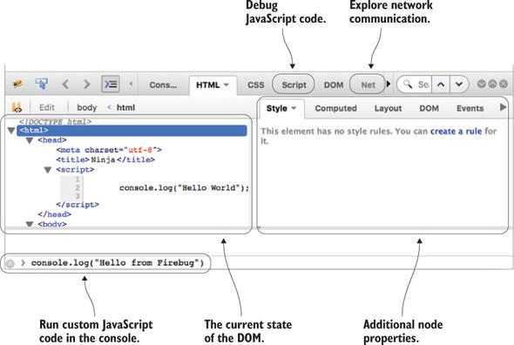
7
The Document Object Model (DOM) allows JavaScript to read and modify the structure and content of a webpage.

14.1 DOM fundamentals
- What the DOM is
- DOM tree structure
- Document, element, text, and comment nodes
- window versus document
- DOM loading and script placement
- DOMContentLoaded
- The load event
- Selecting elements and understanding node collections

14.2 Selecting elements
- getElementById()
- getElementsByClassName()
- getElementsByTagName()
- querySelector()
- querySelectorAll()
- CSS selectors in JavaScript
- matches()
- closest()
- contains()

14.3 Reading and changing content
- textContent
- innerText
- innerHTML
- outerHTML
- insertAdjacentHTML()
- insertAdjacentText()
- Reading and setting form values
- Safe text insertion
- Risks of inserting untrusted HTML

14.4 Creating and removing elements
- createElement()
- createTextNode()
- append()
- appendChild()
- prepend()
- before()
- after()
- replaceWith()
- remove()
- replaceChildren()
- cloneNode()
- DocumentFragment

14.5 Attributes, classes, and styles
- getAttribute()
- setAttribute()
- removeAttribute()
- hasAttribute()
- dataset
- classList.add()
- classList.remove()
- classList.toggle()
- classList.contains()
- style
- getComputedStyle()
- Inline styles versus stylesheet classes

14.6 Traversing the DOM
- parentElement
- children
- childNodes
- firstElementChild
- lastElementChild
- nextElementSibling
- previousElementSibling
- DOM traversal patterns
- Node versus element collections

14.7 DOM projects
- Dynamic greeting
- Character counter
- To-do list
- Accordion
- Tabs
- Modal dialog
- Image gallery
- Course filter
- Dynamic table
- Student management interface

15. Events and event handling

15.1 Event fundamentals
- What events are
- Event handlers
- addEventListener()
- removeEventListener()
- Event objects
- Event targets
- Event types
- Inline handlers versus JavaScript listeners

15.2 Mouse and pointer events
- click
- dblclick
- mousedown
- mouseup
- mousemove
- mouseenter
- mouseleave
- mouseover
- mouseout
- Pointer events
- Touch interaction concepts
- Pointer capture basics

15.3 Keyboard and input events
- keydown
- keyup
- input
- change
- beforeinput
- submit
- reset
- focus
- blur
- focusin
- focusout
- Keyboard shortcuts and modifier keys

15.4 Event propagation
- Capturing phase
- Target phase
- Bubbling phase
- event.target
- event.currentTarget
- stopPropagation()
- stopImmediatePropagation()
- preventDefault()
- Event delegation
- Delegation for dynamically created elements

15.5 Advanced event concepts
- One-time listeners
- Passive listeners
- Abortable event listeners
- Custom events
- dispatchEvent()
- Event delegation performance
- Handling events accessibly
Practical projects: Interactive navigation, keyboard-accessible dropdown, to-do list with event delegation, and modal with proper focus handling.

16. Forms, validation, and user input

16.1 Reading form data
- Accessing inputs by ID and name
- .value
- .checked
- .selectedIndex
- .selectedOptions
- Reading radio button groups
- Reading checkbox selections
- FormData
- form.elements
- input versus change events
- Converting input strings to numbers

16.2 Form submission
- Handling the submit event
- event.preventDefault()
- Form reset
- Preventing duplicate submissions
- Disabling submit buttons during requests
- Displaying validation messages
- Handling success and failure states

16.3 Validation techniques
- Required fields
- Email and phone validation
- Password rules
- Confirm-password validation
- Minimum and maximum lengths
- Numeric ranges
- Custom validation functions
- checkValidity()
- reportValidity()
- setCustomValidity()
- validity and validationMessage
- Native HTML validation versus JavaScript validation

16.4 Practical form projects
- Login form
- Registration form
- Password strength indicator
- Live character counter
- Course enquiry form
- Multi-step form
- Student admission form
- Dynamic form fields
Important: Client-side validation improves user experience, but server-side validation is still necessary for security and data integrity.

17. Asynchronous JavaScript
Asynchronous programming lets JavaScript handle operations such as network requests, timers, and file access without unnecessarily blocking the main thread.

17.1 Synchronous versus asynchronous code
- Execution order
- Blocking and non-blocking operations
- Call stack
- Browser runtime environment
- Task queues
- Event loop
- Microtask queue
- Macrotask/task queue
- Rendering and asynchronous callbacks

17.2 Timers
- setTimeout()
- clearTimeout()
- setInterval()
- clearInterval()
- Timer delay limitations
- Nested timers
- Countdown timers
- Debouncing and throttling concepts
- Why timers do not guarantee exact execution times

17.3 Callbacks
- Callback functions
- Callback-based APIs
- Error-first callback patterns
- Nested callbacks
- Callback hell
- Refactoring nested callbacks
- Callback error handling

17.4 Promises
- What a Promise is
- Pending, fulfilled, and rejected states
- Creating promises
- resolve() and reject()
- .then()
- .catch()
- .finally()
- Promise chaining
- Returning values from promise handlers
- Promise error propagation
- Converting callback logic to promises

17.5 Promise utilities
- Promise.all()
- Promise.allSettled()
- Promise.race()
- Promise.any()
- Handling partial failures
- Parallel versus sequential operations
- Choosing the appropriate Promise utility

17.6 Async and await
- async functions
- await
- Awaiting promises
- Error handling with try...catch
- Sequential versus parallel requests
- await with Promise.all()
- Common async/await mistakes
- Returning promises from async functions

17.7 Cancellation and timeouts
- AbortController
- AbortSignal
- Cancelling fetch requests
- Request timeouts
- Handling aborted operations
- Avoiding stale UI updates
- Cleanup in long-running operations
Practical projects: Countdown timer, quiz timer, delayed search, concurrent API requests, and a dashboard that loads multiple data sources.

18. Fetch API and working with APIs

18.1 API fundamentals
- What an API is
- Client-server communication
- HTTP and HTTPS
- Request methods
- Endpoints and query parameters
- Request headers
- Response headers
- Status codes
- JSON data format
- REST API concepts
- Authentication basics

18.2 Fetch API
- fetch()
- Request URLs
- GET requests
- POST requests
- PUT and PATCH requests
- DELETE requests
- Request headers
- Sending JSON
- Parsing responses using .json()
- Reading text and binary responses
- Checking response.ok
- Understanding that HTTP error statuses do not automatically reject a fetch promise
- Handling network errors
- Handling malformed JSON

18.3 HTTP status codes
- 200 — OK
- 201 — Created
- 204 — No Content
- 400 — Bad Request
- 401 — Unauthorized
- 403 — Forbidden
- 404 — Not Found
- 409 — Conflict
- 422 — Unprocessable Content
- 429 — Too Many Requests
- 500 — Internal Server Error
- 502 — Bad Gateway
- 503 — Service Unavailable

18.4 API integration patterns
- Loading states
- Error states
- Empty states
- Retry controls
- Pagination
- Filtering and sorting
- Search with query parameters
- Debounced search
- Handling slow connections
- Request cancellation
- Avoiding duplicate requests
- Rendering API results in the DOM

18.5 CORS and browser security
- Same-origin policy
- Cross-Origin Resource Sharing (CORS)
- Preflight requests
- Why frontend code cannot bypass server CORS policy
- API keys and public versus secret credentials
- Why private credentials must not be placed in frontend JavaScript
Practical projects: Weather interface, GitHub profile finder, product listing page, searchable course catalogue, and API-driven dashboard.

19. JSON and data handling

19.1 JSON fundamentals
- JSON syntax
- Objects and arrays in JSON
- Strings, numbers, booleans, and null
- Valid and invalid JSON
- JSON versus JavaScript object literals
- JSON data limitations

19.2 JSON methods
- JSON.stringify()
- JSON.parse()
- Pretty-printing JSON
- Replacer and reviver functions
- Handling parsing errors
- Serialization limitations
- Dates, functions, undefined, and special numeric values in JSON

19.3 Practical data handling
- Read JSON from an API
- Convert form data into JSON
- Display JSON records in a table
- Filter and sort JSON data
- Export records as JSON
- Import and validate JSON files
- Transform nested API responses

20. Browser storage and state persistence

20.1 Web Storage
- localStorage
- sessionStorage
- setItem()
- getItem()
- removeItem()
- clear()
- key()
- The storage event
- String-only storage and JSON serialization
- Storage limits and failure handling

20.2 Cookies
- What cookies are
- Expiration and lifetime
- Domain and path
- Secure
- SameSite
- HttpOnly
- Session cookies versus persistent cookies
- JavaScript-accessible cookies versus server-set cookies

20.3 IndexedDB
- Why IndexedDB exists
- Databases, object stores, and indexes
- Transactions
- Adding and retrieving records
- Updating and deleting records
- Asynchronous database operations
- Offline-first data storage concepts

20.4 Storage selection and security
- When to use localStorage
- When to use sessionStorage
- When to use IndexedDB
- Storage quotas
- Clearing and migrating stored data
- Avoiding storage of sensitive authentication secrets in JavaScript-accessible storage
- Persistence versus server-side storage
Practical projects: Persistent to-do list, theme preference switcher, shopping cart, offline notes app, and local student record manager.

21. ES6+ and modern JavaScript

21.1 Core modern syntax
- let and const
- Arrow functions
- Template literals
- Default parameters
- Rest parameters
- Spread syntax
- Destructuring
- Enhanced object literals
- Computed property names
- Optional chaining
- Nullish coalescing
- Logical assignment operators

21.2 Modern array and object methods
- map(), filter(), and reduce()
- find() and findIndex()
- Object.entries()
- Object.fromEntries()
- Object.hasOwn()
- Array.from()
- Array.of()
- Array.isArray()
- Immutable array methods
- toSorted(), toReversed(), and toSpliced()

21.3 Advanced language features
- Symbols
- Iterators
- Generators
- BigInt
- WeakMap and WeakSet
- Proxy basics
- Reflect basics
- Private class fields
- Static class fields and methods
- Class inheritance
- Dynamic imports
- Top-level await in supported module contexts
- Newer syntax and feature compatibility

21.4 Internationalization
- Intl.NumberFormat
- Intl.DateTimeFormat
- Intl.Collator
- Locale-aware sorting
- Formatting currencies such as INR
- Formatting dates for Indian users
- Handling different languages and locales

22. Object-oriented programming (OOP)

22.1 OOP fundamentals
- Objects and classes
- Properties and methods
- Constructors
- Instances
- Encapsulation
- Abstraction
- Inheritance
- Polymorphism
- Composition versus inheritance

22.2 JavaScript classes
- class
- constructor()
- Instance methods
- Static methods
- Getters and setters
- extends
- super()
- Method overriding
- Private fields using #
- Static fields
- Static initialization blocks
- Class expressions
- Class initialization behavior

22.3 Prototypes and inheritance
- Prototype chain
- Object.getPrototypeOf()
- Object.create()
- Object.setPrototypeOf() and performance considerations
- Constructor functions
- prototype property
- new operator
- instanceof
- Prototype-based inheritance versus class syntax

22.4 OOP projects
- Bank account model
- Student management system
- Employee and department classes
- Product inventory system
- Shopping cart
- Library management system

23. Functional programming concepts

23.1 Core principles
- Pure functions
- Immutability
- Avoiding unnecessary side effects
- Declarative programming
- Function composition
- Higher-order functions
- Referential transparency concepts
- Separating logic from UI operations

23.2 Practical functional patterns
- Transforming data with map()
- Filtering data with filter()
- Aggregation with reduce()
- Composing small functions
- Returning functions
- Closures
- Avoiding mutation in state updates
- Immutable object and array updates
- Handling asynchronous pipelines

23.3 Functional versus object-oriented design
- Strengths and limitations
- Choosing an approach based on the problem
- Combining functions and objects
- Readability and testability
- Reusable data transformation logic

24. Regular expressions (RegExp)

24.1 Regex fundamentals
- Creating regex literals
- RegExp constructor
- Pattern matching
- Literal characters
- Metacharacters
- Character classes
- Character ranges
- Quantifiers
- Anchors
- Groups
- Alternation

24.2 Advanced patterns
- Capturing groups
- Non-capturing groups
- Named capture groups
- Greedy and lazy matching
- Positive and negative lookahead
- Lookbehind
- Escaping special characters
- Flags: g, i, m, s, u, y, d
- Unicode-aware patterns
- Common regex performance pitfalls

24.3 Regex with JavaScript
- test()
- exec()
- match()
- matchAll()
- replace()
- replaceAll()
- search()
- Extracting values
- Finding patterns in text
- Replacing unwanted characters

24.4 Practical exercises
- Basic email-format checks
- Password rule checks
- Extract phone-like patterns
- Find numbers in text
- Replace repeated spaces
- Validate simple identifiers
- Parse structured strings
Regex is useful for format checks, but complex input validation should not rely on a single overly restrictive expression.

25. JavaScript modules and code organization

25.1 Module fundamentals
- Why modules are needed
- Splitting code into files
- Module scope
- Named exports
- Default exports
- Importing functions, variables, and classes
- Renaming imports and exports
- Re-exporting modules
- Importing everything with * as
- Import and export syntax

25.2 Browser modules
- <script type="module">
- Module loading behavior
- Relative and absolute module paths
- Module strict mode
- Module caching
- Top-level this behavior
- Dynamic import()
- Top-level await
- Import maps
- Cross-origin restrictions and MIME type requirements
- Why ES modules generally need a local or hosted server

25.3 Project architecture
- Entry-point files
- Utility modules
- Service/API modules
- UI modules
- Data modules
- Constants and configuration
- Separating business logic from DOM code
- Avoiding circular dependencies
- Reusable code organization
Example project structure:
edvent-app/
├── index.html
├── css/
│ └── styles.css
└── js/
├── main.js
├── api.js
├── utils.js
├── ui.js
└── validation.js

25.4 Practical module project
Build a course management application with separate modules for:
- Student records
- Course data
- Form validation
- API requests
- DOM rendering
- Application initialization

26. Browser APIs and web platform capabilities
JavaScript is the language; browser APIs provide features such as networking, storage, clipboard access, and notifications.

26.1 Window and document APIs
- window
- document
- location
- history
- navigator
- screen
- innerWidth and innerHeight
- matchMedia()
- requestAnimationFrame()
- requestIdleCallback() where supported

26.2 Clipboard API
- Reading clipboard text
- Writing clipboard text
- Permissions and secure contexts
- Handling rejected clipboard operations
- Copy buttons
- Paste workflows
- Fallbacks for unsupported environments

26.3 File APIs
- File input handling
- File
- Blob
- FileReader
- Object URLs
- URL.createObjectURL()
- URL.revokeObjectURL()
- Reading text files
- File previews
- Downloading generated files
- File size and type validation

26.4 Geolocation API
- Requesting location permission
- getCurrentPosition()
- watchPosition()
- clearWatch()
- Handling permission denial
- Handling timeouts and errors
- Secure-context requirements
- Privacy considerations

26.5 Other browser APIs
- Fullscreen API
- Page Visibility API
- Resize Observer
- Intersection Observer
- Mutation Observer
- Drag and Drop API
- Web Animations API
- Web Notifications API
- Web Audio API basics
- Canvas API
- Web Components
- Service Workers
- Web Workers
Practical projects: Clipboard copy tool, image preview app, file reader, scroll-progress indicator, and lazy-loading content demo.

27. JavaScript and the DOM: advanced interaction patterns

27.1 Dynamic rendering
- Rendering arrays of records
- Creating reusable rendering functions
- Building tables dynamically
- Rendering nested data
- Empty states
- Loading indicators
- Error messages
- Updating individual components
- Efficient DOM updates

27.2 UI state management
- Application state
- State versus DOM content
- Keeping state consistent with UI
- Updating state immutably
- Derived state
- Event-driven updates
- Basic state management patterns
- Avoiding duplicated state
- Separating data from presentation

27.3 Interactive patterns
- Tabs
- Accordions
- Dropdown menus
- Modals
- Toast notifications
- Search and filter panels
- Pagination
- Sorting tables
- Shopping carts
- Multi-step forms
- Theme switching
- Responsive menus
- Drag-and-drop interfaces

27.4 Accessibility in interactive JavaScript
- Keyboard event handling
- Focus management
- Focus trapping in modal dialogs
- Restoring focus when a modal closes
- Escape key behavior
- ARIA state updates
- Announcing dynamic changes
- Accessible error messages
- Avoiding inaccessible click-only interactions

28. Browser navigation, URLs, and history
- window.location
- URL
- URLSearchParams
- Reading query strings
- Updating query parameters
- URL encoding and decoding
- history.pushState()
- history.replaceState()
- popstate
- Browser back and forward navigation
- Hash-based navigation
- Single-page application routing concepts
- Preserving search and filter state in URLs
- Route handling concepts
- Why direct page refreshes need server support for many SPA routes
Practical project: Build a searchable course catalogue whose search term, filters, and page number can be preserved in the URL.

29. Web Workers, service workers, and offline support

29.1 Web Workers
- Main thread versus worker thread
- Creating a worker
- postMessage()
- onmessage
- Structured cloning
- Worker errors
- Terminating workers
- Worker modules
- Tasks suitable for background computation
- Limitations: workers do not directly manipulate the DOM

29.2 Service Workers
- Service worker lifecycle
- Registration
- Installation and activation
- Fetch event
- Cache API
- Cache-first and network-first strategies
- Offline fallbacks
- Updating service workers
- Unregistering and debugging
- Secure-context requirements

29.3 Progressive Web App concepts
- Web app manifest
- Installability
- Offline behavior
- Cache invalidation
- Network failure handling
- Background synchronization concepts
- Push notifications
- Permissions and privacy
- Limitations across browsers
Practical project: Create a small offline-capable course notes application.

30. JavaScript security

30.1 Common frontend security risks
- Cross-site scripting (XSS)
- Unsafe HTML injection
- DOM-based XSS
- Insecure handling of user-generated content
- Exposing secrets in frontend code
- Insecure dependencies
- Unsafe redirects
- Prototype pollution concepts

30.2 Secure coding practices
- Prefer textContent for untrusted text
- Avoid inserting untrusted strings into innerHTML
- Sanitize HTML when rich HTML is genuinely required
- Validate data on the server
- Encode data appropriately for its output context
- Avoid eval() and the Function constructor
- Use HTTPS
- Understand Content Security Policy (CSP)
- Handle authentication tokens carefully
- Keep dependencies updated
- Never treat hidden buttons or client-side checks as access control

30.3 Authentication concepts
- Authentication versus authorization
- Sessions and cookies
- Secure, HttpOnly, and SameSite cookie concepts
- Token-based authentication basics
- Refresh-token concepts
- CSRF fundamentals
- Why authentication and authorization must be enforced server-side

31. Performance optimization

31.1 JavaScript performance fundamentals
- Parsing and compilation concepts
- Execution time
- Main-thread blocking
- Long tasks
- Memory usage
- Garbage collection concepts
- Avoiding unnecessary work
- Algorithmic complexity basics

31.2 Performance techniques
- Debouncing
- Throttling
- Efficient DOM updates
- Event delegation
- Lazy loading
- Code splitting
- Dynamic imports
- Reducing bundle size
- Avoiding unnecessary listeners
- Caching repeated computations
- Avoiding memory leaks
- Optimizing large lists
- Virtualization concepts

31.3 Measuring performance
- Browser Performance panel
- Network panel
- Memory panel
- Lighthouse
- Core Web Vitals concepts
- Long task analysis
- Profiling slow functions
- Comparing before and after optimization

32. Testing and code quality

32.1 Testing fundamentals
- Why testing matters
- Manual versus automated testing
- Unit tests
- Integration tests
- End-to-end tests
- Test cases and expected results
- Edge cases
- Regression testing

32.2 JavaScript testing tools
- Node.js built-in test runner
- Jest concepts
- Vitest
- Playwright
- Cypress
- Browser testing
- Mocking API responses
- Testing asynchronous functions
- Testing DOM interactions

32.3 Code quality tools
- ESLint
- Prettier
- Editor formatting
- Linting rules
- Naming conventions
- Small and focused functions
- Error handling
- Removing duplicate logic
- Code review
- Refactoring
- Writing maintainable documentation

33. Node.js fundamentals — preparation for backend JavaScript
This section is an introduction to the runtime needed for later backend development. It is not a replacement for a complete Node.js syllabus.

33.1 Node.js environment
- What Node.js is
- Browser JavaScript versus Node.js
- Running scripts from the terminal
- Node REPL
- process
- Environment variables
- Exit codes
- Standard input and output
- Basic command-line programs

33.2 Built-in modules
- node:fs
- node:path
- node:os
- node:http
- node:crypto
- node:events
- node:util
- node:url
- Synchronous versus asynchronous file operations

33.3 Package management
- npm
- package.json
- package-lock.json
- Installing dependencies
- Development dependencies
- npm scripts
- Semantic versioning
- Dependency updates
- Basic security audits
- CommonJS versus ES modules

33.4 Introductory projects
- Command-line calculator
- Text file reader
- File organizer
- JSON data processor
- Simple HTTP server
- Command-line student record manager

34. Tooling, build systems, and deployment

34.1 Development tools
- Browser DevTools
- VS Code debugging
- Node.js debugger
- Git and GitHub basics
- npm scripts
- Environment configuration
- Project structure

34.2 Build tools
- Vite
- Bundling concepts
- Transpilation concepts
- Minification
- Tree shaking
- Source maps
- Environment variables
- Development versus production builds
- Dependency management

34.3 Deployment
- Static website hosting
- Build and deployment workflow
- Environment configuration
- Browser compatibility
- Error monitoring basics
- Source map considerations
- Handling failed network requests
- Production testing
- Deployment troubleshooting

35. JavaScript interview and problem-solving preparation

35.1 Fundamentals
- Data types
- Scope
- Hoisting
- Closures
- Type coercion
- Equality
- this
- Callbacks
- Promises
- Async/await
- Event loop

35.2 Array and string problems
- Reverse a string
- Check palindrome
- Find duplicates
- Find the missing number
- Find the second-largest number
- Count character frequency
- Group anagrams
- Remove duplicates
- Flatten nested arrays
- Find common array elements
- Sort records by a property

35.3 Object and function problems
- Deep versus shallow copy
- Group records by property
- Count occurrences using a Map
- Implement a counter with closures
- Write a debounce function
- Write a throttle function
- Implement array transformations
- Explain call(), apply(), and bind()
- Explain prototype inheritance
- Handle parallel asynchronous tasks

35.4 Browser and practical interview tasks
- Build a to-do list
- Validate a form
- Fetch and display API data
- Implement pagination
- Create a searchable table
- Build a modal dialog
- Explain event delegation
- Fix a broken layout interaction
- Debug a rejected promise
- Improve a slow UI

36. Complete JavaScript practical project roadmap
Build these projects in order. Each project should be completed independently before moving to the next level.
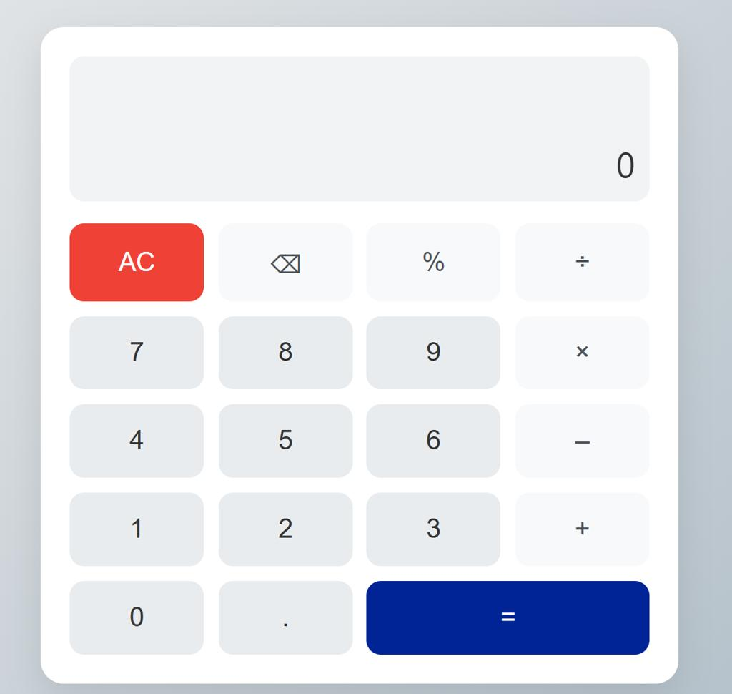
Project 1 — Calculator
Beginner
Practice variables, operators, functions, conditionals, DOM selection, and click events.
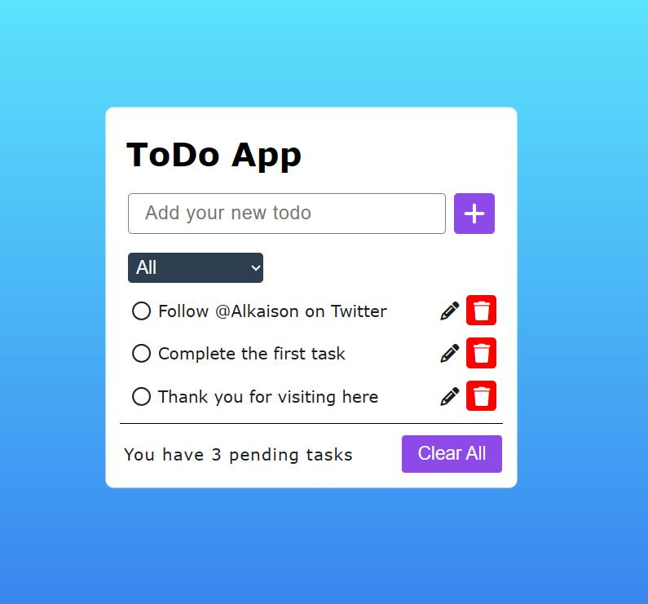
Project 2 — To-do list
Beginner
Practice arrays, objects, event listeners, dynamic DOM rendering, and localStorage.
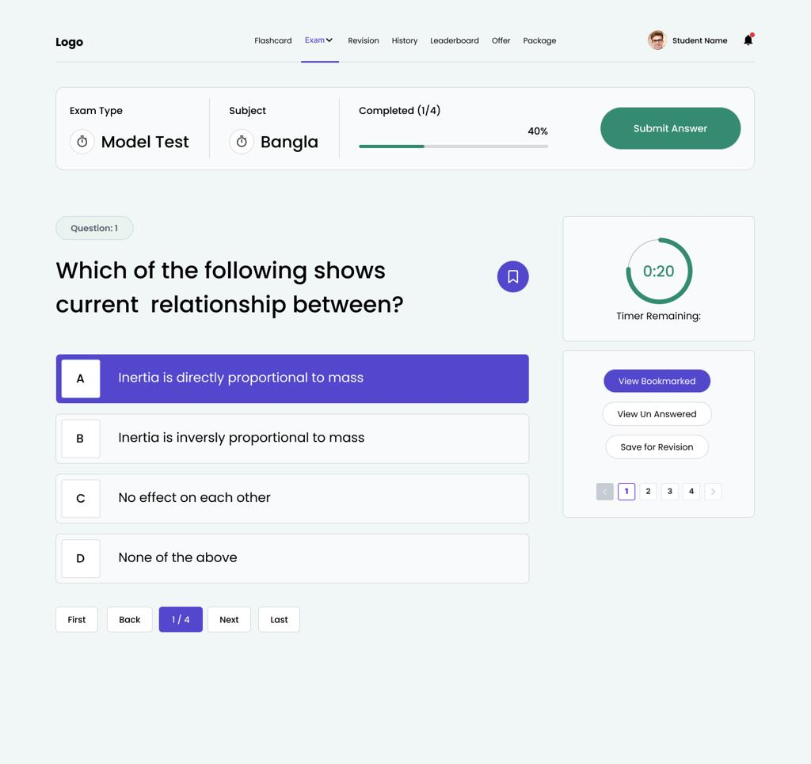
Project 3 — Quiz application
Beginner to intermediate
Practice arrays of objects, timers, scoring, conditional rendering, and form controls.
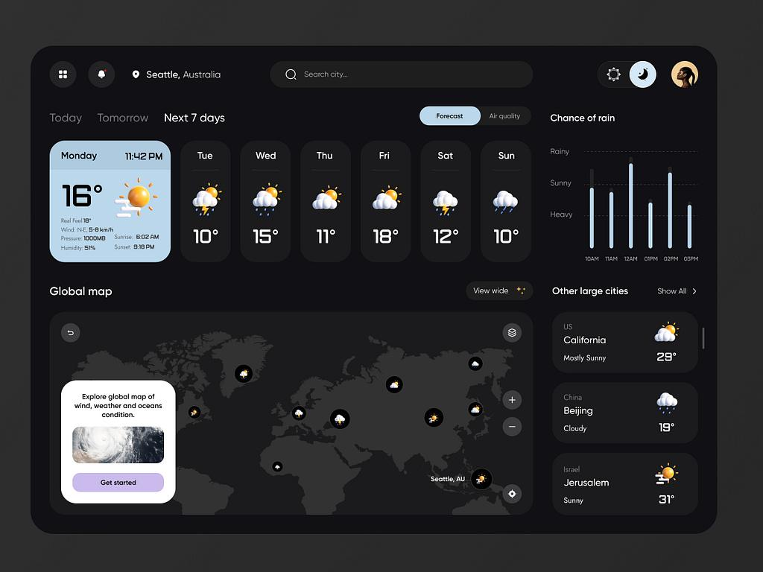
Project 4 — Weather dashboard
Intermediate
Practice Fetch API, async/await, JSON, loading states, error handling, and API integration.
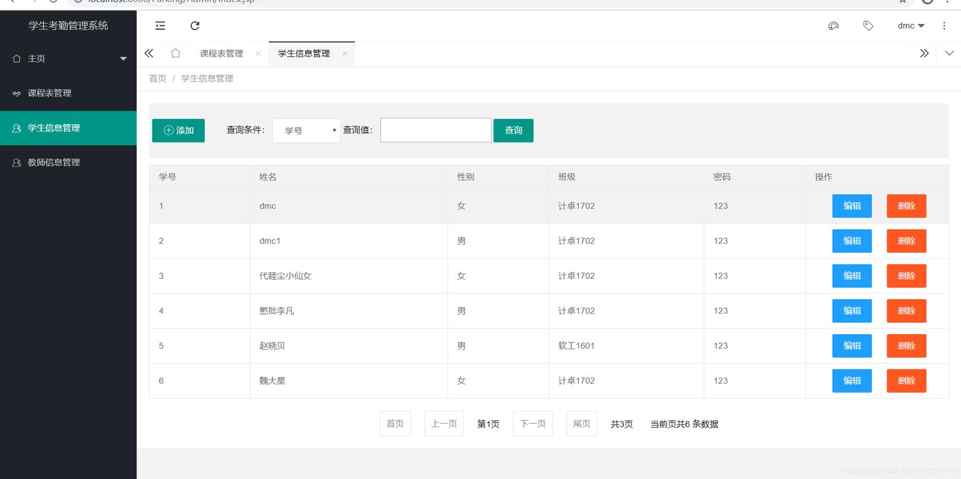
Project 5 — Student management system
Intermediate
Practice CRUD operations, forms, arrays of objects, validation, filtering, sorting, and persistent storage.
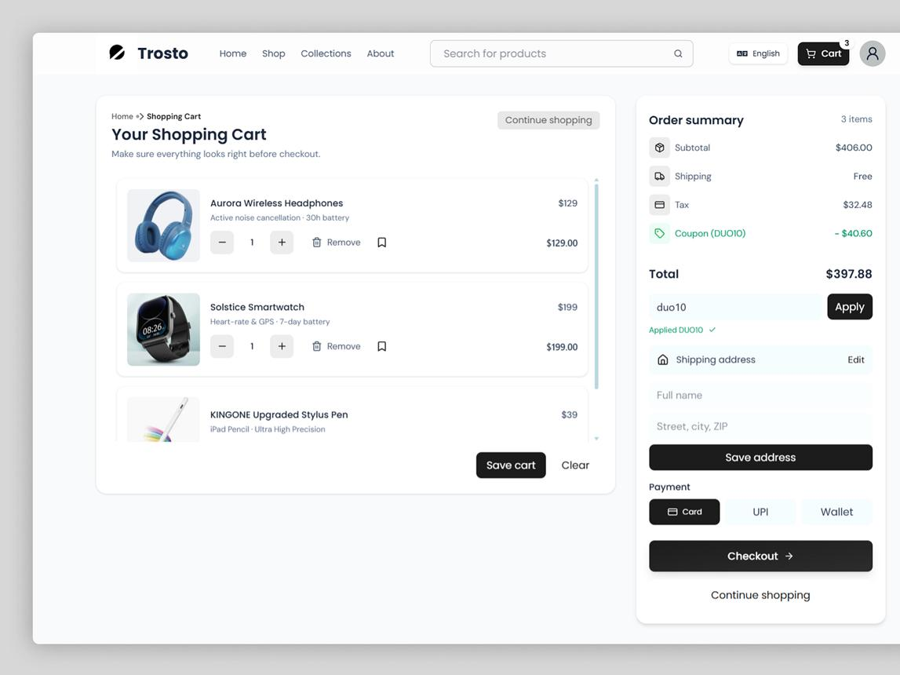
Project 6 — Shopping cart
Intermediate to advanced
Practice object modeling, array methods, price calculations, cart state, and localStorage.
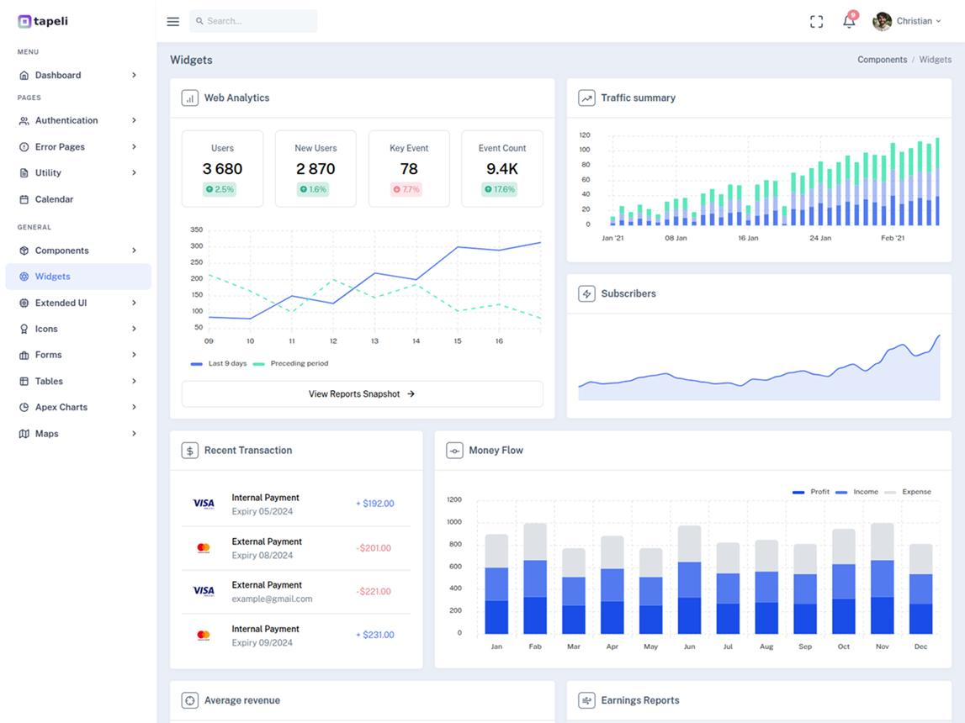
Project 7 — API-powered analytics dashboard
Advanced
Practice modules, asynchronous requests, data transformations, charts, reusable UI functions, and error handling.

Project 8 — EDVENT course portal
Capstone
Combine HTML, CSS, JavaScript modules, search, filters, course details, form validation, API integration, accessibility, and responsive behavior.

Additional project ideas
- Expense tracker
- Digital clock and stopwatch
- Password generator
- Notes application
- Memory card game
- Rock-paper-scissors game
- GitHub profile search
- Pagination and sorting component
- Drag-and-drop task board
- Multi-step registration form
- Offline notes application
- Node.js command-line student manager
For portfolio projects, include a README, screenshots, clear setup instructions, responsive styling, error handling, and a live demo where appropriate.

37. Recommended learning roadmap
The durations below assume consistent practice and are estimates rather than fixed deadlines.
Stage | Topics | Suggested duration
1 | Fundamentals, variables, types, operators | 1 week
2 | Conditions, loops, strings, numbers | 1 week
3 | Functions, arrays, objects | 2 weeks
4 | Sets, Maps, errors, debugging | 1 week
5 | DOM manipulation and events | 2 weeks
6 | Forms and validation | 1 week
7 | Promises, async/await, Fetch API | 2 weeks
8 | Modern JavaScript and modules | 1–2 weeks
9 | OOP, functional programming, regex | 1–2 weeks
10 | Browser APIs, storage, security, performance | 2 weeks
11 | Testing, tooling, and Node.js basics | 1–2 weeks
12 | Projects, interview practice, revision | 2–4 weeks
Estimated total: approximately 17–22 weeks. Learners who already understand programming fundamentals may progress faster.

38. JavaScript mastery tracker
Use this checklist to track progress through the syllabus. Mark a topic complete only when you can explain it and use it in a working program.

Course progress
0 of 35 topics completed

0%

Foundations
Variables, scope, and data types
Operators and type coercion
Conditions and loops
Strings, numbers, and dates
Functions and closures

Data structures
Array methods and transformations
Objects and destructuring
Set, Map, and weak collections
Errors and debugging
OOP and prototypes

Browser development
DOM selection and manipulation
Events and event delegation
Forms and validation
CSS and DOM integration
Accessibility for interactive UI

Asynchronous JavaScript
Event loop and timers
Callbacks and promises
Async/await and error handling
Fetch API and HTTP
JSON and API integration

Advanced JavaScript
Modern ES features
Modules and project structure
Functional programming
Regular expressions
Browser APIs and storage

Production skills
Security and safe DOM updates
Performance optimization
Testing and code quality
Node.js fundamentals
Build tools and deployment

Portfolio projects
Calculator and to-do list
Quiz or game
API-powered application
CRUD management system
Complete EDVENT course portal
ResetCopy checklist

39. Official JavaScript learning resources
- MDN JavaScript Guide — Core language guide
- JavaScript.info — Modern JavaScript tutorial
- ECMAScript specification — Language specification
- Node.js documentation — Node.js API reference
- Vite — Development tooling guide
- freeCodeCamp — Free coding exercises and projects

Final recommendation for EDVENT
Structure your JavaScript course into four levels:
- JavaScript Fundamentals: variables, data types, operators, conditions, loops, functions, arrays, and objects.
- Browser JavaScript: DOM, events, forms, validation, and interactive UI development.
- Advanced JavaScript: asynchronous programming, APIs, modules, OOP, browser storage, security, and performance.
- Projects and Career Preparation: real-world applications, debugging, GitHub portfolio, interview exercises, and an introduction to Node.js.
The most important rule: do not teach JavaScript as a list of syntax and methods to memorize. Every major topic should lead to a coding exercise or mini-project. Before starting React, students should be comfortable with functions, arrays and objects, destructuring, array methods, modules, DOM events, promises, async/await, and API data handling.

