Complete Java Programming Syllabus: Beginner to Advanced
A structured, industry-oriented curriculum for EDVENT
This syllabus takes a student from zero programming knowledge to advanced Java development. It is suitable for classroom teaching, self-study, interview preparation, and building real-world applications.
The recommended approach is to learn Core Java first, then Object-Oriented Programming, Collections, modern Java features, databases, testing, and backend development with Spring Boot. Students should write code and complete practical assignments throughout the course—not just study theory.
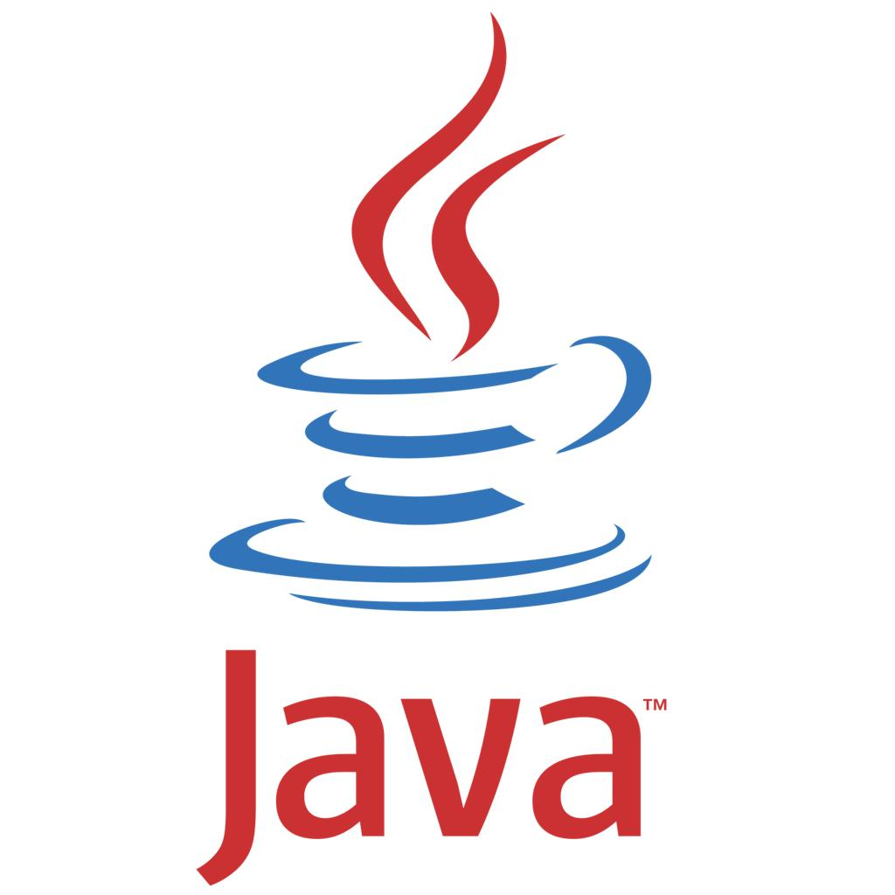

Course overview
Beginner → Intermediate → Advanced → Job-ready
- Core Java: Programming fundamentals, OOP, exception handling, Collections and generics
- Advanced Java: Multithreading, JVM, networking, reflection and performance
- Professional development: SQL, JDBC, Maven/Gradle, Git, testing and design principles
- Backend specialization: Spring Boot, REST APIs, security, databases and deployment

28–36 weeks
Recommended comprehensive track

20+ projects
Exercises, mini-projects and capstones

Zero prerequisites
Start without programming experience

Career-focused
Core Java and backend development

1. Recommended technology stack
Area | Recommended tools
Java version | Java 21 or Java 25 LTS, depending on the environment
IDE | IntelliJ IDEA, Eclipse or VS Code with Java extensions
Build tools | Maven first; Gradle afterward
Version control | Git and GitHub
Database | MySQL or PostgreSQL
Testing | JUnit 5, Mockito
Backend framework | Spring Boot
API testing | Postman or an equivalent REST client
Containers | Docker fundamentals
Deployment | A cloud or platform-as-a-service environment
Version strategy: Use a consistent supported JDK across the course. Java 21 and Java 25 are Long-Term Support (LTS) releases. Teach the language fundamentals using the selected JDK, then introduce modern features from newer releases. Some frameworks, tools and institutional environments may support different Java versions.

2. Complete learning roadmap

01
Programming Foundations
Computer basics, algorithms, flowcharts and problem-solving

02
Java Fundamentals
Syntax, variables, operators, conditions, loops and methods

03
Core Java
Arrays, strings, classes, objects, OOP and exception handling

04
Intermediate Java
Collections, generics, lambdas, streams and file handling

05
Advanced Java
Concurrency, JVM, memory management, reflection and networking

06
Professional Tools
SQL, JDBC, Maven, Git, testing and clean code

07
Backend Development
Spring Boot, REST APIs, persistence, security and deployment

08
Portfolio and Interview Preparation
DSA, system design fundamentals and capstone projects

Part 1 — Programming foundations

Module 1: Introduction to programming and computer fundamentals
Duration: 1 week

Topics
- What is a computer program?
- What is programming and why do we need it?
- Machine language, assembly language and high-level languages.
- Compiler, interpreter and bytecode.
- Programming paradigms:
  - Procedural programming
  - Object-oriented programming
  - Functional programming
  - Event-driven programming
- Algorithm fundamentals.
- Pseudocode and flowcharts.
- Understanding input, processing and output.
- Syntax errors, runtime errors and logical errors.
- Introduction to debugging and problem-solving.

Practical exercises
- Write algorithms for calculating the sum of two numbers.
- Draw a flowchart to determine whether a number is even or odd.
- Create an algorithm to calculate simple interest.
- Design a flowchart for finding the largest of three numbers.
Assignment: Write pseudocode for 10 everyday problems before writing any Java code.

Module 2: Java language and development environment
Duration: 1 week

Topics
- History and purpose of Java.
- Key characteristics of Java:
  - Platform independence
  - Object orientation
  - Strong type system
  - Automatic memory management
  - Multithreading support
- Java editions and ecosystem: Java SE, Jakarta EE and Java-based frameworks.
- JDK, JRE and JVM: their roles and differences.
- Java source code, bytecode and execution process.
- Installing and configuring the JDK.
- Setting JAVA_HOME and configuring PATH.
- Installing and configuring an IDE.
- Creating a Java project.
- Compiling and running Java programs from the terminal.
- Understanding .java and .class files.
- Using jshell for interactive experimentation.
- Introduction to Java API documentation.

First program
public class Main {
public static void main(String[] args) {
System.out.println("Welcome to Java!");
}
}
Understand every part of the program: class declaration, main() method, method signature, statements, semicolons and output.

Practical exercises
- Print personal details, a table and a simple pattern.
- Compile and run a Java file from the command line.
- Intentionally create syntax errors and fix them.
- Run simple expressions in JShell.
Mini-project: Personal introduction and formatted receipt generator.

Part 2 — Java fundamentals

Module 3: Variables, data types and literals
Duration: 1 week

Topics
- Java tokens and identifiers.
- Keywords and reserved words.
- Naming conventions and coding style.
- Variables and declaration.
- Local variables, instance variables and static variables.
- Primitive data types:
  - byte
  - short
  - int
  - long
  - float
  - double
  - char
  - boolean
- Reference types and object references.
- Literals: integer, floating-point, character, string, Boolean and null.
- Constants using final.
- Default field values versus local-variable initialization.
- Type inference with var for eligible local variables.
- Type conversion and casting.
- Widening and narrowing conversions.
- Integer overflow and numeric precision.
- Wrapper classes and autoboxing/unboxing introduction.

Practical exercises
- Build a program that stores and displays student information.
- Convert Celsius to Fahrenheit.
- Calculate area and perimeter.
- Demonstrate type casting and integer division.
- Explore floating-point precision issues.
Mini-project: Student marksheet with total, percentage and grade.

Module 4: Operators and expressions
Duration: 4–5 days

Topics
- Arithmetic operators.
- Unary operators and increment/decrement.
- Relational operators.
- Equality operators.
- Logical operators: &&, ||, !.
- Assignment and compound assignment operators.
- Bitwise operators.
- Shift operators.
- Ternary operator.
- Operator precedence and associativity.
- Short-circuit evaluation.
- Numeric promotion.
- Expression evaluation and side effects.
- Comparing primitive values and object references.

Practical exercises
- Build a calculator.
- Check even/odd and positive/negative values.
- Swap two values using different approaches.
- Explore bitwise operations.
- Write expressions that demonstrate operator precedence.

Module 5: Input and output
Duration: 3–4 days

Topics
- Output using System.out.print() and println().
- Formatted output using printf().
- Escape sequences and newline characters.
- User input using Scanner.
- Reading integers, decimals and strings.
- The next() versus nextLine() distinction.
- Common input-buffer issues.
- Basic command-line arguments using String[] args.
- Input validation and handling invalid input.

Practical exercises
- Build a user registration form in the console.
- Calculate salary from user input.
- Create a bill calculator with formatted output.
- Accept command-line arguments and print a summary.
Mini-project: Console-based shopping bill generator.

Module 6: Conditional statements
Duration: 4–5 days

Topics
- if statements.
- if-else.
- Nested conditions.
- else-if ladder.
- switch statements and expressions.
- Multiple case labels.
- Scope of variables in blocks.
- Conditional expressions with the ternary operator.
- Input validation.
- Avoiding deeply nested and duplicated conditions.

Practical exercises
- Check eligibility based on age and marks.
- Build a grade calculator.
- Calculate electricity charges using slabs.
- Create a menu-driven calculator.
- Determine leap years and validate dates.
Mini-project: Student admission eligibility checker.

Module 7: Loops and iteration
Duration: 1 week

Topics
- while loop.
- do-while loop.
- Traditional for loop.
- Enhanced for loop.
- Nested loops.
- break and continue.
- Labeled break and continue.
- Infinite loops and termination conditions.
- Loop invariants and tracing.
- Basic time-complexity intuition.
- Pattern printing.
- Avoiding off-by-one errors.

Practical exercises
- Print multiplication tables.
- Find factorials.
- Generate Fibonacci sequences.
- Check prime numbers.
- Reverse an integer.
- Calculate digit sums.
- Print star, number and pyramid patterns.
- Find GCD and LCM.
Mini-project: Number analysis toolkit.

Module 8: Methods and modular programming
Duration: 1 week

Topics
- What is a method?
- Method declaration, definition and invocation.
- Parameters and arguments.
- Return types and void.
- Method signatures.
- Local variables and block scope.
- Pass-by-value in Java.
- Passing primitive values and object references.
- Method overloading.
- Varargs.
- Recursion and base cases.
- Static methods.
- Method decomposition and reusability.
- Javadoc comments.
- Basic unit-testing concepts.

Practical exercises
- Create reusable methods for arithmetic operations.
- Write methods for checking prime numbers and palindromes.
- Implement factorial using iteration and recursion.
- Create a reusable grade-calculation module.
- Refactor a large program into smaller methods.
Mini-project: Modular console utility library.

Part 3 — Core Java and object-oriented programming

Module 9: Arrays
Duration: 1 week

Topics
- Array fundamentals and declaration.
- Array creation and initialization.
- Array indexes and bounds.
- Default values in array elements.
- Traversing arrays.
- Updating, inserting and deleting logically.
- Searching in arrays.
- Sorting arrays.
- Copying arrays.
- Arrays utility class.
- Multidimensional arrays.
- Jagged arrays.
- Arrays of objects.
- Array references and aliasing.
- Limitations of fixed-size arrays.

Practical exercises
- Find the minimum, maximum and average.
- Find the second-largest element.
- Reverse an array.
- Remove duplicates.
- Merge two arrays.
- Implement linear and binary search.
- Implement basic sorting algorithms.
- Perform matrix addition and multiplication.
Mini-project: Student marks analysis system.

Module 10: Strings and text processing
Duration: 1 week

Topics
- The String class.
- String literals and the string pool.
- String immutability.
- String comparison: equals(), equalsIgnoreCase() and ==.
- Searching and extracting substrings.
- String concatenation.
- StringBuilder and StringBuffer.
- Common string methods.
- Character handling using Character.
- Unicode and character encoding fundamentals.
- Splitting and joining strings.
- Basic regular expressions.
- Parsing numeric values from strings.
- Efficient string manipulation.
- Text validation and sanitization.

Practical exercises
- Reverse a string.
- Count vowels, words and characters.
- Check palindromes.
- Detect anagrams.
- Count word frequency.
- Validate simple email and phone-number formats.
- Remove duplicate words.
- Build a text search utility.
Mini-project: Text analyzer and password-format validator.

Module 11: Classes and objects
Duration: 1 week

Topics
- Understanding classes and objects.
- Class members and object state.
- Fields and methods.
- Creating objects using new.
- Constructors and constructor overloading.
- Default constructor behavior.
- The this keyword.
- Instance versus static members.
- Static initialization blocks.
- Initialization order.
- Encapsulation and accessors.
- Access modifiers: public, protected, package-private and private.
- Packages and imports.
- Organizing classes into packages.
- Object identity and references.
- toString(), equals() and hashCode() introduction.

Practical exercises
- Create Student, Employee, Product and BankAccount classes.
- Implement constructors with validation.
- Keep account balance private.
- Separate classes into packages.
- Compare objects using logical equality.
Mini-project: Bank account management system.

Module 12: Object-oriented programming principles
Duration: 2 weeks

Topics
A. Encapsulation
- Data hiding.
- Controlled access to object state.
- Invariants and validation.
- Immutable objects.
B. Inheritance
- extends and single class inheritance.
- Parent and child classes.
- The super keyword.
- Constructor chaining.
- Method overriding.
- The final keyword in classes and methods.
- Inheritance versus composition.
C. Polymorphism
- Compile-time polymorphism through overloading.
- Runtime polymorphism through overriding.
- Dynamic method dispatch.
- Upcasting and safe downcasting.
- instanceof and pattern matching where supported.
D. Abstraction
- Abstract classes and abstract methods.
- Interfaces.
- Implementing multiple interfaces.
- Default and static interface methods.
- Private interface methods in supporting Java versions.
- Functional interfaces.
- Abstract classes versus interfaces.
E. Object design
- Coupling and cohesion.
- Favoring composition where appropriate.
- Substitutability and contracts.
- Avoiding unnecessary inheritance.

Practical exercises
- Create a vehicle hierarchy.
- Build an employee payroll hierarchy.
- Implement payment methods through an interface.
- Design a notification system.
- Model a library using composition.
Mini-project: Employee payroll and role-management system.

Module 13: Advanced class and object concepts
Duration: 1 week

Topics
- Object lifecycle.
- Initialization blocks.
- Static fields, methods and nested types.
- Static nested classes.
- Inner classes.
- Local classes.
- Anonymous classes.
- Enums and enum-specific methods.
- Records for concise data carriers.
- Sealed classes and interfaces.
- Immutable class design.
- Defensive copying.
- Copying objects and shallow versus deep copies.
- Object equality contracts.
- hashCode() contract and implications for collections.
- Comparable and Comparator.
- Why Java does not support C++-style operator overloading.
- Object serialization considerations.

Practical exercises
- Implement an immutable Student record or class.
- Create enums for order and payment statuses.
- Use comparators to sort employees by multiple fields.
- Implement correct equals() and hashCode().
- Model restricted class hierarchies with sealed types.
Mini-project: E-commerce product and order model.

Module 14: Exception handling
Duration: 1 week

Topics
- Errors versus exceptions.
- Exception hierarchy: Throwable, Exception and Error.
- Checked and unchecked exceptions.
- try, catch and finally.
- Multiple catch blocks.
- Multi-catch.
- Exception propagation.
- throw and throws.
- Creating custom exceptions.
- Try-with-resources.
- Suppressed exceptions.
- Exception chaining and causes.
- Best practices for exception messages.
- Avoiding swallowed exceptions.
- When not to use exceptions for ordinary control flow.

Practical exercises
- Handle invalid user input.
- Validate account withdrawals.
- Create custom validation exceptions.
- Read files safely with try-with-resources.
- Handle database-related failures.
Mini-project: Banking application with robust error handling.

Part 4 — Intermediate Java

Module 15: Packages, access control and Java API
Duration: 3–4 days

Topics
- Built-in packages such as java.lang, java.util, java.io and java.time.
- Creating user-defined packages.
- Import statements and static imports.
- Package-private access.
- Protected access across packages.
- Classpath basics.
- JAR files and their purpose.
- Java API documentation.
- Introduction to module descriptors and the Java Platform Module System (JPMS).
- Understanding public API versus internal implementation.

Practical exercises
- Organize a project into model, service and utility packages.
- Build a reusable JAR.
- Document public methods with Javadoc.
- Experiment with access modifiers across packages.

Module 16: Wrapper classes, generics and type safety
Duration: 1 week

Topics
- Wrapper classes: Integer, Double, Boolean, Character and others.
- Boxing and unboxing.
- Wrapper caching and reference comparison pitfalls.
- Parsing and converting values.
- Generic classes.
- Generic interfaces.
- Generic methods.
- Bounded type parameters.
- Multiple bounds.
- Wildcards: ?, ? extends T and ? super T.
- PECS principle: Producer Extends, Consumer Super.
- Type erasure.
- Generic invariance.
- Raw types and unchecked warnings.
- Generic restrictions and type-safety limitations.
- Generic utility methods and APIs.

Practical exercises
- Build a generic Box<T> class.
- Implement a generic pair or tuple.
- Write a generic method to find the maximum.
- Create a reusable repository interface.
- Use bounded wildcards to process collections.
Mini-project: Generic inventory storage and search utility.

Module 17: Java Collections Framework
Duration: 2 weeks

Topics
A. Framework fundamentals
- Why collections are needed.
- Collection hierarchy.
- Iterable, Collection and Map.
- Generics and type safety.
- Iterators and enhanced for loops.
B. Lists
- ArrayList
- LinkedList
- Vector and legacy Stack
- Index-based operations
- Sorting and searching
- Choosing a list based on workload
C. Sets
- HashSet
- LinkedHashSet
- TreeSet
- Uniqueness and ordering
- Equality and hashing requirements
D. Queues and deques
- Queue and Deque
- PriorityQueue
- ArrayDeque
- FIFO and priority-based processing
E. Maps
- HashMap
- LinkedHashMap
- TreeMap
- Hashtable as legacy context
- ConcurrentHashMap introduction
- Keys, values and entry sets
- Frequency counting and grouping
F. Iteration and utilities
- Iterator and ListIterator
- Fail-fast behavior
- Comparable versus Comparator
- Collections and Arrays utility classes
- Immutable and unmodifiable collection views
- Factory methods such as List.of() and Map.of()
- Collection complexity and memory trade-offs

Practical exercises
- Store and sort student records.
- Count word frequency using a Map.
- Remove duplicates using a Set.
- Build a priority-based task queue.
- Group employees by department.
- Compare list and map operations with large datasets.
Mini-project: Library management system using collections.

Module 18: Lambda expressions and functional interfaces
Duration: 1 week

Topics
- Functional programming concepts in Java.
- Functional interfaces.
- Lambda expression syntax.
- Single-parameter and multi-parameter lambdas.
- Expression and block lambdas.
- Target typing.
- Method references.
- Constructor references.
- Built-in functional interfaces:
  - Predicate<T>
  - Function<T, R>
  - Consumer<T>
  - Supplier<T>
  - UnaryOperator<T>
  - BinaryOperator<T>
- Capturing local variables.
- Effectively final variables.
- Functional composition.
- Side effects and pure-function concepts.
- Anonymous classes versus lambdas.

Practical exercises
- Sort employees with lambdas.
- Filter records with predicates.
- Convert and transform data with functions.
- Use method references.
- Create reusable validation rules.

Module 19: Stream API
Duration: 1 week

Topics
- Stream fundamentals and pipelines.
- Source, intermediate operations and terminal operations.
- filter(), map() and flatMap().
- sorted(), distinct(), limit() and skip().
- forEach(), count(), reduce() and collect().
- Collectors: toList(), joining(), groupingBy() and partitioningBy().
- Aggregation using summarizingInt() and related methods.
- Optional and safe handling of absent results.
- Primitive streams: IntStream, LongStream, DoubleStream.
- Lazy evaluation.
- Short-circuiting operations.
- Stateless and stateful operations.
- Stream reuse limitations.
- Parallel streams.
- Common mistakes involving side effects and shared mutable state.
- When loops are clearer than streams.

Practical exercises
- Calculate average salary by department.
- Find the highest-paid employee.
- Group products by category.
- Generate a sales summary.
- Identify duplicate records.
- Convert a list of orders into a report.
Mini-project: Sales analytics engine using the Stream API.

Module 20: Date, time and localization
Duration: 3–4 days

Topics
- Legacy Date and Calendar overview.
- Modern Date-Time API.
- LocalDate, LocalTime and LocalDateTime.
- Instant, Duration and Period.
- ZonedDateTime and ZoneId.
- Date parsing and formatting with DateTimeFormatter.
- Date arithmetic and comparisons.
- Time-zone conversion.
- Daylight-saving-time considerations.
- Locale, number and currency formatting.
- Internationalization fundamentals.

Practical exercises
- Calculate age from date of birth.
- Calculate attendance and leave duration.
- Create appointment scheduling logic.
- Format currency and dates for different locales.
- Convert timestamps across time zones.
Mini-project: Appointment and attendance manager.

Module 21: File handling and I/O
Duration: 1 week

Topics
- Files, directories and paths.
- Byte streams and character streams.
- InputStream and OutputStream.
- Reader and Writer.
- Buffered I/O.
- File reading and writing.
- File versus modern Path and Files.
- java.nio.file basics.
- File copying, moving and deleting.
- Directory traversal.
- File attributes and permissions.
- Text, CSV and binary files.
- Character encoding, including UTF-8.
- Try-with-resources.
- Object serialization and its security limitations.
- Properties files.
- Standard input, output and error streams.
- Large-file processing and memory considerations.

Practical exercises
- Read a text file and count words.
- Write student data to CSV.
- Search for a term across multiple files.
- Copy and organize files.
- Read application settings from a properties file.
- Process a large log file without loading it entirely into memory.
Mini-project: File-based student record management system.

Module 22: Regular expressions and data parsing
Duration: 3–4 days

Topics
- Regex syntax and character classes.
- Quantifiers and groups.
- Anchors and boundaries.
- Capturing and non-capturing groups.
- Pattern and Matcher.
- Replacement and splitting.
- Input validation.
- Parsing structured text.
- Escaping special characters.
- Regex performance and catastrophic backtracking awareness.
- Why regex alone is not suitable for every structured-data format.

Practical exercises
- Extract phone numbers from text.
- Validate structured identifiers.
- Parse log lines.
- Extract dates and amounts from sample records.
Mini-project: Log parsing and report generator.

Part 5 — Advanced Java programming

Module 23: Memory management and garbage collection
Duration: 1 week

Topics
- Stack frames and heap memory concepts.
- Object creation and references.
- Object reachability.
- Garbage collection fundamentals.
- Strong, soft, weak and phantom references.
- Memory leaks in garbage-collected languages.
- Static references and object retention.
- Resource leaks versus memory leaks.
- OutOfMemoryError and memory pressure.
- Heap dumps and basic memory analysis.
- Garbage collector overview.
- Generational collection concepts.
- GC logs and basic interpretation.
- JVM heap options.
- Resource management with try-with-resources.
- Why System.gc() is not a reliable memory-management strategy.
- Why finalization is deprecated and should not be used.

Practical exercises
- Demonstrate object reachability.
- Identify accidental retention in a collection.
- Compare resource leaks with memory leaks.
- Inspect a heap dump using a profiler or JVM diagnostic tool.

Module 24: JVM architecture and performance
Duration: 1 week

Topics
- JVM architecture.
- Class loading, linking and initialization.
- Bytecode and class files.
- Class loaders and delegation.
- Runtime data areas.
- Execution engine and JIT compilation.
- HotSpot JVM overview.
- Interpreted versus compiled execution.
- Just-In-Time compilation concepts.
- JVM options and system properties.
- Classpath and module path.
- Garbage collector selection fundamentals.
- Java Flight Recorder and Java Mission Control.
- Profiling CPU and memory.
- Benchmarking pitfalls.
- Microbenchmarking with JMH.
- Performance optimization based on measurement.

Practical exercises
- Inspect compiled bytecode with javap.
- Compare alternative implementations with a benchmark.
- Record CPU and memory profiles.
- Analyze a slow operation and propose evidence-based improvements.

Module 25: Multithreading and concurrency
Duration: 2 weeks

Topics
A. Fundamentals
- Processes versus threads.
- Thread lifecycle.
- Creating threads using Thread and Runnable.
- Callable and Future.
- sleep(), join() and interruption.
- Daemon threads and thread naming.
B. Shared-state problems 7. Race conditions. 8. Critical sections. 9. Thread safety. 10. synchronized methods and blocks. 11. Intrinsic locks and monitor concepts. 12. Deadlocks, livelocks and starvation. 13. volatile and visibility. 14. Atomicity, visibility and ordering. 15. Java Memory Model and happens-before relationships.
C. Concurrency utilities 16. Executor framework. 17. Thread pools. 18. ExecutorService lifecycle. 19. Future and CompletableFuture. 20. CountDownLatch, CyclicBarrier and Semaphore. 21. ReentrantLock and other lock types. 22. Concurrent collections. 23. Atomic classes. 24. Producer-consumer patterns. 25. Cancellation, timeouts and graceful shutdown.
D. Modern concurrency 26. Fork/Join framework. 27. Parallel streams and their trade-offs. 28. Virtual threads. 29. Structured concurrency concepts, noting version and preview-status differences. 30. Choosing between platform and virtual threads. 31. Diagnosing thread contention and deadlocks.

Practical exercises
- Implement a thread-safe counter.
- Build a producer-consumer queue.
- Process files concurrently.
- Compare sequential and parallel workloads.
- Use CompletableFuture for independent asynchronous operations.
- Create a blocking-I/O example with virtual threads.
Mini-project: Multithreaded file-processing engine.

Module 26: Asynchronous programming and modern Java features
Duration: 1 week

Topics
- Asynchronous versus synchronous programming.
- Completion stages and CompletableFuture.
- Combining and chaining asynchronous tasks.
- Exception handling in asynchronous pipelines.
- Timeouts and cancellation.
- Executor selection.
- Virtual-thread use cases.
- Records.
- Sealed classes and interfaces.
- Pattern matching for instanceof.
- Pattern matching for switch in supporting releases.
- Text blocks.
- Switch expressions.
- Local-variable type inference.
- Modern instanceof and null-handling considerations.
- Relevant Java 9–25 language and API evolution.
- Preview features versus finalized features.
- Selecting modern features based on project compatibility.

Practical exercises
- Build an asynchronous data-fetching simulation.
- Model API results with records and sealed types.
- Refactor old switch statements into switch expressions.
- Use virtual threads for independent blocking tasks.

Module 27: Reflection, annotations and dynamic behavior
Duration: 1 week

Topics
- Reflection fundamentals.
- The Class class.
- Discovering fields, methods and constructors.
- Inspecting annotations.
- Invoking methods reflectively.
- Runtime versus compile-time metadata.
- Built-in annotations.
- Custom annotations.
- Annotation retention and targets.
- Annotation processing overview.
- Dynamic proxies.
- Reflection and dependency injection.
- Framework use cases.
- Performance, encapsulation and security limitations.

Practical exercises
- Build a class-inspection utility.
- Create a custom validation annotation.
- Read annotations at runtime.
- Implement a basic method-invocation logger.
Mini-project: Annotation-driven validation framework.

Module 28: Networking and communication
Duration: 1 week

Topics
- Networking fundamentals.
- IP addresses, ports, DNS and sockets.
- TCP and UDP concepts.
- Java socket programming.
- Client-server architecture.
- Socket and ServerSocket.
- DatagramSocket and UDP datagrams.
- Stream-based communication.
- Timeouts and connection failures.
- Concurrent client handling.
- HTTP fundamentals.
- Java HTTP Client API.
- Request and response bodies.
- HTTP methods, status codes and headers.
- JSON and structured data exchange.
- TLS and certificate basics.
- Network error handling and resource cleanup.

Practical exercises
- Build a TCP client and server.
- Create a simple multi-client chat.
- Send an HTTP request to a public test endpoint.
- Parse a JSON response using a suitable library.
Mini-project: Console-based chat application.

Module 29: JDBC and relational databases
Duration: 1 week

Topics
- Database fundamentals and relational modelling.
- Tables, keys and constraints.
- SQL essentials: SELECT, INSERT, UPDATE, DELETE.
- Filtering, sorting, joins and aggregation.
- Installing MySQL or PostgreSQL.
- JDBC architecture and drivers.
- Opening and closing database connections.
- Connection, Statement and PreparedStatement.
- ResultSet and row mapping.
- Prepared statements and SQL injection prevention.
- Transactions and ACID concepts.
- Commit and rollback.
- Batch processing.
- Connection pooling.
- Data-access layers and repository patterns.
- Exception handling for database operations.
- Schema migrations introduction.
- Database configuration and secrets management.

Practical exercises
- Connect Java to a database.
- Perform CRUD operations.
- Implement a login lookup using prepared statements.
- Transfer funds inside a database transaction.
- Add search, sorting and pagination.
Mini-project: Database-backed inventory management system.

Part 6 — Data structures, algorithms and problem-solving

Module 30: Data structures and algorithms using Java
Duration: 3–4 weeks
This module is important for technical interviews, writing efficient software and understanding how Java collections work.

A. Complexity analysis
- Time and space complexity.
- Big-O, Big-Theta and Big-Omega concepts.
- Best, average and worst cases.
- Complexity of loops and nested loops.
- Recurrence relations and recursion basics.
- Amortized analysis introduction.
- Trade-offs between time and memory.

B. Searching and sorting
- Linear search.
- Binary search.
- Bubble sort.
- Selection sort.
- Insertion sort.
- Merge sort.
- Quick sort.
- Heap sort concepts.
- Comparator-based sorting.
- Stable versus unstable sorting.
- Choosing appropriate algorithms.

C. Linked lists
- Singly linked lists.
- Doubly linked lists.
- Circular linked lists.
- Insertion, deletion and traversal.
- Reversing a linked list.
- Cycle detection.
- Middle element and merging sorted lists.

D. Stacks and queues
- Stack operations.
- Queue operations.
- Circular queues.
- Deques.
- Implementing stacks and queues.
- Monotonic stacks and queues.
- Applications in parsing and scheduling.

E. Trees and heaps
- Binary trees.
- Binary search trees.
- Tree traversals.
- Balanced tree concepts.
- AVL and red-black tree overview.
- Heaps and priority queues.
- Trie data structure.
- Lowest common ancestor.
- Tree height and depth.

F. Hashing
- Hash functions.
- Hash tables.
- Collision handling concepts.
- hashCode() and equals().
- Hash maps and sets.
- Frequency counting.
- Common hashing problems.

G. Graphs
- Graph representations: adjacency list and matrix.
- Directed and undirected graphs.
- Weighted graphs.
- Breadth-first search (BFS).
- Depth-first search (DFS).
- Cycle detection.
- Topological sorting.
- Shortest-path algorithms.
- Minimum spanning tree concepts.
- Connected components.

H. Algorithmic techniques
- Two pointers.
- Sliding window.
- Prefix sums.
- Recursion and backtracking.
- Greedy algorithms.
- Dynamic programming.
- Memoization and tabulation.
- Divide and conquer.
- Bit manipulation.
- Basic string-matching algorithms.

Practical assignments
- Solve array and string problems.
- Implement a linked list from scratch.
- Build a priority queue.
- Traverse and search trees.
- Implement BFS and DFS.
- Solve dynamic-programming exercises.
- Complete a curated set of easy, medium and selected hard interview problems.
Target: Solve approximately 100–150 well-selected problems over time, prioritizing understanding and explaining the solution over raw problem count.

Part 7 — Professional Java development

Module 31: Build tools and project management
Duration: 1 week

Topics
- Why build tools are needed.
- Dependency management.
- Maven project structure.
- Maven coordinates: group ID, artifact ID and version.
- pom.xml fundamentals.
- Maven lifecycle and common commands.
- Dependencies and dependency scopes.
- Plugins and build profiles.
- Packaging JAR files.
- Gradle fundamentals.
- Gradle build scripts and dependency declarations.
- Dependency conflict resolution.
- Reproducible builds.
- Multi-module projects.
- Managing development and production configuration.
- Semantic versioning fundamentals.

Practical exercises
- Create a Maven project.
- Add external dependencies.
- Build an executable application JAR.
- Run automated tests during a build.
- Create a multi-module project.

Module 32: Git, GitHub and collaborative development
Duration: 4–5 days

Topics
- Version control fundamentals.
- Creating and cloning repositories.
- Staging and committing changes.
- Branching and merging.
- Resolving merge conflicts.
- .gitignore.
- Working with remote repositories.
- Pull requests and code reviews.
- Branch protection and collaboration.
- Writing useful commit messages.
- README files and project documentation.
- Managing secrets and configuration files.
- Basic GitHub Actions and CI workflows.

Practical assignment
Publish a Java project with:
- Source code.
- README with setup instructions.
- Build instructions.
- Example inputs and outputs.
- Unit tests.
- A clear commit history.

Module 33: Unit testing and software quality
Duration: 1 week

Topics
- Purpose of automated testing.
- Unit, integration, system and acceptance tests.
- JUnit 5 fundamentals.
- Test methods and assertions.
- Setup and teardown.
- Parameterized tests.
- Exception testing.
- Test fixtures and test data.
- Test naming and organization.
- Test-driven development (TDD) introduction.
- Mockito and mock objects.
- Stubs, mocks and dependency isolation.
- Code coverage and its limitations.
- Testing service and repository layers.
- Integration testing with a database.
- Regression testing.
- Continuous integration.
- Avoiding brittle and overly coupled tests.

Practical exercises
- Write unit tests for a calculator.
- Test bank-account validation.
- Mock a payment gateway.
- Test database operations.
- Run tests automatically through Maven.
Mini-project: Add a complete test suite to an existing Java application.

Module 34: Clean code, SOLID and design patterns
Duration: 1 week

Topics
Clean code
- Meaningful names.
- Small, focused methods.
- Cohesion and coupling.
- Avoiding duplicated logic.
- Readability and maintainability.
- Comments versus self-explanatory code.
- Refactoring safely.
SOLID principles
- Single Responsibility Principle.
- Open/Closed Principle.
- Liskov Substitution Principle.
- Interface Segregation Principle.
- Dependency Inversion Principle.
Design patterns
- Singleton and its limitations.
- Factory Method.
- Abstract Factory overview.
- Builder.
- Strategy.
- Observer.
- Adapter.
- Decorator.
- Facade.
- Template Method.
- Repository pattern.
- Dependency injection.
Architecture fundamentals
- Layered architecture.
- Separation of concerns.
- DTOs and domain models.
- Service and repository layers.
- Dependency direction.
- Basic domain-driven design concepts.
- Avoiding overengineering.

Practical exercise
Refactor a tightly coupled console application into maintainable model, service, repository and presentation layers.

Module 35: Logging, configuration and application diagnostics
Duration: 3–4 days

Topics
- Why logging is necessary.
- Logging levels: TRACE, DEBUG, INFO, WARN and ERROR.
- Logging frameworks such as SLF4J and Logback.
- Structured logging fundamentals.
- Avoiding sensitive data in logs.
- Application configuration.
- Properties and YAML files.
- Environment variables.
- Separating development and production configuration.
- Exception logging.
- Log rotation and retention concepts.
- Basic application metrics and health checks.

Practical exercise
Add structured logging and environment-specific configuration to an existing project.

Part 8 — Backend development with Spring Boot
Important: This is the recommended specialization for students who want to use Java for backend and full-stack web development. It builds on the Core Java syllabus above.

Module 36: Web and HTTP fundamentals
Duration: 4–5 days

Topics
- Client-server architecture.
- Browsers, servers and APIs.
- HTTP request-response cycle.
- HTTP methods: GET, POST, PUT, PATCH and DELETE.
- Status codes.
- Headers, cookies and sessions.
- Query parameters and path variables.
- JSON fundamentals.
- REST architectural constraints.
- Statelessness and resource-oriented design.
- Authentication versus authorization.
- CORS fundamentals.
- API versioning.
- Idempotency and error responses.

Module 37: Spring Framework fundamentals
Duration: 1 week

Topics
- Introduction to Spring and Spring Boot.
- Inversion of Control (IoC).
- Dependency Injection (DI).
- Spring beans and bean lifecycle.
- Component scanning.
- @Component, @Service, @Repository and @Controller.
- Constructor injection and why it is generally preferred.
- Spring configuration classes.
- Bean scopes.
- Application properties and YAML.
- Profiles and environment-specific configuration.
- Auto-configuration.
- Spring Boot starters.
- Running and packaging applications.

Practical exercise
Build a small Spring Boot application with separate controller, service and repository components.

Module 38: Building REST APIs with Spring Boot
Duration: 1–2 weeks

Topics
- Creating a Spring Boot project.
- REST controllers.
- @RestController and request mappings.
- Path variables and query parameters.
- Request bodies and response entities.
- DTOs and entity separation.
- Validation using Bean Validation.
- Centralized exception handling.
- @ControllerAdvice and @ExceptionHandler.
- Standardized API error responses.
- Pagination and sorting.
- Filtering and search endpoints.
- API documentation using OpenAPI/Swagger tooling.
- API versioning strategies.
- Testing endpoints with Postman.
- REST API integration testing.

Practical exercises
- Build CRUD APIs for students.
- Add search and pagination.
- Validate request bodies.
- Return meaningful status codes.
- Document endpoints.
Mini-project: Student management REST API.

Module 39: Spring Data JPA and Hibernate
Duration: 1–2 weeks

Topics
- Object-relational mapping (ORM).
- Entities and primary keys.
- Hibernate and JPA roles.
- Entity lifecycle.
- Repository interfaces.
- CRUD repositories and paging/sorting repositories.
- Derived query methods.
- JPQL and native queries.
- Relationships: one-to-one, one-to-many, many-to-one and many-to-many.
- Fetch types and loading strategies.
- Lazy loading and eager loading.
- Cascades and orphan removal.
- Transactions with @Transactional.
- Database constraints and schema migrations.
- N+1 query problem.
- Pagination and performance considerations.
- Optimistic and pessimistic locking fundamentals.
- Entity validation and DTO mapping.
- Avoiding accidental exposure of entities in API responses.

Practical exercises
- Map a student database.
- Create order and order-item relationships.
- Add pagination to repositories.
- Diagnose and fix an N+1 query.
- Implement a transaction across multiple operations.

Module 40: Spring Security and authentication
Duration: 1–2 weeks

Topics
- Authentication and authorization.
- Security filters and the request security chain.
- Password hashing and password storage.
- Role-based access control.
- Method-level security.
- Session-based authentication.
- Token-based authentication.
- JSON Web Tokens (JWT): structure, validation and limitations.
- Access tokens and refresh-token concepts.
- OAuth 2.0 and OpenID Connect fundamentals.
- Secure API endpoints.
- CORS and CSRF.
- Login, logout and session management.
- Security configuration.
- Secret and signing-key management.
- Common web security vulnerabilities.
- Principle of least privilege.
- Authorization testing.
Practical exercise: Add registration, login and role-based permissions to a student management API. Use a supported Spring Security configuration rather than copying outdated tutorials.

Module 41: Advanced backend features
Duration: 1–2 weeks

Topics
- Transaction boundaries and propagation.
- Scheduled jobs.
- Background processing.
- Email integration.
- File upload and download.
- Multipart requests and file validation.
- Caching fundamentals.
- Spring caching abstractions.
- Redis introduction.
- Asynchronous method execution.
- Event-driven application concepts.
- Messaging introduction with a broker such as RabbitMQ or Kafka.
- Retry and timeout strategies.
- Rate limiting concepts.
- External API integration.
- Resilience and graceful failure.
- Idempotency for critical operations.
- Health checks and metrics.
- API documentation and operational readiness.

Module 42: Deployment and production readiness
Duration: 1 week

Topics
- Creating production builds.
- Externalized configuration.
- Environment variables and secrets.
- JAR deployment.
- Linux command-line fundamentals.
- Reverse proxies and HTTPS concepts.
- Docker images and containers.
- Dockerfile fundamentals.
- Database deployment and migrations.
- Cloud deployment fundamentals.
- CI/CD pipelines.
- Logs, metrics and monitoring.
- Health checks.
- Database backup and recovery concepts.
- Application shutdown and resource cleanup.
- Production security checklist.
- Performance testing and load testing introduction.

Final backend capstone
Build a complete REST API with authentication, authorization, database persistence, validation, pagination, testing, logging and deployment.

Part 9 — Optional advanced specializations
These topics are useful after Core Java and the backend fundamentals. They can be offered as separate advanced modules instead of requiring every student to master every specialization.

Module 43: Java modules and library development
- Java Platform Module System (JPMS).
- module-info.java.
- Exports, requires and module boundaries.
- Modular JARs.
- Public API design.
- Semantic versioning.
- Publishing reusable libraries.
- Documentation and compatibility.

Module 44: Reactive programming
- Synchronous versus asynchronous processing.
- Reactive Streams concepts.
- Publisher, Subscriber and backpressure.
- Reactor fundamentals.
- Mono and Flux.
- Error handling and retry strategies.
- Non-blocking I/O.
- Reactive database access overview.
- Reactive versus virtual-thread-based architectures.
- Appropriate use cases and complexity trade-offs.

Module 45: Microservices architecture
- Monoliths versus microservices.
- Service boundaries and domain modelling.
- Inter-service communication.
- Synchronous REST and asynchronous messaging.
- API gateways.
- Service discovery.
- Centralized configuration.
- Distributed tracing.
- Resilience patterns.
- Circuit breakers.
- Distributed transactions and saga concepts.
- Eventual consistency.
- Observability.
- Containerization and orchestration introduction.

Module 46: Advanced security
- Secure coding principles.
- OWASP Top 10 awareness.
- SQL injection and input validation.
- Cross-site scripting and related web risks.
- CSRF and CORS distinctions.
- Authentication and authorization design.
- Secure password storage.
- Secrets management.
- Dependency vulnerability scanning.
- TLS and certificate validation.
- Least privilege and secure defaults.
- Audit logging and data privacy.

Module 47: Performance engineering
- CPU and memory profiling.
- Garbage-collection tuning fundamentals.
- JFR and JVM diagnostic tools.
- JMH benchmarking.
- Allocation reduction.
- Lock contention.
- Thread-pool sizing.
- Database query optimization.
- Connection-pool tuning.
- Caching strategies.
- Load and stress testing.
- Performance regression testing.
- Evidence-based optimization.

Module 48: Java desktop and GUI development
Choose this specialization if the course includes desktop applications.
- GUI programming concepts.
- JavaFX introduction.
- Stage, scene and controls.
- Layout containers.
- Event handling.
- Forms and validation.
- Table and list views.
- CSS styling in JavaFX.
- Background tasks and UI responsiveness.
- Database integration.
- Packaging and distributing desktop applications.
Note: JavaFX is a separate technology and may require additional setup; it is not part of the standard JDK in the same way as the core language APIs.

Module 49: Android development with Java — optional
- Java's role in Android.
- Android Studio and project structure.
- Activities and lifecycle.
- Layouts and UI components.
- Event handling.
- Intents and navigation.
- Permissions.
- Local persistence.
- Networking and API consumption.
- Background tasks.
- App architecture.
- Testing and debugging.
- Packaging and publishing fundamentals.
Note: Modern Android development often emphasizes Kotlin. Teach Java for Android when it matches the students' goals, existing codebases or course requirements.

Part 10 — Project portfolio
Students should build projects progressively, with each project reusing previously learned concepts. The goal is to demonstrate independent problem-solving and code quality—not merely complete tutorial exercises.
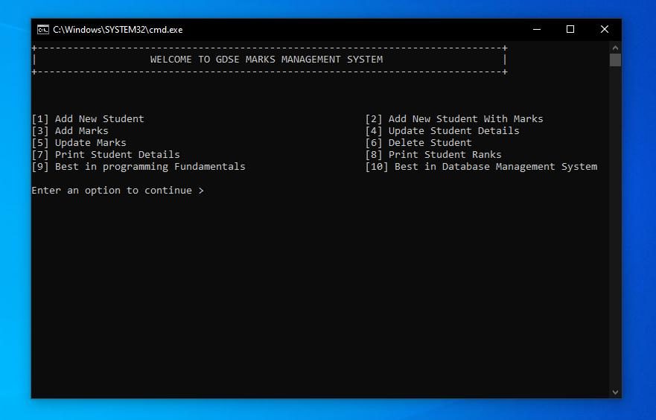
Project 1: Student Management System
Beginner
Modules 3–12
- Add, view, search and update student records.
- Calculate marks, grades and averages.
- Use classes, methods, arrays or collections.
- Validate input and handle exceptions.
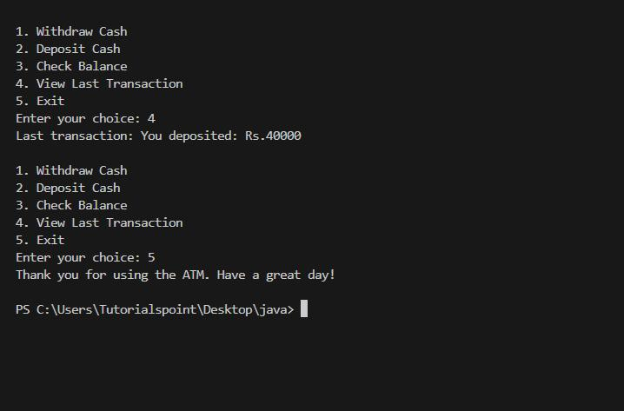
Project 2: Banking Application
Beginner–Intermediate
Modules 11–17
- Create accounts and track transactions.
- Implement deposits and withdrawals.
- Apply encapsulation and custom exceptions.
- Maintain transaction history and account summaries.
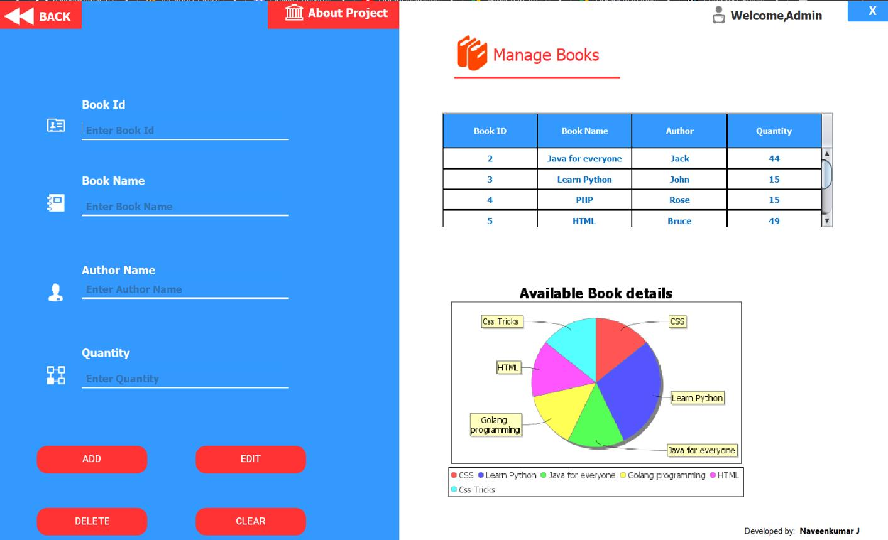
Project 3: Library Management System
Intermediate
Modules 17–21 and 29
- Manage books, members, loans and returns.
- Search and sort catalogue records.
- Persist data in a relational database.
- Add validation, reporting and tests.
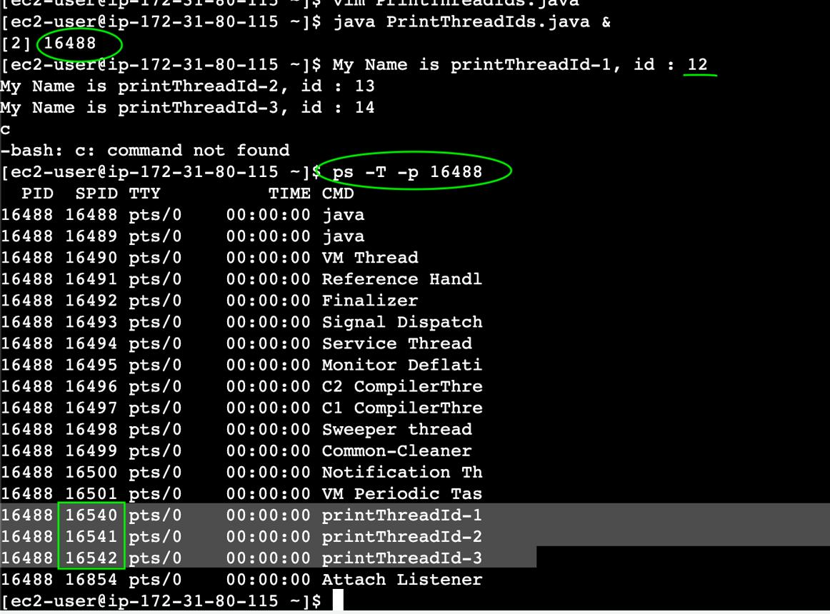
Project 4: Concurrent Log Analyzer
Advanced Core Java
Modules 21–29
- Parse large log files.
- Filter records by severity and date.
- Calculate error frequencies.
- Process independent files concurrently and benchmark performance.
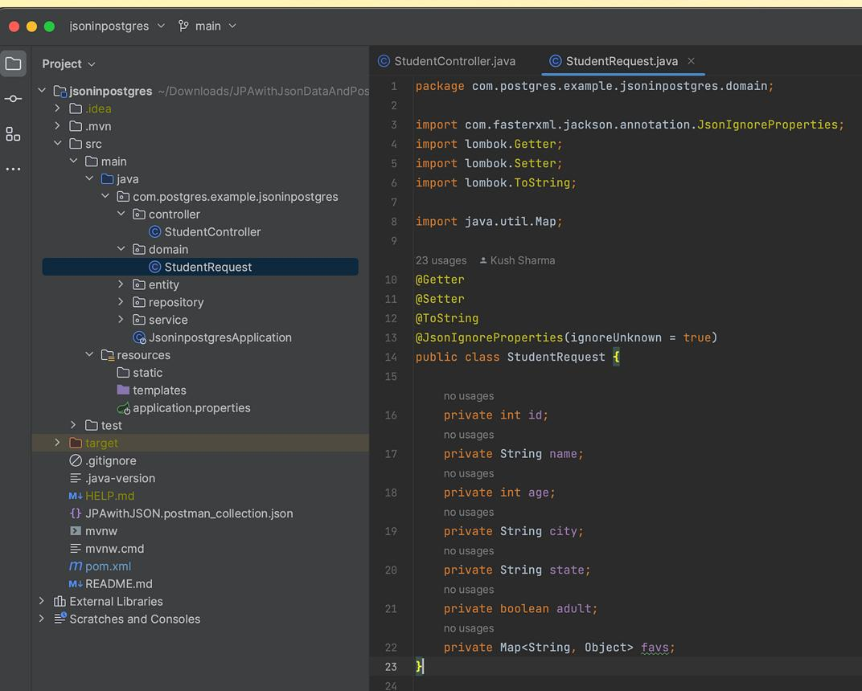
Project 5: Inventory Management REST API
Backend
Modules 36–42
- Build CRUD endpoints for products and categories.
- Add SQL persistence, validation and pagination.
- Implement authentication and roles.
- Include tests, documentation, logs and deployment.

Project 6: EDVENT Institute Management System
Capstone
Full Java backend track
- Manage students, courses, batches and faculty.
- Track attendance, fees and payments.
- Provide role-based access for administrators and teachers.
- Create reports and a documented REST API.
- Add integration tests, database migrations and deployment.

Additional project ideas
Level | Project | Main learning outcomes
Beginner | Calculator | Methods, operators, conditions
Beginner | Quiz application | Loops, collections, scoring
Beginner | Expense tracker | Classes, dates, persistence
Intermediate | Contact manager | Collections, file I/O
Intermediate | E-commerce cart | OOP, interfaces, collections
Intermediate | CSV analytics tool | Files, streams, aggregations
Intermediate | Chat application | Sockets, threads
Advanced | Task scheduler | Concurrency, priority queues
Advanced | URL shortener API | Spring Boot, SQL, REST
Advanced | Booking system | Transactions, validation, concurrency
Advanced | Authentication service | Spring Security, token-based authentication
Advanced | Microservices prototype | Service boundaries, messaging, observability

Part 11 — Suggested 32-week course plan
This schedule assumes approximately 10–15 hours per week, including coding practice. A student starting from zero may need more time, especially for DSA and backend development.
Week | Curriculum
1 | Programming fundamentals, JDK setup, first Java programs
2 | Variables, types, operators, input and output
3 | Conditions, loops and pattern problems
4 | Methods, scope, recursion and mini-project
5 | Arrays and multidimensional arrays
6 | Strings and text processing
7 | Classes, objects, constructors and encapsulation
8 | Inheritance, polymorphism, abstraction and interfaces
9 | Advanced OOP, enums, records and object contracts
10 | Exception handling and packages
11 | Generics and wrapper classes
12 | Collections Framework
13 | Lambdas, functional interfaces and streams
14 | Date-Time API, regular expressions and file I/O
15 | JDBC and SQL fundamentals
16 | DSA: complexity, searching and sorting
17 | DSA: linked lists, stacks and queues
18 | DSA: trees, heaps and hashing
19 | DSA: graphs, recursion and dynamic programming
20 | JVM, memory management and profiling fundamentals
21 | Multithreading and concurrency
22 | Modern Java features, reflection and annotations
23 | Networking and HTTP client programming
24 | Maven, Git, JUnit and Mockito
25 | Clean code, SOLID and design patterns
26 | Spring Boot and REST API fundamentals
27 | Spring Data JPA and database integration
28 | Validation, exception handling and API documentation
29 | Spring Security and authentication
30 | Testing, logging and production configuration
31 | Docker, deployment and CI/CD fundamentals
32 | Capstone completion, code review and interview preparation
Optional extension: Add 4–8 weeks for microservices, advanced performance engineering, reactive programming, advanced concurrency or a desktop/Android specialization.

Part 12 — Interactive syllabus completion tracker
Use this checklist to track student progress or monitor your own preparation. Mark a topic complete only after the student can explain the concept and write a working example independently.

Java mastery tracker
0 of 44 milestones completed

0%

Foundation and Core Java
Programming fundamentals and algorithms
JDK, JVM, IDE and compilation
Variables, data types and operators
Input/output and conditional statements
Loops and methods
Arrays and strings
Classes, objects and constructors
Inheritance, polymorphism and abstraction
Advanced OOP and object contracts
Exception handling and packages

Intermediate Java
Wrapper classes and generics
Collections Framework
Lambda expressions and functional interfaces
Stream API and Optional
Date-Time API and regular expressions
File handling and NIO
JDBC and SQL fundamentals

Advanced Java
Data structures and algorithms
JVM architecture and memory management
Garbage collection and profiling
Multithreading and concurrency
Asynchronous programming and virtual threads
Reflection and annotations
Networking and HTTP

Professional Development
Maven or Gradle
Git and GitHub
JUnit and Mockito
Clean code and SOLID
Design patterns
Logging and configuration

Spring Boot Backend
HTTP and REST fundamentals
Spring Core and dependency injection
REST API development
JPA, Hibernate and database design
Validation and error handling
Spring Security and authentication
Advanced backend features
Testing, Docker and deployment

Portfolio
Beginner console project
OOP-based application
Database-backed application
DSA problem set
Concurrent or networking project
Deployed Spring Boot capstone
Reset trackerCopy progress

Part 13 — Official learning resources
Use official documentation as the primary reference, supplemented by exercises and projects.
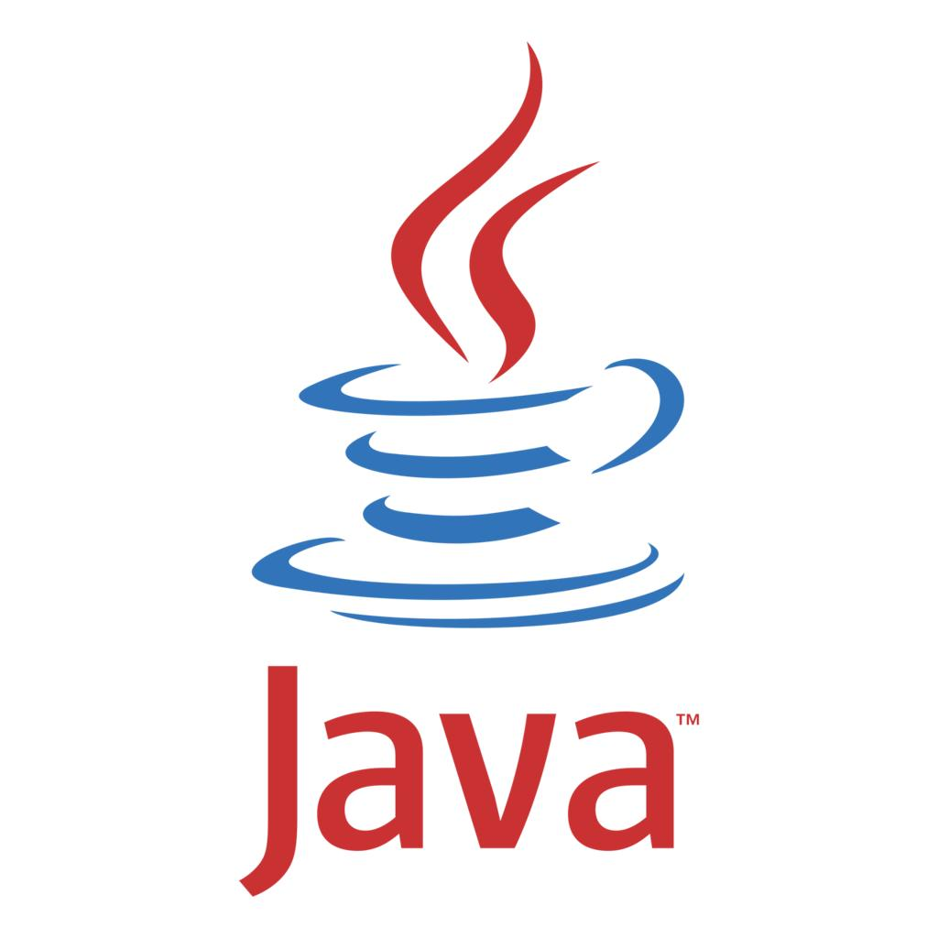
Java language and platform
- Java documentation
- Java language specifications
- Java tutorials and learning resources
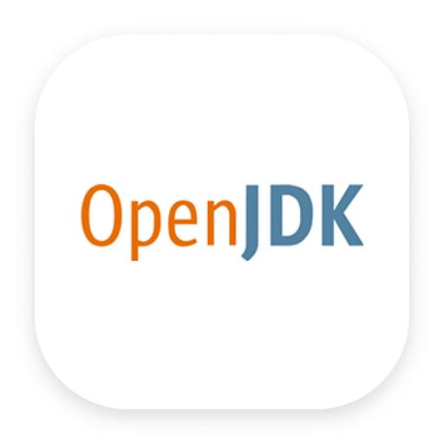
JDK and JVM
- OpenJDK
- Java API documentation
- Java SE downloads
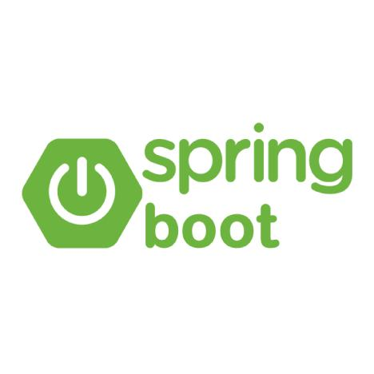
Backend development
- Spring Boot documentation
- Spring Framework documentation
- Spring Guides
- Spring Security reference

Build tools and testing
- Apache Maven
- Gradle documentation
- JUnit 5 User Guide
- Mockito documentation

Developer workflow
- Git documentation
- GitHub Skills
- Docker documentation

Part 14 — Teaching methodology for EDVENT
For every module, use a repeatable teaching structure:
- Concept: Explain the theory with diagrams and real-life examples.
- Instructor demonstration: Write code step by step and explain each important line.
- Guided practice: Students solve similar problems with assistance.
- Independent assignment: Students implement the concept without copying.
- Code review: Discuss naming, structure, correctness, edge cases and performance.
- Assessment: Use a short quiz and practical coding test.
- Revision: Revisit difficult concepts through cumulative assignments.

Suggested weekly distribution
Activity | Weekly time
Theory and demonstrations | 3 hours
Guided coding | 4 hours
Independent exercises | 3 hours
Project work | 3 hours
Revision and assessment | 2 hours
Total | 15 hours

Final recommendation
For a professional Java course, organize the curriculum into three teachable stages:
- Stage 1 — Core Java: Modules 1–22. Students learn programming, OOP, Collections, files and modern Java.
- Stage 2 — Advanced Java and engineering: Modules 23–35. Students learn the JVM, concurrency, DSA, databases, build tools, testing and maintainable software design.
- Stage 3 — Java backend development: Modules 36–42. Students build and deploy secure REST APIs with Spring Boot and a relational database.
Offer the remaining specializations—microservices, reactive programming, advanced security, performance engineering and desktop or Android development—as optional advanced courses.
The most important outcome is that students can write, debug, test, explain and maintain Java applications independently. Finishing the syllabus is useful, but demonstrated skill through projects and code reviews is what makes the course genuinely career-oriented.

