Complete Python Programming Syllabus: Beginner to Advanced
A structured, industry-oriented curriculum for EDVENT
This syllabus takes students from zero programming knowledge to advanced Python programming, software development, automation, data handling, testing and optional specializations in data analytics, AI and backend development.
The recommended learning sequence is Python fundamentals → data structures → functions and OOP → modules and file handling → advanced Python → testing and software engineering → specialization projects.
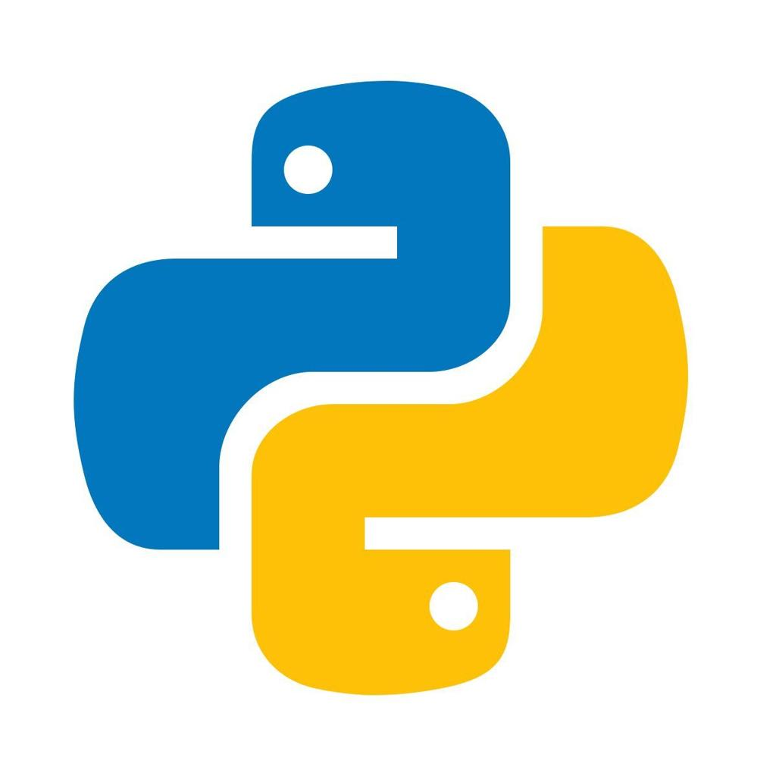

Course overview
Beginner → Intermediate → Advanced → Industry-ready
- Core Python: Syntax, data types, loops, functions, collections and OOP.
- Advanced Python: Iterators, generators, decorators, context managers, concurrency and memory.
- Professional development: Testing, debugging, Git, packaging, APIs and databases.
- Specializations: Data analytics, automation, web development, AI/ML and scripting.

28–36 weeks
Comprehensive learning track

20+ projects
Practice, assignments and capstones

Zero prerequisites
No previous coding experience needed

Career-focused
Foundation plus specialization choices

1. Recommended technology stack
Area | Recommended tools
Python version | Python 3.13 or 3.14, based on library compatibility
IDE/editor | VS Code or PyCharm
Interactive environment | Python REPL and JupyterLab
Package management | venv and pip; introduce uv as an optional tool
Version control | Git and GitHub
Testing | unittest and pytest
Code quality | Ruff, type checking and formatting tools
Database | SQLite first, then PostgreSQL or MySQL
Data analytics | NumPy, pandas, Matplotlib and Seaborn
Backend option | FastAPI or Django
Deployment | Docker fundamentals and a suitable hosting platform
Version strategy: Use a supported Python 3 release and pin project dependencies. Some third-party libraries may lag behind the newest Python version, so verify compatibility before selecting the environment for a course or production project.

2. Complete learning roadmap

01
Programming Foundations
Algorithms, flowcharts, problem-solving and computer fundamentals

02
Python Fundamentals
Syntax, variables, data types, operators, conditions and loops

03
Core Python
Strings, collections, functions, modules and file handling

04
Object-Oriented Python
Classes, inheritance, composition, exceptions and object models

05
Advanced Python
Iterators, generators, decorators, context managers and concurrency

06
Professional Python
Testing, debugging, Git, packaging, type hints and clean code

07
Practical Development
APIs, databases, automation and deployment

08
Specialization and Portfolio
Data analytics, backend development, AI/ML or automation capstone

Part 1 — Programming foundations

Module 1: Introduction to programming
Duration: 1 week

Topics
- What is a computer program?
- What is programming and why is it needed?
- Machine language, assembly language and high-level languages.
- Compilers, interpreters and runtime environments.
- Programming paradigms:
  - Procedural programming
  - Object-oriented programming
  - Functional programming
  - Event-driven programming
- Algorithms and step-by-step problem-solving.
- Pseudocode and flowcharts.
- Input, processing and output.
- Syntax errors, runtime errors and logical errors.
- Debugging fundamentals.
- Breaking large problems into smaller tasks.
- Introduction to time and space complexity.

Practical exercises
- Write an algorithm to calculate the sum of two numbers.
- Create a flowchart to check whether a number is even or odd.
- Design a grade-calculation algorithm.
- Write pseudocode to find the largest of three numbers.
- Trace the execution of simple algorithms manually.
Assignment: Write pseudocode and flowcharts for 10 everyday problems before implementing them in Python.

Module 2: Python introduction and development environment
Duration: 1 week

Topics
- Introduction to Python and its use cases.
- Python history and major characteristics.
- Python implementations and runtime basics.
- Installing Python.
- Installing and configuring VS Code or PyCharm.
- Running Python from the terminal.
- Interactive Python shell (REPL).
- Running .py files.
- Introduction to Jupyter notebooks.
- Understanding source code, bytecode and execution at a high level.
- print() and basic program structure.
- Comments and code readability.
- Indentation and Python's block structure.
- Python documentation and built-in help.
- Virtual environments introduction.

First program
def main(): print("Welcome to Python!") print("Welcome to EDVENT!")if __name__ == "__main__": main()
Explain the function, indentation, function call and __name__ guard, including why it is useful in reusable modules.

Practical exercises
- Print personal details and formatted messages.
- Run scripts from the terminal.
- Experiment with the interactive shell.
- Intentionally create syntax and indentation errors, then fix them.
Mini-project: Personal introduction and formatted receipt generator.

Part 2 — Python fundamentals

Module 3: Variables, data types and type conversion
Duration: 1 week

Topics
- Variables and assignment.
- Naming rules and conventions.
- Dynamic typing.
- Object references and object identity.
- Built-in data types:
  - int
  - float
  - complex
  - bool
  - str
  - NoneType
- Checking types with type() and isinstance().
- Type conversion and constructors.
- Implicit Boolean evaluation and truthiness.
- Mutable versus immutable objects.
- Constants by naming convention.
- Multiple assignment and unpacking.
- Numeric precision and floating-point limitations.
- Integer arithmetic and division.
- None and missing-value concepts.
- Python naming conventions (PEP 8).

Practical exercises
- Store and display student details.
- Convert Celsius to Fahrenheit.
- Calculate area, perimeter and simple interest.
- Demonstrate type conversion and Boolean evaluation.
- Explore floating-point precision.
- Swap two variables using assignment.
Mini-project: Student marksheet with total, percentage and grade.

Module 4: Operators and expressions
Duration: 4–5 days

Topics
- Arithmetic operators.
- Comparison operators.
- Logical operators: and, or, not.
- Assignment and augmented assignment.
- Identity operators: is and is not.
- Membership operators: in and not in.
- Bitwise operators.
- Operator precedence and associativity.
- Short-circuit evaluation.
- Chained comparisons.
- Expressions and evaluation order.
- Difference between equality (==) and identity (is).
- Operator overloading introduction.

Practical exercises
- Build a basic calculator.
- Check even and odd numbers.
- Demonstrate membership and identity.
- Explore bitwise operations.
- Write expressions using chained comparisons.

Module 5: Input and output
Duration: 3–4 days

Topics
- print() and input().
- Reading user input.
- Input as strings and explicit conversion.
- Formatting using f-strings.
- str.format() and format specifications.
- Escape sequences and newline characters.
- Multiple arguments in print().
- sep and end parameters.
- Command-line arguments introduction.
- Input validation.
- Handling invalid numeric input.
- Formatting currency, percentages and decimal places.

Practical exercises
- Build a console registration form.
- Calculate monthly salary and annual income.
- Create a formatted shopping bill.
- Accept command-line inputs and produce a summary.
Mini-project: Console-based billing application.

Module 6: Conditional statements
Duration: 4–5 days

Topics
- if statements.
- if-else.
- if-elif-else.
- Nested conditions.
- Conditional expressions.
- Truthy and falsy values.
- Logical conditions and Boolean expressions.
- Pattern matching using match-case.
- Guard clauses and early returns.
- Avoiding deeply nested conditions.
- Input validation and boundary cases.

Practical exercises
- Check positive, negative and zero.
- Build a grade calculator.
- Calculate electricity bills using slabs.
- Check leap years.
- Validate eligibility based on multiple conditions.
- Create a menu-driven calculator.
Mini-project: Student admission eligibility checker.

Module 7: Loops and iteration
Duration: 1 week

Topics
- while loops.
- for loops.
- Iterables and iterators introduction.
- The range() function.
- Nested loops.
- break and continue.
- Loop else clauses.
- Infinite loops and termination conditions.
- enumerate() for indexed iteration.
- zip() for parallel iteration.
- Nested iteration and performance.
- Pattern printing.
- Off-by-one errors.
- Loop invariants and tracing.

Practical exercises
- Print multiplication tables.
- Calculate factorials.
- Generate Fibonacci sequences.
- Check prime numbers.
- Reverse numbers and strings.
- Calculate digit sums.
- Print star and number patterns.
- Find GCD and LCM.
- Search for elements in a list.
Mini-project: Number analysis toolkit.

Module 8: Functions and reusable code
Duration: 1 week

Topics
- Defining functions using def.
- Calling functions.
- Parameters and arguments.
- Return values.
- Positional and keyword arguments.
- Default parameter values.
- Variable-length arguments: *args and **kwargs.
- Positional-only and keyword-only parameters.
- Scope: local, enclosing, global and built-in.
- The LEGB name-resolution rule.
- global and nonlocal.
- Lambda expressions.
- Recursion and base cases.
- Function annotations and type hints.
- Docstrings and documentation.
- First-class functions.
- Functions as arguments and return values.
- Pure functions and side effects.
- Avoiding mutable default arguments.
- Breaking programs into reusable functions.

Practical exercises
- Write reusable arithmetic functions.
- Implement prime-number and palindrome checks.
- Build factorial using recursion and iteration.
- Create a reusable validation module.
- Refactor a long script into functions.
- Write functions with type hints and docstrings.
Mini-project: Reusable utility library.

Part 3 — Core Python data structures

Module 9: Strings and text processing
Duration: 1 week

Topics
- String creation and indexing.
- Positive and negative indexing.
- Slicing and slice notation.
- String immutability.
- Concatenation and repetition.
- Common string methods.
- split() and join().
- strip(), replace() and find().
- String comparisons.
- f-strings and formatting.
- Unicode and character encoding.
- Iterating through strings.
- Checking prefixes and suffixes.
- Basic text normalization.
- Introduction to regular expressions.
- Efficient string construction.
- Text cleaning and validation.

Practical exercises
- Reverse a string.
- Count vowels, words and characters.
- Check palindromes.
- Detect anagrams.
- Count word frequency.
- Remove repeated whitespace.
- Extract usernames or identifiers from text.
- Validate simple input formats.
Mini-project: Text analyzer and text-cleaning utility.

Module 10: Lists and tuples
Duration: 1 week

A. Lists
- Creating and indexing lists.
- Slicing and updating elements.
- Adding elements with append(), extend() and insert().
- Removing elements with remove(), pop() and del.
- Sorting with sort() and sorted().
- Reversing lists.
- Copying lists and aliasing.
- Nested lists.
- List comprehensions.
- Conditional comprehensions.
- Shallow copies and nested mutable objects.
- Common list algorithms.
- List performance considerations.

B. Tuples
- Creating tuples.
- Indexing and unpacking.
- Single-element tuple syntax.
- Tuple immutability.
- Tuple methods.
- Tuples as dictionary keys when their contents are hashable.
- Named tuples introduction.
- Choosing between lists and tuples.

Practical exercises
- Find minimum, maximum and average.
- Remove duplicates.
- Merge and sort lists.
- Find the second-largest element.
- Unpack records into variables.
- Process a list of student marks.
- Implement a two-dimensional matrix.
Mini-project: Student marks and ranking analyzer.

Module 11: Sets and dictionaries
Duration: 1 week

A. Sets
- Creating sets.
- Unique elements and hashability.
- Adding and removing elements.
- Union, intersection and difference.
- Symmetric difference.
- Membership testing.
- Mutable sets and frozenset.
- Deduplication and common set use cases.

B. Dictionaries
- Key-value pairs.
- Creating and updating dictionaries.
- Accessing values with [] and get().
- Adding, updating and deleting entries.
- Iterating through keys, values and items.
- Dictionary methods.
- Nested dictionaries.
- Dictionary comprehensions.
- Dictionary merging.
- Hashability requirements for keys.
- Insertion-order behavior.
- Counting and grouping patterns.
- Missing keys and default values.
- Practical performance considerations.

Practical exercises
- Count word frequencies.
- Remove duplicates using sets.
- Build a phone directory.
- Group employees by department.
- Create a product inventory dictionary.
- Merge two datasets.
- Find common elements between collections.
Mini-project: Contact management and search application.

Module 12: Comprehensions and expressive Python
Duration: 3–4 days

Topics
- List comprehensions.
- Set comprehensions.
- Dictionary comprehensions.
- Generator expressions.
- Nested comprehensions.
- Filtering with conditions.
- Conditional expressions inside comprehensions.
- Transforming and flattening nested data.
- Readability versus compactness.
- Avoiding overly complex comprehensions.

Practical exercises
- Extract even numbers from a sequence.
- Transform names into normalized forms.
- Build a word-frequency dictionary.
- Flatten nested lists.
- Generate lookup tables from records.

Module 13: Sorting, searching and common algorithms
Duration: 1 week

Topics
- Linear search.
- Binary search.
- Sorting with sorted() and list.sort().
- Sort keys and custom sorting.
- Stable sorting.
- Reverse ordering.
- Sorting dictionaries and object records.
- Two-pointer techniques.
- Frequency counting.
- Basic recursion.
- Time and space complexity.
- Big-O notation.
- Algorithm selection.
- Standard-library modules such as bisect and heapq.

Practical exercises
- Implement linear and binary search.
- Sort student records by multiple fields.
- Find duplicates and frequencies.
- Merge sorted sequences.
- Find the top-k values.
- Compare algorithm complexity.
Mini-project: Search and ranking engine for student records.

Part 4 — Object-oriented programming in Python

Module 14: Classes and objects
Duration: 1 week

Topics
- Object-oriented programming concepts.
- Classes and instances.
- Attributes and methods.
- Instance attributes versus class attributes.
- The self parameter.
- The __init__() initializer.
- Object creation and initialization.
- Instance methods.
- Class methods using @classmethod.
- Static methods using @staticmethod.
- Encapsulation and controlled access.
- Properties using @property.
- Naming conventions for public, protected-by-convention and name-mangled attributes.
- Object references and identity.
- __str__() and __repr__().
- Object comparison and equality.
- Data classes using @dataclass.
- Immutable data classes with frozen=True.

Practical exercises
- Create Student, Employee, Product and BankAccount classes.
- Validate values during initialization.
- Add methods to update and retrieve information.
- Use properties for controlled updates.
- Implement readable string representations.
- Create data classes for simple records.
Mini-project: Bank account management system.

Module 15: Inheritance, polymorphism and composition
Duration: 1 week

Topics
- Inheritance fundamentals.
- Single and multilevel inheritance.
- Multiple inheritance.
- Method overriding.
- The super() function.
- Method Resolution Order (MRO).
- Polymorphism and duck typing.
- Abstract base classes using abc.
- Interfaces by convention and protocol-style design.
- Composition and aggregation.
- Inheritance versus composition.
- Multiple inheritance trade-offs.
- Mixins and their appropriate use.
- Substitutability and object contracts.
- Avoiding deep inheritance hierarchies.

Practical exercises
- Build an employee hierarchy.
- Create payment methods using polymorphism.
- Design a notification system.
- Model a library using composition.
- Implement abstract classes for common interfaces.
- Explore MRO with a multiple-inheritance example.
Mini-project: Employee payroll and role-management system.

Module 16: Special methods and Python's data model
Duration: 1 week

Topics
- Dunder methods and the data model.
- Object representation: __str__() and __repr__().
- Equality and ordering methods.
- Hashing and __hash__().
- Arithmetic operator overloading.
- Container methods such as __len__() and __getitem__().
- Iteration methods.
- Callable objects using __call__().
- Context-manager methods.
- Attribute access customization.
- __new__() versus __init__().
- Object creation and lifecycle concepts.
- Data classes and generated methods.
- Correct equality and hash contracts.

Practical exercises
- Create a custom vector class.
- Implement a money type with safe arithmetic.
- Build a custom container.
- Make a class iterable.
- Create a callable object for configurable validation.

Module 17: Exceptions and error handling
Duration: 4–5 days

Topics
- Syntax errors versus runtime exceptions.
- Exception hierarchy.
- try, except, else and finally.
- Catching specific exceptions.
- Raising exceptions with raise.
- Custom exception classes.
- Exception chaining using raise ... from ....
- Cleanup and resource management.
- Designing meaningful error messages.
- Avoiding overly broad exception handling.
- Logging exceptions.
- Handling errors at application boundaries.
- Fail-fast versus recovery strategies.
- Assertions and their limitations.

Practical exercises
- Handle invalid input in a calculator.
- Validate account withdrawals.
- Create custom validation exceptions.
- Handle missing files and malformed data.
- Separate expected user errors from programming defects.
Mini-project: Robust banking application with transaction validation.

Module 18: Modules, packages and imports
Duration: 4–5 days

Topics
- Python modules.
- Importing built-in modules.
- Creating custom modules.
- Import statements and aliases.
- The module search path and sys.path.
- Packages and subpackages.
- __init__.py and package initialization.
- Absolute versus relative imports.
- The __name__ == "__main__" pattern.
- Import cycles and how to avoid them.
- Module namespaces.
- Organizing large applications.
- Reusable utility packages.
- Public interfaces and internal implementation.
- Introduction to Python's standard library.

Practical exercises
- Split a large script into modules.
- Create a reusable validation package.
- Organize a project into model, service and utility layers.
- Write a module that can run as a script or be imported.
Mini-project: Reusable Python utility package.

Part 5 — Files, data formats and external resources

Module 19: File handling and filesystem operations
Duration: 1 week

Topics
- Opening and closing files.
- File modes: r, w, a, x, b and +.
- Reading with read(), readline() and readlines().
- Writing and appending.
- File pointers and seeking.
- Context managers and with.
- Text versus binary files.
- Encoding and UTF-8.
- File paths and the pathlib module.
- Creating and removing directories.
- Copying, moving and deleting files.
- Directory traversal.
- File metadata and timestamps.
- Processing large files efficiently.
- Temporary files and directories.
- File permissions and error handling.
- Safe handling of user-provided paths.

Practical exercises
- Read and write text files.
- Search across multiple log files.
- Count lines, words and characters.
- Organize files by extension.
- Process a large file line by line.
- Build a simple file backup utility.
Mini-project: File organizer and log analyzer.

Module 20: CSV, JSON, XML and structured data
Duration: 1 week

Topics
- CSV file structure.
- Reading and writing CSV using csv.
- Headers, delimiters and quoting.
- JSON syntax and data types.
- Serialization and deserialization with json.
- Handling missing or invalid fields.
- Nested JSON structures.
- XML fundamentals and parsing with standard-library tools.
- Data validation.
- Dates and numeric values in structured data.
- Character encoding.
- Interoperability and schema considerations.
- Avoiding unsafe deserialization techniques.
- Introduction to configuration files.

Practical exercises
- Import student records from CSV.
- Export reports to JSON.
- Parse nested JSON.
- Combine multiple files into one dataset.
- Validate required fields.
- Transform records into a standardized format.
Mini-project: Student data import/export system.

Module 21: Date, time and localization
Duration: 3–4 days

Topics
- The datetime module.
- date, time and datetime.
- timedelta and date arithmetic.
- Parsing and formatting with strptime() and strftime().
- Time zones.
- Aware versus naive datetimes.
- UTC and local time.
- Timestamp handling.
- Locale-sensitive formatting considerations.
- Scheduling and date validation.
- Calendar utilities.

Practical exercises
- Calculate age from date of birth.
- Calculate attendance duration.
- Create appointment scheduling logic.
- Convert timestamps between time zones.
- Generate dated reports.
Mini-project: Attendance and appointment manager.

Module 22: Regular expressions and text extraction
Duration: 3–4 days

Topics
- Regex patterns.
- Character classes and ranges.
- Quantifiers.
- Anchors and boundaries.
- Capturing and non-capturing groups.
- Alternation and grouping.
- re.search(), match() and fullmatch().
- findall() and finditer().
- Substitution and splitting.
- Escaping special characters.
- Extracting structured text.
- Regex validation limitations.
- Performance and catastrophic backtracking awareness.

Practical exercises
- Extract phone numbers from sample text.
- Parse log entries.
- Extract dates and amounts.
- Validate simple identifiers.
- Normalize whitespace and formatting.
Mini-project: Log parsing and report generator.

Module 23: Databases and SQL with Python
Duration: 1 week

Topics
- Relational database fundamentals.
- Tables, rows, columns and constraints.
- Primary keys and foreign keys.
- SQL essentials: SELECT, INSERT, UPDATE and DELETE.
- Filtering, sorting, joins and aggregation.
- SQLite using Python's sqlite3.
- Database connections and cursors.
- Parameterized queries.
- Transactions and commit/rollback.
- CRUD operations.
- Schema design and normalization introduction.
- Database error handling.
- Connection management.
- Connection pooling overview for server applications.
- PostgreSQL or MySQL integration.
- SQL injection prevention.
- Repository and data-access patterns.
- Database migrations introduction.

Practical exercises
- Create a database for student records.
- Implement CRUD operations.
- Search and paginate records.
- Add transactions to a financial operation.
- Import CSV data into a database.
- Generate reports from SQL queries.
Mini-project: Database-backed inventory management system.

Part 6 — Advanced Python language features

Module 24: Iterables, iterators and generators
Duration: 1 week

Topics
- Iterable versus iterator.
- The iterator protocol: __iter__() and __next__().
- Creating custom iterators.
- Generators using yield.
- Generator functions and generator expressions.
- Lazy evaluation.
- Generator pipelines.
- yield from.
- Generator state and exhaustion.
- Memory efficiency.
- Infinite iterators.
- itertools fundamentals.
- enumerate(), zip() and iter().
- Lazy processing of large datasets.

Practical exercises
- Build a custom iterator.
- Generate Fibonacci numbers lazily.
- Process large CSV files incrementally.
- Create a generator pipeline for filtering logs.
- Use itertools for combinations and grouping.
Mini-project: Memory-efficient data processing engine.

Module 25: Decorators and closures
Duration: 1 week

Topics
- Functions as first-class objects.
- Nested functions.
- Lexical scope and closures.
- nonlocal variables.
- Functions returning functions.
- Decorator fundamentals.
- Decorating functions with arguments.
- *args and **kwargs in decorators.
- Preserving metadata with functools.wraps.
- Stacking decorators.
- Parameterized decorators.
- Class decorators.
- Common built-in decorators: @property, @classmethod and @staticmethod.
- functools.cache and lru_cache.
- Timing, logging and validation decorators.
- Decorator limitations and debugging.

Practical exercises
- Create a function-timing decorator.
- Implement a logging decorator.
- Add validation to selected function arguments.
- Cache the results of expensive calculations.
- Create a parameterized retry decorator for a safe example.
Mini-project: Reusable logging and validation utilities.

Module 26: Context managers and resource management
Duration: 3–4 days

Topics
- The with statement.
- Context manager protocol.
- __enter__() and __exit__().
- Creating context managers with contextlib.
- Generator-based context managers.
- Resource cleanup.
- File, lock and temporary-resource management.
- Nested context managers.
- Exception handling inside context managers.
- Designing reliable cleanup logic.

Practical exercises
- Build a custom context manager.
- Measure execution time using a context manager.
- Manage temporary directories.
- Demonstrate automatic cleanup after an exception.

Module 27: Type hints and static typing
Duration: 1 week

Topics
- Type annotations.
- Function parameter and return annotations.
- Built-in generic types such as list[str] and dict[str, int].
- Optional values and unions.
- Any versus specific types.
- TypedDict.
- Literal and Final.
- Type aliases.
- Callable types.
- Protocols and structural subtyping.
- Generic classes and functions.
- Type narrowing.
- Static type checking with mypy or Pyright.
- Type hints in public APIs.
- Runtime validation versus static checking.
- Gradual typing and incremental adoption.

Practical exercises
- Add type hints to a utility library.
- Model structured records with TypedDict or data classes.
- Type-check a small project.
- Define protocols for interchangeable components.

Module 28: Functional programming techniques
Duration: 3–4 days

Topics
- Pure functions and side effects.
- Immutability concepts.
- Higher-order functions.
- map(), filter() and reduce().
- Lambda expressions.
- Function composition.
- Closures and partial application.
- functools.partial.
- operator module.
- Immutable data structures and frozenset.
- Declarative transformations.
- Functional versus imperative styles.
- Balancing functional code with readability.

Practical exercises
- Transform a list of transactions.
- Compose data-cleaning functions.
- Build reusable filters.
- Compare loops and functional transformations.

Module 29: Memory model, copying and object lifecycle
Duration: 4–5 days

Topics
- Objects, names and references.
- Identity, equality and type.
- Mutable and immutable objects.
- Reference counting implementation concepts.
- Garbage collection in CPython.
- Reference cycles.
- Shallow and deep copying.
- The copy module.
- Weak references.
- Object lifetime and resource management.
- Common causes of unintended object retention.
- Memory profiling.
- tracemalloc fundamentals.
- Generators and memory-efficient processing.
- Implementation differences across Python runtimes.
- Why implementation details should not be confused with language guarantees.

Practical exercises
- Demonstrate aliasing and shallow copies.
- Inspect object allocation.
- Compare memory use of lists and generators.
- Profile a script and identify avoidable allocations.

Module 30: Concurrency and parallelism
Duration: 2 weeks

A. Threading
- Concurrency versus parallelism.
- Threads and threading.
- Shared state and race conditions.
- Locks and synchronization.
- Event, Semaphore and Condition.
- Producer-consumer patterns.
- Thread-safe queues.
- Daemon threads and shutdown.
- Deadlocks and lock ordering.
- Thread safety in shared objects.

B. Multiprocessing
- Processes versus threads.
- The multiprocessing module.
- Process pools.
- Inter-process communication.
- Queues, pipes and shared data.
- Process start methods and platform differences.
- Pickling constraints.
- Worker lifecycle and error handling.

C. Asynchronous programming
- async and await.
- Coroutines.
- The asyncio event loop.
- Tasks and task groups.
- Concurrent asynchronous operations.
- Async I/O.
- Asynchronous context managers and iterators.
- Timeouts and cancellation.
- Async generators.
- Integrating async HTTP clients.
- Avoiding blocking calls in the event loop.

D. Performance considerations
- The Global Interpreter Lock (GIL) in traditional CPython builds.
- I/O-bound versus CPU-bound workloads.
- When to use threads, processes or async.
- Alternative and free-threaded Python builds at an introductory level.
- Profiling concurrent applications.
- Graceful shutdown and error propagation.

Practical exercises
- Download multiple files concurrently.
- Process independent datasets using a process pool.
- Implement a thread-safe producer-consumer system.
- Build an asynchronous HTTP client.
- Compare execution times for different workloads.
Mini-project: Concurrent file-processing and reporting engine.

Module 31: Introspection, reflection and metaprogramming
Duration: 1 week

Topics
- Introspection using type(), dir() and help().
- getattr(), setattr() and hasattr().
- Inspecting functions and signatures.
- The inspect module.
- Dynamic attribute access.
- Dynamic class creation.
- Descriptors.
- Properties and attribute control.
- Metaclasses introduction.
- __init_subclass__().
- Class creation lifecycle.
- Plugin discovery and registration.
- Metaprogramming trade-offs.
- Avoiding unnecessary dynamic behavior.

Practical exercises
- Build an object-inspection utility.
- Create a plugin registration system.
- Implement a reusable descriptor.
- Explore dynamic method registration.

Module 32: Advanced standard library
Duration: 1 week

Topics
- collections: Counter, defaultdict, deque, namedtuple.
- itertools: iteration tools and combinatorics.
- functools: caching, wrapping and functional utilities.
- operator: functional access to common operations.
- heapq and priority queues.
- bisect for sorted sequences.
- enum for symbolic constants.
- dataclasses for record-oriented classes.
- decimal for decimal arithmetic.
- fractions for rational arithmetic.
- statistics for basic statistics.
- logging for application diagnostics.
- argparse for command-line interfaces.
- subprocess for external commands.
- shutil for filesystem operations.
- tempfile for temporary resources.
- concurrent.futures.
- contextlib.
- secrets for security-sensitive random values.
- hashlib and cryptographic hashing concepts.
- pathlib and os.
- sys and platform.
- Choosing standard-library solutions before adding dependencies.

Practical exercises
- Create a command-line report generator.
- Implement a priority-based task queue.
- Build a file backup tool.
- Create a configurable logging utility.
- Process large datasets using iterators.

Part 7 — Professional Python development

Module 33: Debugging and development workflow
Duration: 4–5 days

Topics
- Reading tracebacks.
- Using breakpoints.
- Step over, step into and step out.
- Inspecting variables and call stacks.
- Conditional breakpoints.
- Debugging in VS Code or PyCharm.
- Interactive debugging with pdb.
- Logging versus debugging.
- Reproducing and isolating bugs.
- Assertions and invariants.
- Debugging asynchronous and concurrent code.
- Writing minimal reproducible examples.

Practical exercises
- Debug a script containing multiple defects.
- Trace variable values through function calls.
- Find a data-processing bug.
- Diagnose an exception using the traceback.

Module 34: Unit testing and automated quality assurance
Duration: 1 week

Topics
- Why automated testing matters.
- Unit, integration and end-to-end tests.
- unittest.
- pytest fundamentals.
- Assertions and test discovery.
- Fixtures and setup/teardown.
- Parameterized tests.
- Testing exceptions.
- Mocking and dependency isolation.
- Test doubles and monkeypatching.
- Temporary files and isolated test data.
- Test coverage and its limitations.
- Regression testing.
- Property-based testing introduction.
- Test-driven development (TDD).
- Testing database and API integrations.
- Continuous integration basics.

Practical exercises
- Test a calculator and utility library.
- Test validation logic and edge cases.
- Mock an external API.
- Test file-processing functions.
- Run tests automatically on code changes.
Mini-project: Add a complete automated test suite to a Python application.

Module 35: Code quality, formatting and static analysis
Duration: 3–4 days

Topics
- PEP 8 coding conventions.
- Naming and code organization.
- Docstrings and documentation.
- Ruff for linting and formatting.
- Type checking with mypy or Pyright.
- Complexity and maintainability.
- Avoiding duplicated code.
- Refactoring safely.
- Code review practices.
- Pre-commit checks.
- Configuration of quality tools.
- Managing technical debt.

Practical exercises
- Refactor a poorly structured program.
- Configure linting and formatting.
- Add type checks.
- Review another student's code against a checklist.

Module 36: Virtual environments, packages and dependency management
Duration: 1 week

Topics
- Why dependencies need isolation.
- Creating virtual environments with venv.
- Activating and deactivating environments.
- Installing packages with pip.
- requirements.txt.
- Dependency pinning and version constraints.
- Dependency conflicts.
- pyproject.toml.
- Project metadata and build backends.
- Package structure and imports.
- Building wheels and source distributions.
- Editable installs.
- Publishing packages.
- Versioning and release management.
- Lockfiles and reproducible environments.
- Optional introduction to uv or Poetry.
- Managing private and development dependencies.
- Dependency security scanning.

Practical exercise
Create a reusable Python package with documentation, tests, version metadata and installation instructions.

Module 37: Git, GitHub and collaboration
Duration: 4–5 days

Topics
- Version control fundamentals.
- Repositories and commits.
- Branching and merging.
- Resolving conflicts.
- .gitignore.
- Remote repositories.
- Pull requests and code reviews.
- Issues and project tracking.
- README files.
- Branching strategies.
- Managing environment files and secrets.
- GitHub Actions for automated testing.
- Versioned releases.

Practical assignment
Publish a Python project with a README, setup instructions, test suite, dependency configuration and clean commit history.

Module 38: Security and safe Python programming
Duration: 4–5 days

Topics
- Input validation and sanitization.
- SQL injection prevention.
- Safe file handling.
- Path traversal risks.
- Secure subprocess usage.
- Password hashing concepts.
- Secure random generation with secrets.
- API key and secret management.
- HTTPS and TLS fundamentals.
- Dependency vulnerabilities.
- Unsafe deserialization and pickle risks.
- Logging without exposing sensitive data.
- Authentication and authorization basics.
- Least privilege.
- Threat modelling fundamentals.

Practical exercises
- Replace unsafe SQL string construction with parameterized queries.
- Validate file paths.
- Secure configuration using environment variables.
- Audit a sample application for common security issues.

Part 8 — APIs, networking and automation

Module 39: HTTP, REST APIs and JSON
Duration: 1 week

Topics
- Client-server architecture.
- HTTP fundamentals.
- Requests, responses and headers.
- HTTP methods: GET, POST, PUT, PATCH and DELETE.
- Status codes.
- Query parameters and path parameters.
- JSON serialization and deserialization.
- REST API principles.
- API authentication basics.
- API keys and bearer tokens.
- Pagination and rate limits.
- Timeouts and retries.
- Error handling.
- API versioning.
- Rate limiting and backoff strategies.
- Using urllib and third-party clients such as requests or httpx.
- Synchronous versus asynchronous HTTP.
- Respecting API terms, quotas and robots policies where applicable.

Practical exercises
- Retrieve data from a public API.
- Parse JSON responses.
- Submit data to a test API.
- Handle timeouts and HTTP errors.
- Implement pagination.
- Save API results to CSV or a database.
Mini-project: Weather or public-data reporting application using an API.

Module 40: Web scraping and browser automation
Duration: 1 week

Topics
- HTML and DOM fundamentals.
- HTTP requests and response handling.
- Parsing HTML with Beautiful Soup.
- CSS selectors and element selection.
- Extracting tables, links and text.
- Pagination and multi-page extraction.
- Handling missing and inconsistent data.
- Rate limiting and polite request intervals.
- Terms of service and access restrictions.
- Dynamic pages and browser automation concepts.
- Selenium or Playwright introduction.
- Headless browser execution.
- Screenshots and browser logs.
- Retry and failure recovery.
- Exporting results to CSV, JSON or databases.

Practical exercises
- Extract structured data from a permitted sample website.
- Parse tables from HTML.
- Normalize extracted text.
- Automate a local demo website.
- Generate a data-extraction report.
Mini-project: Website information collector for a site that explicitly permits the activity.

Module 41: Command-line applications and operating-system automation
Duration: 1 week

Topics
- Command-line interface design.
- Parsing arguments with argparse.
- Subcommands and command options.
- Environment variables.
- File and directory automation.
- Batch processing.
- os, pathlib and shutil.
- Running external programs with subprocess.
- Exit codes and process output.
- Logging and error reporting.
- Scheduling scripts using operating-system tools.
- Cross-platform path and process differences.
- Configuration files.
- Dry-run modes and safe automation.
- Packaging command-line tools.

Practical exercises
- Batch rename files.
- Organize downloads by extension.
- Create automated backup scripts.
- Generate reports from folders of files.
- Build a command-line utility with multiple commands.
Mini-project: File management and backup automation toolkit.

Module 42: Email, spreadsheets and business automation
Duration: 1 week

Topics
- Reading and writing CSV files.
- Excel workbook operations with openpyxl.
- Reading and processing Excel data with pandas.
- Creating worksheets and formatting reports.
- Generating PDFs using an appropriate library.
- Email concepts and SMTP.
- Email templates and attachments.
- Environment-based credentials.
- Batch report generation.
- Scheduling recurring jobs.
- Error handling and audit logs.
- Automating repetitive office workflows.
- Validating input files before processing.
- Reporting completion and failures.

Practical exercises
- Merge multiple Excel workbooks.
- Clean and validate spreadsheet data.
- Generate invoices from a template.
- Create monthly business reports.
- Email reports through an authorized mail service.
Mini-project: Automated office reporting system.

Part 9 — Data structures and algorithms using Python

Module 43: Data structures and algorithmic problem-solving
Duration: 2–3 weeks

A. Complexity analysis
- Time and space complexity.
- Big-O notation.
- Best, average and worst cases.
- Complexity of loops and recursion.
- Amortized analysis introduction.

B. Searching and sorting
- Linear search.
- Binary search.
- Bubble, selection and insertion sort.
- Merge sort and quicksort.
- Stable versus unstable sorting.
- Custom sort keys.
- Using built-in sorting effectively.

C. Linear data structures
- Arrays and dynamic lists.
- Stacks and queues.
- Deques.
- Linked lists.
- Common operations and complexity.
- Practical applications.

D. Hash-based structures
- Hash tables.
- Dictionaries and sets.
- Collision concepts.
- Frequency counting.
- Equality and hashability.

E. Trees and heaps
- Binary trees.
- Binary search trees.
- Tree traversal.
- Heaps and heapq.
- Priority queues.
- Tries introduction.

F. Graphs
- Adjacency lists and matrices.
- Breadth-first search.
- Depth-first search.
- Cycle detection.
- Topological sorting.
- Shortest-path concepts.
- Connected components.

G. Problem-solving techniques
- Two pointers.
- Sliding window.
- Prefix sums.
- Recursion and backtracking.
- Greedy algorithms.
- Dynamic programming.
- Memoization and tabulation.
- Divide and conquer.
- Bit manipulation.
- Basic string algorithms.

Practical assignments
- Implement a stack and queue.
- Write binary search.
- Find duplicate values and frequency counts.
- Traverse trees and graphs.
- Solve recursion and dynamic-programming problems.
- Analyze the complexity of each solution.
Target: Solve 100–150 carefully selected coding problems over time, with explanations and tests.

Part 10 — Specialization A: Data analytics with Python
This is a strong option for students interested in reporting, business intelligence, data cleaning and analytical roles.

Module 44: NumPy
Duration: 1 week

Topics
- NumPy installation and arrays.
- Array dimensions and shapes.
- Data types and type conversion.
- Indexing and slicing.
- Reshaping and transposing.
- Vectorized operations.
- Broadcasting.
- Aggregations and statistical operations.
- Boolean masks.
- Fancy indexing.
- Random number generation.
- Missing values and numerical edge cases.
- Linear algebra fundamentals.
- Performance comparisons with Python lists.
- Memory layout introduction.

Practical exercises
- Generate and transform numerical arrays.
- Calculate summary statistics.
- Filter values with Boolean masks.
- Perform matrix operations.
- Compare vectorized and loop-based code.

Module 45: pandas and data manipulation
Duration: 1–2 weeks

Topics
- Series and DataFrame.
- Loading CSV, Excel, JSON and SQL data.
- Inspecting datasets.
- Data types and conversion.
- Selecting rows and columns.
- Filtering and sorting.
- Missing-value handling.
- Duplicate detection.
- String operations.
- Date and time processing.
- Grouping and aggregation.
- Merging and joining.
- Reshaping and pivot tables.
- Applying functions and vectorization.
- Outlier detection introduction.
- Data validation.
- Exporting clean datasets.
- Memory and performance considerations.

Practical exercises
- Clean a sales dataset.
- Merge multiple data sources.
- Group sales by region and month.
- Analyze student attendance.
- Create a reusable data-cleaning pipeline.

Module 46: Data visualization
Duration: 1 week

Topics
- Visualization fundamentals.
- Matplotlib figures and axes.
- Line, bar, scatter and histogram charts.
- Box plots and distribution charts.
- Labels, titles and legends.
- Subplots and layout.
- Saving high-quality charts.
- Seaborn statistical visualizations.
- Correlation and distribution plots.
- Choosing the right chart.
- Avoiding misleading visualizations.
- Dashboard design principles.
- Communicating analytical findings.

Practical exercises
- Visualize sales trends.
- Compare category performance.
- Analyze distributions and outliers.
- Create a set of charts for a business report.

Module 47: Statistics and exploratory data analysis
Duration: 1–2 weeks

Topics
- Population and sample.
- Mean, median and mode.
- Range, variance and standard deviation.
- Percentiles and quartiles.
- Probability fundamentals.
- Common probability distributions.
- Sampling and sampling bias.
- Correlation versus causation.
- Covariance and correlation.
- Confidence intervals.
- Hypothesis testing introduction.
- p-values and statistical significance.
- A/B testing fundamentals.
- Exploratory data analysis (EDA).
- Data quality and bias.
- Communicating limitations and conclusions.

Practical exercises
- Explore a public dataset.
- Compare groups using descriptive statistics.
- Analyze correlations.
- Conduct a basic hypothesis test.
- Write a concise findings report.

Module 48: Business analytics and reporting project
Duration: 1 week

Topics
- Translating business questions into analysis.
- Defining metrics and KPIs.
- Cleaning and validating data.
- Aggregation and segmentation.
- Time-series summaries.
- Creating visual reports.
- Exporting results to Excel.
- Writing an executive summary.
- Reproducible analysis.
- Presenting limitations and recommendations.
Capstone: Build a sales analytics report that imports raw data, cleans it, calculates KPIs, visualizes trends and produces a documented report.
Optional extensions include Power BI integration, forecasting, SQL-based analytics and dashboard applications.

Part 11 — Specialization B: Web development with Python

Module 49: Web fundamentals
Duration: 4–5 days

Topics
- Client-server architecture.
- HTML, CSS and JavaScript overview.
- HTTP requests and responses.
- Cookies and sessions.
- JSON and REST.
- Forms and validation.
- Authentication versus authorization.
- Basic web security.
- Browser-server communication.
- Deployment concepts.

Module 50: Backend development with FastAPI
Duration: 1–2 weeks

Topics
- Creating a FastAPI project.
- Path operations.
- Path and query parameters.
- Request and response models.
- Data validation with Pydantic.
- Automatic API documentation.
- HTTP status codes.
- Exception handling.
- Dependency injection.
- Database integration.
- Authentication and authorization.
- Async endpoints and blocking operations.
- Testing endpoints.
- CORS and configuration.
- Logging and deployment.
Project: Build a student management REST API with validation, database persistence, authentication and automated tests.

Module 51: Backend development with Django
Duration: 2 weeks

Topics
- Django project and app structure.
- URL routing.
- Views and templates.
- Models and ORM.
- Migrations.
- Forms and validation.
- Authentication and permissions.
- Admin interface.
- Static and media files.
- Class-based views.
- Middleware fundamentals.
- REST API development with Django REST Framework.
- Pagination and filtering.
- Testing.
- Production configuration and deployment.
Project: Build a course and student management web application.
Recommendation: Teach FastAPI for API-focused development or Django for a more batteries-included web framework. Students do not need to master both frameworks in the initial course.

Part 12 — Specialization C: Artificial intelligence and machine learning
This track should begin after students understand Python functions, collections, modules, file handling, NumPy, pandas and basic statistics.

Module 52: Machine learning foundations
Duration: 1 week

Topics
- AI, machine learning and deep learning.
- Supervised and unsupervised learning.
- Regression and classification.
- Features, labels and datasets.
- Training, validation and test sets.
- Data leakage.
- Feature engineering.
- Overfitting and underfitting.
- Bias-variance concepts.
- Model evaluation.
- Reproducibility and random seeds.
- Ethical considerations and model limitations.

Module 53: Scikit-learn and classical machine learning
Duration: 2 weeks

Topics
- Scikit-learn workflow.
- Data preprocessing.
- Train-test splitting.
- Linear regression.
- Logistic regression.
- Decision trees.
- Random forests.
- k-nearest neighbors.
- Support vector machines overview.
- Clustering with k-means.
- Feature scaling and encoding.
- Pipelines and column transformers.
- Cross-validation.
- Hyperparameter tuning.
- Classification metrics.
- Regression metrics.
- Confusion matrices and precision-recall.
- Model persistence and inference.
- Interpreting results responsibly.
Project: Build and evaluate a customer churn, house-price or student-performance prediction model using an appropriate public dataset.

Module 54: Deep learning introduction
Duration: 1–2 weeks

Topics
- Neural network fundamentals.
- Tensors and tensor operations.
- Layers, weights and biases.
- Activation functions.
- Loss functions.
- Gradient descent and backpropagation concepts.
- Training and validation.
- Overfitting and regularization.
- Introduction to PyTorch or TensorFlow/Keras.
- Image and text classification overview.
- GPU acceleration fundamentals.
- Model evaluation and responsible use.

Module 55: Generative AI and large language models
Duration: 1 week

Topics
- Large language model fundamentals.
- Tokens, context windows and embeddings.
- Using model APIs.
- Prompt design and structured outputs.
- API authentication and rate limits.
- Handling errors, timeouts and cost.
- Retrieval-augmented generation (RAG) introduction.
- Vector search fundamentals.
- Evaluation and hallucination awareness.
- Privacy and sensitive data handling.
- Safety and output validation.
- Building a small AI-enabled application.
Project: Create a document question-answering assistant with citations to the source documents and an evaluation set.

Part 13 — Optional advanced specializations
These topics can be taught as separate modules after the core Python syllabus.

Module 56: Advanced software architecture
- Layered architecture.
- Separation of concerns.
- Dependency injection concepts.
- Repository and service patterns.
- SOLID principles applied to Python.
- Domain modelling.
- Design patterns.
- Plugin architectures.
- Configuration management.
- Maintainability and refactoring.

Module 57: Async systems and distributed applications
- Async I/O patterns.
- Message queues.
- Task scheduling.
- Background jobs.
- Retries and exponential backoff.
- Idempotency.
- Caching with Redis.
- Distributed tracing.
- Service boundaries.
- Resilience and graceful failure.

Module 58: DevOps and production Python
- Linux and shell fundamentals.
- Docker images and containers.
- Environment-based configuration.
- CI/CD pipelines.
- Application logging.
- Health checks and monitoring.
- Deployment strategies.
- Secrets management.
- Dependency and vulnerability scanning.
- Production debugging.
- Backup and recovery fundamentals.

Module 59: Performance engineering
- Profiling with cProfile.
- Measuring memory with tracemalloc.
- Benchmarking with timeit.
- Algorithmic optimization.
- Efficient use of iterators and generators.
- Vectorization with NumPy.
- Caching.
- Concurrency trade-offs.
- Database query optimization.
- Native extensions and Cython introduction.
- Evidence-based optimization.

Part 14 — Project portfolio
Students should build projects progressively and publish selected work to GitHub with documentation, tests and reproducible setup instructions.
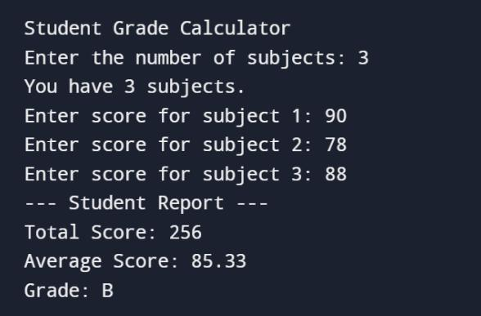
Project 1: Student Grade Calculator
Beginner
- Variables, input, conditions and functions.
- Calculate totals, percentages and grades.
- Validate marks and handle invalid inputs.
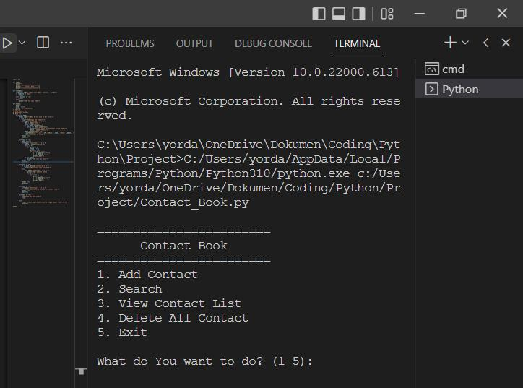
Project 2: Contact and Expense Manager
Beginner–Intermediate
- Use lists, dictionaries, functions and classes.
- Store data in JSON or CSV.
- Add search, filters and input validation.
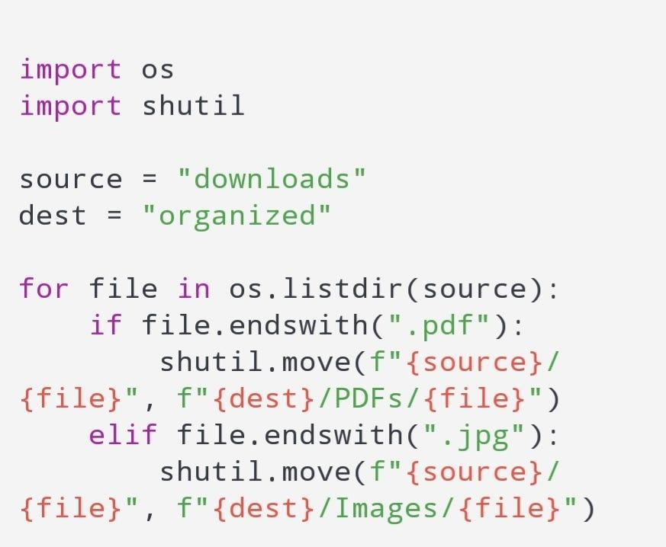
Project 3: File Organizer and Report Generator
Intermediate
- Work with paths, files and exceptions.
- Automate sorting, backups and reporting.
- Add logging and a command-line interface.
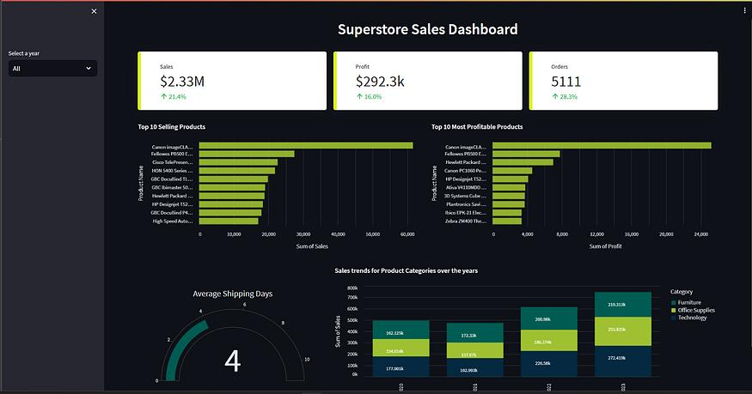
Project 4: Sales Data Analytics
Data Analytics
- Clean data with pandas.
- Analyze KPIs and trends.
- Visualize results and export a report.
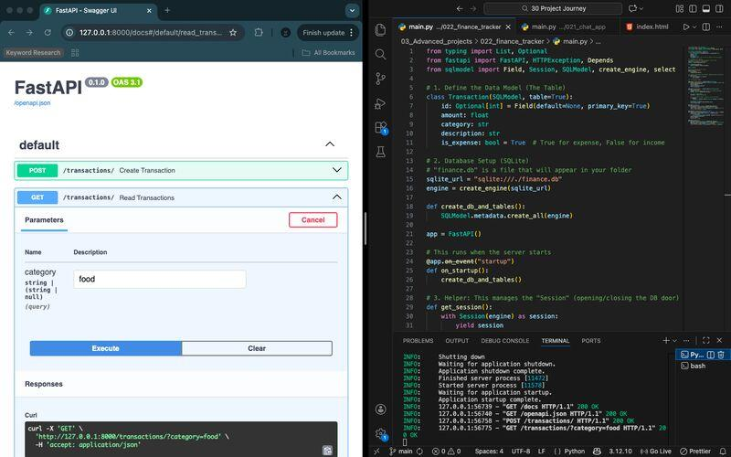
Project 5: Student Management API
Backend
- Build REST endpoints.
- Integrate a relational database.
- Add validation, authentication and tests.
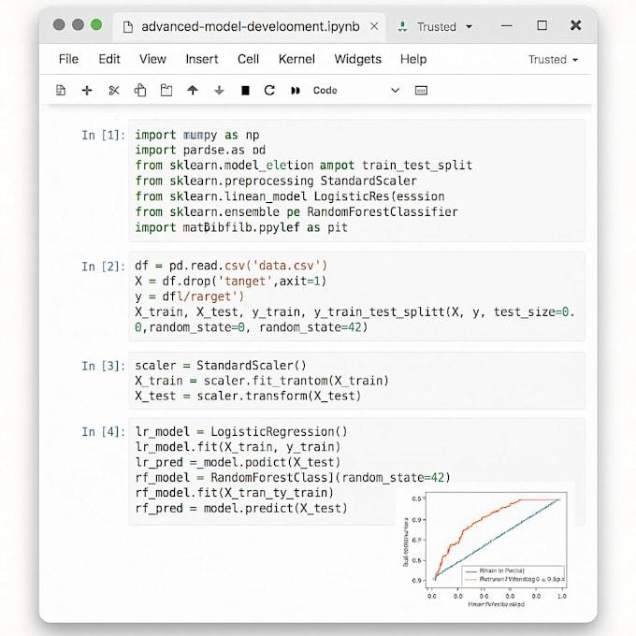
Project 6: Machine Learning Application
AI/ML
- Prepare a dataset.
- Train and evaluate a model.
- Expose predictions through a simple interface or API.
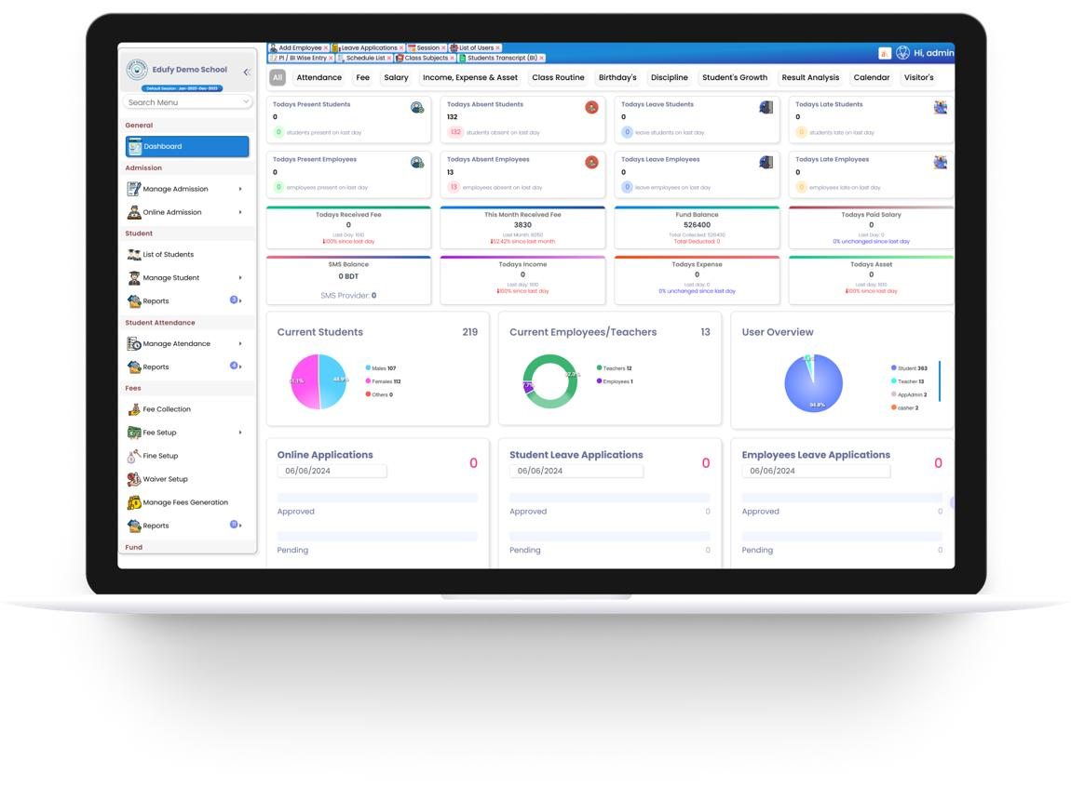
Project 7: EDVENT Institute Management System
Capstone
- Manage students, batches, courses and faculty.
- Track attendance, fees and payments.
- Generate reports and manage user roles.
- Use a database, automated tests and deployment.

Additional project ideas
Level | Project | Skills practiced
Beginner | Number guessing game | Loops, conditions and functions
Beginner | Quiz application | Collections and scoring
Beginner | Password generator | Strings and secure random generation
Intermediate | CSV cleaning utility | File I/O and data validation
Intermediate | Log analyzer | Generators, regex and aggregation
Intermediate | Weather API client | HTTP and JSON
Intermediate | Automated Excel reports | openpyxl and pandas
Intermediate | Personal expense tracker | OOP and SQLite
Advanced | Concurrent file processor | Multiprocessing and profiling
Advanced | Web scraping pipeline | HTML parsing and data cleaning
Advanced | REST API with authentication | FastAPI or Django
Advanced | Data visualization dashboard | Analytics and visualization
Advanced | ML prediction service | Scikit-learn and API integration
Advanced | AI document assistant | LLM API, retrieval and evaluation

Part 15 — Suggested 32-week learning schedule
This plan assumes approximately 10–15 hours per week, including lectures, coding exercises and project work. A complete beginner may need more time to become proficient.
Week | Topics
1 | Programming fundamentals, algorithms and Python setup
2 | Variables, data types, operators and input/output
3 | Conditions and loops
4 | Functions, scope and recursion
5 | Strings and text processing
6 | Lists, tuples and comprehensions
7 | Sets, dictionaries and common algorithms
8 | Classes, objects and encapsulation
9 | Inheritance, polymorphism and composition
10 | Special methods, exceptions and modules
11 | Files, paths and structured data
12 | Dates, regular expressions and database basics
13 | Iterators, generators and decorators
14 | Context managers, type hints and functional techniques
15 | Memory management and object lifecycle
16 | Threading, multiprocessing and asynchronous programming
17 | Introspection and advanced standard-library tools
18 | Debugging, testing and code quality
19 | Virtual environments, packaging and dependency management
20 | Git, GitHub, collaboration and CI fundamentals
21 | APIs, HTTP and JSON
22 | Automation, filesystem scripting and command-line applications
23 | DSA: complexity, searching and sorting
24 | DSA: linked lists, stacks, queues and hashing
25 | DSA: trees, graphs and dynamic programming
26 | Specialization foundations: analytics, backend or automation
27 | Specialization tools and practical exercises
28 | Specialization mini-project
29 | Capstone planning and database or data-pipeline design
30 | Capstone implementation
31 | Testing, documentation, security and optimization
32 | Deployment, code review and portfolio presentation
Important: This timeline is a structured guide, not a guarantee of mastery. For data analytics, backend development or AI/ML, allocate additional weeks to the chosen specialization rather than trying to learn all of them deeply in one course.

Part 16 — Interactive syllabus completion tracker
Use this tracker for classroom progress or self-study. Mark a milestone complete when you can explain the concept and implement it independently.

Python mastery tracker
0 of 44 milestones completed

0%

Programming and Core Python
Programming foundations and algorithms
Python setup and execution
Variables, data types and operators
Input/output and conditions
Loops and functions
Strings and text processing
Lists, tuples, sets and dictionaries
Comprehensions and algorithms

OOP and Data Handling
Classes and objects
Inheritance, polymorphism and composition
Special methods and data model
Exceptions and modules
File handling and filesystem
CSV, JSON and structured data
Date-Time API and regular expressions
SQL and Python database integration

Advanced Python
Iterators and generators
Decorators and closures
Context managers
Type hints and static typing
Functional programming techniques
Memory model and object lifecycle
Concurrency, multiprocessing and asyncio
Introspection and advanced standard library

Professional Development
Debugging and IDE tools
Unit testing and pytest
Linting, formatting and static analysis
Virtual environments and packaging
Git and GitHub
Security and safe Python
HTTP, REST APIs and JSON
Automation and command-line tools

Choose a Specialization
NumPy and pandas
Statistics and data visualization
FastAPI or Django
Machine learning fundamentals
Deployment and Docker
Performance engineering

Portfolio and Capstone
Beginner project completed
Intermediate project completed
Advanced project completed
Capstone documented and tested
Code published to GitHub
Project demonstrated or deployed
Reset trackerCopy progress

Part 17 — Official learning resources
Use official documentation as the primary reference and reinforce it with coding exercises and projects.
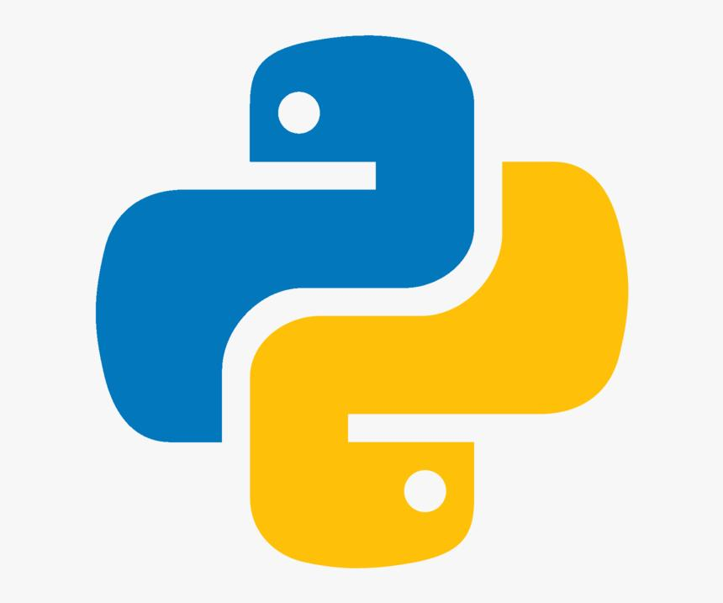
Python fundamentals
- Official Python tutorial
- Python documentation
- Python downloads
- Python Packaging User Guide
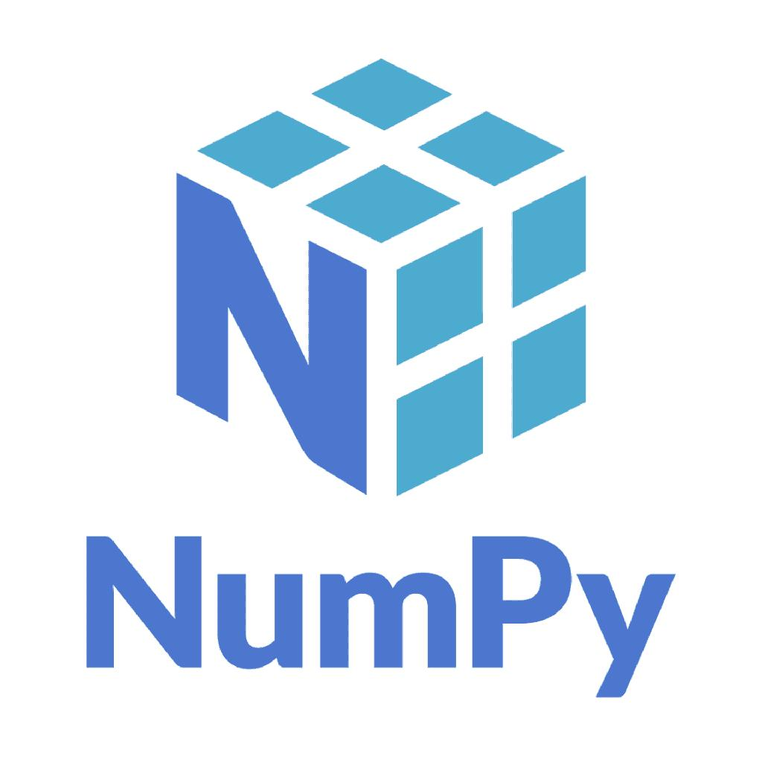
Data analytics
- NumPy documentation
- pandas documentation
- Matplotlib documentation
- Seaborn documentation
- Jupyter documentation
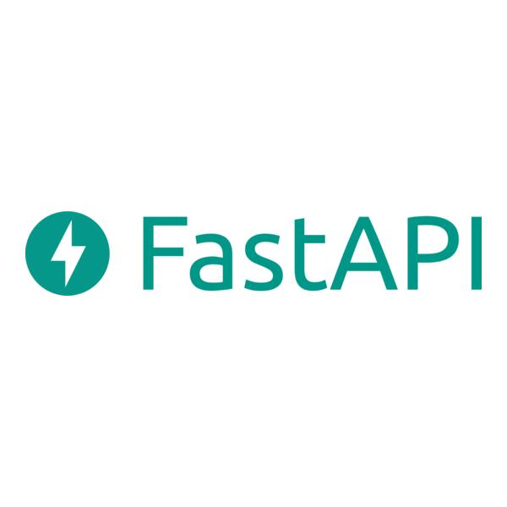
Web development
- FastAPI documentation
- Django documentation
- Requests documentation
- Beautiful Soup documentation
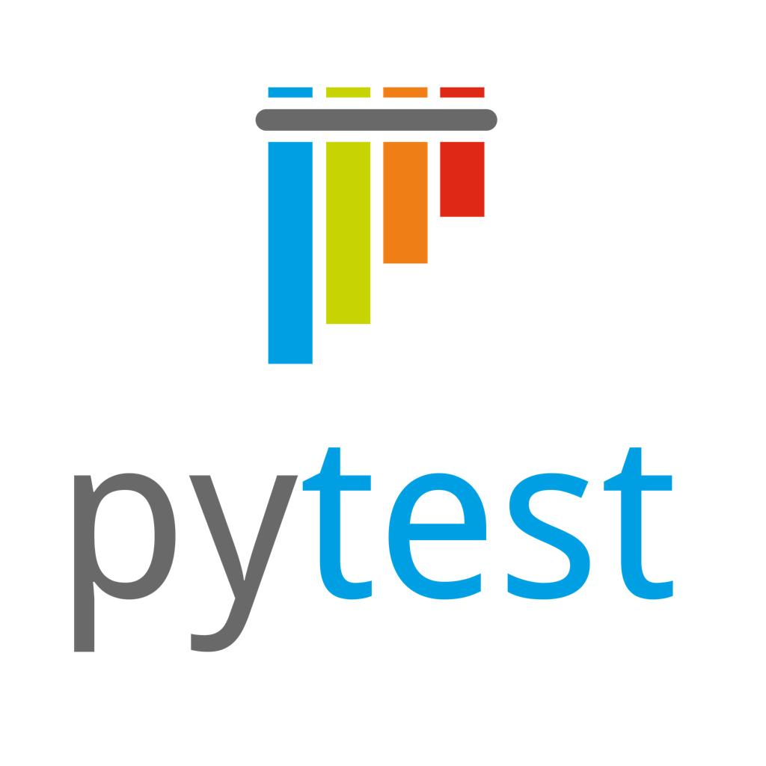
Testing and development tools
- pytest documentation
- Ruff documentation
- mypy documentation
- Git documentation
- Docker documentation
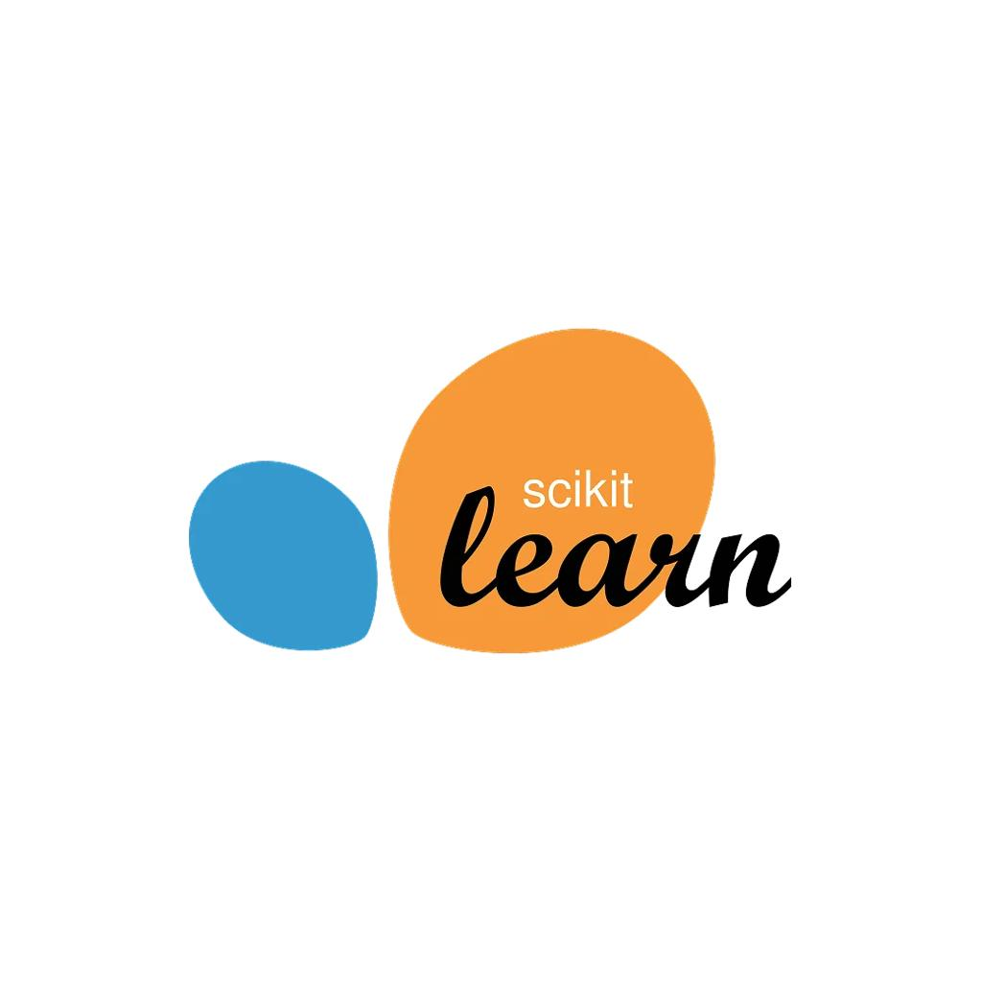
Machine learning
- Scikit-learn documentation
- PyTorch documentation
- TensorFlow documentation

Part 18 — Teaching methodology for EDVENT
For each module, use the same teaching cycle:
- Concept: Explain the theory with diagrams and practical examples.
- Live coding: Write code step by step and explain the important lines.
- Guided practice: Students solve similar exercises with assistance.
- Independent assignment: Students solve new problems without copying.
- Code review: Check correctness, readability, edge cases and performance.
- Assessment: Conduct a short quiz and practical coding test.
- Revision: Revisit difficult concepts through cumulative assignments.

Suggested weekly time distribution
Activity | Hours per week
Theory and demonstrations | 3
Guided coding | 4
Independent exercises | 3
Project work | 3
Revision and assessment | 2
Total | 15

Final recommendation: How to package the Python course
For EDVENT, divide the complete curriculum into three main courses instead of trying to teach every advanced topic in one uninterrupted batch.

Course 1 — Python Programming Fundamentals
Approximately 8–10 weeks
Modules 1–18: Fundamentals, data structures, functions, OOP, exceptions and modules.
Outcome: Students can write structured Python programs and solve basic programming problems.

Course 2 — Advanced Python and Software Development
Approximately 8–10 additional weeks
Modules 19–43: Files, databases, advanced language features, concurrency, testing, packaging, APIs and DSA.
Outcome: Students can build maintainable applications, automate tasks and work with external systems.

Course 3 — Python Career Specialization
Approximately 8–16 additional weeks, depending on track
Choose data analytics, backend development, AI/ML, or automation and deployment.
Outcome: Students complete a focused portfolio demonstrating skills relevant to their chosen field.
The most important principle: Students should spend at least as much time writing and debugging code as they spend watching demonstrations. A student who completes fewer topics independently and builds strong projects is better prepared than one who finishes every module without practical mastery.

