Complete React.js Master Syllabus — Beginner to Advanced
This syllabus is designed for EDVENT’s frontend and full-stack development curriculum, continuing from HTML, CSS, and JavaScript. It takes students from React fundamentals to component architecture, hooks, routing, API integration, state management, testing, performance optimization, and production deployment.
The curriculum focuses on modern React with function components and Hooks, while covering the concepts students need to build professional applications and progress toward full-stack MERN development.

1. Introduction to React.js
Level: Beginner

1.1 React fundamentals
- What React is
- Why React was developed
- Problems React solves
- React versus vanilla JavaScript
- React versus traditional DOM manipulation
- React versus other frontend libraries and frameworks
- Declarative versus imperative programming
- Component-based architecture
- Reusable UI components
- Single-page applications (SPAs)
- Multi-page applications versus SPAs
- Advantages and limitations of React

1.2 React ecosystem
- React library
- React DOM
- JSX
- React Router
- State management libraries
- UI component libraries
- Build tools and development servers
- Testing tools
- React DevTools
- React Compiler concepts

1.3 Prerequisites
Students should be comfortable with:
- HTML semantic elements and forms
- CSS selectors, Flexbox, Grid, and responsive design
- JavaScript variables, functions, arrays, and objects
- Arrow functions and destructuring
- Spread and rest syntax
- Array methods such as map(), filter(), and reduce()
- ES modules
- Promises and async/await
- Fetch API and JSON
- DOM fundamentals

2. React development environment

2.1 Setting up the environment
- Installing Node.js and npm
- Understanding the terminal
- Installing VS Code
- Creating a React project
- Understanding package.json
- Understanding package-lock.json
- Installing and managing dependencies
- Starting a development server
- Understanding development versus production builds

2.2 Creating React applications
- Creating a React project with Vite
- Understanding the project structure
- index.html
- src/main.jsx
- src/App.jsx
- CSS and asset files
- public directory
- Development scripts
- Production build scripts
- Environment configuration basics

2.3 Introduction to JSX
- What JSX is
- JSX versus HTML
- JavaScript expressions inside JSX
- JSX attributes
- className versus class
- htmlFor versus for
- Self-closing tags
- Returning a single root element
- Fragments
- Parentheses for multiline JSX
- Comments in JSX
- JSX compilation concepts

2.4 Running and debugging
- Running the development server
- Hot Module Replacement (HMR)
- Reading terminal errors
- Browser console errors
- React DevTools installation
- Inspecting the component tree
- Debugging invalid JSX
- Fixing missing keys and rendering warnings

3. Understanding React components
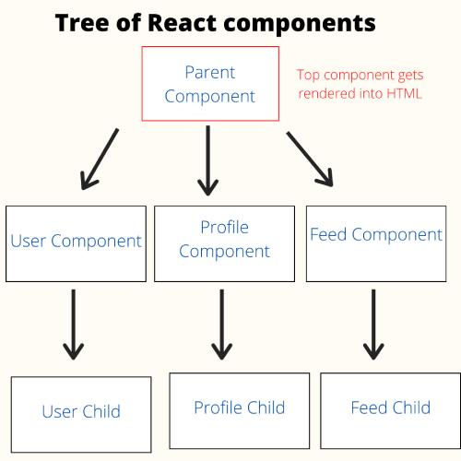
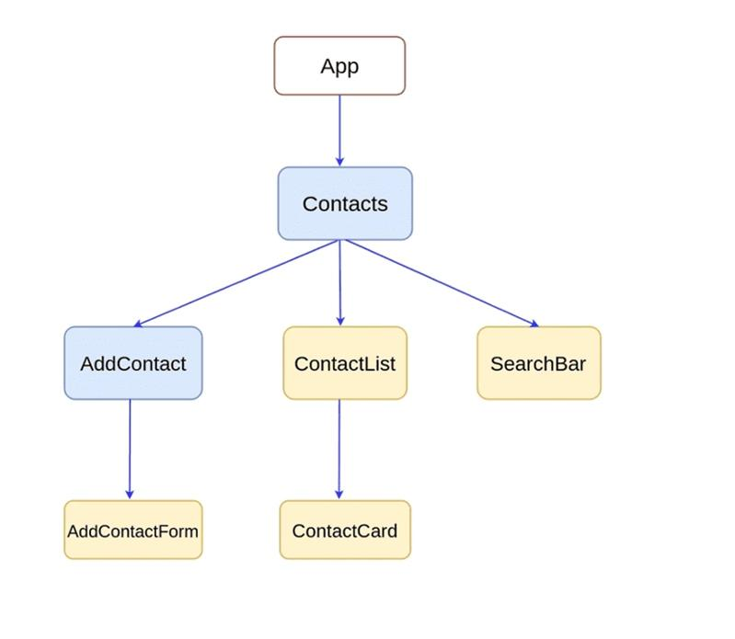
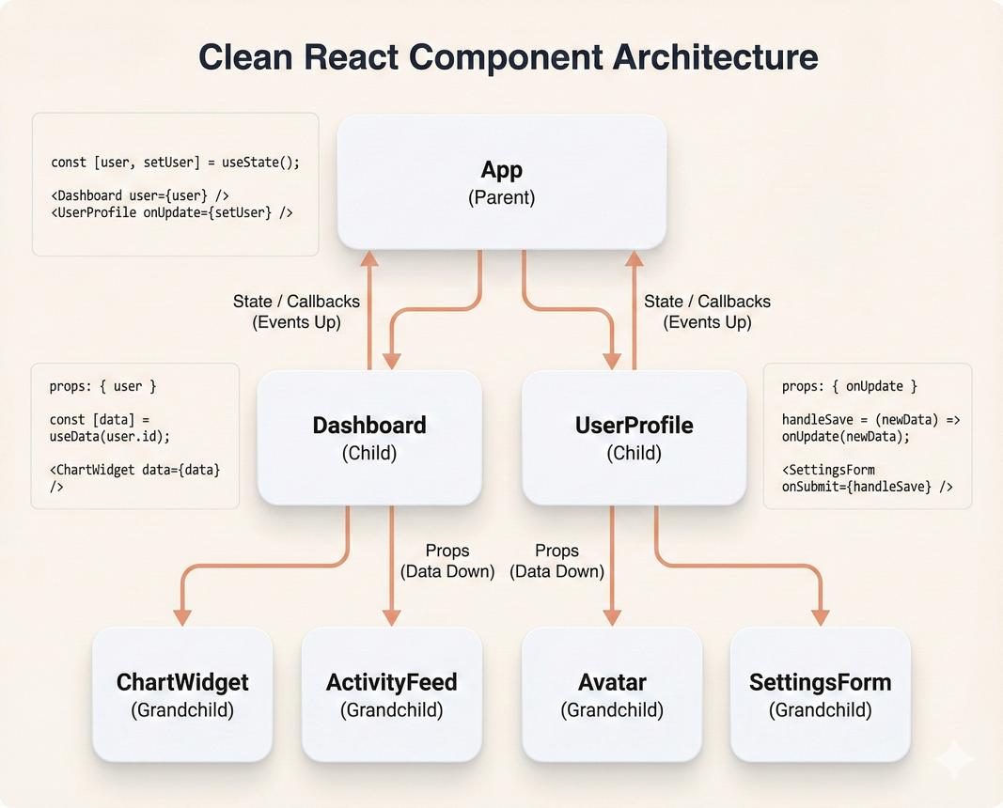
13

3.1 Component fundamentals
- What a component is
- Function components
- Component naming conventions
- Exporting and importing components
- Default exports versus named exports
- Component composition
- Reusable components
- Nested components
- Parent and child components
- Component trees
- Separating UI into components

3.2 Component structure
- Creating components in separate files
- Organizing components by feature
- Reusable layout components
- Shared components
- Page components
- UI components
- Container and presentation patterns
- Component responsibilities
- Avoiding unnecessarily large components

3.3 Component composition patterns
- Parent-child composition
- Reusable wrappers
- Children-based composition
- Layout components
- Slot-like patterns using props and children
- Compound components introduction
- Controlled versus uncontrolled components
- Component reuse versus over-abstraction

3.4 Practical exercises
- Greeting component
- Profile card
- Product card
- Navigation bar
- Footer component
- Reusable button
- Reusable alert component
- Multi-component landing page

4. JSX and rendering

4.1 JSX expressions
- Embedding variables
- Arithmetic expressions
- Function calls in JSX
- Property access
- Conditional expressions
- Rendering formatted values
- JavaScript expressions versus statements
- Why ordinary if statements cannot be placed directly inside JSX expressions

4.2 Rendering elements
- Text nodes
- HTML elements
- React components
- Fragments with <>...</>
- Rendering arrays
- Rendering nested content
- Rendering optional content
- Empty output using null
- Understanding React elements

4.3 Conditional rendering
- if statements outside JSX
- Ternary operator
- Logical AND &&
- Logical OR ||
- Returning null
- Early returns
- Loading, success, empty, and error states
- Conditional classes
- Conditional component rendering
- Avoiding the accidental rendering of 0 with logical AND expressions

4.4 Rendering lists
- map() in JSX
- Lists of strings
- Lists of objects
- Rendering nested lists
- Empty lists
- Filtering before rendering
- Sorting data before rendering
- Stable keys
- Why array indexes can be problematic as keys
- Why random keys should be avoided

5. Props — passing data between components

5.1 Props fundamentals
- What props are
- Passing props from parent to child
- Reading props
- Props as function parameters
- Destructuring props
- Default values
- String, number, boolean, and object props
- Array props
- Function props
- Passing JSX through props

5.2 Advanced props
- Passing event handlers
- Passing callbacks
- Passing component types
- children prop
- Props spreading
- Forwarding props carefully
- Conditional props
- Optional props
- Avoiding excessive prop forwarding
- Avoiding mutation of props

5.3 One-way data flow
- Parent-to-child data flow
- Child-to-parent communication through callbacks
- Sharing data between sibling components
- Lifting state up
- Prop drilling
- Composition as an alternative to prop drilling

5.4 Practical projects
- Product catalogue
- Student profile cards
- Reusable course cards
- Pricing comparison cards
- Dynamic navigation menu
- Configurable alert and button components

6. State management with useState

6.1 State fundamentals
- What state is
- Props versus state
- Declaring state with useState
- Initial state
- Updating state
- State setter functions
- Rendering after state updates
- State as a snapshot
- Why direct state mutation is incorrect
- State initialization from a value
- Lazy state initialization

6.2 Updating state correctly
- Updating strings and numbers
- Updating booleans
- Updating arrays
- Updating objects
- Functional state updates
- Using previous state
- Copying arrays with spread syntax
- Copying objects immutably
- Updating nested objects
- Updating individual array records
- Batching state updates

6.3 State behavior
- State preservation
- State reset
- State tied to component position
- State updates based on props
- Avoiding redundant state
- Derived values versus stored state
- Avoiding stale state assumptions
- Understanding state update timing

6.4 Practical projects
- Counter
- Toggle switch
- Like button
- Shopping cart quantity
- Dynamic list manager
- Expand/collapse panel
- Theme toggle
- Student attendance tracker

7. Handling events in React

7.1 Event fundamentals
- React event handling
- onClick
- onChange
- onSubmit
- onInput
- onFocus and onBlur
- onMouseEnter and onMouseLeave
- onKeyDown and onKeyUp
- onDoubleClick
- onScroll
- Event handlers versus event handler calls
- Passing arguments to handlers
- Inline handlers versus named functions

7.2 Event objects
- Accessing event information
- event.target
- event.currentTarget
- event.preventDefault()
- event.stopPropagation()
- Keyboard event properties
- Mouse and pointer event properties
- Form submission handling
- Event propagation
- Parent-child event interactions

7.3 Advanced event patterns
- Passing callbacks as props
- Updating state from events
- Event delegation concepts
- Handling events on dynamic lists
- Debouncing search input
- Throttling frequent events
- Handling keyboard shortcuts
- Cleaning up native event listeners

7.4 Practical projects
- Search box
- Interactive dropdown
- Keyboard-controlled counter
- Modal with close button
- Sortable table
- Interactive course filter

8. React Hooks — complete fundamentals
Hooks allow function components to use React features such as state, context, effects, and refs.

8.1 Rules of Hooks
- Call Hooks at the top level of components or custom Hooks
- Do not call Hooks inside loops, conditions, or nested callbacks
- Call Hooks from React function components or custom Hooks
- Understand why consistent Hook call order matters
- Using the React Hooks lint rules
- Recognizing invalid Hook calls

8.2 useState
- State creation
- Updating state
- Functional updates
- Lazy initialization
- Managing objects and arrays
- Resetting state

8.3 useEffect
- What an Effect is
- Synchronizing with external systems
- Effect setup functions
- Dependency arrays
- Effects without a dependency array
- Effects with an empty dependency array
- Effects with dependencies
- Cleanup functions
- Re-running Effects
- Stale closures
- React Strict Mode and development behavior
- Avoiding unnecessary Effects
- Avoiding infinite render loops
- Separating event logic from Effect logic

8.4 useRef
- Creating refs
- Accessing DOM elements
- Focusing input fields
- Storing mutable values
- Previous-value patterns
- Why ref changes do not trigger rendering
- Ref cleanup and lifecycle considerations
- Ref callbacks
- When state is preferable to a ref

8.5 useContext
- Creating a context
- Providing context values
- Consuming context
- Context for themes
- Context for authentication state
- Context for language preferences
- Avoiding unnecessary context updates
- Context versus props

8.6 useReducer
- Reducer fundamentals
- State and actions
- Reducer functions
- Dispatching actions
- Initial state
- Lazy initialization
- Reducer versus useState
- Managing complex state transitions
- Combining useReducer with Context

8.7 Other built-in Hooks
- useMemo
- useCallback
- useId
- useTransition
- useDeferredValue
- useSyncExternalStore
- useLayoutEffect
- useImperativeHandle
- useDebugValue
- useInsertionEffect and its specialized purpose
Learn the purpose and trade-offs of each Hook rather than using every Hook in every component.

9. Side effects and lifecycle concepts

9.1 Understanding side effects
- What a side effect is
- Rendering versus side effects
- Event handlers versus Effects
- Synchronizing with browser APIs
- Synchronizing with subscriptions
- Fetching data and handling results
- Timers and intervals
- Browser event listeners
- Third-party widget integration

9.2 Component lifecycle concepts
- Mounting
- Updating
- Unmounting
- Effects during component lifetime
- Cleanup before an Effect reruns
- Cleanup on unmount
- Development Strict Mode behavior
- Lifecycle concepts in function components
- Comparison with class lifecycle methods

9.3 Effect best practices
- Specify accurate dependencies
- Avoid suppressing dependency warnings without understanding them
- Prevent stale closure bugs
- Avoid Effects for simple derived values
- Avoid Effects for handling user-triggered actions that belong in event handlers
- Prevent race conditions in asynchronous Effects
- Use cleanup and cancellation where necessary
- Keep Effects focused on synchronization

9.4 Practical exercises
- Digital clock
- Window resize listener
- Online/offline status indicator
- Document title updater
- Debounced search
- Timer with cleanup
- Subscribe/unsubscribe example

10. Forms and controlled components

10.1 Form fundamentals
- Forms in React
- Controlled inputs
- Uncontrolled inputs
- The value prop
- The defaultValue prop
- The checked prop
- The defaultChecked prop
- Handling text inputs
- Handling textareas
- Handling select menus
- Handling radio buttons
- Handling checkboxes
- Handling multiple selections
- Handling file inputs

10.2 Form state
- State for individual fields
- State for multiple fields
- Updating fields dynamically
- Handling form submission
- Resetting form state
- Displaying validation messages
- Tracking touched fields
- Tracking dirty fields
- Form loading and submission states
- Preventing duplicate submissions

10.3 Validation
- Required fields
- Email validation
- Password validation
- Confirm-password validation
- Numeric ranges
- Custom validation rules
- Cross-field validation
- Inline errors
- Summary errors
- Server-side validation errors
- Accessible labels and error messages
- HTML validation versus JavaScript validation

10.4 Advanced forms
- Dynamic form fields
- Field arrays
- Conditional fields
- Multi-step forms
- Dependent dropdowns
- File uploads
- Image previews
- Form serialization
- Form submission to APIs
- Handling server responses

10.5 Form libraries
- React Hook Form
- Formik concepts
- Schema validation with Zod
- Yup concepts
- Choosing native state versus a form library
- Integrating validation schemas
- Handling large forms efficiently
Practical project: Build an EDVENT student admission form with field validation, course selection, file upload, and a review-before-submit step.

11. React Router and client-side navigation

11.1 Routing fundamentals
- What routing is
- Client-side routing
- Single-page application navigation
- React Router installation
- Router setup
- Route definitions
- Layout routes
- Nested routes
- Index routes
- Not-found routes
- Navigation without full-page reloads

11.2 Navigation components and Hooks
- Link
- NavLink
- useNavigate
- useLocation
- useParams
- useSearchParams
- Outlet
- Navigate
- Programmatic navigation
- Active navigation styling
- Back and forward navigation

11.3 Dynamic routes
- Route parameters
- Dynamic course detail pages
- Student profile routes
- URL query parameters
- Search and filtering in the URL
- Route-level error handling
- Redirects
- Optional and nested route patterns

11.4 Advanced routing
- Protected route patterns
- Authentication-aware navigation
- Role-based UI routing
- Lazy-loaded routes
- Route-level loading states
- Data loaders and actions in supported React Router modes
- Error boundaries
- Route-based code splitting
- Scroll restoration
- Server fallback configuration for client-side routes

11.5 Practical project
Build a multipage education website with:
- Home
- Courses
- Course details
- About
- Contact
- Login
- Student dashboard
- Not-found page
Use route protection only as a UI navigation measure; enforce authorization on the server as well.

12. Working with APIs in React

12.1 API fundamentals
- REST API concepts
- HTTP methods
- Endpoints
- Headers
- JSON
- Status codes
- Request and response bodies
- Query parameters
- Authentication basics
- CORS
- Environment variables

12.2 Fetching data
- Using fetch()
- Using async/await
- Parsing JSON
- Checking response.ok
- Handling network failures
- Handling HTTP errors
- Handling malformed responses
- Managing loading states
- Managing error states
- Handling empty results
- Preventing stale responses
- Cancelling requests with AbortController

12.3 CRUD operations
- GET: read records
- POST: create records
- PUT: replace records
- PATCH: partially update records
- DELETE: remove records
- Submitting forms to APIs
- Updating the UI after mutations
- Optimistic UI concepts
- Rollback on failed updates
- Handling validation responses

12.4 API integration patterns
- API service modules
- Separating data access from UI components
- Reusable request helpers
- Request state management
- Pagination
- Filtering
- Sorting
- Search
- Debounced API requests
- Retry behavior
- Concurrent requests
- Request deduplication
- Caching concepts

12.5 Data-fetching libraries
- TanStack Query (React Query)
- SWR
- Caching and cache invalidation
- Query keys
- Mutations
- Refetching
- Background updates
- Stale versus fresh data
- Optimistic updates
- When a library is preferable to manual Effects
Practical project: Create a course catalogue that loads data from an API and supports search, filters, pagination, details, and error recovery.

13. Context API and global state management

13.1 State management fundamentals
- Local component state
- Shared state
- Global state
- Server state versus client state
- UI state versus persisted state
- Prop drilling
- Lifting state
- State ownership
- Avoiding duplicated sources of truth

13.2 Context API in practice
- createContext()
- Context providers
- useContext()
- Multiple contexts
- Theme context
- Authentication context
- Language context
- Context value stability
- Avoiding excessive re-renders
- Combining Context with reducers

13.3 Redux Toolkit
- Why Redux exists
- Store
- State
- Actions
- Reducers
- Dispatch
- Selectors
- configureStore()
- createSlice()
- createAsyncThunk()
- React Redux Provider
- useSelector()
- useDispatch()
- Redux DevTools
- Async state and loading/error patterns
- Redux Toolkit Query concepts

13.4 Other state management options
- Zustand
- Jotai
- Recoil concepts and ecosystem status
- MobX concepts
- Choosing a state management library
- Avoiding global state when local state is sufficient
- Avoiding duplication of server state

13.5 Practical projects
- Shopping cart with global state
- Theme and language manager
- Authentication UI state
- Student dashboard
- Course enrolment workflow

14. Custom Hooks
Custom Hooks allow students to extract reusable stateful logic from components.

14.1 Custom Hook fundamentals
- What a custom Hook is
- Naming conventions beginning with use
- Extracting reusable logic
- Sharing logic without sharing component state
- Calling other Hooks inside custom Hooks
- Custom Hook parameters and return values
- Returning objects versus arrays
- Custom Hook composition

14.2 Common custom Hooks
- useLocalStorage
- useSessionStorage
- useDebounce
- useWindowSize
- useOnlineStatus
- usePrevious
- useToggle
- useClickOutside
- useMediaQuery
- useFetch concepts
- useDocumentTitle
- useEventListener

14.3 Advanced custom Hook design
- Dependency management
- Effect cleanup
- Handling asynchronous state
- Cancellation and race conditions
- Avoiding unnecessary abstractions
- Type-safe custom Hooks with TypeScript
- Testing custom Hooks
- Composing multiple custom Hooks
Practical exercise: Build a reusable useDebounce Hook and use it in a course search component.

15. React rendering and reconciliation
This section explains what React does when state or props change and why some components render again.

15.1 Rendering fundamentals
- Triggering a render
- Rendering versus committing
- Initial render
- Re-rendering after state updates
- Parent and child render behavior
- Component purity
- Render calculations
- Why rendering should not perform side effects
- Understanding Strict Mode development checks

15.2 Reconciliation
- How React compares element trees
- Element types and component identity
- The role of keys
- State preservation
- State reset through changing keys
- Conditional rendering and component state
- List reconciliation
- Why unstable keys cause bugs
- Component position and state identity

15.3 Render optimization
- Identifying expensive renders
- Avoiding unnecessary state
- Splitting components appropriately
- React.memo
- useMemo
- useCallback
- Stable references
- Memoization trade-offs
- Measuring performance before optimizing

15.4 Practical exercises
- Fix incorrect list keys
- Diagnose unexpected state resets
- Reduce expensive calculations
- Profile a large table
- Compare memoized and non-memoized components

16. Performance optimization

16.1 React performance fundamentals
- Render cost versus commit cost
- Component render frequency
- Expensive calculations
- Large lists
- State update patterns
- Unnecessary context updates
- Avoiding premature optimization

16.2 Core optimization tools
- React.memo
- useMemo
- useCallback
- Lazy initialization
- Code splitting
- Dynamic imports
- lazy()
- Suspense
- Route-level lazy loading
- Bundle-size analysis
- Tree shaking concepts

16.3 Large data sets
- List virtualization
- Windowing concepts
- Pagination
- Infinite scrolling
- Debounced search
- Throttled events
- Efficient filtering and sorting
- Avoiding unnecessary DOM nodes

16.4 Modern React performance features
- useTransition
- useDeferredValue
- useActionState
- React Compiler concepts
- Automatic batching
- Concurrent rendering concepts
- Suspense boundaries
- Understanding urgent versus non-urgent updates
- Using the Profiler

16.5 Performance measurement
- React DevTools Profiler
- Browser Performance panel
- Lighthouse
- Network panel
- Bundle analysis
- Measuring before and after changes
- Core Web Vitals concepts
- Avoiding unnecessary memoization

17. Error handling and error boundaries

17.1 Error fundamentals
- JavaScript errors in components
- Errors in event handlers
- Promise rejections
- API errors
- Rendering failures
- Error messages and stack traces
- Logging errors appropriately

17.2 React error boundaries
- What an error boundary is
- Fallback UI
- Error boundary lifecycle concepts
- Class-based error boundaries
- getDerivedStateFromError()
- componentDidCatch()
- Resetting error boundaries
- Error boundaries versus try...catch
- Limitations for event handlers and asynchronous callbacks

17.3 Production error handling
- API failure states
- Retry controls
- Form submission errors
- Route-level error UI
- Logging and monitoring
- User-friendly error messages
- Avoiding sensitive information in error output
- Handling unexpected failures gracefully

18. Advanced React component patterns

18.1 Component composition
- Children-based composition
- Layout components
- Reusable wrappers
- Compound components
- Controlled and uncontrolled components
- Configurable components
- Slot-like composition patterns

18.2 Advanced patterns
- Higher-order components (HOCs)
- Render props
- Function-as-child patterns
- Provider patterns
- Headless components
- Dependency injection concepts
- Component adapters
- Avoiding unnecessary abstraction

18.3 Reusable UI design
- Button systems
- Form controls
- Dialogs and modals
- Dropdown menus
- Tabs and accordions
- Toast notifications
- Data tables
- Pagination
- Loading indicators
- Skeleton components
- Empty states
- Error states

18.4 Accessibility in reusable components
- Keyboard interaction
- Focus management
- Focus restoration
- Semantic HTML
- ARIA attributes
- Accessible names
- Screen-reader announcements
- Managing disabled states
- Avoiding custom controls when native HTML is sufficient

19. Styling React applications

19.1 CSS in React
- External CSS files
- Global styles
- Component-specific CSS files
- CSS naming conventions
- Conditional classes
- Dynamic class names
- CSS variables
- Theme variables
- Responsive components

19.2 CSS Modules
- Module-scoped styles
- Importing CSS modules
- Class-name mapping
- Composing classes
- Conditional CSS module classes
- CSS Modules with Vite

19.3 CSS-in-JS concepts
- Styled-components concepts
- Emotion concepts
- Dynamic styles based on props
- Theme providers
- Runtime versus build-time styling trade-offs
- Bundle size and performance considerations

19.4 Utility-first CSS
- Tailwind CSS
- Utility classes in JSX
- Responsive variants
- Hover and focus variants
- Conditional utility classes
- Reusable component patterns
- Theme customization
- Managing long class lists

19.5 UI component libraries
- Material UI (MUI)
- Ant Design
- Chakra UI concepts
- shadcn/ui
- Radix UI
- React Bootstrap
- Component accessibility
- Theme customization
- Choosing a library based on project needs

20. React with TypeScript
TypeScript is strongly recommended for students preparing for professional React roles.

20.1 TypeScript fundamentals
- Primitive types
- Arrays and tuples
- Objects and interfaces
- Type aliases
- Union and intersection types
- Literal types
- Optional properties
- Enums and alternatives
- Type inference
- Generics
- Narrowing and type guards
- unknown versus any

20.2 Typing React components
- Typing props
- Optional props
- Default values
- Typing children
- Function component return types
- Typing event handlers
- Form events
- Input values
- Button props
- Component composition
- Discriminated union props

20.3 Typing Hooks and data
- useState types
- useReducer types
- useRef types
- Context types
- Custom Hook return types
- Typing API responses
- Loading, success, and error states
- Generic reusable components
- Typing reducer actions
- Type-safe form data

20.4 TypeScript project setup
- Creating a React TypeScript project
- TSX files
- tsconfig.json
- Strict mode
- Type checking
- Type-safe API service modules
- TypeScript with React Router
- TypeScript with state management libraries

21. Testing React applications

21.1 Testing fundamentals
- Why React applications need tests
- Unit testing
- Component testing
- Integration testing
- End-to-end testing
- Test cases and assertions
- Mocking dependencies
- Test-driven development concepts

21.2 Testing tools
- Vitest
- Jest concepts
- React Testing Library
- render()
- screen
- getByRole()
- getByLabelText()
- getByText()
- userEvent
- findBy... and asynchronous assertions
- Mocking network requests with suitable tools
- Testing Library principles

21.3 What to test
- Component rendering
- Props
- User interactions
- Form validation
- State changes
- Conditional rendering
- API loading and error states
- Navigation
- Accessibility behavior
- Custom Hooks
- Reducers and utility functions

21.4 End-to-end testing
- Playwright
- Cypress
- User journeys
- Login and registration workflows
- Course search and enrolment
- Testing responsive behavior
- Test data setup
- Continuous integration concepts

22. React with backend APIs and authentication

22.1 Frontend-backend integration
- Connecting React to Node.js and Express
- REST API integration
- API service layers
- Environment variables
- Request headers
- JSON request bodies
- Handling status codes
- Loading and error states
- CORS configuration concepts
- API validation errors

22.2 Authentication workflows
- Registration
- Login
- Logout
- Session handling
- Cookie-based authentication concepts
- Token-based authentication concepts
- Refresh flows
- Expired sessions
- Authentication state
- Redirecting after login
- Protected navigation
- Role-based UI rendering

22.3 Security fundamentals
- Never embedding private API secrets in frontend code
- Avoiding unsafe HTML injection
- Understanding XSS
- CSRF and cookie security concepts
- Secure token handling
- Server-side authorization
- Validating user permissions on the backend
- Handling sensitive error responses
- Avoiding client-side-only access controls

22.4 Practical project
Build a course portal with login, course browsing, student dashboard, profile management, and backend-connected enrolment records.

23. Server-side rendering, static rendering, and React frameworks

23.1 Rendering strategies
- Client-side rendering (CSR)
- Server-side rendering (SSR)
- Static site generation (SSG)
- Incremental static regeneration concepts
- Hydration
- Streaming rendering
- Server Components concepts
- Trade-offs between rendering strategies

23.2 React Server Components
- Server versus Client Components
- What executes on the server
- Client interactivity boundaries
- Serializing props between server and client
- Data access on the server
- Server-only dependencies
- Understanding that Server Components are a framework-enabled architecture rather than a replacement for all client components

23.3 Suspense and asynchronous UI
- Suspense
- Fallback UI
- Lazy component loading
- Suspense boundaries
- Error boundaries alongside Suspense
- Streaming UI concepts
- Framework-managed asynchronous data loading
- Understanding which data-fetching patterns are supported by a given React framework

23.4 Next.js introduction
- Why React frameworks are useful
- Next.js project structure
- App Router concepts
- Pages and layouts
- Dynamic routes
- Server and Client Components
- Data fetching
- Route handlers
- Loading and error UI
- Metadata and SEO
- Image optimization
- Deployment
- Framework-specific caching concepts

23.5 React framework alternatives
- React Router framework capabilities
- Remix concepts and its relationship to React Router
- Gatsby concepts
- Choosing a framework for the project
- Static sites versus dynamic applications
Note: Framework APIs and React features evolve. Teach current documentation alongside the core concepts rather than relying solely on older tutorials.

24. React with Redux Toolkit and advanced server state
This section expands state management for larger applications.

24.1 Redux Toolkit in production
- Organizing slices by feature
- Store configuration
- Typed selectors and dispatch
- Reducer composition
- Async workflows
- Error and loading states
- Normalizing relational data
- Redux DevTools
- Testing reducers and selectors

24.2 Redux Toolkit Query
- API slices
- Query endpoints
- Mutation endpoints
- Generated Hooks
- Cache keys
- Cache invalidation
- Refetch policies
- Optimistic updates
- Error handling
- API caching versus manual state management

24.3 Server state versus client state
- Remote data versus UI preferences
- Caching API results
- Cache freshness
- Synchronizing mutations
- Invalidating stale data
- Background refetching
- Query libraries versus Redux
- Choosing the simplest suitable architecture

24.4 State architecture exercises
- Global shopping cart
- Multi-page course catalogue
- Student dashboard
- User preferences
- API-backed enrolment workflow
- Normalized student and course records

25. React portals, refs, and imperative APIs

25.1 Portals
- What portals are
- createPortal()
- Rendering modals outside the main DOM hierarchy
- Tooltips and overlay panels
- Event propagation through portals
- Styling and stacking contexts
- Portal cleanup

25.2 Refs in depth
- DOM refs
- Focusing inputs
- Scrolling to elements
- Measuring element dimensions
- Callback refs
- Managing external widgets
- Ref cleanup
- Avoiding refs for values that should trigger rendering

25.3 Imperative handles
- useImperativeHandle
- Exposing limited component methods
- forwardRef and React-version considerations
- Ref APIs versus declarative props
- Encapsulating imperative behavior
- When imperative APIs are justified

25.4 Practical exercises
- Modal using a portal
- Search input that receives focus
- Scroll-to-section component
- Third-party chart integration
- Reusable dialog component

26. React and animation

26.1 Native approaches
- CSS transitions with React state
- Conditional classes
- CSS keyframe animations
- Transitioning between UI states
- Reduced-motion support
- Animating entry and exit states
- Avoiding layout shifts

26.2 Animation libraries
- Framer Motion / Motion
- React Transition Group
- GSAP integration concepts
- Animation variants
- Staggered animations
- Layout transitions
- Gesture interactions
- Scroll-based effects
- Coordinating animation with component state

26.3 Animation best practices
- Avoiding excessive animation
- Respecting prefers-reduced-motion
- Keeping animations performant
- Cleaning up animation instances
- Avoiding animation-only state
- Choosing CSS versus JavaScript animation
Practical project: Create an animated course catalogue with card transitions, modal animations, and accessible reduced-motion behavior.

27. React with charts, tables, and data visualization

27.1 Data visualization
- Transforming API data
- Preparing datasets
- Handling missing values
- Date and number formatting
- Chart legends and tooltips
- Responsive charts
- Empty and error states
- Accessible chart descriptions

27.2 Chart libraries
- Recharts
- Chart.js with React
- Apache ECharts concepts
- D3.js integration concepts
- Choosing the appropriate charting library

27.3 Tables and dashboards
- Sorting rows
- Filtering data
- Pagination
- Search
- Row selection
- Column visibility
- Loading placeholders
- Export controls
- Large table performance
- TanStack Table concepts

27.4 Practical project
Build an EDVENT admin dashboard showing student enrolments, course popularity, monthly revenue, attendance, and filtered student records.

28. React accessibility and inclusive design

28.1 Semantic React development
- Semantic HTML inside components
- Accessible component names
- Correct button and link usage
- Labels for form controls
- Headings and landmarks
- Lists and tables
- Accessible error messages
- Avoiding unnecessary ARIA

28.2 Keyboard accessibility
- Tab navigation
- Focus indicators
- Keyboard-operable dropdowns
- Modal focus management
- Escape key behavior
- Focus restoration
- Keyboard interaction patterns for custom widgets
- Avoiding keyboard traps

28.3 Assistive technology
- Screen reader basics
- Accessible names and descriptions
- aria-label
- aria-labelledby
- aria-describedby
- aria-live
- aria-expanded
- aria-controls
- aria-selected
- Announcing dynamic updates
- Managing loading and validation announcements

28.4 Accessibility testing
- Keyboard-only testing
- Browser accessibility tree
- Automated accessibility checks
- axe-core concepts
- Lighthouse accessibility audits
- Contrast checks
- Screen reader spot checks
- Manual testing alongside automated tools

29. React security and reliability

29.1 Security fundamentals
- XSS risks
- Unsafe dangerouslySetInnerHTML
- Sanitizing rich HTML when needed
- Protecting credentials
- Avoiding frontend-only authorization
- Validating server responses
- Dependency security
- Secure API communication

29.2 Reliability patterns
- Error boundaries
- API retries where appropriate
- Request cancellation
- Avoiding stale responses
- Offline and connection-loss states
- Handling expired sessions
- Graceful fallbacks
- Logging and monitoring
- User-friendly error messages

29.3 Production readiness
- Environment configuration
- Secure build configuration
- Error reporting
- Dependency updates
- Smoke tests
- Browser compatibility
- Performance budgets
- Deployment verification

30. React project structure and architecture

30.1 Organizing a small application
- components/
- pages/
- hooks/
- utils/
- assets/
- services/
- styles/
- constants/
- Entry-point files
- Component naming

30.2 Organizing a larger application
- Feature-based folders
- Shared UI components
- Domain-specific modules
- API service modules
- Route organization
- State management organization
- Reusable Hooks
- Design system folders
- Type definitions
- Test files

30.3 Architecture principles
- Separation of concerns
- Single responsibility
- Component composition
- Avoiding oversized components
- Avoiding unnecessary abstraction
- Managing dependencies
- Reusable logic versus reusable UI
- Avoiding circular dependencies
- Consistent naming conventions
- Code review and refactoring
Example structure:
edvent-portal/
├── public/
├── src/
│ ├── app/
│ ├── assets/
│ ├── components/
│ ├── features/
│ │ ├── courses/
│ │ ├── students/
│ │ └── auth/
│ ├── hooks/
│ ├── layouts/
│ ├── pages/
│ ├── services/
│ ├── utils/
│ ├── App.jsx
│ └── main.jsx
├── package.json
└── README.md
This is a suggested structure, not a mandatory convention. The right organization depends on the application's size and complexity.

31. Git, collaboration, and deployment

31.1 Git and GitHub
- Creating a Git repository
- Tracking source files
- Commits and commit messages
- Branches
- Merging
- Pull requests
- Resolving merge conflicts
- .gitignore
- README files
- Issues and code review
- Collaborating with a team

31.2 Production build
- Development versus production mode
- Vite build command
- Build output
- Asset handling
- Environment variables
- Bundle size
- Source maps
- Build errors
- Testing the production build locally

31.3 Deployment platforms
- Vercel
- Netlify
- Static hosting
- Cloud hosting concepts
- Environment configuration
- SPA route fallback rules
- Custom domains
- HTTPS
- Continuous deployment
- Preview deployments
- Deployment troubleshooting

31.4 Deployment checklist
- Test primary user flows
- Test mobile responsiveness
- Verify environment variables
- Check API URLs
- Confirm client-side routes work on refresh
- Check console errors
- Check loading and error states
- Verify forms and validation
- Review accessibility
- Confirm the deployed build works

32. Complete React.js practical project roadmap
Students should build these projects in sequence. The aim is to demonstrate the ability to create, debug, test, and deploy complete applications—not merely follow tutorials.
Project 1 — Component-based profile website
Beginner
Practice JSX, components, props, CSS, reusable cards, and rendering lists.
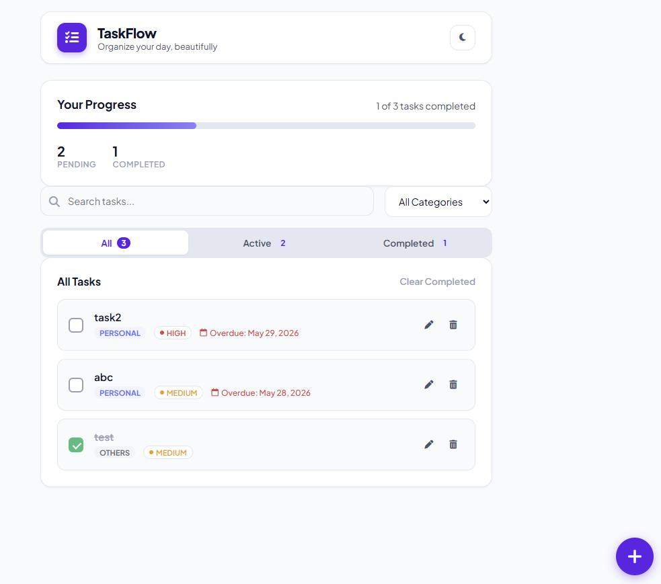
Project 2 — To-do application
Beginner
Practice useState, events, forms, list rendering, CRUD operations, and localStorage.
Project 3 — Course catalogue
Beginner to intermediate
Practice props, reusable components, filtering, sorting, search, and responsive layouts.
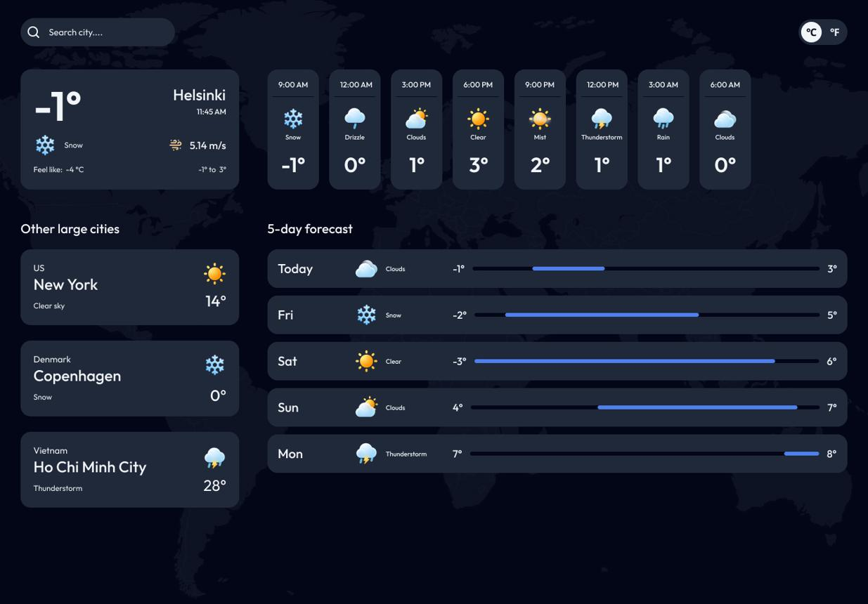
Project 4 — API-powered weather app
Intermediate
Practice useEffect, Fetch API, async/await, loading states, error handling, and request cleanup.

Project 5 — E-commerce frontend
Intermediate
Practice Context or a state library, product details, cart management, routing, and checkout form validation.
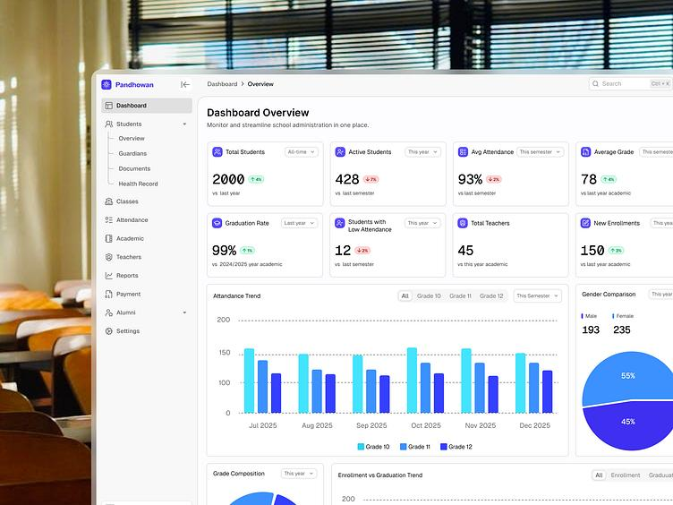
Project 6 — Student management system
Intermediate to advanced
Practice CRUD API integration, forms, React Router, pagination, filters, authentication UI, and error handling.
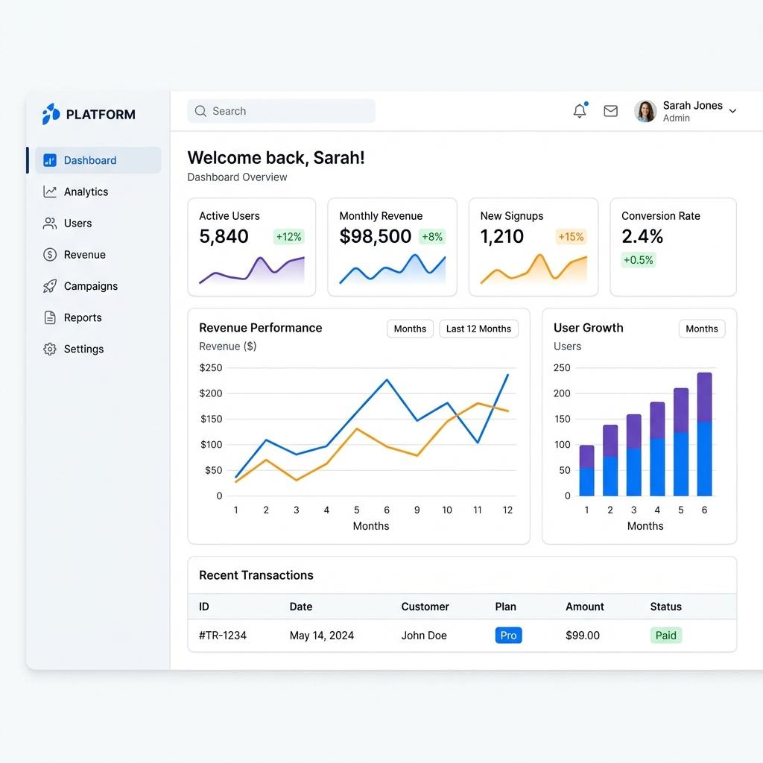
Project 7 — Analytics dashboard
Advanced
Practice data visualization, global state, API caching, reusable components, testing, and performance optimization.
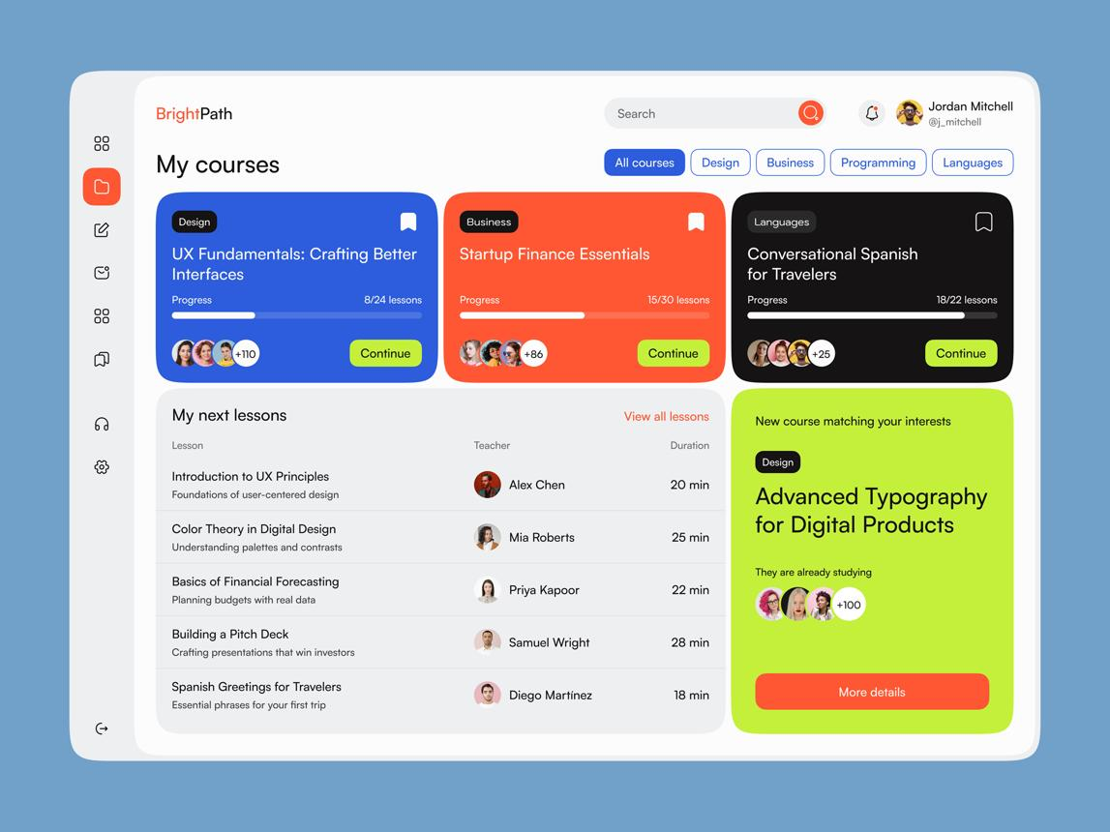
Project 8 — EDVENT course portal
Capstone
Combine routing, authentication integration, course management, forms, API data, responsive design, testing, and deployment.

Additional project ideas
- Personal portfolio built with React
- Quiz and examination application
- Expense tracker
- Notes application with search
- Movie or book discovery app
- GitHub profile explorer
- Job listing portal
- Multi-step registration system
- Real-time chat frontend
- Kanban task board
- E-commerce admin dashboard
- Full-stack MERN student management system
For the capstone, students should use GitHub, write a proper README, deploy the application, document known limitations, and demonstrate the application working.

33. Recommended React.js learning roadmap
Stage | Topics | Suggested duration
1 | Environment setup, JSX, components | 1 week
2 | Props, lists, conditional rendering | 1 week
3 | State, events, useState | 1–2 weeks
4 | Hooks, Effects, refs, lifecycle concepts | 2 weeks
5 | Forms and validation | 1 week
6 | React Router | 1 week
7 | API integration and async data | 1–2 weeks
8 | Context and state management | 1–2 weeks
9 | Custom Hooks and advanced rendering | 1–2 weeks
10 | Performance, accessibility, testing | 2 weeks
11 | TypeScript and production tooling | 1–2 weeks
12 | Framework concepts and capstone | 2–4 weeks
Estimated total: approximately 16–22 weeks for a thorough course, depending on prior JavaScript knowledge, daily practice, and project complexity.

34. React.js mastery tracker
Mark each topic complete after you can explain it, implement it, and debug a practical example.

React course progress
0 of 34 items completed

0%

Core React
Development setup and JSX
Components and composition
Props and children
Conditional rendering and lists
State and event handling

Hooks and forms
useState and immutable updates
useEffect and cleanup
useRef and useContext
useReducer
Controlled forms and validation
Custom Hooks

Navigation and data
React Router and dynamic routes
Fetch API and async/await
CRUD operations
Loading, error, and empty states
Context and global state
Redux Toolkit or an alternative

Advanced React
Rendering and reconciliation
Memoization and performance
Suspense and lazy loading
Portals and advanced component patterns
TypeScript with React
Server rendering and framework concepts

Quality and production
Testing with React Testing Library
End-to-end testing
Accessibility
Security and error handling
Git and GitHub
Build and deployment

Projects
Component-based website
To-do application
API-powered application
CRUD management system
Complete EDVENT course portal
ResetCopy checklist

35. Official React learning resources
- React official documentation — Learn React
- React API reference — Components, Hooks, and APIs
- React Router — Routing documentation
- Vite — Project setup and build guide
- Redux Toolkit — State management guide
- TanStack Query — Data fetching and caching
- React Testing Library — Component testing guide
- TypeScript with React — TypeScript and JSX

Final recommendation for EDVENT
Organize your React course into four levels:
- React Foundation: JSX, components, props, lists, conditional rendering, state, and events.
- React Application Development: Hooks, forms, routing, APIs, Context, and state management.
- Advanced React: custom Hooks, performance, TypeScript, testing, accessibility, security, and framework concepts.
- Portfolio and Full-Stack Preparation: complete projects, GitHub, deployment, and integration with Node.js, Express, and MongoDB.
The key prerequisite is strong JavaScript. Students should understand array methods, object destructuring, modules, closures, promises, async/await, and API handling before beginning React. They do not need to master every advanced JavaScript topic first, but weak fundamentals will make Hooks, state updates, and asynchronous data flows significantly harder to understand.

Complete Next.js Master Syllabus — Beginner to Advanced
This syllabus is designed for EDVENT’s frontend and full-stack development curriculum, continuing from HTML, CSS, JavaScript, and React.js. It progresses from Next.js fundamentals to the App Router, layouts, routing, Server and Client Components, data fetching, caching, mutations, authentication, SEO, testing, performance, and production deployment.
The curriculum focuses on the modern Next.js App Router. The older Pages Router is included later so students can understand legacy projects and existing codebases.

Learning target
Build production-ready websites, dashboards, and full-stack applications using React and Next.js.
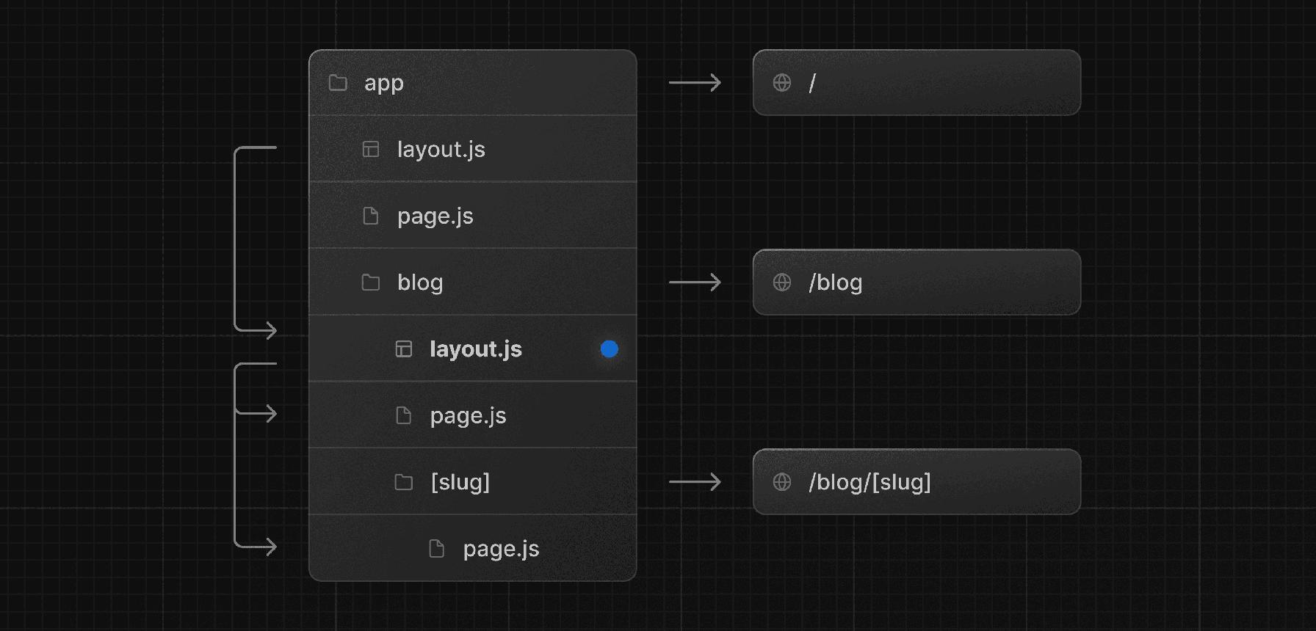
Core focus
File-based routing, Server Components, data fetching, caching, server-side mutations, and rendering strategies.

1. Introduction to Next.js
Level: Beginner — React prerequisite required

1.1 Next.js fundamentals
- What Next.js is
- Why Next.js was developed
- Next.js as a React framework
- React library versus Next.js framework
- What Next.js adds to React
- Client-side rendering versus server-side rendering
- Static rendering and dynamic rendering
- Full-stack web development with Next.js
- Single-page applications versus multi-page navigation
- Advantages, limitations, and trade-offs of Next.js

1.2 Next.js ecosystem
- React and React DOM
- App Router
- Server Components and Client Components
- React Server Functions and Server Actions
- Routing and layouts
- Data fetching and caching
- Metadata and SEO
- Image and font optimization
- Route handlers
- Middleware and request interception concepts
- Deployment platforms and server runtimes

1.3 Prerequisites
Students should understand:
- HTML semantic elements and forms
- CSS, Flexbox, Grid, and responsive design
- JavaScript ES6+ syntax
- Functions, arrays, objects, and destructuring
- Promises and async/await
- React components, props, state, and Hooks
- React Router concepts
- HTTP, JSON, and REST APIs
- Git and GitHub fundamentals
- Basic Node.js and npm usage
Recommended: Complete the React fundamentals syllabus before starting Next.js. Students can learn React Server Components and framework-specific rendering patterns more effectively once they understand ordinary React components and Hooks.

2. Development environment and project setup

2.1 Installing the environment
- Installing a supported Node.js version
- npm, pnpm, and yarn overview
- Installing VS Code
- Using the terminal
- Understanding package managers
- Creating a Next.js project
- Selecting JavaScript or TypeScript
- Selecting a linter
- Setting up CSS and styling options
- Choosing the App Router
- Understanding project setup options

2.2 Creating a project
- Using create-next-app
- Understanding the generated project
- Running the development server
- Production build and start commands
- Understanding development versus production behavior
- Hot Module Replacement and Fast Refresh
- Environment configuration
- Reading compilation errors

2.3 Project structure
- app/
- public/
- src/ when used
- package.json
- next.config.js or next.config.ts, depending on the project
- tsconfig.json
- ESLint configuration
- CSS files
- Environment files
- Route files and shared components
- Build output and generated files

2.4 Development tools
- Browser DevTools
- React Developer Tools
- Next.js development indicators
- Terminal logs
- Network inspection
- Server-side versus browser-side error messages
- Debugging TypeScript
- Debugging hydration errors

3. Next.js project architecture

3.1 App Router fundamentals
- What the App Router is
- The app directory
- File-system-based routing
- Routes versus components
- Pages and layouts
- Shared UI
- Nested routes
- Route groups
- Private folders
- Organizing code by feature
- Shared components outside route files

3.2 Important special files
- page.js / page.tsx
- layout.js / layout.tsx
- template.js / template.tsx
- loading.js / loading.tsx
- error.js / error.tsx
- not-found.js / not-found.tsx
- global-error.js / global-error.tsx
- route.js / route.ts
- default.js for supported parallel route use cases
- icon and favicon files
- opengraph-image and related metadata image files

3.3 Architecture best practices
- Separating routes from business logic
- Reusable UI components
- Feature-based organization
- Data access layers
- Utility functions
- Server-only modules
- Client-only modules
- Avoiding circular dependencies
- Keeping secrets out of browser bundles
- Avoiding unnecessarily large components

4. File-based routing

4.1 Basic routing
- Creating a homepage
- Creating static routes
- Route URLs and file names
- Nested route folders
- Route segments
- Pages inside nested folders
- Shared layout behavior
- Handling missing routes

4.2 Dynamic routes
- [slug]
- [id]
- Dynamic route parameters
- Multiple dynamic segments
- Reading route parameters
- Generating pages for products and courses
- Route parameter validation
- Static generation for dynamic paths

4.3 Catch-all routes
- [...slug]
- [[...slug]]
- Catch-all parameters
- Optional catch-all segments
- Documentation and category routes
- Handling unknown paths

4.4 Route groups and private folders
- (groupName)
- Sharing layouts without changing URLs
- Organizing marketing and dashboard routes
- Private folders such as _components
- Keeping implementation details separate from URL structure

4.5 Route conflicts and URL design
- Static versus dynamic routes
- Route specificity
- Conflicting route segments
- Case sensitivity and URL conventions
- Trailing slash configuration
- Canonical URLs
- Clean and descriptive URL structures
Practical project: Build routes for an EDVENT website with home, courses, course details, instructors, about, contact, and student dashboard pages.

5. Layouts, templates, and shared UI

5.1 Root layout
- Creating app/layout.tsx
- The required root layout structure
- HTML and body elements
- Global CSS imports
- Root metadata
- Shared navigation and footer
- Site-wide providers
- Root-level configuration
- Font setup

5.2 Nested layouts
- Layouts inside route folders
- Shared UI across related routes
- Nested layout composition
- Layout persistence during navigation
- Avoiding unnecessary repeated rendering
- Layouts for dashboards and marketing pages
- Authentication-specific layouts
- Multiple root layouts and their implications

5.3 Layout versus template
- layout.tsx versus template.tsx
- State preservation in layouts
- Template remounting behavior
- When a template is useful
- Navigation and component lifecycle implications

5.4 Shared interface components
- Header and navigation
- Footer
- Sidebar
- Breadcrumbs
- Search bar
- Reusable cards
- Dashboard shell
- Course catalogue layout
- Responsive navigation
- Shared components across route groups

6. Server Components and Client Components
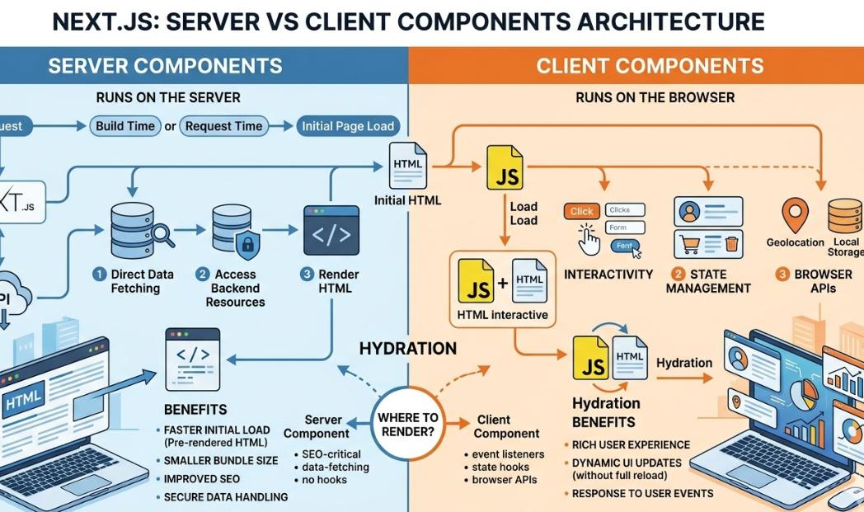
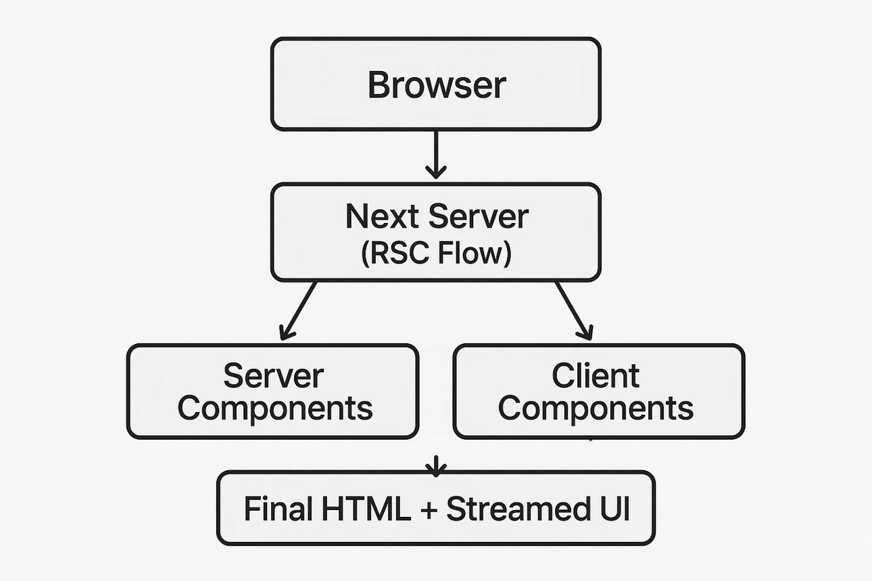
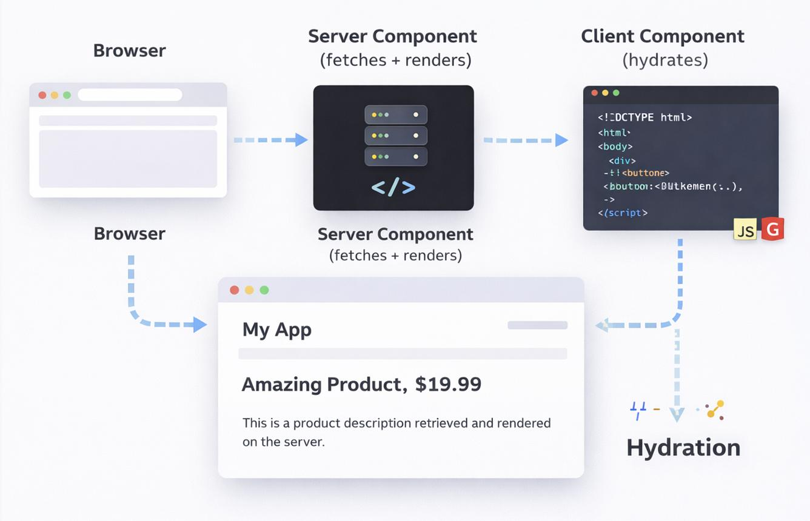
9
This is one of the most important sections of the course.

6.1 React Server Components in Next.js
- What Server Components are
- Why the App Router uses Server Components by default
- Server rendering and component execution
- Rendering output versus sending JavaScript to the browser
- Accessing server-side data
- Keeping private logic on the server
- Server Component limitations
- Why browser APIs cannot be used directly in Server Components
- Why interactive Hooks cannot be used directly in Server Components

6.2 Client Components
- The 'use client' directive
- Defining a client boundary
- State and event handlers
- Browser APIs
- Client-side Hooks
- Interactive forms
- Browser-side storage
- Third-party interactive libraries
- Bundle size implications
- Client-side hydration

6.3 Mixing Server and Client Components
- Server Components importing Client Components
- Passing serializable props across the boundary
- Passing Server Component content as children
- Client Components containing Server Component output
- Why importing a Server Component into a Client Component changes the execution boundary
- Keeping client boundaries small
- Avoiding unnecessary 'use client' directives
- Server-side data preparation for interactive components

6.4 Common errors and limitations
- Using useState in a Server Component
- Using useEffect in a Server Component
- Passing non-serializable values across boundaries
- Accessing window or document during server rendering
- Hydration mismatches
- Using server-only packages in client code
- Accidentally exposing secrets
- Debugging server and client errors separately

6.5 Practical exercises
- Server-rendered course catalogue
- Client-side search box
- Interactive course filter
- Server-rendered product details
- Client-side shopping cart button
- Small client boundary inside a mostly server-rendered page

7. Rendering strategies

7.1 Client-side rendering (CSR)
- Browser-side rendering
- Initial HTML and JavaScript
- Hydration
- Client-side navigation
- Benefits and limitations
- Suitable use cases

7.2 Server-side rendering (SSR)
- Server-rendered HTML
- Request-time rendering
- Dynamic data
- Personalised pages
- Server response lifecycle
- Trade-offs involving latency and server resources

7.3 Static rendering and pre-rendering
- Build-time rendering
- Static HTML output
- Pre-rendered routes
- Static generation of dynamic routes
- generateStaticParams()
- Static content delivery
- Revalidation and freshness

7.4 Dynamic rendering
- Request-time data
- Cookies and headers
- Personalised content
- Dynamic route behavior
- Runtime dependencies
- Understanding when a route must be dynamic
- Version-dependent rendering and caching behavior

7.5 Streaming and partial rendering
- Streaming HTML
- Suspense boundaries
- Rendering independent sections
- Fast shell rendering
- Slow data sections
- Streaming fallback UI
- Avoiding unnecessary blocking
- Understanding framework support for streaming

7.6 Choosing the correct strategy
- Static content websites
- Blogs and documentation
- Product catalogue
- Personalised dashboard
- Authenticated account pages
- Live or frequently changing data
- Balancing performance, freshness, and infrastructure cost

8. Data fetching in Next.js

8.1 Server-side data fetching
- Fetching data inside async Server Components
- Using the Fetch API on the server
- Reading data from a database
- Calling internal service functions
- Fetching external APIs
- Handling loading and error states
- Returning serializable data
- Keeping database credentials server-side

8.2 Client-side data fetching
- Fetching from Client Components
- useEffect with fetch requests
- Loading indicators
- Error handling
- Request cancellation
- Avoiding race conditions
- Refreshing data after user interactions
- Client-side polling concepts

8.3 Data-fetching libraries
- TanStack Query
- SWR
- Client-side caching
- Revalidation
- Optimistic updates
- Server prefetching concepts
- Hydration of cached data
- Choosing a data-fetching strategy

8.4 Parallel and sequential data fetching
- Sequential requests
- Parallel requests with Promise.all()
- Independent versus dependent data
- Avoiding request waterfalls
- Handling partial failures
- Fetching multiple dashboard datasets efficiently

8.5 Data access architecture
- Service modules
- Repository patterns
- Data access functions
- Server-only modules
- Database queries
- Data validation
- Error normalization
- Reusing data access logic
- Avoiding duplicated API calls where practical

8.6 Practical project
Build a course detail page that fetches course information, instructor details, reviews, and related courses. Load independent data concurrently and handle missing or failed records appropriately.

9. Caching and revalidation
Caching behavior is particularly important in Next.js because the exact defaults and APIs have changed across major versions. Students should learn the model for the installed version rather than assume all fetch requests are cached identically.

9.1 Caching fundamentals
- What caching is
- Browser cache versus server cache
- HTTP caching
- Data caching
- Rendered route output
- Request memoization
- Cache keys
- Cache freshness
- Cache invalidation
- Stale data and consistency

9.2 Next.js caching concepts
- Request memoization
- Data Cache concepts
- Full Route Cache concepts
- Router Cache concepts
- Static and dynamic rendering interactions
- Request-time data
- Cache boundaries
- Version-specific defaults
- How caching affects navigation and data freshness

9.3 Revalidation
- Time-based revalidation
- On-demand revalidation
- revalidatePath()
- revalidateTag()
- updateTag() in supported versions
- Cache tags
- Route-level revalidation settings
- Revalidating after data mutations
- Choosing revalidation intervals
- Avoiding stale dashboard data

9.4 Cache strategies
- Cache-first
- Network-first
- Time-based freshness
- On-demand invalidation
- Public versus personalised data
- Avoiding shared caching of user-specific content
- Cache invalidation after course updates
- Understanding cache behavior across deployment environments

9.5 Practical exercises
- Cached public course catalogue
- Revalidate after creating a course
- Update a course and refresh affected pages
- Compare cached and uncached data
- Test stale data behavior
- Verify personalised content is not leaked between users

10. Loading states, error handling, and Suspense

10.1 Loading UI
- loading.tsx
- Route-level loading states
- Suspense boundaries
- Fallback UI
- Loading skeletons
- Streaming content
- Loading nested sections independently
- Avoiding layout shifts

10.2 Error handling
- error.tsx
- Error boundaries
- Route-level failures
- Resetting an error boundary
- global-error.tsx
- Handling server-side errors
- User-friendly fallback messages
- Logging errors without leaking sensitive data

10.3 Not-found handling
- not-found.tsx
- notFound()
- Missing records
- Invalid course IDs
- Unknown URLs
- Custom 404 page
- Not-found behavior for nested routes

10.4 Robust asynchronous UI
- Slow APIs
- Partial data failures
- Retry controls
- Cancelled requests
- Empty results
- Network failures
- Error versus not-found distinctions
- Graceful degradation

11. Navigation and redirects

11.1 Navigation components
- Link
- Prefetching concepts
- Client-side navigation
- Dynamic links
- Active navigation styles
- Shared layouts during navigation
- Navigation between nested routes

11.2 Programmatic navigation
- useRouter()
- usePathname()
- useSearchParams()
- useParams()
- router.push()
- router.replace()
- router.back()
- router.refresh()
- Query parameter updates
- Browser history behavior

11.3 Redirects and access flows
- redirect()
- permanentRedirect()
- notFound()
- Configuration-based redirects
- Redirecting after form submission
- Redirecting after login
- Avoiding redirect loops
- Handling return URLs safely

11.4 URL state
- Query strings
- URLSearchParams
- Search and filters in the URL
- Pagination state
- Shareable filtered pages
- Preserving query parameters
- Canonical URLs
- Avoiding unnecessary client state duplication

12. Server Actions and mutations

12.1 Server Actions fundamentals
- What Server Actions are
- The 'use server' directive
- Server-side functions triggered by user actions
- Calling actions from forms
- Invoking actions from Client Components
- Server execution and data boundaries
- Returning results and validation errors

12.2 Form submissions
- Native form actions
- FormData
- Extracting submitted values
- Validating server-side input
- Handling validation errors
- Pending states
- Success messages
- Redirecting after submission
- Progressive enhancement concepts

12.3 Mutation Hooks and patterns
- useActionState
- useFormStatus
- useOptimistic
- Pending UI
- Optimistic updates
- Rollback and failure handling
- Handling repeated submissions
- Idempotency concepts
- Separating validation from database writes

12.4 Database mutations
- Creating a course
- Updating course details
- Deleting records
- Creating a student enrolment
- Updating attendance
- Saving profile information
- Verifying permissions
- Revalidating affected routes or tags
- Returning structured errors

12.5 Security considerations
- Treat Server Actions as server entry points
- Validate all input on the server
- Authenticate the current user
- Authorize every protected operation
- Avoid trusting client-supplied user IDs or roles
- Protect against abuse and repeated requests
- Keep database access and secrets on the server
Practical project: Build a course management dashboard with create, edit, delete, and enrolment operations using server-side validation and appropriate cache revalidation.

13. Route Handlers and building APIs

13.1 Route Handler fundamentals
- What Route Handlers are
- route.ts and route.js
- Route Handler location and conventions
- Request and response objects
- The Web Request and Response APIs
- JSON responses
- Status codes
- Headers
- Query parameters
- Dynamic route parameters
- Error responses

13.2 HTTP methods
- GET
- POST
- PUT
- PATCH
- DELETE
- OPTIONS
- HEAD and its implementation considerations
- Request validation
- Method handling
- Consistent response formats

13.3 API implementation
- Creating a courses API
- Listing courses
- Retrieving a course by ID
- Creating records
- Updating records
- Deleting records
- Pagination
- Search and filtering
- Sorting
- Request body parsing
- Input validation
- Error handling

13.4 Advanced API topics
- Authentication and authorization
- Rate limiting concepts
- CORS configuration
- File upload endpoints
- Webhook handling
- Request size limitations
- API versioning concepts
- Logging
- Idempotency
- Database transactions
- Avoiding sensitive information in API responses

13.5 Route Handlers versus Server Actions
- APIs for external clients
- Server Actions for application mutations
- Reusable server-side business logic
- When to use each approach
- Avoiding unnecessary internal HTTP calls
- Calling shared server functions directly when appropriate
Practical project: Build a REST API for courses, students, and enrolments, with validation, pagination, authorization, and consistent error responses.

14. Database integration

14.1 Database fundamentals
- Relational versus document databases
- Tables and collections
- Records and documents
- Primary and foreign keys
- Relationships
- Indexes
- Queries
- Transactions
- Connection pooling concepts

14.2 MongoDB with Next.js
- MongoDB Atlas
- Connection strings
- Environment variables
- Database client configuration
- Connecting from server-side code
- CRUD operations
- Object IDs
- Schema validation concepts
- Handling connection reuse
- Avoiding repeated database connections

14.3 SQL database integration
- PostgreSQL or MySQL
- Database drivers
- ORM concepts
- Prisma
- Drizzle ORM
- Schema definitions
- Migrations
- Relationships
- Querying records
- Transactions
- Type-safe data access

14.4 Data access architecture
- Separating database logic from UI
- Server-only database modules
- Data access functions
- Repository patterns
- Validating IDs and inputs
- Handling missing records
- Normalizing database errors
- Avoiding N+1 queries
- Avoiding unnecessary data transfer

14.5 Practical database project
Create a student and course management system with:
- Students
- Courses
- Instructors
- Enrolments
- Attendance
- Payment records
- Search and pagination
- Role-based access
- Data validation and error handling

15. Authentication and authorization

15.1 Authentication fundamentals
- Authentication versus authorization
- Login and registration
- Password hashing
- Sessions
- Cookies
- Token-based authentication
- Secure logout
- Expired sessions
- Account recovery concepts
- Identity provider integration

15.2 Authentication libraries
- Auth.js concepts
- OAuth and OpenID Connect
- Google sign-in concepts
- Credentials-based login
- Session storage strategies
- Authentication callbacks
- Provider configuration
- Version-specific library setup

15.3 Session and cookie security
- HttpOnly
- Secure
- SameSite
- Cookie expiration
- Session invalidation
- CSRF protection concepts
- Session rotation concepts
- Avoiding sensitive tokens in localStorage
- Avoiding session leakage

15.4 Authorization
- Protected pages
- Role-based access control
- Admin and student roles
- Permission checks in Server Components
- Permission checks in Server Actions
- Permission checks in Route Handlers
- Database-level access patterns
- Preventing direct URL access to protected data
- Revalidating permissions for sensitive operations

15.5 Practical project
Build an EDVENT portal with student, instructor, and admin roles, secure sessions, protected dashboards, and server-side authorization.

16. Middleware and request interception

16.1 Middleware concepts
- Request interception
- Middleware file conventions
- Matching routes
- Reading request information
- Redirects and rewrites
- Request and response headers
- Cookie handling
- Excluding static assets
- Middleware execution considerations

16.2 Common use cases
- Redirecting old URLs
- Locale routing
- Request logging
- Lightweight access checks
- Adding headers
- Rewriting routes
- Basic bot or abuse filtering concepts

16.3 Important limitations
- Middleware is not a substitute for authorization inside protected operations
- Database access may be inappropriate or unsupported in some runtimes
- Middleware naming and runtime support are version-dependent
- Keep middleware lightweight
- Avoid duplicated or expensive checks
- Understand deployment runtime constraints
Practical exercise: Add locale-aware routes and redirects to an educational website.

17. SEO and metadata

17.1 Metadata fundamentals
- Why SEO matters
- Static metadata
- The metadata export
- The generateMetadata() function
- Page titles
- Title templates
- Meta descriptions
- Canonical URLs
- Robots directives
- Open Graph metadata
- Social sharing previews
- Twitter/X card metadata

17.2 Metadata for dynamic pages
- Course-specific titles
- Product descriptions
- Dynamic Open Graph images
- Metadata from database records
- Fallback metadata
- Parent and child metadata merging
- Avoiding duplicate titles
- Metadata generation and caching considerations

17.3 SEO technical files
- robots.txt
- sitemap.xml
- robots.ts
- sitemap.ts
- Favicons
- Web manifests
- Canonical links
- Structured data
- JSON-LD
- Breadcrumb structured data
- Course and organization schema where appropriate

17.4 Search visibility
- Semantic HTML
- Crawlable navigation
- Server-rendered content
- Internal links
- Descriptive URLs
- Pagination and canonicalization
- Redirects
- Not-found responses
- Avoiding duplicate content
- Indexing controls

17.5 SEO validation
- Inspecting page source
- Search Console concepts
- Testing structured data
- Checking social previews
- Auditing canonical URLs
- Checking robots directives
- Validating sitemaps
- Monitoring indexing issues

18. Images, fonts, and asset optimization

18.1 Image optimization
- next/image
- Image width and height
- Responsive image sizing
- sizes
- Local images
- Remote images
- Remote image configuration
- Image priority and loading behavior
- Lazy loading
- Preventing layout shifts
- Image quality and format considerations
- Responsive image performance

18.2 Image configuration and security
- Allowed remote hosts or patterns
- Image optimization settings
- Untrusted remote image sources
- Signed URLs and protected assets
- Image loader concepts
- CDN integration
- When to use a plain HTML image element

18.3 Font optimization
- next/font
- Local fonts
- Google Fonts integration
- Font subsets
- Font weights
- Variable fonts
- Font fallbacks
- Reducing layout shifts
- Font loading performance

18.4 Static assets
- The public directory
- Importing assets
- SVG files
- Favicons
- Logos
- Videos
- Downloadable files
- Cache headers
- Asset organization

19. Styling Next.js applications

19.1 CSS fundamentals in Next.js
- Global CSS
- CSS Modules
- Component-specific styling
- Global resets
- CSS variables
- Responsive styling
- Theme systems
- Shared design tokens

19.2 Styling frameworks
- Tailwind CSS
- Sass/SCSS
- CSS-in-JS concepts
- UI component libraries
- Material UI
- shadcn/ui
- Radix UI
- Component theming
- Design systems
- Choosing a styling strategy

19.3 Responsive and accessible design
- Mobile-first layouts
- Flexbox and Grid
- Responsive navigation
- Accessible forms
- Focus indicators
- Keyboard navigation
- Reduced motion
- Color contrast
- Responsive image and content behavior

19.4 Theme management
- Light and dark modes
- CSS custom properties
- Theme preference persistence
- System color scheme
- Hydration-safe theme initialization
- Avoiding theme flashes
- Theme switching in Client Components

20. Environment variables and configuration

20.1 Environment variables
- .env files
- .env.local
- Development and production environments
- Server-side variables
- NEXT_PUBLIC_ variables
- Why public variables can be exposed to the browser
- Secrets and API keys
- Environment-specific configuration
- Validating required environment variables

20.2 Next.js configuration
- next.config.js and next.config.ts support according to version
- Redirects
- Rewrites
- Headers
- Image configuration
- Build configuration
- TypeScript configuration
- Linting configuration
- Base paths and deployment paths
- Trailing slash behavior
- Experimental features and compatibility risks

20.3 Deployment configuration
- Production environment variables
- Preview environments
- Database connection strings
- Public API URLs
- Secure secret management
- Configuration validation
- Avoiding secrets in Git
- Differences between build-time and runtime configuration

21. Performance optimization

21.1 Core Web Vitals
- Largest Contentful Paint (LCP)
- Interaction to Next Paint (INP)
- Cumulative Layout Shift (CLS)
- Measuring real-user performance
- Lab data versus field data
- Performance budgets
- Prioritizing high-impact improvements

21.2 Rendering optimization
- Reducing unnecessary Client Components
- Minimizing JavaScript sent to the browser
- Server Component boundaries
- Streaming slow sections
- Avoiding request waterfalls
- Static rendering where appropriate
- Caching and revalidation
- Efficient database access
- Avoiding oversized page payloads

21.3 Asset optimization
- Image optimization
- Font optimization
- Code splitting
- Dynamic imports
- Third-party script management
- Lazy loading
- Reducing unused CSS
- Optimizing dependencies
- Bundle analysis

21.4 Measurement and debugging
- Lighthouse
- Browser Performance panel
- Network waterfalls
- React DevTools Profiler
- Production monitoring
- Slow server request analysis
- Cache verification
- Hydration performance
- Measuring before and after changes

22. Security in Next.js applications

22.1 Application security
- Cross-site scripting (XSS)
- Cross-site request forgery (CSRF)
- SQL injection
- NoSQL injection
- Open redirects
- Insecure direct object references
- Authentication failures
- Authorization failures
- Dependency vulnerabilities

22.2 Secure implementation
- Server-side input validation
- Output encoding
- Safe HTML rendering
- Avoiding unsafe dangerouslySetInnerHTML
- Parameterized database queries
- Validating IDs and permissions
- Secure cookies
- Protecting Server Actions
- Protecting Route Handlers
- Rate limiting
- Avoiding sensitive error messages

22.3 Security configuration
- Content Security Policy (CSP)
- Security headers
- HTTPS
- Secret management
- Dependency auditing
- Authentication library configuration
- Logging and monitoring
- Incident response basics
Key principle: A hidden UI element or protected-looking route is not a security boundary. Validate authentication and authorization at every server-side operation that accesses or changes protected data.

23. Internationalization (i18n) and localization

23.1 Internationalization fundamentals
- Internationalization versus localization
- Multiple languages
- Locale-aware content
- Regional date and number formats
- Currency formatting
- Right-to-left layouts
- Language-specific metadata
- Locale-aware URL structures

23.2 Routing for languages
- Locale route segments
- Language prefixes such as /en/ and /hi/
- Locale detection
- Redirecting to a preferred language
- Locale-aware navigation
- Language switching
- Localized page metadata
- Fallback languages

23.3 Internationalization libraries
- next-intl
- Translation dictionaries
- Translation keys
- Interpolation
- Pluralization
- Date and number formatting
- Translation namespaces
- Missing translation handling
- Server and Client Component integration

23.4 Practical project
Create a bilingual EDVENT website with English and Hindi content, localized navigation, date and currency formatting, and language-specific metadata.

24. File uploads and media processing

24.1 Upload fundamentals
- HTML file inputs
- FormData
- Uploading through Route Handlers
- Uploading through Server Actions where appropriate
- File size limits
- MIME types
- File extension validation
- Handling upload errors
- Progress indicators and client-side upload requests

24.2 Secure file handling
- Never trusting the filename or client-provided MIME type alone
- Server-side validation
- File size limits
- Storage permissions
- Malware scanning concepts
- Safe filename generation
- Private versus public files
- Access-controlled downloads

24.3 Storage options
- Local disk limitations in serverless deployments
- Object storage concepts
- Amazon S3
- Cloudinary
- Uploadthing concepts
- Signed upload URLs
- CDN delivery
- File deletion and lifecycle policies

24.4 Practical project
Build a student document submission workflow with file validation, secure storage, upload status, and protected downloads.

25. Real-time features and external integrations

25.1 Real-time communication
- Polling
- Server-Sent Events (SSE)
- WebSockets
- Real-time notifications
- Connection lifecycle
- Reconnection handling
- Authentication for real-time connections
- Hosting limitations and infrastructure considerations

25.2 Third-party integrations
- Payment gateway concepts
- Email service integration
- SMS services
- Analytics tools
- Logging and monitoring
- Maps and geolocation
- Video embedding
- CAPTCHA and bot protection
- Webhook processing

25.3 Payment integration fundamentals
- Creating payment orders on the server
- Payment provider SDKs
- Checkout redirects
- Payment status verification
- Webhook signature verification
- Idempotent payment handling
- Order records
- Failed and pending payments
- Never trusting client-reported payment success

25.4 Practical project
Create a course enrolment checkout flow using a payment provider's test environment, with server-side order creation and payment verification.

26. Pages Router — legacy and migration knowledge
The App Router should be the main learning path, but developers may encounter older Next.js applications using the Pages Router.

26.1 Pages Router fundamentals
- The pages/ directory
- File-based routes
- _app.js
- _document.js
- pages/404.js
- pages/500.js
- Dynamic routes
- API routes
- Shared layouts
- Navigation with next/link

26.2 Data fetching methods
- getStaticProps
- getStaticPaths
- getServerSideProps
- Client-side fetching
- Static versus request-time data
- Legacy API routes
- Incremental Static Regeneration concepts

26.3 App Router versus Pages Router
- app/ versus pages/
- Layouts versus _app.js
- Server Components versus the traditional page model
- Route Handlers versus API routes
- Loading and error conventions
- Data fetching differences
- Migration planning
- Coexistence considerations
- Incremental migration strategies

26.4 Migration exercises
- Migrate a static page
- Convert a shared layout
- Replace legacy data fetching
- Move an API route
- Test navigation and metadata
- Identify incompatible assumptions
- Avoid mixing conventions incorrectly

27. Testing Next.js applications

27.1 Unit and component testing
- Vitest or Jest
- React Testing Library
- Testing components
- Testing form validation
- Testing utility functions
- Testing loading and error states
- Mocking network requests
- Mocking server-dependent functions appropriately

27.2 Integration testing
- Testing Route Handlers
- Testing data access functions
- Testing Server Actions
- Database test setup
- Validation tests
- Authentication checks
- Permission tests
- Error response tests

27.3 End-to-end testing
- Playwright
- Cypress
- Testing navigation
- Testing dynamic routes
- Login and logout
- Course enrolment
- File uploads
- Checkout workflows
- Responsive behavior
- Browser console errors

27.4 Production quality
- Accessibility testing
- Security testing
- Performance testing
- Regression testing
- Build verification
- Environment configuration tests
- Deployment smoke tests
- Continuous integration concepts

28. Deployment and production operations

28.1 Deployment preparation
- Production build
- Build-time errors
- Type checking
- Linting
- Environment variables
- Database connectivity
- Asset handling
- Error monitoring
- Dependency security checks

28.2 Hosting options
- Vercel
- Node.js hosting
- Docker-based deployment
- Cloud platforms
- Static export where compatible
- CDN deployment
- Serverless deployment concepts
- Runtime and feature limitations

28.3 Production concerns
- Server logs
- Error tracking
- Database connection pooling
- Cache invalidation
- Scheduled jobs
- Background processing
- Rate limiting
- Health checks
- Rollbacks
- Database migrations
- Backup and recovery planning

28.4 CI/CD
- GitHub Actions
- Automated builds
- Automated tests
- Preview deployments
- Environment separation
- Deployment approval
- Release management
- Rollback strategy

28.5 Practical deployment exercise
Deploy a Next.js application with a database, environment variables, authentication, logging, and automated testing. Verify that the deployed application works on direct URLs as well as client-side navigation.

29. Advanced architecture and scalability

29.1 Application design
- Feature-based organization
- Domain-driven design concepts
- Separation of UI and business logic
- Shared service modules
- Data access layer
- Validation layer
- Error normalization
- Dependency boundaries
- Avoiding circular dependencies

29.2 Scaling considerations
- Database query performance
- Connection pooling
- Caching strategy
- CDN usage
- Background jobs
- Rate limiting
- Queue-based processing
- Monitoring
- Observability
- Multi-environment deployment

29.3 Reliability
- Graceful degradation
- Retry policies
- Idempotency
- Transaction boundaries
- Timeout handling
- Partial failure handling
- Circuit breaker concepts
- Structured logging
- Incident response

29.4 Architecture review exercises
- Refactor a large route
- Separate data access from UI
- Reduce duplicate API logic
- Improve permission enforcement
- Diagnose slow queries
- Review caching boundaries
- Reduce unnecessary client JavaScript

30. Complete Next.js capstone projects
Build these projects after finishing the main concepts.

Project 1 — EDVENT marketing website
Beginner to intermediate
Practice layouts, routing, metadata, responsive design, optimized images, static rendering, and contact forms.

Project 2 — Blog and documentation platform
Intermediate
Practice dynamic routes, metadata, content rendering, search, sitemap generation, and static generation.

Project 3 — E-commerce storefront
Intermediate to advanced
Practice product pages, data fetching, caching, cart state, checkout integration, and secure server-side operations.
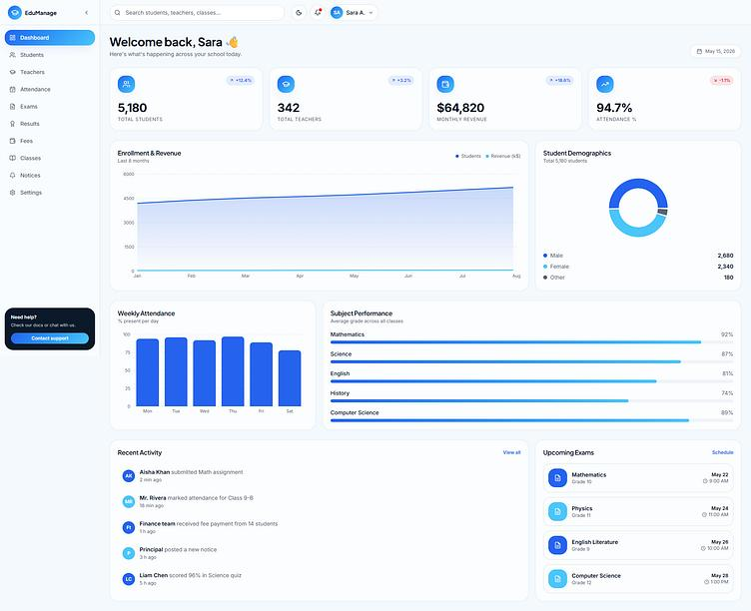
Project 4 — Student management portal
Advanced
Practice database integration, Server Actions, Route Handlers, authentication, authorization, CRUD, and testing.
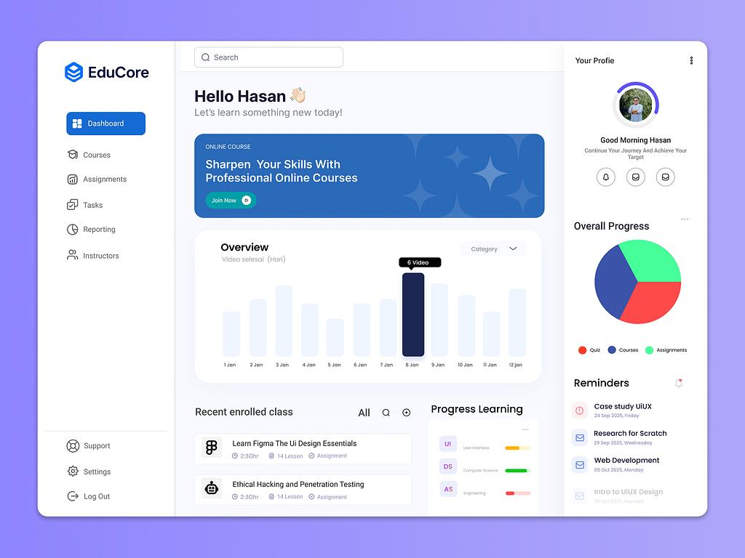
Project 5 — Full-stack learning management system
Capstone
Combine courses, lessons, enrolments, student dashboards, instructor tools, progress tracking, roles, and deployment.

Additional project ideas
- Job portal
- Real-estate listing platform
- Appointment booking system
- Customer relationship management dashboard
- Subscription-based SaaS application
- Multi-language education website
- File upload and document management portal
- Analytics dashboard with live data
- Student payment and attendance system
- Full-stack MERN application with a Next.js frontend

31. Recommended Next.js learning roadmap
Stage | Topics | Suggested duration
1 | Setup, architecture, routing, layouts | 1 week
2 | Server and Client Components | 1–2 weeks
3 | Rendering strategies and data fetching | 1–2 weeks
4 | Caching, revalidation, loading, errors | 1–2 weeks
5 | Navigation, forms, Server Actions | 1–2 weeks
6 | Route Handlers and APIs | 1 week
7 | Database integration | 1–2 weeks
8 | Authentication and authorization | 1–2 weeks
9 | Metadata, assets, and styling | 1 week
10 | Security and performance | 1–2 weeks
11 | Testing and deployment | 1–2 weeks
12 | Capstone project | 3–5 weeks
Estimated total: approximately 17–24 weeks for a thorough course, assuming students already know React and JavaScript. A learner starting from programming fundamentals will need additional time.

32. Next.js mastery tracker
Use this checklist to track progress through the course. A topic is complete when you can explain it, implement it, and debug a working example.

Course progress
0 of 32 topics completed

0%

Foundations and routing
Project setup and structure
App Router and special files
Dynamic and catch-all routes
Layouts, templates, and route groups
Navigation and URL state

React rendering architecture
Server Components
Client Components and client boundaries
Rendering strategies
Streaming and Suspense
Hydration and rendering errors

Data and mutations
Server-side and client-side data fetching
Caching and revalidation
Loading and error states
Server Actions and form submissions
Route Handlers and REST APIs
Database integration

Application security
Authentication and sessions
Authorization and roles
Server-side validation
Secure file uploads
Environment variables and secret management

Production development
Metadata and SEO
Images and font optimization
Responsive styling
Performance optimization
Testing and accessibility
Git, deployment, and CI/CD

Portfolio projects
Marketing website
Blog or documentation platform
E-commerce storefront
Student management portal
Full-stack learning management system
ResetCopy checklist

33. Official Next.js learning resources
- Next.js documentation — Complete documentation
- Next.js App Router — Routing, layouts, rendering, and data
- Next.js Learn — Step-by-step learning course
- React documentation — React fundamentals
- Next.js deployment documentation — Deployment guide
- Vercel — Hosting and deployment documentation

Final recommendation for EDVENT
Organize your Next.js course into four levels:
- Next.js Foundation: setup, App Router, routing, layouts, navigation, and project structure.
- Rendering and Data: Server Components, Client Components, rendering strategies, data fetching, caching, and revalidation.
- Full-Stack Development: Server Actions, Route Handlers, databases, authentication, authorization, SEO, security, and testing.
- Production and Capstone: performance, deployment, monitoring, and a complete learning management system.
Most important teaching priority: give extra attention to the relationship between Server Components, Client Components, data fetching, and caching. These concepts distinguish modern Next.js development from simply using React with a routing library.
Also, teach against the current stable Next.js documentation and pin the framework version used in your course. APIs and caching defaults evolve, so older tutorials may describe behavior that differs from the version students are using.

