## INTRODUCTION

Spindles are rhythmic transients present in the electroencephalogram (EEG) characteristic of stage two sleep. Though varying definitions of spindles exist in literature, the American Academy of Sleep Medicine (AASM) has standardized them by describing spindles as “oscillatory bursts on EEG, of 11-16Hz sinusoidal waves, with a duration of 0.5 to 2 seconds and a waxing and waning envelope” [1, 2].

The primary role of spindles is to aid in sleep staging [1, 2]. Recent research on spindles has found an association with various pathological phenomenon such as sleep ‘stability’, memory formation, depression, epilepsy, Parkinson, Alzheimer and schizophrenia, further raising their significance [3, 4, 5, 6, 7]. For example in [3] spindles are proposed as possible physiological markers of intellectual ability as spindle properties were found to be highly correlated with tests of intelligence such as IQ tests. The authors also discuss the role of spindles in consolidation of declarative memory by aiding the interaction between the hippocampus and the thalamus. Similarly in [5], the authors showed that grouping and density of fast spindles correlated positively with mental ability measured from standard Raven Progressive Matrices test. Authors in [6] reported a significant decrease in the power and density of spindles before epileptic seizures especially in extratemporal lobe epilepsies. Patients with schizophrenia were also found to have drastically reduced density, number and coherence of sleep spindles [7].

These analyses require accurate labelling of sleep spindles in EEG recordings, which is time-consuming and error-prone when done manually. Automated spindle detection is thus gathering increasing attention from the research community. As spindles are of sinusoidal nature, characterized by progressively increasing, then gradually decreasing amplitude, most spindle detectors utilize features best suited for sinusoidal functions such as Filter banks, Fast Fourier Transforms, Wavelets and Matching pursuit [8, 9, 10]. The accuracy of these features however decreases in higher background EEG levels causing an increase in the number of false positives. Automatic sleep spindle detection is also hindered due to fluctuations in the frequency patterns and large inter-individual variability [11, 12]. However a more significant issue in the development of accurate sleep spindle detectors is the proper training or tuning of these detectors. The broad AASM definition for sleep spindles leaves the manual marking of spindles in EEG data open to some interpretation, leading to low inter-expert agreement for spindle scoring. Thus the accuracy of sleep spindle detectors when trained and tested using data scored from a single scorer but can fall significantly when tested using data scored by other experts. This also makes it difficult to develop validated assessment criteria for automatic sleep spindle detectors to compare the performance of proposed detectors.

A number of mathematical models have been proposed to better characterize the structure of sleep spindles, thus enabling a better understanding of their structure and facilitating further analysis [13, 14, 15, 16, 17, 18]. In [14] the authors fitted autoregressive (AR) models onto EEG data and used it to analyze oscillatory patterns including spindles. The authors further expanded their work in [13] to study the temporal organization of spindles. Though spindles were detected by studying damping constants of the AR model, no physical characteristics of the spindle were modeled. A similar approach was later proposed in [15] where oscillations in EEG including spindles were detected using AR models through surrogate data testing. In [16]**,** the authors modeled the amplitude and frequency of spindles using bivariate normal distributions. The work, motivated by the widely varying values of spindle properties, used tolerance intervals of normal models to detect spindles. However it was limited to the detection of spindles and did not model intra-spindle variations of these properties.

Spindle models as above have been adequate for applications such as the detection of spindles. However, they fail to incorporate details such as the intra-spindle variation of frequencies or ‘skewness’ of the envelope. These details more than often vary with abnormalities or other factors, requiring a model that parameterizes these variations. As spindles have strong amplitude and frequency modulations, it is necessary to use non-stationary sinusoidal analysis where the amplitude and frequency are allowed to evolve within the analysis frame. In this context, Ktonas et al. [17] modelled spindles as amplitude and frequency modulated sinusoids. The model consisted of six parameters which captured the time varying microstructure of spindles. The authors also compared various time-frequency analysis methods for parameter estimation in [18] and concluded that complex demodulation provided the best results. The AM/FM model proposed however assumed a pure sinusoidal envelope for spindles, a relaxation on the waxing and wining definition.

In this paper, we propose a new Quadratic Parameter Sinusoid model for spindles that addresses the deficiencies in previous models. The model utilizes a quadratic representation to characterize the specific duration and frequency variations within spindles. The QPS model was originally used to model non-stationary speech and music [19]. Non-stationary speech frames were approximated as a sum of time varying frequency and amplitude sinusoids and spectrally analyzed using Short Time Fourier Transforms.

The rest of the paper is structured as follows. In Section 2, we define the QPS model and discuss how it parameterizes various spindle characteristics. In Section 3**,** the methodology utilized for the numerical estimation of the model parameters is explained. Section 4 summarizes the results obtained from parameter estimation on real and simulated spindles followed by discussions in Section 5.

## QUADRATIC PARAMETER SINUSOID

Sleep spindles have a waxing and waning sinusoidal form which enables them to be represented as a modulated sinusoidal whose instantaneous frequency and amplitude continuously varies with time. A sleep spindle $s\left(t\right)$ can thus be represented as

|  |  |  |
| --- | --- | --- |
|  | $s\left(t\right)= e^{A(t)}\cos{[P(t)}$] | (1) |

where $, A(t)$ represents the instantaneous logarithmic amplitude and $P\left(t\right),$ the instantaneous phase. The instantaneous frequency $F(t)$ can be obtained from the time derivative of $P\left(t\right)/2π$. Due to the non-stationary nature of EEG, both $A\left(t\right)$ and $F(t)$ are time-varying, making their determination non-trivial. For each spindle, as shown in [20], both $A(t)$ and $P(t)$ can be approximated using Taylor’s polynomials around a center time ${ t}_{c}$. $P(t)$ is given by

|  |  |  |
| --- | --- | --- |
|  | $$P(t)= \sum_{n=0}^{∞}{p_{n}{\left(t-t_{c}\right)}^{n}/n!}$$ | (2) |

where,

|  |  |  |
| --- | --- | --- |
|  | $$p_{n}=\frac{d^{(n)}P(t_{c})}{dt^{(n)}}$$ | (3) |

|  |  |  |
| --- | --- | --- |
|  |  | (4) |

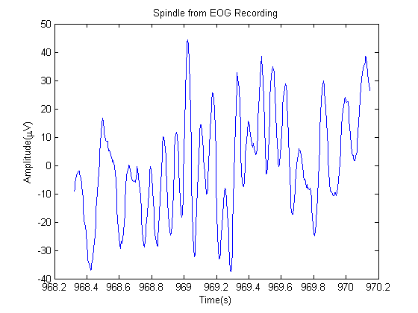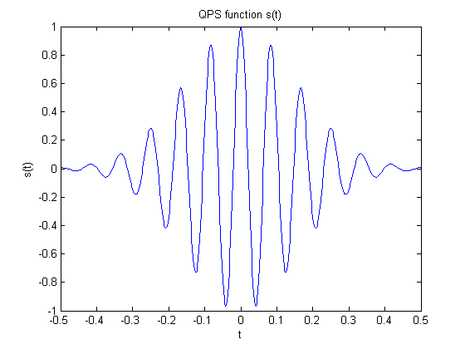 For frequency to be time-varying, there must be at least one non-zero $p_{n}$ for $n≥2$ in $P(t)$. Hence the minimum possible approximation of $P(t)$ would be as a quadratic function if the higher order terms are assumed to be negligible. $A(t)$ can similarly be represented as a quadratic function. This allows the sleep spindle to be defined as a Quadratic-Parameter Sinusoid (QPS) where

(a)

$a, b,$ $c,$ $d,$ $e$ and $f$ are the parameters of the quadratic functions $A\left(t\right)$ and $P(t)$ from (1) respectively.

As (4) gives only the real part of QPS model, the general form of $s\left(t\right)$ would be given by

|  |  |  |
| --- | --- | --- |
|  | $$s\left(t\right)= e^{(a+bt+ct^{2})}e^{i(d+ft+gt^{2})}$$ | (5) |

Figure 1(a) shows an example of a simulated spindle-like signal from the QPS model whereas Figure 1(b) shows a real spindle from a sample EEG recording. Excluding disturbances in the real-life recording, the figure shows similarities in the sinusoidal activity and the waxing and waning envelope.

(b)

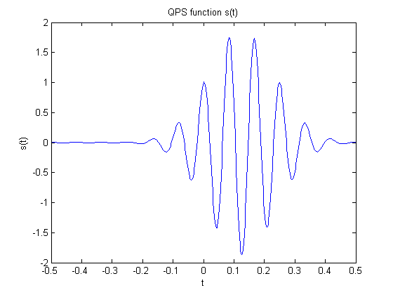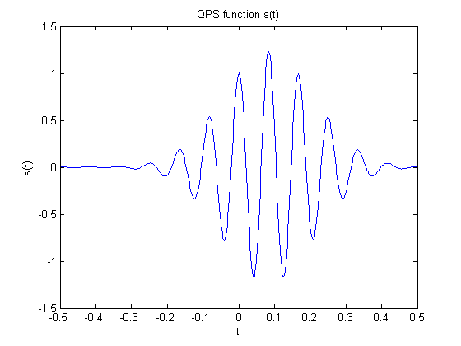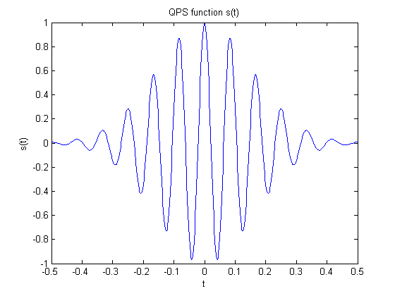The 6 parameters from $a to f$ in the QPS model determine the characteristics such as frequency, change in frequency, amplitude, variation in amplitude and the shape envelope of the signal $s(t)$. Parameters $a$, $b$ and $c$ largely determine the amplitude and the shape of the envelope of the QPS model and hence, that of the spindle. $a$ is the approximate instantaneous log-amplitude at time, $t=0$, $b$ the rate of change of amplitude and $c$, the Gaussian parameter which determines the shape and duration of the curve [21]. In symmetrical spindles, $b=0$. Negative values of $c$ causes the signal to decay, giving the spindle its rising and waning shape. When analyzing spindles on their own, $a,$ the initial amplitude offset, can be taken to be zero.

Figure 1: **(a) A simulated spindle-like signal generated using the QPS model (b) A real spindle from EEG recording.**

(b)

Figure 2: **Variation of QPS function with varying b and c (a) b = 0, c = -20 (b) b = 5, c = -30 (c) b = 10, c = -40**

(c)

(a)

Figure 2(a), (b) and (c) illustrates the variations in amplitude of s(t) caused by increasing values of $b$ and decreasing values of $c$. The remaining three parameters $d$, $e$ and $f$ influence the frequency characteristics and phase of the signal. $d$ represents the initial phase at $t=0$. The initial frequency of the signal is given by $e$, whereas $f$ represents the frequency rate change [20]. For a spindle, in the absence of drastic variations, parameter $e$ determines the dominant spindle frequency and $f$ enables a linear variation of this frequency within the spindle duration. The initial phase $, d,$ can be assumed to be zero when analyzing spindles on their own, similar to $a$. Figure 3 (a), (b) and (c) show the variation in spindle frequency with increasing $e$ and $f$.

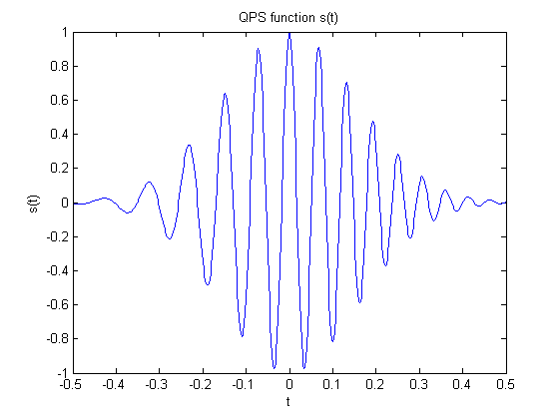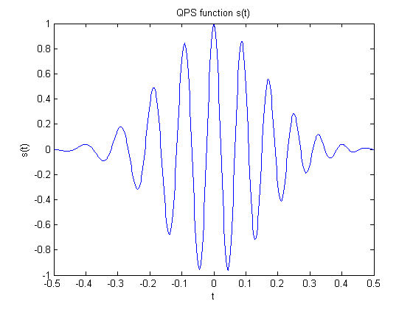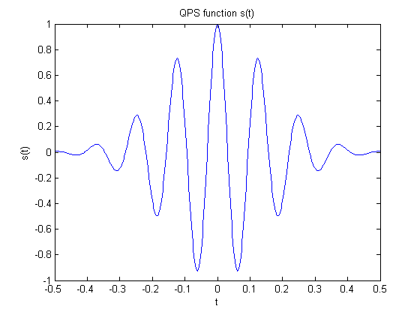

Figure 3: **Variation of QPS function with varying e and f (a) e = 50, f = 0 (b) e = 70, f = 20 (c) e = 90, f = 40**

(a)

(a)

(c)

(c)

(b)

(b)

## METHODOLOGY

The highly nonlinear structure of the QPS signal makes parameter estimation of a QPS model for a real spindle non-trivial. We used non-linear least square (NLLS) estimation using the ‘Levenberg-Marquardt’ technique to obtain the parameters for the QPS model due to its relative simplicity and dependability.

NLLS estimation algorithms are iterative numerical methods which attempt to converge towards optimal parameter values by successively minimizing a sum of squares cost function. The ‘Levenberg-Marquardt’ technique utilized in this work is a standard NLLS implementation which adaptively varies the parameter update between Gradient-descent and Gauss-Newton methods using a damping factor. If an iteration results in a large reduction of the cost, the damping factor is decreased bringing the algorithm closer to Gauss-Newton approach. On the other hand, if an iteration produces negligible cost reduction, the damping factor is increased to mimic a more Gradient-descent strategy. Like all NLLS algorithms, the algorithm can converge to local minima and is heavily dependent on the initial conditions. In our work, convergence was ensured by initializing the parameters to spindle-like values and applying known constraints.

The accuracy of our estimation algorithm was validated by generating simulated spindles with known parameter values as given in Table 1 on page 7. Artificial spindles simulated from the QPS model provided a reference to quantify estimation errors in the estimated parameters from NLLS. As spindles are often superimposed with background EEG noise, we also tested the noise rejection capabilities of the NLLS on generated sleep spindles with different levels of additive noise. White additive noise (representative of background EEG) with a wide ranging SNR values were added to each of these spindles. The parameters of the resulting noisy QPS model were obtained by using NLLS and compared with the actual parameter values of simulated QPS signals.

The NLLS algorithm was then tested on actual spindles from MASS (Montreal Archive of Sleep Studies) database [22]. This database includes about 1700 hours of PSG recording sampled at 256 Hz [22]. EEG recordings were retrieved from 18 patients from a subset of MASS database (MASS-C1/SS2). The patients from this subset comprised of 11 women and 8 men with a mean age of 24.3 and 23.2 years respectively and an age range of 18 – 33 years [22]. Spindles were isolated from the EEG recordings using the annotations of an expert scorer.

The QPS model was tested on 18 patients. Each patient was discerned by using a unique id and henceforth, patients will be referred to using a patient id (such as patient 1, patient 2, patient 3 and so on). Due to the variation in the amount of spindles present in each patient’s recording, the QPS model was tested on 97-500 spindles per patient. The validity of QPS model was evaluated by computing the error in frequency and error in energy as seen in section []. Further evaluation was carried out by observing the variation of error in energy and frequency across multiple patients. To develop a better understanding of the xx trends, we also studied the distribution of parameter values across patients. Finally, in order to correlate the results from a real spindle with a simulated spindle, we discerned the significance of each parameter and evaluated these results with the results obtained from a simulated spindle.

## RESULTS

## Parameter estimation of simulated spindles with noise

White Gaussian noise was added to the simulated spindle in Figure 1(a) at an SNR of 10. The parameters of the resultant signal were then estimated using the NLLS algorithm. Both the true and estimated parameter values are given in Table 1. As seen, the estimated parameters are approximately equal to the true values with a narrow confidence interval. Figure 4 illustrates the estimated signal (shown in red) superimposed on the noisy signal (shown in blue). The resultant signal obtained from the estimated parameters is smoother than the simulated spindle with noise suggesting that the NLLS has also significantly reduced the noise level.

|  |  |  |  |
| --- | --- | --- | --- |
| Parameter | True Value | Estimated Value | Confidence Bounds |
| a | 0 | 0.003995 | (-0.01843, 0.02642) |
| b | 0 | 0.01055 | (-0.1505, 0.1716) |
| c | -20 | -19.35 | (-20.35, -18.35) |
| d | 0 | -0.01817 | (-0.0406, 0.004255) |
| e | 75 | 75.03 | (74.87, 75.19) |
| f | 0 | 0.6464 | (-0.3566, 1.649) |
| Table 1: True and estimated parameters for a simulated spindle | | | |

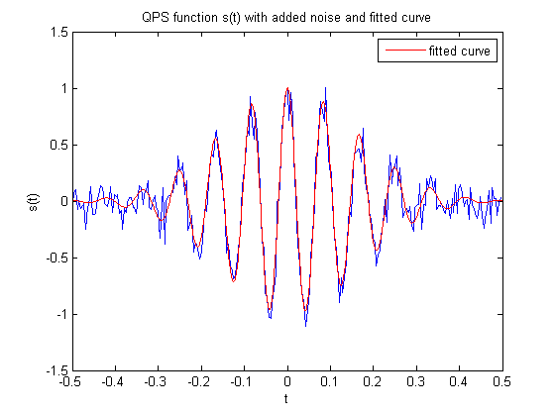The robustness of the NLLS algorithm on noisy signals was demonstrated by computing these goodness of fit (GOF) measures on five simulated spindles with varying SNR values:

Figure 4: **Simulated signal with added noise (blue) and the predicted signal from estimated parameters (red).**

Figure 4: **Simulated signal with added noise (blue) and the predicted signal from estimated parameters (red).**

1. Sum of Squared Errors (SSE), Rsquare

|  |  |  |
| --- | --- | --- |
|  | $$SSE= \sum_{i=1}^{n}{{(s_{i}-{\hat{s}}_{i})}^{2}}$$ | (6) |

where $s_{i}$ is the th sample of the original signal, ${\hat{s}}_{i}$ the th sample of the estimated signal and $n$ is the number of samples. An ideal fit would result in an SSE = 0.

1. Degree of Freedom adjusted Rsquare (AdjRsquare)

|  |  |  |
| --- | --- | --- |
|  | $$Rsquare=1-\frac{SSE}{SST}$$ | (7) |

where $SST= \sum_{i=1}^{n}{{(s_{i}-\overline{s})}^{2}}$ is the total sum of squares about the mean $\overline{s}$. Rsquare measures the proportion of variance accounted for by the model and should ideally be 1.

|  |  |  |
| --- | --- | --- |
|  | $$Rsquare=1-\frac{SSE(n-1)}{SST(v)}$$ | (8) |

where $v=n-m$; $v$ is the residual degree of freedom and $m$ the number of coefficients.

1. Root Mean Squared Error (RMSE). These measures are defined as follows:

|  |  |  |
| --- | --- | --- |
|  | $$RMSE= \sqrt{MSE}=\sqrt{{SSE}/v}$$ | (9) |

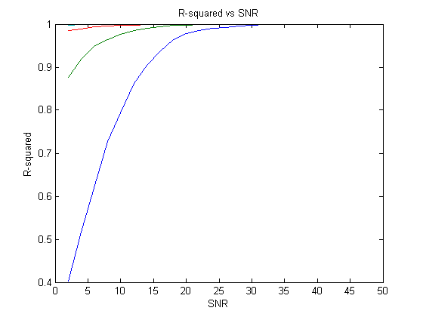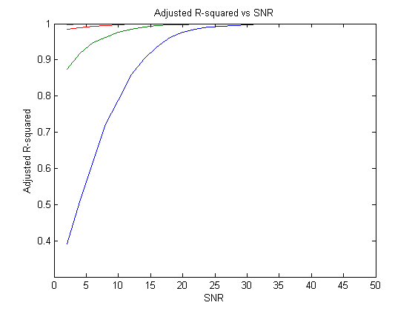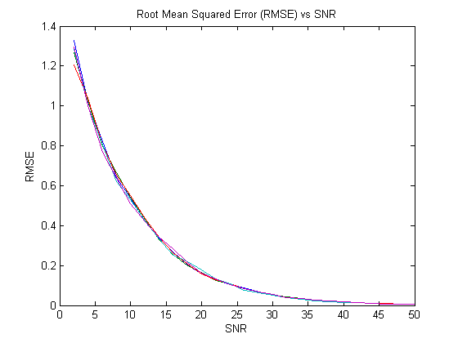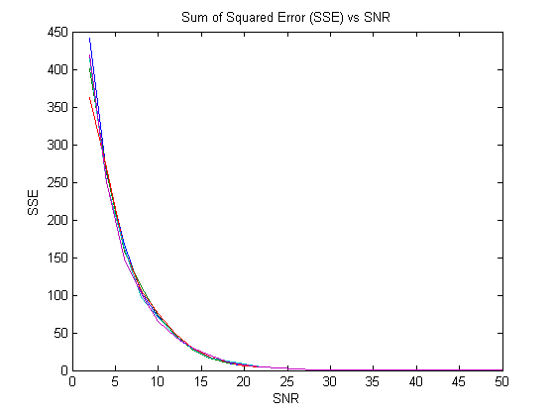Figure 5 (a), (b), (c) and (d) plots the four GOF measures calculated for a range of SNRs for the five simulated spindles. As seen, all four GOF measures approach their ideal values with increasing SNR.

Figure 5: **GOF measures calculated over a range of SNR values for five simulated spindles (a) Sum of Squared Error (b) R-Squared Error (c) Adjusted R-Squared Error (c) Root Mean Squared Error**

(c)

(c)

(d)

(d)

(a)

(a)

(b)

(b)

It should be noted that the actual values of GOF measures also depend on the initial parameter values from which the NLLS algorithm starts execution. Figure 6 shows results obtained from the NLLS algorithm when executed for the same spindle but using different initial conditions. It is seen that the estimates converge at all SNRs despite minor variations in initial conditions

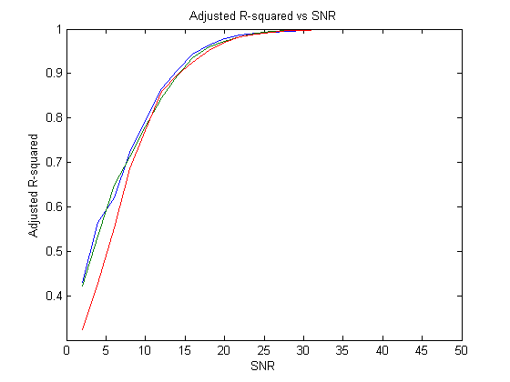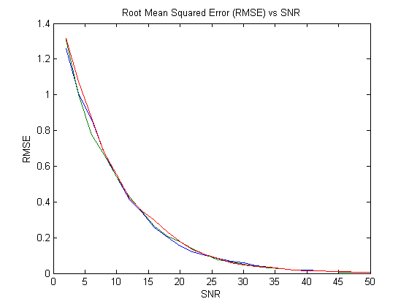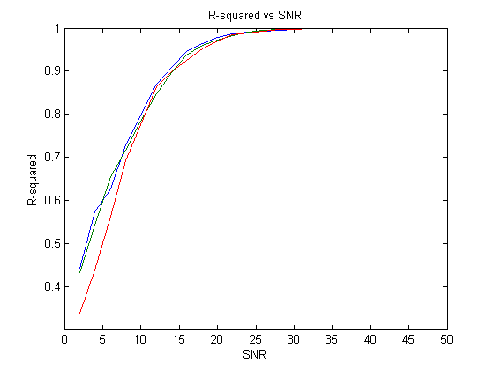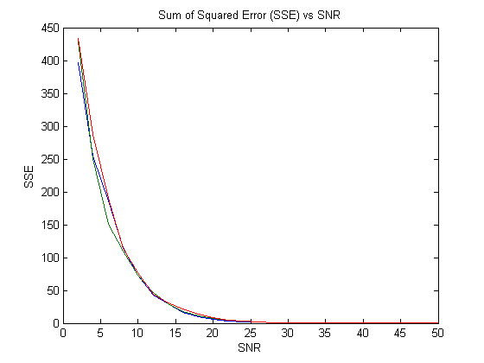

Figure 6: **GOF measures calculated over a range of SNR values for a single spindle but with different initial values for NLLS (a) Sum of Squared Error (b) R-Squared Error (c) Adjusted R-Squared Error (c) Root Mean Squared Error**

Figure 6: **GOF measures calculated over a range of SNR values for a single spindle but with different initial values for NLLS.**

(d)

(d)

(c)

(c)

(b)

(b)

(a)

(a)

Figure 5 and Figure 6 show that parameters estimated with the NLLS converged to their true values with higher SNR as expected. These estimates were obtained with high confidence levels as seen in the sample confidence bounds shown for a simulated spindle in Table 1. Figure 7 further illustrates the confidence levels of the parameter estimates of a simulated spindle at varying SNRs. Both the accuracy and the confidence of estimation improve with higher SNR for all the parameters.

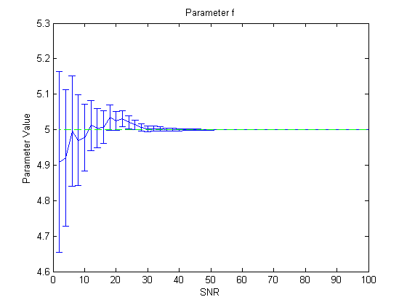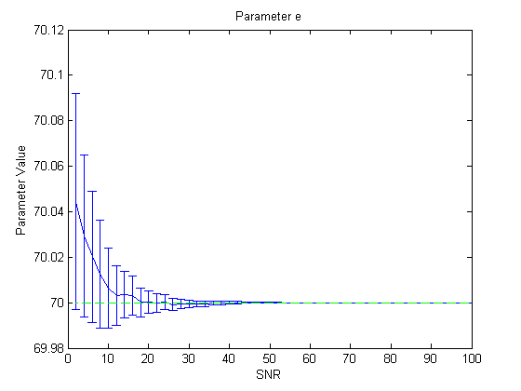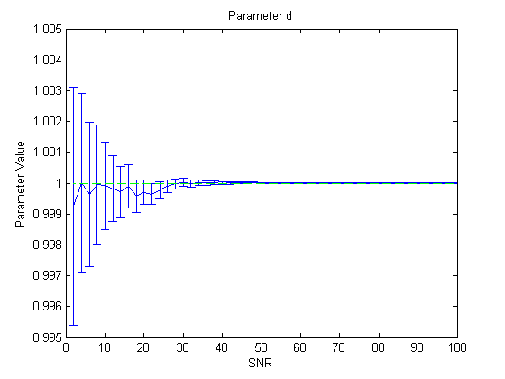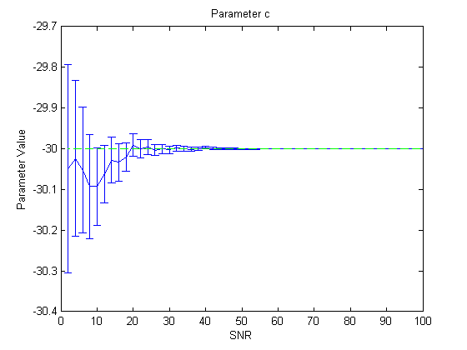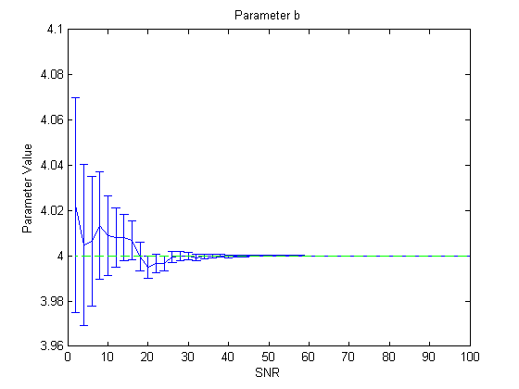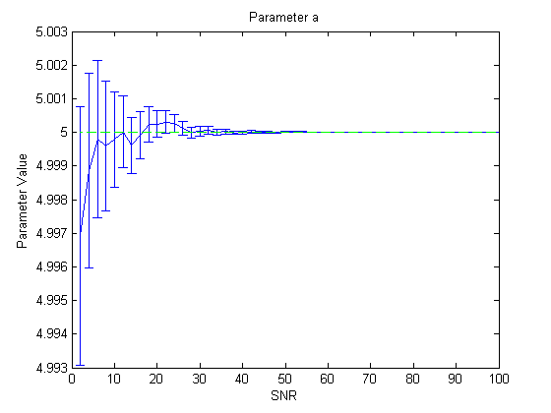

(c)

(c)

(b)

(b)

(a)

(a)

Figure 7: **Estimated values of parameter (a) a (b) b (c) c (d) d (e) e (f) f for varying SNRs. The whiskers show the 95% confidence bounds and the green line indicates the true value of the parameter.**

Figure 7: **Estimated values of parameter (a) a (b) b (c) c (d) d (e) e (f) f for varying SNRs. The whiskers show the 95% confidence bounds and the green line indicate the true value of the parameter.**

(e)

(e)

(d)

(d)

(f)

*Figure 7* (f)

This approach was then tested on spindles obtained from EEG data. As the true parameter values of the real spindles are not known, we instead compared the spindle properties to the properties derived from the parameter estimates. As discussed in section 3, $e/2π$ provides an estimate of the frequency in Hertz.

|  |  |  |  |  |
| --- | --- | --- | --- | --- |
| Frequency | Spindle 1 | Spindle 2 | Spindle 3 | Average Error |
| From Model | 12.4677 | 13.6787 | 14.0753 |  |
| From Spectrum | 12.5 | 13.5 | 14 |
| Relative Error | 0.0323 | 0.1787 | 0.0753 | 0.0954 |
| **Table 2:** Estimates of central frequencies in Hz for three spindles from the model and their frequency spectrums. | | | |  |

Table 2 compares frequencies of 3sample real spindles obtained from the most dominant peak in their frequency spectrum to the frequency obtained from the QPS model. As seen, the estimated frequency has an average error of only ~0.1Hz.

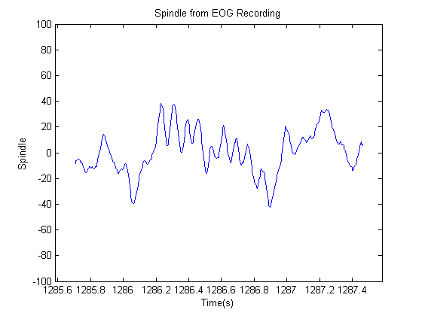To illustrate the goodness of fit, the three spindles from Table 2 are shown in Figure 8. The first row of figures illustrate the spindles scored on the raw EEG data. The second row of figures show the filtered spindles (in blue) and the QPS model fitted on them (in red).

(a)

(a)

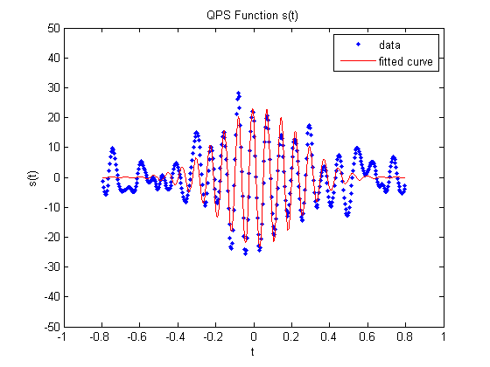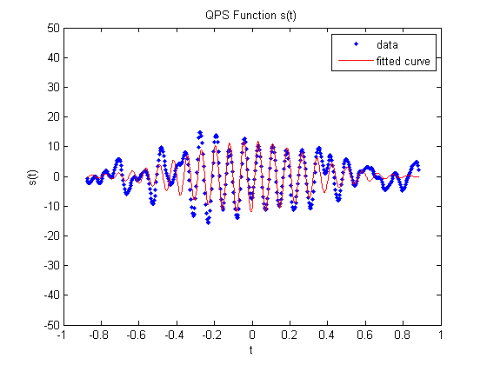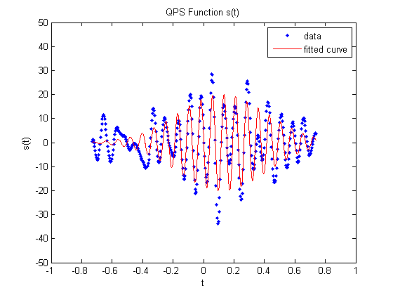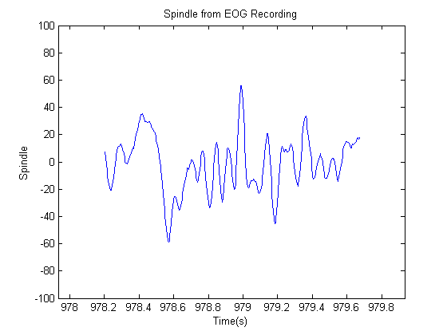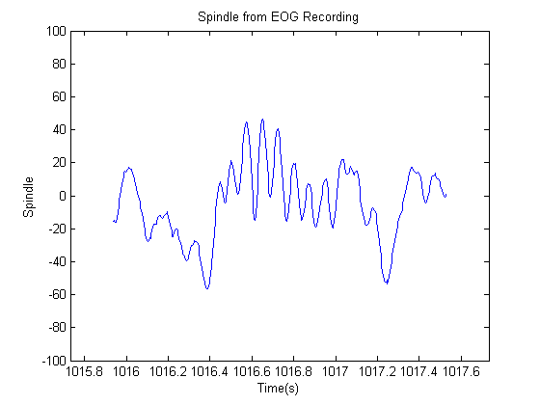

(b)

(b)

Figure 8: **(a) Spindle retrieved from EEG recording (b) Retrieved spindle fitted with QPS model**

# Distribution of the 6 parameters

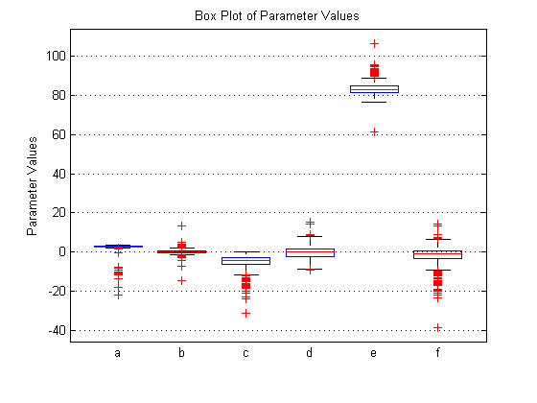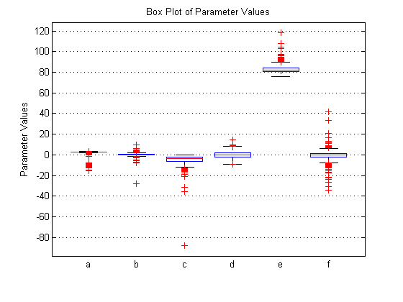The NLLS algorithm was applied to real spindle data obtained from EEG signals. The figures [] below show the distribution of QPS parameter values across 500 spindles for patient 1 and patient 2. It should be worth noting that similar distribution patterns were observed for all the 18 patients (not shown), indicating that these parameter values can be used to characterize spindles and potentially be used to automatically score spindles.

Figure 9: **Boxplot depicting parameter values for (a) patient 1 and (b) patient 2**

(b)

(b)

(a)

(a)

As evident from the boxplots in figure [], similar parameter values are observed for both the patients. Interestingly, parameter $a$, with the exception of a few outliers show negligible variation. This trend has been observed over 18 patients with only one exception as seen in figure []. Furthermore, the parameters do not show significant variation and is symmetrical about the median.

It was stated earlier that parameter ‘e’ corresponds to the angular frequency of a spindle [] and from the above plots show that the frequency range fall within 11-16 Hz with the exception of a few outliers. The relatively similar distribution of parameter values across multiple patients point to the fact that there is potential for automatic spindle detection using these parameter values. However, there is a significant presence of outliers across all the parameters except for parameter d which can result in plausible false detection.

# Mean Value of Parameters

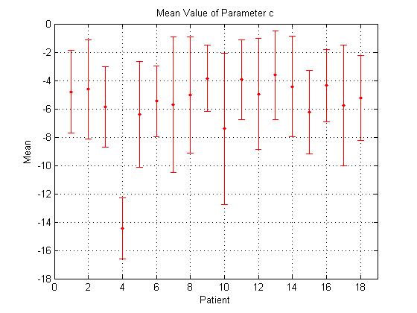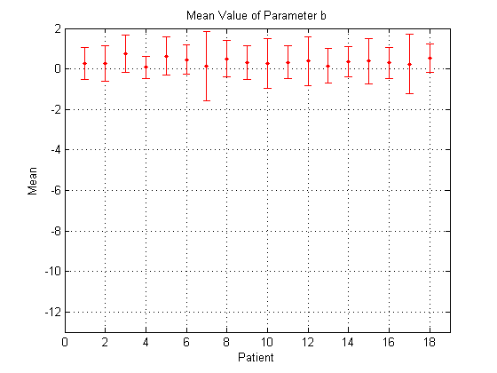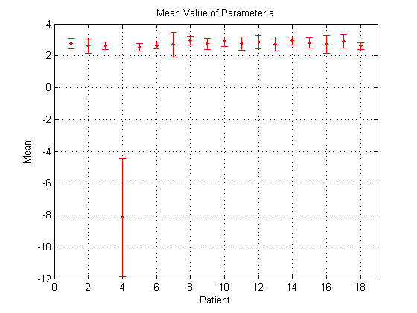We were interested in observing the variation of parameter values across multiple patients. This was done by computing the mean value of all the six parameters for 18 patients, after discarding the outliers. Figure [] shows the mean value of the parameters and the accompanying standard deviation, through an error bar.

(a)

(a)

(c)

(c)

(b)

(b)

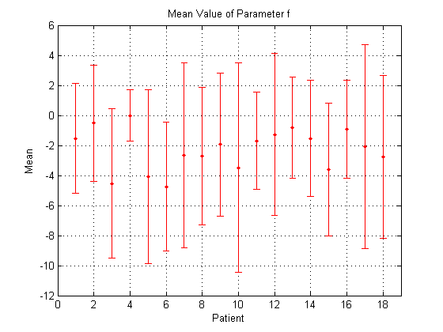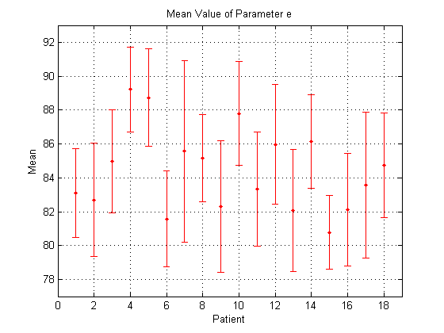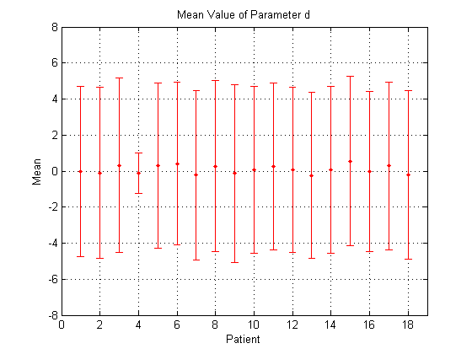

(d)

(d)

(f)

(f)

(e)

(e)

Figure 10: **Mean value of parameter (a) a (b) b (c) c (d) d (e) e (f) f across 18 patients. The whiskers indicate the standard deviation of the parameter.**

A quick glance at the six plots clearly depict the misalignment in parameter values of patient 4. This is an anomaly and indicative of the fact that the said patient does not fit our model well. Parameter ‘a’ shows negligible variation across patients as seen from figure []. Parameter ‘a’ is one of coefficients of the exponential term, $e^{A(t)}$ from the quadratic parameter sinusoid []. Spindle amplitude is a characteristic feature of all spindles [source]. Hence, it is prudent to expect minor variation of this particular parameter (‘a’) across multiple patients. Likewise, parameter ‘b’ shows minor variation across patients as seen from figure []. Parameter ‘b’ is used to characterize the shape of the envelope of the complex parameter sinusoid [] and thus, indirectly affects the amplitude of spindle. Interestingly, parameter‘d’ shows identical distribution of values across patients (see figure []). Additionally parameter ‘e’, which corresponds to the angular frequency of spindle falls within the characteristic spindle frequency range 11-16 Hz or 69-101 radians. Compared to the parameter mentioned above, parameter ‘c’ and ‘f’ demonstrate the greatest variation in parameter data across all patients.

# Distribution of frequency and energy error

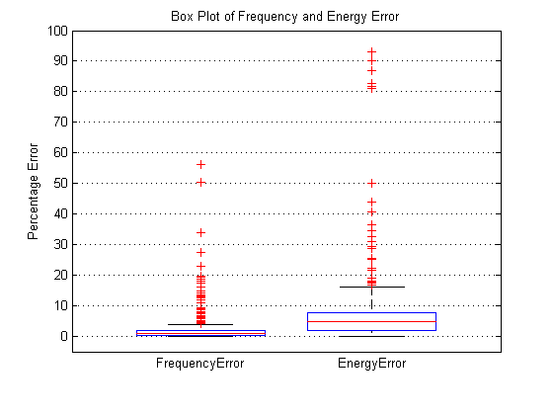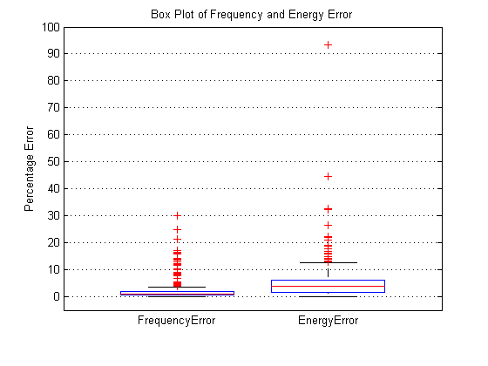To further validate the accuracy and test of our model, the energy and frequency error between the spindle generated by the mathematical model and the corresponding actual spindle was calculated.

(b)

(b)

(a)

(a)

Figure 11: **Box plot depicting energy and frequency error for (a) patient 1 and (b) patient 2**

Figure 11: **Box plot depicting energy and frequency error for (a) patient 1 and (b) patient 2**

The two box plots shown in figure [], is the distribution of energy and frequency error across 500 spindles for two patients. The frequency of spindle obtained from parameter ‘e’ of spindle model and was compared to the spindle frequency. These plots establish that with the exception of a few outliers the percentage error in frequency is less than 5% for a majority of spindles. This indicates a high level of accuracy while computing the frequency of spindle from the proposed mathematical model. Meanwhile, the percentage error in energy between the spindle generated by the mathematical model and the actual spindle is less than 10%. It would be worth observing that the percentage error is close to 100% for some spindles as seen in figure [], which brings forth certain limitations to the proposed model and the fact that it is not a ubiquitous fit for

|  |  |  |  |
| --- | --- | --- | --- |
| Percentage of spindles with energy error less than 10% | | Percentage of spindles with frequency error less than 5% | |
| Patient1 | 92.6 | Patient1 | 93.8 |
| Patient2 | 84.2 | Patient2 | 92 |
| Patient3 | 92 | Patient3 | 94 |
| Patient4 | 98.5 | Patient4 | 10.5 |
| Patient5 | 86.3 | Patient5 | 90.3 |
| Patient6 | 89 | Patient6 | 90 |
| Patient7 | 66.2 | Patient7 | 81.2 |
| Patient8 | 79.3 | Patient8 | 91.3 |
| Patient9 | 84.4 | Patient9 | 91.8 |
| Patient10 | 79.4 | Patient10 | 90 |
| Patient11 | 89.4 | Patient11 | 91 |
| Patient12 | 69 | Patient12 | 88.6 |
| Patient13 | 87.4 | Patient13 | 89.4 |
| Patient14 | 81.8 | Patient14 | 92 |
| Patient15 | 94.9 | Patient15 | 93.8 |
| Patient16 | 93.8 | Patient16 | 92.8 |
| Patient17 | 65.4 | Patient17 | 82.6 |
| Patient18 | 86 | Patient18 | 91.7 |
| 1. (b)   **Table 3:** Percentage of spindles with (a) energy error less than 10% and (b) frequency error than 5% | | | |

spindles. However, such cases are an exception and statistically insignificant over 500 spindles.

The table in figure [] shows a majority of spindles (more than 80% in most cases) in all the patients have a percentage error in energy that is less than 10%. In case of frequency error, an even higher percentage (more than 90%) of spindles have error in frequency that is less than 5% as seen from figure [].

# Mean Value of Energy

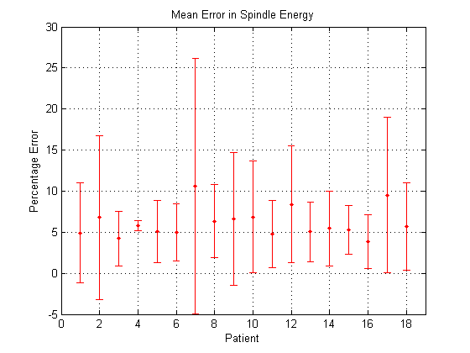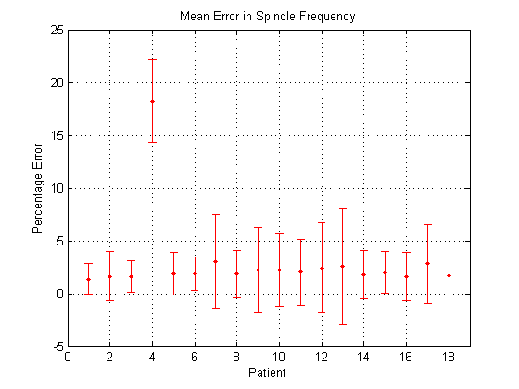To further analyze the accuracy of the spindle model, the variation of error in spindle energy and spindle frequency was observed across multiple patients. Figure [] shows the mean error in energy and frequency for all the patients along with the accompanying standard deviation through an error bar.

(b)

(b)

(a)

(a)

Figure 12: **Mean value of percentage error in (a) frequency (b) energy across 18 patients. The whiskers indicate the standard deviation of the percentage error.**

As seen in figure [], the mean error in frequency is less than 5% for all the 18 patients except for one. The patient showing a higher percentage error in spindle frequency has vastly different parameter values than the other 17 patients and hence this can be considered as an exceptional case. The mean error in energy is less than 11% for all the patients as shown in figure []. The model has a greater accuracy in predicting the frequency of the spindle than its energy.

# Fitted Distribution of the 6 Parameters

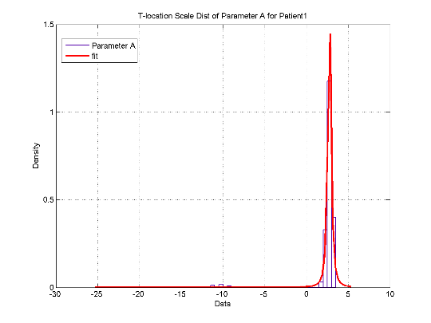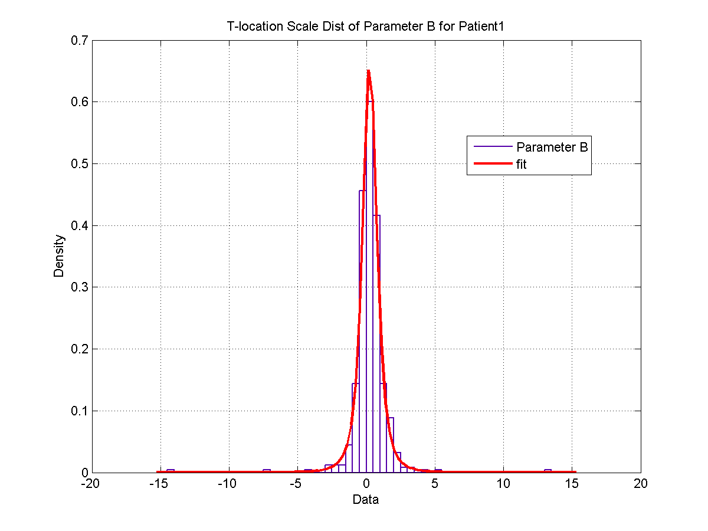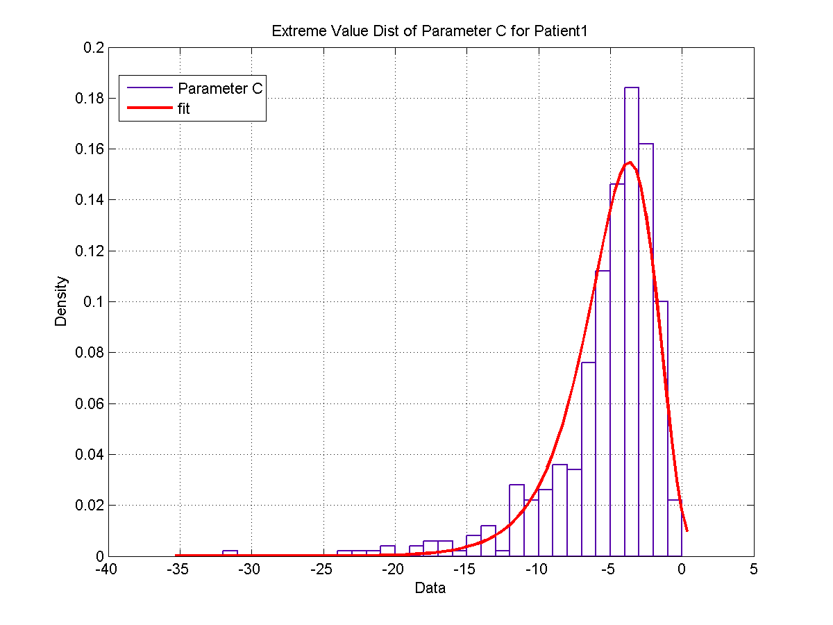The dispersal of each parameter values over 500 spindles was plotted for one of the patients and statistical distributions were fitted to these spread of values. The best distribution fit for each parameter was visually determined and concurrently these fitted distributions were applied to each of the 18 patients. This was done to observe if the parameter values follow similar distribution patterns across all the 18 patients.

(a)

(a)

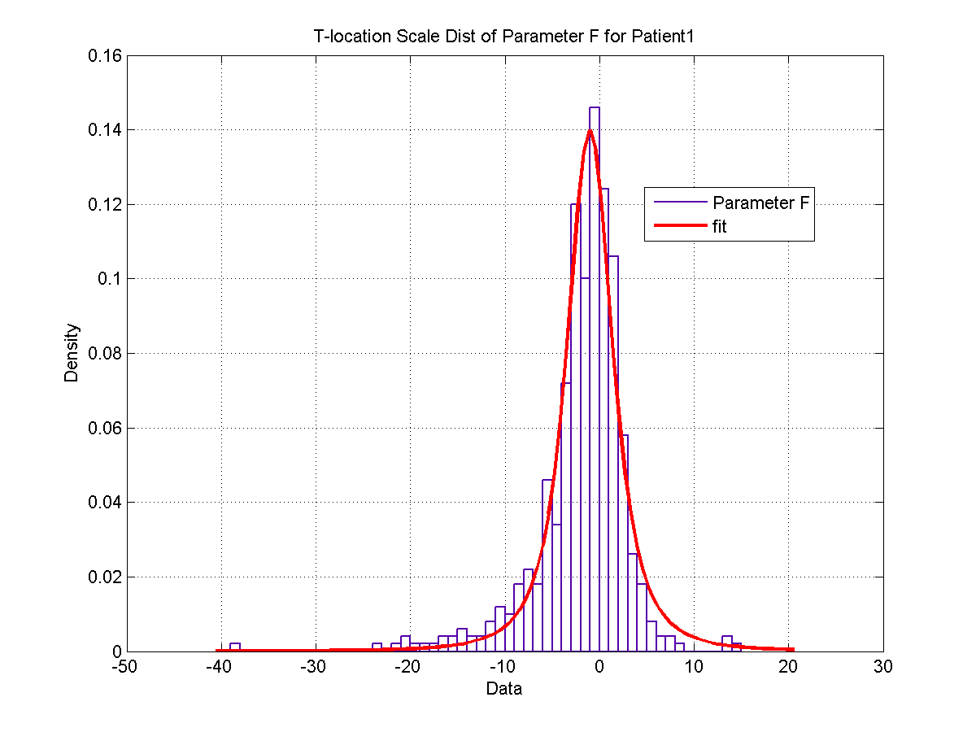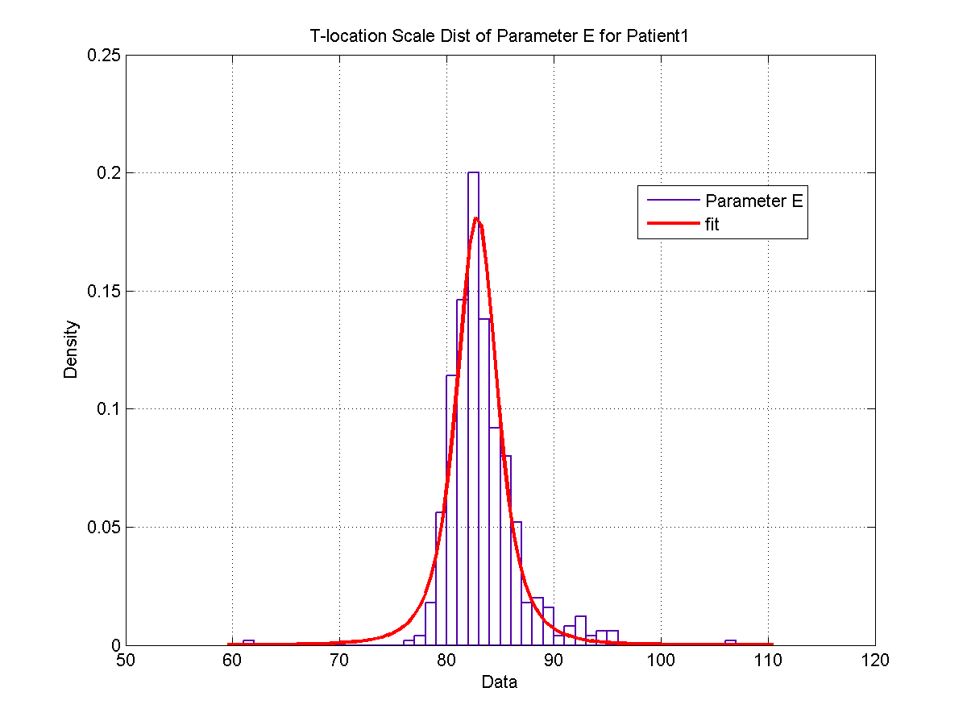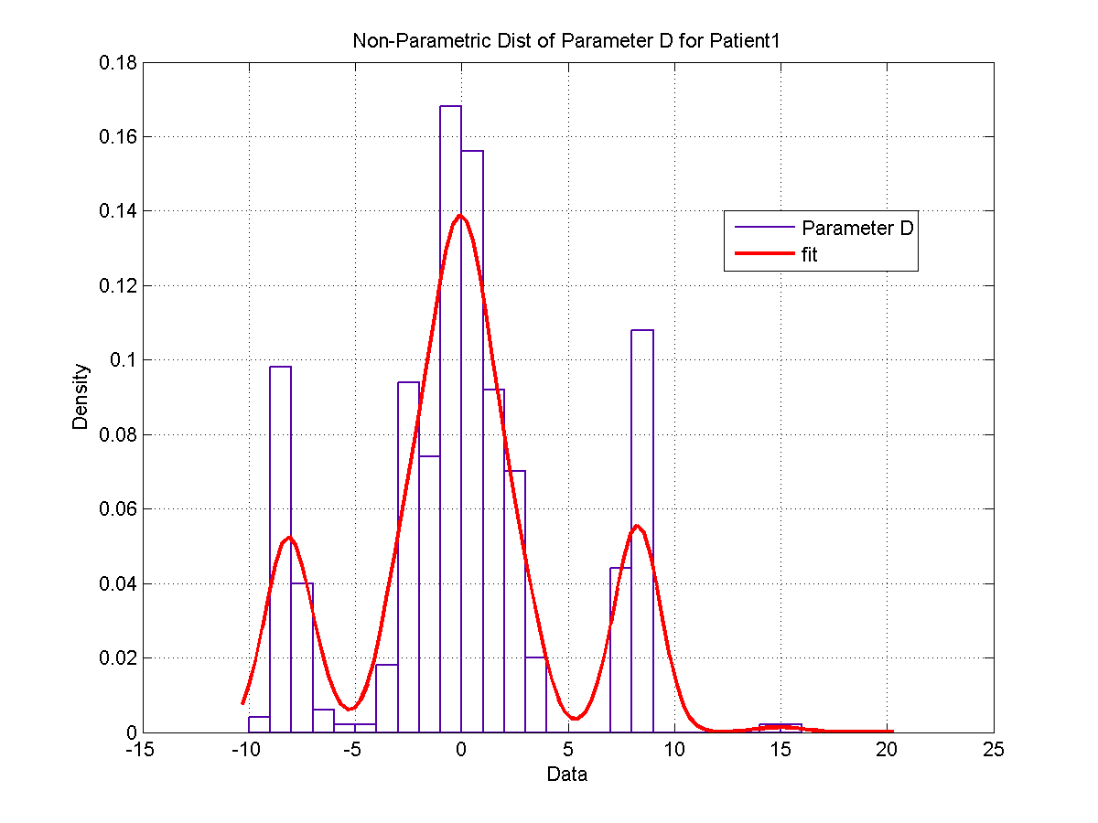

(c)

(c)

(b)

(b)

Figure 13: **T-location scale distribution of parameter (a) ‘a’ (b) ‘b’. (c) Extreme value distribution of parameter ‘c’. (d) Non-parametric distribution of parameter ‘d’. (e) T-location scale distribution of parameter (e) ‘e’ (f) ‘f’.**

(d)

(d)

(f)

(f)

(e)

(e)

A histogram plot of parameter values over 500 spindles and the corresponding statistical distribution fit can be seen in figure []. The statistical distribution that best fits the data was inspected visually. The best fit for each parameter was then applied to the distribution of parameter values for all the 18 patients (not shown) and…. Goodness of fit).

# Significance of Parameters

Next, the effect of each parameter on the quadratic parameter sinusoid function (spindle model) was observed. This was accomplished by linearly increasing the value of the parameter in question while choosing a fixed value of the other 5 parameters. The data was obtained from 500 spindles from one of the patients at random and sorted in an increasing order. Concurrently, the mean value of the other 5 parameter was computed so that the models generated can be classified as real spindles.

# Parameter A

(b)

(b)

(a)

(a)

Figure 14:**(a) Variation of QPS function with different values of a (b) Subplot of QPS function with different values of a.**

The above plots in figure [] show that the value of parameter ‘a’ and the corresponding spindle model. The figures clearly depict that increasing the value of parameter ‘a’ increase the amplitude of the function, thereby demonstrating that parameter ‘a’ has a direct correlation to the amplitude of the spindle function. As seen here, increasing the amplitude from -21.92 to 3.48 increases the amplitude range of the spindle function.

# Parameter B

(b)

(b)

(a)

(a)

Figure 15: **(a) Variation of QPS function with different values of b (b) Subplot of QPS function with different values of b.**

The value of parameter ‘b’ and the corresponding spindle model is shown in figure []. In these figures parameter ‘b’ is varied in an increasing order and this brings forth change in the amplitude and induces a horizontal shift on the spindle function. As observed, the function gradually shifts to the right with the increase in value of ‘b’ while decreasing in amplitude and then once again increases in amplitude. Figure [] shows that increasing the value of ‘b’ from -14.38 to 13.46 decreases the amplitude first and then increases the amplitude, all the while shifting the waveform to the right.

# Parameter C

(b)

(b)

(a)

(a)

Figure 16: **(a) Variation of QPS function with different values of c (b) Subplot of QPS function with different values of c.**

The plots in figure [] show the value of parameter ‘c’ and the corresponding spindle model. The figures clearly demonstrate that parameter ‘c’ controls the decay of the spindle function linearly, implying that the spindle will decay faster for lower values of ‘c’ and decay slower for higher values of ‘c’. Furthermore, as the value of ‘c’ approaches 0, the spindle does not decay. This is an anomaly as the spindle loses its characteristic shape as ‘c’ approaches 0. As seen in figure [], increasing the value of ‘c’ from -31.07 to -3.23 gradually increases the decay in spindle wave.

# Parameter D

(a)

(a)

(b)

(b)

Figure 17: **(a) Variation of QPS function with different values of d (b) Subplot of QPS function with different values of d.**

Figure [] shows the value of parameter ‘d’ and the corresponding spindle model. From the plots, it is evident that changing the value of parameter ‘d’ induces a phase shift in the spindle model. Here the phase shift is shown using a black solid line. The line coincides with the maximum value of the spindle function. In figure [], parameter ‘d’ is increased from -9.25 to 15.51 and as seen, this induces a phase shift in either the positive or negative direction.

# Parameter E

(b)

(b)

(a)

(a)

Figure 19: **(a) Subplot of QPS function with different values of e (b) Frequency domain plot of QPS function with different values of e.**

The above plots in figure [] show the value of parameter ‘e’ and the corresponding spindle model. From the plots, it can be visually observed that changing the value of parameter ‘e’ increase the frequency of the spindle model. As shown in figure[], increasing e from 61.26 to 106.27 increases the frequency from 10 to 17.5 Hz. Since, parameter ‘e’ corresponds to the spindle’s angular frequency, this information can also be used to validate the fact that as parameter ‘e’ increases the frequency also increases.

# Parameter F

(b)

(b)

(a)

(a)

Figure 19: **(a) Subplot of QPS function with different values of f (b) Subplot of QPS function with different values f.**

The value of parameter ‘f’ and the corresponding spindle model is shown in figure []. The above plots show that changing ‘f’ varies the frequency. A spindle wave with a frequency of 13.27 Hz was varied by increasing the value of ‘f’. As seen in figure [], this causes a minor variation in the frequency of the spindle. Here, ‘f’ is increased from -38.403 to 14.452 and this changes the frequency of the spindle wave, ranging from 13 to 14.5 Hz. The minimum value of ‘f’ coincides with the maximum frequency value of 14.5 Hz.

## DISCUSSIONS

As explained in section **[]**, the QPS model successfully incorporates various intra-spindle characteristics within its six parameters. The estimation of these parameters are also straight forward using standard NLLS methods and exhibit good convergence. The estimation was also found to be robust against good amount of noise.

However, NLLS estimation techniques do suffer from a few drawbacks. A major challenge is the technique’s high sensitivity to initial conditions. An appropriate approach towards selection of reasonable initial conditions is required. The definition of spindles and results from preceding estimates can be utilized to select appropriate initial values for this application.

Interestingly, similar distribution patterns of parameter values were observed across multiple patients. In particular parameter a and b showed little to no variation across patients. The relative error in frequency was less than 5% for a majority of the patients indicating that the QSP model can be used to accurately detect the frequency of the spindle. The similarity in distribution patterns, the limited range of parameter values and unique shape of spindles imply that there is a considerate amount of potential for developing an automatic scoring algorithm for detection of spindles using the distribution of parameter values.

The significance of each parameter value on the QSP model can help in evaluating the variation of multiple spindles by changing these parameter values.

Mention possibilities with present model. Illustrate scope with example if possible

conclude

# REFERENCES

|  |  |
| --- | --- |
| [1] | A. Rechtschaffen and A. Kales, A manual of standardized terminology, techniques and scoring system for sleep stages of human subjects, Washington: Public Health Service, U.S. Government Printing Office, 1968. |
| [2] | I. C, A.-I. S, C. A and Q. SF, The AASM manual for the scoring of sleep and associated events: rules,terminology and technical specifications, Westchester: American Academy of Sleep Medicine, 2007. |
| [3] | S. M. Fogela and C. T. Smith, "The function of the sleep spindle: A physiological index of intelligence and a mechanism for sleep-dependent memory consolidation," *Neuroscience and Biobehavioral Reviews,* vol. 35, pp. 1154-1165, 2011. |
| [4] | H. G. Weia, E. Riela, C. A. Czeislera and D.-J. Dijk, "Attenuated amplitude of circadian and sleep-dependent modulation of electroencephalographic sleep spindle characteristics in elderly human subjects," *Neuroscience Letters,* vol. 260, pp. 29-32, 1999. |
| [5] | R. Bódizs, T. Kis, A. S. Lázár, L. Havrán, P. Rigó, Z. Clemens and P. Halász, "Prediction of general mental ability based on neural oscillation measures of sleep.," *Journal of sleep research,* vol. 14, no. 3, pp. 285-292, 2005. |
| [6] | I. Tezer, J. Rémi, N. Erbil, S. Noachtar and S. Saygi, "A reduction of sleep spindles heralds seizures in focal epilepsy," *Clinical Neurophysiology,* vol. March, 2014. |
| [7] | E. J. Wamsley, M. A. Tucker, A. K. Shinn, K. E. Ono, S. K. McKinley, A. V. Ely, D. C. Goff, R. Stickgold and D. S. Manoach, "Reduced Sleep Spindles and Spindle Coherence in Schizophrenia: Mechanisms of Impaired Memory Consolidation?," *Biological Psychiatry,* vol. 41, no. 2, pp. 154-161, 2012. |
| [8] | R. Bódizs, J. Körmendi, P. Rigó and A. Lázár, "The individual adjustment method of sleep spindle analysis: methodological improvements and roots in the fingerprint paradigm," *Journal of Neuroscience Methods,* vol. 178, no. 1, pp. 205-213, 2009. |
| [9] | G. G.-H. A. S. A. V. J. H. S. H. E. Huupponen, "Development and comparison of four sleep spindle detection methods," *Artificial Intelligence in Medicine,* vol. 40, no. 3, pp. 157-170, 2007. |
| [10] | E. d. S.-H. R. R. M. C. G. G. S.V. Schönwald, "Benchmarking matching pursuit to find sleep spindles," *Journal of Neuroscience Methods,* vol. 156, no. 1, pp. 314-321, 2006. |
| [11] | D. Kunz, H. Danker-Hopfe, G. Gruber, J. L. Lorenzo, S. L. Himanen, B. Kemp, T. Penzel, J. Roschke and G. Dorffner, "Interrater reliability between eight European sleep-labs in healthy subjects of all age-groups," *Journal of Sleep Research,* vol. 9, no. 1, p. 106, 2000. |
| [12] | K. Campbell, A. Kumar and W. Hofman, "Human and automatic validation of a phase-locked loop spindle detection," *Electroencephalography and Clinical Neurophysiology,* vol. 45, no. 5, pp. 602-605, 1980. |
| [13] | E. Olbrich and P. Achermann, "Analysis of the Temporal Organization of Sleep Spindles in the Human Sleep EEG Using a Phenomenological Modeling Approach," *Journal of Biological Physics,* vol. 34, pp. 341-349, 2008. |
| [14] | E. Olbrich and P. Achermann, "Analysis of oscillatory patterns in the human sleep EEG using a novel detection algorithm," *Journal of Sleep Research,* vol. 14, pp. 337-346, 2005. |
| [15] | V. Perumalsamy, S. Sankaranarayanan and S. Rajamony, "Sleep spindles detection from human sleep EEG signals using autoregressive (AR) model: a surrogate data approach," *Journal of Biomedical Science and Engineering,* vol. 2, pp. 294-303, 2009. |
| [16] | A. Nonclercq, C. Urbain, D. Verheulpen, C. Decaestecker, P. V. Bogaert and P. Peigneux, "Sleep spindle detection through amplitude–frequency normal modelling," *Journal of Neuroscience Methods,* vol. 214, pp. 192-203, 2013. |
| [17] | P. Ktonas, S. Golemati, P. Xanthopoulos, V. Sakkalis, M. Ortigueira, H. Tsekou, M. Zervakis, T.Paparrigopoulos and C. Soldatos, "Potential dementia biomarkers based on the time-varying microstructure of sleep EEG spindles," in *29th Annual International Conference of the IEEE EMBS*, Cité Internationale, Lyon, France, 2007. |
| [18] | P. Xanthopoulos, S. Golemati, V. Sakkalis, P. Y. Ktonas, M. Zervakis and C. R. Soldatos, "Modeling the time-varying microstructure of simulated sleep EEG spindles using time-frequency analysis methods," in *28th IEEE EMBS Annual International Conference*, New York City, USA, 2006. |
| [19] | J. S. Marques and L. B. Almeida., "Frequency-varying sinusoidal modeling of speech.," *IEEE Transactions on Acoustics, Speech and Signal Processing,* vol. 5, pp. 763-765, 1989. |
| [20] | M. Ito and M. Yano, "Sinusoidal modeling for nonstationary voiced speech based on a local vector transform," *The Journal of the Acoustical Society of America,* vol. 121, no. 3, pp. 1717-27, 2007. |
| [21] | M. Abe and J. O. Smith, "AM/FM rate estimation for time-varying sinusoidal modeling.," in *IEEE International Conference on Acoustics, Speech, and Signal Processing*, 2005. |
| [22] | C. O'Reilly, N. Gosselin, J. Carrier and T. Nielsen, "Montreal Archive of Sleep Studies: An open-access resource for instrument benchmarking & exploratory research," pp. 2, 14. |