Case Study 2: Architecture, Budget, and the Case for a Paid Generator
EU AI Act high-risk classification, evaluation framework. Prepared for the follow-up meeting. 18 September 2026.
One page each on: what the system is, what we reused and dropped, what a paid generator actually costs, and the honest reason it is worth paying for.
1. Evaluation architecture
The compliance agent is the system under test. The contribution is the evaluation: measuring whether a faithfulness score tracks legal correctness. One retrieval pipeline is reused across three prompt configurations, and every answer is scored on two independent axes.

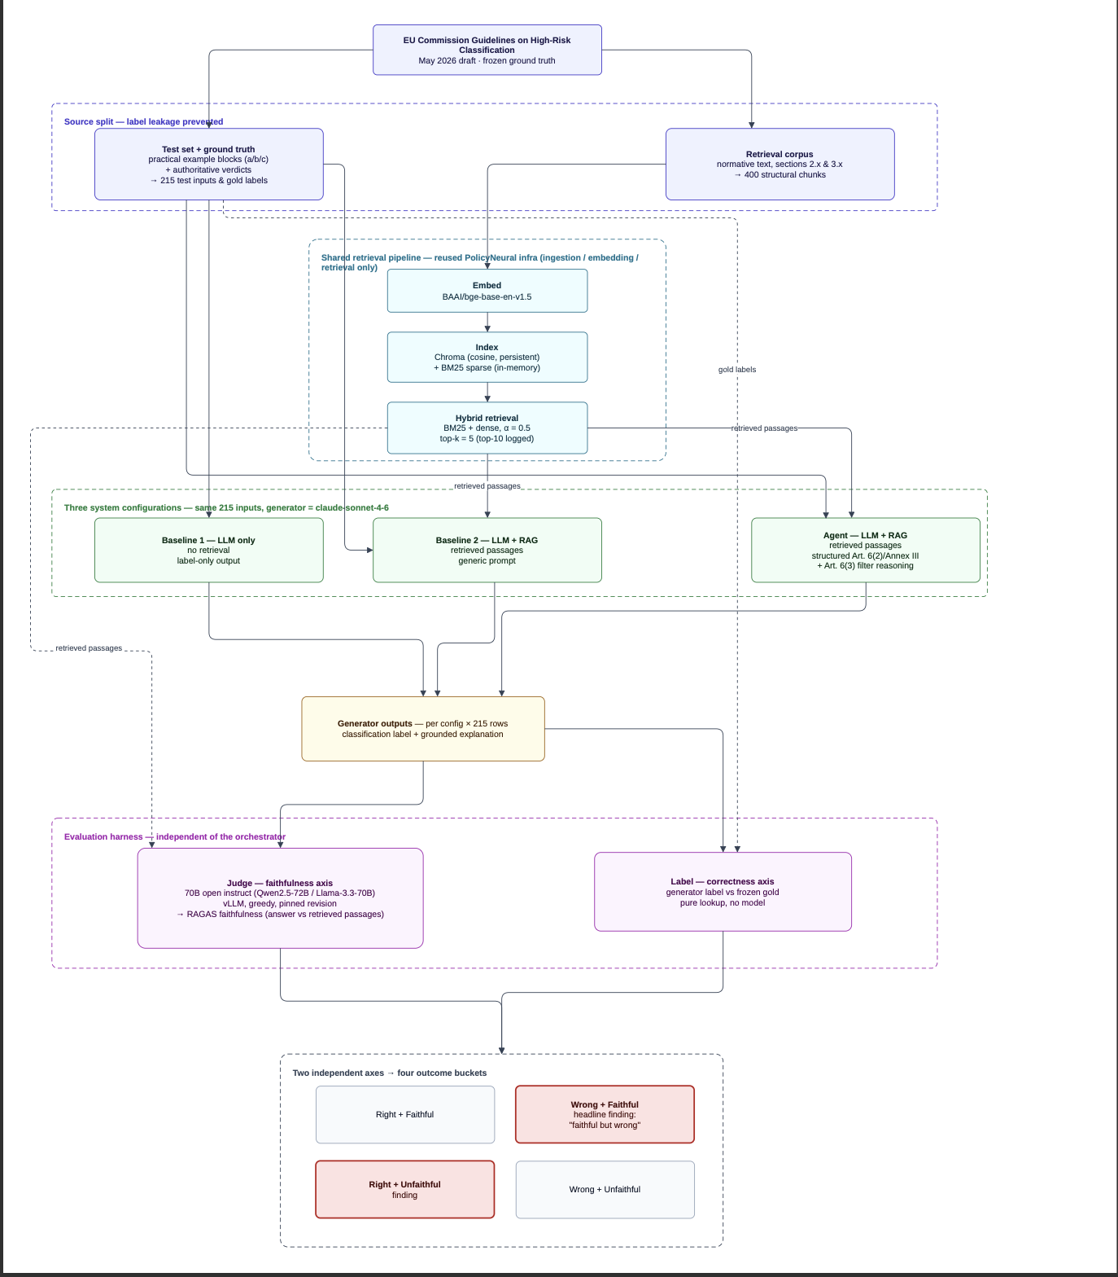
The two off-diagonal cells are the findings. Wrong and faithful is the headline: a legally wrong answer that the faithfulness score still rates as well grounded.

2. Reused RAG infrastructure: kept vs discarded
The agent infrastructure is reused from a prior project (PolicyNeural). Only the retrieval spine is kept. Everything that would touch the answer before it is judged, or make retrieval non-reproducible, is removed. This is stated once as reused infrastructure, never as a contribution.
Component | Status | Why
Ingestion, embedding, retrieval | Kept | The retrieval spine. Deterministic, does not touch the generated answer.
DebateAgent A, DebateAgent B, VerifierAgent, EvaluatorAgent | Removed | They revise or critique the answer before scoring, which would confound the faithfulness measurement.
MemoryAgent | Removed | Auto-tunes retrieval per row, which destroys reproducibility across the 215 inputs.
SummarizerAgent, TopicModelAgent, PlannerAgent, GuardrailsAgent | Removed | Not relevant to a single classification task.
Nine agents removed in total. The kept spine is exactly what the diagram above shows in the retrieval column.
3. Budget: what a paid generator actually costs
Only the generator costs money. The judge, the retrieval, and the embedding all run free on the university GPU. One full graded run is the three configurations over all 215 inputs, so 645 model calls.
Item | Amount | Note
Tokens per full run (measured) | ~0.62M in / ~0.14M out | from the real test set, 400-chunk corpus, and prompt sizes
Sonnet 4.6 rate | $3 / $15 per M | input / output
One full run, standard | ~$4 | 645 calls
One full run, Batch API | ~$2 | 50% off, async, same output
Judge + retrieval + embedding | $0 | on the university GPU

Top-up option | Amount | Covers
Floor (one graded run, no buffer) | ~5 euros | a single clean pass
Recommended top-up | 25 to 30 euros | full study, re-runs after fixes
4. Why a paid generator: the honest case
The finding does not require a paid model. The metric being blind to correctness is provable on the free model too, and can be shown today. What the paid model buys is a result that holds up as a citeable artifact.
- Reproducibility (the real reason). Free models get retired and cannot be pinned to a fixed version. Two used during this project (gemini-2.0-flash, llama-3.3-70b) were already retired mid-project. The university GPU sandbox also wipes on close. A stable, reproducible result cannot sit on a moving target. The frozen design already specified claude-sonnet-4-6 precisely because its dateless ID is a fixed snapshot.
- Cost is trivial and the expensive part is free. The usually-expensive component, the LLM judge, is a free local 72B model on the university GPU. Only the generator is paid, about 2 to 4 euros per run.
- Reliability (supporting). Free models break mechanically: on the demo run, 7.5 percent of the agent's answers came back empty or truncated and were silently scored as wrong. This is a free-model fault, but it is a minor supporting point, not the headline.
- Realism (supporting). The system under test should be one that would actually be deployed for legal compliance. That is a capable model, not a free one. Minor support, not a claim that free models write worse answers.

Case Study 2, MSc Data Science, SRH Heidelberg. Supervisor Prof. Swati Chandna. Generator claude-sonnet-4-6; judge Qwen2.5-72B-Instruct-AWQ. Demo numbers (n=40) are from a free model and are not graded results.

