srh
SRH Hochschule Heidelberg

FAITHFUL BUT WRONG? EVALUATING RETRIEVAL-AUGMENTED CLASSIFICATION OF HIGH-RISK AI SYSTEMS UNDER THE EU AI ACT AGAINST AN AUTHORITATIVE ANSWER KEY

BY
Rahul Rawat
[Matriculation number]
M.Sc. Data Science and Analytics
SRH Hochschule Heidelberg
Case Study 2
September 2026

Supervisor: Prof. Dr. Swati Chandna

Abstract
Retrieval-augmented generation (RAG) systems are increasingly proposed as compliance assistants, and they are usually evaluated with automated faithfulness metrics that check whether an answer is grounded in the retrieved text. This case study asks whether such a metric says anything about whether the legal answer is actually right. The task is the high-risk classification of AI systems under Article 6(2) and Annex III of the EU AI Act, including the Article 6(3) filter. The answer key is taken from the worked examples in the European Commission's May 2026 draft guidelines, which gives 215 test inputs with authoritative labels. Three systems built on one shared retrieval pipeline are compared: a plain language model without retrieval, a standard RAG system, and a structured agent whose prompt walks through the legal test step by step. Answers are scored on two independent axes: correctness against the Commission label, and RAGAS faithfulness computed by a separate 72B judge model. During the study, 129 of the 215 inputs were found to contain the Commission's verdict text; these were redacted and all systems were run again. On the redacted inputs, retrieval clearly helps (accuracy 0.688 without retrieval against 0.879 and 0.856 with it), but the structured agent is not better than standard RAG. For the agent, faithfulness does not separate right from wrong answers (AUC 0.465, 95% CI 0.36 to 0.57), and 17 of its 31 wrong answers still pass as faithful. Error analysis shows that these are mostly errors in applying a correctly retrieved rule, which the metric is not designed to detect. The practical conclusion is that faithfulness is not a proxy for legal correctness and needs to be reported next to a correctness check whenever a ground truth exists.
Index Terms: EU AI Act, high-risk classification, retrieval-augmented generation, RAGAS, faithfulness, LLM evaluation, LLM-as-a-judge, legal NLP, label leakage.

Contents
Abstract 2
Contents 3
1. Introduction 4
2. Background and Related Work 4
3. Task and Data 5
3.1 Task Definition 5
3.2 Ground Truth 5
3.3 Test Set Construction 6
3.4 Label Leakage Found and Fixed 7
4. Methodology 8
4.1 Retrieval Corpus and Index 10
4.2 The Three Systems Under Test 10
4.3 Generator 10
4.4 Judge and RAGAS Faithfulness 11
4.5 Correctness 11
4.6 The Four-Bucket Analysis 11
4.7 Reproducibility 12
5. Experiments and Results 12
5.1 Retrieval Quality 12
5.2 Correctness of the Three Systems 13
5.3 Effect of the Label Leak 15
5.4 Faithfulness Versus Correctness 15
5.5 Article 6(3) Filter Cases 18
5.6 Error Analysis of Faithful-but-Wrong Answers 18
6. Discussion 20
7. Conclusion and Future Work 20
8. Code and Data Availability 21
9. References 22

1. Introduction
The EU AI Act (Regulation (EU) 2024/1689) [1] sorts AI systems by risk, and the most consequential step for a provider is deciding whether a system is high-risk. For the Annex III route this means checking whether the system's intended purpose falls within one of eight listed areas, such as employment, education or access to essential services, and then whether one of the Article 6(3) conditions lets it out again. The European Commission's draft guidelines of May 2026 [2] explain this test and illustrate it with many worked examples, each ending in a clear verdict.
Tools that answer such questions by retrieving passages from legal text and letting a language model write the answer are an obvious fit, and they are commonly evaluated with reference-free metrics. The most widely used of these is faithfulness as defined in RAGAS [3]: the share of claims in an answer that can be inferred from the retrieved context. Faithfulness is attractive because it needs no answer key. By design, however, it only checks whether the explanation stays close to the retrieved text. It does not check whether the conclusion is legally correct.
This case study measures how far apart those two things are on a task where the correct answer is known. The compliance system is the system under test, not the contribution; the contribution is the evaluation. The central question is whether correctness and faithfulness come apart, and in particular whether there are answers that are faithful but wrong (well grounded, legally incorrect) and answers that are right but unfaithful (correct label, reasoning not traceable to the retrieved text). The study was set up to give a real answer in either direction.
The report is organised as follows. Section 2 gives background. Section 3 describes the task, the ground truth and the test set, including a label leak found during the study and how it was fixed. Section 4 describes the three systems and the evaluation harness. Section 5 reports the results and an error analysis, Section 6 discusses them, and Section 7 concludes with limitations and future work.

2. Background and Related Work
High-risk classification under the AI Act. Article 6 defines two routes to high-risk status. The Article 6(1) route covers AI systems that are safety components of products under Union harmonisation legislation listed in Annex I; it depends on a separate body of product law and is out of scope here. The Article 6(2) route covers the use cases listed in Annex III. Article 6(3) then acts as a filter: an Annex III system is not high-risk if it only performs a narrow procedural task, improves the result of a completed human activity, detects decision patterns without replacing human assessment, or performs a preparatory task, unless it profiles natural persons, in which case it is always high-risk. The Commission guidelines [2] turn this into practical guidance and are the only source of authoritative labels used in this study.
Evaluating RAG systems. RAG [4] combines a retriever with a generator so that answers can draw on an external corpus. RAGAS [3] proposes reference-free metrics for such systems, among them faithfulness, computed in two steps: an LLM breaks the answer into atomic statements, and an LLM then decides for each statement whether it can be inferred from the retrieved context. ARES [5] trains lightweight judges for context relevance, answer faithfulness and answer relevance and calibrates them with a small set of human labels. Both frameworks evaluate grounding and relevance; neither is built to check a domain-specific correct answer, which is the gap this study measures.
Legal NLP benchmarks. LexGLUE [6] collects legal classification tasks with gold labels and shows that legal text remains hard for general models. It evaluates label accuracy but not the grounding of explanations, which is the other half of the picture examined here.
Other frameworks. The OECD framework for classifying AI systems [7] and the NIST AI Risk Management Framework [8] offer broader ways of describing and managing AI risk. They do not produce EU high-risk labels and are therefore used only as context; all labels in this study come from the Commission guidelines.
[Note for Rahul, remove before sending: add Wallat et al. (2025), 'Correctness is not Faithfulness in RAG Attributions', here once you have read it in full. Position this study as the legal-domain case with an authoritative answer key, not as the first to observe the gap.]

3. Task and Data

3.1 Task Definition
Each test input is a short description of an AI system and its intended purpose. The system under test must return one of two labels, high-risk or not-high-risk, under the Article 6(2) and Annex III route including the Article 6(3) filter, together with an explanation. The label is scored for correctness; the explanation is scored for faithfulness. The Article 6(1) product-safety route is excluded because it has no clean ground truth in the source.

3.2 Ground Truth
The ground truth is the European Commission's draft guidelines on the classification of high-risk AI systems for Annex III, May 2026 version [2]. The document was downloaded once and frozen; later revisions were deliberately not followed during the project. Its worked examples each describe a concrete system and state whether it is high-risk, which gives one known correct answer per input. Without such an answer key the claim that a metric missed a legal error could not be made.

3.3 Test Set Construction
A Python parser extracted the worked examples from the text layer of the PDF, handling page breaks, footnotes and numbering. An automatic sanity check flagged suspected truncations and length outliers; 21 rows were repaired by stripping a heading of the next example that the parser had concatenated, and 4 rows were dropped as merged or truncated. No label was changed. The locked test set has 215 inputs covering all eight Annex III areas: 66 high-risk and 149 not-high-risk (31% and 69%), with 41 inputs that are Article 6(3) filter cases (Table 1). Because of the imbalance, precision, recall and F1 for the high-risk class are reported next to accuracy.
Annex III area | Inputs | High-risk | Not high-risk
1 Biometrics | 32 | 14 | 18
2 Critical infrastructure | 18 | 8 | 10
3 Education | 28 | 9 | 19
4 Employment | 32 | 14 | 18
5 Essential services | 43 | 21 | 22
6 Law enforcement | 23 | 0 | 23
7 Migration and border control | 23 | 0 | 23
8 Justice and democracy | 16 | 0 | 16
Total | 215 | 66 | 149
Table 1. Test set by Annex III area. 41 of the 215 inputs are Article 6(3) filter cases.
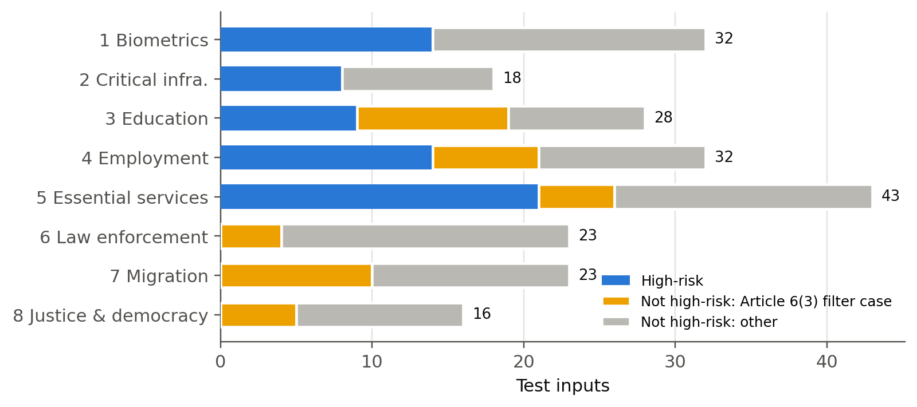
Figure 1. Composition of the test set by Annex III area: high-risk inputs, Article 6(3) filter cases and other not-high-risk inputs.
The source has no high-risk worked examples for law enforcement, migration or justice and democracy (Figure 1); every example there is either a filter case or out of scope. The evaluation therefore tests high-risk detection in five areas and correct rejection in all eight. This is a property of the source and is reported as such.

3.4 Label Leakage Found and Fixed
The first full run produced suspiciously high accuracy, and inspecting the inputs showed why: the Commission's examples usually end with the verdict and its legal reasoning (for example 'It therefore falls outside the use case of point 4(a) of Annex III'), and the extractor had kept this text as part of the system description. A keyword scan flagged 129 of the 215 inputs (60%) as stating or strongly implying the answer, including 36 of the 41 filter cases. The effect was large for the model without retrieval, which reached 0.938 accuracy on the flagged inputs but only 0.674 on the 86 clean ones, and small for the two retrieval systems (0.922 and 0.961 flagged, 0.953 and 0.953 clean).
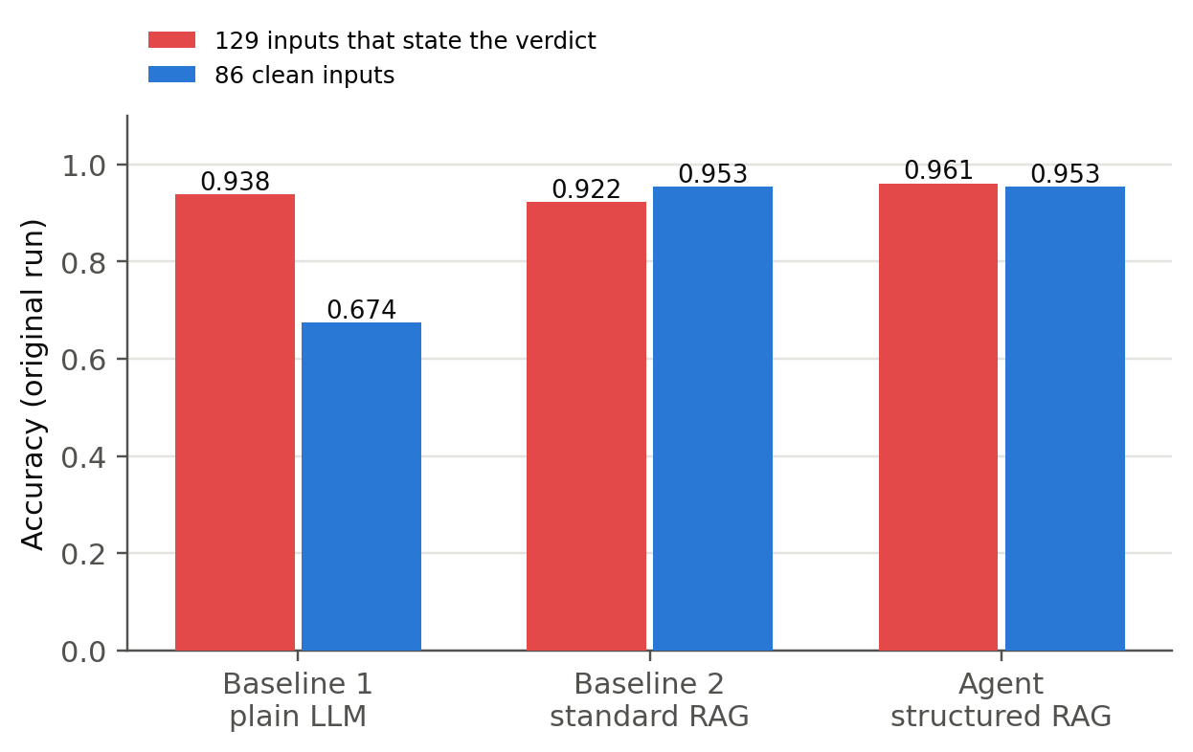
Figure 2. Accuracy in the first run on the 129 inputs whose text stated the verdict and on the 86 clean inputs. Only the model without retrieval depends heavily on the leak.
The inputs were therefore redacted and all systems were run again. The rule was to keep what the system does, who uses it, what data it uses, what its output is used for and how humans are involved, and to remove every legal conclusion and every citation of an article, annex point, recital or section. IDs and gold labels were not touched, and the model never sees the label field. Redaction was done in three layers: an automatic filter that drops sentences containing legal vocabulary, hand edits where the verdict sat inside a descriptive sentence, and a full manual review of the hand-edited rows by the author (Table 2). In that review the author restored some wording that describes the legal test without stating the label (for example that a system has no relevant impact on a decision), while every explicit verdict was removed. This residual wording is disclosed as a limitation in Section 7. The redaction is fully scripted and the reviewed text is stored with the dataset, so the redacted set can be rebuilt exactly.
Handling | Inputs
Unchanged (no verdict text) | 42
Automatic sentence removal | 96
Hand-edited clause removal | 31
Hand-edited, then reviewed and revised by the author | 46
Total | 215
Table 2. Redaction of the test inputs. Mean description length fell from 557 to 392 characters.
All results in Section 5 use the redacted inputs unless stated otherwise. The first run is kept for comparison only.

4. Methodology
Figure 3 shows the whole pipeline. One retrieval pipeline and one generator are shared by all three systems, so the only thing that changes between them is the prompt. The evaluation harness is separate from the systems and reads only their output files.
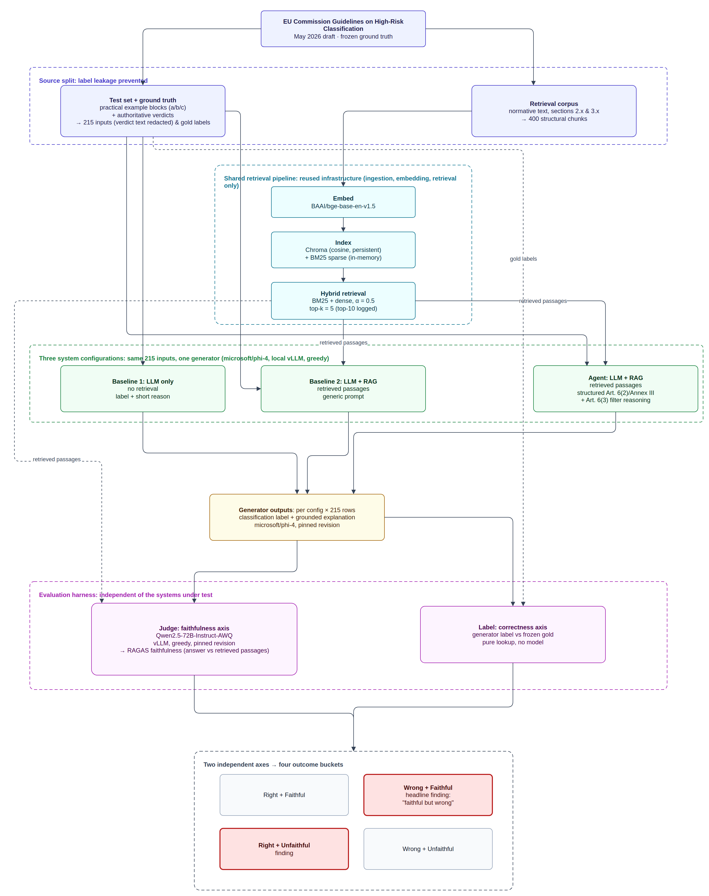
Figure 3. End-to-end evaluation framework: the source split that keeps worked examples out of the retrieval corpus, the shared retrieval pipeline, the three configurations with one generator, the evaluation harness with its two independent axes, and the four outcome buckets.

4.1 Retrieval Corpus and Index
The retrieval corpus is built from the same guidelines document, but only from its normative text. Chunking is structural: one chunk per heading and numbered paragraph, with footnotes attached to the paragraph they annotate. The worked examples and verdict lists are held out, because they are the test set and would otherwise leak labels into retrieval, and the Annex I section is excluded as out of scope. The corpus has 400 chunks. They are embedded with BAAI/bge-base-en-v1.5 [9] and stored in a persistent Chroma index, and a BM25 [10] index is built in memory. Retrieval is hybrid with equal weighting (alpha 0.5, not tuned during evaluation). The top 5 passages go to the generator and the top 10 are logged for analysis. An earlier version of the corpus builder mistook footnote dates for headings and silently lost 39 chunks, including the whole recruitment section; this was caught by the retrieval evaluation and fixed before any generation run.

4.2 The Three Systems Under Test
- Baseline 1, plain LLM. The description only, no retrieved text. The model returns a label and a short reason. It has no retrieved context, so it has no faithfulness score by design.
- Baseline 2, standard RAG. The description plus the top 5 passages and a generic instruction to classify the system and ground the explanation in the passages.
- Agent, structured RAG. The same passages, with a prompt that walks through the legal test: identify the intended purpose, check it against the eight Annex III areas, apply the Article 6(3) conditions, note that profiling always makes a system high-risk, and state which point and condition apply with reference to the passages.
All three return strict JSON with a label and an explanation, which is parsed deterministically. The retrieval components were reused from an earlier RAG project of the author; its other agents (debate, verification, evaluation, memory, planning, guardrails, summarisation and topic modelling) were removed because they would either interfere with the faithfulness measurement or make runs non-reproducible.

4.3 Generator
The generator is microsoft/phi-4 [11], a 14-billion-parameter open instruction model, served locally with vLLM [12] on the university GPU server with greedy decoding (temperature 0, top-p 1) and a pinned model revision. The original plan used a commercial API model. A local open model was chosen instead because it can be pinned to an exact version and rerun at any time, it gives full control over decoding and output length, and it costs nothing. Free hosted models tried during development could not be pinned and produced empty or truncated answers under their token limits; with the local setup, none of the 645 generations failed to parse, came back empty or hit the 2,048 token output limit (the longest answer was 260 tokens).

4.4 Judge and RAGAS Faithfulness
Faithfulness is computed by a separate judge, Qwen/Qwen2.5-72B-Instruct in 4-bit AWQ quantisation [13], [14], served with vLLM on one 48 GB GPU, greedy decoding, pinned revision. The judge comes from a different model family from the generator, so the generator is never graded by itself. The judge follows the two RAGAS steps [3]: it splits the explanation into self-contained statements (using the system description as the question), then decides for each statement whether it can be inferred from the five passages the generator actually saw. Faithfulness is the share of supported statements.

4.5 Correctness
Correctness is a pure lookup of the predicted label against the Commission label, with no model involved. Accuracy, precision, recall and F1 for the high-risk class, and macro F1 are reported, broken down by Annex III area and by filter versus normal cases. A reply that cannot be parsed would count as wrong; none occurred.

4.6 The Four-Bucket Analysis
Crossing the two axes gives four buckets: right and faithful, right and unfaithful, wrong and faithful, wrong and unfaithful. The two off-diagonal buckets are the findings. This is a cross-tabulation of two different measures, not a confusion matrix. An answer counts as faithful at a score of 0.5 or above, because this cut is a reporting choice, a threshold sweep is also reported. Threshold-free statistics are reported as well, the mean faithfulness of right and wrong answers, the point-biserial correlation between correctness and faithfulness, and the AUC of faithfulness as a detector of correct answers (0.5 means no better than chance). 95% confidence intervals come from 2,000 bootstrap resamples of the 215 inputs. Paired differences in accuracy between systems are tested with McNemar's exact test.

4.7 Reproducibility
Component | Setting
Ground truth | Commission Annex III draft guidelines, May 2026 (frozen)
Test set | 215 inputs, redacted descriptions, labels unchanged
Corpus | 400 structural chunks, worked examples held out
Embedding | BAAI/bge-base-en-v1.5, 768 dimensions
Retrieval | Hybrid BM25 + dense, alpha 0.5, top 5 (top 10 logged)
Generator | microsoft/phi-4, vLLM, temperature 0, max 2,048 tokens, pinned revision
Judge | Qwen2.5-72B-Instruct-AWQ, vLLM, temperature 0, pinned revision
Faithful cut | 0.5 (sweep 0.3 to 1.0 reported)
Hardware | University JupyterLab server, NVIDIA RTX A6000 48 GB
Table 3. Frozen settings. Model revisions are recorded in the run manifest.
Every run writes, per input, the prompt configuration, the retrieved passages and their scores, the raw model output, the parsed label and explanation, and the token usage. The whole pipeline runs from one notebook, and generation resumes from the last completed input if a session is interrupted.

5. Experiments and Results
The results are presented in the order of the pipeline, first whether retrieval finds the right part of the guidelines, then how often each system gets the label right, then how much the label leak had distorted the first run, and finally the central question of whether faithfulness tells right answers from wrong ones. The section ends with a close reading of the answers that are faithful but wrong.

5.1 Retrieval Quality
Retrieval is scored against the guideline section named as the source of each test input. On the redacted inputs the correct section is among the top 5 passages for 79.5% of inputs (Table 4). Redaction lowered this only slightly, even though the inputs became about 30% shorter. Retrieval is weakest for law enforcement (0.565) and migration (0.652) and better for filter cases than before (0.732).
Metric | Original inputs | Redacted inputs
Hit@5 (primary) | 0.833 | 0.795
Hit@10 | 0.898 | 0.856
MRR | 0.633 | 0.651
Hit@5, filter cases (41) | 0.707 | 0.732
Hit@5, normal cases (174) | 0.862 | 0.810
Table 4. Retrieval quality against the gold guideline section.
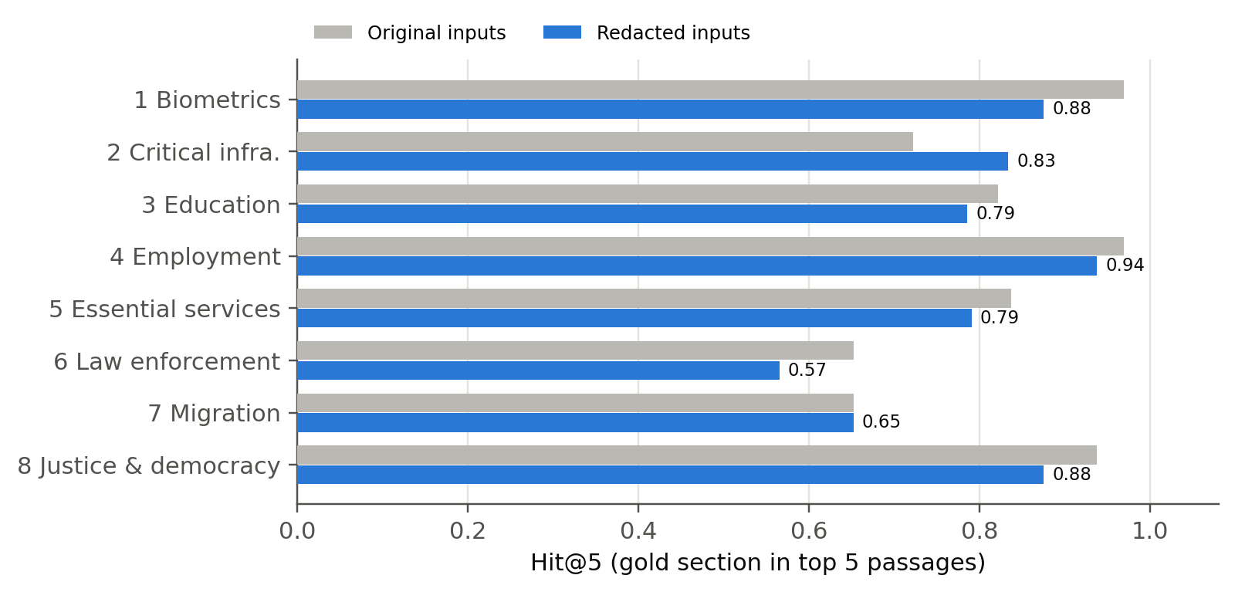
Figure 4. Retrieval Hit@5 by Annex III area, original against redacted inputs.

5.2 Correctness of the Three Systems
System | Accuracy | HR precision | HR recall | HR F1 | Macro F1 | False HR | Missed HR
Baseline 1: plain LLM | 0.688 | 0.496 | 0.894 | 0.638 | 0.682 | 60 | 7
Baseline 2: standard RAG | 0.879 | 0.770 | 0.864 | 0.814 | 0.862 | 17 | 9
Agent: structured RAG | 0.856 | 0.722 | 0.864 | 0.786 | 0.839 | 22 | 9
Table 5. Correctness on the 215 redacted inputs (HR = high-risk, the positive class).
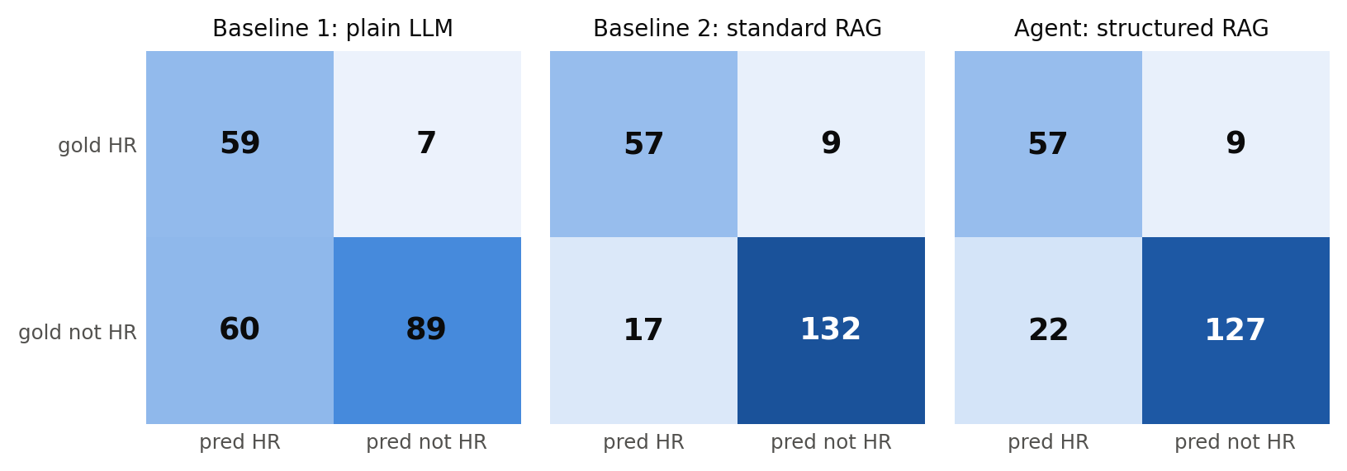
Figure 5. Confusion matrices on the redacted inputs (HR = high-risk).
Retrieval makes a large and significant difference. Both retrieval systems beat the plain model (standard RAG 0.879 and agent 0.856 against 0.688; McNemar p < 0.001 in both cases). Without retrieval the model labels many systems high-risk that are not: 60 false high-risk calls against 17 and 22. The structured agent, however, is not better than standard RAG. It is slightly worse (5 inputs only the agent got right, 10 only standard RAG got right; McNemar p = 0.30), and it makes more false high-risk calls. Recall is the same for both (0.864).
Figure 6 breaks accuracy down by area. Critical infrastructure is the hardest area for both retrieval systems (0.61 and 0.56), because the test there hinges on whether a system is a safety component rather than on the sector it works in. Without retrieval, law enforcement collapses to 0.26, because the plain model labels most police uses high-risk although none of the law-enforcement examples is; both retrieval systems reach 0.87 or more there.
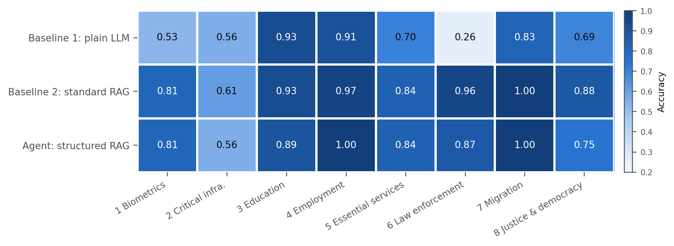
Figure 6. Accuracy by Annex III area and system on the redacted inputs.

5.3 Effect of the Label Leak
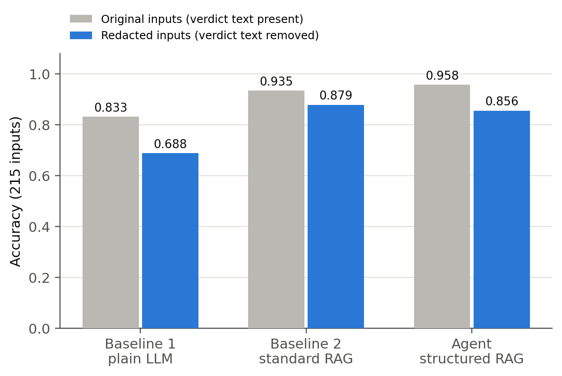
Figure 7. Accuracy before and after removing the verdict text from the inputs.
Figure 7 shows how much the leak inflated the first run. Accuracy fell for every system, most for the plain model (0.833 to 0.688) and least for standard RAG (0.935 to 0.879). The ranking of the two retrieval systems also flipped: on the leaky inputs the agent looked best (0.958), on the clean inputs standard RAG is ahead. Without the fix, the study would have reported both an inflated baseline and the wrong winner.

5.4 Faithfulness Versus Correctness
Table 6 and Figures 8 and 9 give the main result. For the agent, faithfulness carries no information about whether the label is right. Wrong answers are on average slightly more faithful than right ones (0.487 against 0.450), the correlation is close to zero (-0.043, 95% CI -0.17 to 0.08), and as a detector of correct answers faithfulness does no better than chance (AUC 0.465, 95% CI 0.36 to 0.57). For standard RAG there is a weak signal (AUC 0.615, 95% CI 0.52 to 0.71; correlation 0.142), which is far too weak to be used as a check on legal correctness.
Measure | Baseline 2: standard RAG | Agent: structured RAG
Mean faithfulness | 0.548 | 0.455
Mean faithfulness, label right | 0.561 | 0.450
Mean faithfulness, label wrong | 0.451 | 0.487
AUC (95% CI) | 0.615 (0.52 to 0.71) | 0.465 (0.36 to 0.57)
Point-biserial r (95% CI) | 0.142 (0.05 to 0.23) | -0.043 (-0.17 to 0.08)
Right and faithful | 110 | 91
Right and unfaithful | 79 | 93
Wrong and faithful (faithful but wrong) | 14 | 17
Wrong and unfaithful | 12 | 14
Table 6. Faithfulness against correctness on the redacted inputs; bucket counts at a cut of 0.5.
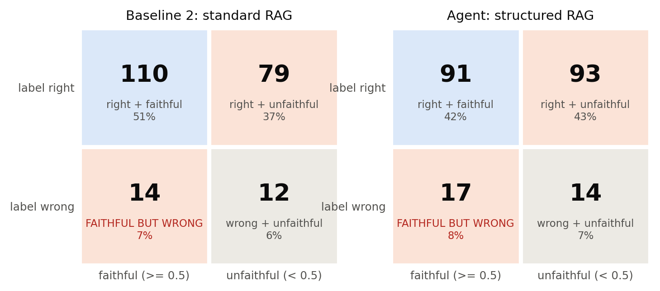
Figure 8. The four outcome buckets for the two retrieval systems at a faithful cut of 0.5. The shaded off-diagonal cells are the findings.
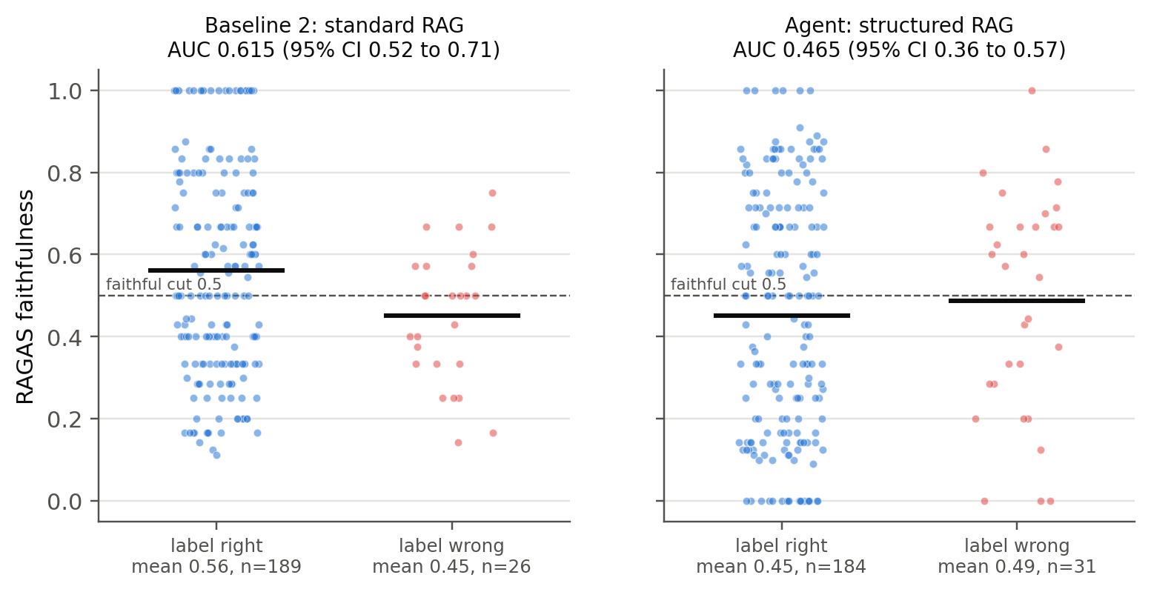
Figure 9. Faithfulness of every answer, split by whether the label was right. Bars mark the group means; the dashed line is the 0.5 cut.
Both off-diagonal buckets are well populated. Faithful but wrong: 17 of the agent's 31 wrong answers (55%) and 14 of standard RAG's 26 score as faithful. Right but unfaithful: about half of all correct answers score below 0.5 (93 of 184 for the agent, 79 of 189 for standard RAG). Part of the second effect is mechanical: the judge marks sentences that restate the system description as unsupported, because the passages do not contain them. This is how RAGAS faithfulness is defined and was not changed during the study.
Faithful cut | 0.3 | 0.5 | 0.7 | 0.9
Agent: faithful but wrong | 22 | 17 | 7 | 1
Standard RAG: faithful but wrong | 21 | 14 | 1 | 0
Table 7. Faithful-but-wrong answers at different cuts. Seven agent errors score 0.7 or higher.
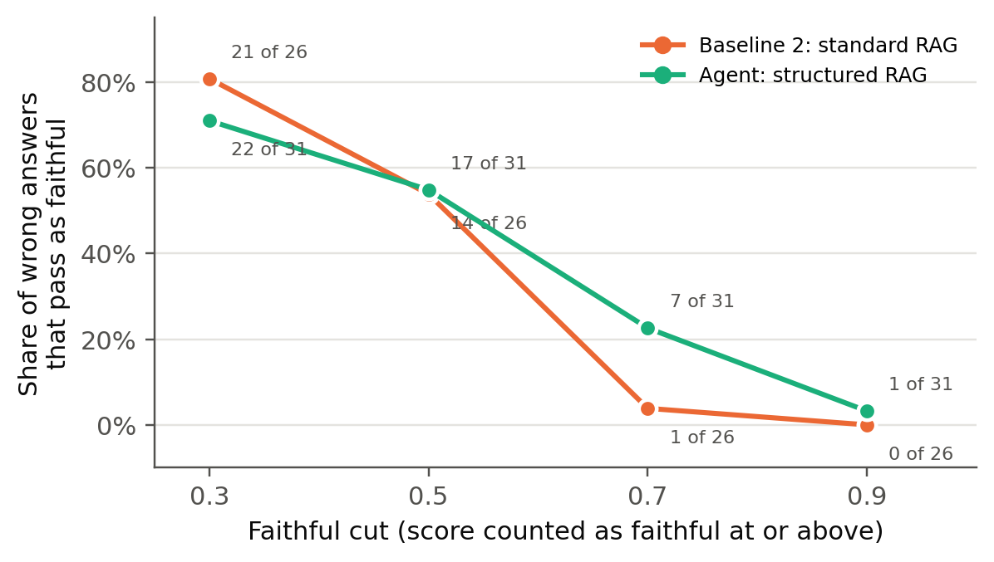
Figure 10. Share of wrong answers that still pass as faithful, as the faithful cut is raised.
The count depends on the cut, as expected (Figure 10), but the agent keeps 7 wrong answers at 0.7 and one wrong answer with a perfect score of 1.0, so the effect does not rest on a lenient threshold. On the leaky inputs the same analysis gave an AUC of 0.507 for the agent, but with only 9 wrong answers, which is why the redacted run is the one reported.

5.5 Article 6(3) Filter Cases
All 41 filter cases have the gold label not-high-risk: the system is in an Annex III area but one of the Article 6(3) conditions takes it out. Standard RAG handles these best (0.878), the agent and the plain model both reach 0.780. On normal cases the two retrieval systems are close (0.879 and 0.874) and the plain model is far behind (0.667). The step-by-step prompt therefore did not help with the one part of the test it was written for; Section 5.6 shows the typical failure.
System | Filter cases (41) | Normal cases (174)
Baseline 1: plain LLM | 0.780 | 0.667
Baseline 2: standard RAG | 0.878 | 0.879
Agent: structured RAG | 0.780 | 0.874
Table 8. Accuracy on Article 6(3) filter cases and on normal cases (redacted inputs).

5.6 Error Analysis of Faithful-but-Wrong Answers
All 17 faithful-but-wrong answers of the agent were read in full, together with their inputs, retrieved passages and judge verdicts, and sorted by the main cause of the error (Table 9). Fourteen are false high-risk calls and three are missed high-risk systems.
Error type | Count | Inputs
A. Sector taken as use case: in a critical-infrastructure sector, so labelled high-risk without the safety-component test | 6 | 031, 034, 041, 044, 049, 050
B. Article 6(3) exception not applied although the task is narrow, preparatory or reviewing completed work | 4 | 066, 126, 207, 210
C. Profiling or sensitive-data rule applied where it does not fit | 3 | 022, 023, 177
D. Legal condition misread or a fact invented | 2 | 008, 051
E. Too cautious on a short description (missed high-risk) | 2 | 035, 042
Table 9. Causes of the agent's 17 faithful-but-wrong answers (input IDs without the anx3- prefix).
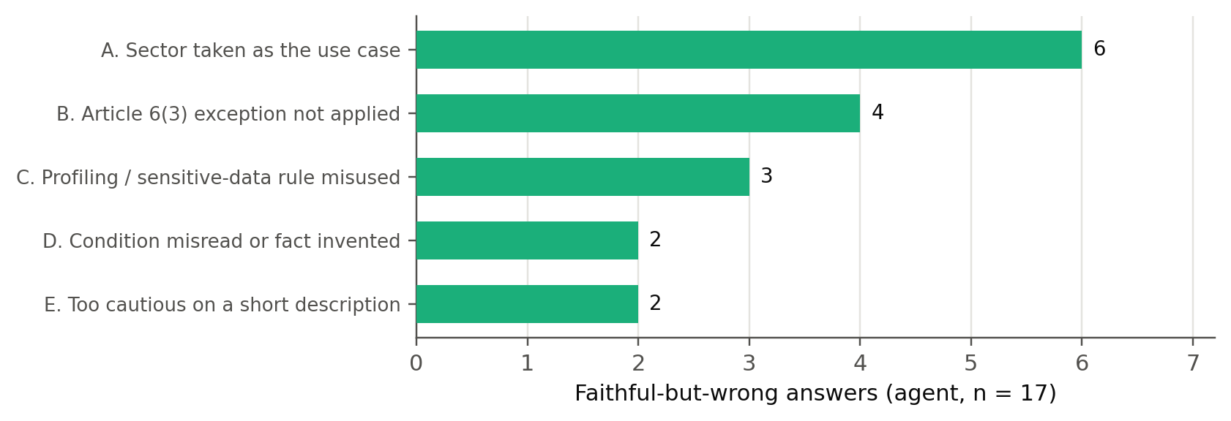
Figure 11. Faithful-but-wrong answers of the agent by error type.
Two observations explain why these answers still look faithful. First, retrieval was not the problem: for 14 of the 17 inputs the correct guideline section was among the five passages. The model had the right rule and applied it wrongly. Second, the judge accepted most of the legal conclusions: 21 of the 31 statements that state a verdict or reject an exception were marked as supported, because the passages state the general rule correctly. Faithfulness checks whether a statement can be traced to the passages; it never checks whether the rule was applied correctly to this system.
The clearest case is input 207, a system that pre-classifies incoming court cases by type. The agent correctly places it near point 8(a) and then states that no Article 6(3) condition applies, while the guidelines treat it as a narrow procedural or preparatory task. All six statements in the explanation were judged supported, so the answer scores a perfect 1.00 and is wrong. Error type A is similar: grid forecasting or network ticketing tools are labelled high-risk because the passages say that critical infrastructure is an Annex III area, while the passages also say that only safety components with a direct link to physical harm qualify. Error type C appears to be partly prompted: the agent's instructions stress that profiling always makes a system high-risk, and the model then finds profiling where there is none, for example in an anti-money-laundering transaction monitor or in keystroke-based gender inference, where it also wrongly treats gender as a sensitive attribute under Article 9(1) GDPR.
Two gold labels deserve a caveat. Input 022 comes from an example whose source text is written as a conditional, and input 035 (a real-time translation tool for public transport staff) is labelled high-risk by the Commission in a way that is open to debate. Both are kept as labelled; excluding them still leaves 15 faithful-but-wrong answers.

6. Discussion
The results answer the study question clearly. On a real legal classification task with an authoritative answer key, a high faithfulness score says almost nothing about whether the answer is right. For the structured agent the two axes are effectively independent, and more than half of its legal errors would pass a faithfulness check. For standard RAG the link is weak. This is not a failure of the judge: it is what the metric is designed to measure. Faithfulness asks whether the explanation stays inside the retrieved text, and a wrong legal conclusion can be built entirely from correctly quoted rules. The error analysis shows that this is exactly what happens: most errors come from applying a correctly retrieved rule to the wrong facts or skipping one of its conditions.
The comparison of systems adds two practical points. Retrieval matters a lot: the plain model over-predicts high-risk heavily, and grounding in the guidelines removes most of those false alarms. A more elaborate prompt, however, did not help. The step-by-step agent was not more accurate than a generic RAG prompt and was worse on the filter cases it was designed for, and its instruction about profiling seems to have encouraged over-calls. A plausible explanation is that a procedure written into the prompt invites the model to produce the right-sounding steps without doing the underlying judgement. This is a hypothesis for further work, not a tested result.
For practitioners the consequence is simple. Faithfulness is necessary but not sufficient for legal compliance tools. Where a ground truth exists, it should be reported next to a correctness measure, and a high faithfulness score should not be read as evidence that a classification is right. The label leak found in this study also shows how easily a benchmark built from worked examples can overstate performance: the leak inflated accuracy by up to 15 points and reversed the ranking of the two best systems.

7. Conclusion and Future Work
This case study built an evaluation framework for RAG-based EU AI Act high-risk classification with an authoritative answer key, compared three systems on one shared pipeline, and measured correctness and RAGAS faithfulness as two independent axes. The main finding is that the two axes come apart: for the structured agent, faithfulness does not distinguish right from wrong answers (AUC 0.465), and 17 of its 31 errors are faithful but wrong. The errors are mostly failures to apply a correctly retrieved rule, which faithfulness cannot see. Retrieval itself improves accuracy substantially, while the structured prompt does not.
Limitations. The study uses one generator and one judge, so the result may depend on these models; phi-4 is smaller than the strongest commercial models, and a stronger generator would make fewer errors but would not change what faithfulness measures. There is a single annotator and no inter-annotator agreement; the author both reviewed the redaction and categorised the errors. About 20 redacted inputs still contain wording that describes the legal test without stating the label. The number of wrong answers is modest (26 and 31), so the confidence intervals are wide. The test inputs are the Commission's own examples, which are cleaner than real product descriptions, and the class balance (31% high-risk) and the absence of high-risk examples in three areas are properties of the source. The faithful cut of 0.5 is a reporting choice, which is why the sweep and threshold-free measures are given.
Future work. The most direct extension is a second, stronger generator, including a closed commercial model, run on the same redacted inputs, to test whether the gap holds across model families and sizes. A second annotator for the error categories and a small set of realistic product descriptions labelled against the guidelines would make the result more robust. Finally, a correctness-aware check that tests whether the conclusion follows from the retrieved rule and the stated facts could be evaluated against the same answer key; fixing the metric was out of scope here, but the framework and the labelled failure cases make that a natural next step, and a possible basis for a thesis or paper.

8. Code and Data Availability
The source code (corpus builder, retriever, generation harness, judge, scoring, redaction scripts and the run notebooks) is available at:
https://github.com/rahulrawat20022002/case_study2
The repository contains the original and redacted test sets, the redaction log with the author's review, the retrieval corpus, and the run manifests with pinned model revisions. Model weights are not included and are downloaded from Hugging Face at the recorded revisions.

9. References
[1] Regulation (EU) 2024/1689 of the European Parliament and of the Council of 13 June 2024 laying down harmonised rules on artificial intelligence (Artificial Intelligence Act), Official Journal of the European Union, L series, 12 July 2024.
[2] European Commission, "Draft Guidelines on the classification of high-risk AI systems: Annex III," draft, May 2026.
[3] S. Es, J. James, L. Espinosa-Anke, S. Schockaert, "RAGAS: Automated Evaluation of Retrieval Augmented Generation," in Proc. EACL 2024: System Demonstrations, pp. 150-158.
[4] P. Lewis et al., "Retrieval-Augmented Generation for Knowledge-Intensive NLP Tasks," in Advances in Neural Information Processing Systems (NeurIPS) 33, 2020.
[5] J. Saad-Falcon, O. Khattab, C. Potts, M. Zaharia, "ARES: An Automated Evaluation Framework for Retrieval-Augmented Generation Systems," in Proc. NAACL 2024, pp. 338-354.
[6] I. Chalkidis, A. Jana, D. Hartung, M. Bommarito, I. Androutsopoulos, D. M. Katz, N. Aletras, "LexGLUE: A Benchmark Dataset for Legal Language Understanding in English," in Proc. ACL 2022, pp. 4310-4330.
[7] OECD, "OECD Framework for the Classification of AI Systems," OECD Digital Economy Papers, No. 323, OECD Publishing, Paris, 2022.
[8] National Institute of Standards and Technology, "Artificial Intelligence Risk Management Framework (AI RMF 1.0)," NIST AI 100-1, 2023.
[9] S. Xiao, Z. Liu, P. Zhang, N. Muennighoff, D. Lian, J.-Y. Nie, "C-Pack: Packed Resources For General Chinese Embeddings," in Proc. SIGIR 2024. arXiv:2309.07597.
[10] S. Robertson, H. Zaragoza, "The Probabilistic Relevance Framework: BM25 and Beyond," Foundations and Trends in Information Retrieval, vol. 3, no. 4, pp. 333-389, 2009.
[11] M. Abdin et al., "Phi-4 Technical Report," arXiv:2412.08905, 2024.
[12] W. Kwon et al., "Efficient Memory Management for Large Language Model Serving with PagedAttention," in Proc. SOSP 2023.
[13] Qwen Team, "Qwen2.5 Technical Report," arXiv:2412.15115, 2024.
[14] J. Lin et al., "AWQ: Activation-aware Weight Quantization for On-Device LLM Compression and Acceleration," in Proc. MLSys 2024.

