EECE 419 - Pod 1

X-Reserve Project Summary
November 30, 2009
Sean Clark | 36538056
Yang Gao | 52588050
Shen Li | 65962060
Neil Gentleman | 62973029
Arash Malekzadeh | 33685058
Michael Tando | 79529061
Wei-Chen Wang | 64341043

Table of Contents
1.0 Introduction 1
2.0 Development History 1
3.0 Further Work 4
4.0 Conclusion 5

Illustration Index
Figure 1: Hours Spent per Member 2
Figure 2: Project Release Schedule 2
Figure 3: Lines of Code and Churn Level 3
Figure 4: Contributed Lines of Code 3

1.0 Introduction
The number of hotels and their branches around the world is increasing every day, and this has created a demand for solid and reliable hotel management solutions. X-Reserve offers a scalable solution with a number of features available to hotel managements, staff, and guests. What sets X-Reserve apart from other solutions in the market is that it provides security, reliability, integrity, and maintainability. These features come first in importance as hotel management deals with a large amount of data related to guests and hotels. In addition, X-Reserve provides unique features such as reports, which help hotel managers to maximize their profit.
X-Reserve is developed in a group of 7 people with the following roles.
- Sean Clark: Project Manager
- Yang Gao: Designer
- Shen Li: Quality Assurance and Test
- Neil Gentleman: Developer
- Arash Malekzadeh: Developer
- Michael Tando: Librarian and Release Manager
- Wei-Chen Wang: Analyst
The time spent on this project was 3 months and about 70% of the time was spent on the project design and requirements. There are also various test performed to make sure the software meets all the requirements and is reliable.

2.0 Development History
Throughout the development of X-Reserve, our team held weekly meetings to track and discuss our progress. We also used this time to collaborate and plan new features and to schedule tasks for the week. Additional meetings were sometimes held when we needed to collaborate on our documentation or specific features. A summary of total time spent on our project can be found in Figure 1.

Figure 1: Hours Spent per Member

Figure 2: Project Release Schedule

3.0 Further Work
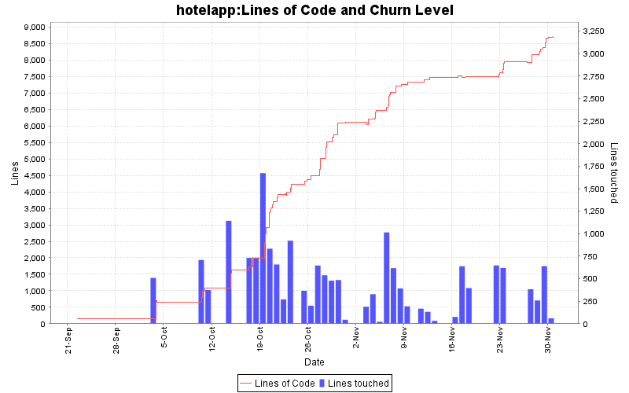Figure 3: Lines of Code and Churn Level
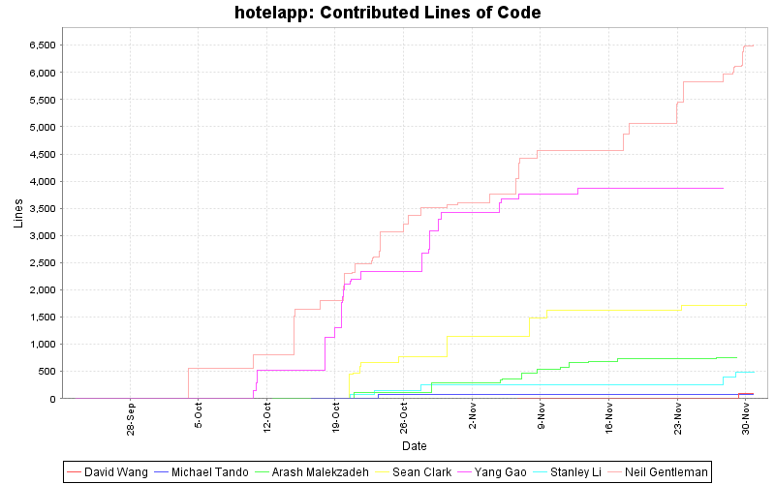Figure 4: Contributed Lines of Code
This section discusses the further work that will be required to turn X-Reserve into a deliverable product to the client. Estimated human power and time will be provided to each action.
- Improving usability
  - Document usability issues through usability testing
  - Require 2 testers and 1 developer
  - Costs approximately 1 month
- Correcting bugs
  - Document clearly all the bugs found and provide the date in resolving the bug
  - Require 3 testers and 2 developers
  - Cost approximately 2 months
- Updating user interface
  - User interface requires to be updated periodically; it should provide a fresh, clear, and distinct look.
  - Require 1 developer
  - Cost approximately 2 months
- Developing additional features
  - Develop some additional features such as check dirty room and mark clean room. Check dirty room function will assist housekeeper to keep track of dirty rooms. Mark clean room function will provide the staff to know which rooms are available to be ready to be checked in.
  - Require 2 developers
  - Cost approximately 0.5 month
In conclusion, X-Reserve will still require 3 months with addition of 3 testers and 4 developers to complete the product in deliverable quality.

4.0 Conclusion
The main objective of this project was to develop a complete software product that provides a web-based interface for hotel reservation management system. Throughout the project course, our team has not only focused on the programming aspect of the software product, but emphasis was gradually placed on demonstrating crucial software engineering practices such as software life cycle management, time management, design, testing and documentation. Special attention was
given to the functional and non-functional requirements during the software implementation to ensure the validity of our software product.
Given our lack of knowledge and experience in real world hotel administrative, overall we feel that we have built a satisfactory hotel reservation management software product that is guaranteed to meet customer’s requirements. The X-Reserve along with the documentations have been released as scheduled. The project is a success.

